Module 3: Information Gathering and Vulnerability Scanning

3.1. Performing Passive Reconnaissance
3.1.1 Overview
Reconnaissance: is the initial step in a cyber attack. An attacker must first gather information about the target in order to be successful.
In Military, reconnnaissance is gathering of information about the enemy, such as information about the enemy’s location, capabilities, and movements.
In Penetration testing, reconnaissance engagement typically consists of scanning and enumeration.
3.1.2 Active Reconnaissance vs. Passive Reconnaissance
Active reconnaissance is a method of information gathering in which the tools used actually send out probes to the target network or systems in order to elicit responses that are then used to determine the posture of the network or system.
Passive reconnaissance is a method of information gathering in which the tools do not interact directly with the target device or network.
The passive reconnaissance technique that you use depends on the type of information that you wish to obtain.
One of the most important aspects of learning about penetration testing is developing a good methodology that will help you select the appropriate tools and technologies to use during the engagement.
Common active reconnaissance tools and methods include the following:
- Host enumeration
- Network enumeration
- User enumeration
- Group enumeration
- Network share enumeration
- Web page enumeration
- Application enumeration
- Service enumeration
- Packet crafting
Common passive reconnaissance tools and methods include the following:
- Domain enumeration
- Packet inspection
- Open-source intelligence (OSINT)
- Recon-ng
- Eavesdropping
3.1.5 DNS Lookups
Typically, an attacker would start with a small amount of information and gather more information while scanning, eventually moving on to performing different types of scans and gathering additional information.
For instance, the attacker targeting h4cker.org might start by using DNS lookups to determine the IP address or addresses used by h4cker.org and any other subdomains that might be in use.
Let’s say that those queries reveal that h4cker.org is using the IP addresses 185.199.108.153 for www.h4cker.org, 185.199.110.153 for mail.h4cker.org, and 185.199.110.153 for portal.h4cker.org. Example 3-1 shows an example of the DNSRecon tool in Kali Linux being used to query the DNS records for h4cker.org.
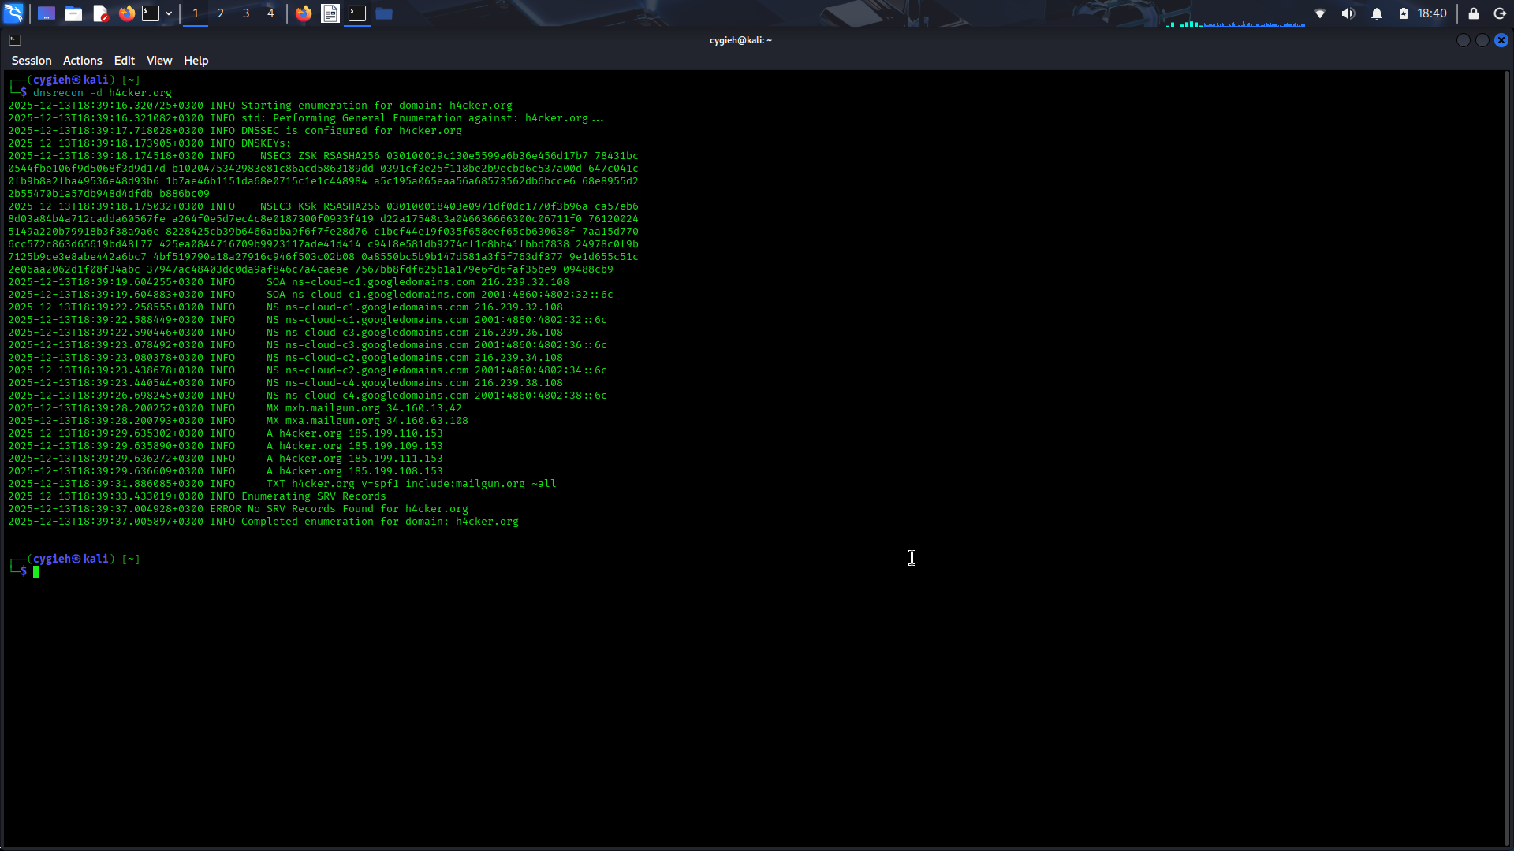
You can use other basic DNS tools, such as the nslookup, host, and dig Linux commands, to perform name resolution and obtain additional information about a domain. Example 3-2 shows how the Dig tool is used to show the DNS resolution details for h4cker.org.
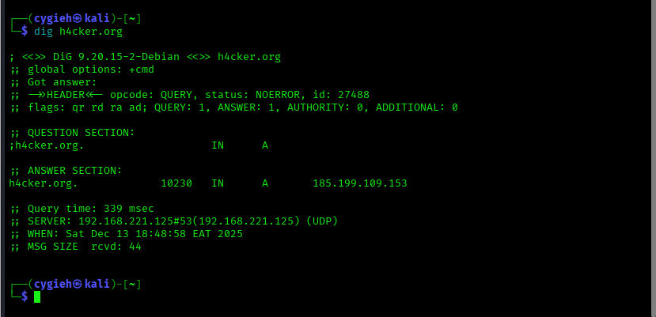
The highlighted lines show the IP addresses associated with h4cker.org. Similarly, you can use the dig < domain > mx command to obtain the email servers used by h4cker.org (mail exchanger [MX] record), as demonstrated in Example 3-3
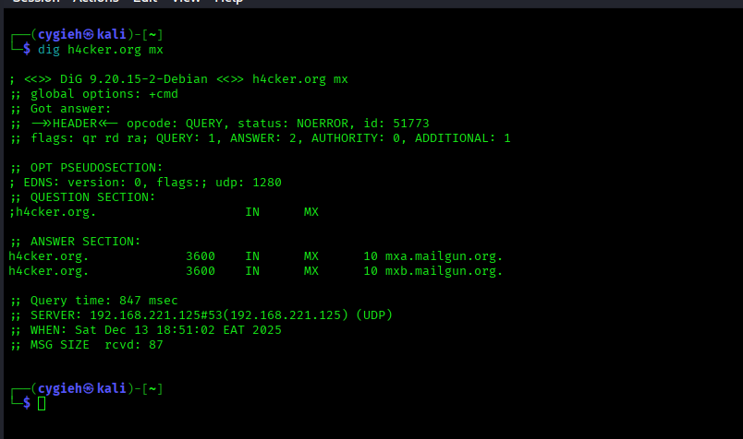
You can easily identify domain technical and administrative contacts by using the Whois tool. Many organizations keep their registration details private and instead use the domain registrar organization contacts. For instance, let’s look at the technical and administrative contacts of h4cker.org (shown in Example 3-4). Omar Santos owns the h4cker.org domain; however, the technical and administrative details are private. Only the abuse contact email and phone number from Google (the domain registrar) are displayed.
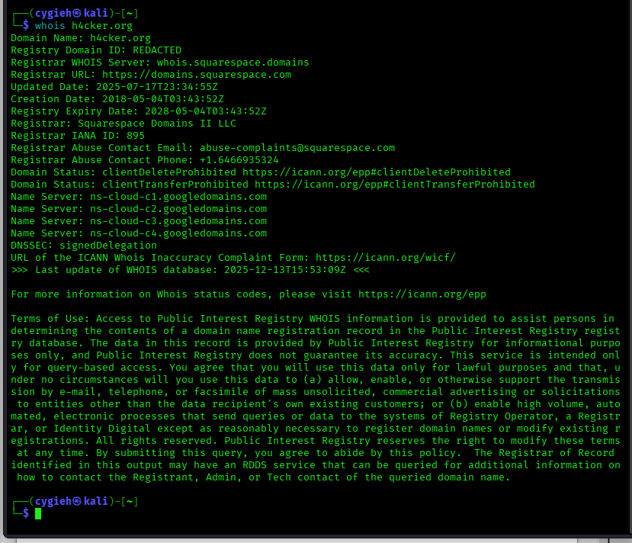
Now let’s look at the Whois details for tesla.com, shown in Example 3-5.
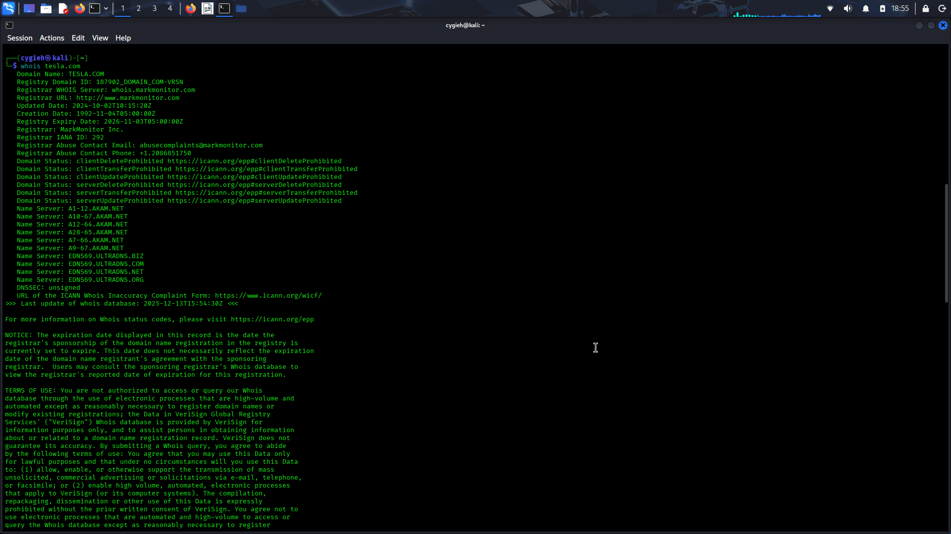
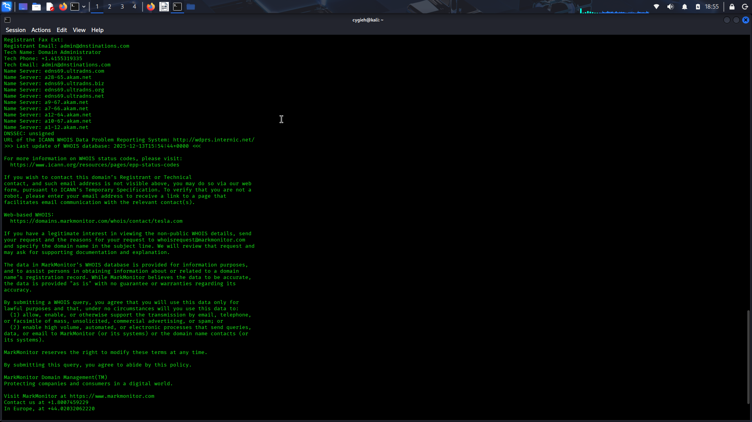
debientasolutions
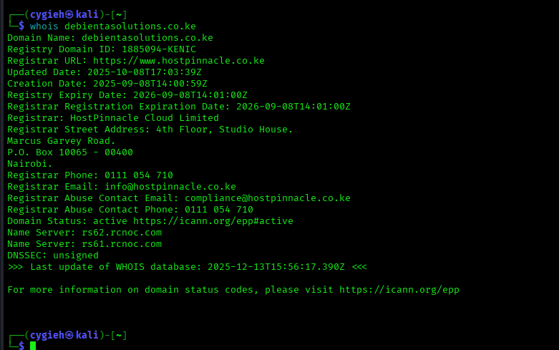
The highlighted lines in Example 3-5 show the technical and administrative contacts for the domain (which are also the ones for the domain registrar [MarkMonitor]). Example 3-6 shows another example; this example shows the technical and administrative email contacts for the domain cisco.com.
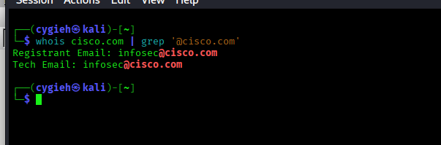
3.1.10 Cloud vs. Self-Hosted Applications and Related Subdomains
A company can own a domain and related subdomain, but its applications might be hosted in the cloud. For example, Netflix (at the time of writing) owns the domain netflix.com, which resolves to IPv4 addresses 3.230.129.93, 52.3.144.142, and 54.237.226.164 (as demonstrated in Example 3-7 with the Linux host command).
Example 3-7 - DNS Name Resolution for netflix.com
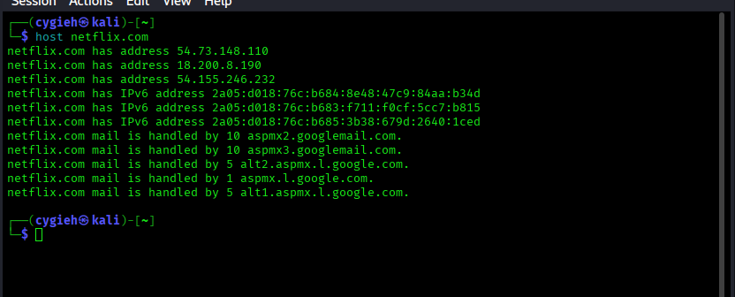
However, the IPv4 addresses are owned by Amazon Web Services (AWS), which hosts Netflix.com, as demonstrated in Example 3-8.
Example 3-8 - Example of the Ownership of IP Addresses and Applications Hosted in the Cloud
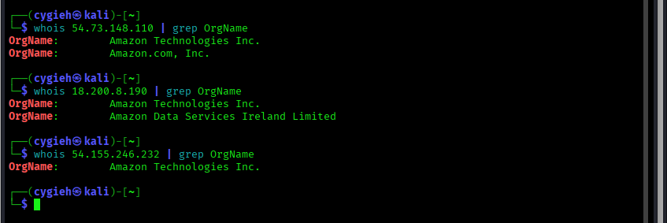
In Example 3-8, the whois command is used to retrieve the organization name (OrgName) of the owner for each of the IP addresses.

3.1.13 Cryptographic Flaws
During the reconnaissance phase, attackers often can inspect Secure Sockets Layer (SSL) certificates to obtain information about the organization, potential cryptographic flaws, and weak implementations.
Information inside digital certificates:
the certificate serial number,
the subject common name,
the uniform resource identifier (URI) of the server it was assigned to,
the organization name,
Online Certificate Status Protocol (OCSP) information,
the certificate revocation list (CRL)
URI
Certificate revocation is the act of invalidating a digital certificate.
Attackers can also leverage certificate transparency to reveal additional information and enumerate subdomains.
Certificate transparency was created to better detect the issuing of malicious certificates.
The goal of certificate transparency is for any organization or individual to be able to “transparently” verify the issuance of a digital certificate.
Certificate transparency allows certificate authorities (CAs) to provide details about all certificates that have been issued for a given domain and organization.
Attackers can also use this information to reveal what other subdomains and systems an organization may own.
Tools such as crt.sh enable you to obtain detailed certificate transparency information about any given domain.
3.1.15 Company Reputation and Security Posture
Security breaches can have a direct impact on a company’s reputation. Attackers can leverage information from past security breaches that an organization might have experienced. They may, for example, leverage the following data while trying to gather information about their victims:
- Password dumps
- File metadata
- Strategic search engine analysis/enumeration
- Website archiving/caching
- Public source code repositories
Password Dumps
Attackers can leverage password dumps from previous breaches. There are a number of ways that an attacker can get access to such password dumps, such as by using Pastebin, dark web websites, and even GitHub in some cases. Several different tools and websites make this task very easy. An example of a tool that allows you to find email addresses and passwords exposed in previous breaches is h8mail. You can install h8mail by using the pip3 install h8mail command, as demonstrated below
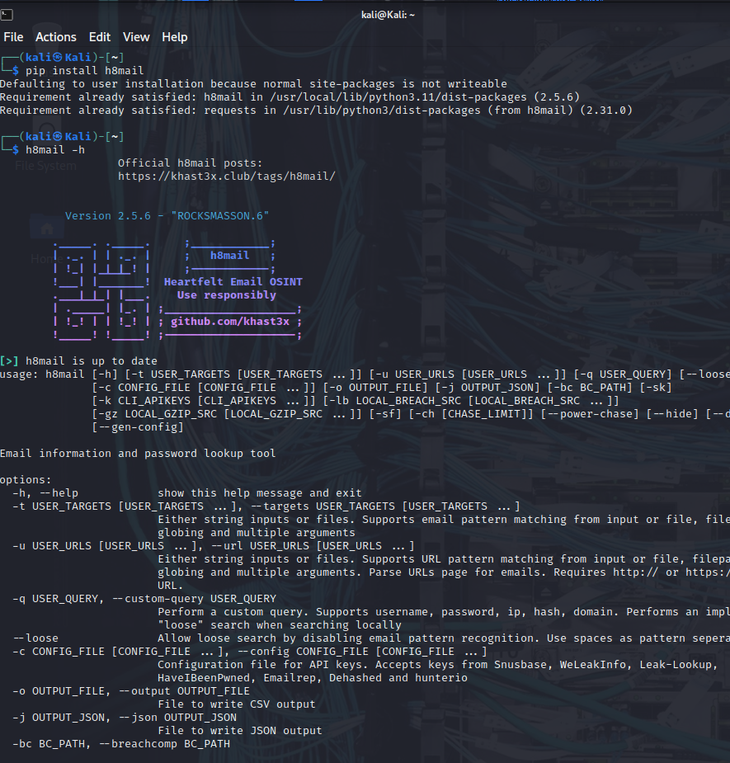
The following are additional tools that allow you to search for breach data dumps:
- WhatBreach: https://github.com/Ekultek/WhatBreach
- LeakLooker: https://github.com/woj-ciech/LeakLooker
- Buster: https://github.com/sham00n/buster
- Scavenger: https://github.com/rndinfosecguy/Scavenger
- PwnDB: https://github.com/davidtavarez/pwndb
Tools like h8mail and WhatBreach take advantage of breached data repositories of websites such as haveibeenpwned.com and snusbase.com. Historically, websites such as weleakinfo.com (seized by the FBI) have been used by criminals to dump information from past security breaches.
File Metadata
You can obtain a lot of information from metadata in files such as images, Microsoft Word documents, Excel files, PowerPoint files, and more.
For instance, Exchangeable Image File Format (Exif) is a specification that defines the formats for images, sound, and supplementary tags used by digital cameras, mobile phones, scanners, and other systems that process image and sound files.
Several tools can show Exif details. One of the most popular of them, ExifTool, is demonstrated below.
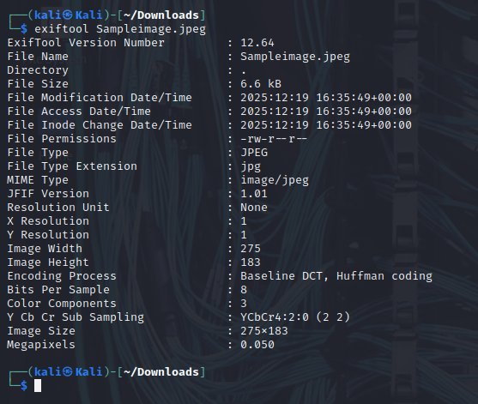
Strategic Search Engine Analysis/Enumeration
Most of us use search engines such as DuckDuckGo, Bing, and Google to locate information. What you might not know is that search engines, such as Google, can perform much more powerful searches than most people ever dream of. Google can translate documents, perform news searches, and do image searches.
In addition, hackers and attackers can use it to do something that has been termed Google hacking.
By using basic search techniques combined with advanced operators, both you and attackers can use Google as a powerful vulnerability search tool. The following are some advanced operators:
- Filetype: Directs Google to search only within the text of a particular type of file (for example, filetype:xls)
- Inurl: Directs Google to search only within the specified URL of a document (for example, inurl:search-text)
- Link: Directs Google to search within hyperlinks for a specific term (for example, link:www.domain.com)
- Intitle: Directs Google to search for a term within the title of a document (for example, intitle: “Index of /etc”)
By using these advanced operators in combination with key terms, both you and attackers can get Google to uncover many pieces of sensitive information that shouldn’t be revealed. These search strings are often called Google dorks.
To see how Google dorking works, enter the following phrase into Google:
intext:JSESSIONID OR intext:PHPSESSID inurl:access.log ext:log
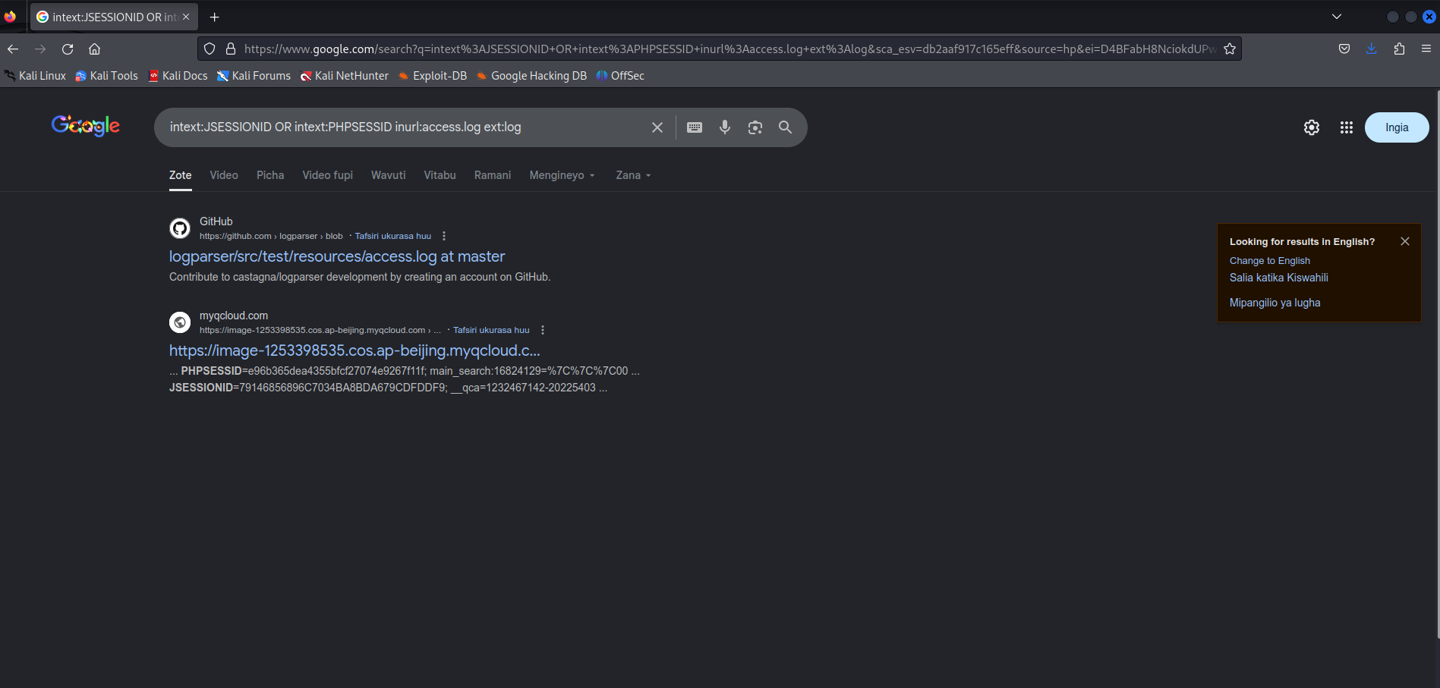
This query searches in a URL for the session IDs that could be used to potentially impersonate users. It's not unusual for this search to find more than 100 sites that store sensitive session IDs in logs that were publicly accessible. If these IDs have not timed out, they could be used to gain access to restricted resources.
You can use advanced operators to search for many types of data. The following is another example of a Google search string (or Google dork) that can reveal passwords of web applications:
"public $user =" | "public $password = " | "public $secret =" | "public $db =" ext:txt | ext:log -git
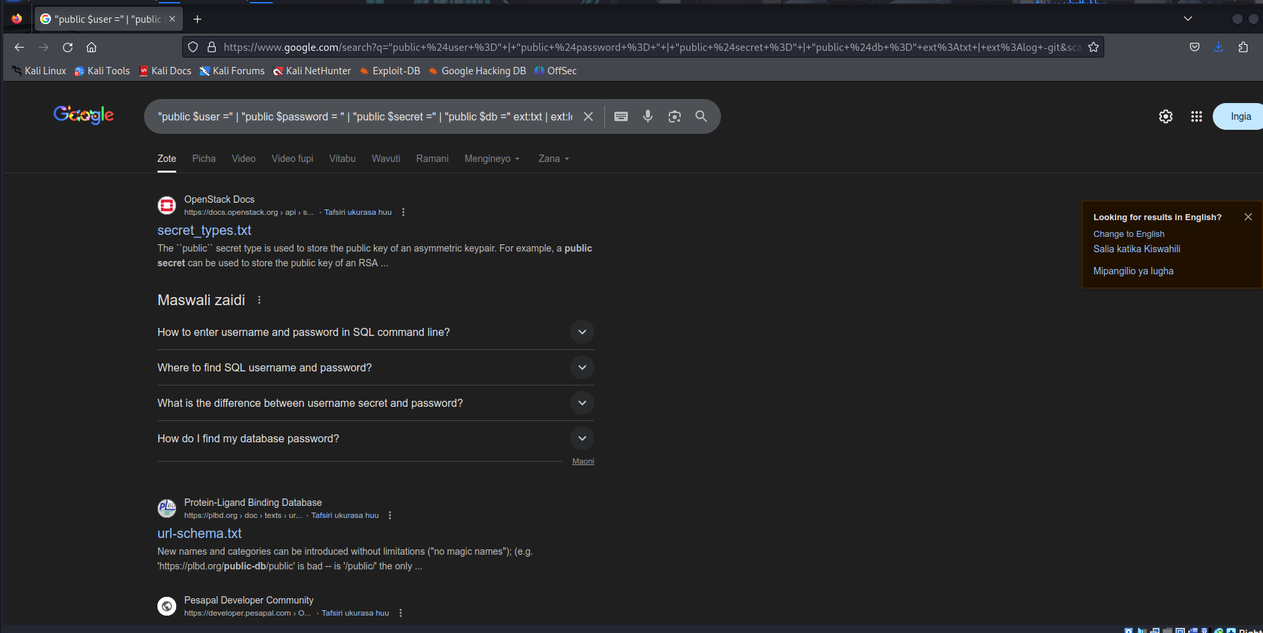
Now that we have discussed some basic Google search techniques, let’s look at advanced Google hacking. We recommend that you visit the Google Hacking Database (GHDB) repositories at https://www.exploit-db.com/google-hacking-database/. GHDB has the following search categories:
- Footholds
- Files containing usernames
- Sensitive directories
- Web server detection
- Vulnerable files
- Vulnerable servers
- Error messages
- Files containing juicy info
- Files containing passwords
- Sensitive online shopping info
- Network or vulnerability data
- Pages containing login portals
- Various online devices
- Advisories and vulnerabilities
GHDB is a community effort. Anyone can upload a new Google dork to perform these types of searches. Once you start playing with the dorks in GHDB, you will be surprised by the unbelievable things found through Google hacking. GHDB has made using Google dorks very easy, and there are other options as well. Later in this module, you will learn about additional tools that can be used to perform similar searches (such as Recon-ng).
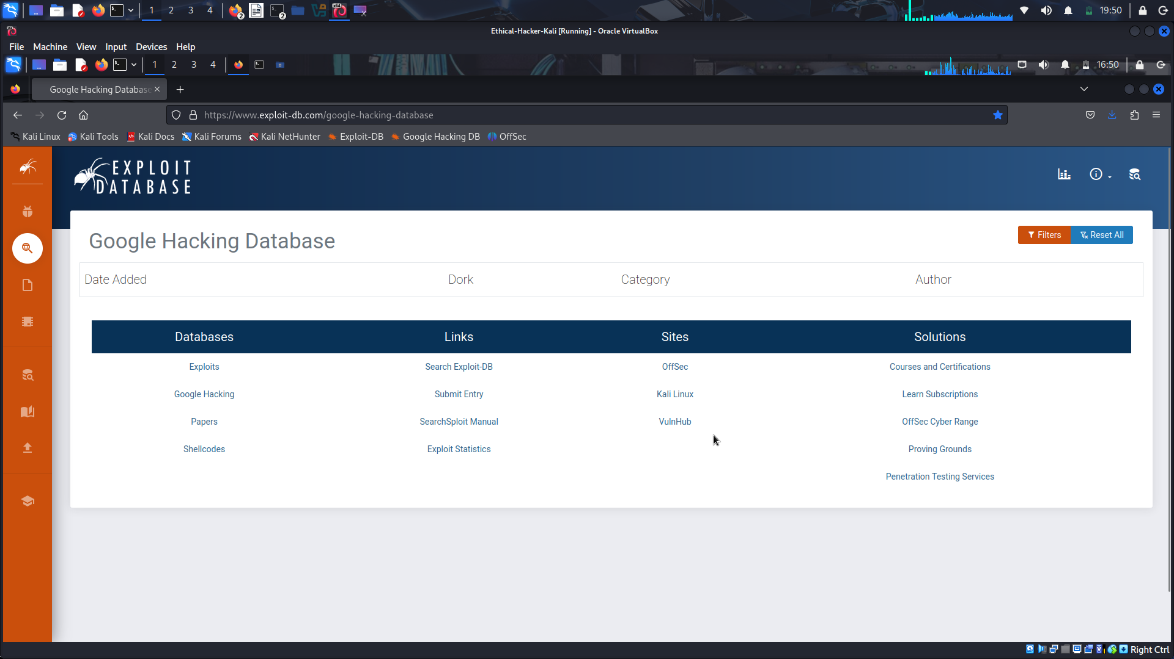
Website Archiving/Caching
Several organizations archive and cache website data on the Internet. One of the most popular repositories is the “Wayback Machine” of Internet Archive (https://archive.org/web).
The Wayback Machine allows you to go back in time on the Internet.
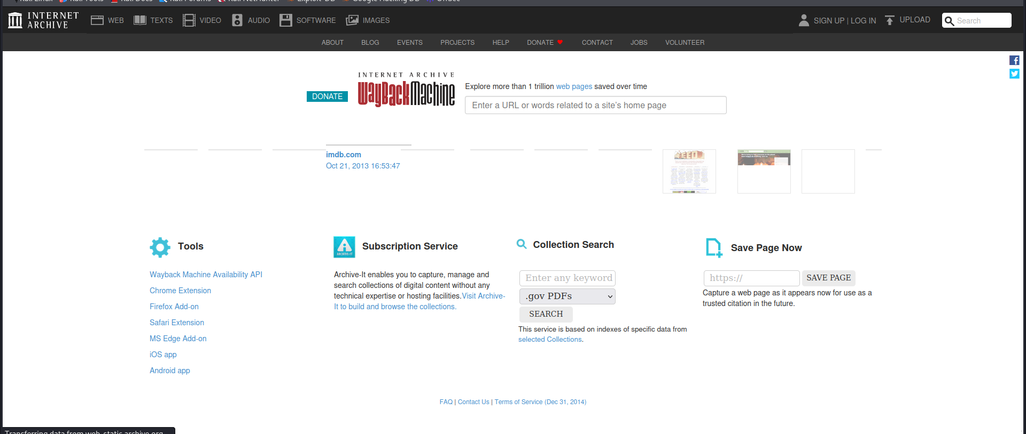
For example, the figure below shows what Cisco’s website looked like on November 3, 1999. You can access the archive of the site shown by copying the following link into your browser address bar: https://web.archive.org/web/19991103121048/http://www.cisco.com/.
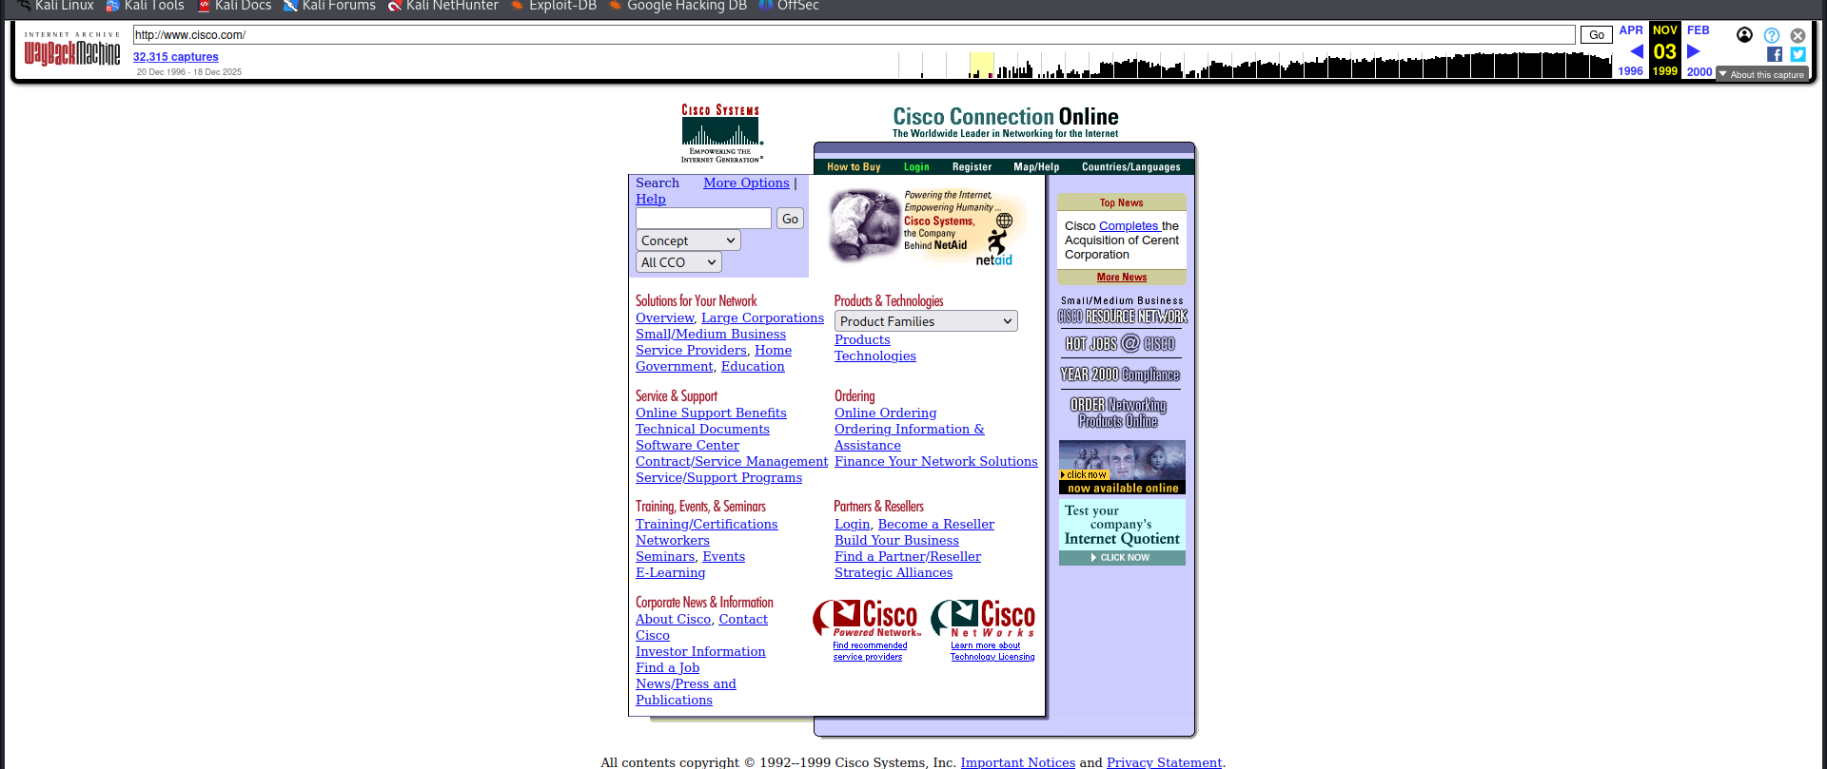
Public Source Code Repositories
An attacker can obtain extremely valuable information from public source code repositories such as GitHub and GitLab. Most of the applications and products we consume today use open-source software that is freely available in these public repositories. Attackers can find vulnerabilities in those software packages and use them to their advantage.
Similarly, as a penetration tester, you can obtain valuable information from these public repositories. Even if you do not immediately find security vulnerabilities in the code, these repositories can give you insights into the architecture and underlying code used in the organization’s applications and infrastructure.
3.1.20 Open-Source Intelligence (OSINT) Gathering
Open-source intelligence (OSINT) gathering is a method of gathering publicly available intelligence sources to collect and analyze information about a target. OSINT is “open source” because collecting the information does not require any type of covert methods. Typically, the information can be found on the Internet. The larger the online presence of the target, the more information that will be available. This type of collection can often start with a simple Google search, which can reveal a significant amount of information about a target. It will at least give you enough information to know what direction to go with your information-gathering process. Let's cover two tools that can be used for OSINT gathering: Recong-ng and Shodan.
Recon-ng
This module covers a number of individual sources and tools used for information gathering. These tools are all very effective for their specific uses;
It is a framework developed by Tim Tomes of Black Hills Information Security. This tool was developed in Python with Metasploit msfconsole in mind. If you have used the Metasploit console before, Recon-ng should be familiar and easy to understand.
Recon-ng is a modular framework, which makes it easy to develop and integrate new functionality. It is highly effective in social networking site enumeration because of its use of application programming interfaces (APIs) to gather information. It also includes a reporting feature that allows you to export data in different report formats. Because you will always need to provide some kind of deliverable in any testing you do, Recon-ng is especially valuable.
Select each of the following steps for an example of running Recon-ng in Kali Linux.
Step 1: Start Recon-ng
To start using Recon-ng, you simply run recon-ng from a new terminal window. Example 3-11 shows the command and the initial menu that Recon-ng starts with.
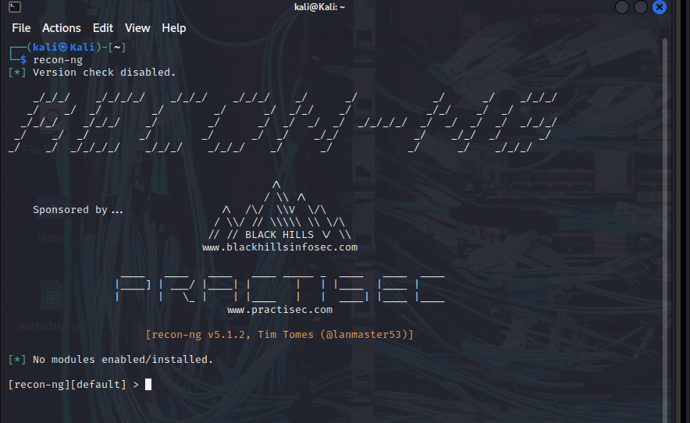
Step 2. View available commands
To get an idea of what commands are available in the Recon-ng command-line tool, you can simply type help and press Enter. Example 3-12 shows the output of the help command.
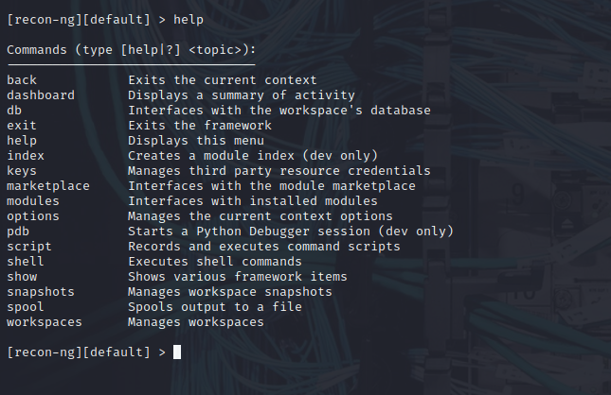
Step 3. Search for available modules.
Before you can start gathering information using the Recon-ng tool, you need to understand what modules are available. (You can see from the initial screen the current number of modules that are installed in Recon-ng.) Recon-ng comes with a “marketplace,” where you can search for available modules to be installed. You can use the marketplace search command to search for all the available modules in Recon-ng
Scroll the output to the right to see the D and K columns The letter D indicates that the module has dependencies. The letter K indicates that an API key is needed in order to use the resources used in a particular module. For example, the module with the path recon/companies-contacts/censys_email_address has dependencies and needs an API key in order to query the Censys database. (Censys is a very popular resource for querying OSINT data.)
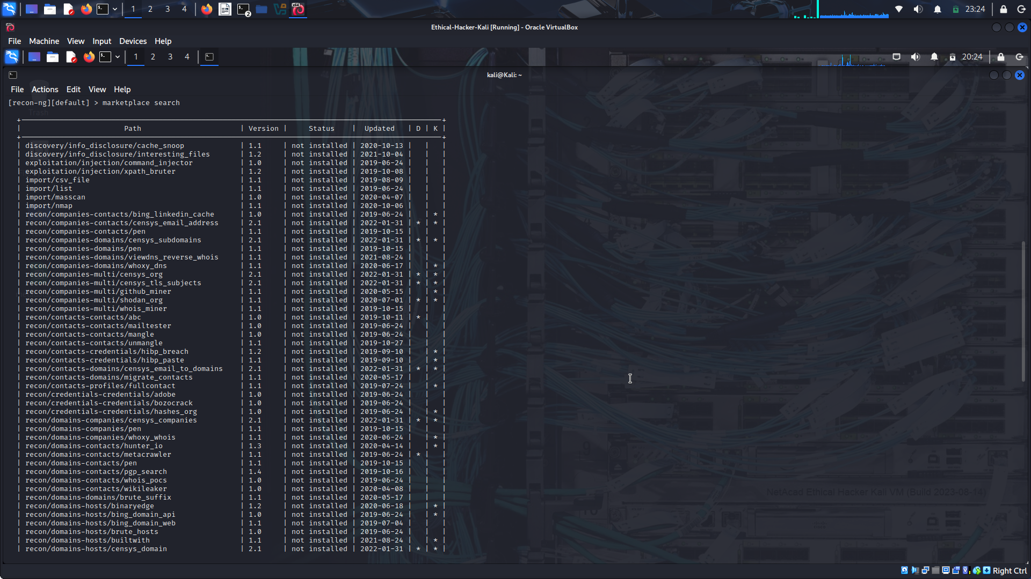
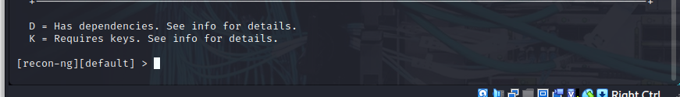
Step 4. Refresh the marketplace.
You can refresh the data about the available modules by using the marketplace refresh command
Step 5. Search the marketplace.
Let’s perform a quick search to find different subdomains of one of my domains (h4cker.org). We can use the module bing_domain_web to try to find any subdomains leveraging the Bing search engine. You can perform a keyword search for any modules by using the command marketplace search < keyword >
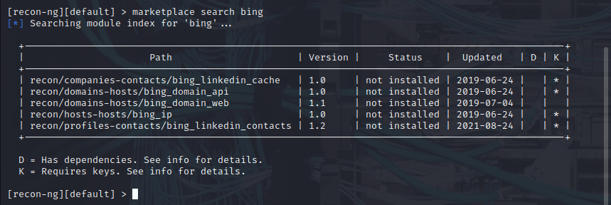
Step 6. Install a module.
Several results matched the bing keyword. However, the one that we are interested in is recon/domains-hosts/bing_domain_web. You can install the module by using the marketplace install command
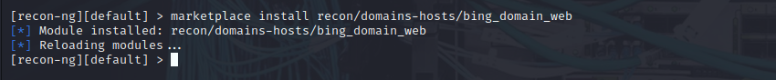
Step 7. Show installed modules.
You can use the modules search command to show all the modules that have been installed in Recon-ng.
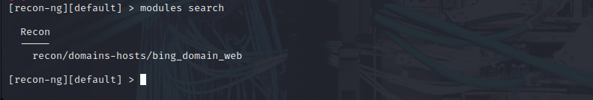
Step 8. Load a module.
To load the module that you would like to use, use the modules load command.
The bing_domain_web module is loaded. Notice that the prompt changed to include the name of the loaded module. After the module is loaded, you can display the module options by using the info command.
Step 9. Change the source.
You can change the source (the domain to be used to find its subdomains) by using the command options set SOURCE, as demonstrated in Example 3-19. After the source domain is set, you can type run to run the query. The highlighted lines show that four subdomains were found using the bing_domain_web module.
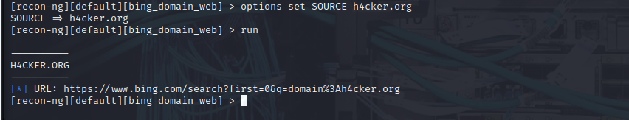
Recon-ng is incredibly powerful because it uses the APIs of various OSINT resources to gather information. Its modules can query sites such as Facebook, Indeed, Flickr, Instagram, Shodan, LinkedIn, and YouTube.
Shodan
Shodan is an organization that scans the Internet 24 hours a day, 365 days a year. The results of those scans are stored in a database that can be queried at shodan.io or by using an API. You can use Shodan to query for vulnerable hosts, Internet of Things (IoT) devices, and many other systems that should not be exposed or connected to the public Internet. Figure below shows different categories of systems found by Shodan scans, including industrial control systems (ICS), databases, network infrastructure devices, and video games.
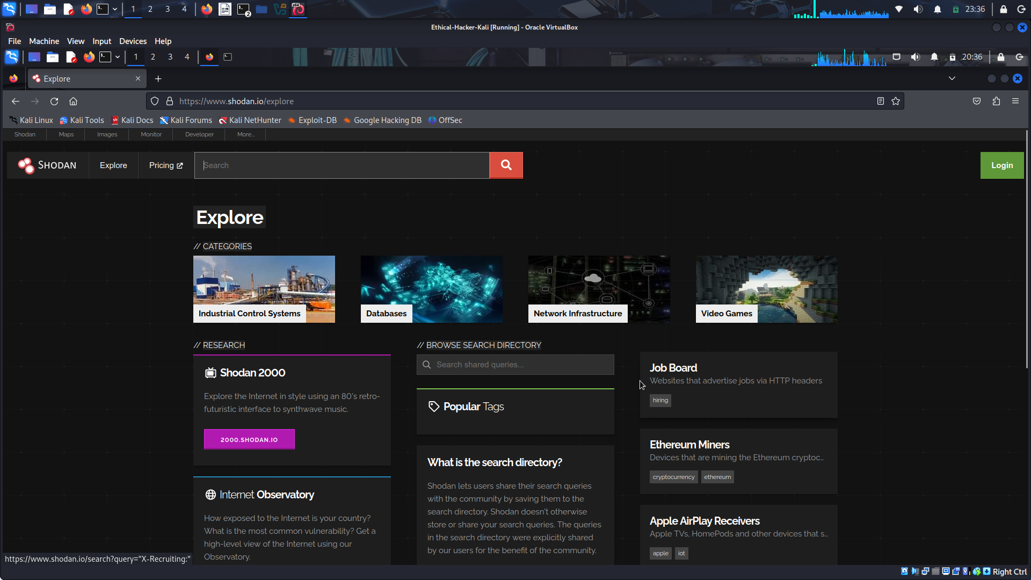
Figure below shows a query performed to find network infrastructure devices that are running a broken protocol called Cisco Smart Install. Attackers have leveraged this protocol for years to compromise different infrastructures. Cisco removed this protocol from its systems many years ago. However, many people are still using it in devices connected to the public Internet.


