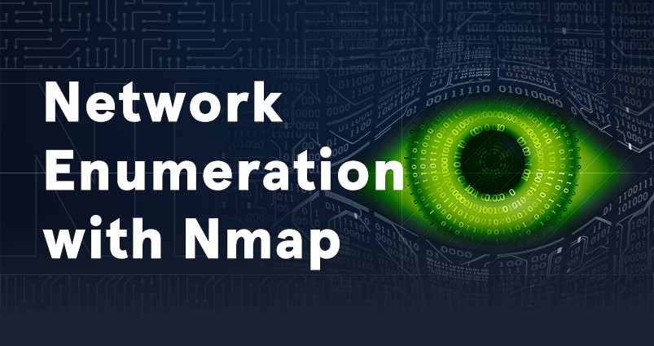
Lab - Enumeration with Nmap
Topology
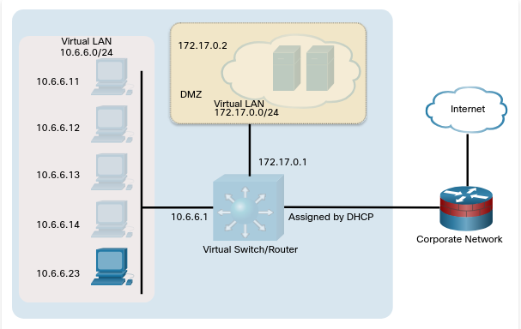
Objectives
Nmap is a powerful open-source tool for network mapping and discovery. In this lab, you will use Nmap as part of your active reconnaissance strategy.
- Investigate Nmap
- Perform Basic Nmap Scans

Background / Scenario
A Wireshark capture shows unusual activity on a machine on the 10.6.6.0 DMZ network. You’ve been asked to do some active recon on the machine to determine what services it may be offering and if there are vulnerable applications that could present security issues. The IP address of the suspicious computer is 10.6.6.23. You have access to a Kali Linux system on the 10.6.6.0 network.

Required Resources
- Kali VM customized for Ethical Hacker course

Instructions

Part 1: Investigate Nmap

Step 1: Log into Kali Linux and verify the environment.
- Log into the Kali system with the username kali and the password kali. You are presented with the Kali desktop.
- Open a terminal window.
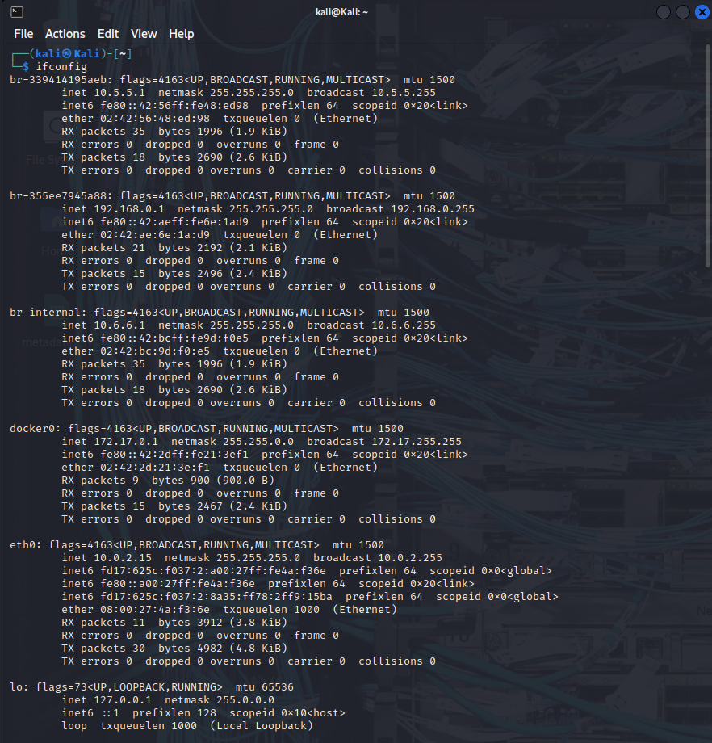
- Verify that Kali has an interface in the 10.6.6.0/24 network using the ifconfig command.

- Use the nmap -V command to verify that Nmap is installed and to display the Nmap version. The output will be similar to what is shown below.
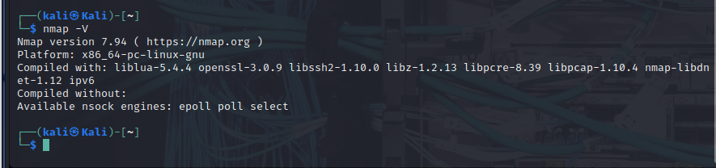

Step 2: Investigate Nmap Options and Features
- Using the command nmap without specifying any options or targets returns a list of commonly used Nmap options.
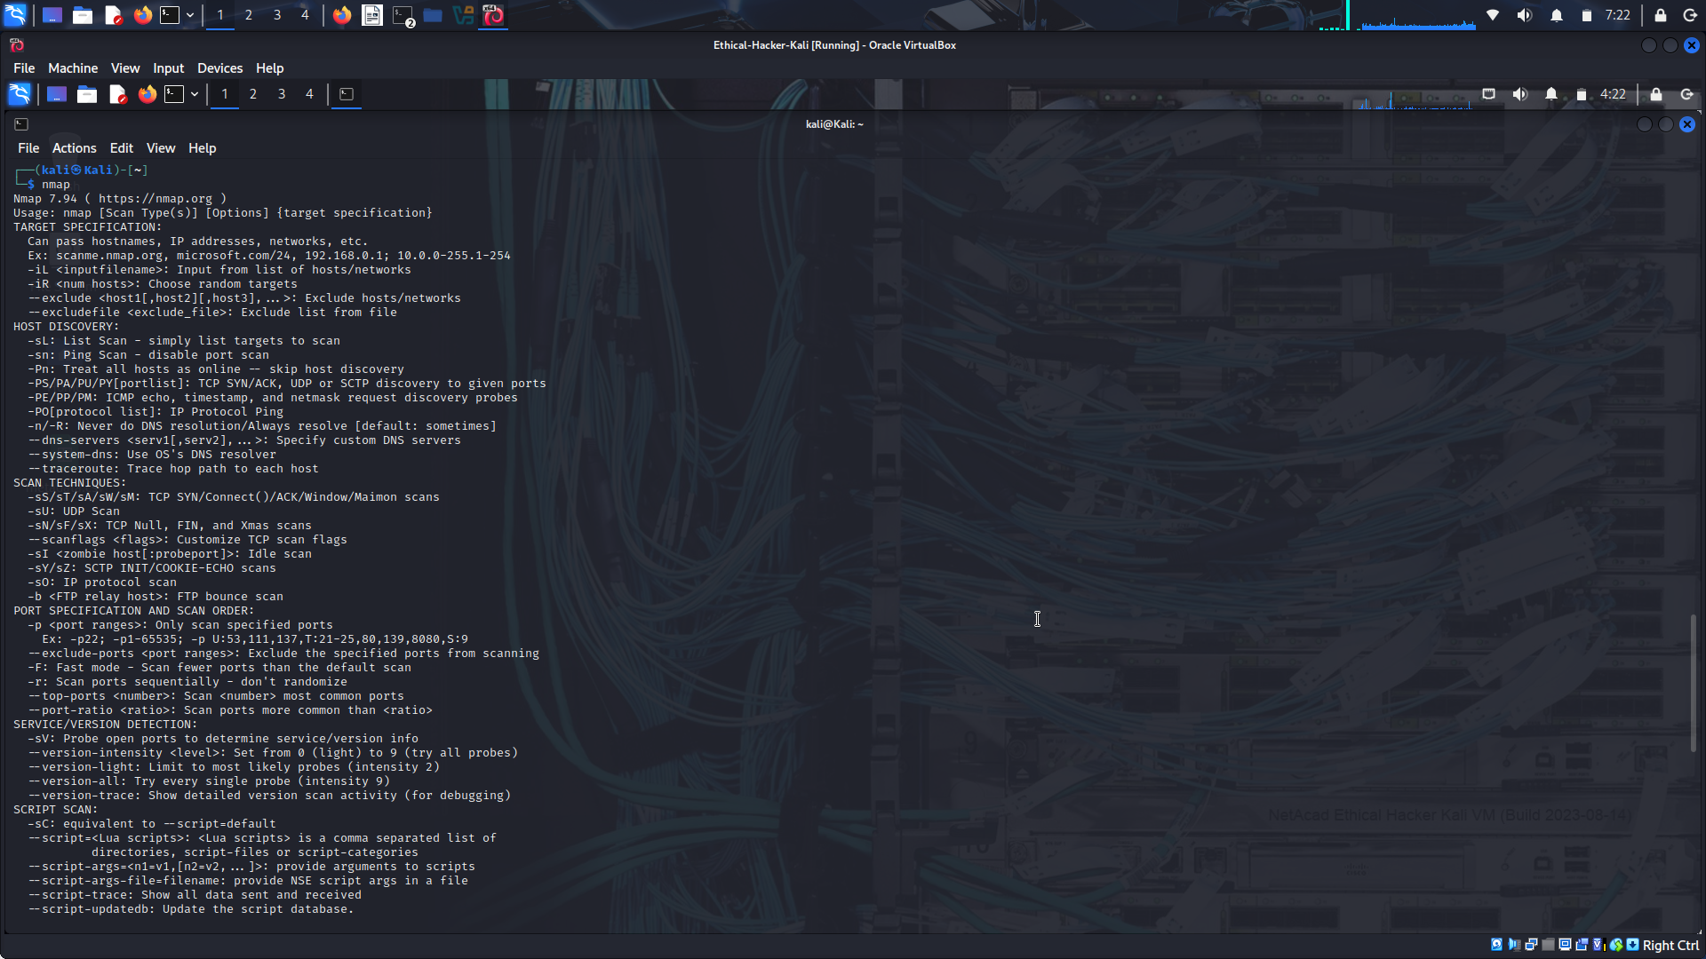
To access the Nmap help system use the command nmap -h. The help output is divided into sections based on the type of detection that the option supports.
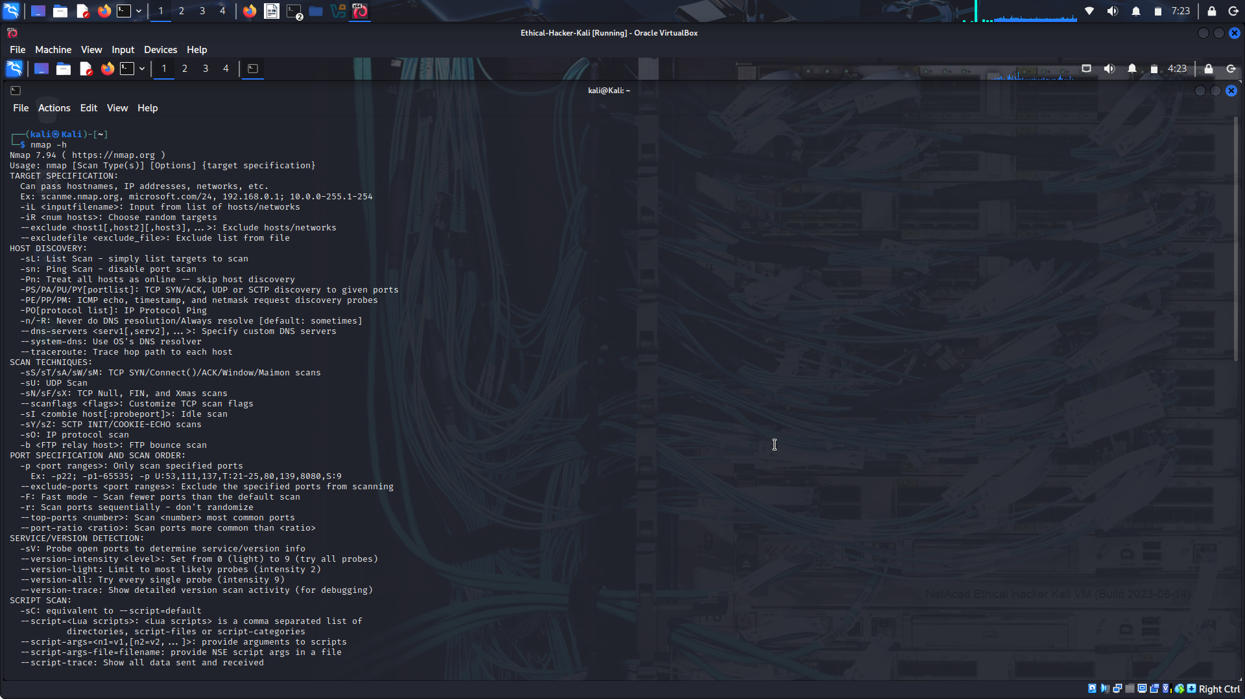
- The man page for Nmap provides additional information. To access the man page, enter the command man nmap. To exit the man pages, press q to quit and return to the terminal prompt.
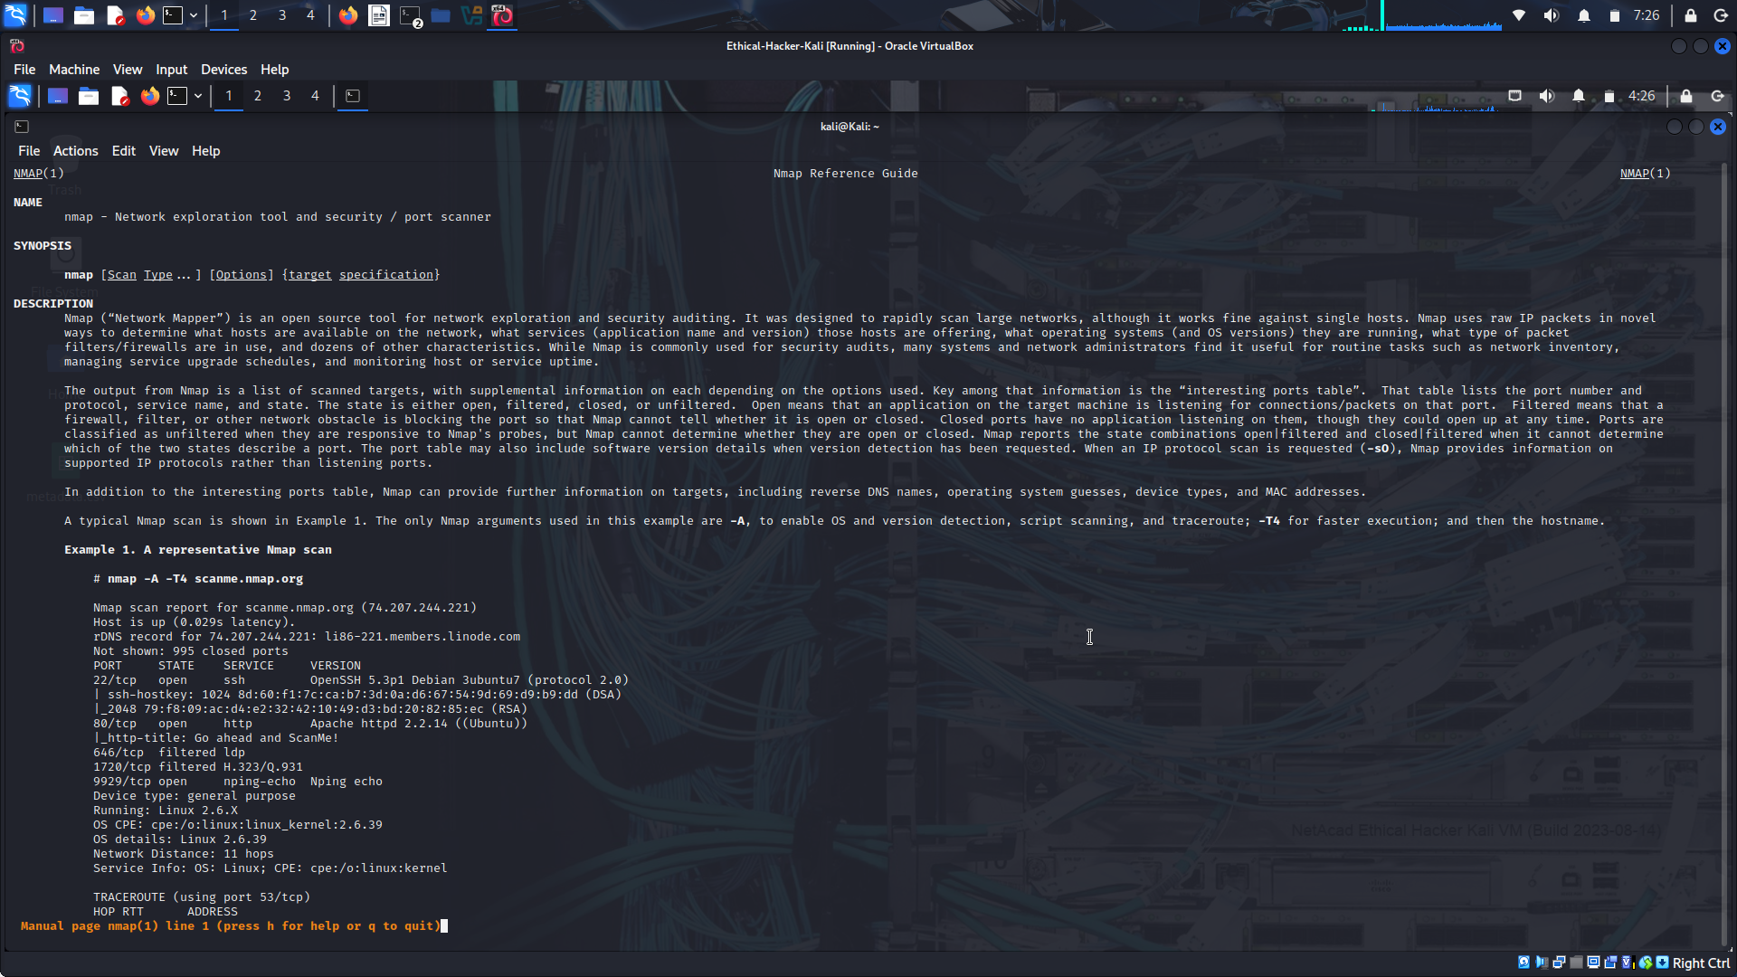
Use the man page for Nmap to complete the table.
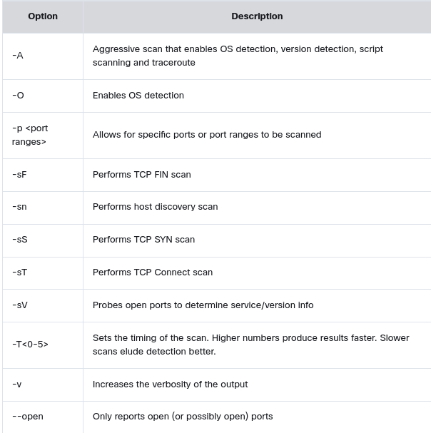

Part 2: Perform Basic Nmap Scans

Step 1: Initiate a basic Nmap scan of the target computer.
- To quickly scan the DMZ for active hosts, you can perform a discovery scan. In a discovery scan, the scanning host sends an ICMP echo request (ping), a TCP SYN to port 443, a TCP ACK to port 80, and an ICMP timestamp request. A response to any of the requests indicates that the host is up and the IP protocol stack on the host is functioning. Enter the following command to scan the DMZ network:
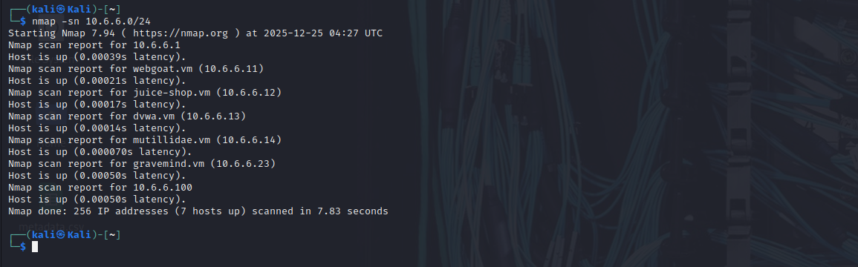
The host 10.6.6.23 was identified as suspicious in a Wireshark capture, and it is necessary to perform additional reconnaissance to discover more about the computer and its services. Use the nmap command to execute a default scan on the target host.
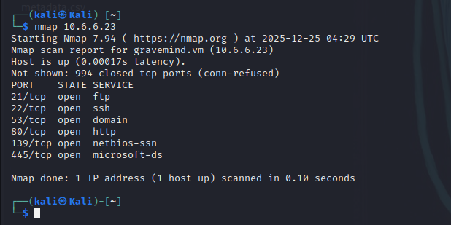
By default, Nmap performs a connect scan of 1000 most common TCP ports. This makes use of the operating system’s networking software to establish a full TCP connection. This type of scan creates a lot of networking traffic and increases the probability of detection by intrusion detection services. You can also specify a TCP connect scan using the command option nmap -sT.
The output of the connect scan includs the status codes shown below:
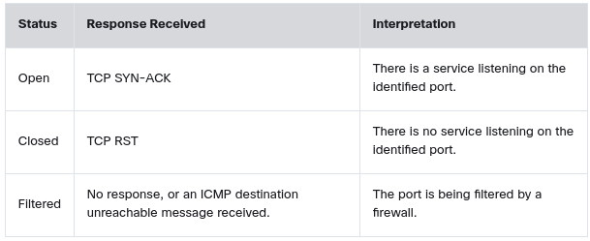
The -O option can be used to further determine information about the operating system running on the target host. Some Nmap options require additional permissions and must be run as root or using the sudo command. To find operating system information on the target host, use the nmap -O command. Enter the password of kali when prompted.
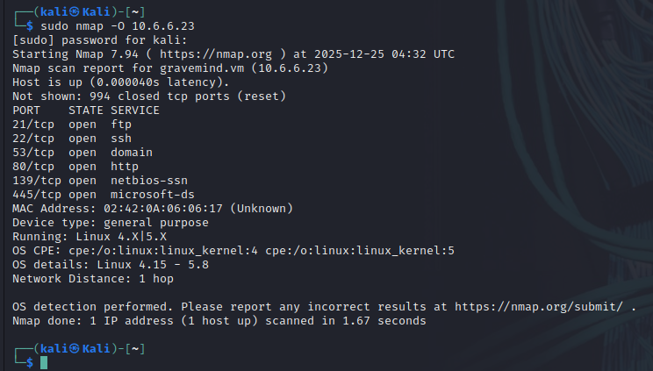
Step 2: Obtain additional information about the host and services.
- To provide additional information about the target computer, it is possible to combine different options into a single command line. The previous command identified several potentially open ports on the 10.6.6.23 host. You can use -v, -p, and -sV to find additional information about the services running on the open ports. This command provides information about the FTP service running on port 21 on the target in verbose mode, with the timing set to fast (-T4):
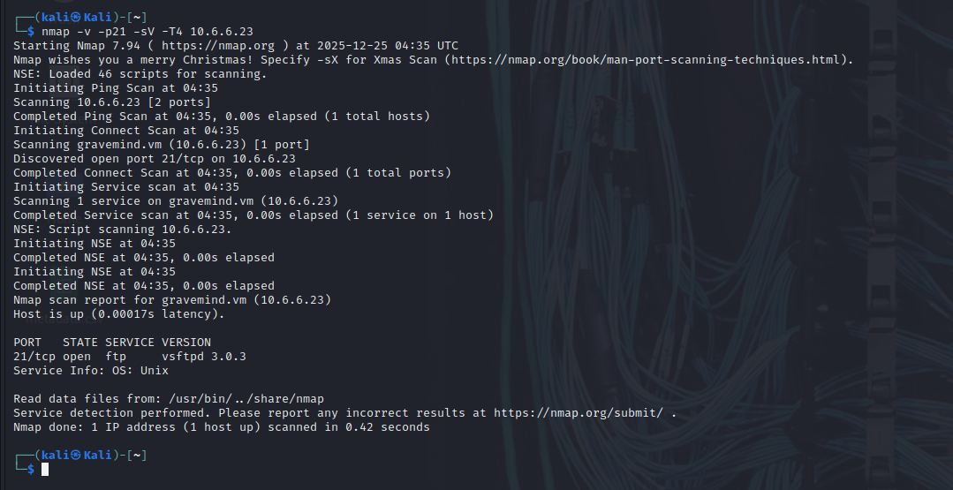
The -A option executes OS detection, version detection, script scanning, and traceroute. The -A scan can be very intrusive and therefore will be detected by many IDS systems, so ensure that you have permission before attempting this scan outside of the lab environment. To gather more information regarding the FTP service, enter the command nmap -p21 -sV -A 10.6.6.23.
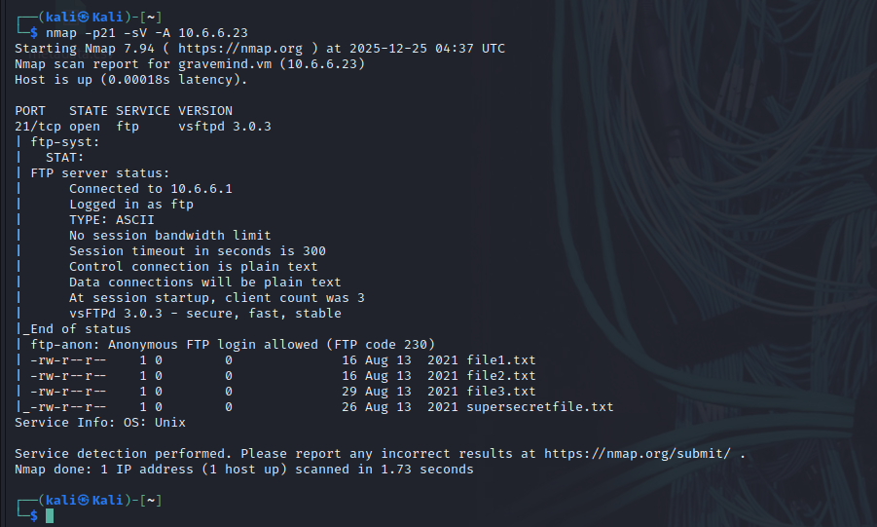
The sample detailed output of this command is shown below:
Examine the output of the nmap -A command. Notice that the output indicates that a connection was made between the Kali Linux system and the target FTP service. How many files on the FTP server are accessible through this connection? 4 text files
What weakness in the FTP server configuration enabled the Kali Linux system to log into the FTP server? The FTP server is configured to permit anonymous logins.

Step 3: Investigate SMB Services with Scripts
The Server Message Block (SMB) protocol is a network file sharing protocol supported on Windows computers and by SAMBA on Linux. SMB enables applications to read and write files or request services over a network. Open public shares or shared devices such as print servers on a network, can be accessed through SMB.
- The earlier scan of open ports on the target computer indicates that the SMB ports 139 and 445 are open. Find more information on these ports using the -A and -p command options. The -A option executes several functions including running the default scripts. Specify more than one port to scan by listing them separately with a comma between them.
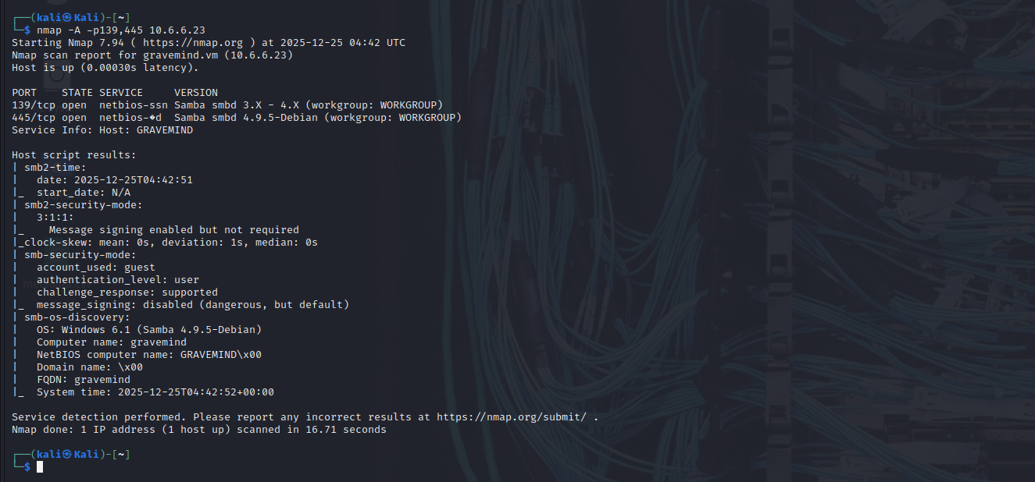
Examine the information returned by the Nmap scan. From this information, it can be determined that the target computer is a member of the default workgroup, named WORKGROUP, and that SMB supported on this host through SAMBA on Linux.
What is the NetBIOS computer name assigned to the target host? GRAVEMIND\x00

Nmap contains the powerful Nmap Scripting Engine (NSE), which enables the programming of various Nmap options and conditional actions to be taken as a result of the responses. NSE has built-in scripts that enumerate users, groups, and network shares. One of the more commonly used scripts for SMB discovery is the smb-enum-users.nse script. Use the Nmap NSE script with the command:
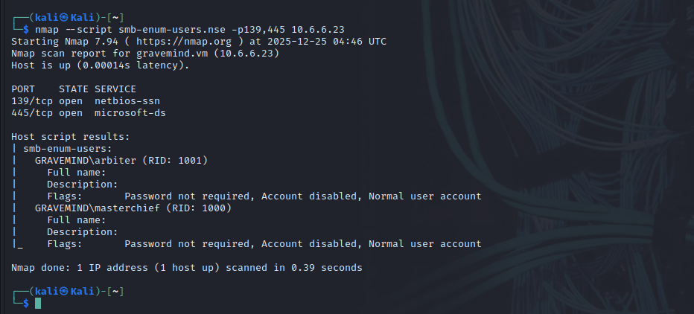
Did the script uncover any SMB usernames on the target host? If so, how many? Yes, 2 usernames: arbiter and masterchief.

A serious security concern is the existence of publicly shared directories (folders). You can enumerate the network shares using another NSE script, smb-enum-shares.nse. To discover shared directories on the target computer. Use the Nmap share enumeration script with the command:
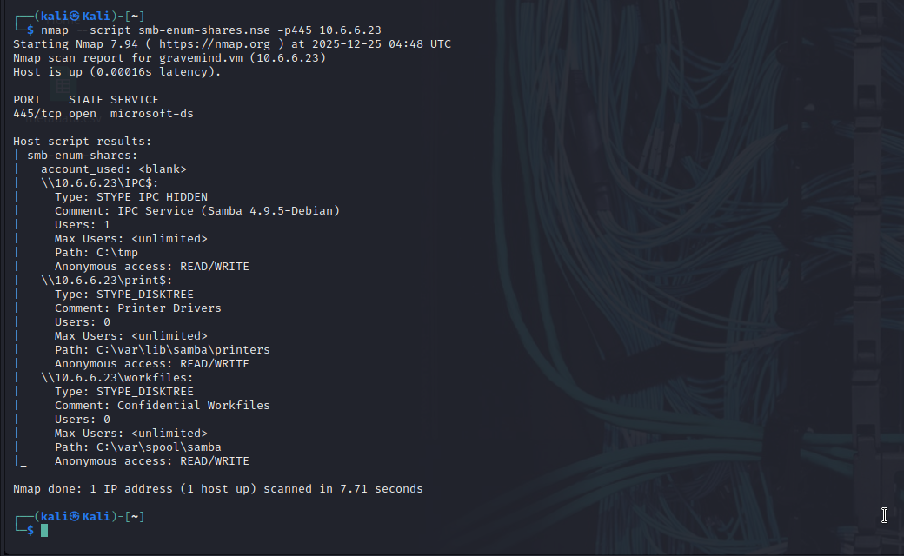
Examine the output created by the smb-enum-shares script. In the output, share names that end with a “$” character represent hidden shares that include system and administrative shares. How many hidden shares were discovered on the target host? 2
What serious security risk is uncovered in this script output? Anonymous access: READ/WRITE.

N/B
Nmap scans can be used to identify active devices on a network. The basic scans will uncover open ports and services that may need to be secured. Anonymous access to FTP files or network shares can be detected and corrected or limited. Malicious actors can use these same functions to find computers that may be vulnerable to attack.

