Lab - Network Sniffing with Wireshark

Objectives
In this lab, you will use the Linux utility tcpdump to capture and save network traffic. You will then use Wireshark to investigate the traffic capture.
- Prepare the host to capture network traffic.
- Capture and save network traffic.
- View and Analyze the Packet capture.

Background / Scenario
Wireshark is a network packet capture utility that can be used by network administrators to troubleshoot network problems. It can also be used to eavesdrop on network communications to passively collect information about users and services. Wireshark is considered a passive tool because it does not create traffic on the network.

Required Resources
- Kali VM customized for Ethical Hacker course
- Internet access

Instructions

Part 1: Prepare the Host to Capture Network Traffic.

Step 1: Start the virtual machine and log in.
- Start the Kali workstation virtual machine.
- Start a terminal session by clicking on the terminal icon on the menu bar.

Step 2: Verify the environment.
- Verify the user directory that will be used to store the captured traffic. To display the current directory, use the pwd command to display the full path to the current working directory. Record the directory location. home/kali
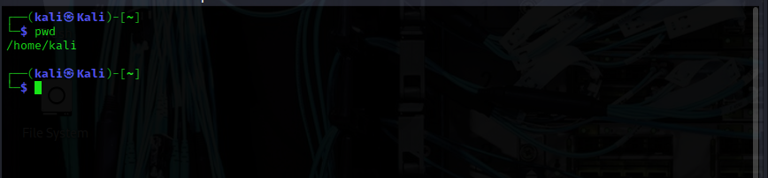
Determine the IP address of the Kali Ethernet interface using the ifconfig command. The ethernet interface is usually named eth0. Record the IP address and MAC address of the Ethernet network interface. This will be the source address for packets originating on the Kali machine.
MAC add fd17:625c:f037:2:6f7b:c14f:c463:f1f7
IP add: 10.0.2.15
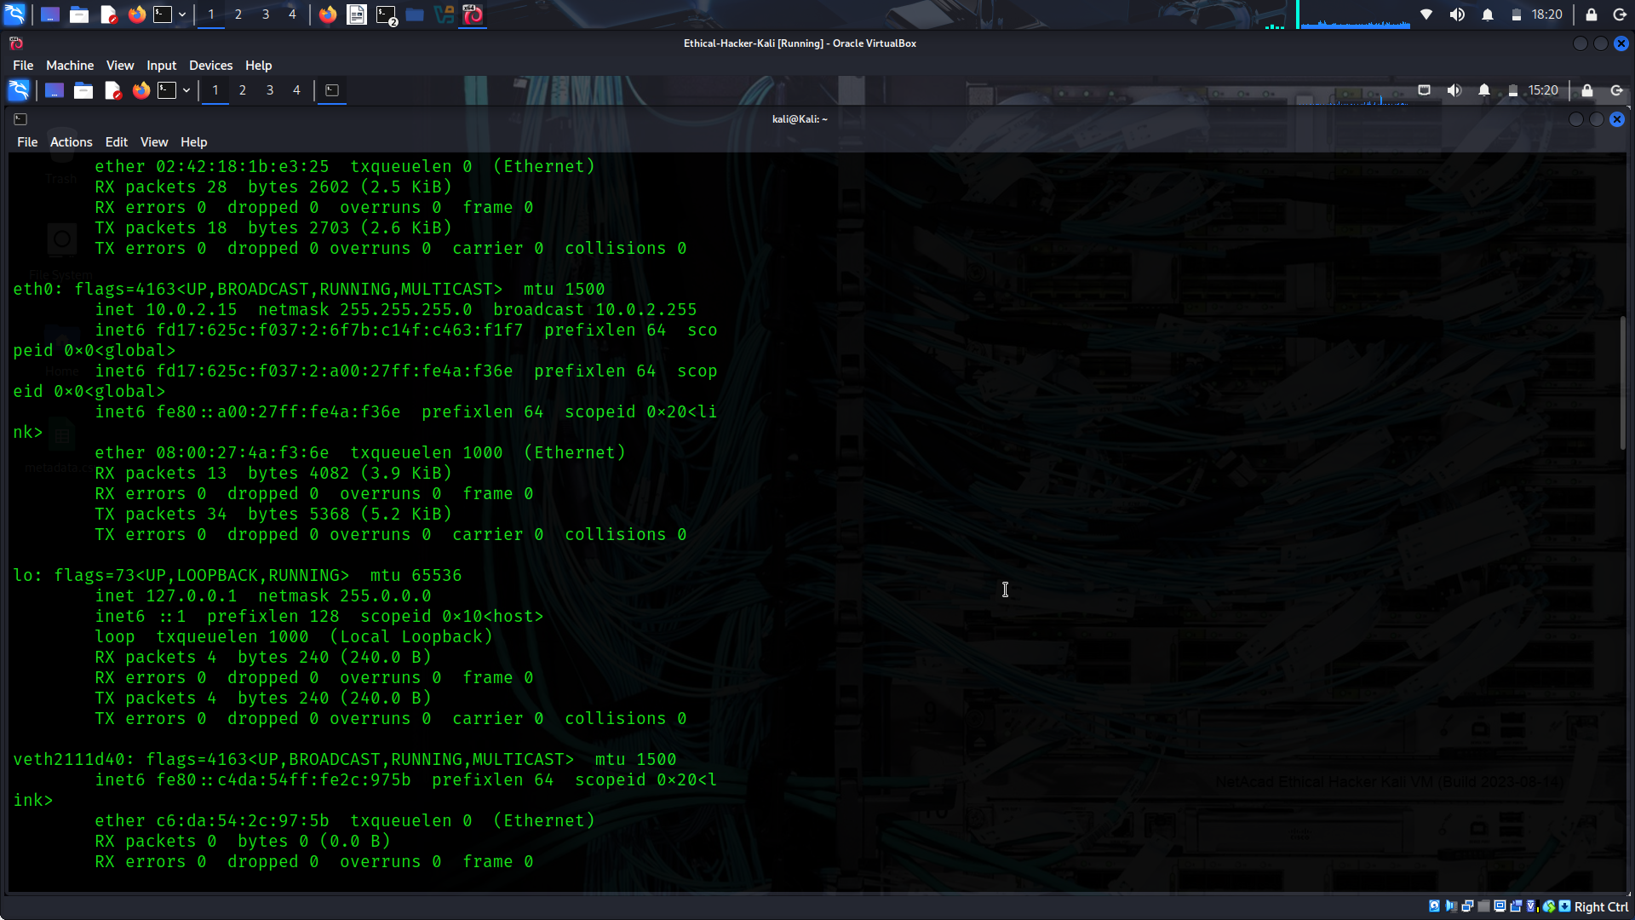
Determine the default gateway assigned to the Kali host using the ip route command.
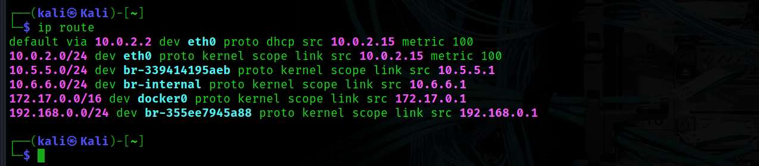
Record the IP address of the default gateway. The default gateway responds to ARP requests for destination IP address located off the source network. 10.0.2.2
Note: The IP address of the default gateway must be on the same IP subnet as the Ethernet interface address.
Determine the address of the configured default DNS server by displaying the contents of the /etc/resolv.conf file. You can view the file using the cat <file name> command.
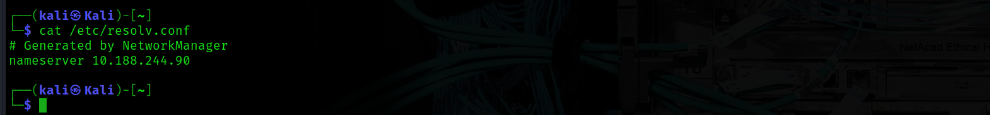
Record the IP address of the configured default DNS server. The DNS server IP address will be the destination address of standard query packets and the source address for DNS reply packets. 10.188.244.90

Part 2: Capture and Save Network Traffic.
In this part, you will use tcpdump from the CLI to capture traffic. You will use command options to save the traffic to a packet capture (pcap) file. These records can then be analyzed using different applications that read pcap files, including Wireshark.
Step 1: Open a terminal and start tcpdump.
- Open a terminal application and enter the command ifconfig.

