Tools and Code Analysis
10.1. Understanding the Basic Concepts of Scripting and Software Development
To work successfully as a penetration tester, you need to be familiar with coding, most specifically scripting languages, although knowledge of common compiled languages is also a plus.
There are two major reasons for this:
First, malware is code. Some of it is compiled code, and much of it is scripts. Although threat actors do as much as they can to obfuscate their code to make it hard to identify and interpret, skilled penetration testers can decipher it.
The other reason is that we often need to automate reconnaissance and vulnerability scanning in order to make our tests more efficient and effective. Although automated scanning tools already exist, they don't always give us what we need. You will need to be able to recognize what our existing automation scripts do, how to modify them to fit our current needs, and also how to write your own.
10.1.2 Logic Constructs
Programming logic constructs are the building blocks that include the sequence or order in which instructions occur and are processed, the path a program takes when it is running, and the iteration (or repeated execution) of a section of code.
Most programming languages include the following logic constructs:
Loops: A loop is used to repeatedly execute a section of code. They include for or while loops in different scripting languages like bash and programming languages like Python, Ruby, Perl, and JavaScript.
Conditionals: Conditionals are programming language commands that are used for handling decisions. The if statement in many programming languages, such as Python, Ruby, and Bash, is an example of a conditional statement, or conditional expression.
Boolean Operators: Also known as boolean conditionals, these operators are simple words (AND, OR, NOT, or AND NOT) that are used as conjunctions to combine or exclude keywords in a search, resulting in more focused and productive results. Using Boolean operators can save you time and effort by eliminating inappropriate hits that must be scanned only to be discarded.
String Operators: These operators allow you to manipulate values of variables in various useful ways.
Arithmetic Operators: These operators perform mathematical operations (such as addition, subtraction, multiplication, division, and modulus) on operands.
10.1.4 Data Structures
JavaScript Object Notation (JSON): JSON is a lightweight format for storing and transporting data that is easy to understand. It is the most common data structure in RESTful APIs and many other implementations.
Arrays: An array is a special variable that holds more than one value at a time.
Dictionaries: A dictionary is a collection of data values that are ordered using a key/value pair. The following is an example of a dictionary in Python: dict = {'Name': 'Omar Santos', 'Twitter': '@santosomar'}
Comma-separated values (CSV): A CSV file is a plaintext file that contains data delimited by commas (,) and sometimes tabs or other characters, like semicolons (;).
Lists: A list is a data structure in programming languages that contains an ordered structure of elements. The following is an example of a list in Python: cves = ['CVE-2022-0945', 'CVE-2023-1234’, 'CVE-2022-0987']
Trees: A tree is a non-linear data structure represented using nodes in a hierarchical model.
10.1.6 Libraries
A library is a collection of resources that can be reused by programs. Libraries can include the following:
- Prewritten code
- Configuration information
- Subroutines
- Documentation and help information
- Message templates
- Classes
10.1.7 Procedures
A procedure is a section of code that is created to perform a specific task. A procedure can be used several times throughout a program.
Procedures can make code simpler and more concise.
Functions and procedures are very similar in nature. In some programming languages, functions and procedures are practically the same thing.
10.1.8 Functions
A function is a block of code that is very useful when you need to execute similar tasks over and over. A function runs only when it is called.
10.1.9 Classes
A class is a code template that can be used to create different objects.
It provides initial values for member variables and functions or methods.
In object-oriented programming languages such as Java, Python, and C++, numerous components are objects, including properties and methods.
A class is like a blueprint for creating objects.
10.1.10 Analysis of Scripts and Code Samples for Use in Penetration Testing
Two of the best ways to become familiar with Bash, Python, Ruby, PowerShell, Perl, and JavaScript languages are by creating your own scripts and inspecting scripts created by others.
10.1.12 The Bash Shell
Bash is a command shell and language interpreter that is available for operating systems such as Linux, macOS, and even Windows.
The name Bash is an acronym for the Bourne-Again shell.
A shell is a command-line tool that allows for interactive or non-interactive command execution. Having a good background in Bash enables you to quickly create scripts, parse data, and automate different tasks and can be helpful in penetration testing engagements.
Learn:
Python: Python is one of the most popular programming languages in the industry. It can be used to automate repetitive tasks and create sophisticated applications; it can also be used in penetration testing.
Ruby: Ruby is another programming language that is used in many web and other types of applications.
Powershell: PowerShell and related tools can be used for exploitation and post-exploitation activities.
Perl:
Javascript
Part 1: Write a Bash Script to Automate an Nmap Scan and Store the Results.
Step 1: Create a basic Bash script.
ping the target host at 10.6.6.23 to ensure that it is available on the network.
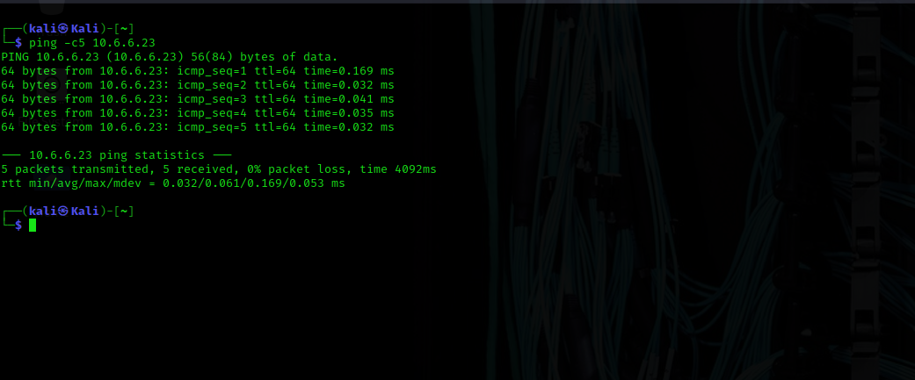
Open the Mousepad text editor from the Applications menu.
The first line in the Bash script is a special kind of comment line that indicates the location of the interpreter to be used to run the code. This line is called a "shebang" and is common to most Linux scripts. Enter the shebang #!/bin/bash on line 1 this identifies the language of the script to the command interpreter.
In this script, the user will enter the IP address of the target as a command line option. If no option is entered, the user will receive an error message showing the proper command syntax. Enter the if/then sequence.
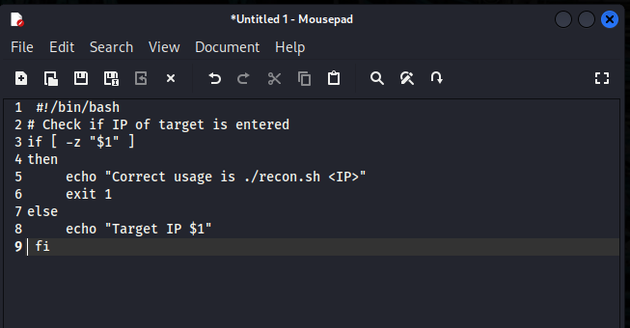
Analyzing script code is an important skill for a penetration tester. Not only will you write automation code, you will often need to determine what an existing script does. The meaning of each line of is as follows:
- Line 2 is a comment line that begins with a hash tag #. Lines starting with # are used to document the script. Comment lines are ignored by the command interpreter.
- Line 3 starts a test to determine if the input option variable $1 exists. By default, Bash scripts accept command line options into variables numbered by their position in the command. The -z returns "true" if the value of $1 is null. Bash requires a space after the first bracket [ and a space before the last bracket ].
- Line 4 indicates what to do if the option variable does not exist (is null). Lines 5 and 6 are indented to indicate that they are part of the then clause.
- Line 5 prints a message to the screen. Bash uses the echo command to print what is in the double quotes to the screen.
- Line 6 will cause the script execution to stop and exit to the CLI if the condition is met.
- Line 7 indicates what to do if the if condition is false.
- Line 8 prints a message with the input value that was supplied and stored in the $1 variable. Note that further work is required to validate that the input was actually a valid IP address. This is beyond the scope of this lab.
- Line 9 indicates that the if/then clauses are complete.
Save your file with the name recon.sh.
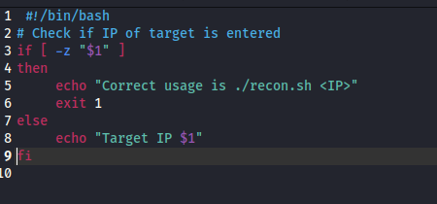
To make a text file into an executable, it is necessary to change the Linux permissions on the file. Open a terminal window on the Kali desktop. List the directory using ls and verify that your script file is there and has the correct name. Enter the chmod +x command to add the executable permission to your file.
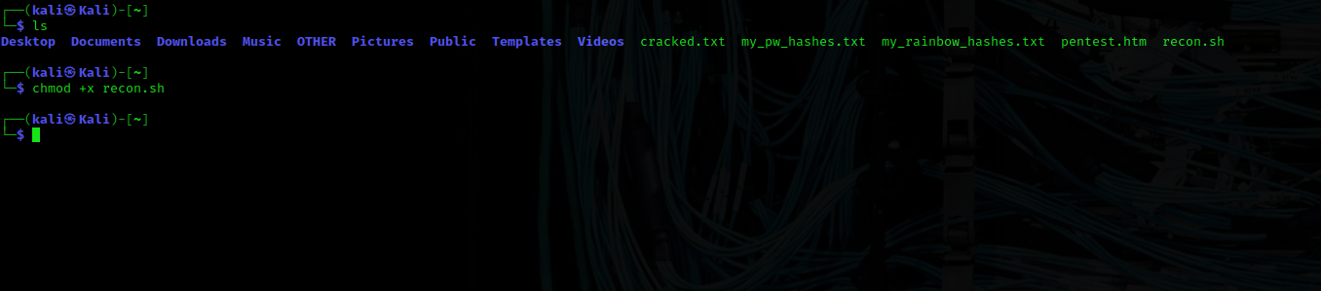
Test your script by running it first with the IP address of the target (10.6.6.23) specified.
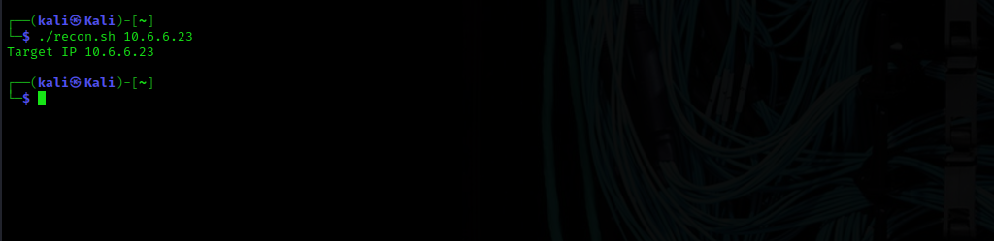
Edit the script file to enter the commands that will run the Nmap scan. Use the variable $1 to indicate the IP address of the target device you want to scan. The results of the Nmap scan will be written to a file named scan_results.txt in the current directory. Save the script
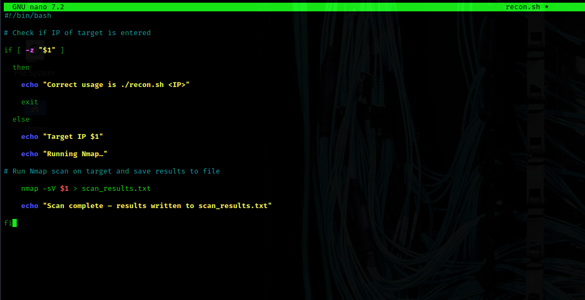
Run it again with the target IP address supplied.
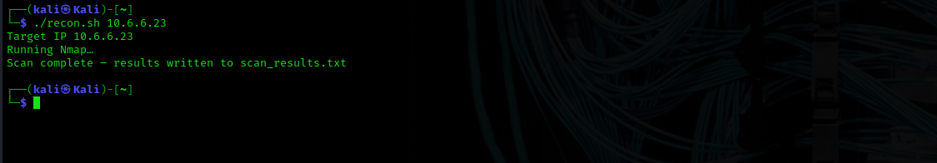
Use the cat command to view the contents of the scan_results.txt file that you created with the script.
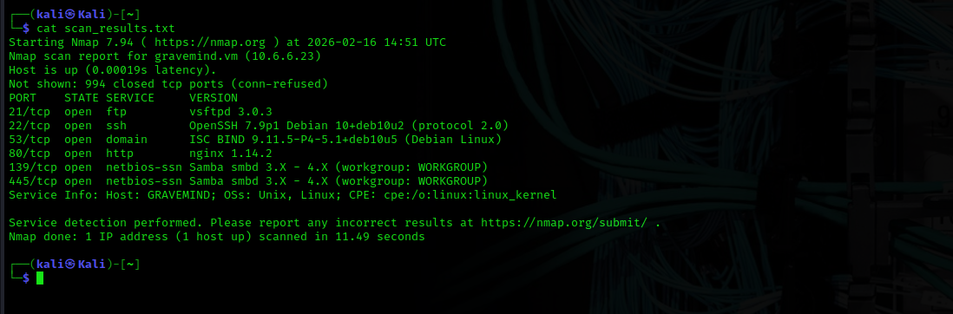
What ports are open on the target?
21/tcp open ftp
22/tcp open ssh
53/tcp open domain
80/tcp open http
139/tcp open netbios-ssn
445/tcp open microsoft-ds

Step 2: Modify the script to enumerate shares on the target.
As seen in the previous step, the target at 10.6.6.23 has open ports that could indicate a Samba server. In this step, you will edit your script to run enum4linux if a Samba drive share port is open to determine any available drive shares or user accounts.
What indicates that a Samba server is running on the hosts? Port 139 and 445 are open
Open the recon.sh file in the text editor. Add the following commands.

- Line 13 is a comment.
- Line 14 indicates the start of an if/then statement that will search in the Nmap results for open port 445. The grep command searches lines in the file that match the pattern “445 open.” The grep command searches for lines that match the pattern “445” first. Then the output is piped into a second grep command to search again for lines that match the pattern open. With the option -i, the grep command ignores the case distinctions in the search patterns. The option -q suppresses standard outputs.
- Line 15 is the "then" clause. This contains the command that will be executed should the if test return "true".
- Lines 16 - 19 are executed if the SMB file sharing port (445) is found. Line 16 runs enum4linux with the -U and -S options on the target host specified in $1 and appends the results to the end of the scan_results.txt file. Lines 17, 18 and 19 display messages when emun4linux finished the scan and provides directions to view the results.
- Line 20 indicates that the action to take if the logical if the condition fails.
- Line 21 displays a message if the SMB file sharing port (445) is not open.
- Line 22 the fi signifies the end of the if/then clause.
What do the -U and -S options do in enum4linux?
-U enumerates users found
-S enumerates drive shares
Save the recon.sh file in the text editor and exit to the command prompt.
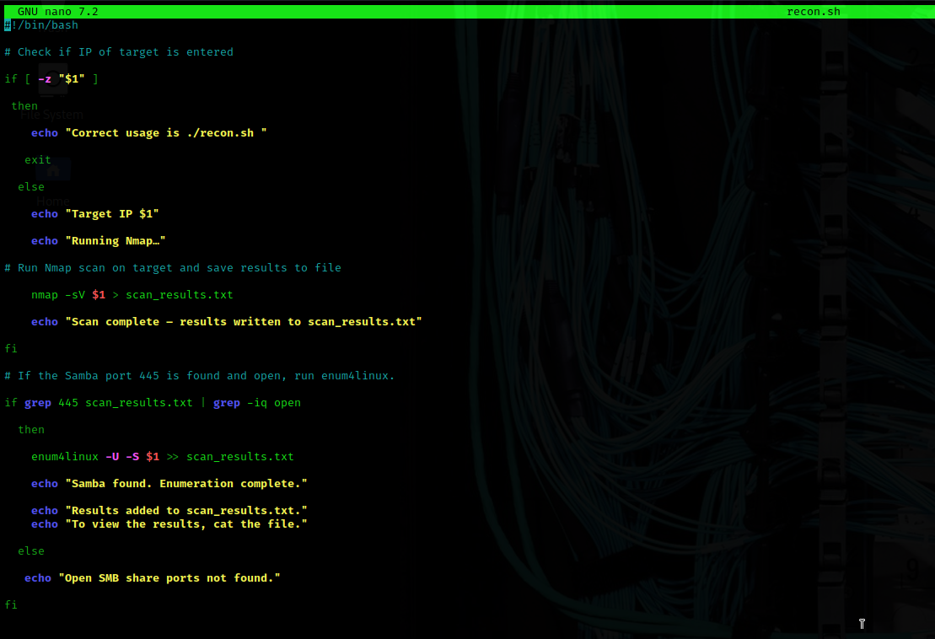
Run the script again on the target system (10.6.6.23).
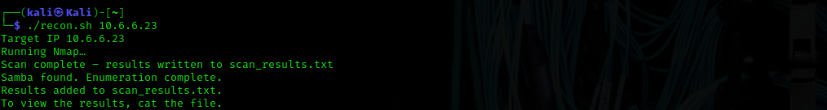
Use the cat command to view the results contained in the scan_results.txt file. What file shares were found on the target?
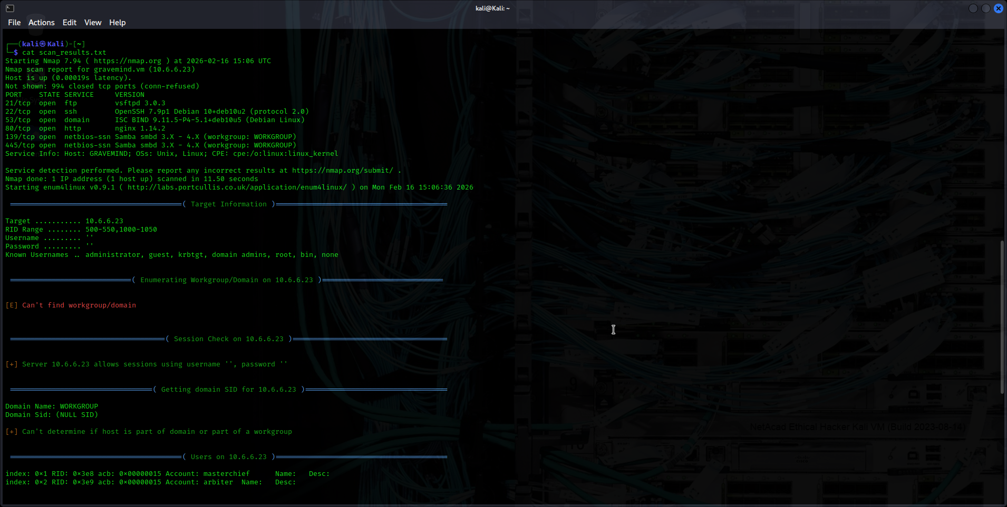
What file shares were found on the target?
Sharename Type Comment
homes Disk All home directories
workfiles Disk Confidential Workfiles
print$ Disk Printer Drivers
IPC$ IPC IPC Service (Samba 4.9.5-Debian)
