Exploiting Wired and Wireless Networks
We will be conducting asset enumeration of the internal network as a precursor to vulnerability scanning. We want to focus on the systems that will potentially give us the most access to proprietary data but need to run vulnerability scans on all in-scope targets. Once assets are identified and we know what protocols and services are running on the network we can devise exploits as a basis for risk analysis. We also need to challenge the Identity and Access Management systems to see if they are adequate to block even simple unauthorized access by internal users as well as more complex external threats. Finally, we will conduct network share enumeration and attempt various on-path (MITM) attacks to gain further unauthorized access to accounts and data.
Exploiting Network Based Vulnerabilities
5.1.2 Windows Name Resolution and SMB Attacks
Name resolution is one of the most fundamental aspects of networking, operating systems and applications.
There are several name-to-IP address resolution technologies and protocols, including:
- Network Basic Input/Output System (NetBIOS)
- Link-Local Multicast Name Resolution (LLMNR)
- Domain Name System (DNS).
1. NetBIOS Name Service and LLMNR
NetBIOS and LLMNR are protocols that are used primarily by Microsoft Windows for host identification. LLMNR, which is based on the DNS protocol format, allows hosts on the same local link to perform name resolution for other hosts. For example, a Windows host trying to communicate to a printer or to a network shared folder may use NetBIOS, as illustrated below
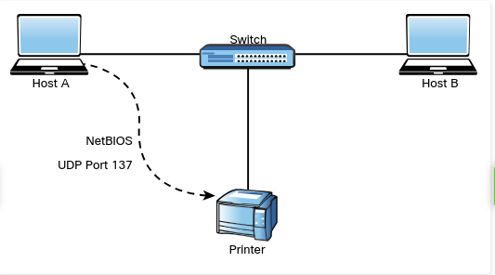
NetBIOS provides three different services:
- NetBIOS Name Service (NetBIOS-NS) for name registration and resolution.
- Datagram Service (NetBIOS-DGM) for connectionless communication.
- Session Service (NetBIOS-SSN) for connection-oriented communication.
NetBIOS-related operations use the following ports and protocols:
- TCP port 135: Microsoft Remote Procedure Call (MS-RPC) endpoint mapper, used for client-to-client and server-to-client communication
- UDP port 137: NetBIOS Name Service
- UDP port 138: NetBIOS Datagram Service
- TCP port 139: NetBIOS Session Service
- TCP port 445: SMB protocol, used for sharing files between different operating systems, including Windows and Unix-based systems
NOTE Traditionally, a NetBIOS name was a 16-character name assigned to a computer in a workgroup by WINS(Windows Internet Name Service) for name resolution of an IP address to a NetBIOS name. Microsoft now uses DNS for name resolution.
In Windows, a workgroup is a (LAN) peer-to-peer network that can support a maximum of 10 hosts in the same subnet. A workgroup has no centralized administration, each user controls the resources and security locally on his or her system.
A domain-based implementation, is a client-to-server network that can support thousands of hosts that are geographically dispersed across many subnets. A user with an account on the domain can log on to any computer system without having an account on that computer. It does this by authenticating to a domain controller.
Their have been several vulnerabilities in NetBIOS, SMB and LLMNR. The default workgroup name in Windows is the WORKGROUP. Many users leave their workgroup configured with this default name and configure file or printer sharing with weak credentials. It is very easy for an attacker to enumerate the machines and potentially compromise the system by brute-forcing passwords or leveraging other techniques.
A common vulnerability in LLMNR involves an attacker spoofing an authoritative source for name resolution on a victim system by responding to LLMNR traffic over UDP port 5355 and NBT-NS traffic over UDP port 137. The attacker basically poisons the LLMNR service to manipulate the victim’s system. If the requested host belongs to a resource that requires identification or authentication, the username and NTLMv2 hash are sent to the attacker. The attacker can then gather the hash sent over the network by using tools such as sniffers. Subsequently, the attacker can brute-force or crack the hashes offline to get the plaintext passwords.
Several tools can be used to conduct this type of attack, such as NBNSpoof, Metasploit, and Responder. Metasploit, is one of the most popular tools and frameworks used by penetration testers and attackers. Another open-source tool that is very popular and has even been used by malware is Pupy,
Pupy is a Python-based cross-platform remote administration and post-exploitation tool that works on Windows, Linux, macOS and even Android.
TIP One of the common mitigations for these types of attacks is to disable LLMNR and NetBIOS in local computer security settings or to configure a group policy. In addition, you can configure additional network- or host-based access controls policies (rules) to block LLMNR/NetBIOS traffic if these protocols are not needed. One of the common detection techniques for LLMNR poisoning attacks is to monitor the registry key HKLMSoftwarePolicies
MicrosoftWindows NTDNSClient for changes to the EnableMulticast DWORD value. If you see a zero (0) for the value of that key, you know that LLMNR is disabled.
2. SMB Exploits
SMB has historically suffered from numerous catastrophic vulnerabilities. You can easily see this by just exploring the dozens of well-known exploits in the Exploit Database (exploit-db.com) by using the searchsploit command, as shown below:
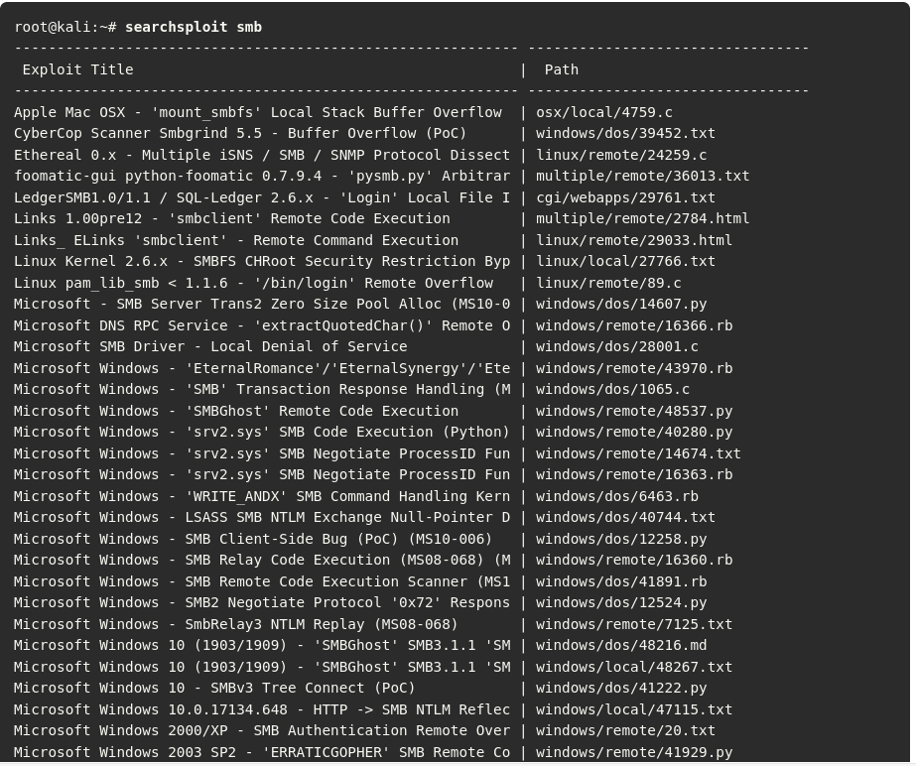
One of the most commonly used SMB exploits in recent times has been the EternalBlue exploit, which was leaked by an entity called the Shadow Brokers that allegedly stole numerous exploits from the U.S. National Security Agency (NSA).
Successful exploitation of EternalBlue allows an unauthenticated remote attacker to compromise an affected system and execute arbitrary code. This exploit has been used in ransomware such as WannaCry and Nyeta. This exploit has been ported to many different tools, including Metasploit.
Figure below provides a very brief example of the EternalBlue exploit in Metasploit.
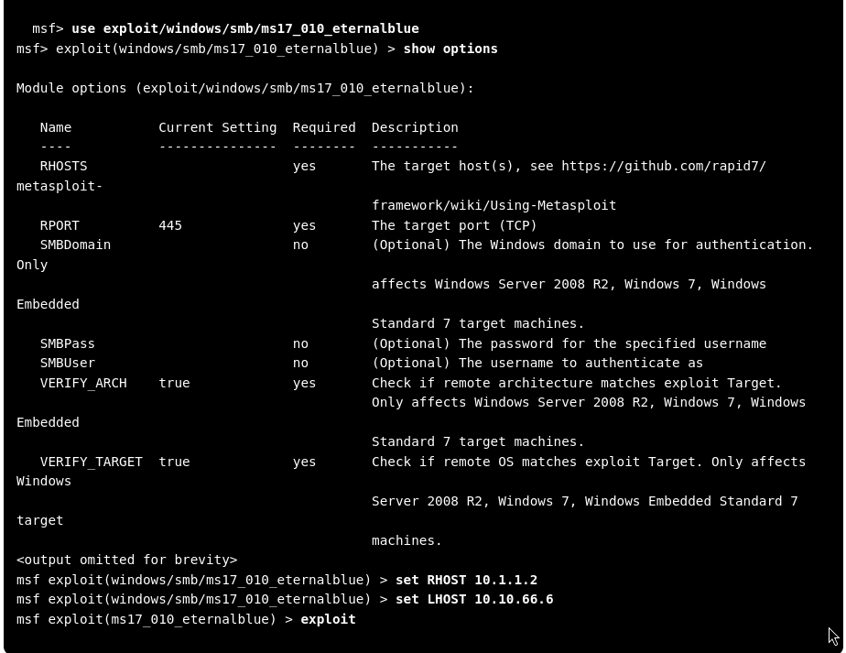
TIP How do you know where to look for a specific exploit, such as the EternalBlue exploit? To determine the exact location of any exploit, you can use the search command in Metasploit.
The use exploit/windows/smb/ms17_010_eternalblue command is invoked to use the EternalBlue exploit.
The show options command is used to show all the configurable options for the EternalBlue exploit. At a very minimum, the IP address of the remote host (RHOST) and the IP address of the host that you would like the victim to communicate with after exploitation (LHOST) must be configured.
To configure the RHOST, you use the set RHOST command followed by the IP address of the remote system (10.1.1.2 in this example).
To configure the LHOST, you use the set LHOST command followed by the IP address of the remote system (10.10.66.6 in this example). The remote port (445) is already configured for you by default. After you run the exploit command, Metasploit executes the exploit against the target system and launches a Meterpreter session to allow you to control and further compromise the system. Meterpreter is a post-exploitation tool

5.1.5 DNS Cache Poisoning
It involves the manipulation of the DNS resolver cache through the injection of corrupted DNS data. This is done to force the DNS server to send the wrong IP address to the victim and redirect the victim to the attacker’s system.

DNS Cache Poisoning Example
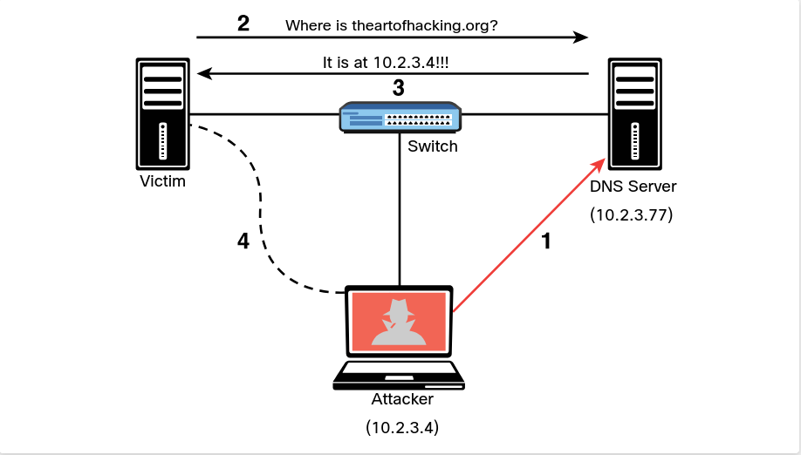

Step 1: The attacker corrupts the data at the DNS server cache to impersonate the website theartofhacking.org
Before the attacker executes the DNS poisoning attack, the DNS server successfully resolves the IP address of the website to connect to the correct address (104.27.176.154) by using the nslookup command. As shown below: DNS Resolution before DNS Cacjhe poisoning attack
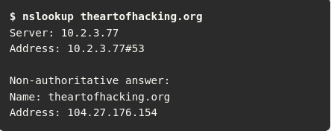
Step 2: After the attacker executes the DNS poisoning attack, the DNS server resolves the theartofhacking.org to the IP address of the attacker’s system (10.2.3.4), as shown below:
DNS Resolution After the DNS Cache Poisoning Attack
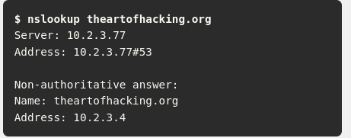
Step 3. The victim sends a request to the DNS server to obtain the IP address of the domain theartofhacking.org.
Step 4. The DNS server replies with the IP address of the attacker’s system.
Step 5. The victim sends an HTTP GET to the attacker’s system, and the attacker impersonates the domain theartofhacking.org.
DNS cache poisoning attacks can also combine elements of social engineering to manipulate victims into downloading malware or to ask a victim to enter sensitive data into forms and spoofed applications.
5.1.7 SNMP Exploits

Simple Network Management Protocol (SNMP) is a protocol that many individuals and organizations use to manage network devices.
SNMP uses UDP port 161. In SNMP implementations, every network device contains an SNMP agent that connects with an independent SNMP server (also known as the SNMP manager). An administrator can use SNMP to obtain health information and the configuration of a networking device, to change the configuration and to perform other administrative tasks. This is very attractive to attackers because they can leverage SNMP vulnerabilities to perform similar actions in a malicious way.
There are several versions of SNMP. The two most popular versions today are SNMPv2c and SNMPv3.
SNMPv2c uses community strings, which are passwords that are applied to a networking device to allow an administrator to restrict access to the device in two ways: by providing read-only or read/write access.
The managed device information is kept in a database called the Management Information Base (MIB).
A common SNMP attack involves an attacker enumerating SNMP services and then checking for configured default SNMP passwords. Unfortunately, this is one of the major flaws of many implementations because many users leave weak or default SNMP credentials in networking devices. SNMPv3 uses usernames and passwords and it is more secure than all previous SNMP versions. Attackers can still perform dictionary and brute-force attacks against SNMPv3 implementations, however. A more modern and security implementation involves using NETCONF with newer infrastructure devices (such as routers and switches).
Kali Linux SNMP-Related NSE Scripts
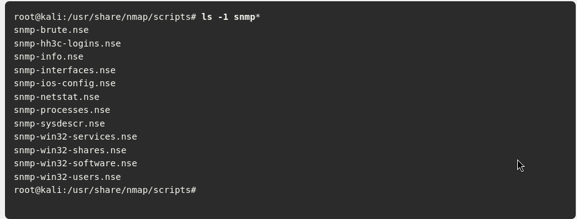
In addition to NSE scripts, you can use the snmp-check tool to perform an SNMP walk in order to gather information on devices configured for SNMP.
5.1.8 SMTP Exploits

Attackers may leverage insecure SMTP servers to send spam and conduct phishing and other email-based attacks. SMTP is a server-to-server protocol, which is different from client/server protocols such as POP3 or IMAP.
Before you can understand how to exploit email protocol vulnerabilities (such as SMTP-based vulnerabilities), you must familiarize yourself with the standard TCP ports used in the different email protocols.
The following TCP ports are used in the most common email protocols:
- TCP port 25: The default port used in SMTP for non-encrypted communications.
- TCP port 465: The port registered by the Internet Assigned Numbers Authority (IANA) for SMTP over SSL (SMTPS). SMTPS has been deprecated in favor of STARTTLS.
- TCP port 587: The Secure SMTP (SSMTP) protocol for encrypted communications, as defined in RFC 2487, using STARTTLS. Mail user agents (MUAs) use TCP port 587 for email submission. STARTTLS can also be used over TCP port 25 in some implementations.
- TCP port 110: The default port used by the POP3 protocol in non-encrypted communications.
- TCP port 995: The default port used by the POP3 protocol in encrypted communications.
- TCP port 143: The default port used by the IMAP protocol in non-encrypted communications.
- TCP port 993: The default port used by the IMAP protocol in encrypted (SSL/TLS) communications.
SMTP Open Relays
SMTP open relay is the term used for an email server that accepts and relays (that is, sends) emails from any user. It is possible to abuse these configurations to send spoofed emails, spam, phishing, and other email-related scams. Nmap has an NSE script to test for open relay configurations.
SMTP Open Relay NSE Script
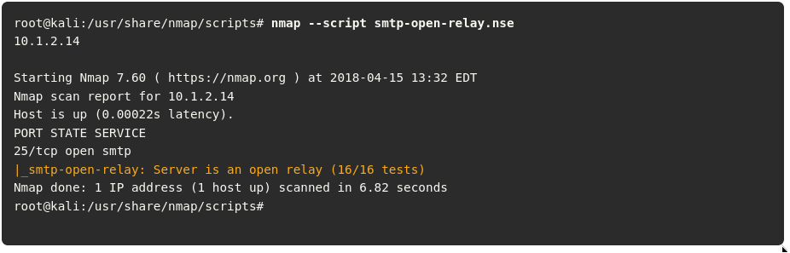
Useful SMTP Commands
Several SMTP commands can be useful for performing a security evaluation of an email server. The following are a few examples:
- HELO: Used to initiate an SMTP conversation with an email server. The command is followed by an IP address or a domain name (for example, HELO 10.1.2.14 ).
- EHLO: Used to initiate a conversation with an Extended SMTP (ESMTP) server. This command is used in the same way as the HELO command.
- STARTTLS: Used to start a Transport Layer Security (TLS) connection to an email server.
- RCPT: Used to denote the email address of the recipient.
- DATA: Used to initiate the transfer of the contents of an email message.
- RSET: Used to reset (cancel) an email transaction.
- MAIL: Used to denote the email address of the sender.
- QUIT: Used to close a connection.
- HELP: Used to display a help menu (if available).
- AUTH: Used to authenticate a client to the server.
- VRFY: Used to verify whether a user’s email mailbox exists.
- EXPN: Used to request, or expand, a mailing list on the remote server.
Figure below shows an example of how you can use some of these commands to reveal email addresses that may exist in the email server. In this case, you connect to the email server by using telnet followed by port 25. (In this example, the SMTP server is using plaintext communication over TCP port 25.) Then you use the VRFY (verify) command with the email username to verify whether the user account exists on the system.
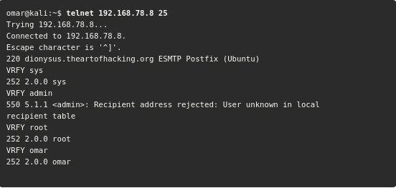
The smtp-user-enum tool (which is installed by default in Kali Linux) enables you to automate these information-gathering steps. Figure below shows the smtp-user-enum options and examples of how to use the tool.
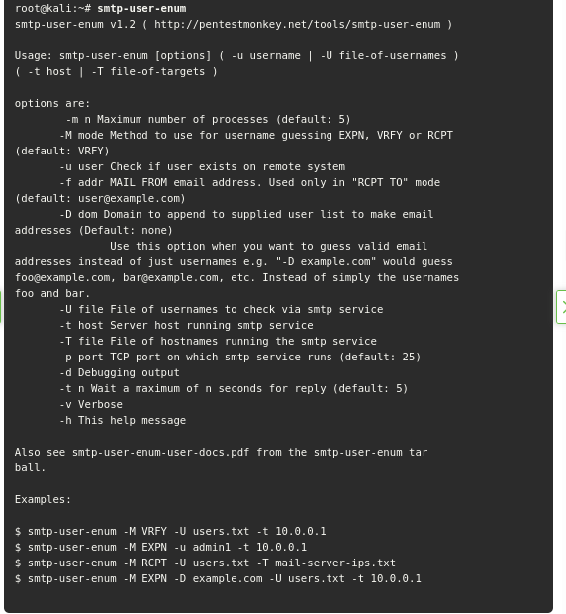
Example below shows how to use the smtp-user-enum command to verify whether the user omar exists in the server. Most modern email servers disable the VRFY and EXPN commands. It is highly recommended that you disable these SMTP commands. Modern firewalls also help protect and block any attempts at SMTP connections using these commands.
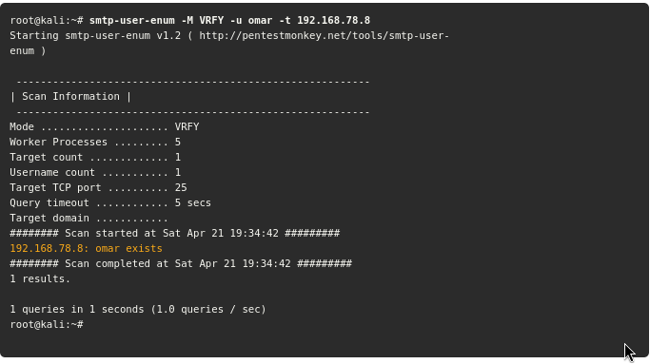
Known SMTP Server Exploits
It is possible to take advantage of exploits that have been created to leverage known SMTP-related vulnerabilities. Example below shows a list of known SMTP exploits using the searchsploit command in Kali Linux.
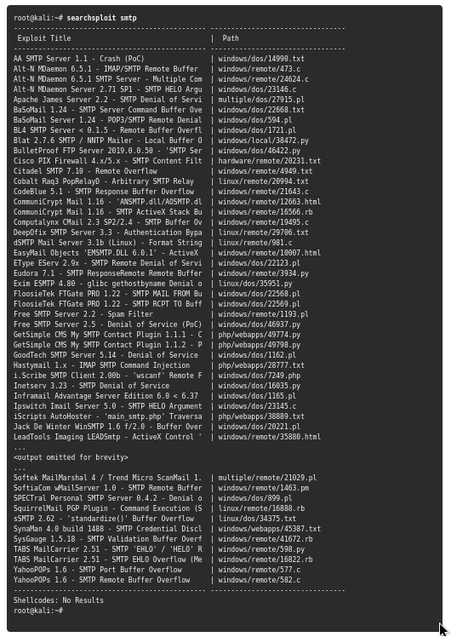
5.1.10 FTP Exploits
Attackers often abuse FTP servers to steal information. The legacy FTP protocol doesn’t use encryption or perform any kind of integrity validation.
Recommended practice dictates that you implement a more secure alternative, such as File Transfer Protocol Secure (FTPS) or Secure File Transfer Protocol (SFTP).
The SFTP and FTPS protocols use encryption to protect data; however, some implementations – such as Blowfish and DES – offer weak encryption ciphers (encryption algorithms). You should use stronger algorithms, such as AES.
Similarly, SFTP and FTPS servers use hashing algorithms to verify the integrity of file transmission. SFTP uses SSH, and FTPS uses FTP over TLS. Best practice calls for disabling weak hashing protocols such as MD5 or SHA-1 and using stronger algorithms in the SHA-2 family (such as SHA-2 or SHA-512).
In addition, FTP servers often enable anonymous user authentication, which an attacker may abuse to store unwanted files in your server, potentially for exfiltration. For example, an attacker who compromises a system and extracts sensitive information can store that information (as a stepping stone) to any FTP server that may be available and allows any user to connect using the anonymous account.
Example below shows a scan (using Nmap) against a server with IP address 172.16.20.136. Nmap can determine the type and version of the FTP server (in this case, vsftpd version 3.0.3).
Using Nmap to Scan an FTP Server
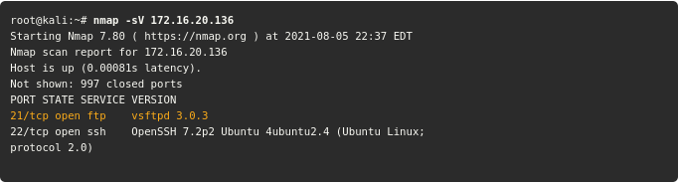
FTP Anonymous Login Verification Using Metasploit
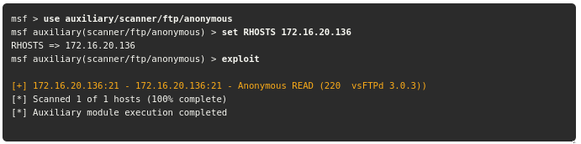
The highlighted line above shows that the FTP server is configured for anonymous login. The mitigation in this example is to edit the FTP server configuration file to disable anonymous login. In this example, the server is using vsFTPd, and thus the configuration file is located at /etc/vsftpd.conf.
The following are several additional best practices for mitigating FTP server abuse and attacks:
- Use strong passwords and multifactor authentication. A best practice is to use good credential management and strong passwords. When possible, use two-factor authentication for any critical service or server.
- Implement file and folder security, making sure that users have access to only the files they are entitled to access.
- Use encryption at rest – that is, encrypt all files stored in the FTP server.
- Lock down administration accounts. You should restrict administrator privileges to a limited number of users and require them to use multifactor authentication. In addition, do not use common administrator usernames such as root or admin.
- Keep the FTPS or SFTP server software up-to-date.
- Use the U.S. government FIPS 140-2 validated encryption ciphers for general guidance on what encryption algorithms to use.
- Keep any back-end databases on a different server than the FTP server.
- Require re-authentication of inactive sessions.
5.1.11 Pass-the-Hash Attacks
All versions of Windows store passwords as hashes in a file called the Security Accounts Manager (SAM) file.
The operating system does not know what the actual password is because it stores only a hash of the password. Instead of using a well-known hashing algorithm, Microsoft created its own implementation that has developed over the years.
Microsoft also has a suite of security protocols for authentication, called this New Technology LAN Manager (NTLM).
NTLM had two versions: NTLMv1 and NTLMv2. Since Windows 2000, Microsoft has used Kerberos in Windows domains. However, NTLM may still be used when the client is authenticating to a server via IP address or if a client is authenticating to a server in a different Active Directory (AD) forest configured for NTLM trust instead of a transitive inter-forest trust.
In addition, NTLM might also still be used if the client is authenticating to a server that doesn’t belong to a domain or if the Kerberos communication is blocked by a firewall.
Because password hashes cannot be reversed, instead of trying to figure out what the user’s password is, an attacker can just use a password hash collected from a compromised system and then use the same hash to log in to another client or server system.
Pass-the-Hash Attack
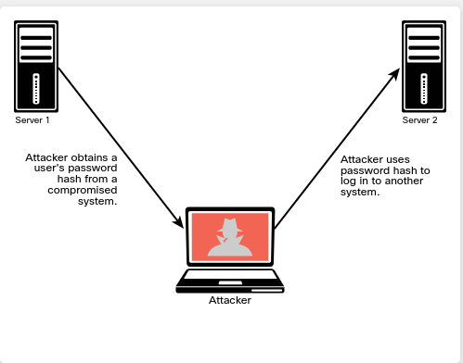
The Windows operating system and Windows applications ask users to enter their passwords when they log in. The system then converts the passwords into hashes (in most cases, using an API called LsaLogonUser). A pass-the-hash attack goes around this process and just sends the hash to the system to authenticate.
Mimikatz is a tool used by many penetration testers, attackers, and even malware that can be useful for retrieving password hashes from memory; it is a very useful post-exploitation tool.
Metasploit also includes Mimikatz as a Meterpreter script to facilitate exploitation without the need to upload any files to the disk of the compromised host.
5.1.12 Kerberos and LDAP-Based Attacks
Kerberos is an authentication protocol defined in RFC 4120 that has been used by Windows for a number of years. Kerberos is also used by numerous applications and other operating systems.
A Kerberos implementation contains three basic elements:
- Client
- Server
- Key distribution center (KDC), including the authentication server and the ticket-granting server
Steps in Kerberos Authentication
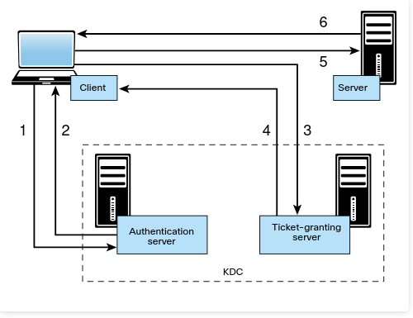
Step 1. The client sends a request to the authentication server within the KDC.
Step 2. The authentication server sends a session key and a ticket-granting ticket (TGT) that is used to verify the client’s identity.
Step 3. The client sends the TGT to the ticket-granting server.
Step 4. The ticket-granting server generates and sends a ticket to the client.
Step 5. The client presents the ticket to the server.
Step 6. The server grants access to the client.
Active Directory uses Lightweight Directory Access Protocol (LDAP) as an access protocol. The Windows LDAP implementation supports Kerberos authentication. LDAP uses an inverted-tree hierarchical structure called the Directory Information Tree (DIT). In LDAP, every entry has a defined position. The Distinguished Name (DN) represents the full path of the entry.
One of the most common attacks is the Kerberos golden ticket attack. An attacker can manipulate Kerberos tickets based on available hashes by compromising a vulnerable system and obtaining the local user credentials and password hashes. If the system is connected to a domain, the attacker can identify a Kerberos TGT (KRBTGT) password hash to get the golden ticket.
Empire is a popular tool that can be used to perform golden ticket and many other types of attacks. Empire is basically a post-exploitation framework that includes a pure-PowerShell Windows agent and a Python agent.
With Empire, you can run PowerShell agents without needing to use powershell.exe.
Example below shows the Empire Mimikatz golden_ticket module, which can be used to perform a golden ticket attack. When the Empire Mimikatz golden_ticket module is run against a compromised system, the golden ticket is established for the user using the KRBTGT password hash.
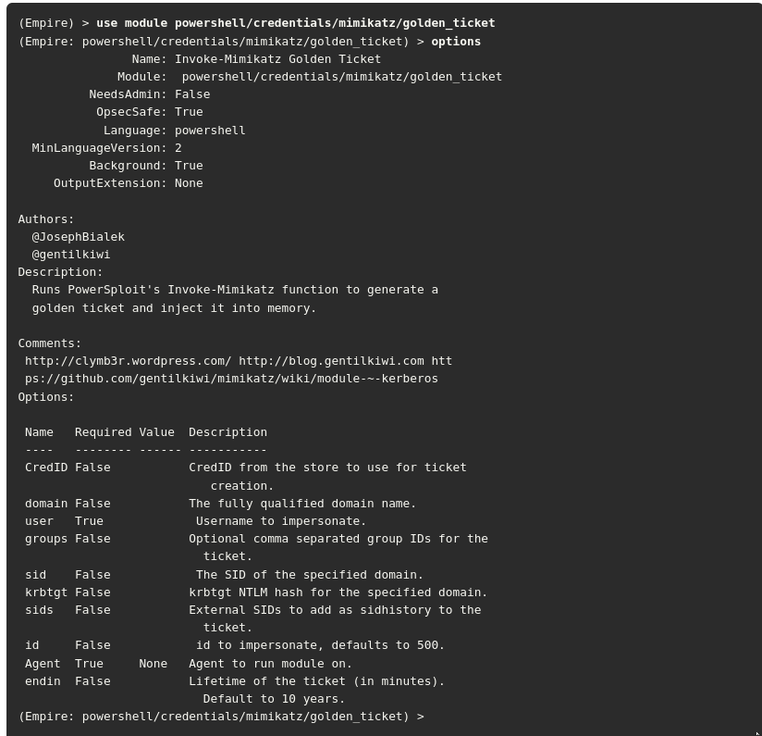
Kerberos silver ticket attack. Silver tickets are forged service tickets for a given service on a particular server.
The Windows Common Internet File System (CIFS) allows you to access files on a particular server, and the HOST service allows you to execute schtasks.exe or Windows Management Instrumentation (WMI) on a given server.
In order to create a silver ticket, you need the system account (ending in $), the security identifier (SID) for the domain, the fully qualified domain name, and the given service (for example, CIFS, HOST). You can also use tools such as Empire to get the relevant information from a Mimikatz dump for a compromised system.
Another weakness in Kerberos implementations is the use of unconstrained Kerberos delegation. Kerberos delegation is a feature that allows an application to reuse the end-user credentials to access resources hosted on a different server. Typically you should allow Kerberos delegation only if the application server is ultimately trusted; however, allowing it could have negative security consequences if abused, and Kerberos delegation is therefore not enabled by default in Active Directory.
5.1.13 Kerberoasting
Another attack against Kerberos-based deployments is Kerberoasting.
Kerberoasting is a post-exploitation activity that is used by an attacker to extract service account credential hashes from Active Directory for offline cracking. It is a pervasive attack that exploits a combination of weak encryption implementations and improper password practices. Kerberoasting can be an effective attack because the threat actor can extract service account credential hashes without sending any IP packets to the victim and without having domain admin credentials.
5.1.14 On-Path Attacks
In an on-path attack (previously known as a man-in-the-middle [MITM] attack), an attacker places himself or herself in-line between two devices or individuals that are communicating in order to eavesdrop or manipulate the data being transferred (such as by performing data corruption or data modification). On-path attacks can happen at Layer 2 or Layer 3.

On-Path Attack
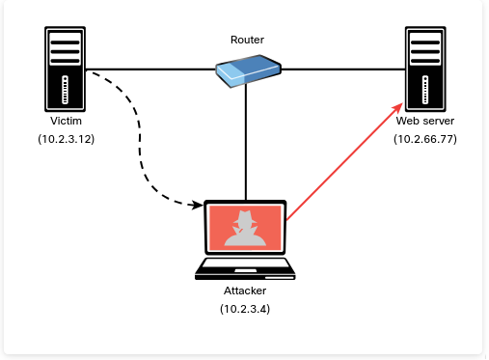
ARP Spoofing and ARP Cache Poisoning
ARP cache poisoning (also known as ARP spoofing) is an example of an attack that leads to an on-path attack scenario. An ARP spoofing attack can target hosts, switches, and routers connected to a Layer 2 network by poisoning the ARP caches of systems connected to the subnet and intercepting traffic intended for other hosts on the subnet.
In the Figure above, the attacker spoofs Layer 2 MAC addresses to make the victim believe that the Layer 2 address of the attacker is the Layer 2 address of its default gateway (10.2.3.4). The packets that are supposed to go to the default gateway are forwarded by the switch to the Layer 2 address of the attacker on the same network. The attacker can forward the IP packets to the correct destination in order to allow the client to access the web server (10.2.66.77).
Media Access Control (MAC) spoofing is an attack in which a threat actor impersonates the MAC address of another device (typically an infrastructure device such as a router).
The MAC address is a hard-coded address on a network interface controller. In virtual environments, the MAC address could be a virtual address (that is, not assigned to a physical adapter). An attacker could spoof the MAC address of physical or virtual systems to either circumvent access control measures or perform an on-path attack.
NOTE A common mitigation for ARP cache poisoning attacks is to use Dynamic Address Resolution Protocol (ARP) Inspection (DAI) on switches to prevent spoofing of the Layer 2 addresses.
Another example of a Layer 2 on-path attack involves placing a switch in the network and manipulating Spanning Tree Protocol (STP) to make it the root switch. This type of attack can allow an attacker to see any traffic that needs to be sent through the root switch.
An attacker can carry out an on-path attack at Layer 3 by placing a rogue router on the network and then tricking the other routers into believing that this new router has a better path than other routers.
It is also possible to perform an on-path attack by compromising the victim’s system and installing malware that can intercept the packets sent by the victim. The malware can capture packets before they are encrypted if the victim is using SSL/TLS/HTTPS or any other mechanism.
An attack tool called SSLStrip uses on-path functionality to transparently look at HTTPS traffic, hijack it, and return non-encrypted HTTP links to the user in response. This tool was created by a security researcher called Moxie Marlinspike.
The following are some additional Layer 2 security best practices for securing your infrastructure:
- Select an unused VLAN (other than VLAN 1) and use it as the native VLAN for all your trunks. Do not use this native VLAN for any of your enabled access ports. Avoid using VLAN 1 anywhere because it is the default.
- Administratively configure switch ports as access ports so that users cannot negotiate a trunk; also disable the negotiation of trunking, thus do not allow Dynamic Trunking Protocol [DTP.
- Limit the number of MAC addresses learned on a given port by using the port security feature.
- Control Spanning Tree to stop users or unknown devices from manipulating it, by using the BPDU Guard and Root Guard features.
- Turn off Cisco Discovery Protocol (CDP) on ports facing untrusted or unknown networks that do not require CDP for anything positive. (CDP operates at Layer 2 and might provide attackers information you would rather not disclose.)
- On a new switch, shut down all ports and assign them to a VLAN that is not used for anything other than a parking lot. Then bring up the ports and assign correct VLANs as the ports are allocated and needed.
- Use Root Guard to control which ports are not allowed to become root ports to remote switches.
- Use DAI.
- Use IP Source Guard to prevent spoofing of Layer 3 information by hosts.
- Implement 802.1X when possible to authenticate and authorize users before allowing them to communicate to the rest of the network.
- Use Dynamic Host Configuration Protocol (DHCP) snooping to prevent rogue DHCP servers from impacting the network.
- Use storm control to limit the amount of broadcast or multicast traffic flowing through a switch. An attacker could perform a packet storm (or broadcast storm) attack to cause a DoS condition. The attacker does this by sending excessive transmissions of IP packets (often broadcast traffic) in a network.
- Deploy access control lists (ACLs), such as Layer 3 and Layer 2 ACLs, for traffic control and policy enforcement.
Downgrade Attacks
In a downgrade attack, an attacker forces a system to favor a weak encryption protocol or hashing algorithm that may be susceptible to other vulnerabilities. An example of a downgrade vulnerability and attack is the Padding Oracle on Downgraded Legacy Encryption (POODLE) vulnerability in OpenSSL, which allowed the attacker to negotiate the use of a lower version of TLS between the client and server.
POODLE was an OpenSSL-specific vulnerability and has been patched since 2014. However, in practice, removing backward compatibility is often the only way to prevent any other downgrade attacks or flaws.
5.1.17 Route Manipulation Attacks
Although many different route manipulation attacks exist, one of the most common is the BGP hijacking attack.
Border Gateway Protocol (BGP) is a dynamic routing protocol used to route Internet traffic. An attacker can launch a BGP hijacking attack by configuring or compromising an edge router to announce prefixes that have not been assigned to his or her organization. If the malicious announcement contains a route that is more specific than the legitimate advertisement or that presents a shorter path, the victim’s traffic could be redirected to the attacker.
In the past, threat actors have leveraged unused prefixes for BGP hijacking in order to avoid attention from the legitimate user or organization. Figure below illustrates a BGP hijacking route manipulation attack. The attacker compromises a router and performs a BGP hijack attack to intercept traffic between Host A and Host B.
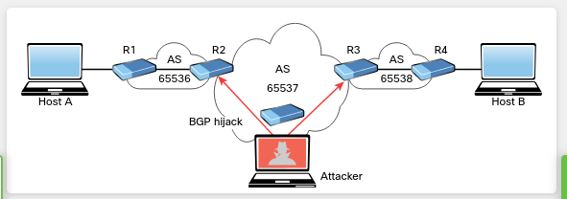
5.1.18 DoS and DDoS Attacks
Denial-of-service (DoS) and distributed DoS (DDoS) attacks have been around for quite some time, but there has been heightened awareness of them over the past few years. DoS attacks can generally be divided into three categories, described in the following sections:
- Direct
A direct DoS attack occurs when the source of the attack generates the packets, regardless of protocol, application, and so on, that are sent directly to the victim of the attack. Figure below illustrates a direct DoS attack.
In Figure below, the attacker launches a direct DoS attack to a web server (the victim) by sending numerous TCP SYN packets. This type of attack is aimed at flooding the victim with an overwhelming number of packets in order to oversaturate its connection bandwidth or deplete the target’s system resources. This type of attack is also known as a SYN flood attack.
Cybercriminals can also use DoS and DDoS attacks to produce added costs for the victim when the victim is using cloud services. In most cases, when you use a cloud service such as Amazon Web Services (AWS), Microsoft Azure, or Digital Ocean, you pay per usage. Attackers can launch DDoS attacks to cause you to pay more for usage and resources.
Another type of DoS attack involves exploiting vulnerabilities such as buffer overflows to cause a server or even a network infrastructure device to crash, subsequently causing a DoS condition.
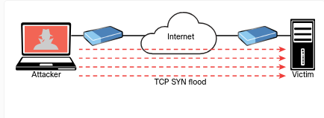
- Botnet
Many attackers use botnets to launch DDoS attacks.
A botnet is a collection of compromised machines that the attacker can manipulate from a command and control (CnC, or C2) system to participate in a DDoS attack, send spam emails, and perform other illicit activities. Figure below shows how an attacker may use a botnet to launch a DDoS attack. The botnet is composed of compromised user endpoints (laptops), home wireless routers, and Internet of Things (IoT) devices such as IP cameras.
In Figure below, the attacker sends instructions to the C2; subsequently, the C2 sends instructions to the bots within the botnet to launch the DDoS attack against the victim server.
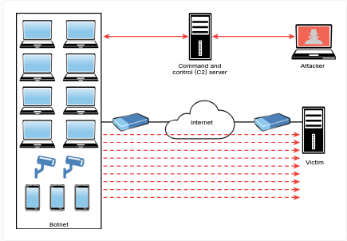
- Reflected
With reflected DoS and DDoS attacks, attackers send to sources spoofed packets that appear to be from the victim, and then the sources become unwitting participants in the reflected attack by sending the response traffic back to the intended victim. UDP is often used as the transport mechanism in such attacks because it is more easily spoofed due to the lack of a three-way handshake. For example, if the attacker decides he wants to attack a victim, he can send packets (for example, Network Time Protocol [NTP] requests) to a source that thinks these packets are legitimate. The source then responds to the NTP requests by sending the responses to the victim, who was not expecting these NTP packets from the source.
In Figure below, the attacker sends a packet to Host A. The source IP address is the victim’s IP address (10.1.2.3), and the destination IP address is Host A’s IP address (10.1.1.8). Subsequently, Host A sends an unwanted packet to the victim. If the attacker continues to send these types of packets, not only does Host A flood the victim, but the victim might also reply with unnecessary packets, thus consuming bandwidth and resources.
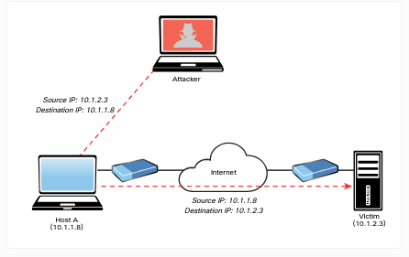
- Amplification
An amplification attack is a form of reflected DoS attack in which the response traffic (sent by the unwitting participant) is made up of packets that are much larger than those that were initially sent by the attacker (spoofing the victim). An example of this type of attack is an attacker sending DNS queries to a DNS server configured as an open resolver. Then the DNS server (open resolver) replies with responses much larger in packet size than the initial query packets. The end result is that the victim’s machine gets flooded by large packets for which it never actually issued queries. Figure below shows an example.
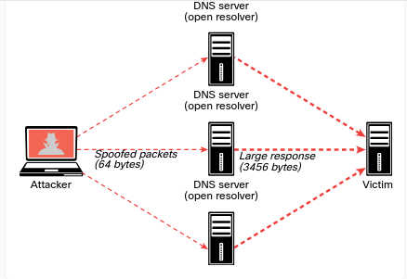
5.1.20 Network Access Control (NAC) Bypass
NAC is a technology that is designed to interrogate endpoints before joining a wired or wireless network. It is typically used in conjunction with 802.1X for identity management and enforcement. In short, a network access switch or wireless access point (AP) can be configured to authenticate end users and perform a security posture assessment of the endpoint device to enforce policy. For example, it can check whether you have security software such as antivirus, anti-malware, and personal firewalls before it allows you to join the network. It can also check whether you have a specific version of an operating system (for example, Microsoft Windows, Linux, or macOS) and whether your system has been patched for specific vulnerabilities.
In addition, NAC-enabled devices (switches, wireless APs, and so on) can use several detection techniques to detect the endpoint trying to connect to the network. A NAC-enabled device intercepts DHCP requests from endpoints. A broadcast listener is used to look for network traffic, such as ARP requests and DHCP requests generated by endpoints.
Several NAC solutions use client-based agents to perform endpoint security posture assessments to prevent an endpoint from joining the network until it is evaluated. In addition, some switches can be configured to send an SNMP trap message when a new MAC address is registered with a certain switch port and to trigger the NAC process.
NAC implementations can allow specific nodes such as printers, IP phones, and video conferencing equipment to join the network by using an allow list (or whitelist) of MAC addresses corresponding to such devices. This process is known as MAC authentication (auth) bypass. MAC auth bypass is a feature of NAC. The network administrator can preconfigure or manually change these access levels. For example, a device accessing a specific VLAN (for example, VLAN 88) must be manually predefined for a specific port by an administrator, making deploying a dynamic network policy across multiple ports using port security extremely difficult to maintain.
An attacker could easily spoof an authorized MAC address (in a process called MAC address spoofing ) and bypass a NAC configuration. For example, it is possible to spoof the MAC address of an IP phone and use it to connect to a network. This is because a port for which MAC auth bypass is enabled can be dynamically enabled or disabled based on the MAC address of the device that connects to it.

Abusing MAC Auth Bypass Implementations
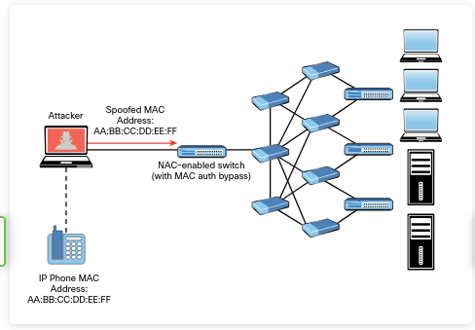
5.1.21 VLAN Hopping
One way to identify a LAN is to say that all the devices in the same LAN have a common Layer 3 IP network address and that they also are all located in the same Layer 2 broadcast domain. A virtual LAN (VLAN) is another name for a Layer 2 broadcast domain. A VLAN is controlled by a switch. The switch also controls which ports are associated with which VLANs. In Figure below, if the switches are in their default configuration, all ports by default are assigned to VLAN 1, which means all the devices, including the two users and the router, are in the same broadcast domain, or VLAN.
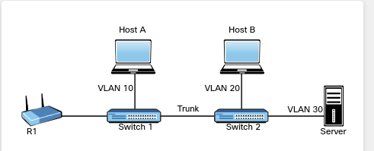
As you start adding hundreds of users, you might want to separate groups of users into individual subnets and associated individual VLANs. To do this, you assign the switch ports to the VLAN, and then any device that connects to that specific switch port is a member of that VLAN. Hopefully, all the devices that connect to switch ports that are assigned to a given VLAN also have a common IP network address configured so that they can communicate with other devices in the same VLAN,
Often, Dynamic Host Configuration Protocol (DHCP) is used to assign IP addresses from a common subnet range to the devices in a given VLAN.
One problem with having two users in the same VLAN but not on the same physical switch is that Switch 1 tells Switch 2 that a broadcast or unicast frame is supposed to be for VLAN 10. The solution is simple: For connections between two switches that contain ports in VLANs that exist in both switches, you configure specific trunk ports instead of configuring access ports. If the two switch ports are configured as trunks, they include additional information called a tag that identifies which VLAN each frame belongs to.
802.1Q is the standard protocol for this tagging. The most critical piece of information (for this discussion) in this tag is the VLAN ID.
Currently, the two hosts in Figure above (Host A and Host B) cannot communicate because they are in separate VLANs (VLAN 10 and VLAN 20, respectively). The inter-switch links (between the two switches) are configured as trunks. A broadcast frame sent from Host A and received by Switch 1 would forward the frame over the trunk tagged as belonging to VLAN 10 to Switch 2. Switch 2 would see the tag, know it was a broadcast associated with VLAN 10, remove the tag, and forward the broadcast to all other interfaces associated with VLAN 10, including the switch port that is connected to Host B. These two core components (access ports being assigned to a single VLAN and trunk ports that tag the traffic so that a receiving switch knows which VLAN a frame belongs to) are the core building blocks for Layer 2 switching, where a VLAN can extend beyond a single switch.
Host A and Host B communicate with each other, and they can communicate with other devices in the same VLAN (which is also the same IP subnet), but they cannot communicate with devices outside their local VLAN without the assistance of a default gateway.
A router could be implemented with two physical interfaces: one connecting to an access port on the switch that is been assigned to VLAN 10 and another physical interface connected to a different access port that has been configured for a different VLAN. With two physical interfaces and a different IP address on each, the router could perform routing between the two VLANs.
Virtual local area network (VLAN) hopping is a method of gaining access to traffic on other VLANs that would normally not be accessible.
There are two primary methods of VLAN hopping: switch spoofing and double tagging.

When you perform a switch spoofing attack, you imitate a trunking switch by sending the respective VLAN tag and the specific trunking protocols. Several best practices can help mitigate VLAN hopping and other Layer 2 attacks.
You should always avoid using VLAN 1 anywhere because it is a default. Do not use this native VLAN for any of your enabled access ports. On a new switch, shut down all ports and assign them to a VLAN that is not used for anything else other than a parking lot. Then bring up the ports and assign correct VLANs as the ports are allocated and needed. Following these best practices can help prevent a user from maliciously negotiating a trunk with a switch and then having full access to each of the VLANs by using custom software on the computer that can both send and receive dot1q-tagged frames. A user with a trunk established could perform VLAN hopping to any VLAN desired by just tagging frames with the VLAN of choice. Other malicious tricks could be used as well, but forcing the port to an access port with no negotiation removes this risk.
Another 802.1Q VLAN hopping attack is a double-tagging VLAN hopping attack. Most switches configured for 802.1Q remove only one 802.1Q tag. An attacker could change the original 802.1Q frame to add two VLAN tags: an outer tag with his or her own VLAN and an inner hidden tag of the victim’s VLAN. When the double-tagged frame reaches the switch, it only processes the outer tag of the VLAN that the ingress interface belongs to. The switch removes the outer VLAN tag and forwards the frame to all the ports belong to native VLAN. A copy of the frame is forwarded to the trunk link to reach the next switch.
5.1.23 DHCP Starvation Attacks and Rogue DHCP Servers
The two most popular attacks against DHCP servers and infrastructure are DHCP starvation and DHCP spoofing (which involves rogue DHCP servers). In a DHCP starvation attack, an attacker broadcasts a large number of DHCP REQUEST messages with spoofed source MAC addresses
DHCP Starvation Attack
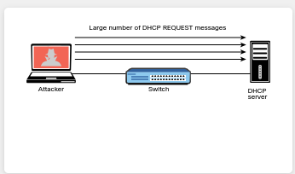
If the DHCP server responds to all these fake DHCP REQUEST messages, available IP addresses in the DHCP server scope are depleted within a few minutes or seconds. After the available number of IP addresses in the DHCP server is depleted, the attacker can then set up a rogue DHCP server and respond to new DHCP requests from network DHCP clients
Rogue DHCP Servers and DHCP Spoofing Attacks
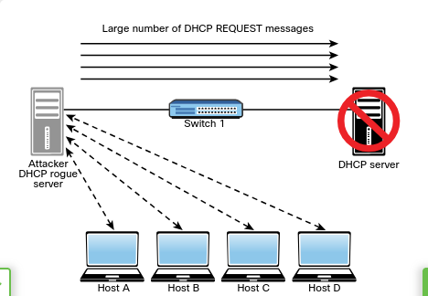
The attacker in Figure above sets up a rogue DHCP server to launch a DHCP spoofing attack. The attacker can set the IP address of the default gateway and DNS server to itself so that it can intercept the traffic from the network hosts.
Figure below shows an example of a tool called Yersenia that can be used to create a rogue DHCP server and launch DHCP starvation and spoofing attacks.
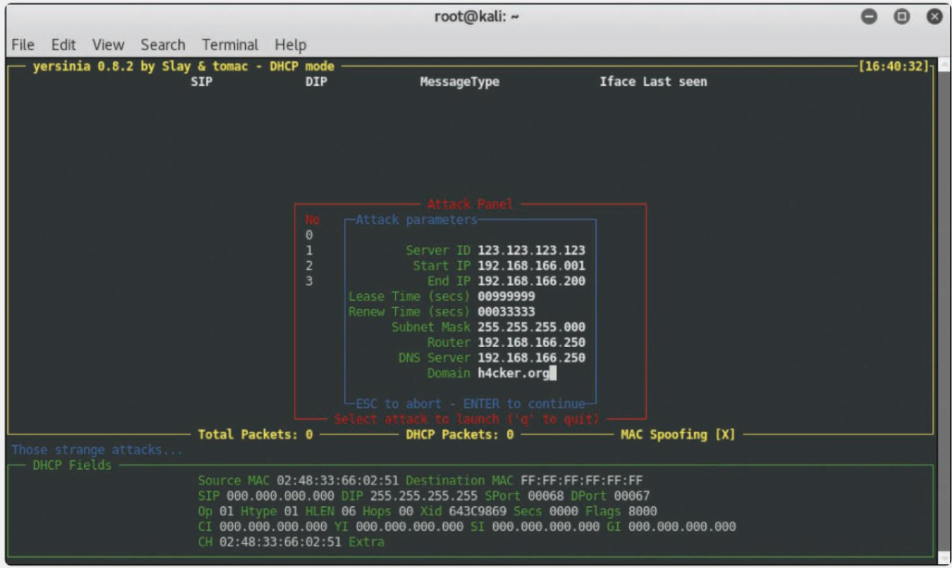
5.2. Exploiting Wireless Vulnerabilities
5.2.2 Rogue Access Points
One of the most simplistic wireless attacks involves an attacker installing a rogue AP in a network to fool users to connect to that AP. Basically, the attacker can use that rogue AP to create a backdoor and obtain access to the network and its systems
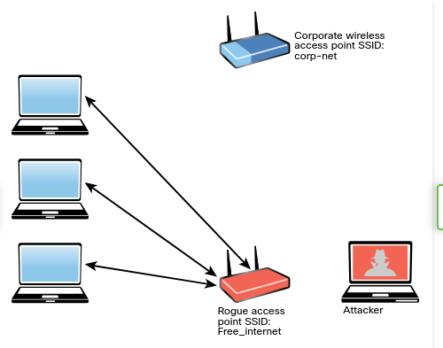
Rogue Wireless Access Point
Evil Twin Attacks
In an evil twin attack, the attacker creates a rogue access point and configures it exactly the same as the existing corporate network.
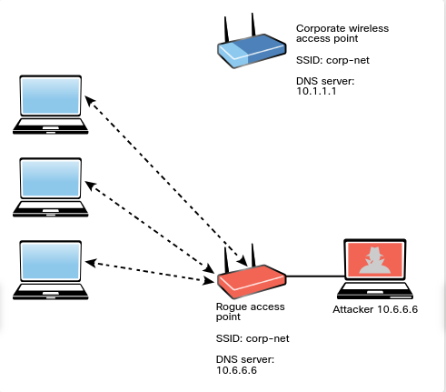
Typically, the attacker uses DNS spoofing to redirect the victim to a cloned captive portal or a website. When users are logged on to the evil twin, a hacker can easily inject a spoofed DNS record into the DNS cache, changing the DNS record for all users on the fake network. Any user who logs in to the evil twin will be redirected by the spoofed DNS record injected into the cache. An attacker who performs a DNS cache poisoning attack wants to get the DNS cache to accept a spoofed record.
Some ways to defend against DNS spoofing are using packet filtering, cryptographic protocols, and spoofing detection features provided by modern wireless implementations.

Captive portals are web portals that are typically used in wireless networks in public places such as airports and coffee shops. They are typically used to authenticate users or to simply display terms and conditions that apply to users when they are using the wireless network. The user can simply click Accept to agree to the terms and conditions. In some cases, the user is asked to view an advertisement, provide an email address, or perform some other required action. Attackers can impersonate captive portals to perform social engineering attacks or steal sensitive information from users.

5.2.4 Disassociation (or Deauthentication) Attacks
An attacker can cause legitimate wireless clients to deauthenticate from legitimate wireless APs or wireless routers to either perform a DoS condition or to make those clients connect to an evil twin. This type of attack is also known as a disassociation attack because the attacker disassociates the user from the authenticating wireless AP and then carries out another attack to obtain the user’s valid credentials.
A service set identifier (SSID) is the name or identifier associated with an 802.11 wireless local area network (WLAN). SSID names are included in plaintext in many wireless packets and beacons. A wireless client needs to know the SSID in order to associate with a wireless AP. It is possible to configure wireless passive tools like Kismet or KisMAC to listen to and capture SSIDs and any other wireless network traffic. In addition, tools such as Airmon-ng (which is part of the Aircrack-ng suite) can perform this reconnaissance.
Example below shows the Airmon-ng tool. The system in this example has five different wireless network adapters, and the adapter wlan1 is used for monitoring.
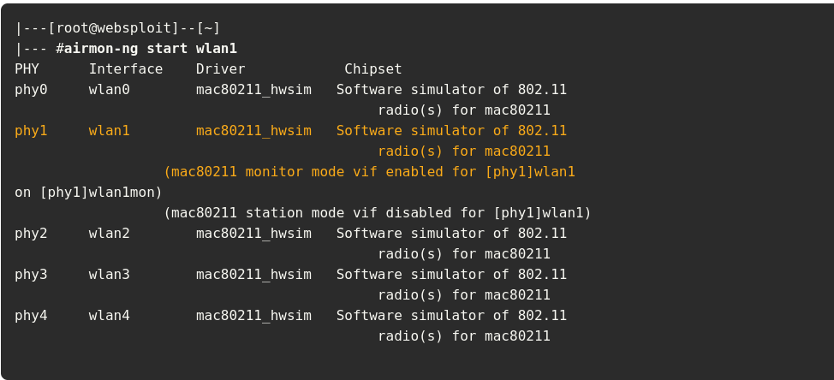
In Example above, the airmon-ng command output shows that the wlan1 interface is present and used to monitor the network.
The command ip -s -h -c link show wlan1 can be used to verify the state and configuration of the wireless interface. When you put a wireless network interface in monitoring mode, Airmon-ng automatically checks for any interfering processes. To stop any interfering process, you can use the airmon-ng check kill command.
The Airodump-ng tool (which is also part of the Aircrack-ng suite) can be used to sniff and analyze wireless network traffic, as shown below.
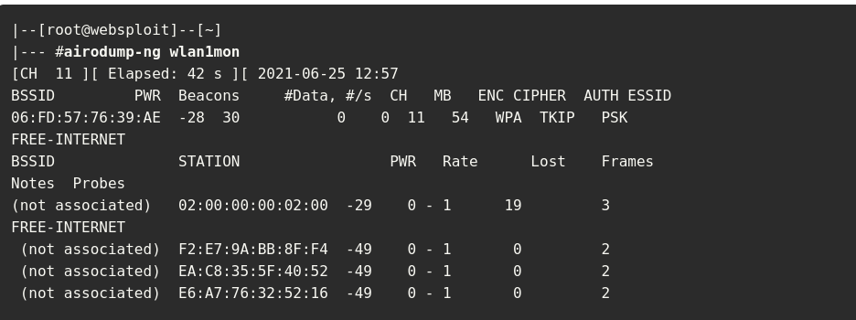
You can use the Airodump-ng tool to sniff wireless networks and obtain their SSIDs, along with the channels they are operating.
Many corporations and individuals configure their wireless APs to not advertise their SSIDs and to not respond to broadcast probe requests. However, if you sniff on a wireless network long enough, you will eventually catch a client trying to associate with the AP and can then get the SSID.
In Example above you can see the basic service set identifier (BSSID) and the extended basic service set identifier (ESSID) for every available wireless network. Basically, the ESSID identifies the same network as the SSID. You can also see the ENC encryption protocol.
The encryption protocols can be Wi-Fi Protected Access (WPA) version 1, WPA version 2 (WPA2), WPA version 3 (WPA3), Wired Equivalent Privacy (WEP), or open (OPN).
In Figure below you can see two terminal windows. The top terminal window displays the output of the Airodump-ng utility on a specific channel (11) and one ESSID (corp-net). In that same terminal window, you can see a wireless client (station) in the bottom, along with the BSSID to which it is connected.
Performing a Deauthentication Attack with Aireplay-ng
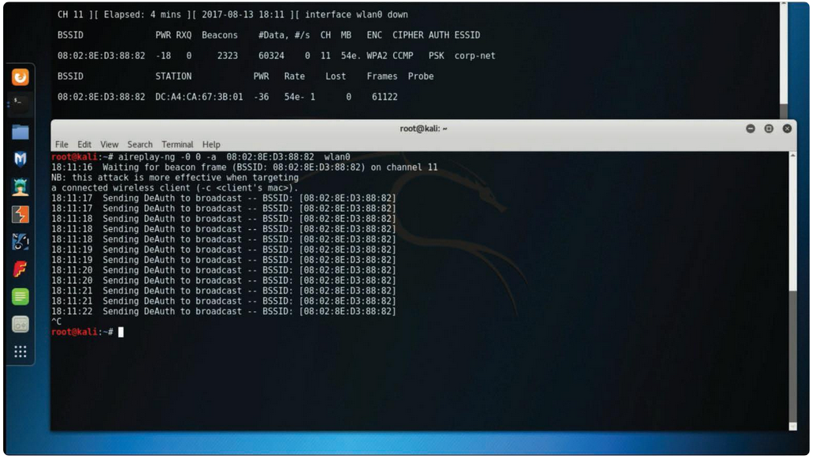
The bottom terminal window in Figure above shows the launch of a deauthentication attack using the Aireplay-ng utility. The victim station has the MAC address DC:A4:CA:67:3B:01, and it is currently associated with the network on channel 11 with the BSSID 08:02:8E:D3:88:82. After the aireplay-ng command is used, the deauthentication (DeAuth) message is sent to the BSSID 08:02:8E:D3:88:82. The attack can be accelerated by sending the deauthentication packets to the client using the -c option.
The 802.11w standard defines the Management Frame Protection (MFP) feature. MFP protects wireless devices against spoofed management frames from other wireless devices that might otherwise deauthenticate a valid user session. In other words, MFP helps defend against deauthentication attacks. MFP is negotiated between the wireless client and the wireless infrastructure device.
NOTE Many wireless adapters do not allow you to inject packets into a wireless network.
5.2.5 Preferred Network List Attacks
Operating systems and wireless supplicants (clients), in many cases, maintain a list of trusted or preferred wireless networks. This is also referred to as the preferred network list (PNL).
A PNL includes the wireless network SSID, plaintext passwords, or WEP or WPA passwords. Clients use these preferred networks to automatically associate to wireless networks when they are not connected to an AP or a wireless router.
It is possible for attackers to listen to these client requests and impersonate the wireless networks in order to make the clients connect to the attackers’ wireless devices and eavesdrop on their conversation or manipulate their communication.
5.2.6 Wireless Signal Jamming and Interference
The purpose of jamming wireless signals or causing wireless network interference is to create a full or partial DoS condition in the wireless network. Such a condition, if successful, is very disruptive. Most modern wireless implementations provide built-in features that can help immediately detect such attacks. In order to jam a Wi-Fi signal or any other type of radio communication, an attacker basically generates random noise on the frequencies that wireless networks use. With the appropriate tools and wireless adapters that support packet injection, an attacker can cause legitimate clients to disconnect from wireless infrastructure devices.
War driving is a method attackers use to find wireless access points wherever they might be. By just driving around, an attacker can obtain a significant amount of information over a very short period of time. Another similar attack is war flying, which involves using a portable computer or other mobile device to search for wireless networks from an aircraft, such as a drone or another unmanned aerial vehicle (UAV).
5.2.8 Initialization Vector (IV) Attacks and Unsecured Wireless Protocols
Because WEP is susceptible to many different attacks, it is considered an obsolete wireless protocol. WEP must be avoided, and many wireless network devices no longer support it.
WEP keys exist in two sizes: 40-bit (5-byte) and 104-bit (13-byte) keys. In addition, WEP uses a 24-bit IV, which is prepended to the pre-shared key (PSK). When you configure a wireless infrastructure device with WEP, the IVs are sent in plaintext.
An attacker can also use the Aircrack-ng set of tools to crack (recover) the WEP PSK. To perform this attack using the Aircrack-ng suite, an attacker first launches Airmon-ng
wireless interface is wlan0
wireless channel is 11
Using Airodump-ng to Listen to All Traffic to the BSSID 08:02:8E:D3:88:82
The command writes all the traffic to a capture file called omar_capture.cap. The attacker only has to specify the prefix for the capture file.
Using Aireplay-ng to Inject ARP Packets
The attacker can use Aireplay-ng to listen for ARP requests and then replay, or inject, them back into the wireless network
he Cracked (Recovered) WEP PSK
After Aircrack-ng cracks (recovers) the WEP PSK, the output is displayed. The cracked (recovered) WEP PSK is shown in the highlighted line.
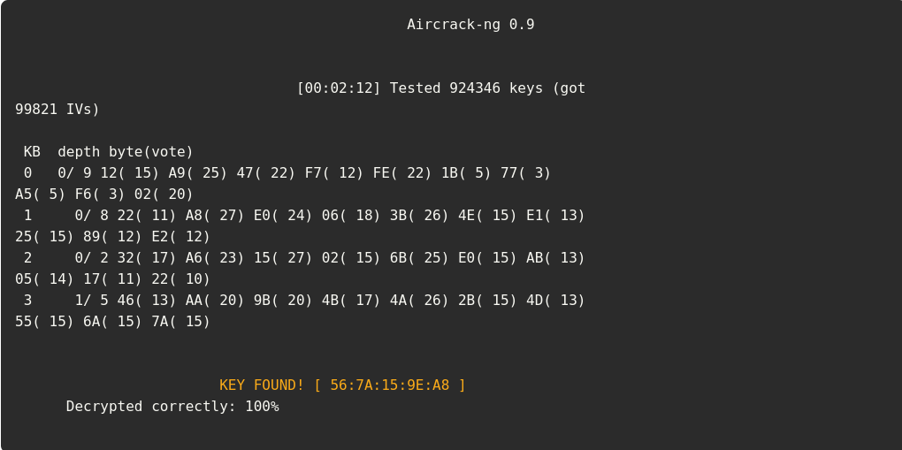
The WPA Four-Way Handshake

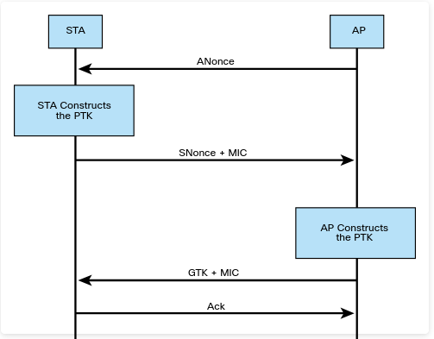
Capturing the WPA Four-Way Handshake and Cracking the PSK
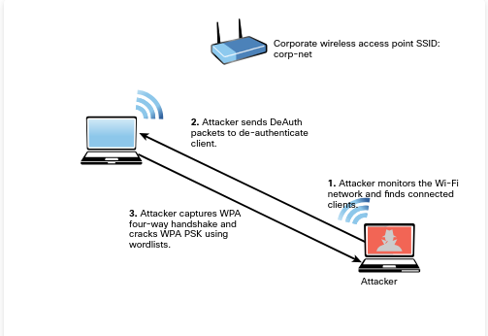
Step 1. An attacker monitors the Wi-Fi network and finds wireless clients connected to the corp-net SSID.
Step 2. The attacker sends DeAuth packets to deauthenticate the wireless client.
Step 3. The attacker captures the WPA four-way handshake and cracks the WPA PSK. (It is possible to use word lists and tools such as Aircrack-ng to perform this attack.)
KARMA (which stands for karma attacks radio machines automatically) is an on-path attack that involves creating a rogue AP and allowing an attacker to intercept wireless traffic.
Credential harvesting is an attack that involves obtaining or compromising user credentials. Credential harvesting attacks can be launched using common social engineering attacks such as phishing attacks, and they can be performed by impersonating a wireless AP or a captive portal to convince a user to enter his or her credentials.
Bluejacking is an attack that can be performed using Bluetooth with vulnerable devices in range.
Bluesnarfing attacks are performed to obtain unauthorized access to information from a Bluetooth-enabled device.
Bluesnarfing is considered riskier than Bluejacking because whereas Bluejacking attacks only transmit data to the victim device, Bluesnarfing attacks actually steal information from the victim device.
Bluesnarfing attacks can also be used to obtain the International Mobile Equipment Identity (IMEI) number for a device. Attackers can then divert incoming calls and messages to another device without the user’s knowledge.
Using the Bluesnarfer Tool to Obtain a Device Name
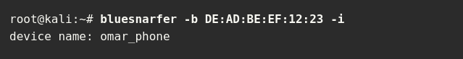
Radio-frequency identification (RFID) is a technology that uses electromagnetic fields to identify and track tags that hold electronically stored information.
Passive tags use energy from RFID readers (via radio waves), and active tags have local power sources and can operate from longer distances.
Password spraying is a type of credential attack in which an attacker brute-forces logins based on a list of usernames with default passwords of common systems or applications.
A similar attack is credential stuffing. In this type of attack, the attacker performs automated injection of usernames and passwords that have been exposed in previous breaches.

