Social Engineering Attacks

4.1. Pretexting for an Approach and Impersonation
Key components of social engineering.
Influence
Interrogation
Impersonation
Elicitation is the act of gaining knowledge or information from people. In most cases, an attacker gets information from a victim without directly asking for that particular information.
How an attacker interrogates and interacts with a victim is crucial for the success of a social engineering campaign.
An interrogator can ask good open-ended questions to learn about an individual’s viewpoints, values, and goals.
It is also possible for an interrogator to use closed-ended questions to get more control of the conversation and to lead the conversation or to actually stop the conversation.
Successful social engineering interrogators use a narrowing approach in their questioning to gain as much information as possible from the victim.
Interrogators pay close attention to the following:
- The victim’s posture or body language
- The color of the victim’s skin, such as the face color becoming pale or red
- The direction of the victim’s head and eyes
- Movement of the victim’s hands and feet
- The victim’s mouth and lip expressions
- The pitch and rate of the victim’s voice, as well as changes in the voice
- The victim’s words, including their length, the number of syllables, dysfunctions, and pauses
With pretexting, or impersonation, an attacker presents as someone else in order to gain access to information.
Social engineers may use pretexting to impersonate individuals in certain jobs and roles even if they do not have experience in those jobs or roles.
Pharming is a type of impersonation attack in which a threat actor redirects a victim from a valid website or resource to a malicious one that could be made to appear as the valid site to the user.
Pharming can be done by altering the host file on a victim’s system, through DNS poisoning, or by exploiting a vulnerability in a DNS server.
Pharming Example
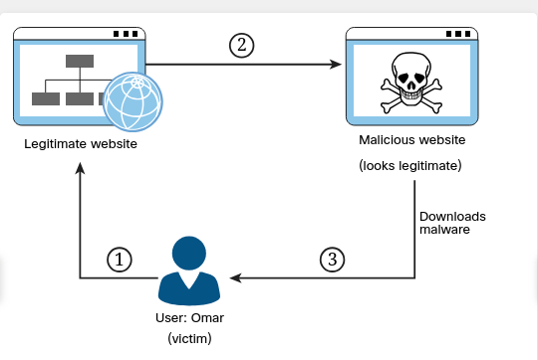
Step 1. The user (Omar) visits a legitimate website and clicks on a legitimate link.
Step 2. Omar’s system is compromised, the host file is modified, and Omar is redirected to a malicious site that appears to be legitimate. (This could also be accomplished by compromising a DNS server or spoofing a DNS reply.)
Step 3. Malware is downloaded and installed on Omar’s system.
An attack that is similar to pharming is called malvertising.
Malvertising involves incorporating malicious ads on trusted websites. Users who click these ads are inadvertently redirected to sites hosting malware.

4.2. Social Engineering Attacks
A social engineering attack leverages the weakest link in an organization, which is the human user.
4.2.2 Email Phishing
An attacker presents to a user a link or an attachment that looks like a valid, trusted resource. When the user clicks it, he or she is prompted to disclose confidential information such as his or her username and password.
Spear Phishing
Spear phishing is a phishing attempt that is constructed in a very specific way and directly targeted to specific groups of individuals or companies. The attacker studies a victim and the victim’s organization in order to be able to make emails look legitimate and perhaps make them appear to come from trusted users within the company.
In the email shown below, the threat actor has become aware that Chris and Omar are collaborating on a book. The threat actor impersonates Chris and sends an email asking Omar to review a document (a chapter of the book). The attachment actually contains malware that is installed on Omar’s system.
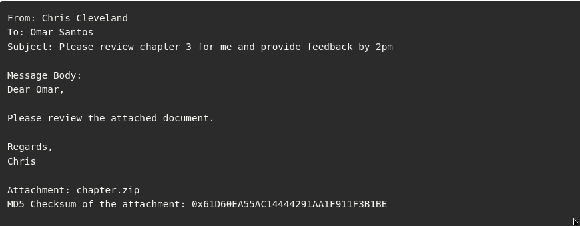
Whaling
It is an attack targeted at high-profile business executives and key individuals in a company. Like threat actors conducting spear phishing attacks, threat actors conducting whaling attacks also create emails and web pages to serve malware or collect sensitive information; however, the whaling attackers’ emails and pages have a more official or serious look and feel.
Whaling emails are designed to look like critical business emails or emails from someone who has legitimate authority, either within or outside the company. In whaling attacks, web pages are designed to specifically address high-profile victims. In a regular phishing attack, the email might be a fake warning from a bank or service provider. In a whaling attack, the email or web page would be created with a more serious executive-level form. The content is created to target an upper manager such as the CEO or an individual who might have credentials for valuable accounts within the organization.
The main goal in whaling attacks is to steal sensitive information or compromise the victim’s system and then target other key high-profile victims.
4.2.3 Vishing
Vishing (which is short for voice phishing) is a social engineering attack carried out in a phone conversation. The attacker persuades the user to reveal private personal and financial information or information about another person or a company.
The goal of vishing is typically to steal credit card numbers, Social Security numbers, and other information that can be used in identity theft schemes. Attackers may impersonate and spoof caller ID to hide themselves when performing vishing attacks.
4.2.4 Short Message Service (SMS) Phishing
Short Message Service (SMS) phishing is the bitcoin-related SMS scams that have surfaced in recent years.
You can help mitigate SMS phishing attacks by not clicking on links from any unknown message senders.
4.2.5 Universal Serial Bus (USB) Drop Key
Many pen testers and attackers have used Universal Serial Bus (USB) drop key attacks to successfully compromise victim systems. This type of attack involves just leaving USB sticks (sometimes referred to as USB keys or USB pen drives) unattended or placing them in strategic locations.
Plugging in that USB stick you found lying around on the street outside your office could lead to a security breach.
Another social engineering technique involves dropping a key ring containing a USB stick that may also include pictures of kids or pets and an actual key or two. These types of personal touches may prompt a victim to try to identify the owner in order to return the key chain. This type of social engineering attack is very effective and also can be catastrophic.
4.2.6 Watering Hole Attacks
A watering hole attack is a targeted attack that occurs when an attacker profiles websites that the intended victim accesses. The attacker then scans those websites for possible vulnerabilities. If the attacker locates a website that can be compromised, the website is then injected with a JavaScript or other similar code injection that is designed to redirect the user when the user returns to that site. (This redirection is also known as a pivot attack.) The user is then redirected to a site with some sort of exploit code. The purpose is to infect computers in the organization’s network, thereby allowing the attacker to gain a foothold in the network for espionage or other reasons.
Watering hole attacks are often designed to profile users of specific organizations. Organizations should therefore develop policies to prevent these attacks. Such a policy might, for example, require updating anti-malware applications regularly and using secure virtual browsers that have little connectivity to the rest of the system and the rest of the network. To avoid having a website compromised as part of such an attack, an administrator should use proper programming methods and scan the organization’s website for malware regularly. User education is paramount to help prevent these types of attacks.

4.3. Physical Attacks
4.3.2 Tailgating

With piggybacking, an unauthorized person tags along with an authorized person to gain entry to a restricted area – usually with the person’s consent. Tailgating is essentially the same but with one difference: It usually occurs without the authorized person’s consent.
Both piggybacking and tailgating can be defeated through the use of access control vestibules (formerly known as mantraps). An access control vestibule is a small space that can usually fit only one person. It has two sets of closely spaced doors; the first set must be closed before the other will open, creating a sort of waiting room where people are identified (and cannot escape). Access control vestibules are often used in server rooms and data centers. Multifactor authentication is often used in conjunction with an access control vestibule; for example, a proximity card and PIN may be required at the first door and a biometric scan at the second.
4.3.3 Dumpster Diving
A person scavenges for private information in garbage and recycling containers. To protect sensitive documents, an organization should store them in a safe place as long as possible. When it no longer needs the documents, the organization should shred them. (Some organizations incinerate their documents or have them shredded by a certified professional third party.) Dumpster divers might find information on paper and on hard drives or removable media.
4.3.4 Shoulder Surfing
Someone obtains information such as personally identifiable information (PII), passwords, and other confidential data by looking over a victim’s shoulder.
These attacks tend to be especially successful in crowded places. In addition, shoulder surfing can be accomplished with small hidden cameras and microphones.
User awareness and training are key to prevention. There are also special screen filters for computer displays to prevent someone from seeing the screen at an angle.
4.3.5 Badge Cloning
Attackers can perform different badge cloning attacks.
For example, an attacker can clone a badge/card used to access a building. Specialized software and hardware can be used to perform these cloning attacks.
Attackers can also use social engineering techniques to impersonate employees or any other authorized users to enter a building by just creating their own badge and attempting to trick other users into letting them into a building. This could even be done without a full clone of the radio frequency (RF) capabilities of a badge.

4.4. Social Engineering Tools
4.4.2 Social-Engineer Toolkit (SET)
This tool can be used to launch numerous social engineering attacks and can be integrated with third-party tools and frameworks such as Metasploit
Select the following steps to see a demonstration of how to easily create a spear phishing email using SET.
Step 1. Launch SET by using the setoolkit command
Step 2. Select 1) Social-Engineering Attacks from the menu to start the social engineering attack.
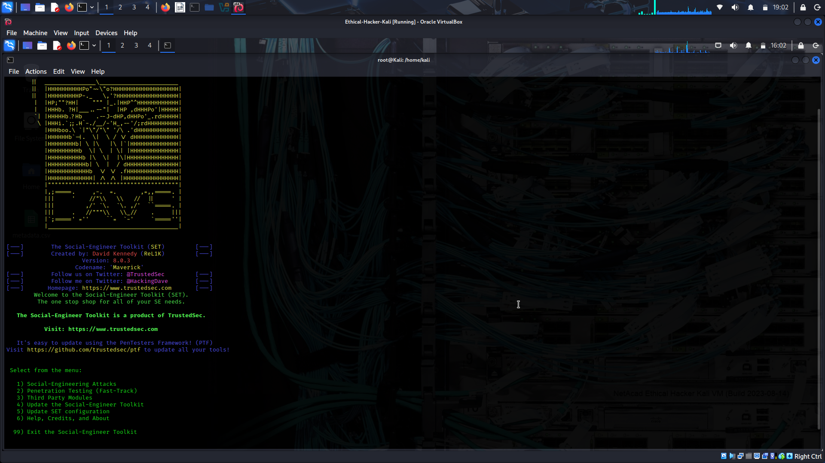
Step 3. Select 1) Spear-Phishing Attack Vectors from the menu to start the spear-phishing attack.
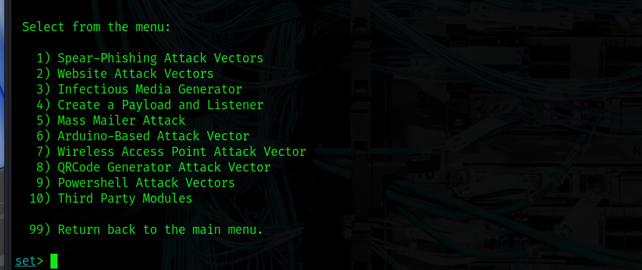
Step 4. To create a file format payload automatically, select 2) Create a FileFormat Payload.
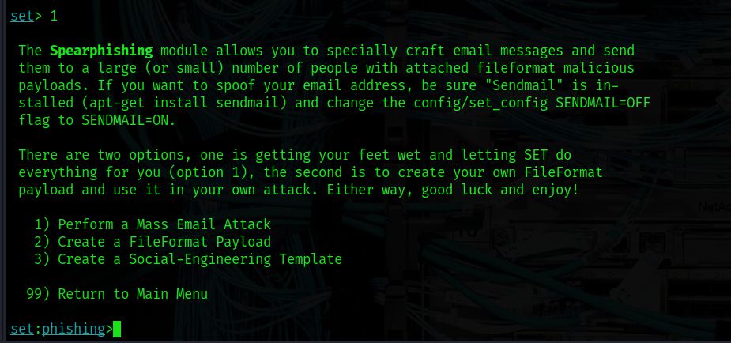
Step 5. Select 13) Adobe PDF Embedded EXE Social Engineering as the file format exploit to use.
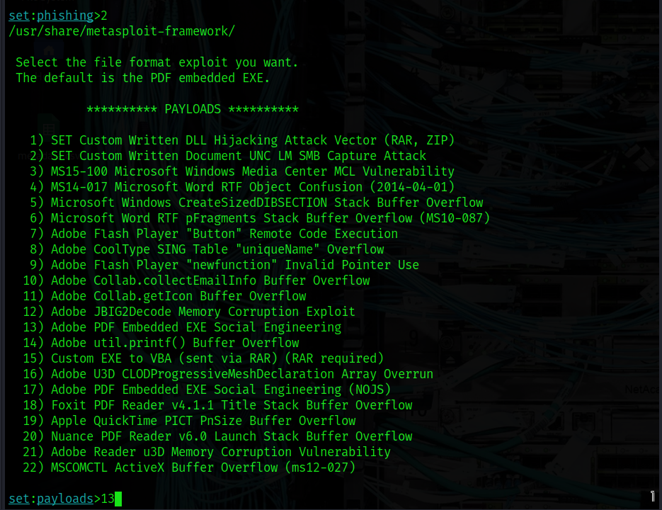
Step 6. To have SET generate a normal PDF with embedded EXE and use a built-in blank PDF file for the attack, select 2) Use built-in BLANK PDF for attack.
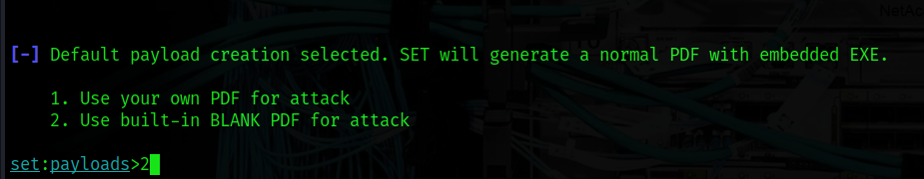
SET gives you the option to spawn a command shell on the victim machine after a successful exploitation. It also allows you to perform other post-exploitation activities, such as spawning a Meterpreter shell, Windows reverse VNC DLL, reverse TCP shell, Windows Shell Bind_TCP, and Windows Meterpreter Reverse HTTPS.
Meterpreter is a post-exploitation tool that is part of the Metasploit framework
Step 7. To use the Windows reverse TCP shell, select 1) Windows Reverse TCP Shell.
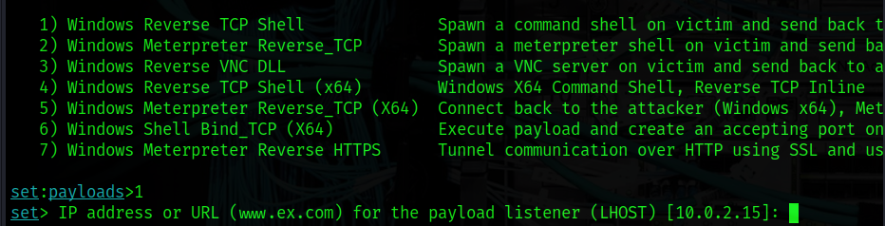
Step 8. When SET asks you to enter the IP address or the URL for the payload listener, select the IP address of your attacking system (10.0.2.15 in this example), which is the default option since it automatically detects your IP address. The default port is 443, but you can change it to another port that is not in use in your attacking system. In this example, TCP port 1337 is used. After the payload is generated, the screen shown below:
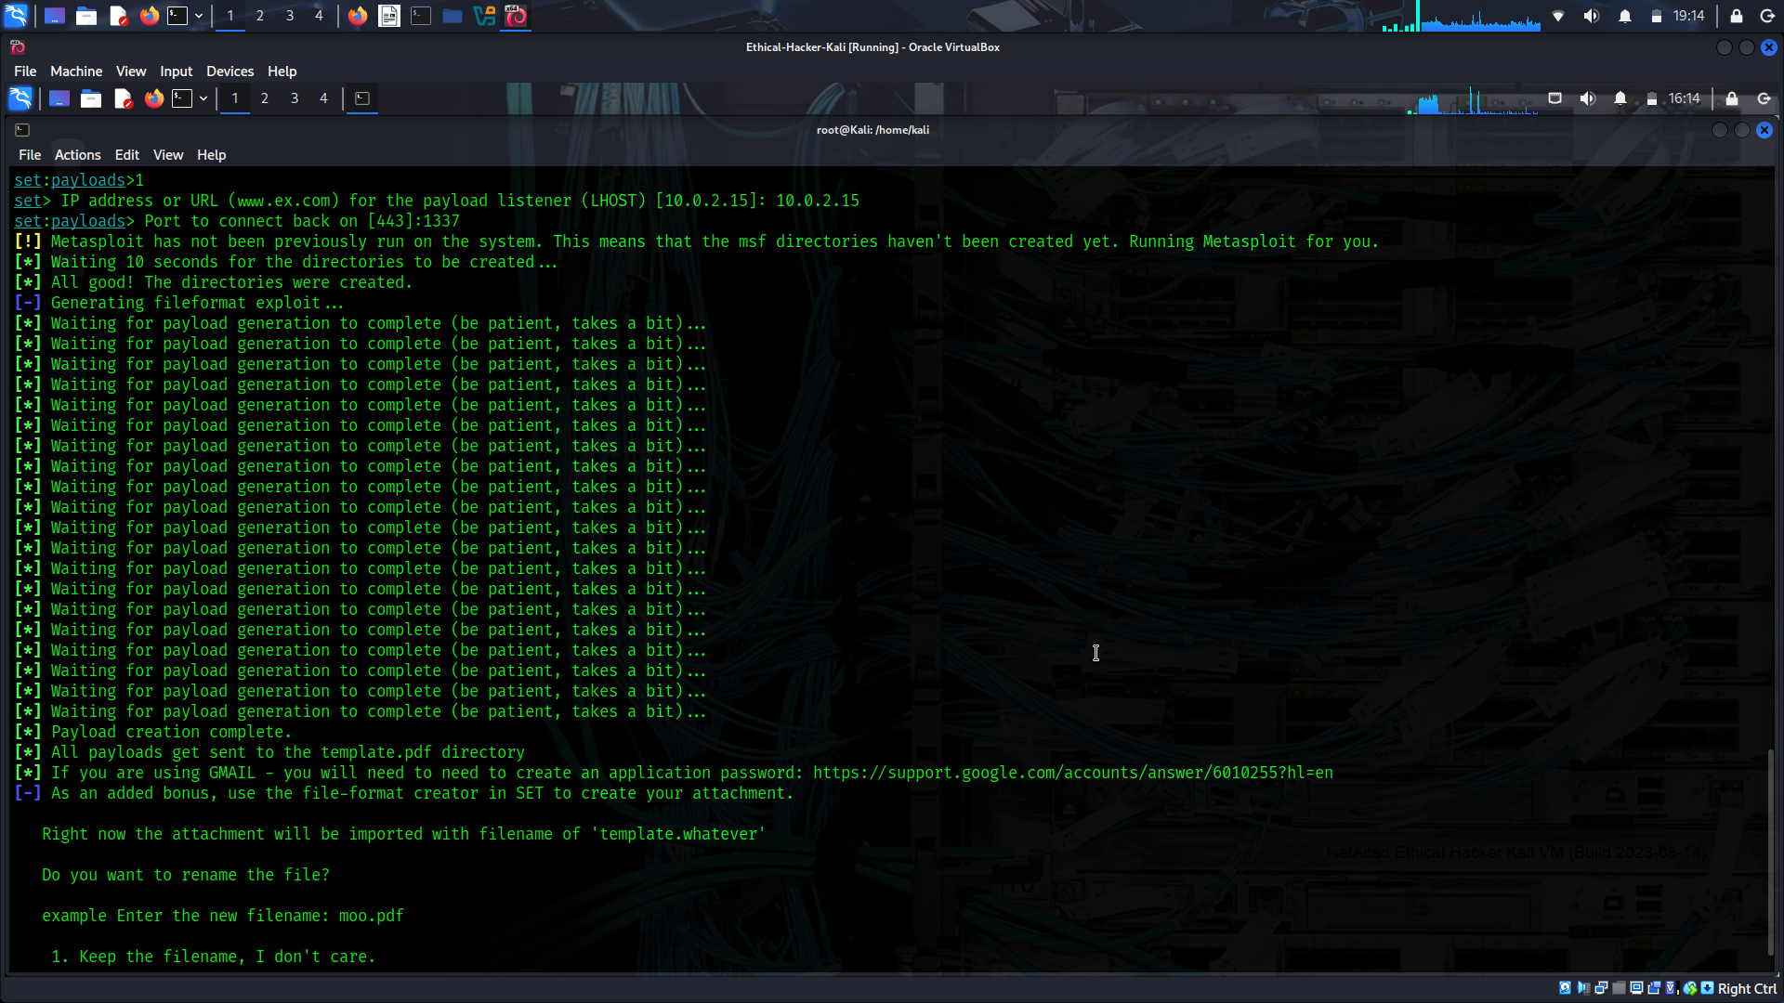
Step 9. When SET asks if you want to rename the payload, select 2. Rename the file, I want to be cool. and enter chapter2.pdf as the new name for the PDF file.
Step 10. Select 1. E-Mail Attack Single Email Address.
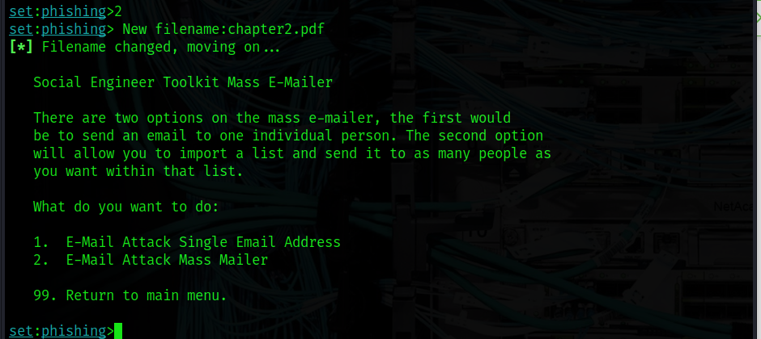
Step 11. When SET asks if you want to use a predefined email template or create a one-time email template, select 2. One-Time Use Email Template.
Step 12. Follow along as SET guides you through the steps to create the one-time email message and enter the subject of the email.
Step 13. When SET asks if you want to send the message as an HTML message or in plaintext, select the default, plaintext.
Step 14. Enter the body of the message by typing or pasting in the text from Example 4-2, earlier in this module (see Figure 4-11).
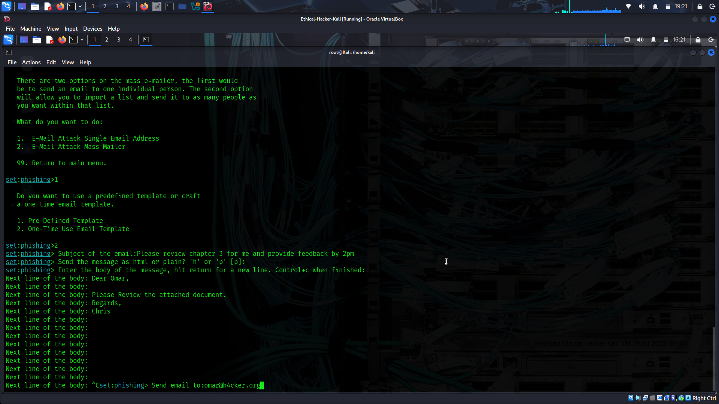
Step 15. Enter the recipient email address and specify whether you want to use a Gmail account or use your own email server or an open mail relay.
Step 16. Enter the “from” email address (the spoofed sender’s email address) and the “from name” the user will see.
Step 17. If you selected to use your own email server or open relay, enter the open-relay username and password (if applicable) when asked to do so.
Step 18. Enter the SMTP email server address and the port number. (The default port is 25.) When asked if you want to flag this email as a high-priority message, make a selection. The email is then sent to the victim.
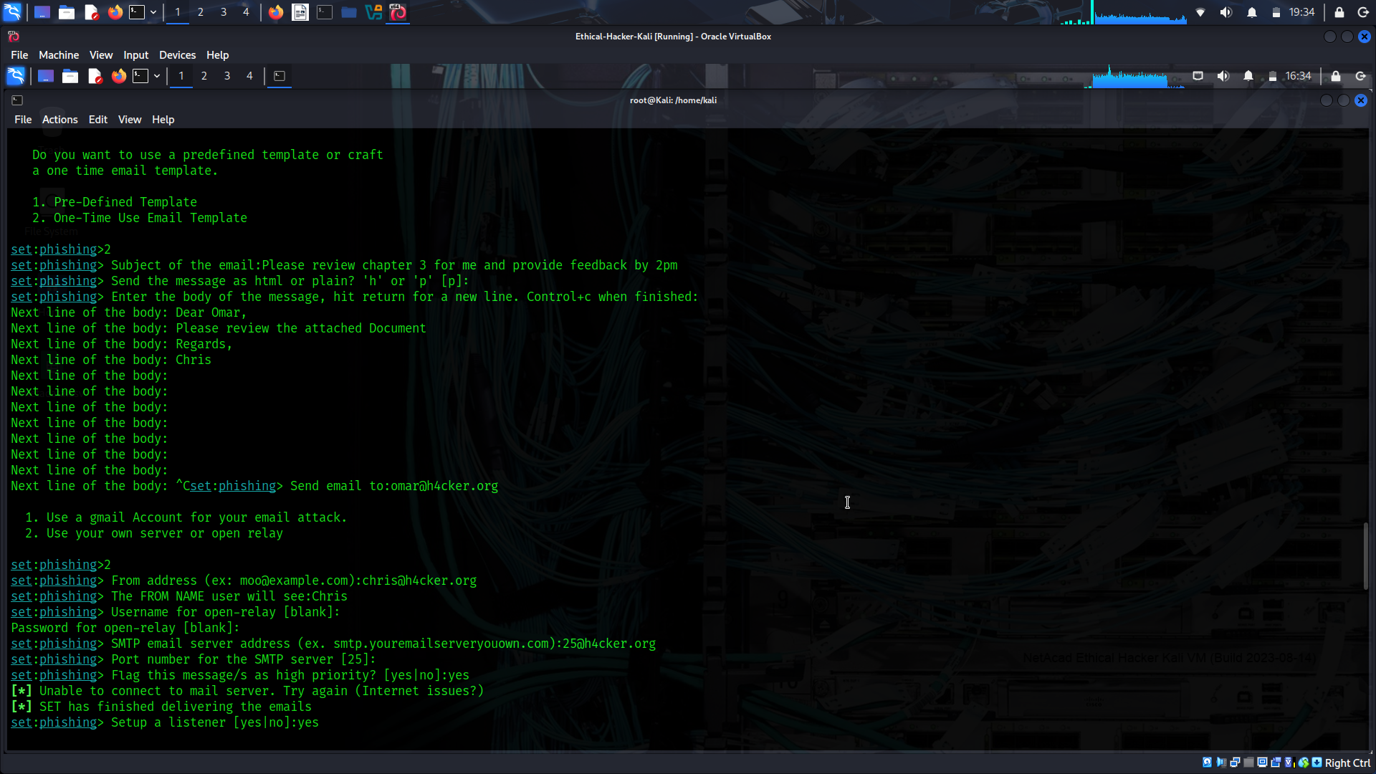
Step 19. When asked if you want to set up a listener for the reverse TCP connection from the compromised system, make a selection.
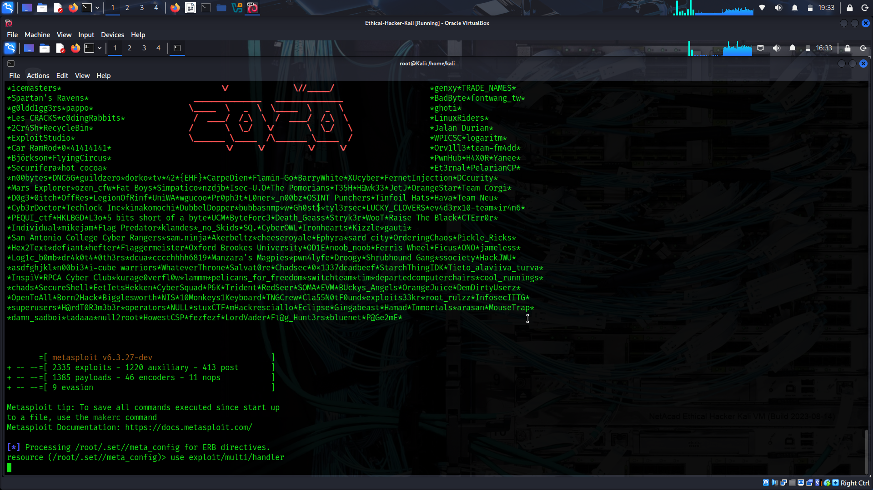
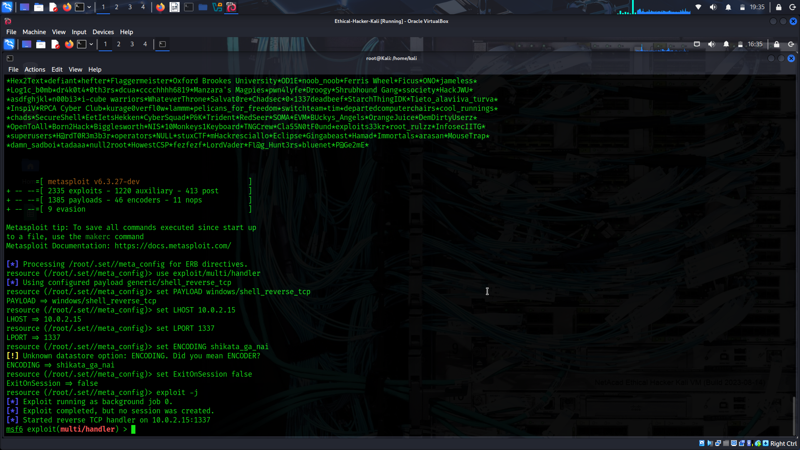
4.4.3 Browser Exploitation Framework (BeEF)
XSS vulnerabilities leverage input validation weaknesses on a web application. These vulnerabilities are often used to redirect users to malicious websites to steal cookies (session tokens) and other sensitive information. Browser Exploitation Framework (BeEF) is a tool that can be used to manipulate users by leveraging XSS vulnerabilities.
Select each tab for an example of using the BeEF tool.
Launching BeEF
The tool starts a web service on port 3000 by default. From there, the attacker can log in to a web console and manipulate users who are victims of XSS attacks.

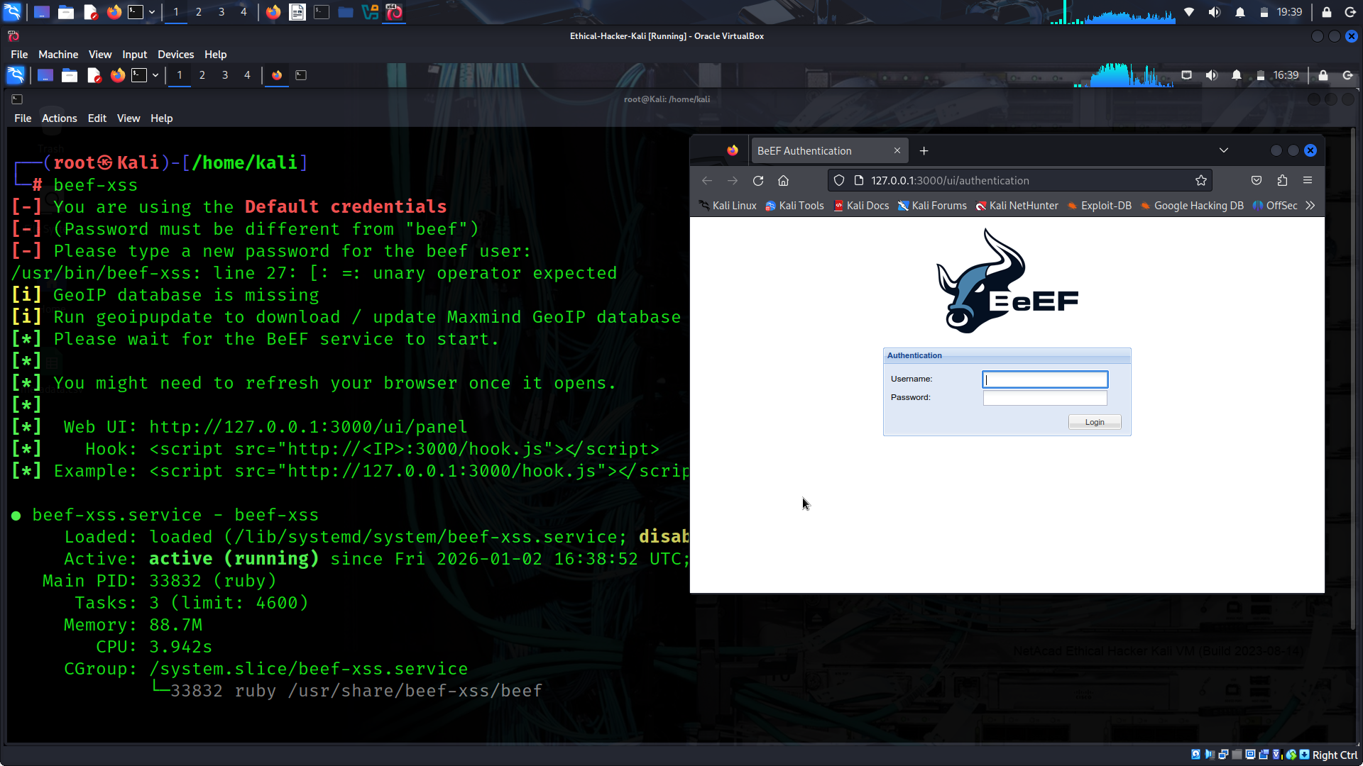
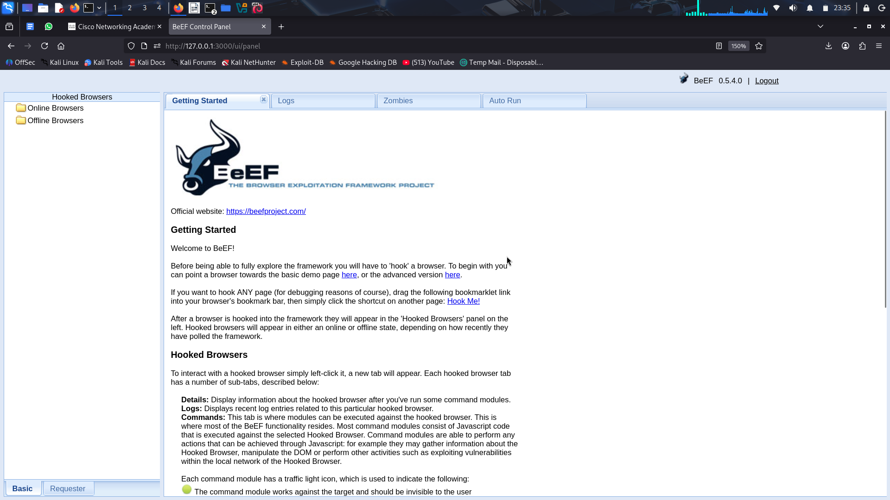
Stealing a Browser Cookie
Figure below shows a successful compromise in which the attacker has stolen the user’s session token (browser cookie).
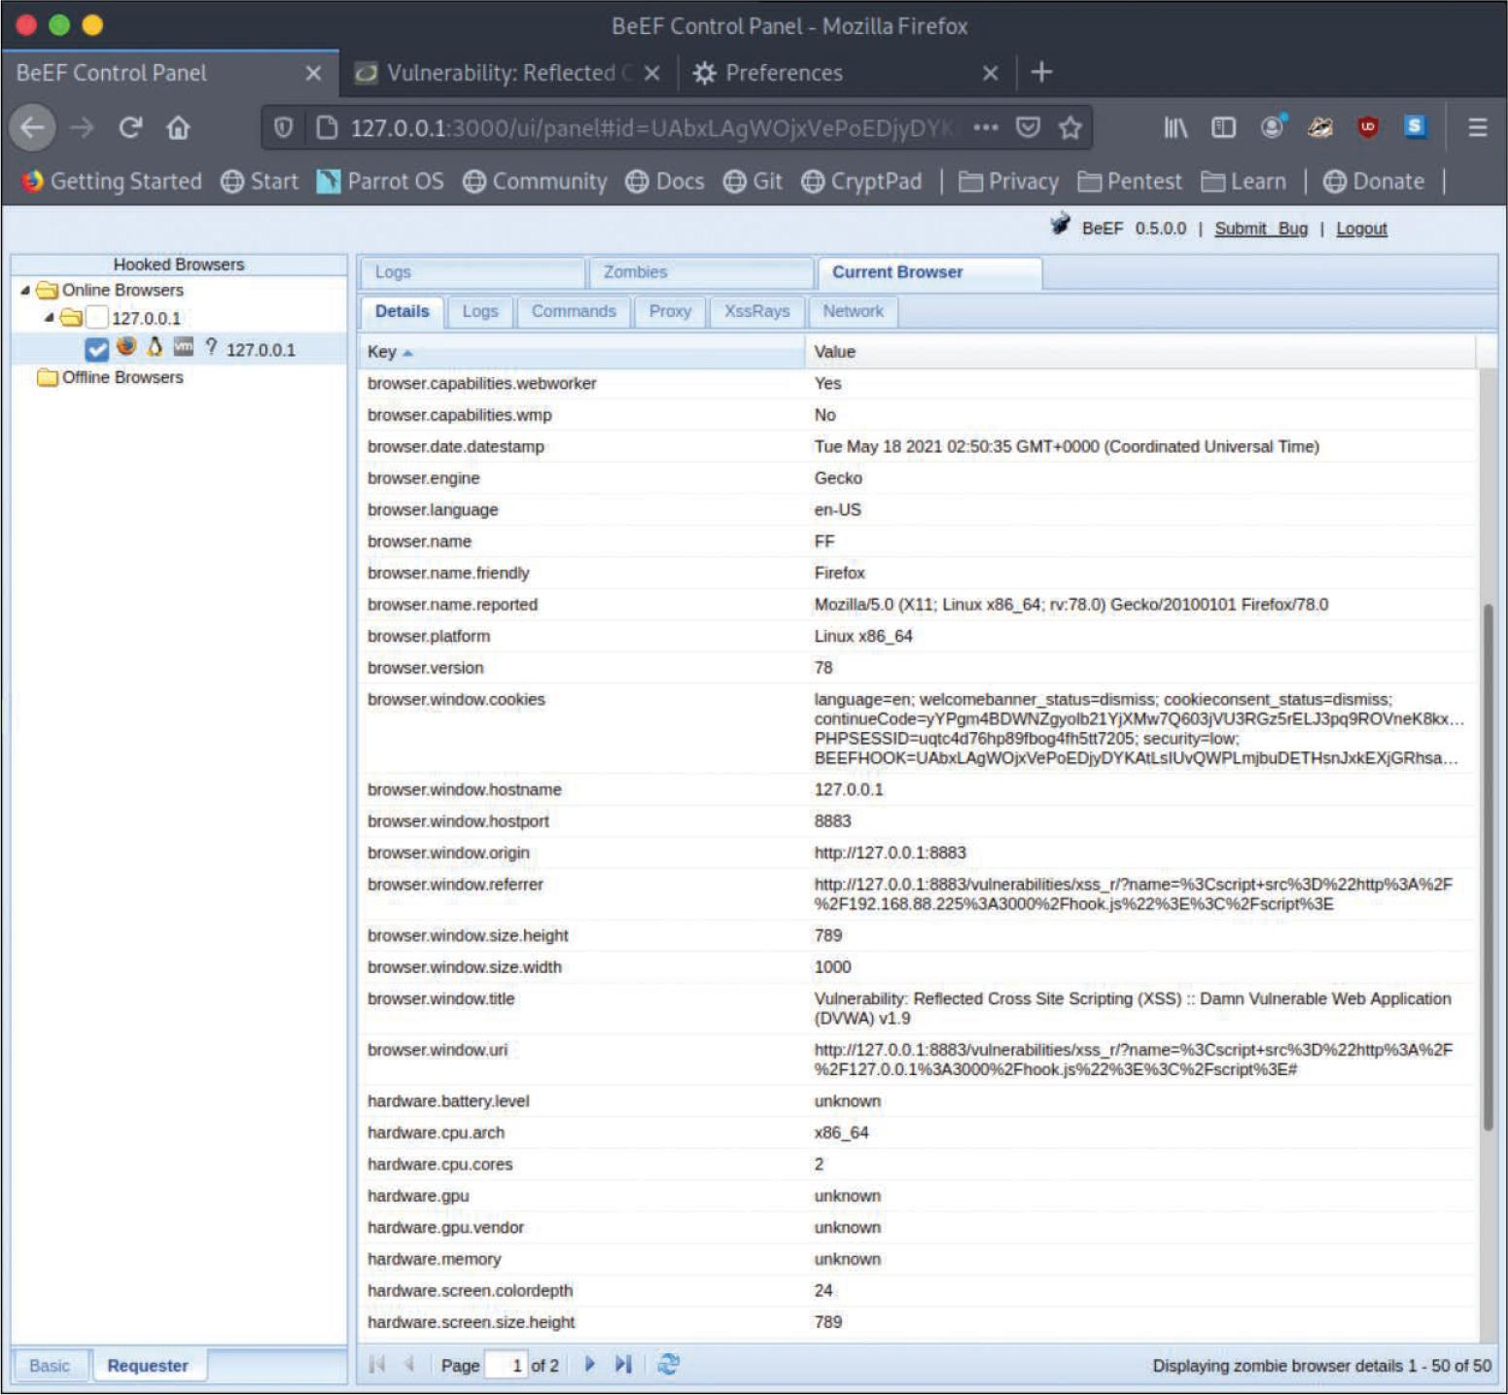
Sending a Fake Notification
Once the system is compromised, the attacker can use BeEF to perform numerous attacks (including social engineering attacks). For example, the attacker can send fake notifications to the victim’s browser, as demonstrated below.
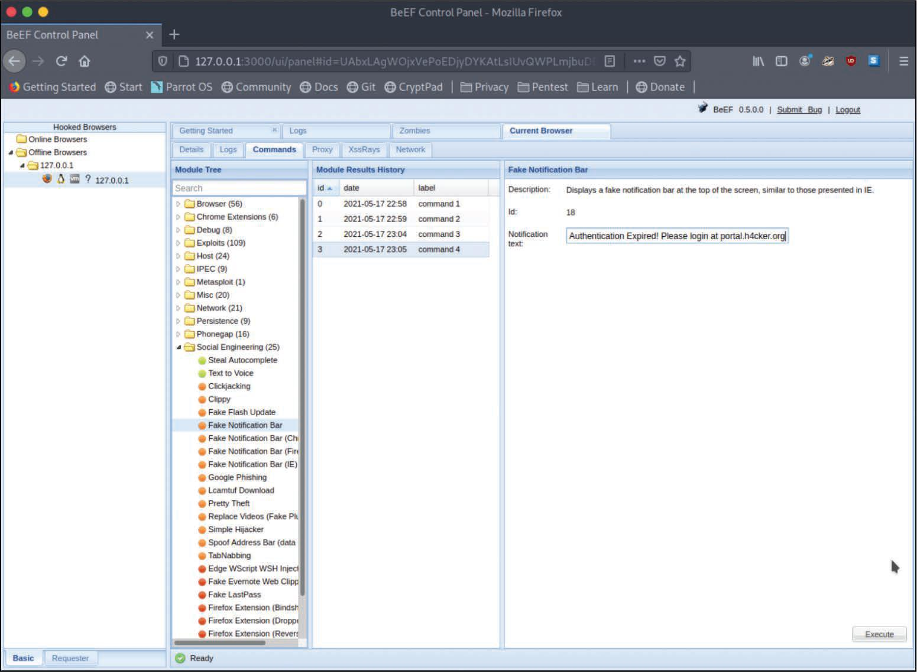
Fake Notification in Browser
Figure below shows the fake notification displayed in the victim’s browser.
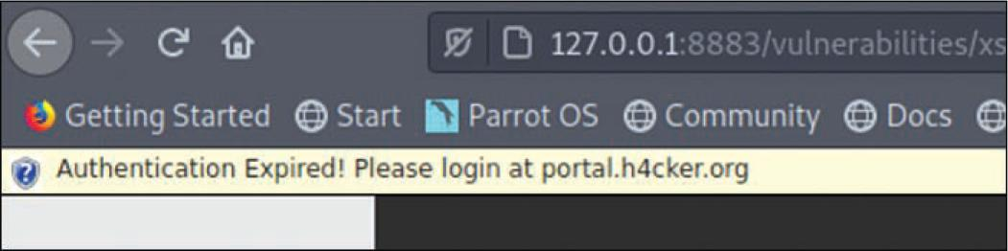
4.4.5 Call Spoofing Tools
You can very easily change the caller ID information that is displayed on a phone. There are several call spoofing tools that can be used in social engineering attacks.
The following are a few examples of call spoofing tools:
- SpoofApp: This is an Apple iOS and Android app that can be used to easily spoof a phone number.
- SpoofCard: This is an Apple iOS and Android app that can spoof a number and change your voice, record calls, generate different background noises, and send calls straight to voicemail.
- Asterisk: Asterisk is a legitimate voice over IP (VoIP) management tool that can also be used to impersonate caller ID.
Social engineering motivation techniques/methods of influence
- Authority: A social engineer shows confidence and perhaps authority–whether legal, organizational, or social authority.
- Scarcity and Urgency: It is possible to use scarcity to create a feeling of urgency in a decision-making context. Specific language can be used to heighten urgency and manipulate the victim. Salespeople often use scarcity to manipulate clients (for example, telling a customer that an offer is only for today or that there are limited supplies). Social engineers use similar techniques.
- Social Proof: It is a psychological phenomenon in which an individual is not able to determine the appropriate mode of behavior. For example, you might see others acting or doing something in a certain way and might assume that it is appropriate. Social engineers may take advantage of social proof when an individual enters an unfamiliar situation that he or she doesn’t know how to deal with. Social engineers may manipulate multiple people at once by using this technique.
- Likeness: Social engineers strive for others to like the way they behave, look, and talk. Most individuals like what is aesthetically pleasing. People also like to be appreciated and to talk about themselves. Social engineers take advantage of these human vulnerabilities to manipulate their victims.
- Fear: Fear is an unpleasant emotion based on the belief that something bad or dangerous may take place. Using fear, social engineers force their victims to act quickly to avoid or rectify a dangerous or painful situation.

