Module 1: Python Fundamentals

Introduction
Python is a high-level, interpreted programming language known for its simplicity, readability, and powerful capabilities.
It was created by Guido Van Rossum and 1st released in 1991
It has grown into a popular language for automation, web development, data science, and cybersecurity especially in offensive and defensive security.
Python follows the Zen of Python, a set of design principles. You can see them by running: import this
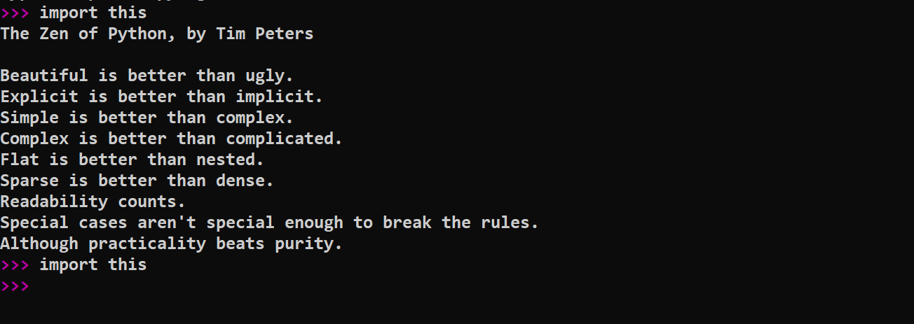
Python Versions
- Python 2 is outdated and no longer supported (EOL in 2020)
- Python 3.x is faster, more secure, and includes features such as print() as a function and better Unicode support
Installing Python
On Windows:
Download from https://www.python.org/downloads/
Important: Check the box "Add Python to PATH" during installation
On Linux:
sudo apt update
sudo apt install python3 python3-pip
On macOS (Homebrew):
brew install python3
Running Python Code
Option 1: Interactive mode (REPL)
Open terminal and type:
python3
>>> print("Hello, world!")
You’ll get:
Hello, world!
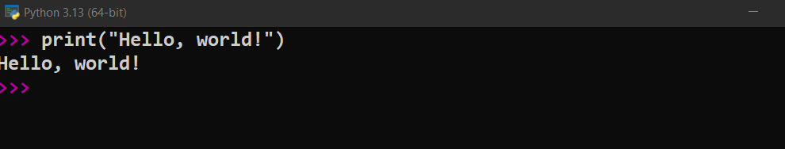
Option 2: Running .py scripts
Create a file:
nano hello.py
Inside:
print("Hello from a script!")
Run:
python3 hello.py

Setting Up an IDE
Recommended environments for coding:
- VS Code (with Python extension)
- PyCharm (Community Edition is free)
- Jupyter Notebooks (for interactive scripts and demos)
- Thonny (great for beginners)
Practice Task
Create a simple script and run.
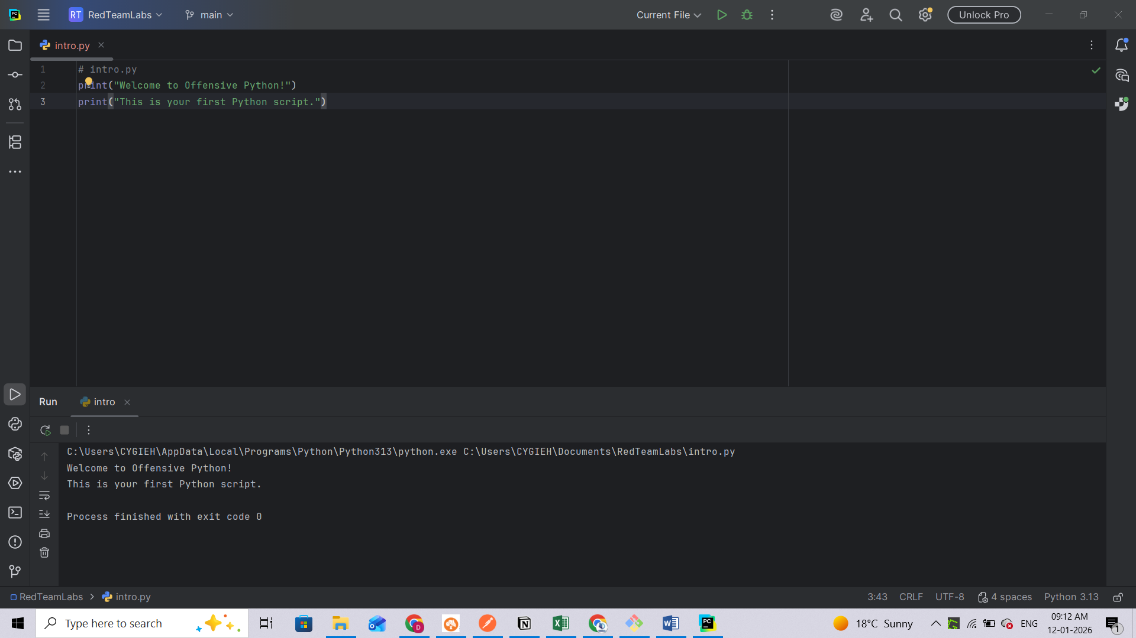

Basic Data Types
Python’s built-in scalar and text types hide a great deal of subtle behavior that becomes important when you start manipulating raw network data, generating shellcode, or processing large log files.
- Numeric Types
Type | Precision | Mutable? | Notes
int | Arbitrary | Immutable | No fixed bit-width; grows to accommodate any integer.
float | 64-bit IEEE-754 | Immutable | Binary floating point; rounding error is common.
complex | Two 64-bit floats | Immutable | 3+4j form; handy for FFTs but rarely used in security code.
bool | Subclass of int | Immutable | True == 1, False == 0.
Integers (int)
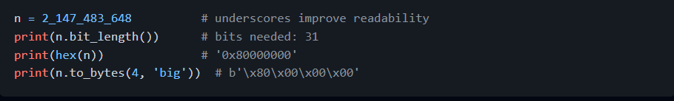Key points
- Unlimited size means cryptographic math (RSA, ECC) can be done without third-party big-int libraries.
- Converting to/from bytes is essential when you craft exploit payloads or network packets.
Floats (float)
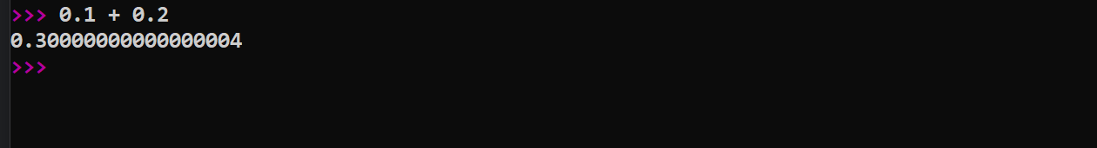
Why it matters: timing attacks and packet timestamping often rely on precise arithmetic. Use the decimal module when you need exact base-10 decimals, or compare floats within tolerances:
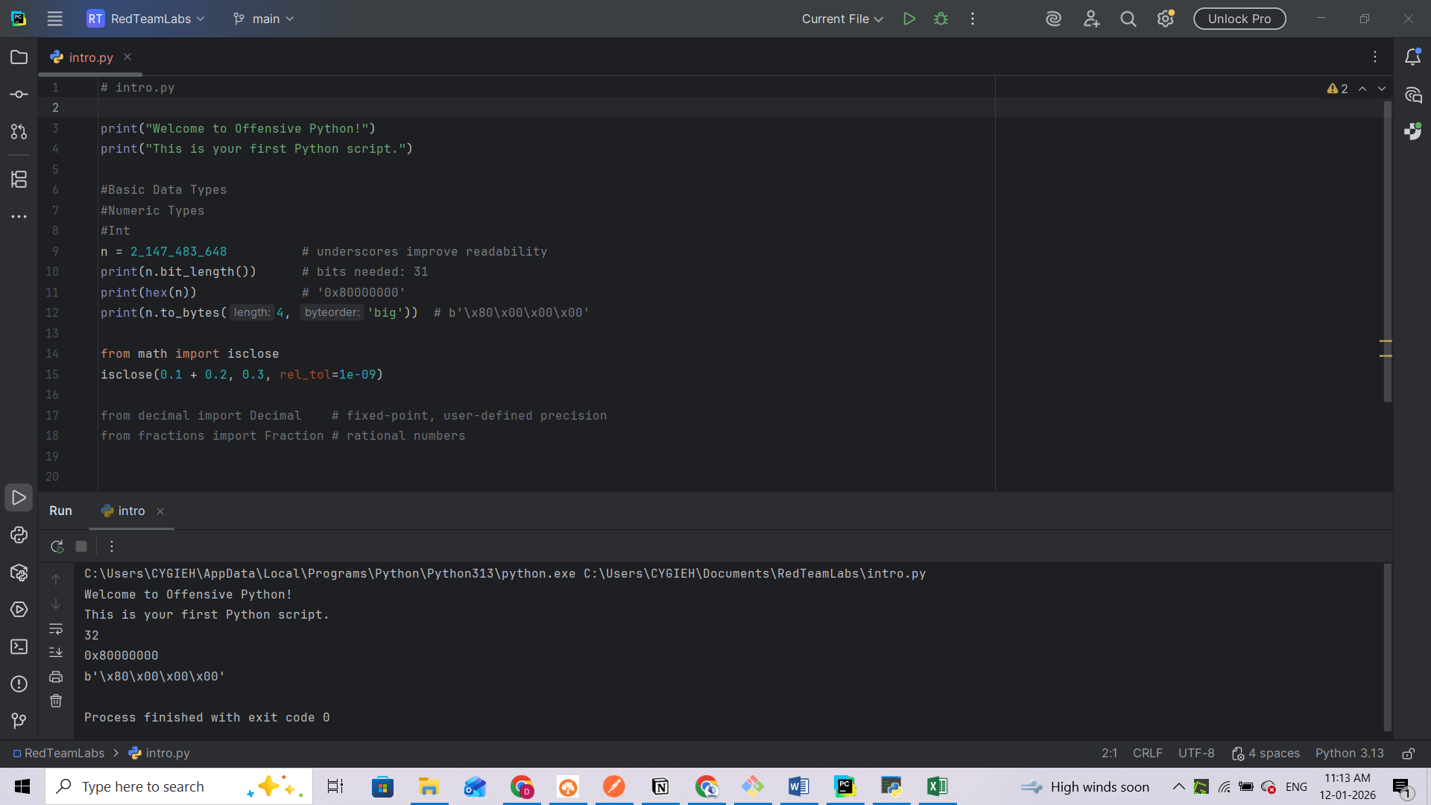
These appear in cryptanalysis and forensic accounting scripts where rounding is unacceptable.
2. Text Data: str
Unicode everywhere
Since Python 3, str stores Unicode code points, not raw bytes. When you receive network data:

