Junior Security Analyst/ SOC L1
Monitor and investigate various security alerts
Participate in SOC brainstorms and workshops
Cooperate with other teams to keep the company safe
Constantly learn and discover new attacks and defenses
SOC and Team
Security Operations Center (SOC) is a team of IT security professionals tasked with monitoring, preventing, detecting, investigating, and responding to threats within a company’s network and systems.
SOC engineers: he maintains security tools and configures alerts to make analyst's job easier.
Senior analyst: helps junior analysts when something is unclear and handles complex cases after level 1s do the initial analysis.
SOC Manager: reports SOC results to the top management and makes sure juniors aren't lost in that big new cyber security world.
Incident Responder: He is called on demand during major incidents.
As Junior analysts, you encounter challenges and lessons where you may:
- Detect and prevent a data stealer infection on a coworker's laptop
- Analyze and stop a phishing campaign targeting the finance team
- Participate in a bigger incident, such as a full-scale ransomware attack
- Team up with teammates to build detection rules and automations
- Go beyond cyber and understand how companies operate from the inside
Security Hierarchy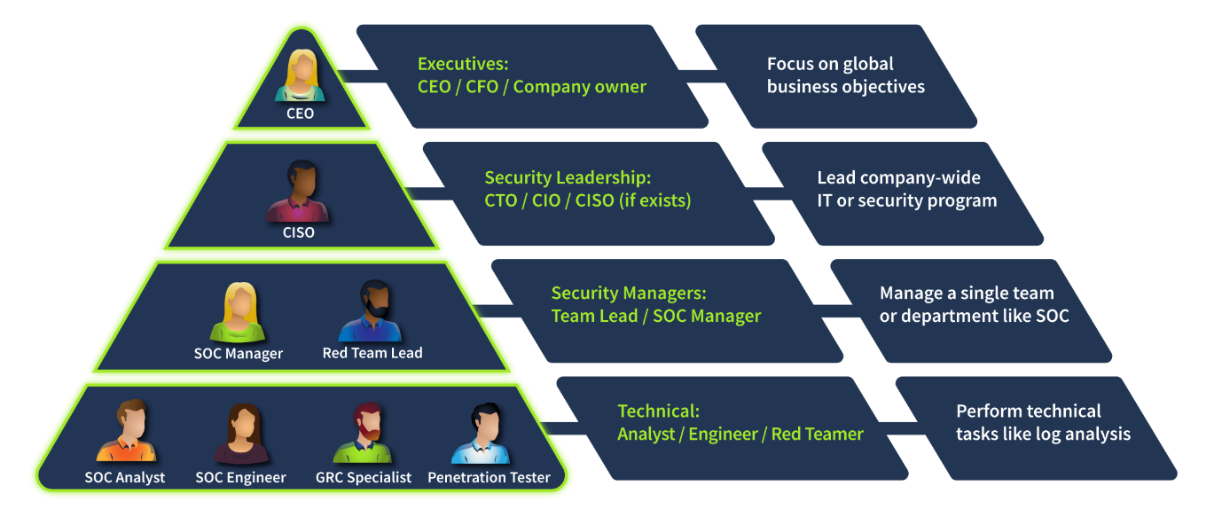
- Red Team: Offensive security experts, pen-testers, or ethical hackers who look for security issues
- GRC Team: Specialists managing policies and ensuring compliance with regulations like PCI DSS
- Blue Team: Defensive security experts like SOC analysts, engineers, or incident responders
Blue Team constantly monitors for attacks and tries to respond to them quickly
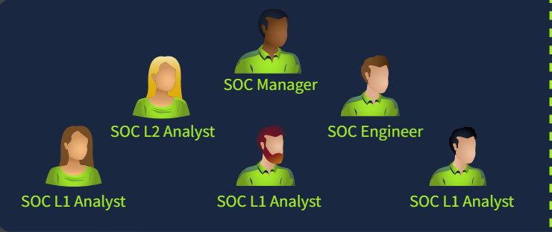
- L1 Analysts: Junior members who triage alerts and pass complex cases to L2
- L2 Analysts: Experienced members who investigate more advanced attacks
- Engineers: Experts in configuring security tools like EDR or SIEM
- Manager: A person who manages the whole SOC team
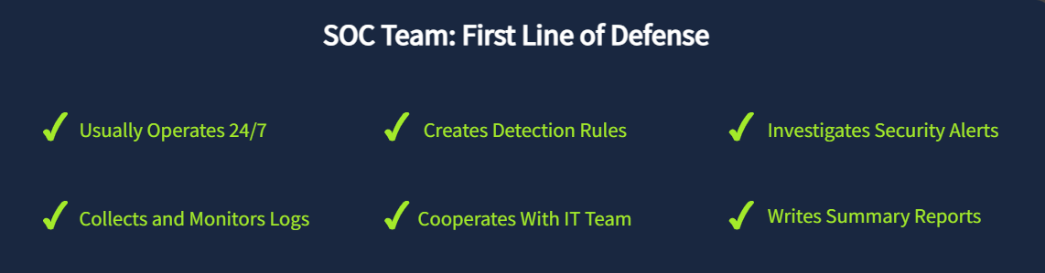
SOC is the central hub for an organization's cyber security - they are the first line of defense, work with various alerts, and handle most attacks.

Cyber Incident Response Team (CIRT)
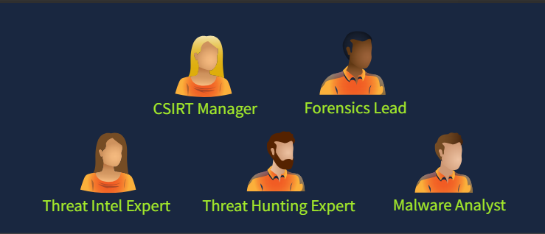
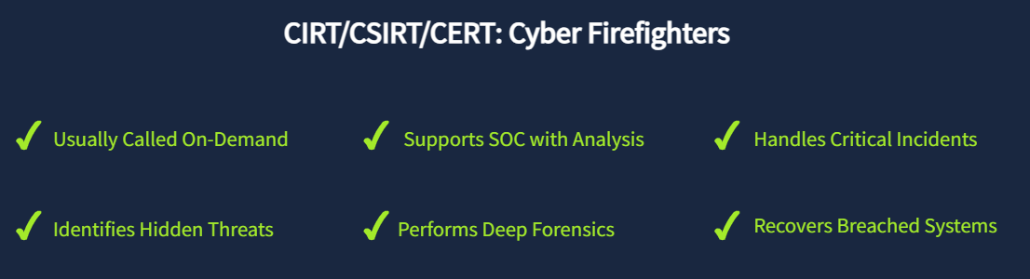

If SOC expertise is not enough or the incident goes out of control, you urgently call the CIRT, also called CSIRT or CERT. The members should have a broad knowledge of cyber threats and handle breaches without depending on tools like EDR or SIEM.
JPCERT: Japan's CERT handling nation-wide breaches
Mandiant: A private team responding to global cyber incidents
AWS CIRT: Investigates security incidents of AWS customers
Specialized Defensive Roles
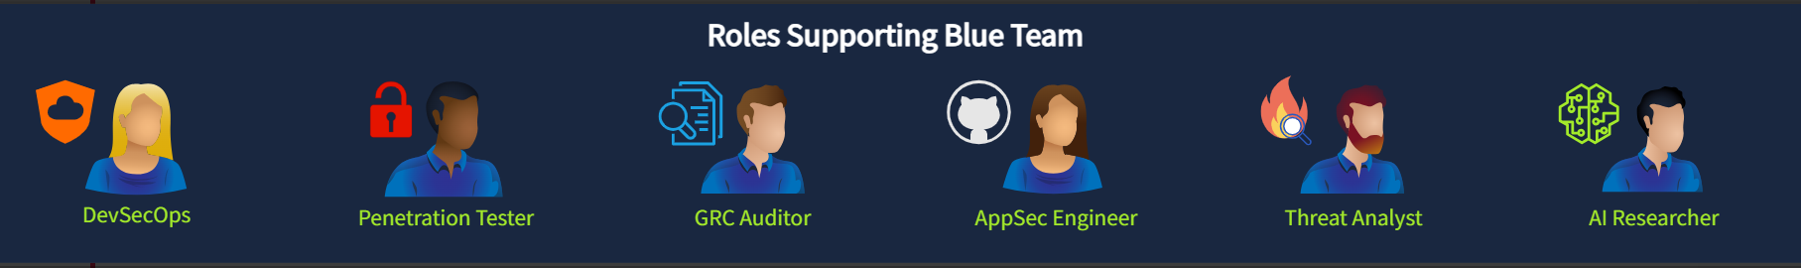
- Digital Forensics Analyst: Uncover hidden threats in disk and memory
- Threat Intelligence Analyst: Gather data about emerging threat groups
- AppSec Engineer: Maintain a secure software development lifecycle
- AI Researcher: Study AI threats and how to defend against them
SOC Path
- Gain core SOC skills and practice them. Related skills like red teaming or general IT would help, too!
- Be proactive, try yourself in CTFs, stay in the loop of cyber news, and consider the SAL1 certification!
- Prepare for an interview, learn the difference between an internal SOC and MSSP, and apply for a job!
- After working for some time in a junior position, consider preparing and advancing to more senior roles!
Topic | Internal SOC | MSSP
Scenario  Example | You work in a SOC team of the bank and protect the bank's systems | You work for a global MSSP protecting its sixty customers in Europe
Working  Pace | You usually have calm shifts without too much time pressure | Your shift usually starts from a queue of urgent alerts to analyze
Security  Tools | You work with just a few tools, but need to know them very well | You have to work with sixty diverse security tools and platforms
Incident  Practice | You saw and learned from just two major cyber attacks last year | Every week, you deal with attacks and breaches, and can learn from it
Internal SOC vs MSSP

