Bank - Money Transfer System

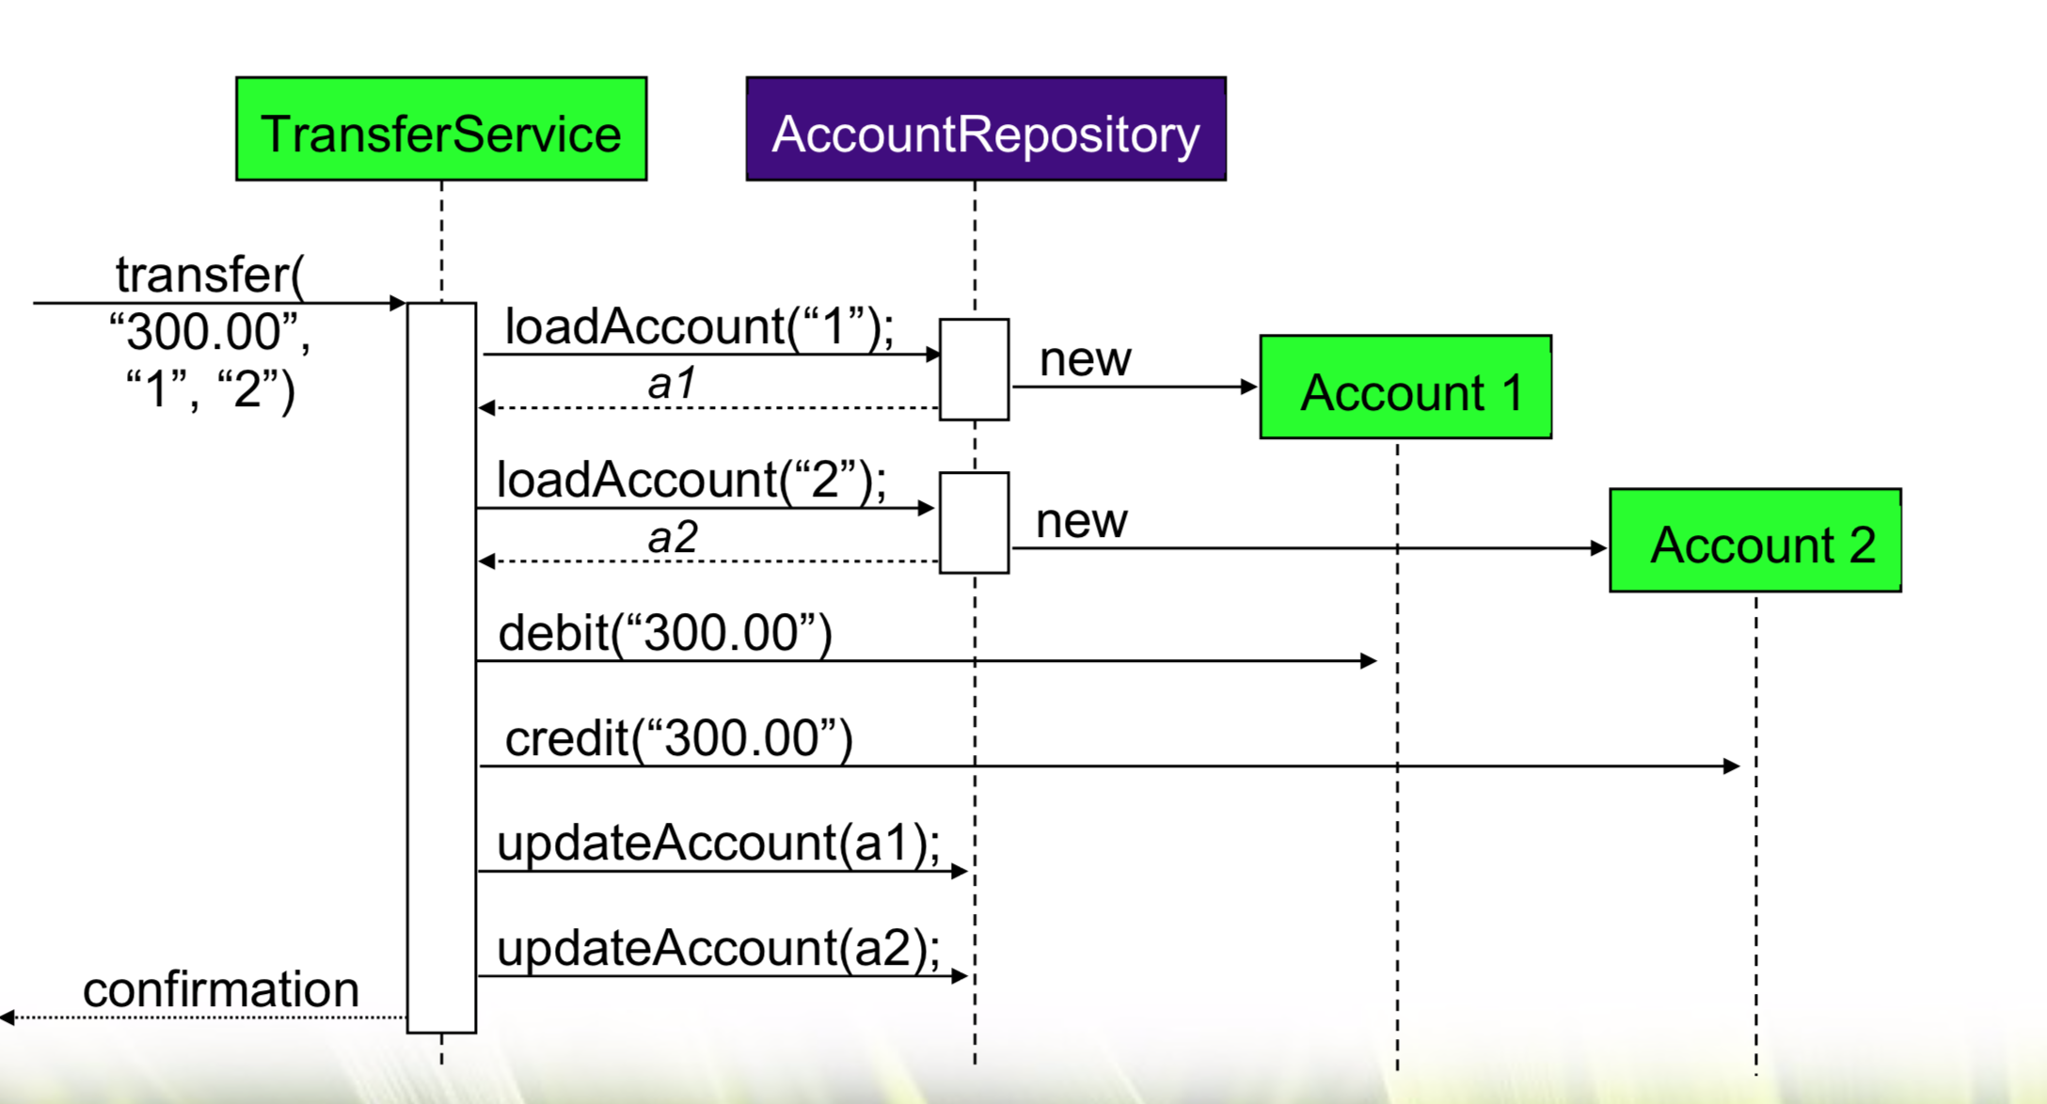

**Problem Statement:**

A bank named my-bank need Money-Transfer-System (MTS) to transfer amount between Account(s).

* After Login, we must show bank-dashboard screen
* Design UI for ‘Transfer’ and ‘statement’ modules
* To Initiate Transfer, user must select from & to accounts and enter amount.
* Customer can view
  + Top 10 Transaction
  + Current month Transactions
  + Last 1 or 3 month Transactions
  + Between date range
* Transactions statement can be viewed as HTML, PDF or Excel representations

Note : PDF or Excel conversion should happen on browser-side only