UI/UX Case Study : Designing a better cinema experience

Going to the cinema is a fun experience, but ordering the tickets in many apps and website often feels like navigation in a really long and frustrating process.

User stories:

In order to build realistic user stories, surveyed 10 people, aged between 22 to 32, who go to the cinema at least once every two months. The questions focused about the last time they went to the cinema. Main takeaways:

1. Six said they wanted to watch **a specific movie**, so they were looking for the right time to see it.
2. Two said they wanted to go to the cinema **at a specific time of the week**, so they were looking for the best movie available at that time.
3. One said she wanted to go to the cinema during **some evening this week**.
4. All of them wanted to go to a movie around their living / working area.

#### Pain Points

1. The current apps does not support any of the user stories really well. It forces the user to give all the exact details (specific movie, specific theater, specific date, specific hour) before seeing if the screening is available / not available.
2. 6/10 complained that the process feels long.
3. 4/10 complained about not having seats after going through the entire process during busy evenings.
4. Other complaints mentioned the app’s low speed or bugs.

Suggested Solution:

The solution takes two of the main user stories into account. split the options to either **Search by Movie** or **Search by Time**. offer relevant screenings at each stage of the process, with extra choices functioning as a smart filter option.

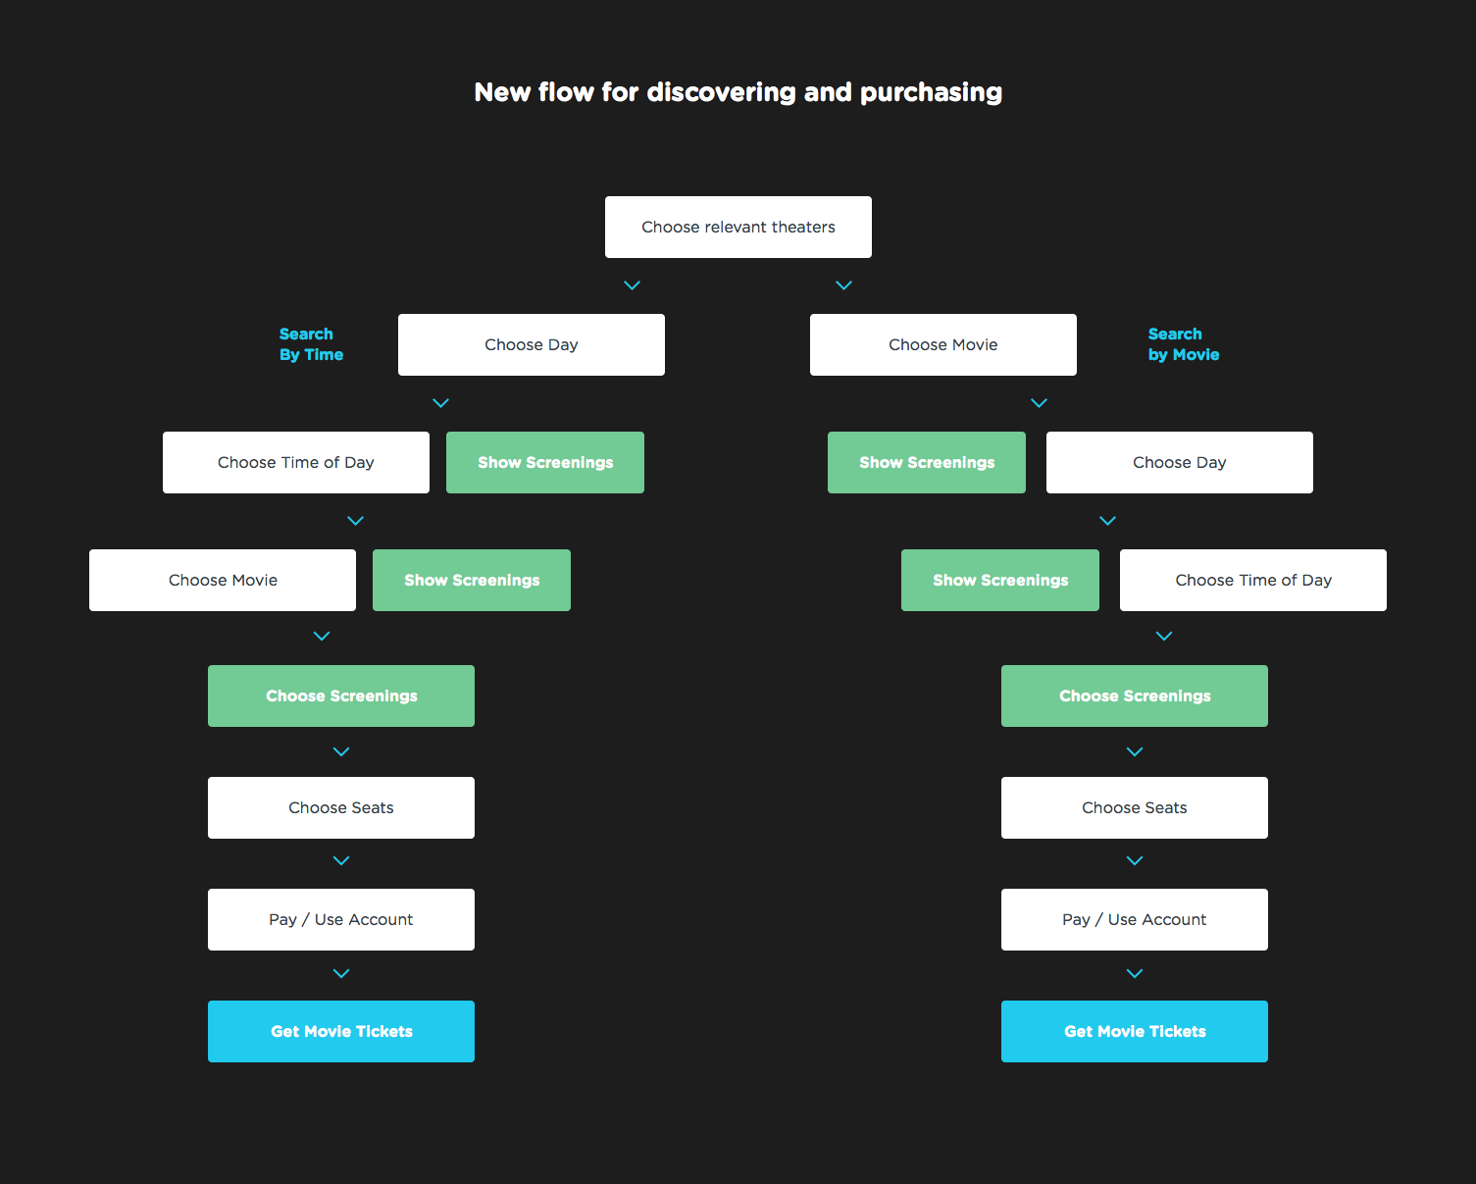

1. Differentiation between the different user stories

The two main user stories are people who are looking for a good time to watch the new Justice League movie (not too bad, by the way), and people who are looking for a nice movie to watch during Wednesday afternoon. These are just specific examples, but they help understand what does the user expect to see.

This information made it easy to make the choice of splitting the browsing functioning, to ‘Search by Title’ and ‘Search by Time’. Doing this, made the UI for both simpler and easier to navigate.

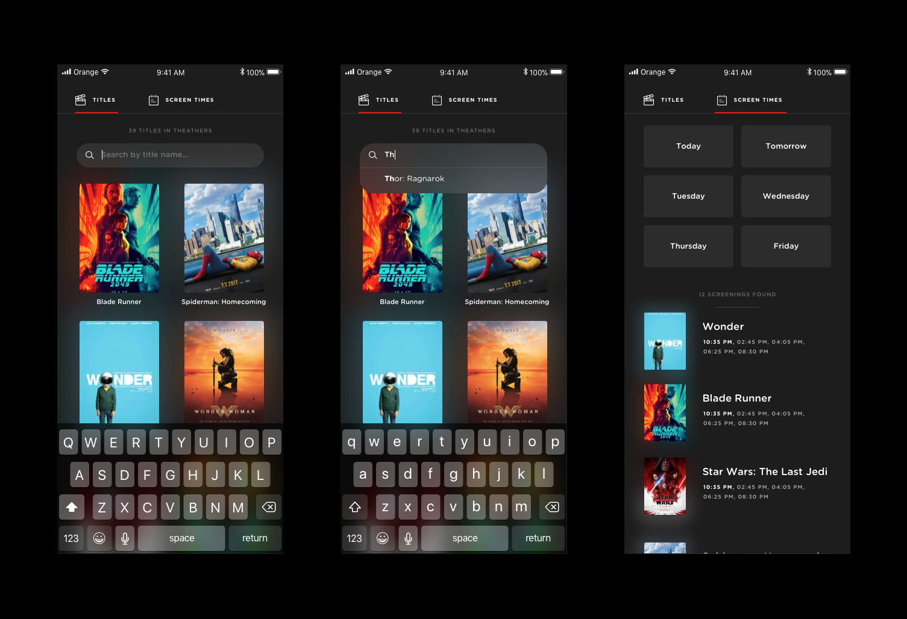

1. Simplification of Fields

When searching for a good movie to watch at a specific time, having a date picker is not really needed, since the tickets are only sold for the following week (true to the example website I chose), and updated every day. Choosing the exact time is not really needed at this stage. The user’s task is to choose a movie and a day / time of day. I chose to spread all the choices using big buttons that will be easily understandable to everybody, and hard to miss. Every choice filters the available movies, and highlights the relevant screen times.

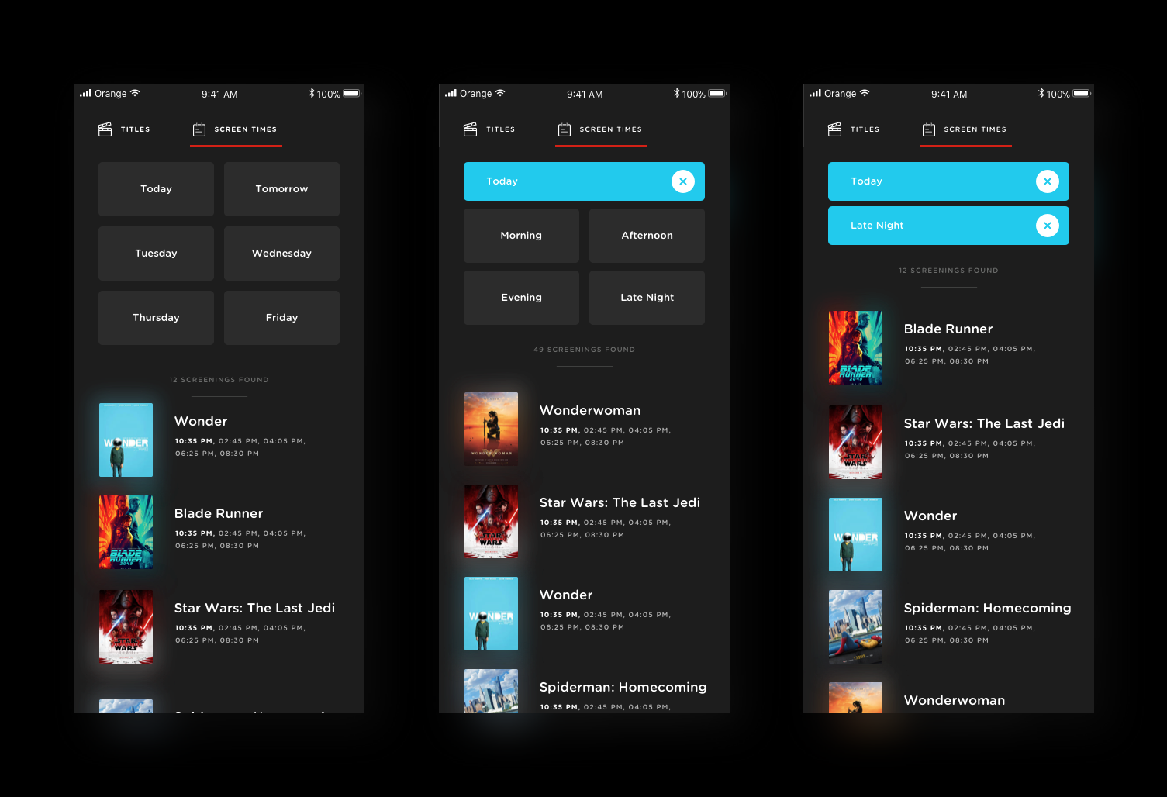

1. Helping the user make better choices

According to the survey, some of the frustrations come from the fact that they finally choose the right screening time + movie for them, only to realize there are no relevant available seats. I solved it by helping them make the right choice. Next to each screening (that will open a ‘choose seats’ dialog followed by payment and producing the ticket), I will show an icon hinting how many seats are available.

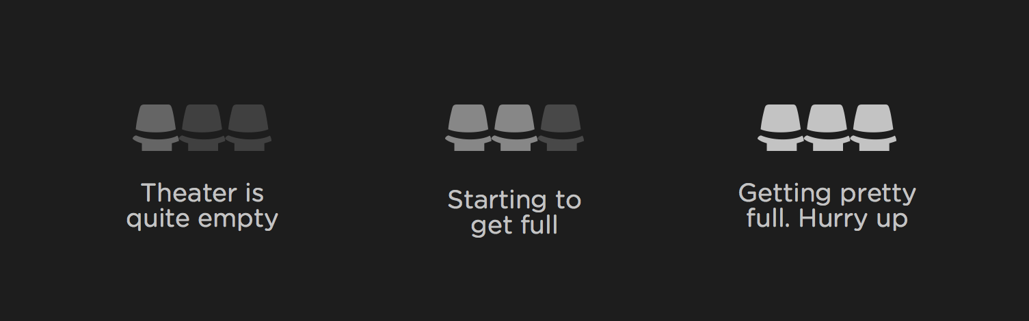

And here is how it looks like integrated in the UI:

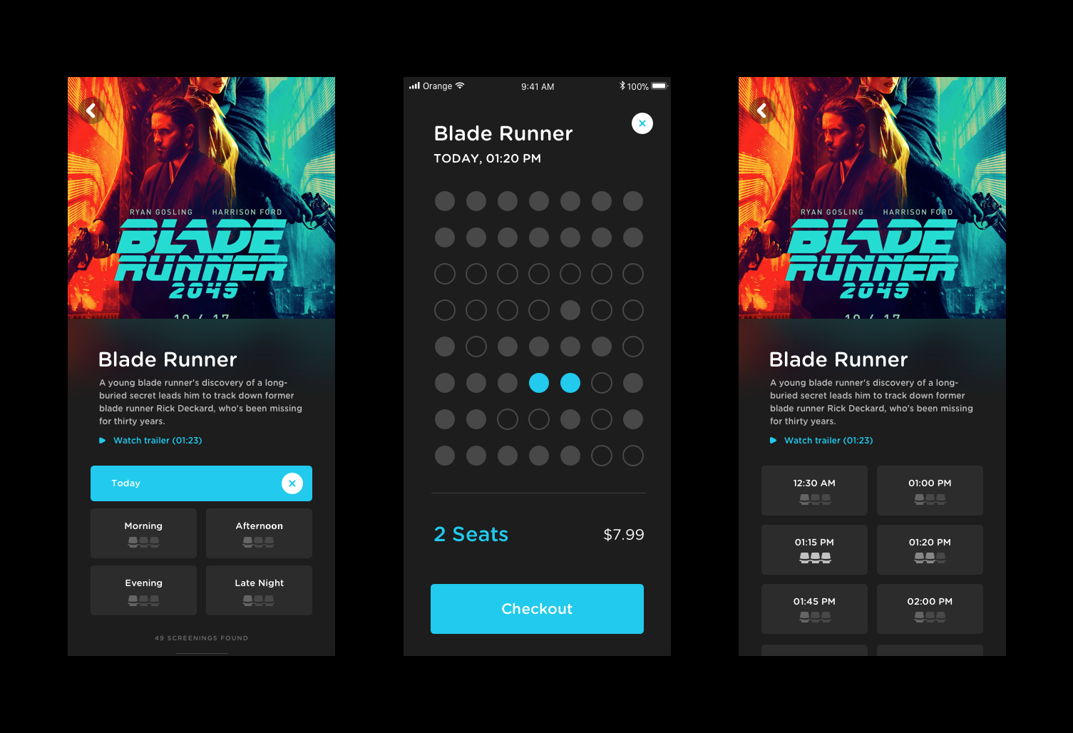

1. Payment

I chose to show the payment once the user selects the seats. The price should be transparent and shown upfront, so there won’t be any surprises.

I didn’t want to reinvent the checkout process, I believe this problem can be best solved by Apple Pay or Google Wallet. In the real app, there would need to be more traditional choices for payment.

I also chose to add illustrations of tickets, to make it feel like the reward (the movie tickets) is just behind this next button. This, I believe, would make the process feel more rewarding.

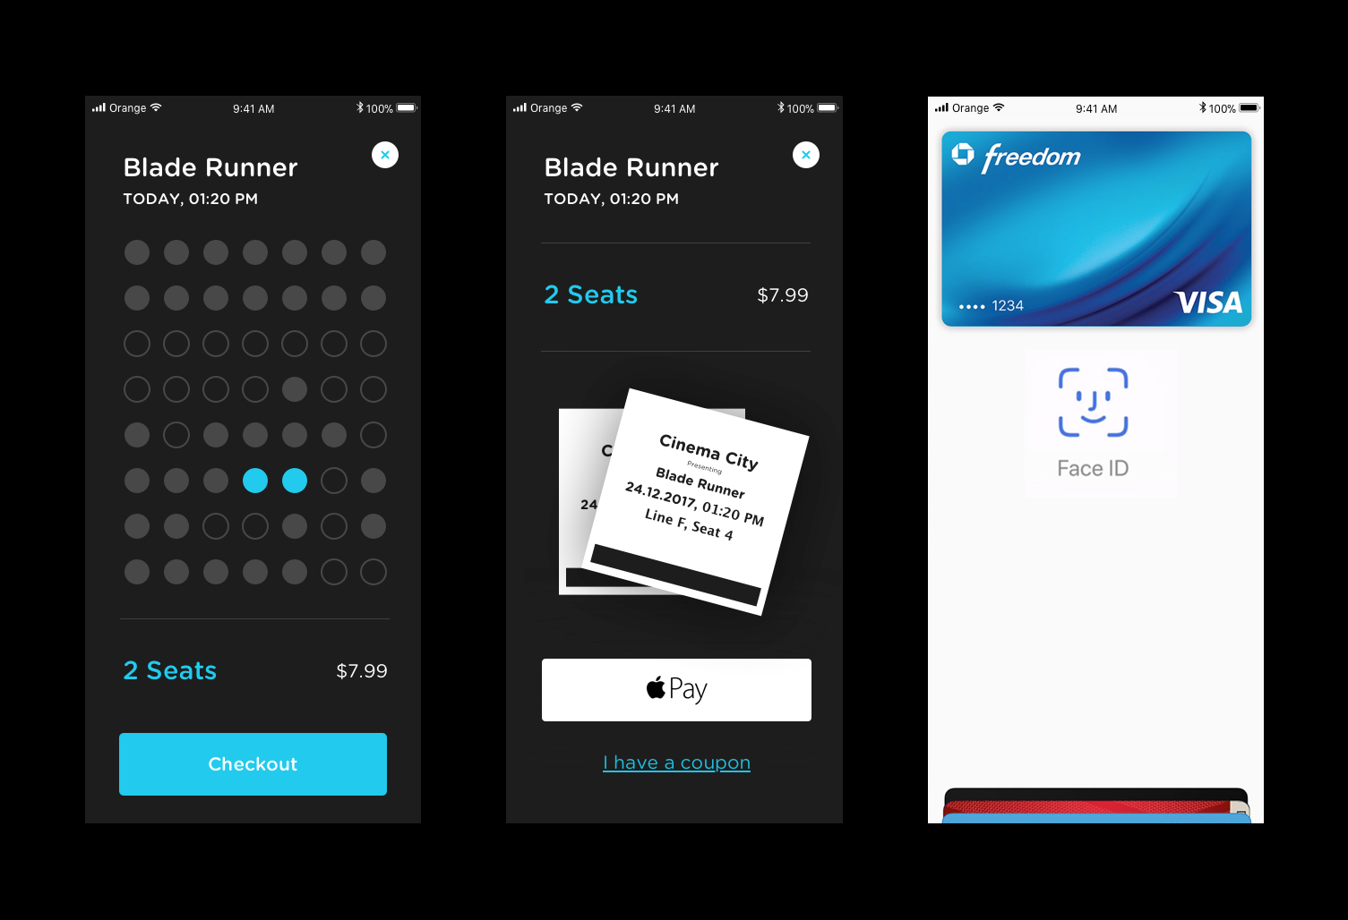

If Cinema companies had more awareness to user experience, I’m sure more people would want to go to the cinemas.

Notes : screens in Mobile App UI, but you need to design Reponsive web UI