- GITHUB Repo Link
https://github.com/debray2523/pokedex-app

- docker images

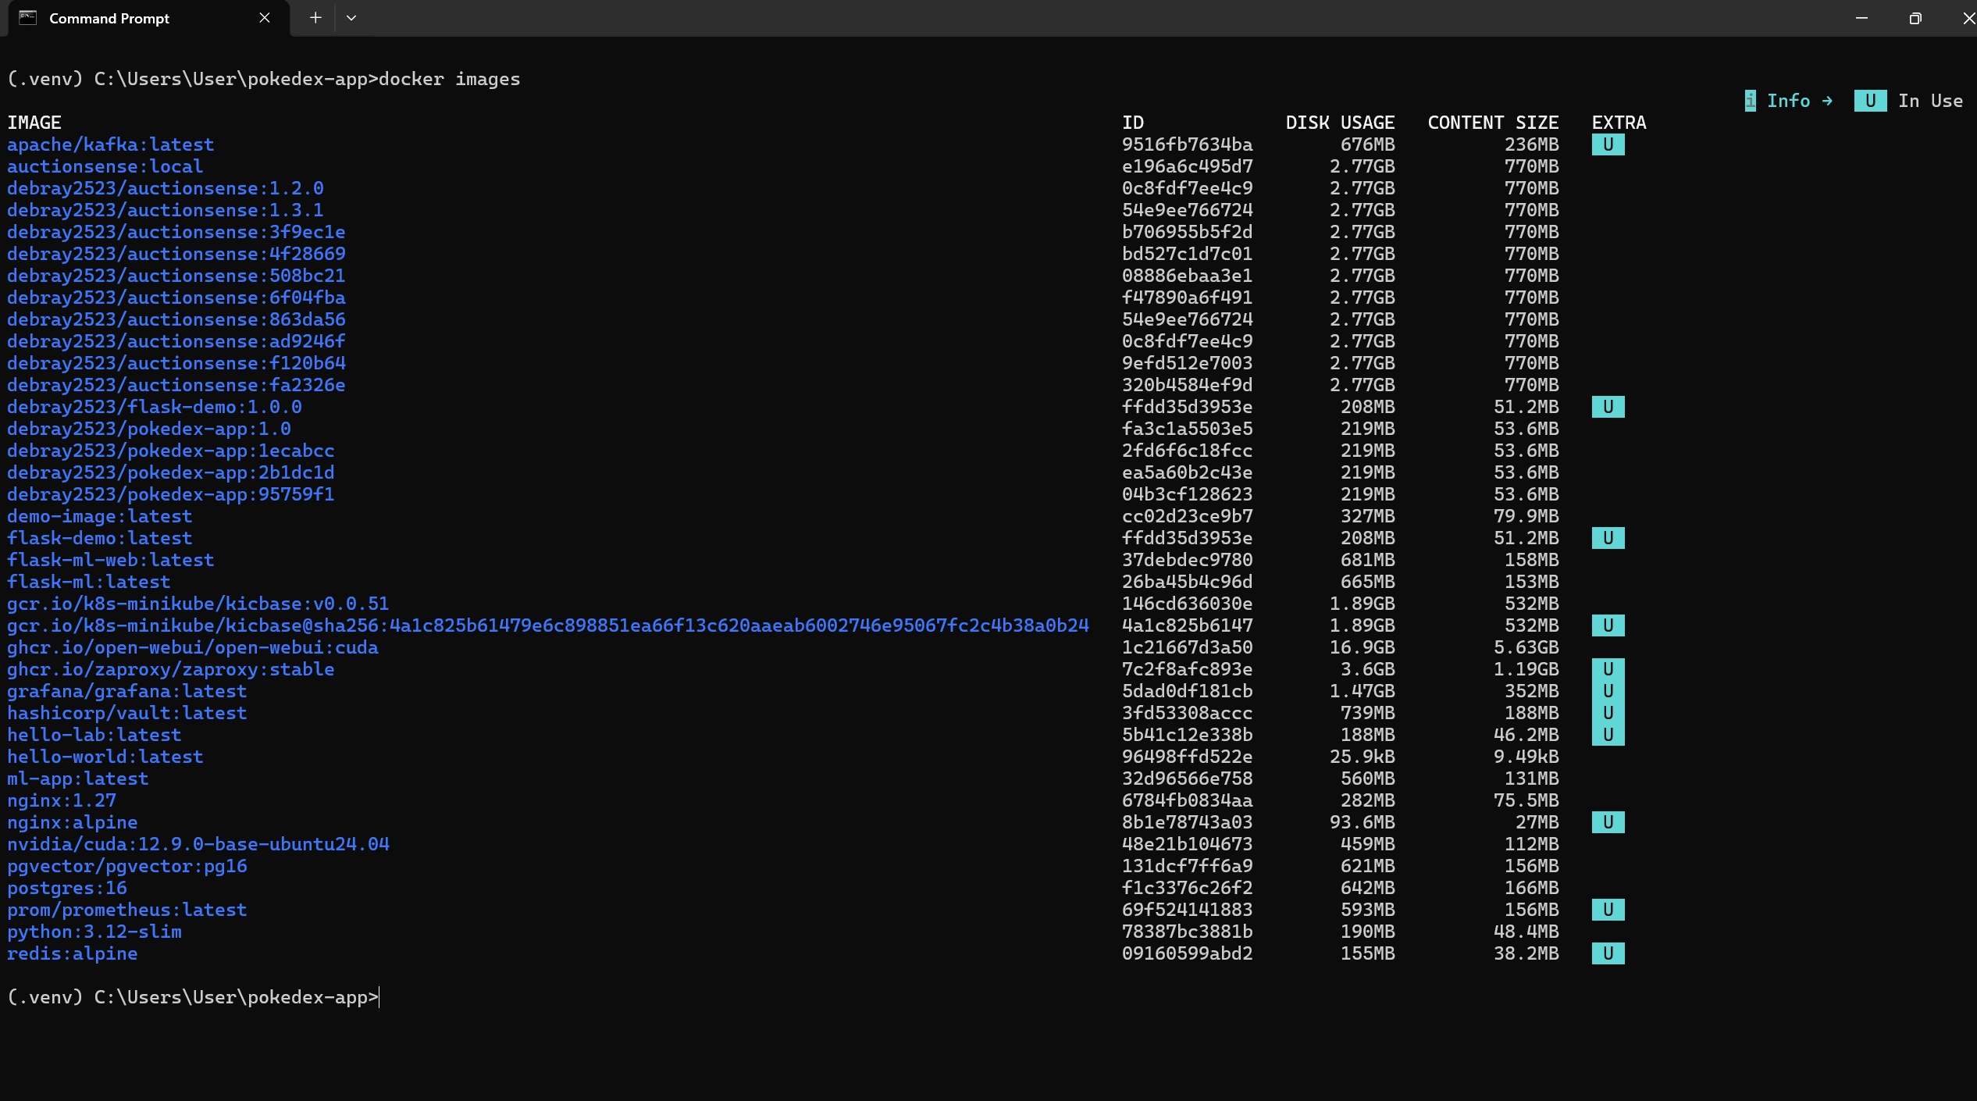

3 kubectl get all

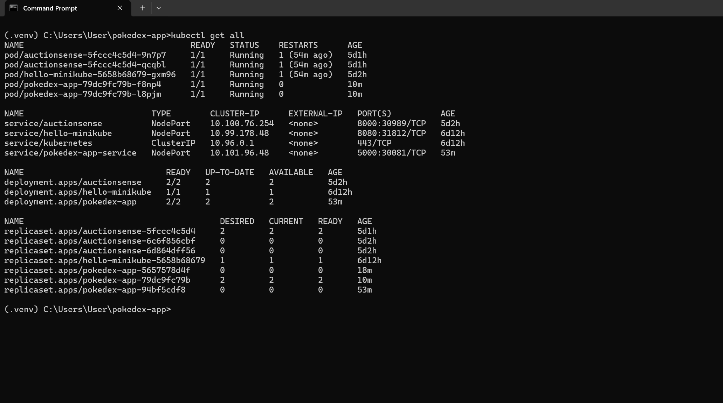

4 web app
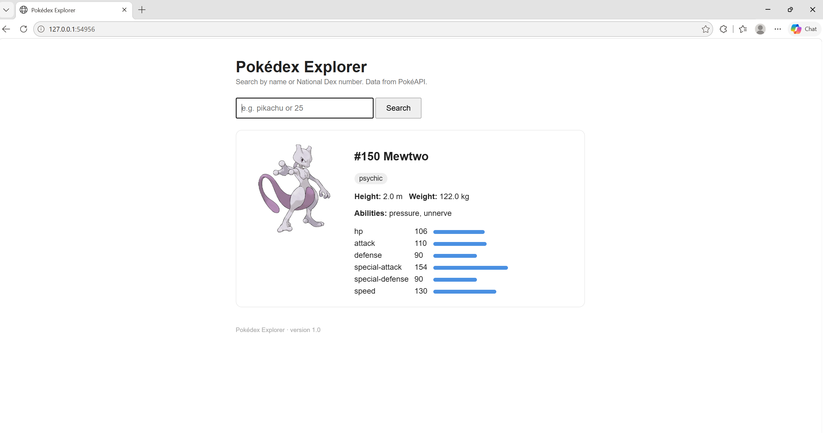
5 Git branches (GitFlow)
Command: git branch -a
Shows main, staging, develop and feature/readme-screenshot, locally and on origin.
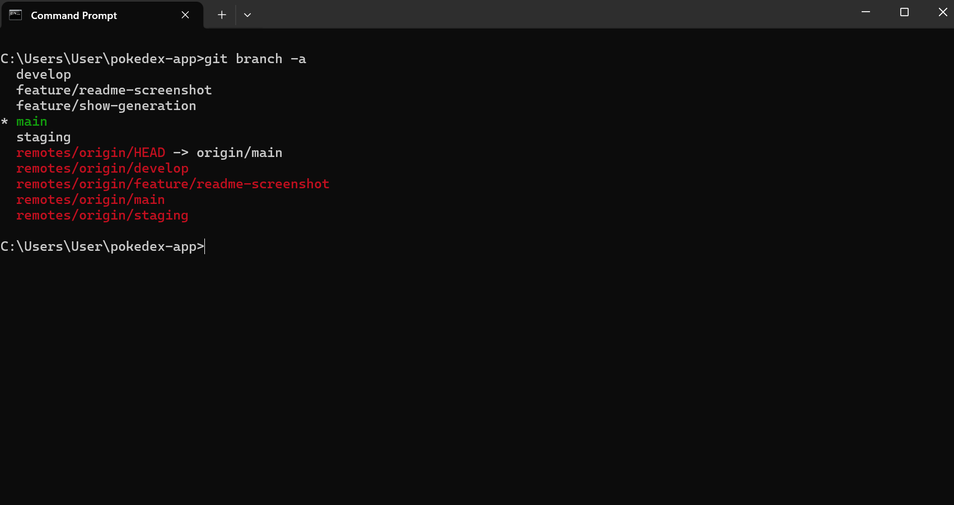

6 Kubernetes service URL
Commands: kubectl get svc pokedex-app-service | minikube service pokedex-app-service --url
Service pokedex-app-service is type NodePort, mapping service port 5000 to node port 30081 (5000:30081/TCP), cluster IP 10.101.96.48.
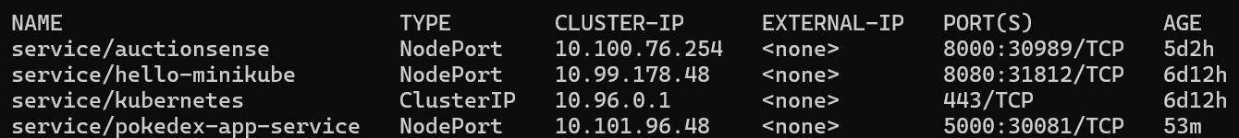
Service URL: minikube service pokedex-app-service --url opened a local tunnel at http://127.0.0.1:61490 (Docker driver on Windows), which routes to NodePort 30081 → container port 5000. The app is shown running at that URL below.
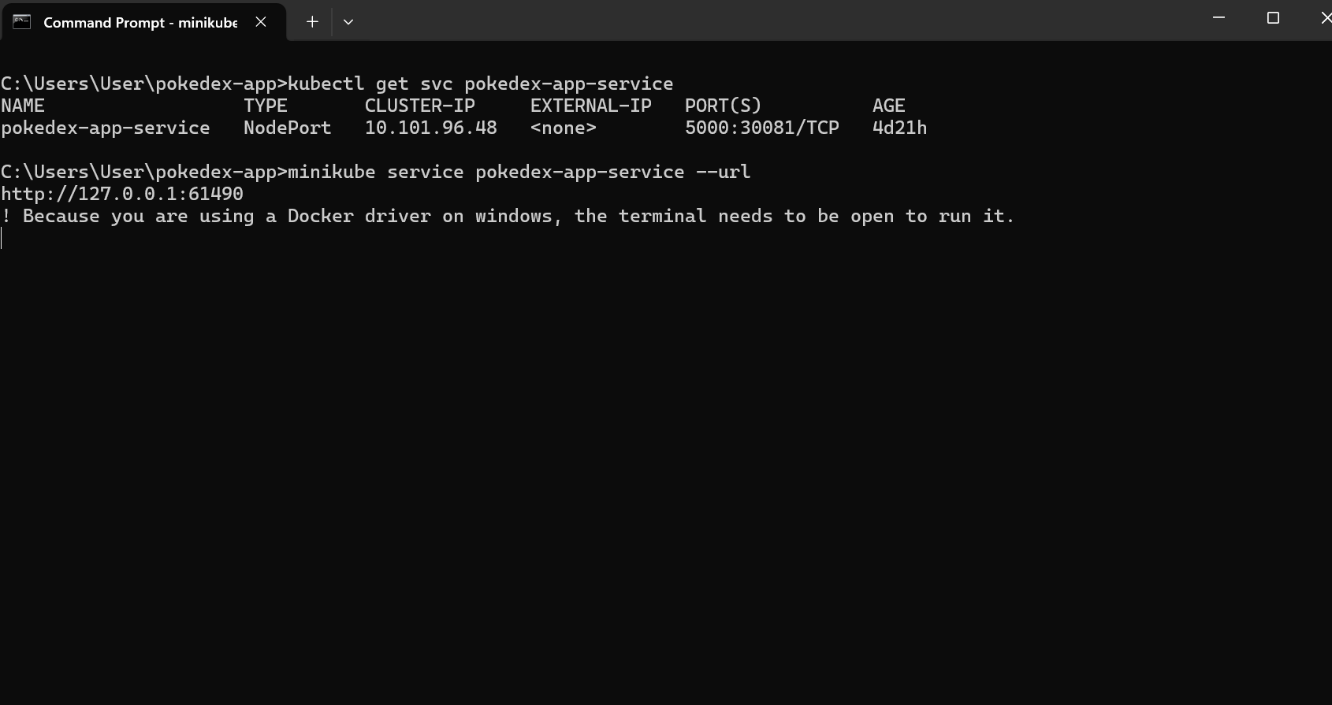
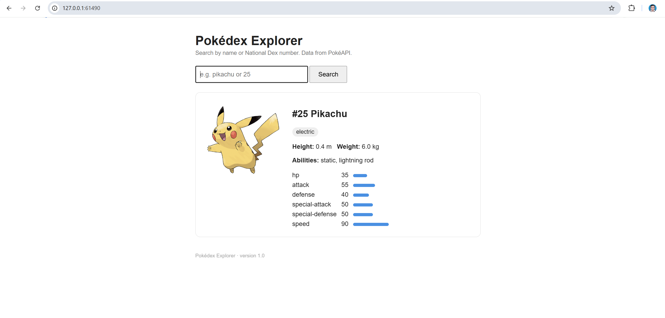
7 Jenkins pipeline run
Command: Jenkins > pokedex-app job > Stage View
Shows the Checkout, Build image, Test in container, Push image and Deploy to Minikube stages all green.
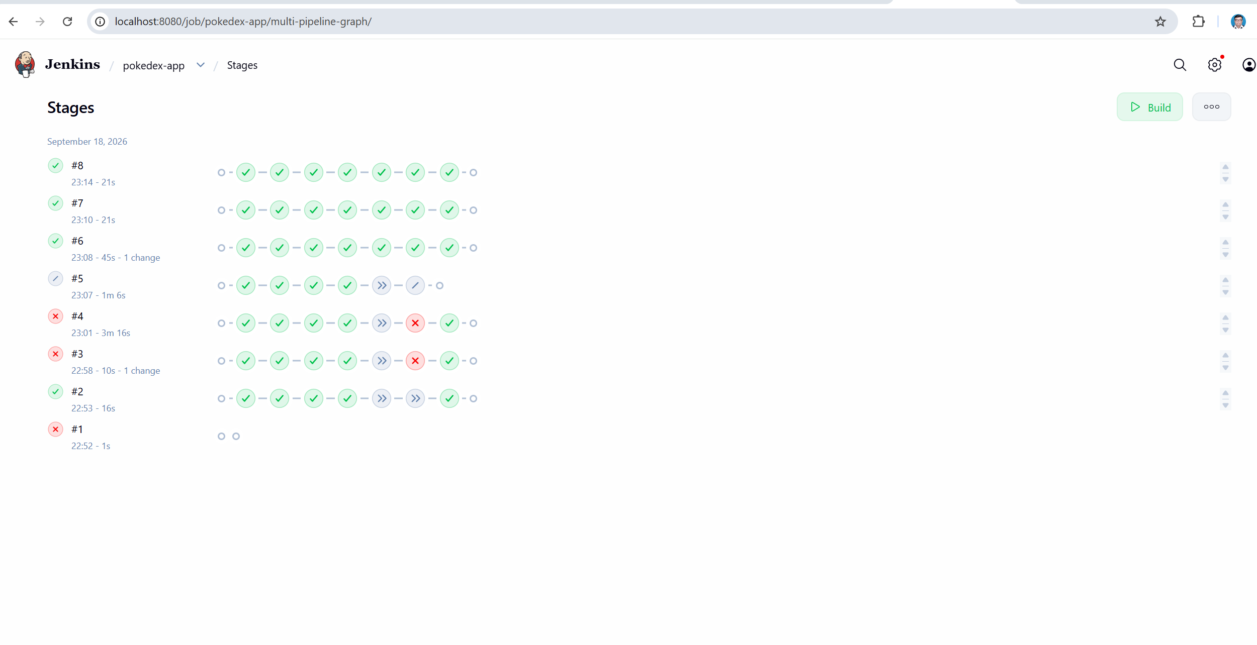
8 README
Pokédex Explorer
A small Flask application over the public PokéAPI (no API key needed). Search a Pokémon by name or National Dex number and see its types, abilities, base stats and artwork.
Built for the Module-1 CI/CD assignment: containerised with Docker, built and tested by a Jenkins pipeline (Jenkinsfile), deployed to a local Minikube cluster (k8s/).
Layout
Path | Purpose
app.py | Flask app: / (search form), /health (probe endpoint)
templates/index.html | The page
tests/test_app.py | 7 tests; PokéAPI calls are mocked so they run offline
Dockerfile | python:3.12-slim image, runs python app.py on port 5000
Jenkinsfile | Checkout → Build image → Test in container → Push (main) → Deploy to Minikube (main)
k8s/deployment.yaml | 2 replicas, readiness/liveness probes on /health, resource limits
k8s/service.yaml | NodePort 30081 → container 5000
Run locally (no Docker)
python -m venv .venv
.venv\Scripts\activate
pip install -r requirements.txt
python -m pytest tests -v
python app.py # open http://localhost:5000
Run in Docker
docker build -t debray2523/pokedex-app:1.0 .
docker run --rm debray2523/pokedex-app:1.0 python -m pytest tests -v
docker run -d --name pokedex -p 5000:5000 debray2523/pokedex-app:1.0
# open http://localhost:5000 ; then: docker rm -f pokedex
Deploy to Minikube by hand (the assignment's Phase-1 path)
minikube start --driver=docker
minikube image load debray2523/pokedex-app:1.0
kubectl apply -f k8s/deployment.yaml -f k8s/service.yaml
kubectl get pods -w # wait for 2/2 Running, Ctrl+C
minikube service pokedex-app-service # opens the browser
deployment.yaml uses imagePullPolicy: IfNotPresent, so the image loaded with minikube image load is used without any registry.
Deploy through Jenkins
The Jenkinsfile builds an image tagged with the short commit hash, runs the tests inside it, and on main pushes it to Docker Hub and rolls it onto the cluster with kubectl set image. Jenkins needs: Docker Desktop running, a dockerhub username/token credential, and the KUBECONFIG / PATH+KUBE environment variables pointing at your Minikube config and kubectl.
Rollback
kubectl rollout undo deployment/pokedex-app

