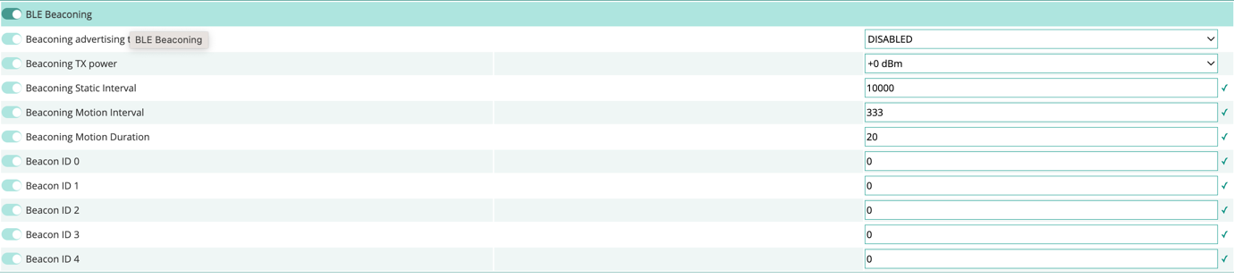

4

Apply the tracker configuration

7

1

1

1

3

2

1

1

1

Check the tracker reported its updated configuration

Enable all the parameters



6

5

Apply the tracker configuration

Get LoRaWAN uplinks to send to the tracker

6

6