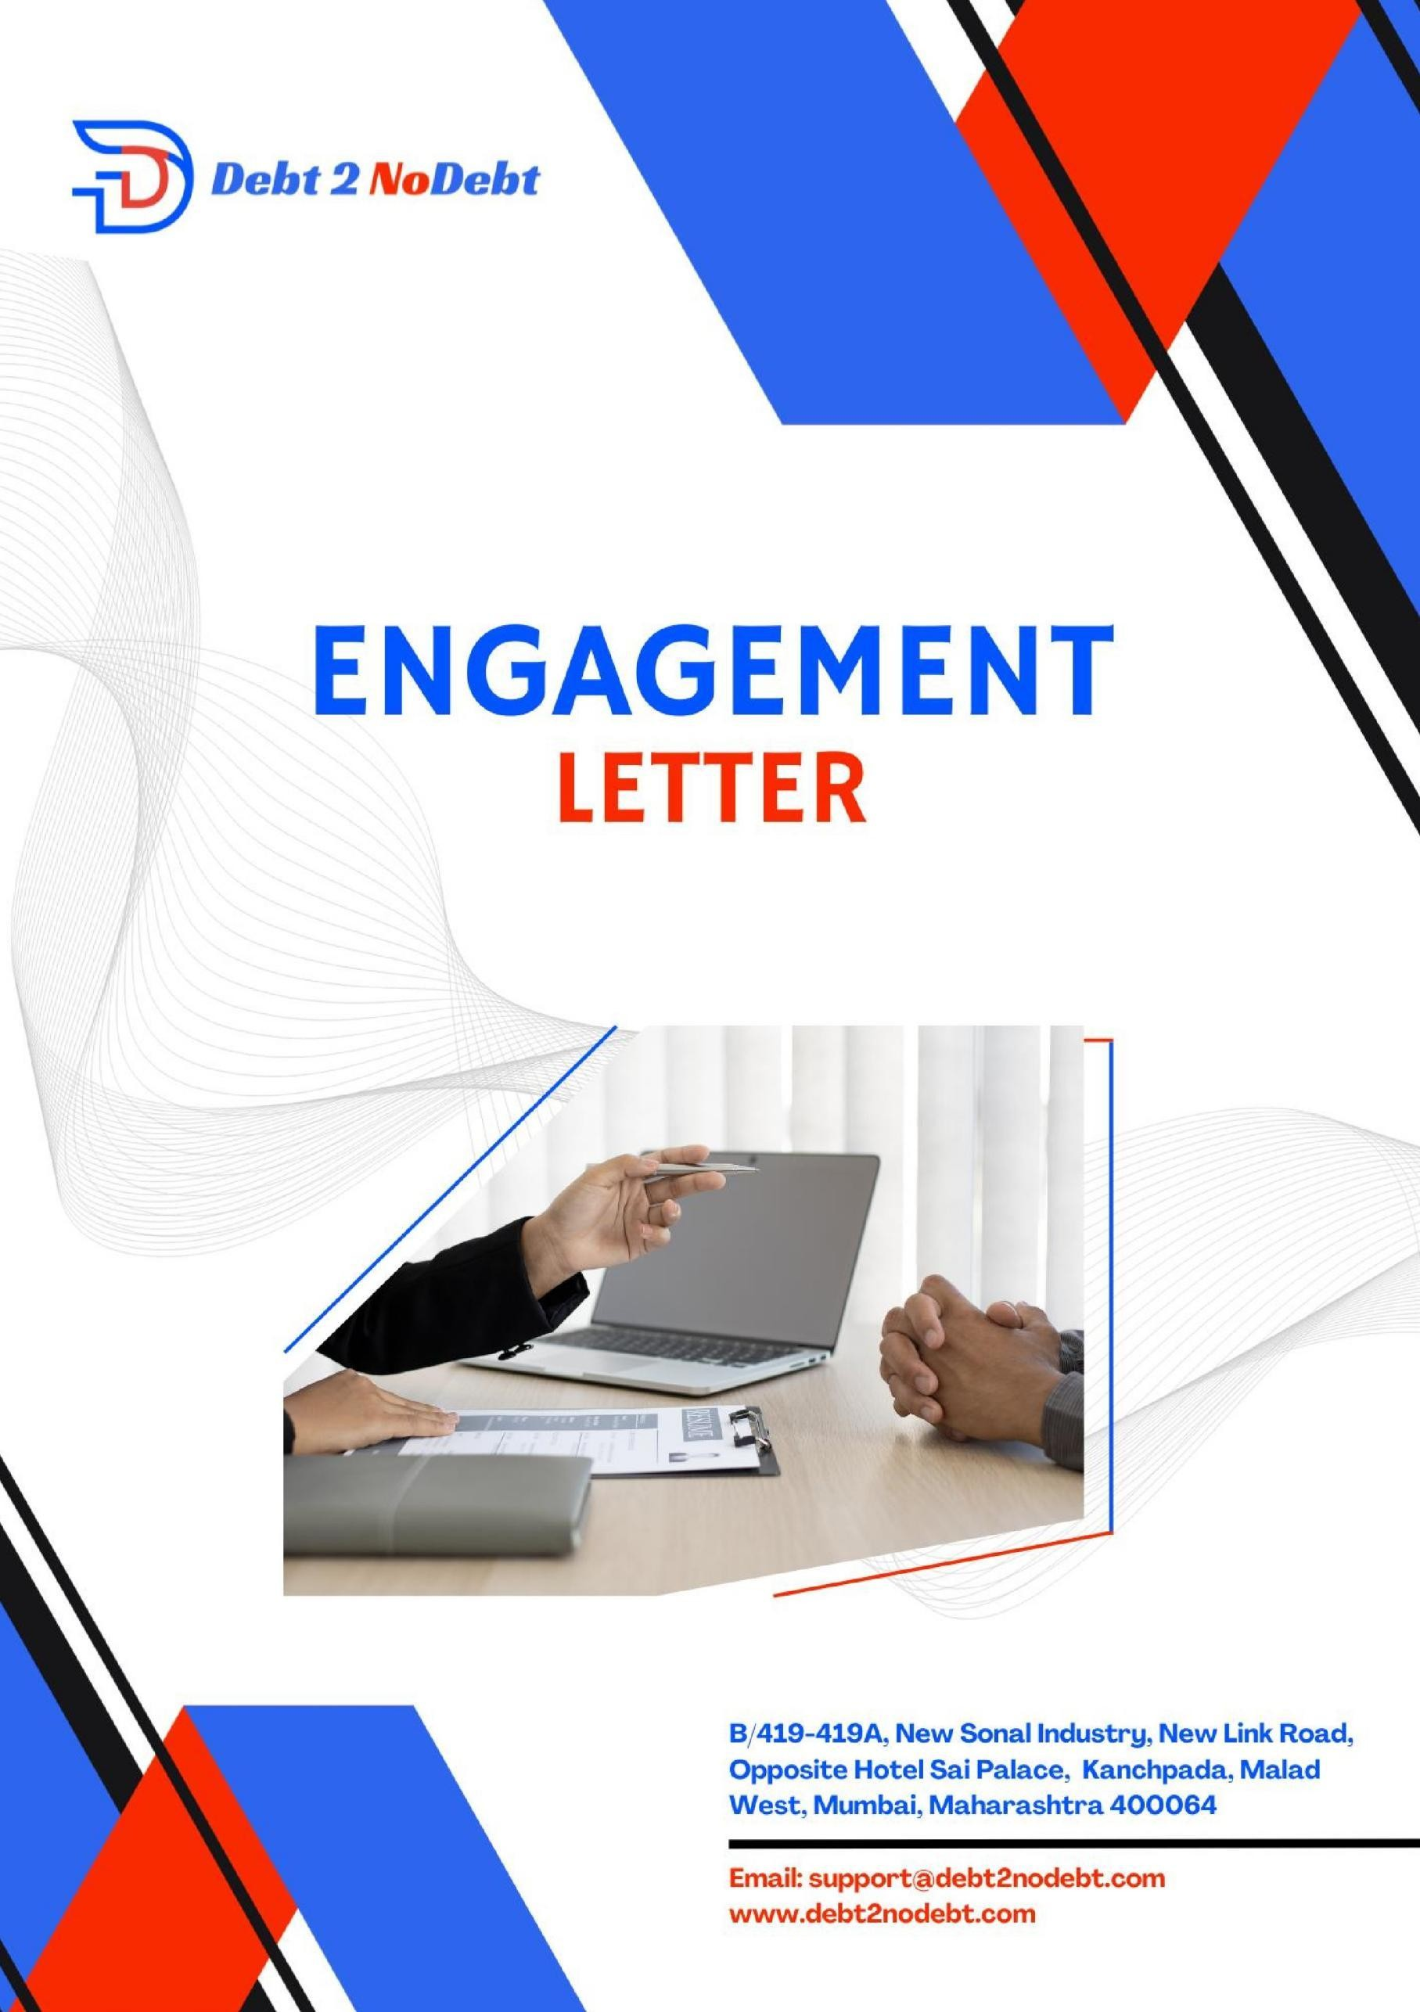

**B/419-419A, New Sonal Industry, New Link Road, Opposite Hotel Sai Palace, Kanchpada, Malad West, Mumbai, Maharashtra 400064**

**Email:** [**support@debt2nodebt.com**](mailto:support@debt2nodebt.com)[**www.debt2nodebt.com**](http://www.debt2nodebt.com/)

{clientname}

{address}

Date- {date}

Dear **Sir / Ma’am**

**Re: Engagement Letter for Debt2NoDebt's Comprehensive Financial Assistance**

We are pleased to extend our services to you at Debt2NoDebt (a brand of Greatminds Debt Ventures Private Limited), understanding the challenges that managing debt can present and being committed to providing you with customer-centric, professional, and genuine solutions. Our mission is to empower you to take control of your finances through our personalized Debt Repayment Plan (DRP), addressing various aspects of debt management, legal protection, and financial empowerment.

# Description of Services:

## Personalized Debt Repayment Plan (DRP):

* Tailoring financial institution approved affordable EMIs according to your income and expenses.
* Crafting a structured plan for debt consolidation, ensuring manageability.

## Negotiations and Debt Restructuring:

* Engaging with creditors to secure reduced monthly payments.
* Negotiating for lower interest rates, minimizing the overall cost of debt.

## Charges Management:

* Addressing late fees and penalties through negotiation or reduction.
* Ensuring a comprehensive approach to ease the financial burden associated with charges.

## Creditors and Collection Agent Interaction:

* Shielding you from creditor calls and legal notices through our empanelled para-legal team.
* Managing communication with creditors on your behalf, providing peace of mind.

## Legal Protection and Advocacy:

* Addressing legal matters and arbitration notices from banks. (Empanelled Experts at actual Costs)
* Advocacy to protect against collection agents and potential criminal matters related to bounced cheques.

## Financial Transaction Monitoring:

* Thoroughly tracking all loan transactions for accuracy.
* Identifying and rectifying potential overcharged interest, promoting fairness.

## Settlement Negotiations:

* Exploring the possibility of significant debt reductions (30-70%) after 8 months.
* Advising on optimal times for settlement negotiations for your unique financial situation.

## Credit Score Improvement:

* Providing guidance on managing the temporary impact on credit scores during the initial enrolment and repayment process.

## Financial Education and Empowerment:

* Fostering financial discipline through budgeting and responsible spending habits.
* Building financial literacy through increased awareness of interest, fees, and repayment terms.

## Long-Term Financial Planning:

* Encouraging controlled spending to make savings and future goal planning feasible.
* Supporting you in developing valuable money management skills for sustained financial wellbeing.

## Transparent Fee Structure:

* Clarifying all fees associated with the Debt Repayment Plan to ensure transparency.

## Continuous Support:

* Providing ongoing support throughout the DRP journey.
* Advising on the best practices for long-term financial stability.

# Considerations for Success:

To ensure a successful engagement, we would like to bring the following considerations to your attention:

## Cost and Fees:

* Clarify all fees associated with the Debt Repayment Plan to make informed decisions.

## Long-Term Commitment:

* Understand the commitment involved in staying on the plan.

## Limited Control:

* Recognize that Debt2Nodebt handles creditor communication and legal matters on your behalf.

## Potential for Delays:

* Acknowledge that resolving debt issues may take time, and rely on a realistic timeline.

## Credit Score Impact:

* Be prepared for potential temporary impacts on your credit score during the enrollment and repayment process.

# Key Features of Debt2Nodebt's DRP:

## Affordability:

* Pay only what you can afford each month.

## Consolidated Repayments:

* Simplify your debt into a single, comfortable monthly payment.

## Professional Negotiations:

* We handle all communication with creditors on your behalf, ensuring a hassle-free process.

## Legal Protection:

* Our empanelled team of advocates safeguards your interests, providing comprehensive legal support.

## Financial Freedom:

* Our goal is to help you become debt-free and regain control of your life.

# Dispute Resolution

Any dispute, controversy, legal suit, action, or proceeding or claim arising out of or relating to this agreement, or the breach, termination or invalidity hereunder shall be instituted exclusively and shall be settled by arbitration administered by the Arbitration and Conciliation Court (ARCO) in accordance with its Arbitration Rules, located in the city of Surat, and each Party irrevocably submits to the exclusive jurisdiction of ARCO in any such suit, action, or proceeding and waives any objection based on improper venue or forum non- convenience.

Service of process, summons, notice, or other documents by mail to such Party’s address set forth herein shall be effective service of process for any suit, action, or other proceeding brought in any such court.

# Mandatory Execution and Signing of the Letter of Authority:

The Client is required to sign and verify the details in the Letter of Authority within twenty- four (24) hours of onboarding with Debt2NoDebt. Failure to comply with this requirement will render the contract null and void, and all services provided by the Company shall be immediately terminated. The Company shall bear no liability for any actions taken in the absence of a duly executed agreement.

# Timely Remittance of Fees:

The Client is obligated to remit all fees by the specified due date without exception. In the event of any unavoidable circumstances that may result in a delay, the Client must inform Debt2NoDebt within three (3) days of the due date. Failure to communicate such delays within the stipulated timeframe may result in the immediate cessation of services, and the contract shall be deemed null and void. The Company reserves the right to pursue any outstanding fees as per the terms of the contract.

# Non-Acceptance of Late EMI Payments:

Should the Client default on an EMI payment, any subsequent request to remit the payment in the following month will be unequivocally declined. In such cases, the Company’s services shall be terminated forthwith, and the contract shall be rendered null and void. The Client will bear full responsibility for all outstanding obligations, and any further engagement with the Company will necessitate the formulation of a new contract, subject to the Company’s sole discretion and applicable terms.

# Addition of Further Accounts:

If the Client wishes to add any further accounts to the existing Letter of Engagement at any point during the term of the contract, additional fees will be charged accordingly. Such additions are expected to escalate the complexity and scope of the ongoing process, and the necessary adjustments will be made to the terms of the engagement to reflect these changes. The Company reserves the right to review and amend the contract to accommodate these additional accounts, with all corresponding costs borne by the Client.

# Legal Notices:

## Response to legal notices

* Debt2NoDebt will respond to legal notices on behalf of the Client free of charge for the first three (3) months of the contract. Beyond this period, a reasonable fee will be charged for each response to cover the costs associated with our legal advocates. The fee will be determined based on the complexity and nature of the notice, and the Client will be informed of the applicable charges in advance.

## Timeframe of Response to Legal Notice

* We commit to responding to legal notices within 3 days of receipt , ensuring a swift and efficient resolution process. This accelerated timeline, compared to the standard 7 days, reflects our dedication to promptly addressing client concerns and safeguarding their interests through thorough and accurate legal responses.

# Refund Policy:

Refunds will be granted only within the first three (3) days of onboarding. After this period, no refunds will be provided under any circumstances. Additionally, if the Client chooses to withdraw from the services at any time, the services will be terminated immediately, and the Client will not be entitled to any refund. This policy is strictly enforced to ensure the integrity of the contractual obligations and to cover the administrative costs incurred by the Company.

# Termination of Services:

Debt2NoDebt reserves the right to terminate services under the following conditions:

## Non-Signing of the Letter of Authority

* + - If the Client fails to sign the Letter of Authority within twenty-four (24) hours of onboarding, the contract will be deemed null and void, and services will be terminated immediately.

## Delays in Fee Payment without Intimation:

* + - If the Client fails to remit payment on the specified due date and does not communicate any unavoidable delays within three (3) days of the due date, the Company will terminate all services, and the contract will become void.

## Missed EMI Payments and Future Payment Promises:

* + - If the Client misses an EMI payment and then promises to pay the missed amount in the following month while requesting the settlement of loan accounts, such requests will not be entertained. The Company will immediately terminate services, and the contract will be rendered null and void.

## Client’s Responsibilty

* + - In all cases of termination, the Client will be held responsible for any outstanding obligations and fees up to the point of termination. Any further engagement with the Company will require a new contract, subject to the Company’s discretion and applicable terms.

# Exclusive Handling of Debt Settlement Matters

## Exclusivity of Representation

* + - The Client agrees that, during the term of this Agreement, all communications, negotiations, and dealings with creditors, banks, or any financial institution regarding any outstanding debts or liabilities shall be conducted exclusively through Debt2NoDebt .
    - The Client acknowledges that Debt2NoDebt has been retained to represent and assist in the resolution of these matters, and shall not, without prior written consent, directly engage with such parties for settlement, negotiation, or any related discussions.

## Respect for the Engagement Process

* + - The Client agrees to respect the process established under this Agreement and refrain from independently contacting or entering into negotiations with creditors or financial institutions during the period of engagement with Debt2NoDebt .
    - This provision is designed to ensure that the debt settlement process is managed effectively with a unified strategy and approach.

## Written Consent for Direct Engagement

* + - Should the Client wish to engage directly with any creditor or financial institution, they shall first seek prior written consent from Debt2NoDebt .
    - Debt2NoDebt will evaluate the circumstances and, at its discretion, may grant such consent, provided it does not undermine the strategy or efforts already in place for resolving the Client's financial matters.

## Fee Payment in the Event of Independent Engagement

* + - In the event that the Client bypasses Debt2NoDebt and engages directly with any creditor, bank, or financial institution without obtaining prior written consent, the Client agrees to pay Debt2NoDebt the full fees due as per the Fee Structure set forth in this Agreement.
    - This payment is due for the services rendered by Debt2NoDebt up to the point of breach, reflecting the efforts already undertaken in relation to the debt settlement.

## Indemnification for Breach of Agreement

* + - The Client agrees to indemnify and hold Debt2NoDebt harmless from any losses, claims, or damages resulting from the Client's breach of this provision, including any legal or administrative costs incurred due to unauthorized dealings with creditors or banks.

## Termination for Non-Compliance

* + - Should the Client engage directly with creditors or banks in violation of this clause, Debt2NoDebt reserves the right to terminate this Agreement with immediate effect.
    - Such termination shall not relieve the Client of any payment obligations due for services already provided by Debt2NoDebt .

# 13 . Standard Workdays and Operating Hours

Our operational hours are from 10:00 AM to 7:00 PM, Monday through Saturday. We remain closed on Sundays and bank holidays. However, in the event of an emergency on a Sunday or on a holiday, a contact number will be provided, which should be used strictly for exigent circumstances.

All things considered, Debt2Nodebt is your dedicated partner in overcoming the burden of debt. Our specially designed financial and legal services prioritize your needs, offering a path to financial freedom. Let us empower you to live a life without the weight of debt, supporting you every step of the way.

In case of any queries or require additional information, please do not hesitate to contact us at mail to: [support@debt2nodebt.com](mailto:support@debt2nodebt.com). & [Dheeraj.Thakur@debt2nodebt.com](mailto:Dheeraj.Thakur@debt2nodebt.com).

We look forward to assisting you on your journey to financial liberty and debt free life. Kindly Refer this link to check our detailed profile [www.debt2nodebt.com](http://www.debt2nodebt.com/)

Sincerely,

Great Minds Debt Ventures Private Limited DEBT2NODEBT

+91-8928068659 / 77150 78979

Date: {date}

Signee-

Place: Mumbai

**B/419-419A to 422 , New Sonal Industry, New Link Road, Opposite Hotel Sai Palace, Kanchpada, Malad West, Mumbai, Maharashtra 400064**

**Email:** [**support@debt2nodebt.com**](mailto:support@debt2nodebt.com)[**www.debt2nodebt.com**](http://www.debt2nodebt.com/)