1. create a spring boot project with

Spring Web and Spring Cloud Config

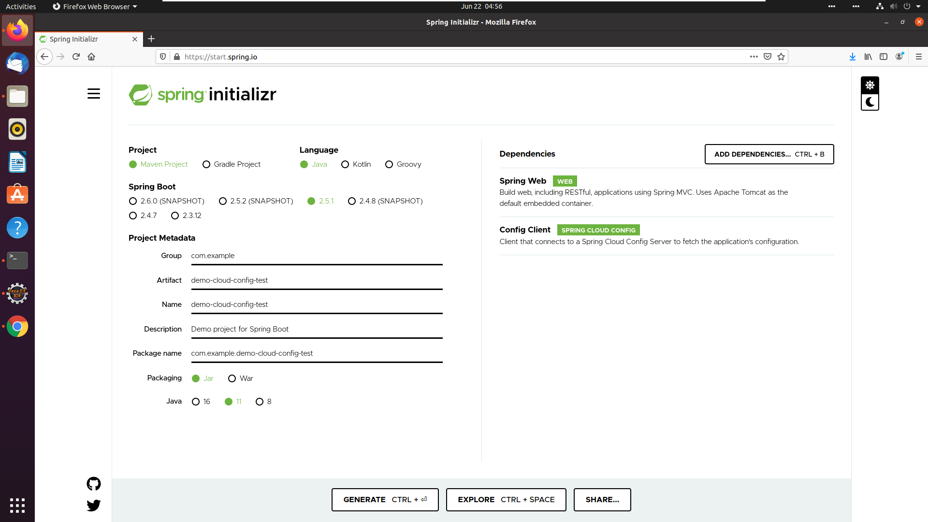

After build you will get the below build error:

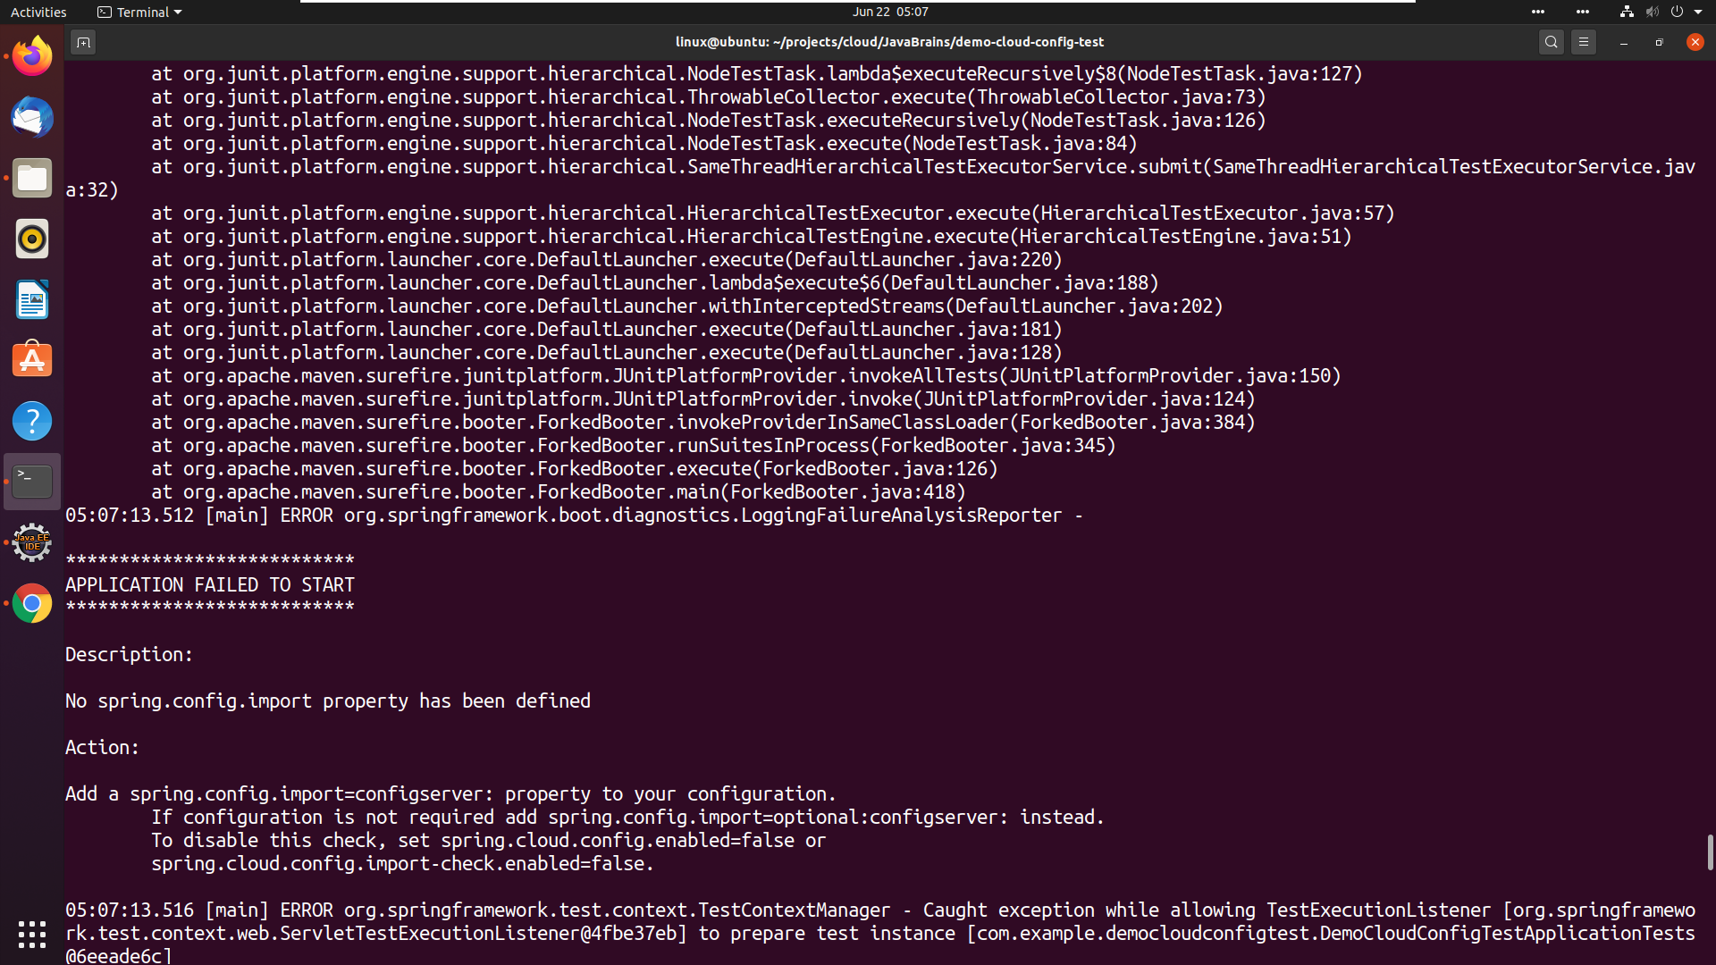

1. pom.xml looks something like this:

open pom.xml and add this dependency:

<dependency>

<groupId>org.springframework.cloud</groupId>

<artifactId>spring-cloud-starter-bootstrap</artifactId>

</dependency>



1. Add the config server uri in bootstrap.yml file.
2. spring:
3. application:
4. name: licensingservice
5. profiles:
6. active:
7. default
8. cloud:
9. config:
10. uri: <http://localhost:8888>

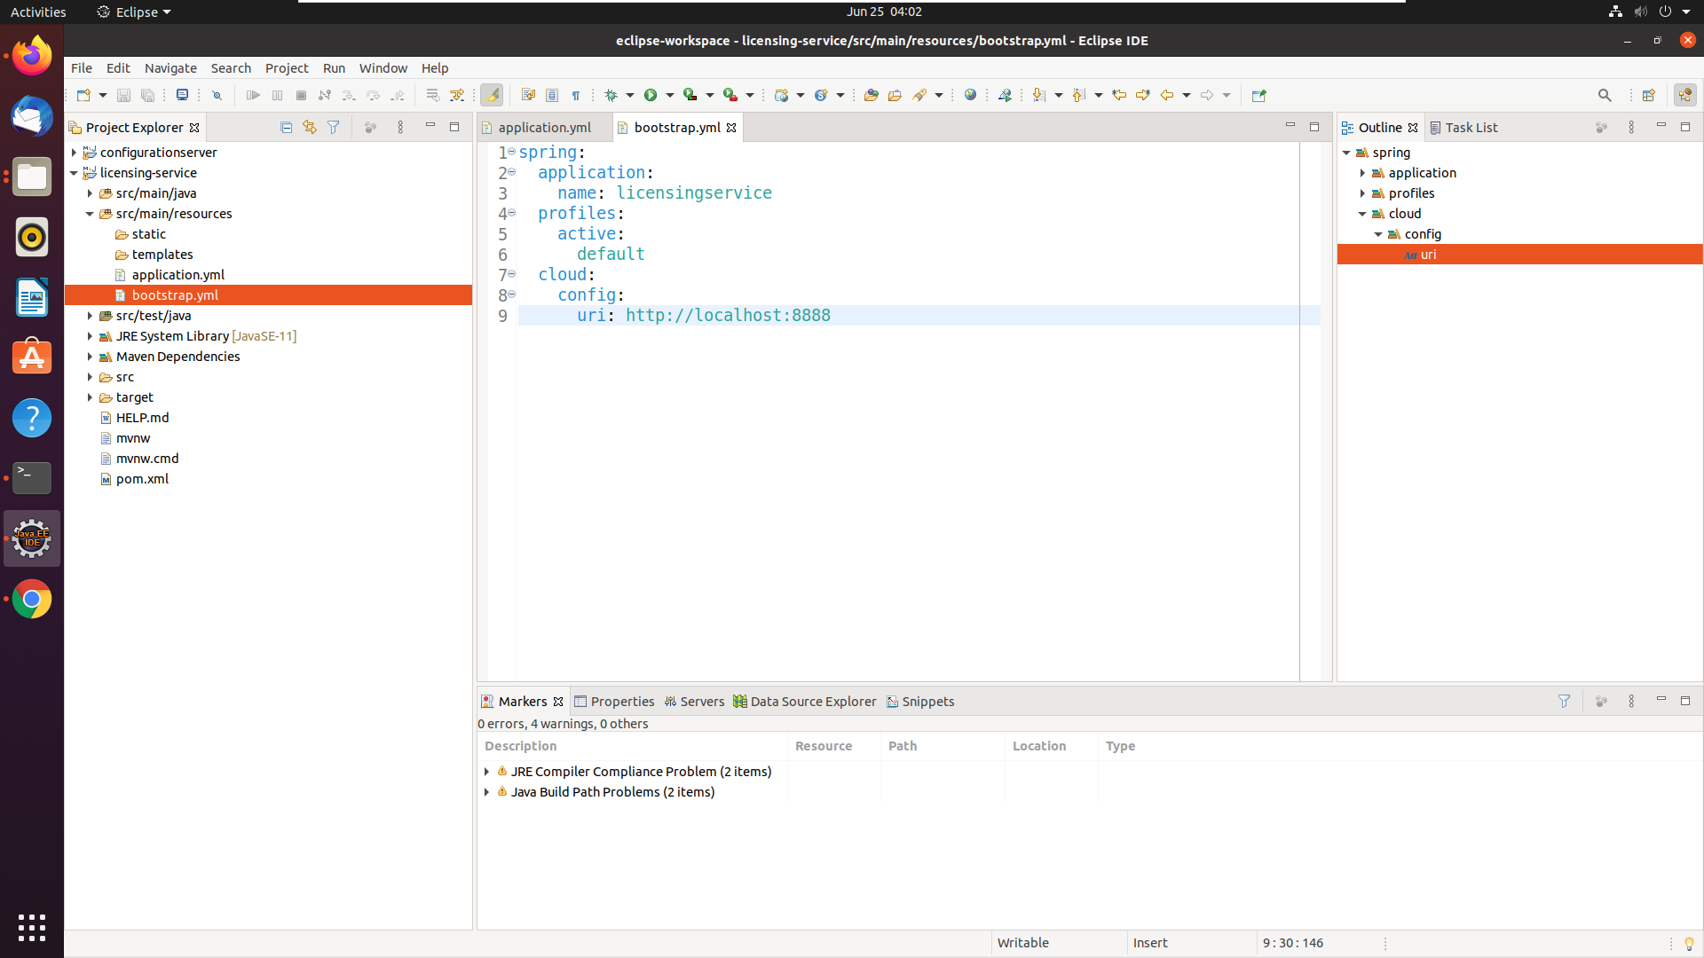

1. You are ready to run your app.

$mvn clean install

$mvn spring-boot:run

Open this URL in browser : <http://localhost:8080>