1. Any spring boot application pom.xml add the Eureka Client dependency.

<dependency>

<groupId>org.springframework.cloud</groupId>

<artifactId>spring-cloud-starter-netflix-eureka-client</artifactId>

</dependency>

1. Open bootstrap.yml and check the application name is defined or not. If not defined, then define it.

spring:

application:

name: licensingservice

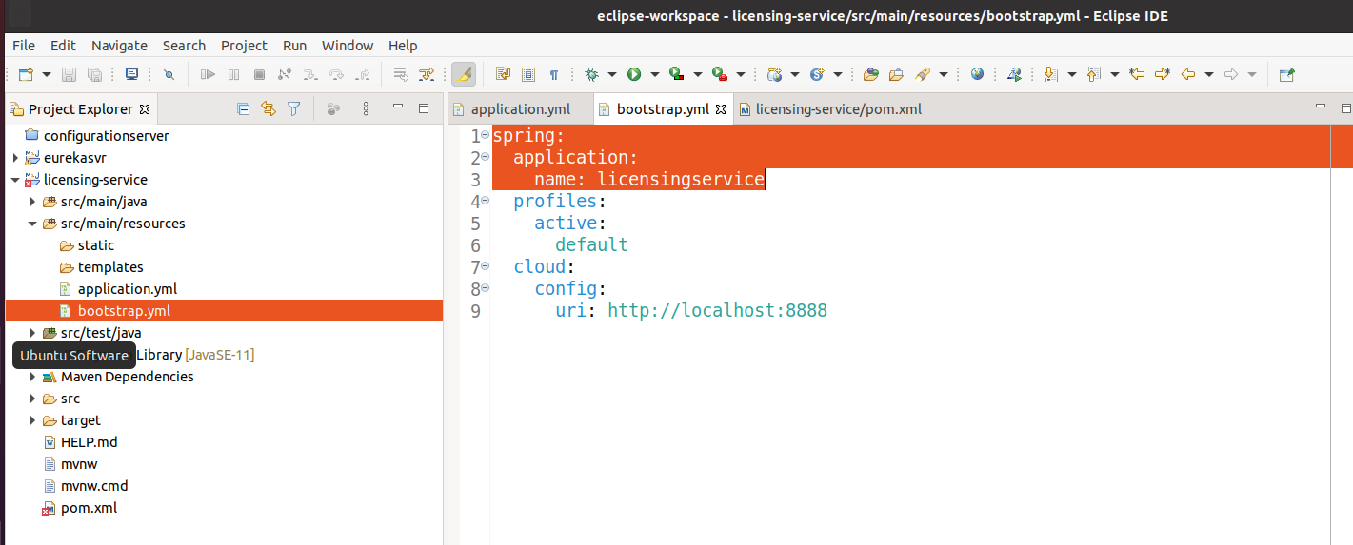

1. Open application.yml file and define Eureka server detail to register the application with Eureka server.

eureka:

instance:

preferIpAddress: true

client:

registerWithEureka: true

fetchRegistry: true

serviceUrl:

defaultZone: <http://localhost:8761/eureka/>

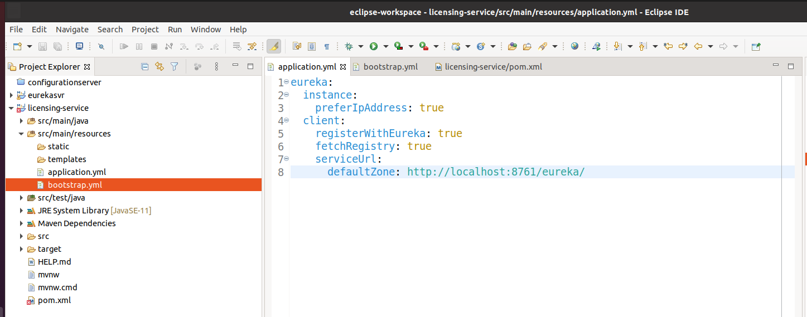

1. Build and run the application. It will automatically register itself with Eureka server.

$ mvn clean install

$ mvn spring-boot:run

Hit the url to see the application detail in Eureka server: <http://localhost:8761/eureka/apps/licensingservice>

