1. create a spring boot project with

Eureka Server.

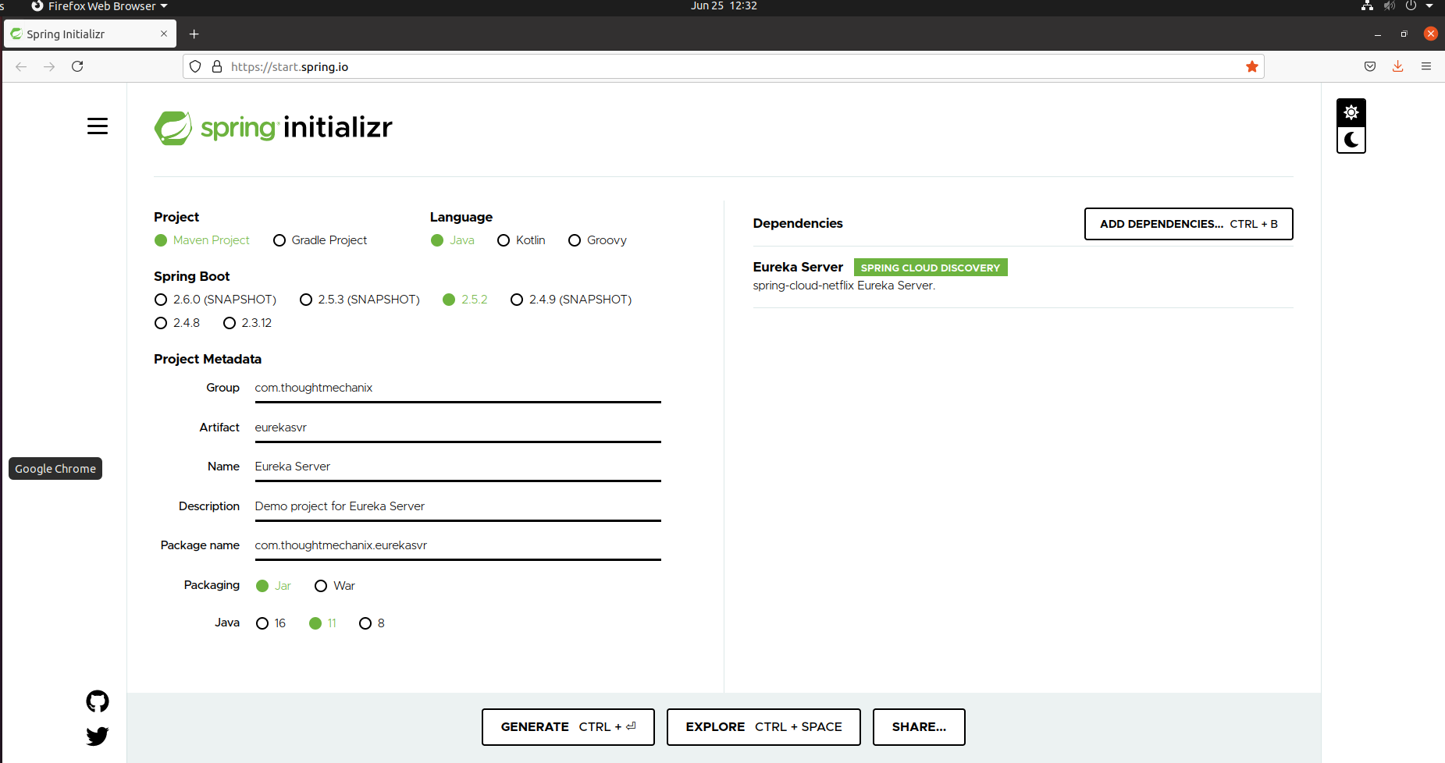

1. pom.xml looks something like this:

<dependency>

<groupId>org.springframework.cloud</groupId>

<artifactId>spring-cloud-starter-netflix-eureka-server</artifactId>

</dependency>

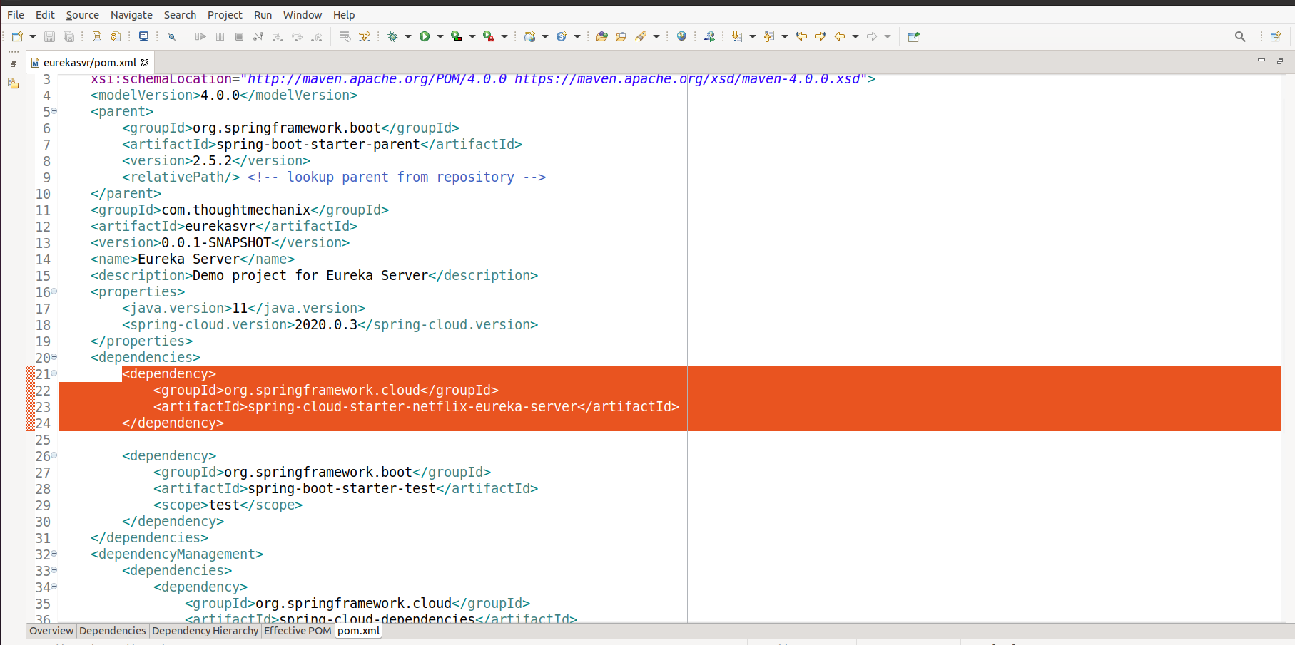

1. Open the resources folder and enter the below data in application.yml file.

#Default port is 8761

server:

port: 8761

eureka:

client:

registerWithEureka: false

fetchRegistry: false

server:

waitTimeInMsWhenSyncEmpty: 5

serviceUrl:

defaultZone: <http://localhost:8761>

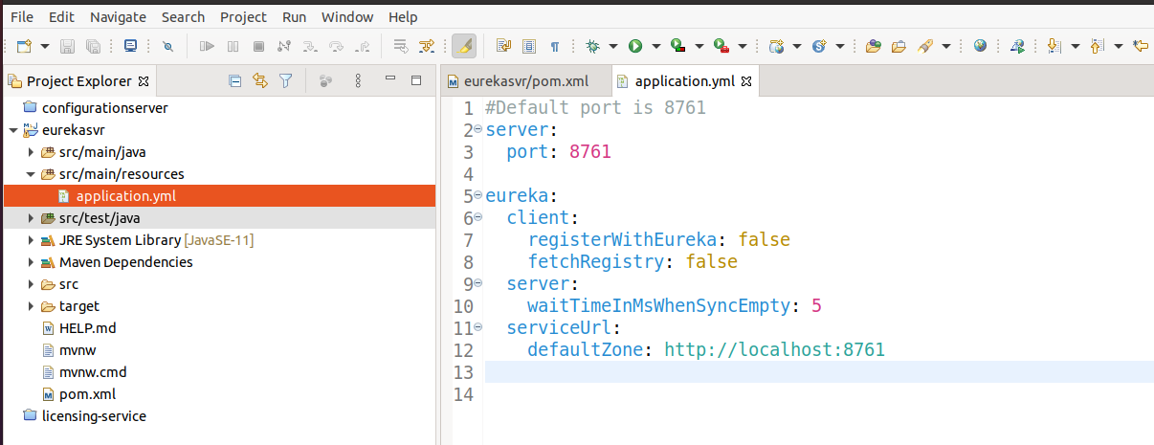

1. Open the EurekaServerApplication.java

And add the annotation : @EnableEurekaServer

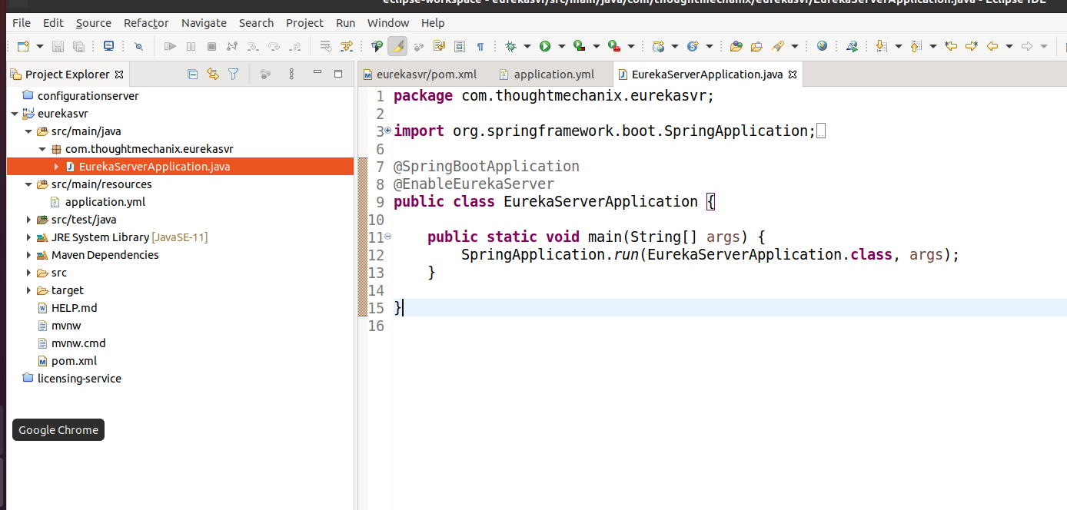

1. Now our Eureka Server is ready to run.

$mvn clean install

$mvn spring-boot:run

Access URL to get the Eureka portal : <http://localhost:8761/>

