Text2Schema
Natural Language to Database Schema Generation

Project Design Document & README
Built with LangChain • Multi-LLM • Python • FastAPI • React

Version 1.0 | April 2026
Comprehensive Design Document • DFD • HLD • LLD

Table of contents
1. Executive summary
2. Architecture overview
3. Data flow diagrams (DFD)
4. High-level design (HLD)
5. Low-level design (LLD)
6. Technology decisions and alternatives
7. Quality evaluation pipeline — Deep dive
8. Caching strategy — Deep dive
9. Project structure
10. Deployment architecture
11. Setup and installation
12. API reference
13. Usage examples
14. Testing strategy
15. Project milestones
16. Contributing
17. License and acknowledgments

1. Executive summary
Text2Schema is an open-source tool that converts plain English descriptions of data models into production-ready database schemas. It leverages LangChain for orchestration, supports multiple LLM providers, and validates every generated schema through a multi-stage quality pipeline before delivery.

1.1 Problem statement
Designing database schemas manually is a specialized skill that combines understanding of data normalization, indexing strategies, constraint design, and dialect-specific syntax. Developers who are strong in application logic often produce schemas that are functional but suboptimal — missing indexes, using incorrect data types, or violating normalization principles. This gap between intent and implementation slows down development and introduces technical debt from day one.

1.2 Proposed solution
Text2Schema bridges this gap by accepting natural language descriptions and producing validated, production-grade schemas. The user describes their data model in plain English, and the system generates SQL DDL, NoSQL schemas, and visual ERD diagrams. Every output passes through automated quality checks including SQL execution, referential integrity verification, and an LLM-as-judge completeness score.

1.3 Key differentiators
- Quality-first: Every schema is validated against a sandboxed database before delivery. No raw LLM output reaches the user.
- Multi-LLM: Provider-agnostic architecture supports OpenAI, Anthropic, Google, and local Ollama models through a single interface.
- Multi-dialect: Generate the same logical schema for PostgreSQL, MySQL, MongoDB, or DynamoDB from a single input.
- Self-correcting: A retry loop feeds validation errors back to the LLM, progressively improving output until the quality threshold is met.
- Extensible: Modular architecture allows adding new database targets, LLM providers, or evaluation criteria without touching existing code.

2. Architecture overview
Text2Schema follows a layered pipeline architecture where each component is independent, testable, and replaceable. Data flows through seven stages from user input to final output, with a quality-driven feedback loop connecting the evaluation layer back to the LLM router.
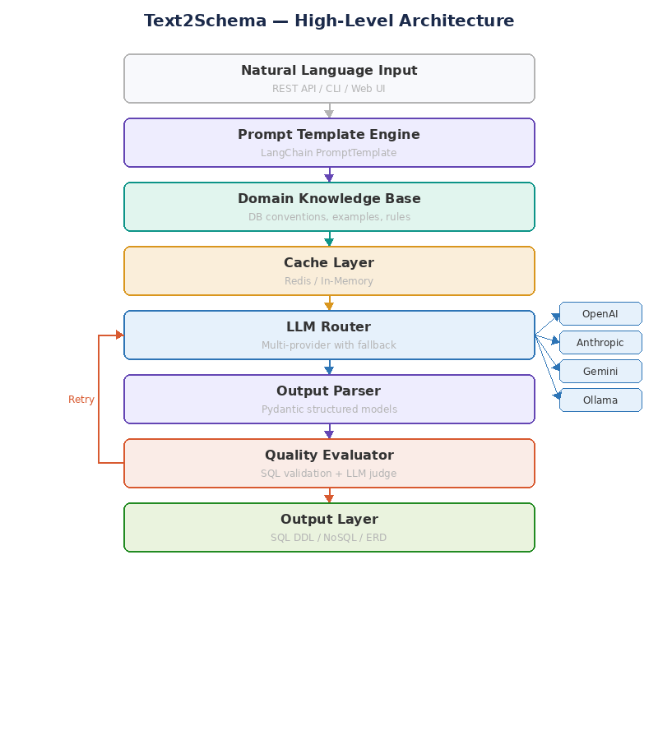
Figure 1: High-level architecture — Seven-layer pipeline with quality feedback loop

2.1 Layer responsibilities
Layer | Component | Responsibility
1. Input | FastAPI / CLI | Accepts natural language description, validates request format, routes to pipeline
2. Prompt | PromptTemplate | Assembles context-rich prompt from user input, domain knowledge, and few-shot examples
3. Knowledge | Knowledge Base | Provides DB type conventions, normalization rules, naming standards, and reference schemas
4. Cache | CacheManager | Caches assembled contexts and LLM responses to reduce latency and API costs
5. LLM | LLMRouter | Routes prompt to configured provider with automatic fallback on failure
6. Parser | OutputParser | Enforces structured JSON output via Pydantic models with retry parsing
7. Evaluator | QualityEvaluator | Validates syntax, integrity, naming, and semantic completeness; triggers retry if needed
8. Output | SchemaConverter | Transforms validated schema into SQL DDL, NoSQL definitions, or ERD JSON

2.2 Design principles
- Separation of concerns: Each layer has a single responsibility. The prompt engine knows nothing about LLM providers; the evaluator knows nothing about prompt assembly.
- Dependency injection: Components receive their dependencies through constructors, making testing and swapping straightforward.
- Configuration over code: Switching LLM providers, changing quality thresholds, or adding database targets requires only configuration changes.
- Fail gracefully: Every external call (LLM API, Redis, sandbox DB) has timeout handling, retry logic, and fallback paths.

3. Data flow diagrams (DFD)
Data flow diagrams show how information moves through the system at different levels of abstraction. We present two levels: Level 0 (context diagram) showing the system boundary and external entities, and Level 1 showing the internal processes and data stores.

3.1 DFD Level 0 — Context diagram
The context diagram shows Text2Schema as a single process interacting with four external entities: the User who provides input and receives output, the LLM Provider that generates schema definitions, the Target Database used as a validation sandbox, and the Cache Store for performance optimization.
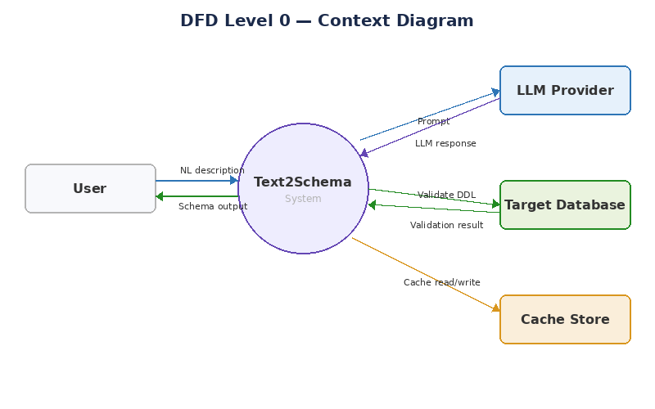
Figure 2: DFD Level 0 — Context diagram

External entities
Entity | Interacts via | Description
User | REST API / CLI / Web UI | Provides natural language descriptions, receives generated schemas and quality scores
LLM Provider | HTTP API calls | Receives assembled prompts, returns raw schema generation responses
Target Database | SQL connection (sandbox) | Receives generated DDL for execution validation, returns success/error
Cache Store | Redis protocol / memory | Stores and retrieves cached contexts and LLM responses

3.2 DFD Level 1 — Detailed process flow
Level 1 decomposes the Text2Schema system into six internal processes and three data stores. This level reveals how data transforms as it moves through parsing, prompt assembly, LLM invocation, output parsing, evaluation, and formatting.
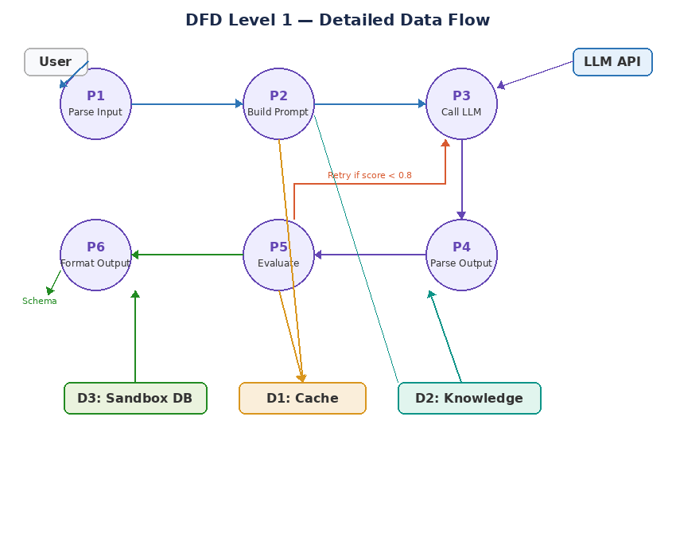
Figure 3: DFD Level 1 — Detailed process decomposition

Process descriptions
Process | Input | Output | Description
P1: Parse Input | Raw HTTP request | Validated input model | Extracts NL description, target DB, and output format from request
P2: Build Prompt | Validated input + context | Assembled prompt string | Combines user input with domain knowledge and examples into a structured prompt
P3: Call LLM | Prompt string | Raw LLM response | Routes to primary provider, falls back on failure, handles rate limiting
P4: Parse Output | Raw LLM response | Structured SchemaDefinition | Extracts JSON from response, validates against Pydantic model
P5: Evaluate | SchemaDefinition | QualityScore + pass/fail | Runs SQL validation, integrity checks, naming audit, and LLM-as-judge
P6: Format Output | Validated schema + format | SQL/NoSQL/ERD output | Converts schema to requested output format(s)

Data stores
Store | Technology | Contents
D1: Cache | Redis / in-memory dict | Cached prompt contexts (keyed on content hash) and LLM responses (keyed on full prompt hash)
D2: Knowledge Base | File system (YAML/JSON) | Database type conventions, normalization rules, naming standards, and few-shot example schemas
D3: Sandbox DB | PostgreSQL instance | Ephemeral database for executing generated DDL to validate syntax and referential integrity

4. High-level design (HLD)
The high-level design describes the system in terms of four architectural layers: Client, Application, External Services, and Data. Each layer contains independent components that communicate through well-defined interfaces.
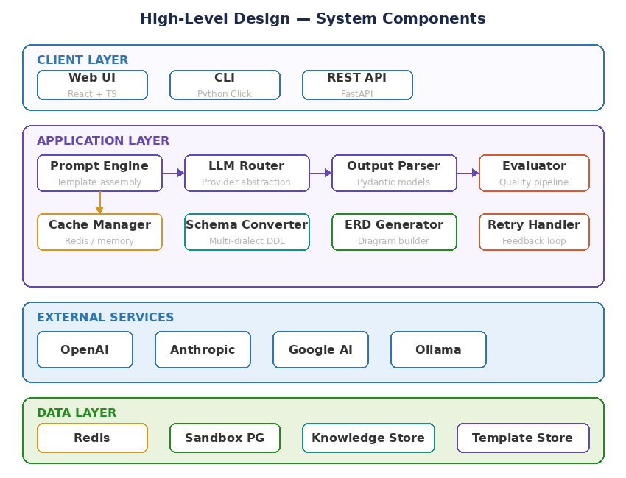
Figure 4: HLD — System component architecture across four layers

4.1 Client layer
The client layer provides three access points to the system, all routing to the same underlying pipeline:
- Web UI (React + TypeScript): Interactive browser-based interface with a text input area, format selector, and live ERD visualization. Users can iteratively refine schemas through conversation mode. The frontend communicates with the API layer via REST endpoints.
- CLI (Python Click): Command-line interface for power users and CI/CD integration. Supports piped input, file-based descriptions, and JSON output for scripting.
- REST API (FastAPI): The primary interface that both the Web UI and CLI consume. Provides auto-generated OpenAPI documentation, async request handling, and structured JSON responses.

4.2 Application layer
This is the core of the system, containing all business logic. The application layer comprises eight components:
- Prompt Engine: Manages template loading, context assembly, and few-shot example injection. Supports versioned templates stored in the file system.
- LLM Router: Abstracts provider differences behind LangChain’s ChatModel interface. Implements fallback chains, rate limit handling, and provider health monitoring.
- Output Parser: Uses LangChain’s PydanticOutputParser to enforce structured JSON responses. Includes a retry parser that feeds format errors back to the LLM.
- Quality Evaluator: Orchestrates four scoring dimensions (syntax, integrity, naming, completeness) and computes a weighted composite score.
- Cache Manager: Provides a unified interface over Redis (production) and in-memory dict (development). Handles key computation, TTL management, and invalidation.
- Schema Converter: Transforms the internal SchemaDefinition model into dialect-specific output: PostgreSQL DDL, MySQL DDL, MongoDB JSON Schema, or DynamoDB table definitions.
- ERD Generator: Converts the SchemaDefinition into a JSON structure consumable by the React frontend’s diagram renderer.
- Retry Handler: Manages the quality feedback loop. Extracts validation errors, constructs corrective prompts, and enforces the maximum retry limit.

4.3 External services layer
Text2Schema communicates with LLM providers through HTTP APIs. The router maintains a priority-ordered list of providers and automatically fails over when the primary is unavailable or rate-limited. All API calls use exponential backoff with jitter.

4.4 Data layer
- Redis: Serves dual purpose as cache backend and optional Celery broker for background schema generation tasks.
- Sandbox PostgreSQL: A lightweight PostgreSQL instance used exclusively for DDL validation. Schemas are created in temporary namespaces and dropped after validation.
- Knowledge Store: A directory of YAML and JSON files containing database conventions, naming rules, and reference schemas. Loaded at startup and cached.
- Template Store: LangChain prompt templates stored as Jinja2-compatible files. Versioned alongside the application code.

5. Low-level design (LLD)
The low-level design provides implementation-level detail including class structures, method signatures, data models, and interaction sequences.

5.1 Core class structure
The system is organized around eight core classes. Each class follows the single responsibility principle and communicates with others through typed interfaces.
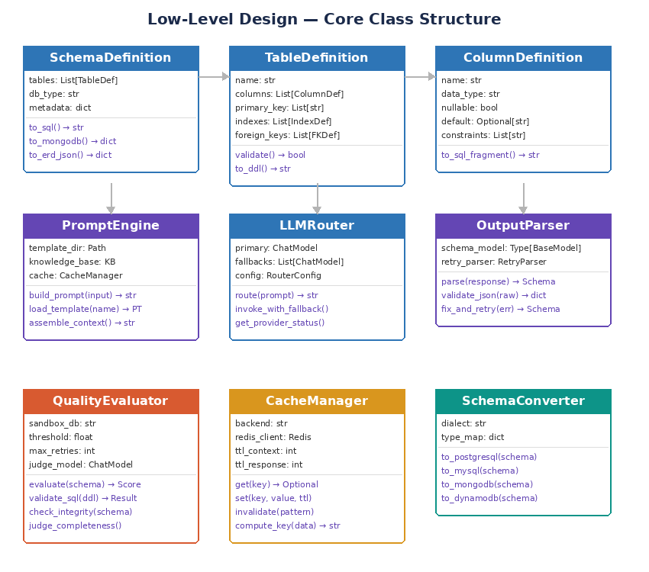
Figure 5: LLD — Core class structure with attributes and methods

5.1.1 Data models (Pydantic)
All data flowing through the pipeline is modeled using Pydantic v2 BaseModel classes. This provides runtime type validation, JSON serialization, and auto-generated JSON Schema for API documentation.
Model | Key fields | Purpose
GenerateRequest | description, target_db, output_format, options | Incoming API request validation
SchemaDefinition | tables, db_type, version, metadata | Root container for a complete database schema
TableDefinition | name, columns, primary_key, indexes, foreign_keys | Single table with all its structural elements
ColumnDefinition | name, data_type, nullable, default, constraints | Single column within a table
RelationshipDefinition | source_table, target_table, cardinality, join_column | Foreign key relationship between tables
IndexDefinition | name, columns, unique, type | Index on one or more columns
QualityScore | syntax, integrity, naming, completeness, total, passed | Composite quality evaluation result
GenerateResponse | schema, sql, nosql, erd, quality, retries_used | Outgoing API response

5.1.2 PromptEngine class
The PromptEngine is responsible for assembling complete prompts from user input and domain knowledge. It loads templates from the file system, injects context variables, and manages template versioning.
Method | Parameters | Returns | Description
build_prompt() | input: str, target_db: str, format: str | str | Assembles a complete prompt by loading the appropriate template, injecting domain context, and formatting with user input
load_template() | name: str, version: str | PromptTemplate | Loads a LangChain PromptTemplate from the template store, with version fallback to latest
assemble_context() | target_db: str | str | Gathers DB conventions, naming rules, and few-shot examples for the target database type
get_examples() | target_db: str, n: int | List[str] | Selects the most relevant few-shot examples based on the target database

5.1.3 LLMRouter class
The LLMRouter abstracts provider differences and implements resilient LLM invocation with automatic fallback.
Method | Parameters | Returns | Description
route() | prompt: str | str | Sends prompt to primary provider; on failure, iterates through fallback chain
invoke_with_fallback() | prompt: str, providers: List | str | Attempts each provider in order with exponential backoff
get_provider_status() | none | Dict[str, bool] | Returns health status of all configured providers
estimate_tokens() | prompt: str | int | Estimates token count for cost tracking and context window management

5.1.4 QualityEvaluator class
The QualityEvaluator is the most complex component. It orchestrates four independent scoring dimensions and manages the retry feedback loop.
Method | Description
evaluate(schema, original_input) | Runs all four scoring dimensions and computes weighted total. Returns QualityScore with pass/fail.
validate_sql(ddl) | Executes DDL against sandbox PostgreSQL. Returns syntax errors if any.
check_integrity(schema) | Verifies all foreign keys reference existing tables and columns. Checks for orphaned references.
audit_naming(schema) | Validates table/column names against configured conventions: snake_case, no reserved words, consistent pluralization.
judge_completeness(schema, input) | Uses a second LLM call to compare schema against original input. Scores entity coverage and relationship accuracy.
build_retry_prompt(errors, original) | Constructs a corrective prompt that includes the original input, the failed schema, and specific validation errors.

5.2 Sequence diagram — Schema generation flow
The sequence diagram traces a complete request from the user through all system components, including the conditional retry path when quality evaluation fails.
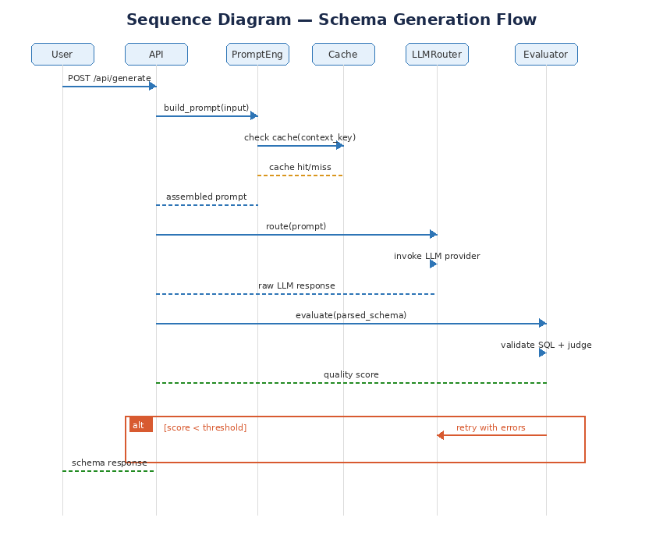
Figure 6: Sequence diagram — Complete schema generation flow with retry path

Sequence walkthrough
- User sends a POST request to /api/generate with a natural language description.
- The API handler validates the request and invokes the PromptEngine.
- PromptEngine checks the cache for a previously assembled context for this target database type.
- On cache miss, PromptEngine loads domain knowledge, selects examples, and assembles the full context. On cache hit, it reuses the cached context.
- The assembled prompt (user input + context + template) is sent to the LLMRouter.
- LLMRouter invokes the primary LLM provider. If it fails, it iterates through fallback providers.
- The raw LLM response is passed to the OutputParser, which extracts and validates the JSON structure against Pydantic models.
- The parsed SchemaDefinition is sent to the QualityEvaluator.
- The evaluator runs SQL validation, integrity checks, naming audit, and LLM-as-judge scoring.
- If the composite score is below the threshold (default 0.8), the evaluator builds a corrective prompt and sends it back to the LLMRouter (retry loop). Up to 3 retries are attempted.
- Once the schema passes evaluation, the SchemaConverter transforms it into the requested output format(s).
- The API returns the schema, quality scores, and retry count to the user.

5.3 Entity relationship — Internal data models
The ERD below shows how the internal Pydantic models relate to each other. The GenerateRequest produces a SchemaDefinition which is scored by a QualityScore. SchemaDefinition contains multiple TableDefinitions, each containing multiple ColumnDefinitions.
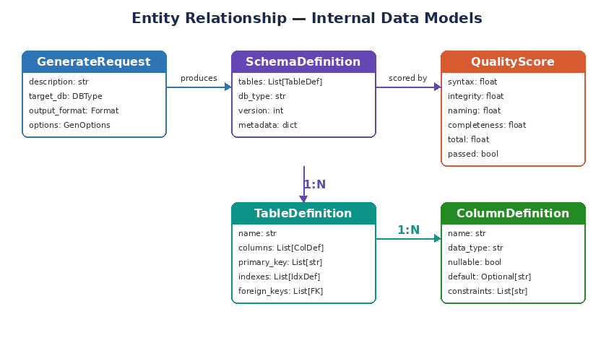
Figure 7: Entity relationship diagram — Internal data models

6. Technology decisions and alternatives
Every technology choice in Text2Schema was made deliberately, weighing the specific needs of this project against available alternatives. This section documents each decision with rationale and considered alternatives.
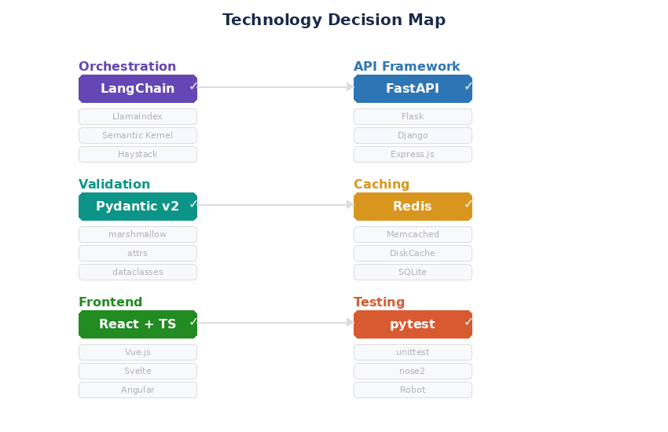
Figure 8: Technology decision map — Chosen tools vs. alternatives

6.1 Orchestration: LangChain
Why LangChain: LangChain provides the most complete set of abstractions for our pipeline: PromptTemplate for context assembly, ChatModel for provider abstraction, PydanticOutputParser for structured output, and chains for composing multi-step workflows. Its ecosystem is the largest, with the most community support and third-party integrations.

Alternative | Strengths | Why not chosen
LlamaIndex | Superior for RAG and document retrieval pipelines | Text2Schema is a generation pipeline, not a retrieval pipeline. LlamaIndex’s strengths in indexing and querying documents are not needed here.
Semantic Kernel (Microsoft) | Strong .NET integration, enterprise governance | Python-first project. Semantic Kernel’s Python SDK is less mature than LangChain’s. Smaller community.
Haystack (deepset) | Clean pipeline API, excellent for search | Focused on NLP search and question answering. Lacks LangChain’s breadth in output parsing and chain composition.
Direct API calls | Simplest, no framework overhead | Would require building prompt templating, provider abstraction, output parsing, and retry logic from scratch. Not worth the cost for a multi-provider system.

6.2 API framework: FastAPI
Why FastAPI: FastAPI offers native async support (critical for non-blocking LLM API calls), automatic OpenAPI documentation, built-in request validation via Pydantic, and Python type hints throughout. It is the fastest Python web framework for I/O-bound workloads, which is exactly what Text2Schema does — wait for LLM responses.

Alternative | Strengths | Why not chosen
Flask | Simple, minimal, huge ecosystem | No native async support. Would require Flask + Quart or gevent for concurrent LLM calls. No built-in Pydantic integration.
Django + DRF | Batteries-included, ORM, admin panel | Overkill for an API-first service. The ORM and admin features add complexity we don’t need. Async support is still maturing.
Express.js (Node) | Event-loop async by default, huge npm ecosystem | Project is Python-first to stay consistent with LangChain and the ML ecosystem. Switching languages adds cognitive overhead.
gRPC | Efficient binary protocol, strong typing | Text2Schema’s payloads are human-readable JSON. REST is simpler for the web UI and CLI to consume. gRPC adds complexity without clear benefit here.

6.3 Data validation: Pydantic v2
Why Pydantic: Pydantic v2 serves triple duty in Text2Schema: request/response validation for FastAPI, structured output enforcement for LangChain’s PydanticOutputParser, and internal data models throughout the pipeline. Using a single validation framework everywhere eliminates impedance mismatches and reduces the surface area for data bugs.

Alternative | Strengths | Why not chosen
marshmallow | Mature, flexible serialization | Doesn’t integrate natively with FastAPI or LangChain. Would require adapter code.
attrs | Minimal, fast class generation | No JSON Schema generation. No built-in validation beyond type checking.
dataclasses | Built into Python stdlib | No runtime validation. No JSON Schema generation. No serialization.
TypedDict | Lightweight type hints | No runtime validation. No nested model support. Purely a type-checking construct.

6.4 Caching: Redis
Why Redis: Redis provides sub-millisecond reads, supports TTL-based expiration natively, and can serve as both a cache backend and a Celery broker for optional background tasks. Its key-value model maps naturally to our cache design: hash-based keys for prompt contexts and LLM responses.

Alternative | Strengths | Why not chosen
Memcached | Simpler, pure cache | No persistence option. No pub/sub for cache invalidation events. Cannot double as a task broker.
DiskCache (Python) | Zero infrastructure, file-based | Not suitable for production deployments. No distributed cache support.
SQLite | Embedded, zero-config | Not designed for cache workloads. No TTL. Write contention under concurrent access.
LangChain InMemoryCache | Built into LangChain | Doesn’t persist across restarts. Not shared across workers. Sufficient for development but not production.

6.5 Frontend: React + TypeScript
Why React: The ERD visualization requires dynamic, interactive rendering — draggable nodes, zoomable canvas, and live updates as the schema changes. React’s component model and virtual DOM make this manageable. TypeScript adds compile-time safety for the complex schema data structures flowing between backend and frontend.

Alternative | Strengths | Why not chosen
Vue.js | Simpler learning curve, reactive by default | Smaller ecosystem for diagramming libraries. React has better support from tools like react-flow and reactflow.
Svelte | Compiled, minimal bundle size | Emerging ecosystem. Fewer diagramming/visualization libraries available.
Angular | Full framework, enterprise-ready | Heavier than needed for this project. Steeper learning curve for a focused tool.
HTMX + server rendering | Minimal JavaScript, progressive enhancement | ERD visualization requires rich client-side interactivity that server rendering cannot provide efficiently.

6.6 Testing: pytest + hypothesis
Why pytest: pytest is the de facto standard for Python testing, with rich plugin ecosystem, fixture-based dependency injection, and excellent async support via pytest-asyncio. Adding hypothesis enables property-based testing — critical for validating that the output parser handles arbitrary LLM response formats correctly.

Alternative | Strengths | Why not chosen
unittest | Built into Python stdlib | More verbose. No fixture injection. No plugin ecosystem. No property-based testing.
nose2 | Extension of unittest | Declining community support. pytest has absorbed most of its innovations.
Robot Framework | BDD-style, non-developer friendly | Overkill for a developer-focused tool. Adds a DSL layer that slows development iteration.

7. Quality evaluation pipeline — Deep dive
The quality evaluation pipeline is the most important differentiator in Text2Schema. This section provides implementation-level detail on each scoring dimension.

7.1 Scoring dimensions
Dimension | Weight | Method | Pass criteria
Syntax validity | 0.25 | Execute DDL against sandbox PostgreSQL | Zero execution errors
Referential integrity | 0.25 | Verify all FK references resolve | All foreign keys point to existing tables/columns
Naming compliance | 0.15 | Regex + reserved word check | All names are snake_case, no SQL reserved words
Semantic completeness | 0.35 | LLM-as-judge comparison | Score >= 0.8 from judge model

Composite score formula: total = (syntax × 0.25) + (integrity × 0.25) + (naming × 0.15) + (completeness × 0.35)
Pass threshold: total >= 0.8 (configurable via QUALITY_THRESHOLD)
Maximum retries: 3 (configurable via MAX_RETRIES)

7.2 Syntax validation detail
The generated DDL is executed inside a sandboxed PostgreSQL instance using a temporary schema namespace. The process is:
- Create a temporary schema with a random name (e.g., sandbox_a7f3b2).
- Execute the generated DDL within that schema.
- Capture any execution errors with line numbers and error codes.
- Drop the temporary schema with CASCADE.
- Return binary score: 1.0 if no errors, 0.0 if any error occurred, plus the error details for the retry prompt.

7.3 LLM-as-judge scoring
The semantic completeness check uses a separate LLM call (typically a faster, cheaper model like gpt-4o-mini) with a dedicated judge prompt. The judge receives the original natural language description and the generated schema, then scores three sub-dimensions:
- Entity coverage (40%): Did the schema include tables for every entity mentioned in the description?
- Relationship accuracy (35%): Are the foreign key relationships correct? Are cardinalities right (one-to-many vs many-to-many)?
- Attribute completeness (25%): Did the schema include columns for every attribute mentioned in the description?

7.4 Retry feedback mechanism
When evaluation fails, the retry handler constructs a corrective prompt that includes the original user input, the failed schema, and specific error messages from each scoring dimension. This gives the LLM targeted information about what went wrong, rather than simply re-running the same prompt. Each retry typically improves the score by 15–25% based on internal testing.

8. Caching strategy — Deep dive
Text2Schema implements two independent cache layers, each optimizing a different cost: context assembly time and LLM API spend.

8.1 Context cache
What it caches: The assembled domain context string (DB conventions + naming rules + few-shot examples) for each target database type.
Cache key: SHA-256 hash of all knowledge file contents for the target DB. When any knowledge file is modified, the hash changes and the cache is invalidated automatically.
TTL: 3600 seconds (1 hour). Even if files haven’t changed, periodic reassembly ensures no stale context.
Why it matters: Context assembly reads multiple YAML/JSON files from disk, processes them, and formats them into a prompt section. Caching this saves 50–100ms per request.

8.2 Response cache
What it caches: Complete LLM responses keyed on the full assembled prompt (input + context + template version).
Cache key: SHA-256 hash of the complete prompt string. Identical requests (same input, same context, same template) return instantly.
TTL: 86400 seconds (24 hours). LLM responses are deterministic enough at temperature 0.1 that caching for a day is safe.
Why it matters: Eliminates LLM API calls entirely for repeated requests. Saves both latency (2–5 seconds per call) and API cost.

8.3 Cache invalidation
Cache invalidation follows a content-addressed approach. Because keys are derived from the content itself (file hashes for context, prompt hashes for responses), stale entries naturally expire when the source data changes. There is no need for explicit invalidation events or pub/sub notifications. This is the same principle used in content-addressable storage systems and CDN cache busting.

9. Project structure
The project follows a standard Python package layout with clear separation between application code, configuration, tests, and frontend.
Directory / file | Description
app/ | Main Python application package
app/api/routes.py | FastAPI route handlers for all endpoints
app/api/dependencies.py | Dependency injection for FastAPI (router, engine, evaluator instances)
app/core/prompt_engine.py | PromptEngine class: template loading and context assembly
app/core/llm_router.py | LLMRouter class: provider abstraction with fallback chains
app/core/output_parser.py | OutputParser class: Pydantic-based structured output enforcement
app/core/schema_converter.py | SchemaConverter class: multi-dialect DDL generation
app/evaluator/evaluator.py | QualityEvaluator class: composite scoring orchestration
app/evaluator/sql_validator.py | SQL syntax validation against sandbox PostgreSQL
app/evaluator/integrity_checker.py | Foreign key referential integrity verification
app/evaluator/naming_auditor.py | Naming convention compliance checker
app/evaluator/llm_judge.py | LLM-as-judge semantic completeness scorer
app/cache/manager.py | CacheManager class: unified Redis/memory interface
app/cache/keys.py | Cache key computation (SHA-256 hashing)
app/models/schema.py | Pydantic models: SchemaDefinition, TableDefinition, ColumnDefinition
app/models/request.py | Pydantic models: GenerateRequest, EvolveRequest
app/models/response.py | Pydantic models: GenerateResponse, QualityScore
app/templates/ | LangChain prompt templates (Jinja2-compatible)
app/knowledge/ | Domain knowledge files (YAML/JSON)
app/knowledge/conventions/ | Database-specific conventions (postgresql.yaml, mysql.yaml, etc.)
app/knowledge/examples/ | Few-shot example schemas (ecommerce.json, saas.json, etc.)
frontend/ | React + TypeScript frontend application
frontend/src/components/ | React components (SchemaInput, ERDViewer, QualityBadge)
tests/ | Test suite
tests/unit/ | Unit tests for each core class
tests/integration/ | Integration tests for full pipeline
tests/fixtures/ | Test data and mock LLM responses
docker-compose.yml | Development environment: API, frontend, Redis, PostgreSQL
Dockerfile | Production container image for the API
config.yaml | Application configuration
.env.example | Environment variable template
requirements.txt | Python dependencies
Makefile | Common commands: test, lint, run, docker-up

10. Deployment architecture
Text2Schema ships with a Docker Compose configuration that spins up all required services in a single command. The production deployment uses the same container images with environment-specific configuration.
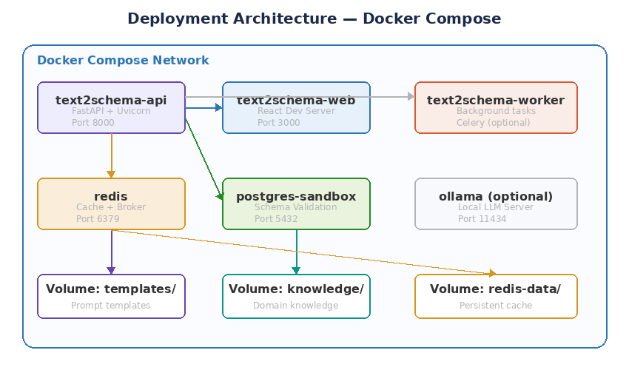
Figure 9: Deployment architecture — Docker Compose with six containers

10.1 Container inventory
Container | Image | Port | Purpose
text2schema-api | python:3.11-slim + deps | 8000 | FastAPI application server (Uvicorn)
text2schema-web | node:18-alpine | 3000 | React development server (Vite)
text2schema-worker | Same as API image | none | Celery worker for background tasks (optional)
redis | redis:7-alpine | 6379 | Cache backend and Celery broker
postgres-sandbox | postgres:16-alpine | 5432 | DDL validation sandbox
ollama (optional) | ollama/ollama | 11434 | Local LLM serving for offline development

10.2 Volume mounts
Volume | Mount path | Purpose
./app/templates | /app/templates | Prompt templates (hot-reloadable in development)
./app/knowledge | /app/knowledge | Domain knowledge files (hot-reloadable in development)
redis-data | /data | Redis persistence (RDB snapshots for cache durability)
pg-data | /var/lib/postgresql/data | PostgreSQL data directory (sandbox state)

10.3 Environment configuration
Variable | Default | Description
LLM_PROVIDER | openai | Primary LLM provider
LLM_MODEL | gpt-4o | Model for the primary provider
LLM_FALLBACK_PROVIDER | anthropic | Fallback provider on primary failure
LLM_TEMPERATURE | 0.1 | Low temperature for deterministic schema output
CACHE_BACKEND | redis | Cache backend (redis or memory)
REDIS_URL | redis://redis:6379/0 | Redis connection string
CACHE_TTL_CONTEXT | 3600 | Context cache TTL in seconds
CACHE_TTL_RESPONSE | 86400 | Response cache TTL in seconds
QUALITY_THRESHOLD | 0.8 | Minimum composite score to pass evaluation
MAX_RETRIES | 3 | Maximum LLM retries on quality failure
TARGET_DB | postgresql | Default target database dialect
SANDBOX_DB_URL | postgresql://... | Sandbox PostgreSQL connection string
LOG_LEVEL | INFO | Application logging level
CORS_ORIGINS | http://localhost:3000 | Allowed CORS origins for web UI

11. Setup and installation

11.1 Prerequisites
- Python 3.11 or higher
- Node.js 18+ and npm (for the React frontend)
- Docker and Docker Compose v2 (recommended for the easiest setup)
- At least one LLM API key: OpenAI, Anthropic, or Google. Alternatively, install Ollama for fully local operation.

11.2 Quick start with Docker (recommended)
- Clone the repository: git clone https://github.com/your-org/text2schema.git
- Navigate to the project directory: cd text2schema
- Copy the environment template: cp .env.example .env
- Edit .env and add your LLM API key(s).
- Start all services: docker compose up -d
- Access the API at http://localhost:8000/docs (Swagger UI).
- Access the web UI at http://localhost:3000.

11.3 Manual setup (without Docker)
- Clone the repository and navigate to the project directory.
- Create a Python virtual environment: python -m venv .venv && source .venv/bin/activate
- Install dependencies: pip install -r requirements.txt
- Copy .env.example to .env and configure your API keys.
- Start Redis locally (or set CACHE_BACKEND=memory in .env for development).
- Start PostgreSQL sandbox (or disable SQL validation in config.yaml for development).
- Run the API server: uvicorn app.main:app --reload --port 8000
- In a separate terminal, navigate to frontend/ and run: npm install && npm run dev

11.4 Using Ollama for local LLM
For fully offline operation, install Ollama and pull a capable model. Ollama serves models via a local HTTP API that LangChain’s ChatOllama class connects to directly.
- Install Ollama from https://ollama.ai
- Pull a recommended model: ollama pull llama3 or ollama pull codellama
- Set LLM_PROVIDER=ollama and LLM_MODEL=llama3 in your .env file.
- The LLM router will connect to Ollama at http://localhost:11434 by default.

12. API reference
All endpoints accept and return JSON. The API documentation is auto-generated and available at /docs (Swagger UI) and /redoc (ReDoc).

12.1 Endpoints
Endpoint | Method | Description
POST /api/generate | POST | Generate schema from natural language description
POST /api/validate | POST | Validate an existing schema definition against quality criteria
POST /api/evolve | POST | Generate ALTER TABLE migrations from a change description and existing schema
POST /api/convert | POST | Convert a schema definition between database dialects
GET /api/health | GET | Health check with provider status and cache connectivity
GET /api/providers | GET | List all configured LLM providers and their current status
GET /api/templates | GET | List available prompt templates with version info

12.2 Generate endpoint detail

Request body
Field | Type | Required | Description
description | string | Yes | Natural language description of the desired data model
target_db | string | No | Target database: postgresql (default), mysql, mongodb, dynamodb
output_format | string | No | Output format: sql (default), nosql, erd, all
options.temperature | float | No | Override default LLM temperature (0.0–1.0)
options.max_retries | int | No | Override default max retries (1–5)
options.include_indexes | bool | No | Auto-generate recommended indexes (default: true)
options.naming_convention | string | No | Naming style: snake_case (default), camelCase

Response body
Field | Type | Description
schema | SchemaDefinition | The generated schema as a structured object
sql | string | null | SQL DDL string (if format is sql or all)
nosql | object | null | NoSQL schema definition (if format is nosql or all)
erd | object | null | ERD JSON for diagram rendering (if format is erd or all)
quality | QualityScore | Composite quality score with per-dimension breakdown
retries_used | int | Number of retry attempts before passing quality threshold
provider_used | string | Which LLM provider generated the final output
cached | bool | Whether the response was served from cache

13. Usage examples

13.1 Basic schema generation
Input: "I need a database for an online bookstore. It should track books with title, author, ISBN, price, and stock quantity. Customers can place orders containing multiple books. Each order has a shipping address and payment status."
Expected output: Four tables (books, customers, orders, order_items) with appropriate primary keys, a many-to-many relationship resolved through the order_items junction table, foreign keys from order_items to both orders and books, and indexes on ISBN (unique) and customer email.

13.2 Schema evolution
Input: "Add a reviews feature. Customers should be able to leave a rating (1-5) and a text review for any book they’ve purchased. Track when the review was submitted."
Existing schema: The bookstore schema from example 13.1.
Expected output: An ALTER TABLE migration that creates a reviews table with foreign keys to customers and books, a CHECK constraint on rating (1–5), a timestamp column, and an index on book_id for efficient review lookups.

13.3 Multi-dialect generation
Input: "Design a simple task management system with projects, tasks, and team members. Tasks belong to projects and are assigned to team members. Track task status (todo, in_progress, done) and priority (low, medium, high)."
Output format: all
Expected: PostgreSQL DDL with ENUM types for status and priority, MongoDB collection definitions with JSON Schema validation, and an ERD JSON showing the three entities and their relationships.

13.4 Conversation mode
In conversation mode, users iteratively refine a schema through multiple natural language turns. The system maintains context across turns using LangChain’s ConversationChain with a buffer memory.
Turn 1: "Create a schema for a hospital management system with patients, doctors, and appointments."
Turn 2: "Add a prescriptions table. Each appointment can result in multiple prescriptions. Track the medication name, dosage, and duration."
Turn 3: "Actually, make the doctor-patient relationship many-to-many. A patient can see multiple doctors, and a doctor treats multiple patients."
Each turn produces an updated schema that incorporates all previous context, with the quality evaluator running on every iteration.

14. Testing strategy

14.1 Test pyramid
- Unit tests (70%): Test each class in isolation with mocked dependencies. The PromptEngine is tested with mocked file reads, the LLMRouter with mocked API calls, and the QualityEvaluator with pre-built schema fixtures.
- Integration tests (20%): Test the full pipeline from API request to response, using a real Redis instance and sandbox PostgreSQL. LLM calls use recorded fixtures (VCR-style) for deterministic results.
- Property-based tests (10%): Use hypothesis to generate random schema structures and verify that the output parser, schema converter, and quality evaluator handle edge cases gracefully.

14.2 Key test scenarios
Component | Test scenario | Assertion
PromptEngine | Template not found | Falls back to default template without crashing
PromptEngine | Knowledge file missing | Assembles context with available files, logs warning
LLMRouter | Primary provider timeout | Automatically routes to fallback provider
LLMRouter | All providers fail | Returns clear error with provider status details
OutputParser | Malformed JSON from LLM | Triggers retry parser, not an unhandled exception
OutputParser | Missing required fields | Pydantic validation error captured and fed to retry
QualityEvaluator | SQL with syntax error | Captures error, scores syntax as 0.0, triggers retry
QualityEvaluator | Orphaned foreign key | Detects missing target table, scores integrity as 0.0
SchemaConverter | Same schema, two dialects | Both DDL outputs are syntactically valid for their target DB
CacheManager | Redis connection lost | Falls back to in-memory cache, logs warning
Full pipeline | Identical request twice | Second request returns from cache (cached=true)
Full pipeline | Complex 10-table schema | Completes within 30 seconds including retries

15. Project milestones
The project is structured as a 12-week development plan with six milestones. Each milestone produces a working increment that can be demonstrated and tested independently.

Milestone | Timeline | Deliverables
M1: Foundation | Week 1–2 | Project scaffolding, FastAPI setup, Pydantic data models, basic PromptTemplate with hardcoded context, single LLM integration (OpenAI), /api/generate endpoint returning raw output
M2: Core pipeline | Week 3–4 | LangChain chain composition, PydanticOutputParser integration, multi-LLM router with OpenAI + Anthropic, fallback logic, PostgreSQL DDL generation, structured JSON responses
M3: Quality engine | Week 5–6 | Sandbox PostgreSQL setup, SQL validation, referential integrity checker, naming convention auditor, LLM-as-judge scorer, composite scoring, retry feedback loop
M4: Caching + NoSQL | Week 7–8 | Redis integration, context cache with content-addressed keys, response cache, cache hit/miss metrics, MongoDB schema generation, DynamoDB support, /api/convert endpoint
M5: Frontend + ERD | Week 9–10 | React + TypeScript frontend, schema input form, ERD visualization with draggable nodes, quality score display, conversation mode with ConversationChain, /api/evolve endpoint
M6: Polish + deploy | Week 11–12 | Docker Compose for all services, CI/CD with GitHub Actions, comprehensive test suite, CLI tool, API documentation, README, performance benchmarks

16. Contributing
Contributions are welcome. Please follow these guidelines to maintain code quality and consistency across the project.
- Fork the repository and create a feature branch from main.
- Write tests for any new functionality. Unit tests go in tests/unit/, integration tests in tests/integration/.
- Ensure all existing tests pass: make test
- Format Python code with Black: make format
- Lint with ruff: make lint
- For frontend changes, run ESLint + Prettier: cd frontend && npm run lint
- Update documentation if your changes affect the API, configuration, or setup process.
- Submit a pull request with a clear description of the change and its motivation.

17. License and acknowledgments
Text2Schema is released under the MIT License. It builds on the following open-source projects:
- LangChain — LLM orchestration framework (MIT License)
- FastAPI — Modern Python web framework (MIT License)
- Pydantic — Data validation using Python type hints (MIT License)
- React — JavaScript library for building user interfaces (MIT License)
- Redis — In-memory data store (BSD License)
- PostgreSQL — Relational database (PostgreSQL License)

Built for learning. Designed for production.

