How Machines Learn to Understand Text
A Beginner's Guide — From Words to Neural Networks
Analogy: Who is this for? Students who are new to AI. No prior knowledge needed. Every topic starts with a simple everyday analogy, then a visual diagram, then the formula with a plain explanation, then a step-by-step calculation. Read it like a conversation — not a textbook.

# | Topic | One-Line Summary
1 | One-Hot Encoding | The simplest way to turn a word into a number
2 | Bag-of-Words | Count how often each word appears in a document
3 | TF-IDF | Reward distinctive words — penalise common ones
4 | Word Embeddings & Word2Vec | Give words meaning through dense vectors
5 | Cosine Similarity | Measure how similar two word vectors are
6 | Recurrent Neural Networks | Process sequences word-by-word with memory
7 | LSTM | Give machines a long-range memory lane
8 | GRU | A lighter, faster version of LSTM
9 | Sentiment Analysis | Combine everything into one working system

Before We Begin — Why Can't Machines Just Read?
When you read the word 'dog', your brain instantly knows it is an animal, it is related to 'puppy' and 'cat', and it is very different from 'airplane'. Computers cannot do any of this — a computer only understands numbers.
So the very first problem in teaching machines to understand language is: how do we convert words into numbers in a way that preserves meaning? This guide answers that question step by step. Each method was invented to fix a weakness in the previous one.

The Big Question: How do we represent the meaning of language in a mathematical form that machines can process and learn from?

1. One-Hot Encoding
The most basic question: how do we turn a single word into a number? One-hot encoding is the simplest possible answer.

The Analogy
Analogy: Imagine a restaurant menu with 5 items: Dosa, Idli, Vada, Pongal, Upma. When you order Vada, the waiter ticks a checklist — one box checked, all others empty. That checklist is a one-hot vector: [0, 0, 1, 0, 0]. Exactly one item is 'hot' (active), everything else is 0.

The Diagram
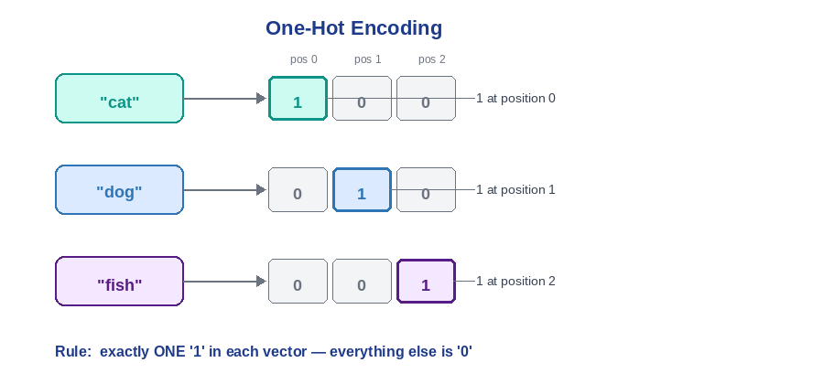

The Formula
For a vocabulary of size V, the one-hot vector for the word at position i is:
x(j) = 1 when j = i (the word's own position)
x(j) = 0 when j ≠ i (all other positions)

Why This Formula?
There is no complex math here — it is a design decision. The reasoning:
- Machines need numbers, not text strings.
- Every word must have a unique, unambiguous representation.
- The simplest unique representation: mark exactly one position as 1, everything else as 0.
- Vector length = vocabulary size, so no two words ever share the same pattern.

Step-by-Step Calculation
Vocabulary: [cat, dog, fish]. Encode the sentence: 'cat dog cat'
Assign positions: cat=0, dog=1, fish=2

cat → position 0 → [1, 0, 0]
dog → position 1 → [0, 1, 0]
cat → position 0 → [1, 0, 0] (same as first 'cat')

Similarity check — dot product of 'cat' and 'dog':
= (1×0) + (0×1) + (0×0) = 0 + 0 + 0
→ Result: 0 ← completely unrelated in this system

Dot product of 'cat' and 'cat':
= (1×1) + (0×0) + (0×0) = 1 + 0 + 0
→ Result: 1 ← identical

Key Takeaway: Every pair of DIFFERENT words gets a similarity score of exactly 0. 'Cat' and 'kitten' look just as unrelated as 'cat' and 'volcano'. One-hot encoding has zero concept of meaning.

Problem: No similarity between words — 'good' and 'great' are as different as 'good' and 'earthquake'.
Problem: Huge sparse vectors — for 200,000 words, each vector has 199,999 wasted zeros.
Problem: No frequency information — 'great' used 10 times looks identical to 'great' used once.

2. Bag-of-Words (BoW)
One-hot works for single words. For entire documents, Bag-of-Words counts how often each word appears.

The Analogy
Analogy: Shake a book over a bag until all the words fall out. Count what is in the bag: 'war' 142 times, 'peace' 89 times, 'battle' 67 times. From those counts alone you can guess this is a book about war — even without reading a single sentence. You lost the order, but kept the frequency.

The Diagram
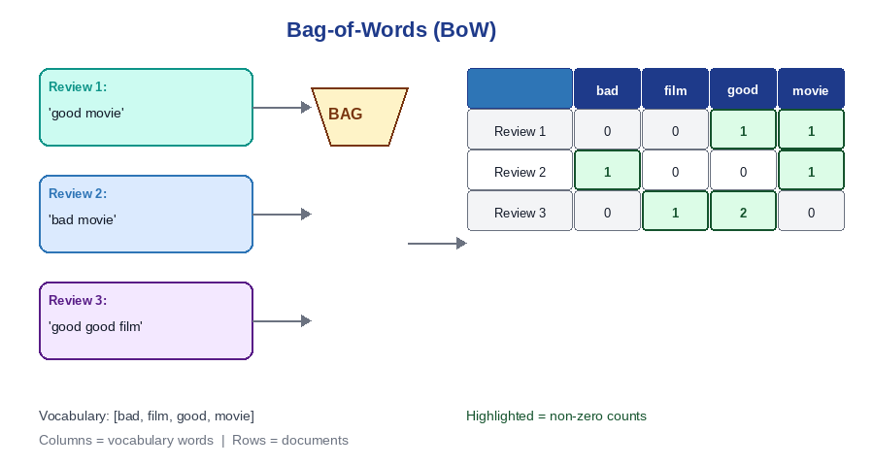

The Formula
BoW(document, word) = count of that word in that document

Why This Formula?
BoW is one-hot encoding extended to whole documents:
- Build a global vocabulary from all unique words across all documents.
- For each document, create a vector of length V (same length as one-hot).
- Instead of a single 1, put the word's COUNT at each position.
Mathematically: BoW(document) = sum of all one-hot vectors for every word in that document.

Step-by-Step Calculation
Three reviews. Vocabulary: [bad, film, good, movie]
Review 1: 'good movie' (2 words total)
bad=0, film=0, good=1, movie=1
→ Vector: [0, 0, 1, 1]

Review 2: 'bad movie' (2 words total)
bad=1, film=0, good=0, movie=1
→ Vector: [1, 0, 0, 1]

Review 3: 'good good film' (3 words total)
bad=0, film=1, good=2, movie=0 ← 'good' counted TWICE
→ Vector: [0, 1, 2, 0]

Improvement: For the first time, documents with similar content will have similar vectors. Reviews sharing words will have non-zero values in the same columns — the first real notion of document similarity.

Problem: Word order is lost — 'Dog bites man' and 'Man bites dog' produce the exact same vector.
Problem: Common words dominate — 'the', 'is', 'a' appear everywhere with huge counts but carry no meaning.
Problem: Still no semantic meaning — 'good' and 'great' are unrelated columns.

3. TF-IDF
BoW counts raw frequencies. But raw frequency is misleading — 'the' appears constantly yet tells you nothing. TF-IDF rewards words that are frequent HERE but rare EVERYWHERE ELSE.

The Analogy
Analogy: You are a detective trying to identify a suspect in a crowd of 1,000 people. Useless clue: 'The suspect has two eyes' — everyone has two eyes. Useful clue: 'The suspect has a dragon tattoo on their left wrist' — very rare, immediately narrows it down. TF-IDF rewards the rare, distinctive clues and ignores the common ones.

The Diagram
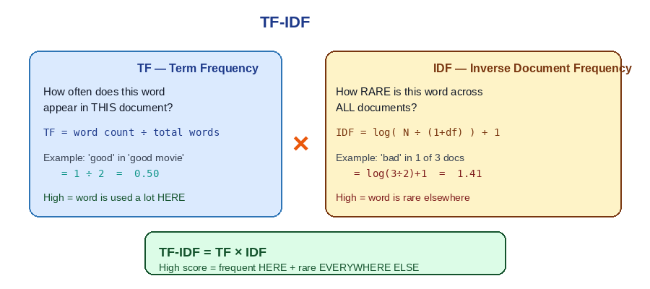

The Formulas
Part 1 — Term Frequency: how often does this word appear in THIS document?
TF(word, doc) = count of word in doc ÷ total words in doc

Part 2 — Inverse Document Frequency: how RARE is this word across ALL documents?
IDF(word) = log( N ÷ (1 + number of docs containing word) ) + 1

Final score:
TF-IDF = TF × IDF

Why Multiply? Why Logarithm?
Why multiply TF and IDF? Because neither alone is enough. TF alone rewards 'the' (frequent everywhere). IDF alone rewards extremely rare words that barely appear. Multiplying creates the ideal criterion: frequent in THIS document, rare in ALL OTHERS.
Why logarithm? A word appearing 100 times is NOT 100 times more important than one appearing once. Importance grows slowly — the log function compresses large numbers into a fair range.
log(1) = 0.0 ← appears in every document → useless → score becomes 0
log(10) = 2.3
log(100) = 4.6 ← not 100, grows much more slowly
log(500) = 6.2 ← very rare word → very informative

Step-by-Step Calculation
Same 3 reviews. N = 3 documents. Vocabulary: [bad, film, good, movie]
STEP 1 — Calculate TF:
Review 1 (2 words): TF(good)=1/2=0.50 TF(movie)=1/2=0.50
Review 2 (2 words): TF(bad)=1/2=0.50 TF(movie)=1/2=0.50
Review 3 (3 words): TF(film)=1/3=0.33 TF(good)=2/3=0.67

STEP 2 — Calculate IDF:
'bad' in 1 doc → IDF = log(3÷(1+1))+1 = log(1.5)+1 = 0.41+1 = 1.41
'film' in 1 doc → IDF = log(3÷(1+1))+1 = 1.41
'good' in 2 docs → IDF = log(3÷(1+2))+1 = log(1.0)+1 = 0+1 = 1.00
'movie' in 2 docs → IDF = log(3÷(1+2))+1 = 1.00

STEP 3 — Multiply TF × IDF:
Review 2, 'bad': 0.50 × 1.41 = 0.71 ← HIGHEST score in entire table!
Review 1, 'good': 0.50 × 1.00 = 0.50
Review 3, 'film': 0.33 × 1.41 = 0.47

Key Takeaway: 'Bad' scores 0.71 — the highest in the table. Not because it appears most, but because it is distinctive. It is the only negative word across all 3 reviews, making it the strongest signal for Review 2.

4. Word Embeddings and Word2Vec
One-hot, BoW, and TF-IDF all treat 'good' and 'great' as completely unrelated. We need vectors where similar words end up geometrically close together. This is what Word2Vec achieves.

The Analogy
Analogy: A word is known by the company it keeps. 'Coffee' and 'tea' both appear near 'hot', 'drink', 'morning', 'cup' millions of times across text. Even if you had never seen those words before, you could guess they are related just from their neighbours in sentences.

The Diagram
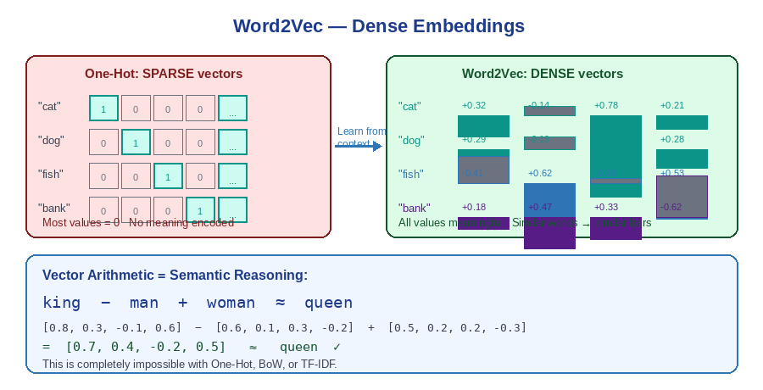

How It Works — Skip-gram Method
Word2Vec trains a neural network on a simple prediction task: given a center word, predict the surrounding words. The weights the network learns to solve this task ARE the word embeddings.
Sentence: 'The dog chases the cat' Window size: 2
Center word: 'chases'

Positive examples (actually near 'chases'): 'dog', 'The', 'the', 'cat'
Negative examples (random words NOT nearby): 'pizza', 'mountain', 'river'

Task: is this word actually near 'chases'? YES or NO?
→ The weights that solve this task = the word embeddings

The Formula
Probability that word c appears in the context of word w:
P(+|w, c) = sigmoid(c · w) = 1 ÷ (1 + exp(−c · w))

Step-by-Step: The King − Man + Woman = Queen Example
Simplified 4-dimensional vectors after training:
king = [0.8, 0.3, -0.1, 0.6]
man = [0.6, 0.1, 0.3, -0.2]
woman = [0.5, 0.2, 0.2, -0.3]
queen = [0.7, 0.4, -0.2, 0.5]

king − man:
= [0.8-0.6, 0.3-0.1, -0.1-0.3, 0.6-(-0.2)]
= [0.2, 0.2, -0.4, 0.8] ← the 'royalty direction'

woman + (king − man):
= [0.5+0.2, 0.2+0.2, 0.2-0.4, -0.3+0.8]
= [0.7, 0.4, -0.2, 0.5] ≈ queen ✓

Key Insight: Vector arithmetic performs semantic reasoning. The direction from 'man' to 'king' encodes the concept of royalty. Adding that same direction to 'woman' lands near 'queen'. Completely impossible with one-hot, BoW, or TF-IDF.

Note: Word2Vec gives ONE fixed vector per word regardless of context. 'Bank' gets the same vector whether you mean a river bank or a financial bank. This was later solved by the Transformer.

5. Cosine Similarity
Now that words are vectors, we need a mathematical way to measure how similar two of them are. The dot product is the natural first attempt — but it has a flaw that cosine similarity fixes.

The Analogy
Analogy: Imagine two people rating movies from 1 to 10. Person A: action=9, sci-fi=8. Person B: action=9, sci-fi=8. Person C: rates EVERY genre as 9 or 10. The dot product would say C is similar to everyone — not because of taste, but because their numbers are all large. Cosine similarity removes this effect — it only cares about the DIRECTION of preferences, not the scale.

The Diagram
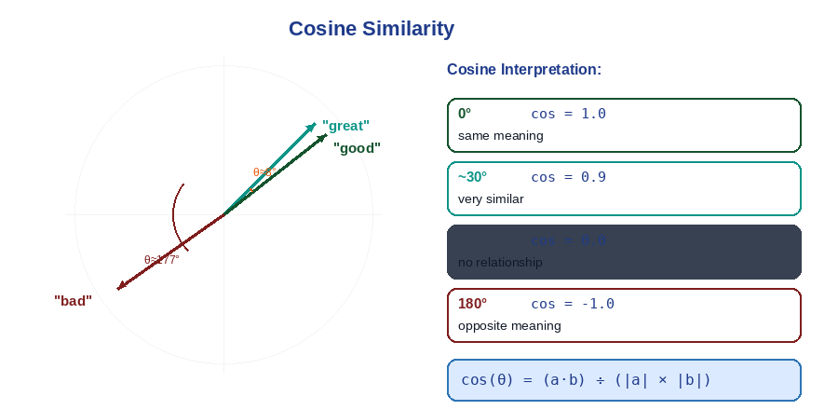

The Formula
cos(θ) = (a · b) ÷ (|a| × |b|)
Where a · b = dot product, |a| and |b| = magnitudes (lengths) of the vectors, θ = angle between them.

Why This Formula?
In geometry: a · b = |a| × |b| × cos(θ). Rearranging: cos(θ) = (a · b) ÷ (|a| × |b|). By dividing by the magnitudes, we normalise both vectors to unit length. Now only the DIRECTION matters — not how long the vectors are.

Step-by-Step Calculation
Three word vectors (3 dimensions): good=[1.0, 0.5, 0.8] great=[0.9, 0.6, 0.7] bad=[-0.8, -0.4, -0.7]
─── 'good' vs 'great' ───────────────────────────────────
Step 1 — Dot product:
= (1.0×0.9) + (0.5×0.6) + (0.8×0.7)
= 0.90 + 0.30 + 0.56 = 1.76
Step 2 — Magnitudes:
|good| = √(1.0²+0.5²+0.8²) = √1.89 = 1.375
|great| = √(0.9²+0.6²+0.7²) = √1.66 = 1.288
Step 3 — Cosine:
= 1.76 ÷ (1.375 × 1.288) = 1.76 ÷ 1.771
→ Result = 0.994 ← almost 1.0 → very similar meaning ✓

─── 'good' vs 'bad' ─────────────────────────────────────
Step 1 — Dot product:
= (1.0×-0.8) + (0.5×-0.4) + (0.8×-0.7)
= -0.80 - 0.20 - 0.56 = -1.56
Step 2 — Magnitude: |bad| = √(0.64+0.16+0.49) = √1.29 = 1.136
Step 3 — Cosine:
= -1.56 ÷ (1.375 × 1.136) = -1.56 ÷ 1.562
→ Result = -0.999 ← almost -1.0 → opposite directions ✓

Note: Antonyms like 'justice' and 'injustice' often score HIGH similarity in Word2Vec — because both appear near the same context words like 'law', 'court', 'system'. Cosine measures contextual similarity, not semantic opposition.

6. Recurrent Neural Networks (RNNs)
Word2Vec gives great word vectors. But to understand a sentence, we need to process words IN SEQUENCE — the meaning of each word depends on what came before it. A regular neural network treats every word independently with no memory.

The Analogy
Analogy: You are reading cricket commentary ball by ball. When you read 'He celebrates', you know 'He' refers to Kohli — because you REMEMBERED the previous ball described Kohli scoring. Your brain maintains a running summary as you read. An RNN does exactly this — it carries a hidden state (memory) forward with every word it processes.

The Diagram
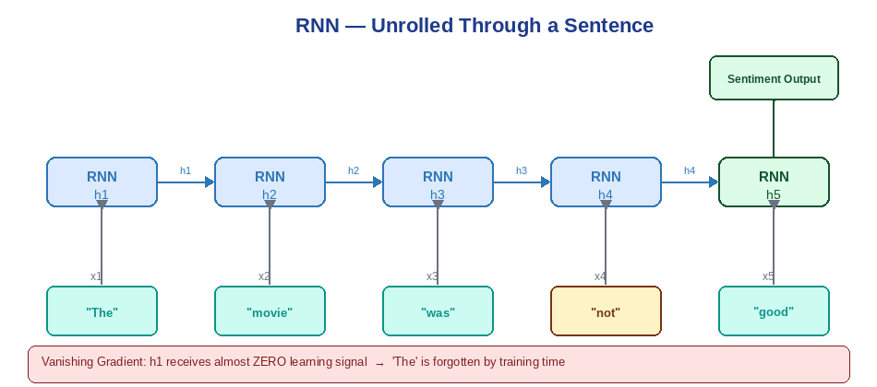

The Formula
h(t) = tanh( W × x(t) + U × h(t−1) + b )
output = sigmoid( V × h(t) + c )
- x(t) = current word vector
- h(t−1) = hidden state from the PREVIOUS step (the memory)
- W = weights connecting input to hidden state
- U = weights connecting old hidden state to new one (the recurrent connection)
- b, c = bias terms. tanh squeezes values between −1 and +1.

Why the Formula Works
The critical term is U × h(t−1). Every computation includes the previous hidden state. Expanding recursively: h(5) = f(x5, x4, x3, x2, x1) — a function of ALL previous words.

Step-by-Step Calculation
Processing 'The movie was not good' for sentiment analysis:
t=1: x='The' → h(1) = tanh(W×x + b)
t=2: x='movie' → h(2) = tanh(W×x + U×h(1) + b) ← uses h(1)
t=3: x='was' → h(3) = tanh(W×x + U×h(2) + b) ← uses h(2)
t=4: x='not' → h(4) = tanh(W×x + U×h(3) + b) ← uses h(3)
t=5: x='good' → h(5) = tanh(W×x + U×h(4) + b) ← uses h(4)

output = sigmoid(V × h(5)) → sentiment prediction
→ h(5) theoretically encodes ALL 5 words including the negation 'not'

The Vanishing Gradient Problem
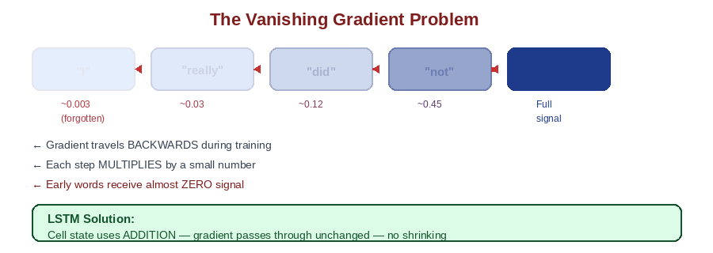
Gradient multiplied at each step backwards:
After 5 steps: 0.9^5 = 0.59
After 10 steps: 0.9^10 = 0.35
After 20 steps: 0.9^20 = 0.12
After 50 steps: 0.9^50 = 0.005 ← nearly zero
→ Early words receive almost no learning signal — the RNN forgets them

7. Long Short-Term Memory (LSTM)
The RNN's single hidden state tries to do two jobs at once: remember old context AND produce current output. These conflict — LSTM fixes this by separating memory into two lanes and adding gates to control them.

The Analogy
Analogy: You are a manager reading a long report. On your desk: a sticky note (short-term — what you are thinking about right now, updated constantly). Next to you: a filing cabinet (long-term — important facts consciously saved). Three decisions at every paragraph: What to throw away from the cabinet? What new info to file? What to pull from the cabinet right now? These are the three LSTM gates.

The Diagram
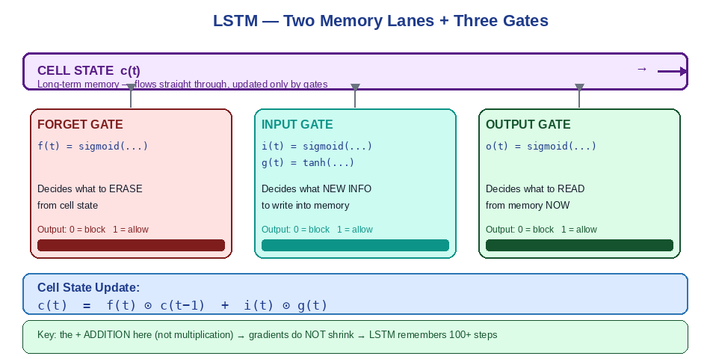

The Formulas
Forget Gate — what to erase from long-term memory:
f(t) = sigmoid( b_f + U_f × h(t−1) + W_f × x(t) )
Input Gate — what new information to write:
i(t) = sigmoid( b_i + U_i × h(t−1) + W_i × x(t) )
g(t) = tanh( b_g + U_g × h(t−1) + W_g × x(t) )
Cell State Update — the critical equation:
c(t) = f(t) ⊙ c(t−1) + i(t) ⊙ g(t)
Output Gate — what to expose right now:
o(t) = sigmoid( b_o + U_o × h(t−1) + W_o × x(t) )
h(t) = o(t) ⊙ tanh( c(t) )
Note: ⊙ = element-wise multiplication. sigmoid outputs 0 to 1 (acts as an on/off gate).

Why Does Addition Solve the Vanishing Gradient?
RNN backward pass: gradient × W × W × W × W × ... → shrinks exponentially

LSTM backward through cell state:
∂c(t)/∂c(t−1) = f(t) ← the forget gate value (close to 1 for important memory)
gradient × 1.0 × 1.0 × 1.0 × ... → preserved, does NOT shrink

→ Addition does NOT shrink gradients the way multiplication does
→ LSTM can remember information 100+ steps back

Step-by-Step Example — Pronoun Resolution
Sentence: 'The trophy did not fit in the bag because it was too big'
Steps 1-2: 'The trophy'
Input gate OPENS → stores 'subject = trophy' in cell state c

Steps 3-5: 'did not fit'
Input gate OPENS → stores 'action = did not fit'
Forget gate STAYS OPEN → trophy still preserved in c

Step 6: 'because' (filler word)
All gates mostly CLOSED → nothing changes

Step 9: 'it'
Output gate OPENS → retrieves 'subject = trophy' from cell state
→ 'it' correctly resolved as 'trophy', not 'bag' ✓
→ An RNN would have overwritten 'trophy' long before step 9

8. Gated Recurrent Units (GRU)
LSTM works well but uses 2 memory lanes, 3 gates, and many parameters — making it slow and memory-heavy. GRU simplifies this to 1 lane and 2 gates without losing much performance.

The Analogy
Analogy: Imagine a dial controlling two complementary things at once. Turn it towards 'keep old' — you preserve your existing memory. Turn it towards 'add new' — you update with fresh information. What you forget and what you add are always perfectly complementary. They always add to 100%. That dial is the GRU Update gate.

The Diagram
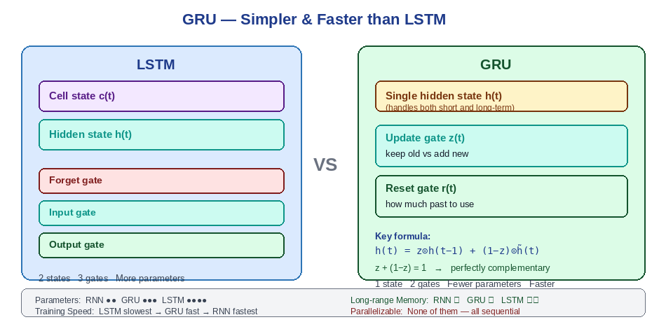

The Formulas
Update Gate — how much of the past to keep vs new info to add:
z(t) = sigmoid( b_z + U_z × h(t−1) + W_z × x(t) )
Reset Gate — how much of the past to use when computing candidate memory:
r(t) = sigmoid( b_r + U_r × h(t−1) + W_r × x(t) )
Candidate new hidden state:
h̃(t) = tanh( W_h × x(t) + r(t) ⊙ U_h × h(t−1) )
Final hidden state — the key equation:
h(t) = z(t) ⊙ h(t−1) + (1 − z(t)) ⊙ h̃(t)

The Elegant Design
h(t) = z(t) ⊙ h(t−1) + (1−z(t)) ⊙ h̃(t)
↑ keep old ↑ add new

z + (1−z) = 1 always → perfectly complementary:
z=0.8: keep 80% old + add 20% new (word is unimportant)
z=0.1: keep 10% old + add 90% new (word is important)
z=0.0: replace entirely with new (critical word)

In LSTM, forget and input gates are independent.
In GRU, they are forced to be complementary → fewer parameters → faster.

Step-by-Step Example
Sentence: 'I really did not like the movie'
Word | Update Gate z | What Happens
"I" | 0.2 | Strong update — subject stored in memory
"really" | 0.7 | Partial update — modifier noted
"did" | 0.85 | Mostly preserve — auxiliary verb, unimportant
"not" | 0.1 | Very strong update — negation stored
"like" | 0.3 | Good update — sentiment stored
"the" | 0.95 | Almost no update — article, irrelevant
"movie" | 0.4 | Moderate update — topic stored

Key Takeaway: The model learns these z values from training data. No one tells it 'not' is important — it discovers this entirely from patterns in thousands of examples.

Property | RNN | LSTM | GRU
Memory lanes | 1 | 2 (h + cell state) | 1
Gates | 0 | 3 | 2
Long-range memory | Poor (~7) | Best (100+) | Good
Vanishing gradient | Severe | Solved | Solved
Training speed | Fastest | Slowest | Fast
Can parallelize? | No | No | No

Note: All three — RNN, LSTM, GRU — still process words one at a time, sequentially. The Transformer architecture breaks this by processing ALL words simultaneously using attention mechanisms.

9. Sentiment Analysis — Everything Combined
Sentiment analysis decides: is this text positive or negative? This section shows how every concept we covered assembles into one working system, trained on 50,000 real movie reviews.

The Full Pipeline
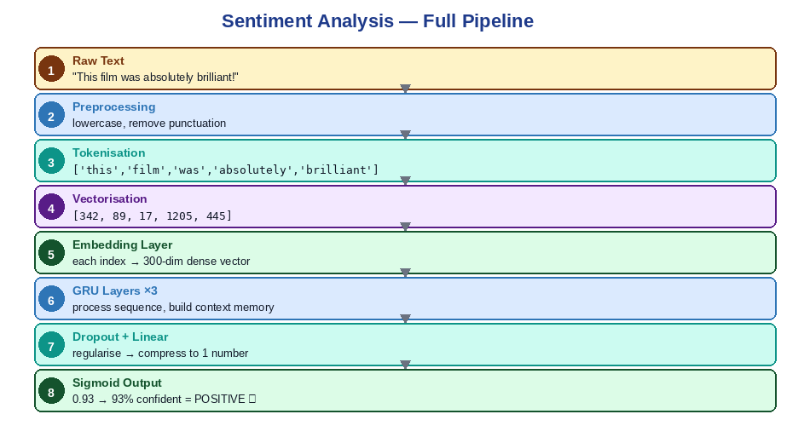

The Loss Function
The model is trained by minimising Binary Cross-Entropy Loss:
Loss = −[ y × log(ŷ) + (1 − y) × log(1 − ŷ) ]
Where y = true label (1=positive, 0=negative), ŷ = model's predicted probability.

Step-by-Step Loss Calculation
Case 1: True = positive (y=1), Model predicts 90% positive (ŷ=0.9)
Loss = −[1 × log(0.9) + 0 × log(0.1)]
= −log(0.9) = −(−0.105) = 0.105
→ Small loss — correct and confident ✓

Case 2: True = positive (y=1), Model predicts 10% positive (ŷ=0.1) — WRONG
Loss = −[1 × log(0.1) + 0 × log(0.9)]
= −log(0.1) = −(−2.303) = 2.303
→ Large loss — severely penalised ✓

Training minimises this loss across all 50,000 reviews.
Small loss = model is confident and correct.
Large loss = model is wrong → weights updated to improve.

Results
Test set: 10,000 reviews (never seen during training)
Overall accuracy: ~87%

CONFUSION MATRIX:
Predicted NEGATIVE Predicted POSITIVE
Actually NEGATIVE 4,151 ✓ 849 ✗
Actually POSITIVE 563 ✗ 4,437 ✓

→ The model gets 87% right on reviews it has never seen

What the Model Learned: Before training, positive and negative review words are randomly mixed. After training, they cluster into distinct regions — the embedding layer learned to move sentiment-similar words close together in vector space.

Final Summary
Topic | Core Idea | Key Formula | Problem Left
One-Hot | Mark one position as 1 | x(j)=1 if j=i, else 0 | No similarity
BoW | Count word frequency | BoW(d,w) = count(w in d) | Common words dominate
TF-IDF | Reward rare, distinctive words | TF × log(N÷(1+df)) | No semantic meaning
Word2Vec | Learn meaning from context | P(+|w,c) = sigmoid(c·w) | Fixed vector per word
Cosine Sim | Measure angle between vectors | cos(θ)=(a·b)÷(|a|×|b|) | Antonyms look similar
RNN | Hidden state passed word-by-word | h(t)=tanh(Wx+Uh(t-1)) | Forgets early words
LSTM | Two lanes + three gates | c(t)=f⊙c(t-1)+i⊙g(t) | Still sequential
GRU | One lane + complementary gates | h(t)=z⊙h(t-1)+(1-z)⊙h̃(t) | Still sequential
Sentiment | All concepts combined | Loss=-[y log(ŷ)+(1-y)log(1-ŷ)] | —

The Pattern That Connects Everything
One-Hot: no frequency info
↓ fixed by
Bag-of-Words: dominated by common words
↓ fixed by
TF-IDF: no semantic meaning
↓ fixed by
Word2Vec: one fixed vector per word (context-insensitive)
↓ combined with
RNN: forgets early words (vanishing gradient)
↓ fixed by
LSTM: still sequential — cannot parallelize
↓ simplified by
GRU: still sequential — cannot parallelize
↓ completely solved by
TRANSFORMER ← the next big topic
Processes ALL words simultaneously using attention.
Foundation of GPT, BERT, Claude, and all modern LLMs.

Final Thought: Every limitation led to a breakthrough. Understanding WHY each method was invented and WHAT problem it left behind is the foundation for understanding how modern AI — including the Transformer and large language models — actually works.

