SchemaEval
JSON Output Quality Evaluation Framework

Compare LLM-Generated JSON Against Golden Datasets
Jaccard • Cosine • Edit Distance • BLEU • Rouge-L • Field Diff • LLM Judge

Version 1.0 | April 2026
Design Document • DFD • HLD • LLD • Metrics Deep Dive • Dashboard Design

Table of contents
1. Executive summary
2. Architecture overview
3. Data flow diagrams (DFD)
4. High-level design (HLD)
5. Low-level design (LLD)
6. Evaluation metrics — Deep dive
7. Technology decisions and alternatives
8. Golden dataset design
9. Dashboard and visualization
10. API reference
11. Deployment architecture
12. Project structure
13. Setup and installation
14. Usage examples
15. Testing strategy
16. Project milestones
17. Contributing

1. Executive summary
SchemaEval is a comprehensive evaluation framework that measures the quality of JSON outputs generated by Large Language Models. It accepts two JSON inputs — one generated by an LLM pipeline and one from a curated golden dataset — and computes a battery of similarity, structural, and semantic metrics to produce an objective quality score.

1.1 Problem statement
LLM-generated structured outputs (JSON, schemas, configurations) are inherently non-deterministic. The same input prompt can produce subtly different outputs across model versions, temperature settings, or inference runs. Without systematic evaluation, structural regressions go undetected, incorrect fields silently pass through, and there is no objective way to compare prompt engineering changes or model upgrades.

1.2 Proposed solution
SchemaEval provides a multi-metric evaluation pipeline that compares LLM-generated JSON against golden reference datasets. It combines seven complementary metrics — from token-level string similarity to high-level semantic judgment — producing both individual metric scores and a weighted composite score. Results are visualized through an interactive dashboard with radar charts, trend lines, and field-level diff views.

1.3 Key features
- Seven evaluation metrics: Jaccard similarity, cosine distance, Levenshtein edit distance, BLEU score, Rouge-L score, field-level structural diff, and LLM-as-judge semantic evaluation.
- Two-input design: Every evaluation takes exactly two parameters — the LLM-generated JSON and the golden reference JSON — making the framework pipeline-agnostic.
- Interactive dashboard: Real-time visualization with radar charts for multi-metric views, trend charts for historical tracking, and side-by-side field-level diff viewers.
- Configurable weights: Each metric’s contribution to the composite score is configurable, allowing teams to prioritize what matters most for their use case.
- CI/CD integration: Exposes pass/fail signals for automated quality gates in deployment pipelines.
- Batch evaluation: Process entire golden datasets in one run, producing aggregate statistics and per-record breakdowns.

2. Architecture overview
SchemaEval follows a pipeline architecture with three major stages: input normalization, metric computation, and result visualization. The evaluation engine is designed to be stateless — each evaluation request is independent — while the dashboard maintains historical state for trend analysis.
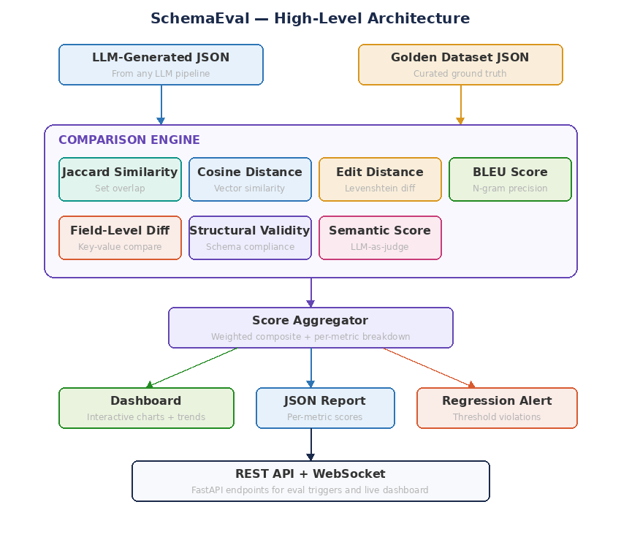
Figure 1: High-level architecture — Two JSON inputs through comparison engine to dashboard

2.1 Layer responsibilities
Layer | Components | Responsibility
Input | REST API, CLI, CI/CD hook | Accepts two JSON inputs (generated + golden), validates format, triggers evaluation
Normalization | JSON Normalizer | Sorts keys, normalizes whitespace, converts types for fair comparison
Metric Computation | 7 scorer classes | Computes Jaccard, cosine, edit distance, BLEU, Rouge-L, field diff, and LLM judge scores independently
Aggregation | ScoreAggregator | Combines individual scores using configurable weights into a composite score
Visualization | React dashboard | Renders radar charts, trend lines, field diff views, and KPI cards via WebSocket
Persistence | PostgreSQL + Redis | Stores evaluation run history for trend analysis; caches frequent computations

2.2 Design principles
- Pipeline-agnostic: The framework evaluates any JSON against any reference. It knows nothing about the upstream LLM pipeline, making it reusable across projects.
- Metric independence: Each scorer is a standalone class with no dependencies on other scorers. Metrics can be added, removed, or weighted without touching other components.
- Deterministic + semantic: Combines deterministic code-based metrics (Jaccard, edit distance) with semantic LLM-based evaluation, covering both structural and meaning-level quality.
- Real-time + batch: Supports single-pair evaluation via API and batch processing of entire golden datasets via worker queues.

3. Data flow diagrams (DFD)
The data flow diagrams show how information moves through SchemaEval at two levels of abstraction.

3.1 DFD Level 0 — Context diagram
The context diagram shows SchemaEval as a single process interacting with five external entities: the LLM pipeline providing generated JSON, the golden dataset store, the dashboard UI consuming results, the CI/CD pipeline receiving pass/fail signals, and the developer triggering evaluations.
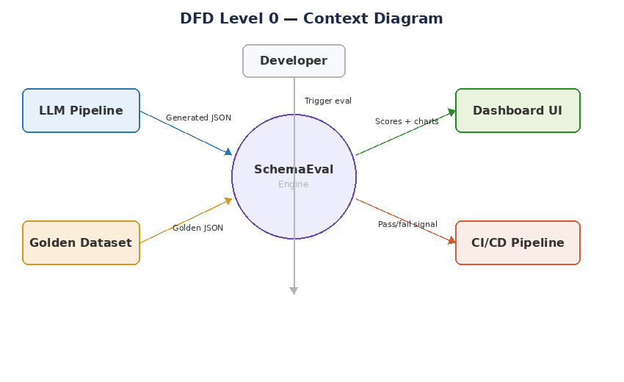
Figure 2: DFD Level 0 — Context diagram
Entity | Data exchanged | Direction
LLM Pipeline | Generated JSON string | Inbound
Golden Dataset | Reference JSON string + metadata | Inbound
Dashboard UI | Scores, charts, field diffs | Outbound
CI/CD Pipeline | Pass/fail signal + composite score | Outbound
Developer | Evaluation trigger + configuration | Inbound

3.2 DFD Level 1 — Detailed evaluation flow
Level 1 decomposes SchemaEval into six processes and three data stores, revealing the internal transformation steps from raw inputs to visualized results.
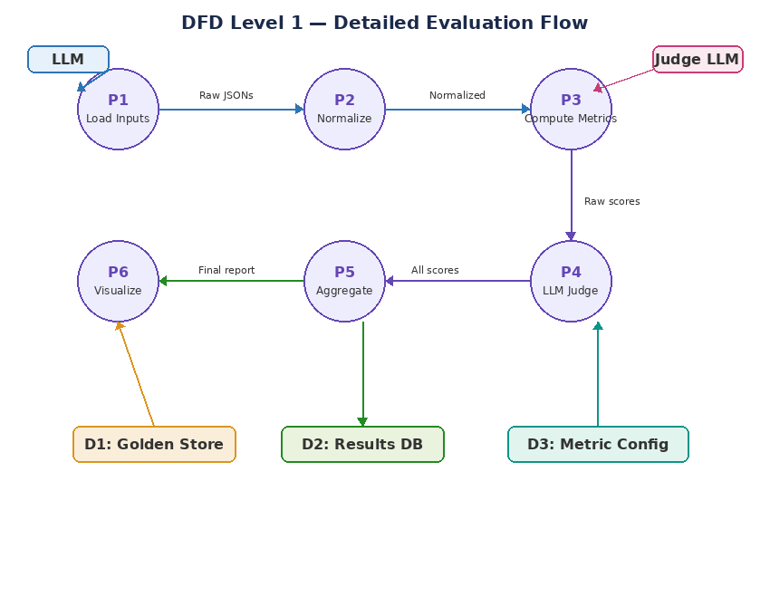
Figure 3: DFD Level 1 — Six processes and three data stores
Process | Input | Output | Description
P1: Load Inputs | Raw JSON strings | Parsed dict objects | Loads and parses both generated and golden JSON from API request or file
P2: Normalize | Parsed dicts | Normalized dicts | Sorts keys recursively, normalizes whitespace, converts numeric strings to numbers
P3: Compute Metrics | Normalized pair | 7 raw metric scores | Runs all scorer classes in parallel, each producing an independent score
P4: LLM Judge | Normalized pair | Semantic score + verdict | Sends both JSONs to judge LLM with a rubric prompt for semantic evaluation
P5: Aggregate | All scores + weights | Composite score + report | Computes weighted average, determines pass/fail, generates structured report
P6: Visualize | EvalReport | Charts + dashboard | Pushes results to dashboard via WebSocket, persists to results DB for trends

4. High-level design (HLD)
The high-level design organizes SchemaEval into four architectural layers: API, Evaluation Engine, Visualization, and Data.
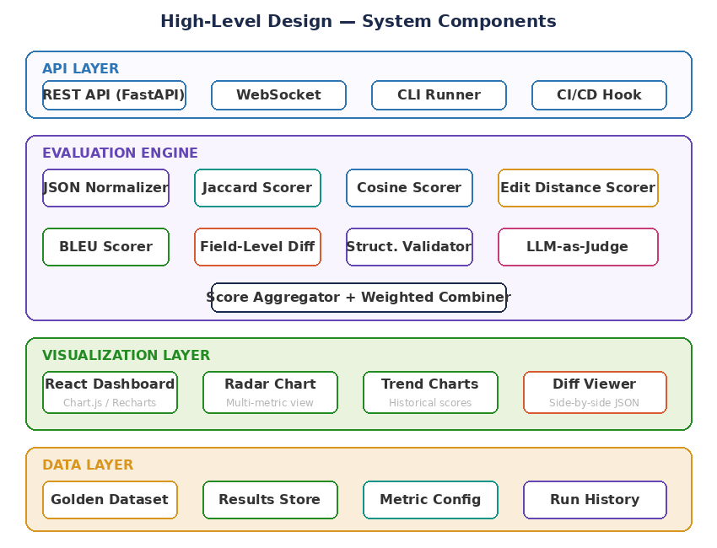
Figure 4: HLD — Four-layer component architecture

4.1 API layer
The API layer provides four access points. The REST API (FastAPI) handles single-pair and batch evaluation requests with auto-generated Swagger documentation. WebSocket support enables real-time score streaming to the dashboard. The CLI runner enables command-line evaluation for scripting and local development. The CI/CD hook provides a lightweight endpoint that returns a pass/fail exit code for integration into GitHub Actions, GitLab CI, or Jenkins pipelines.

4.2 Evaluation engine
The evaluation engine contains eight independent components. The JSON Normalizer prepares inputs for fair comparison. Seven scorer classes each implement a single metric. The Score Aggregator combines all scores using configurable weights. Each scorer follows the same interface: accept two normalized dicts, return a float score between 0.0 and 1.0 (except Field-Level Diff which returns a structured diff object).

4.3 Visualization layer
The visualization layer is a React + TypeScript application with four core views. The Radar Chart shows all metrics simultaneously for a single evaluation. The Trend Chart tracks scores over time across multiple evaluation runs. The Diff Viewer displays side-by-side JSON with highlighted differences. The KPI Cards show headline scores at a glance. All views update in real-time via WebSocket as evaluations complete.

4.4 Data layer
The data layer comprises four stores. The Golden Dataset store holds curated reference JSONs organized by test category. The Results Store (PostgreSQL) persists every evaluation run with full metric breakdowns for historical analysis. The Metric Config store holds weight configurations and scoring thresholds. The Run History provides the data backend for trend visualization.

5. Low-level design (LLD)

5.1 Core class structure
SchemaEval is organized around nine core classes. The EvalEngine orchestrates the pipeline, delegating to seven scorer classes and one aggregator.
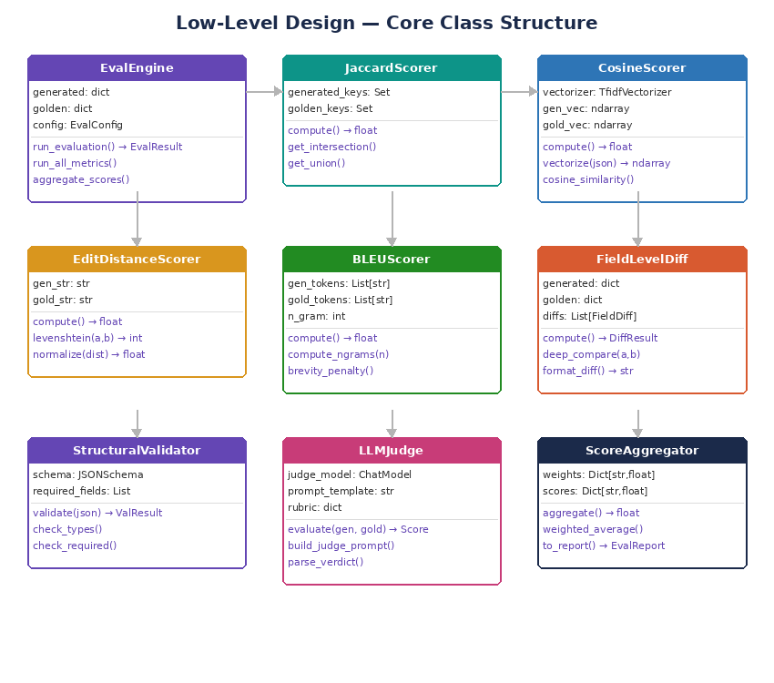
Figure 5: LLD — Core class structure with attributes and methods

5.2 Data models (Pydantic)
Model | Key fields | Purpose
EvalRequest | generated_json: str, golden_json: str, config: Optional[EvalConfig] | Incoming API request
EvalConfig | weights: Dict[str,float], threshold: float, metrics: List[str] | Evaluation configuration
MetricScore | name: str, score: float, details: Optional[dict] | Individual metric result
FieldDiff | path: str, generated_value: Any, golden_value: Any, match: bool | Single field difference
DiffResult | total_fields: int, matching: int, added: int, removed: int, changed: int, diffs: List[FieldDiff] | Complete diff summary
SemanticVerdict | grade: bool, confidence: float, justification: str, completeness_level: int | LLM judge output
EvalResult | composite_score: float, passed: bool, metrics: List[MetricScore], diff: DiffResult, semantic: SemanticVerdict | Complete evaluation result
EvalReport | request_id: str, timestamp: datetime, result: EvalResult, config_used: EvalConfig | Persistable report

5.3 Sequence diagram — Evaluation flow
The sequence diagram traces a complete evaluation from API request through all components to dashboard rendering.
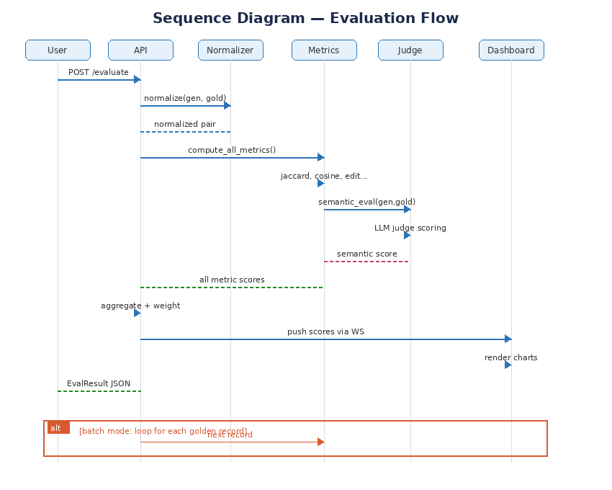
Figure 6: Sequence diagram — Full evaluation flow with batch mode

5.4 Scorer interface
All scorers implement a common interface. This allows the EvalEngine to treat them uniformly and makes adding new metrics trivial.
Method | Parameters | Returns | Description
compute() | generated: dict, golden: dict | float | Computes the metric score. Returns 0.0–1.0 where 1.0 is perfect match.
name() | none | str | Returns the metric name for reporting (e.g., "jaccard_similarity").
supports_details() | none | bool | Whether this scorer provides detailed breakdown beyond the float score.
get_details() | none | dict | Returns detailed breakdown (e.g., intersection/union sets for Jaccard, diff list for FieldDiff).

6. Evaluation metrics — Deep dive
SchemaEval implements seven evaluation metrics, each capturing a different dimension of JSON quality. This section provides implementation-level detail on each metric.
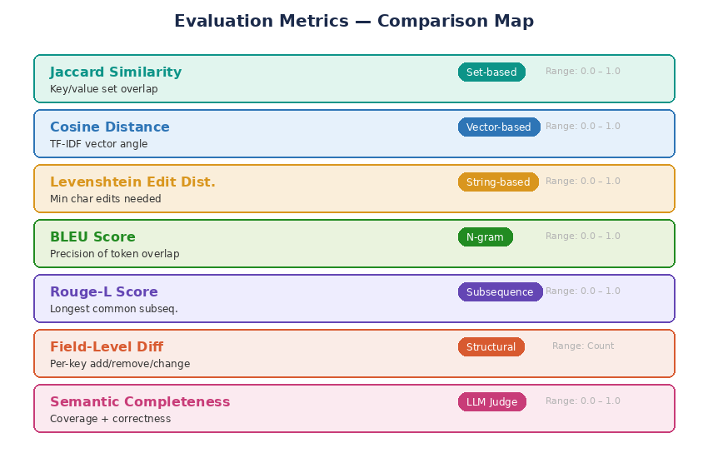
Figure 7: Evaluation metrics overview — Seven metrics across five categories

6.1 Jaccard similarity
Category: Set-based comparison
Formula: J(A,B) = |A ∩ B| / |A ∪ B| where A and B are sets of flattened key-value pairs
Range: 0.0 (no overlap) to 1.0 (identical sets)
The generated and golden JSONs are flattened into sets of dot-notation key-value pairs (e.g., {"questions[0].type": "5", "name": "Office Supply"}). The Jaccard index measures the overlap between these two sets. This metric is sensitive to missing or extra fields but insensitive to field ordering.
Strengths: Intuitive, fast to compute, captures missing and extra fields.
Limitations: Treats all fields equally regardless of importance. A missing field name has the same impact as a missing nested behavior condition.

6.2 Cosine distance
Category: Vector-based comparison
Formula: cos(θ) = (A · B) / (||A|| × ||B||) where A and B are TF-IDF vectors of JSON token streams
Range: 0.0 (orthogonal) to 1.0 (identical direction)
Both JSONs are serialized into token streams (keys, values, structural tokens), then converted to TF-IDF vectors using scikit-learn’s TfidfVectorizer. The cosine similarity between these vectors measures how similar the overall content distribution is, regardless of exact positioning. This metric is robust to reordering but less sensitive to individual field-level differences.
Strengths: Robust to token reordering. Captures overall content similarity even when structure differs.
Limitations: Loses structural information. Two JSONs with the same tokens in completely different structures score high.

6.3 Levenshtein edit distance
Category: String-based comparison
Formula: normalized_score = 1 - (levenshtein(A,B) / max(len(A), len(B)))
Range: 0.0 (completely different) to 1.0 (identical strings)
Both JSONs are serialized to canonical strings (sorted keys, consistent formatting) and the Levenshtein distance is computed. This gives the minimum number of single-character edits (insertions, deletions, substitutions) needed to transform one into the other. The raw distance is normalized by the length of the longer string to produce a 0–1 score.
Strengths: Captures fine-grained character-level differences. Sensitive to typos in values.
Limitations: Expensive for large JSONs (O(n²)). Sensitive to formatting and key ordering if not pre-normalized.

6.4 BLEU score
Category: N-gram precision
Formula: BLEU = BP × exp(∑ w_n × log(p_n)) where p_n is modified precision for n-grams, BP is brevity penalty
Range: 0.0 to 1.0
Originally designed for machine translation evaluation, BLEU measures how many n-grams (sequences of n tokens) in the generated JSON appear in the golden JSON. We tokenize both JSONs at the word/symbol level and compute BLEU with n-grams from 1 to 4. The brevity penalty penalizes generated JSONs that are significantly shorter than the reference.
Strengths: Well-established metric with known properties. Good at catching missing content.
Limitations: Precision-focused; doesn’t penalize extra content as much as missing content. Not designed for structured data.

6.5 Rouge-L score
Category: Longest common subsequence
Formula: Rouge-L = F-measure of LCS precision and recall
Range: 0.0 to 1.0
Rouge-L computes the longest common subsequence (LCS) between the token streams of both JSONs. Unlike BLEU which looks at contiguous n-grams, LCS captures in-order token matches that may be separated by intervening tokens. This makes it better at detecting structural similarities even when fields are interspersed differently.
Strengths: Captures ordering and structural patterns. Complements BLEU by measuring recall alongside precision.
Limitations: Single-number summary loses information about where differences occur.

6.6 Field-level structural diff
Category: Structural comparison
Output: DiffResult with counts of matching, added, removed, and changed fields plus per-field details
This metric recursively traverses both JSONs in parallel, comparing values at each key path. It produces a detailed diff report showing exactly which fields match, which are added in the generated but not in golden, which are missing from generated, and which have different values. Unlike the other metrics which produce a single float, this one produces actionable diagnostic information.
Strengths: Most actionable metric. Tells you exactly what to fix. Powers the side-by-side diff viewer in the dashboard.
Limitations: Not a similarity score — it’s a diagnostic tool. The match percentage can be derived but is less nuanced than Jaccard.

6.7 Semantic completeness (LLM-as-judge)
Category: LLM-based semantic evaluation
Output: SemanticVerdict with grade (pass/fail), confidence (0–100%), justification, and completeness level (1–3)
A judge LLM receives both the generated and golden JSONs along with a structured rubric prompt. It evaluates whether the generated JSON captures the same semantic meaning as the golden reference — not just the same tokens, but the same intent. This catches cases where the structure is different but the meaning is equivalent (e.g., different key names for the same concept) as well as cases where the structure matches but the meaning diverges.
Strengths: Catches semantic equivalences and divergences that no code-based metric can detect. Provides human-readable justification.
Limitations: Non-deterministic. Depends on judge model quality. Slower and more expensive than code-based metrics.

6.8 Metric weight configuration
The composite score is computed as a weighted average of all enabled metrics. Default weights are tuned for JSON evaluation but are fully configurable per evaluation run.
Metric | Default weight | Rationale
Jaccard similarity | 0.20 | Strong overall structural similarity signal
Cosine distance | 0.10 | Captures content overlap independent of structure
Edit distance | 0.10 | Fine-grained character-level differences
BLEU score | 0.10 | N-gram precision for token-level quality
Rouge-L score | 0.10 | Ordering and recall complement to BLEU
Field-level diff (match %) | 0.15 | Direct structural correctness measure
Semantic completeness | 0.25 | Highest weight because it captures meaning, not just form

7. Technology decisions and alternatives
Each technology choice is documented with rationale and considered alternatives.

7.1 Core framework: Python + FastAPI
Why: Python dominates the NLP and ML evaluation ecosystem. Libraries like scikit-learn (TF-IDF, cosine), nltk (BLEU, Rouge), and python-Levenshtein are all native Python. FastAPI provides async endpoints for concurrent evaluations and auto-generated API docs.
Alternative | Strengths | Why not chosen
Node.js + Express | Fast, event-loop async | NLP/evaluation libraries are Python-native. Cross-language FFI adds complexity.
Go + Gin | High performance, compiled | Same library ecosystem issue. Go lacks mature NLP evaluation packages.
Flask | Simpler, widely known | No native async. SchemaEval benefits from concurrent metric computation.

7.2 Similarity computation: scikit-learn + nltk
Why: scikit-learn’s TfidfVectorizer and cosine_similarity are production-grade, well-tested implementations. nltk provides BLEU and Rouge scoring out of the box. python-Levenshtein is a C-optimized extension for edit distance.
Alternative | Strengths | Why not chosen
spaCy | Faster tokenization, better NER | Overkill for JSON tokenization. scikit-learn is lighter and sufficient.
sentence-transformers | Embedding-based similarity | Adds a model dependency. TF-IDF is sufficient for JSON token comparison.
Custom implementations | Full control | Reinventing well-tested algorithms is unnecessary risk.

7.3 Dashboard: React + Recharts
Why: React’s component model suits the dashboard’s multi-view layout (radar, trend, diff). Recharts provides ready-made responsive chart components that handle the radar and line charts natively. WebSocket integration for real-time updates is straightforward with React hooks.
Alternative | Strengths | Why not chosen
Streamlit | Rapid prototyping, Python-only | Limited customization for complex layouts. No WebSocket control.
Grafana | Excellent for time-series dashboards | Requires separate data source configuration. Less flexible for custom diff views.
D3.js (raw) | Maximum control | Development time for radar + trend + diff views is prohibitive vs. Recharts.
Vue + Chart.js | Lighter bundle, reactive | Smaller ecosystem for real-time dashboard patterns.

7.4 Persistence: PostgreSQL + Redis
Why: PostgreSQL stores evaluation run history with full metric breakdowns — ideal for trend queries with date-range filtering. Redis caches golden dataset records and frequently computed TF-IDF vectors to reduce latency on repeated evaluations.
Alternative | Strengths | Why not chosen
SQLite | Zero-config, embedded | No concurrent write support for batch evaluation runs.
MongoDB | Flexible schema for eval results | Overkill for structured evaluation results. PostgreSQL’s JSONB covers flexibility needs.
File-based (JSON) | Simplest possible storage | No query capability. Trend analysis requires SQL.

8. Golden dataset design
The golden dataset is the foundation of SchemaEval. It contains curated pairs of inputs and expected outputs that serve as ground truth for evaluation.

8.1 Record structure
Field | Type | Description
record_id | UUID | Unique identifier for each golden record
category | string | Test category (e.g., simple, complex, edge_case, adversarial)
description | string | Human-readable description of what this test case covers
input_prompt | string | The original natural language prompt that was given to the LLM
golden_json | JSON string | The expected/correct JSON output for this prompt
metadata | dict | Additional context: author, date created, difficulty, tags

8.2 Coverage categories
Category | Example | Why included
Simple | Single-table with 3–4 fields | Baseline correctness for straightforward inputs
Multi-field | Form with 8+ fields of mixed types | Tests handling of complex, interleaved field types
Nested structures | JSON with deeply nested objects/arrays | Validates recursive comparison across all metrics
Reference fields | Fields pointing to external tables/records | Tests correct mapping of reference-type fields
Conditional logic | Behavior rules with AND/OR conditions | Most common failure point in generation
Auto-populate chains | Field A populates Field B which populates C | Tests multi-hop relationship generation
Edge cases | Empty fields, unicode, extremely long values | Ensures robustness under unusual inputs
Adversarial | Ambiguous or contradictory prompts | Tests graceful degradation rather than hallucination

8.3 Why the golden dataset is critical
- Ground truth for metrics: Jaccard, cosine, edit distance, BLEU, and Rouge-L all measure similarity relative to a reference. Without the golden dataset, there is no baseline.
- Deterministic regression detection: Because golden records are fixed, any change in LLM output quality is immediately visible when re-running evaluation against the same dataset.
- Automated evaluation: The input-output pairing makes evaluation fully automated — no human judgment required per run.
- Coverage tracking: Evaluation failures reveal gaps, guiding the addition of new test cases to continuously improve coverage.

9. Dashboard and visualization
The dashboard provides four views for understanding evaluation results at different levels of detail.
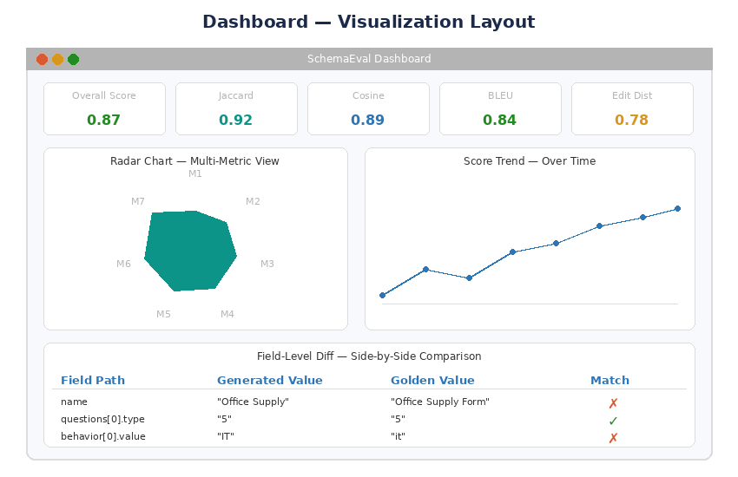
Figure 8: Dashboard wireframe — KPIs, radar chart, trend chart, and diff viewer

9.1 KPI cards (top row)
Five headline metrics displayed as cards: composite score, Jaccard, cosine, BLEU, and edit distance. Each card shows the current score with color coding (green > 0.85, amber 0.70–0.85, red < 0.70). Cards update in real-time via WebSocket as evaluations complete.

9.2 Radar chart (left panel)
A seven-axis radar chart showing all metric scores simultaneously for a single evaluation. This view instantly reveals which dimensions are strong and which are weak. Hovering over a vertex shows the exact score and metric name. Multiple evaluation runs can be overlaid for comparison.

9.3 Trend chart (right panel)
A line chart tracking composite score and individual metric scores across evaluation runs over time. Supports date-range filtering, per-metric toggle, and annotation of significant events (prompt changes, model upgrades). This is the primary view for detecting regressions.

9.4 Field-level diff viewer (bottom panel)
A side-by-side table showing every field path from the generated and golden JSONs with match/mismatch indicators. Mismatched fields are highlighted in red with the specific values displayed. This view is powered by the FieldLevelDiff scorer and provides the most actionable diagnostic information for prompt engineers.

10. API reference

10.1 Endpoints
Endpoint | Method | Description
POST /api/evaluate | POST | Evaluate a single generated JSON against a golden reference
POST /api/evaluate/batch | POST | Evaluate against all records in a golden dataset
GET /api/results/{run_id} | GET | Retrieve results for a specific evaluation run
GET /api/results/trend | GET | Get score trends over time with date-range filtering
GET /api/golden | GET | List all golden dataset records with metadata
POST /api/golden | POST | Add a new record to the golden dataset
GET /api/config | GET | Get current metric weights and thresholds
PUT /api/config | PUT | Update metric weights and thresholds
GET /api/health | GET | Health check with component status
WS /ws/live | WebSocket | Real-time score streaming for dashboard

10.2 Evaluate endpoint detail

Request body
Field | Type | Required | Description
generated_json | string (JSON) | Yes | The LLM-generated JSON string to evaluate
golden_json | string (JSON) | Yes | The golden reference JSON string
config.weights | Dict[str,float] | No | Override default metric weights
config.threshold | float | No | Override pass/fail threshold (default: 0.8)
config.metrics | List[str] | No | Enable only specific metrics (default: all)
config.include_details | bool | No | Include per-metric details in response (default: true)

Response body
Field | Type | Description
composite_score | float | Weighted composite score (0.0–1.0)
passed | bool | Whether composite score meets threshold
metrics | List[MetricScore] | Per-metric scores with optional details
diff | DiffResult | Field-level diff summary and per-field details
semantic | SemanticVerdict | LLM judge output with grade, confidence, justification
run_id | UUID | Unique ID for this evaluation run (for trend tracking)
duration_ms | int | Total evaluation time in milliseconds

11. Deployment architecture
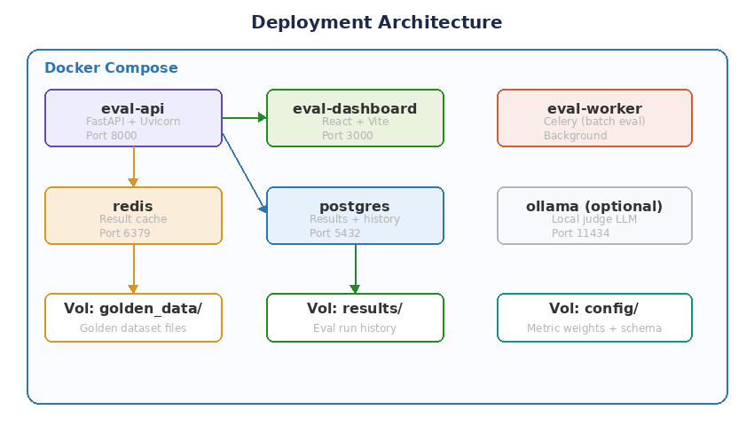
Figure 9: Docker Compose deployment with six containers
Container | Image | Port | Purpose
eval-api | python:3.11-slim + deps | 8000 | FastAPI server with evaluation engine
eval-dashboard | node:18-alpine | 3000 | React dashboard with Recharts
eval-worker | Same as API | none | Celery worker for batch evaluations
redis | redis:7-alpine | 6379 | Cache + Celery broker
postgres | postgres:16-alpine | 5432 | Results storage + run history
ollama (optional) | ollama/ollama | 11434 | Local LLM for semantic judge (offline mode)

12. Project structure
Directory / file | Description
app/ | Main Python application package
app/api/routes.py | FastAPI endpoints for evaluation, golden dataset, and config
app/api/websocket.py | WebSocket handler for real-time dashboard updates
app/core/engine.py | EvalEngine: orchestrates normalization, scoring, and aggregation
app/core/normalizer.py | JSON normalization: key sorting, whitespace, type coercion
app/scorers/jaccard.py | Jaccard similarity scorer
app/scorers/cosine.py | Cosine distance scorer (TF-IDF based)
app/scorers/edit_distance.py | Levenshtein edit distance scorer
app/scorers/bleu.py | BLEU score scorer
app/scorers/rouge.py | Rouge-L score scorer
app/scorers/field_diff.py | Field-level structural diff
app/scorers/llm_judge.py | LLM-as-judge semantic evaluator
app/aggregator.py | ScoreAggregator: weighted combination and pass/fail
app/models/ | Pydantic models for requests, responses, scores, diffs
app/golden/ | Golden dataset storage and management
app/config/ | Metric weights, thresholds, and scorer configuration
frontend/ | React + TypeScript dashboard
frontend/src/components/RadarChart.tsx | Seven-axis radar chart component
frontend/src/components/TrendChart.tsx | Historical score trend line chart
frontend/src/components/DiffViewer.tsx | Side-by-side JSON diff viewer
frontend/src/components/KPICards.tsx | Headline metric cards
tests/ | Unit and integration tests
tests/unit/scorers/ | Per-scorer unit tests with known input/output pairs
tests/integration/ | Full pipeline tests
docker-compose.yml | Development environment
config.yaml | Default metric weights and thresholds
Makefile | Common commands: test, lint, eval, dashboard

13. Setup and installation

13.1 Prerequisites
- Python 3.11+
- Node.js 18+ (for dashboard)
- Docker + Docker Compose (recommended)
- At least one LLM API key for semantic judge (or Ollama for local)

13.2 Quick start
- Clone the repository: git clone https://github.com/your-org/schemaeval.git
- Copy environment template: cp .env.example .env
- Add your LLM API key to .env for the semantic judge.
- Start all services: docker compose up -d
- API available at http://localhost:8000/docs, dashboard at http://localhost:3000.

13.3 Manual setup
- Create virtual environment: python -m venv .venv && source .venv/bin/activate
- Install dependencies: pip install -r requirements.txt
- Start Redis and PostgreSQL (or use in-memory/SQLite for development).
- Run API: uvicorn app.main:app --reload --port 8000
- Run dashboard: cd frontend && npm install && npm run dev

14. Usage examples

14.1 Single evaluation
Send a POST to /api/evaluate with two JSON strings. The response contains all seven metric scores, the composite score, pass/fail status, and the field-level diff.
Example input: generated_json from your LLM pipeline output, golden_json from the golden dataset record for the same input prompt.

14.2 Batch evaluation
Send a POST to /api/evaluate/batch with the golden dataset ID. The system evaluates the LLM’s output for every record in the dataset, producing per-record scores and aggregate statistics (mean, median, min, max for each metric).

14.3 CI/CD integration
Add a step to your CI pipeline that calls /api/evaluate/batch and checks the response’s passed field. If false, the pipeline fails, preventing deployment of a prompt change that degrades quality.

14.4 A/B comparison
Run batch evaluation twice — once with Prompt Version A’s outputs, once with Prompt Version B’s outputs — against the same golden dataset. Compare the composite scores and per-metric breakdowns in the trend chart to decide which prompt to ship.

15. Testing strategy
- Unit tests (70%): Each scorer is tested with known input pairs where the expected score is pre-computed. Example: Jaccard of {"a":1} vs {"a":1} = 1.0; Jaccard of {"a":1} vs {"b":2} = 0.0.
- Integration tests (20%): Full pipeline from API request to EvalResult, using a small golden dataset of 10 records.
- Property-based tests (10%): Hypothesis generates random JSON pairs and verifies that all scorers return values in [0.0, 1.0] and that identical inputs always score 1.0.
Component | Test scenario | Assertion
JaccardScorer | Identical JSONs | Score = 1.0
JaccardScorer | Completely different JSONs | Score = 0.0
CosineScorer | Same tokens, different order | Score > 0.9
EditDistanceScorer | One character different | Score close to 1.0
BLEUScorer | Empty generated JSON | Score = 0.0
FieldLevelDiff | Extra field in generated | added count = 1
LLMJudge | Semantically equivalent JSONs | grade = true
ScoreAggregator | All scores = 1.0 | Composite = 1.0
Normalizer | Unsorted keys | Output keys are sorted
Full pipeline | Golden record | Composite > threshold

16. Project milestones
Milestone | Timeline | Deliverables
M1: Foundation | Week 1–2 | FastAPI scaffold, Pydantic models, JSON normalizer, EvalEngine skeleton, Jaccard and edit distance scorers
M2: Core metrics | Week 3–4 | Cosine scorer (TF-IDF), BLEU scorer, Rouge-L scorer, field-level diff, ScoreAggregator with configurable weights
M3: LLM judge | Week 5–6 | LLM-as-judge integration, judge prompt engineering, SemanticVerdict model, multi-provider support (OpenAI/Anthropic/Ollama)
M4: Golden dataset | Week 7–8 | Golden dataset schema, CRUD API, batch evaluation endpoint, per-record and aggregate reporting
M5: Dashboard | Week 9–10 | React frontend, radar chart, trend chart, diff viewer, KPI cards, WebSocket real-time updates
M6: Polish + deploy | Week 11–12 | Docker Compose, CI/CD hook, CLI runner, comprehensive tests, documentation, performance benchmarks

17. Contributing
Contributions are welcome. Please follow these guidelines:
- Fork the repository and create a feature branch from main.
- Write tests for new scorers: each scorer needs at least 5 test cases with pre-computed expected scores.
- Ensure all tests pass: make test
- Format code with Black, lint with ruff.
- Update metric documentation if adding a new scorer.
- Submit a PR with clear description of the metric, its formula, and why it adds value.

Measure what matters. Trust what you ship.

