Database schema:

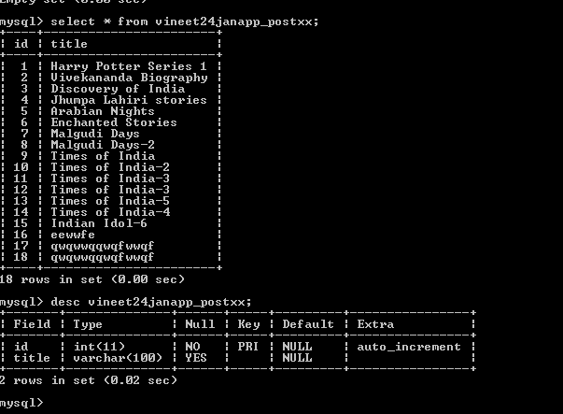

Forms.py

class PostxxForm(forms.ModelForm):

class Meta:

model = Postxx

#fields = ['title']

exclude = ()

Views.py

def cachetbl(request):

entry = Postxx.objects.get(title='Malgudi Days')

entry2 = Postxx.objects.get(id=8)

#cache.set()

if request.method == "POST":

form = PostxxForm(request.POST)

if form.is_valid():

title1 = form.cleaned_data['title']

save_in_mysql = Postxx(title = title1)

save_in_mysql.save()

else:

form = PostxxForm()

return render(request, 'cache1.html',{'form':form,'entry':entry, 'entry2':entry2})

urls.py

from views import PostCreate, cachetbl

url(r'^cache1/$', views.cachetbl, name='cache1test')

