Debug Academy HTML/CSS Guided self-study

For additional practice, attempt any section that was not fully completed during class.

Get stuck or have a question while working on this? It would be surprising not to! Reach out to jack.garratt@debugacademy.com with questions - we’re more than happy to assist!

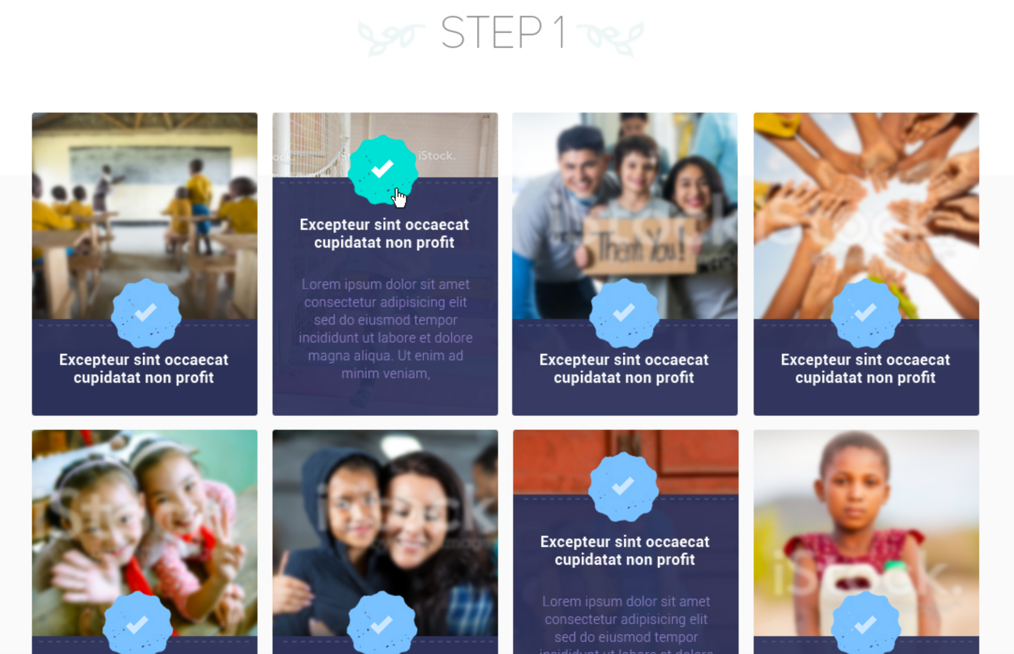
Guidance is provided below:

Code the section’s HTML

Edit the file named homepage.html. This section's HTML code should replace the line that says <!-- The "Step 1" section -->.

This section consists of at least the following elements:

Use an <h2> tag to write the 'Step 1' heading. Note: the flowers will be added to the h2 as part of the CSS in the next step.

Create an unordered list to hold the 'organizations'. Each list item will contain one organization.

We need to decide how to structure the contents of each list item.

Because the background image is part of the content (i.e. is unique to each organization), I would consider it 'content' rather than styling. Therefore, the images should be placed using HTML img tags.

Each list item could contain at least:

a link tag <a> for the title

a paragraph tag <p> for the paragraph of text

an <img> tag for the org's image

Note: You can use any image you'd like for the org images. Three are provided:

images/content/org1.gif

images/content/org2.gif

images/content/org3.gif

Below, you can see how an organization's could be coded within a list item:

<li> <img src="images/content/org1.gif"> <div class="content-overlay"> <a href="#">Organization Name</a> <p>Paragraphs about an organization</p> </div> </li>

Test, save, and commit your work at this point.

Code the section’s CSS

Now that we have our HTML written, we will use CSS to style and arrange it. Note: You will likely update your HTML while writing your CSS (to add classes, IDs, and sometimes to make other minor changes to simplify styling).

Adding the heading text design/images

Set the image "images/heading-flowers.png" as the background image for the <h2> containing the text Step 1. You should add a class either directly to the h2 and/or to the div containing the entire section so that you can target it using a CSS selector.

Ensure the background image does not repeat and that it is positioned appropriately (you may need to adjust the background position). The inspector tool is helpful when adjusting the background image's position, if that ends up being necessary.

Upon completion of the sub-task, save the file, git add, and git commit your work.

Styling the organization items

Ensure the list items are side-by-side rather than above one another.

Remember, the images for each organization were set in the HTML

Set the width and height of each list item appropriately -- They should all be 240px wide, 323px tall

The purple background uses an image: "images/purple-cause-hover.png" -- The purple background section should have a width of 240px and a height of 299px -- Leave the purple background in its 'expanded' state (see the second organization in the continuousgood.jpg image)

The link font color is white: #ffffff

The paragraph font color is light purple: #877dbc

The list items should have spacing in-between one another

Possible fonts include "Montserrat" or "Roboto". They are freely available on Google Fonts.

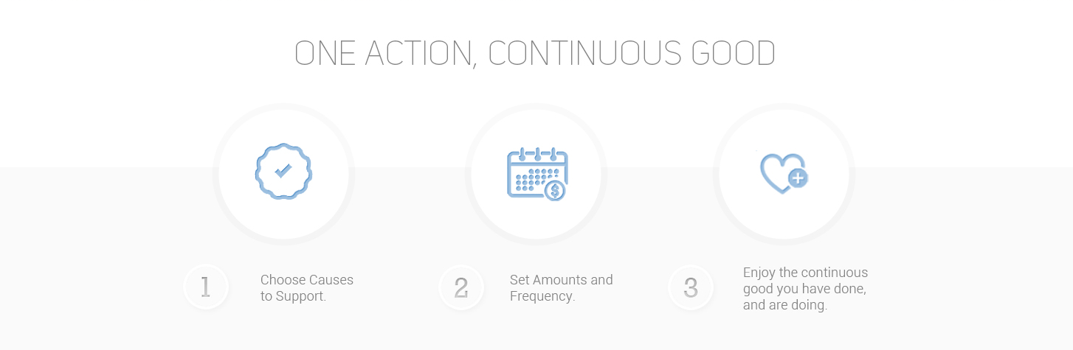

Code the One Action section's HTML

/ Note: the black borders are not part of the design
Edit the file named homepage.html. This section's HTML code should replace the line that says <!-- The "One action, continuous good" section -->.
This section consists of the following elements:
- You should use an appropriate heading tag (h1, h2, h3, etc.) to add the header text of this section (One action, continuous good)
- This should be an unordered list
  - Each list item should contain the following:
    - Its circle image <img>
      - Inner-circle images:
        - The checkbox: images/circle-icon-check.jpg
        - The calendar: images/circle-icon-cal.jpg
        - The heart: images/circle-icon-heart.jpg
    - Its number (1, 2, or 3) wrapped in a span tag (which will be used for CSS targeting)
      - This gives us a way to target the numbers for styling purposes
    - Its text wrapped in a p tag
      - Text:
        - Choose Causes to Support.
        - Set Amounts and Frequency.
        - Enjoy the continuous good you have done, and are doing.
Test and save your work at this point.

Code the One Action section's CSS
Now that we have our HTML written, we will use CSS to style and arrange it. Note: You will likely update your HTML while writing your CSS (to add classes, IDs, and sometimes to make other minor changes to simplify styling).
- The Background image for the entire "One Action" section: images/lightgray-bg.gif
  - ONLY repeats horizontally
  - Background image aligned at the bottom of the div
  - Background color for entire section: #ffffff
- Set the large circle background image to appear behind each of the "circle images":
  - images/circle-section1.png
  - Note: Image sizes can be found by opening the image in sublime text 3
- Set the small circle background image behind the numbers (#1, #2, #3):
  - images/circle-section1.png
  - Note: Image sizes can be found by opening the image in sublime text 3
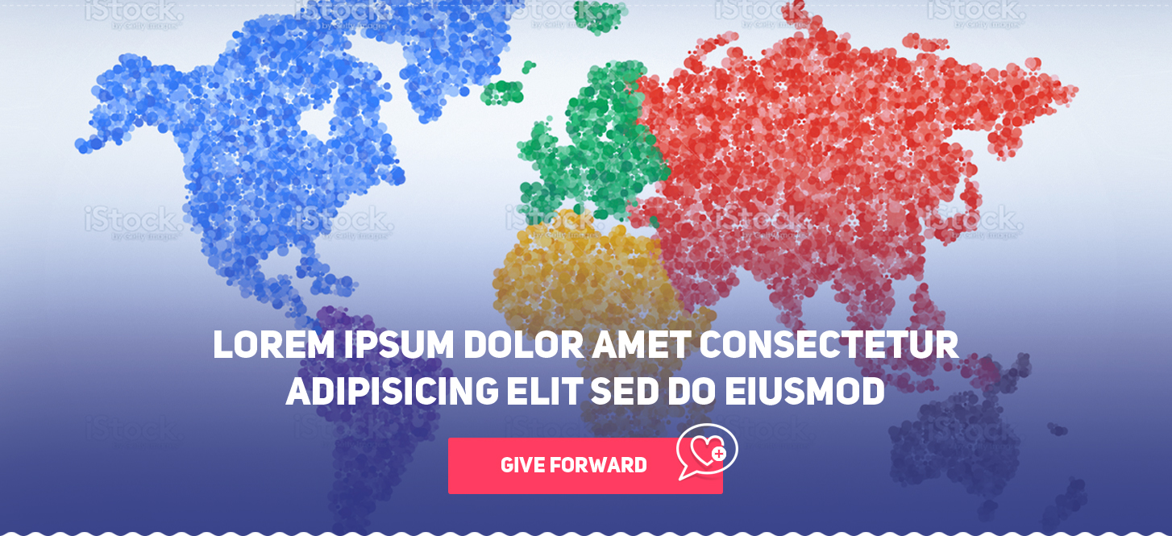

Code the hero's HTML
Edit the file named homepage.html. The hero's HTML code should replace the line that says <!-- The hero section -->.
The hero section consists of the following elements:
- A paragraph <p> with one or more lines of text (The "Lorem ipsum..")
- A link with the words "Give Forward"
  - <a href="#">Give Forward</a>
- Note: The background image and the Give Forward button can both be considered styling - so they should NOT be coded in the HTML file.

Code the hero's CSS
Now that we have our hero's HTML written, we will use CSS to style and arrange it.
- Set the height of the hero div to 665px
- Set the background image for the hero div:
  - Use this image: images/Header-StockPhoto.jpg
- Target the paragraph p within the hero div
  - Center it horizontally
  - Position it vertically
    - This can be done using:
      - Setting position: relative; on the hero div
      - Setting position: absolute; on the <p> in the hero div
- Target the link within the hero div
  - Set the width to 379px
  - Set the height to 107px
  - Center it
  - Set its background image to "images/button-givefwd.png"

Submission:
- To receive feedback, email the homepage.html and style.css files to jack.garratt@debugacademy.com
- Be sure to provide a synopsis of what you worked on, struggled with, or what you learned!
- Continue learning HTML and CSS – we will cover these same topics as well as more advanced topics like responsive design and flex box in Debug Academy’s Drupal Developer course!

