1. Run nslookup to obtain the IP address of a Web server in Asia. What is the IP address of that server?
- IP Address is 123.30.181.113
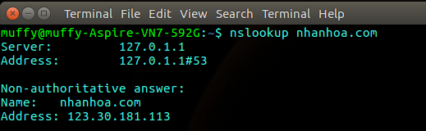
2. Run nslookup to determine the authoritative DNS servers for a university in Europe.
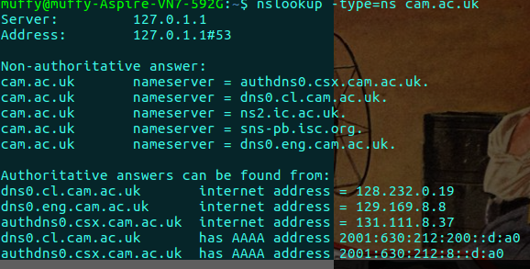
Authoritative answers can be found from:
dns0.cl.cam.ac.uk internet address = 128.232.0.19
dns0.eng.cam.ac.uk internet address = 129.169.8.8
authdns0.csx.cam.ac.uk internet address = 131.111.8.37
dns0.cl.cam.ac.uk has AAAA address 2001:630:212:200::d:a0
authdns0.csx.cam.ac.uk has AAAA address 2001:630:212:8::d:a0

3. Run nslookup so that one of the DNS servers obtained in Question 2 is queried for the mail servers for Yahoo! mail. What is its IP address?
Address: 131.111.8.37#53

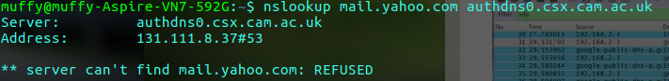

4. Locate the DNS query and response messages. Are then sent over UDP or TCP?
They are sent over UDP
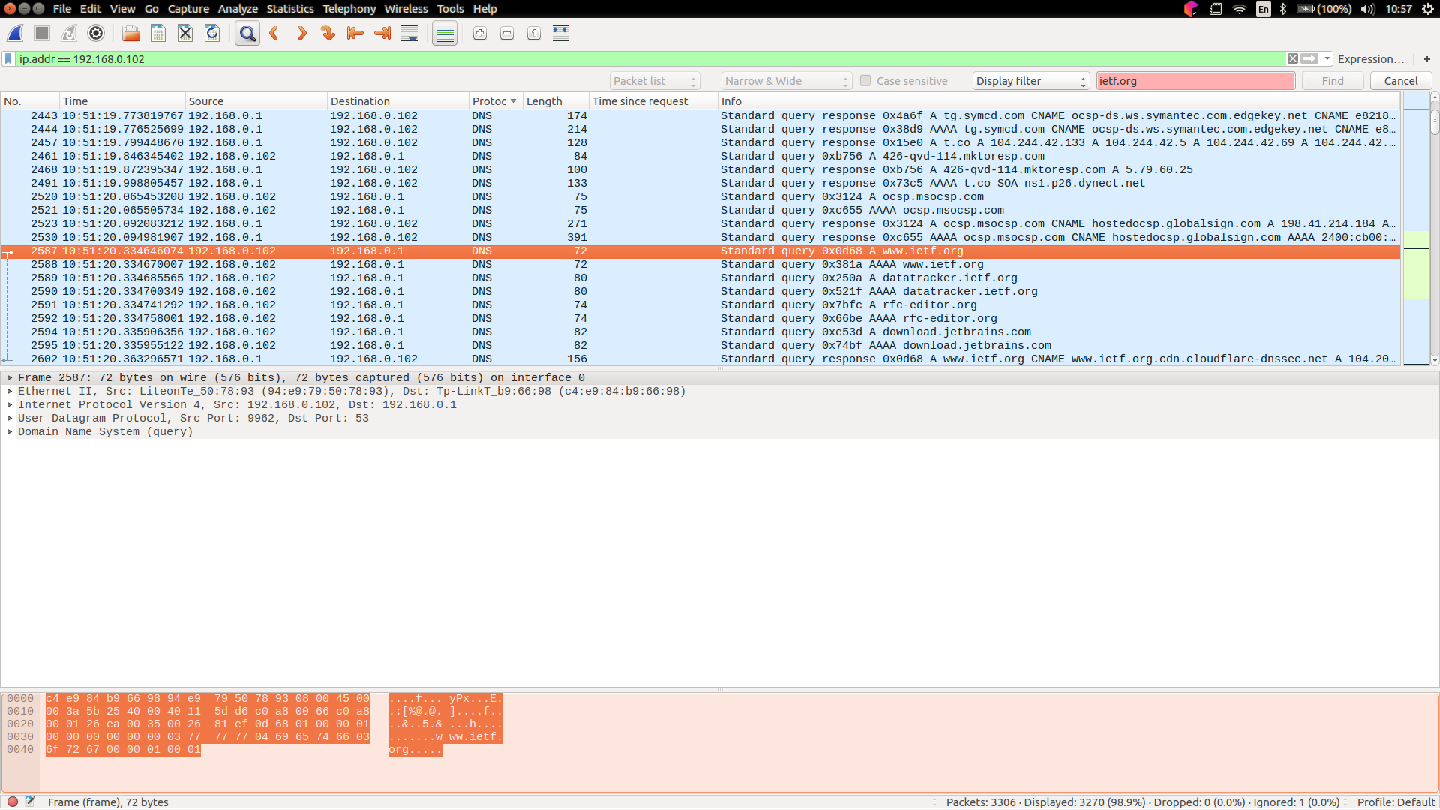

5. What is the destination port for the DNS query message? See the capture. This is 53
What is the source port of DNS response message? 53

6. To what IP address is the DNS query message sent? Use ipconfig to determine the IP address of your local DNS server. Are these two IP addresses the same?
The DNS query messages sent to Destination: 192.168.0.1
They are same.

7. Examine the DNS query message.
What “Type” of DNS query is it? “A”
Does the query message contain any “answers”? No.

8. Examine the DNS response message. How many “answers” are provided? 2
What do each of these answers contain? Name, type, class, time to live, data length, addresses
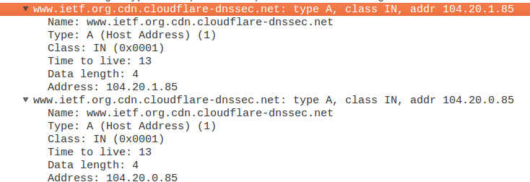

9. Consider the subsequent TCP SYN packet sent by your host. Does the destination IP address of the SYN packet correspond to any of the IP addresses provided in the DNS response message?
Yes, it correspond to 104.20.1.85

10. This web page contains images. Before retrieving each image, does your host issue new DNS queries? No, the images loaded from the web.

11. What is the destination port for the DNS query message?
What is the source port of DNS response message?
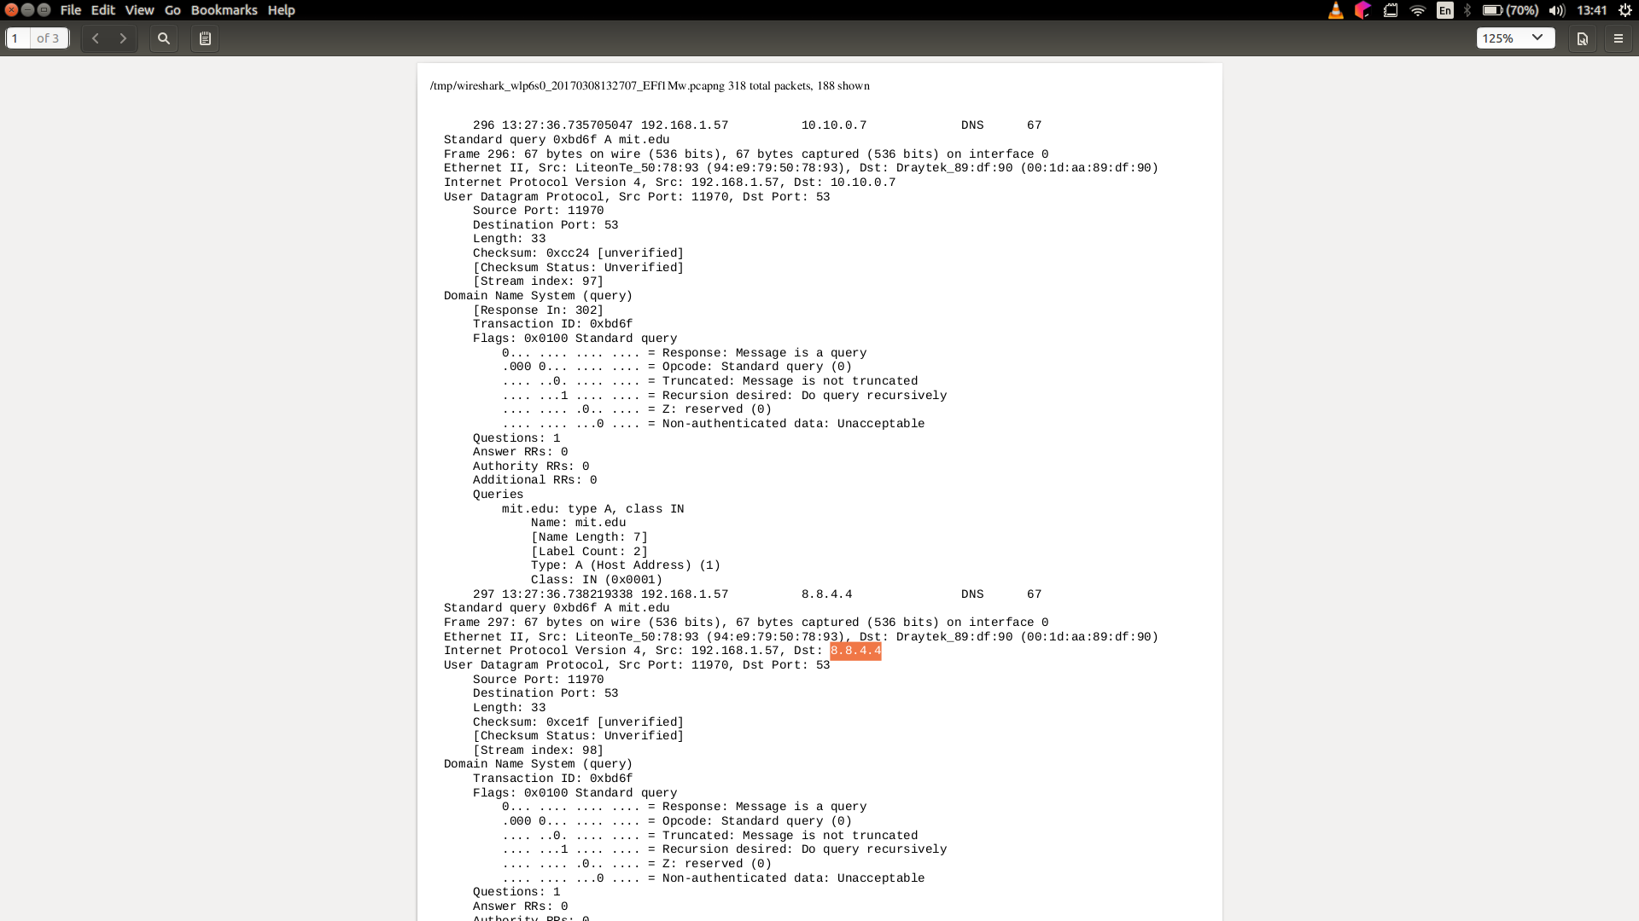

12. To what IP address is the DNS query message sent? 8.8.4.4
Is this the IP address of your default local DNS server? Yes

13. Examine the DNS query message. What “Type” of DNS query is it? Type “A”
Does the query message contain any “answers”? No

14. Examine the DNS response message. How many “answers” are provided? 1
What do each of these answers contain?

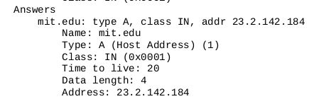

15. Provide a screenshot.
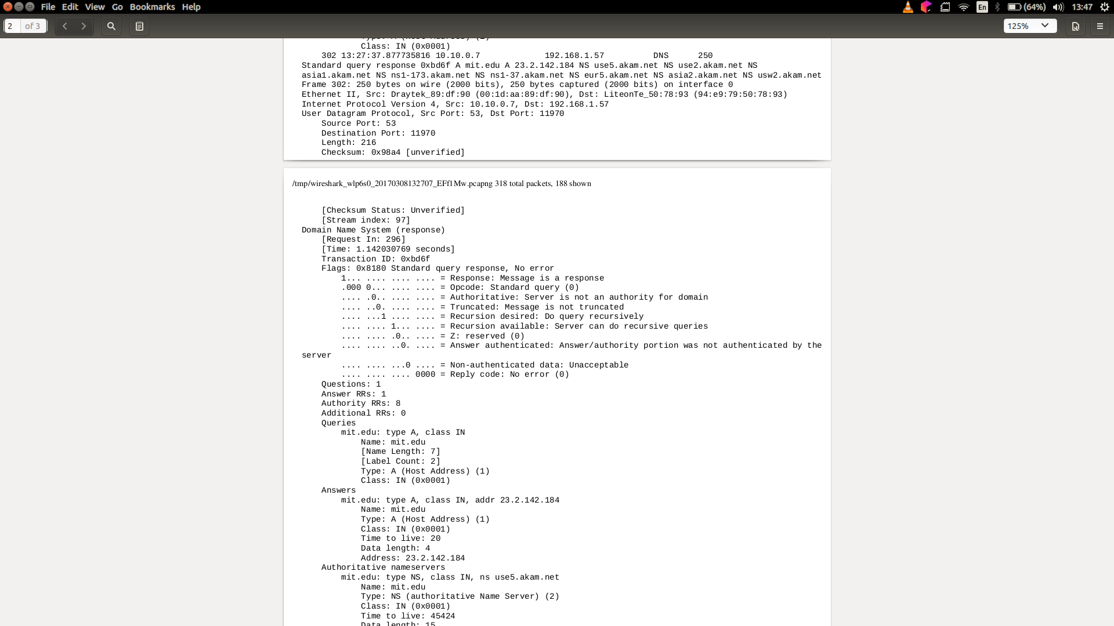

16. To what IP address is the DNS query message sent? 8.8.4.4
Is this the IP address of your default local DNS server? Yes

17. Examine the DNS query message. What “Type” of DNS query is it? “NS”
Does the query message contain any “answers”? No.

18. Examine the DNS response message. What MIT nameservers does the response message provide?
Does this response message also provide the IP addresses of the MIT namesers? No

19. Provide a screenshot.
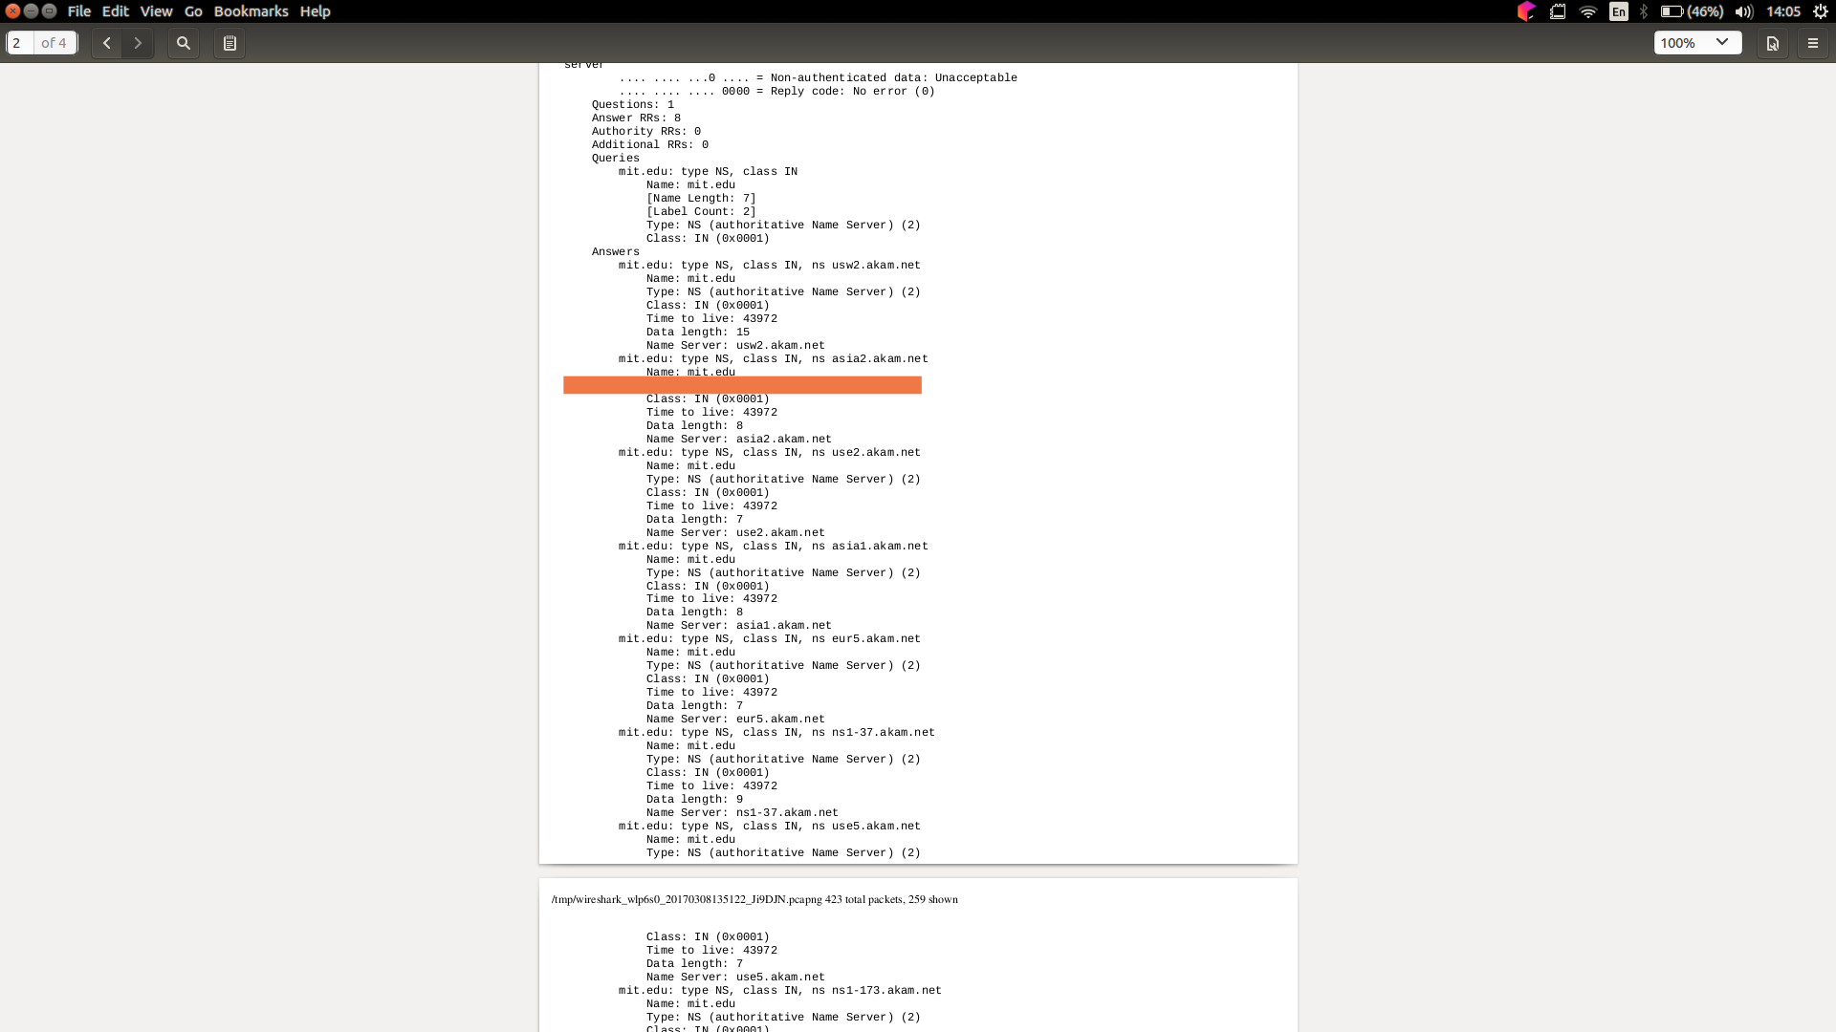

20. To what IP address is the DNS query message sent? 8.8.4.4
Is this the IP address of your default local DNS server? Yes
If not, what does the IP address correspond to?

21. Examine the DNS query message. What “Type” of DNS query is it? “A”
Does the query message contain any “answers”? No

22. Examine the DNS response message. How many “answers” are provided? 1
What does each of these answers contain?
