1. DHCP messages sent over UDP.

2.

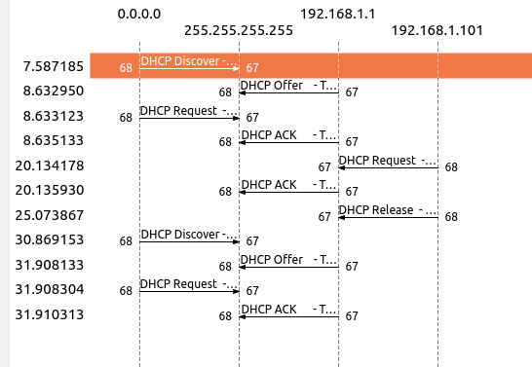
-Discover: Source Port: 68 Destination Port: 67
-Offer: Source Port: 67 Destination Port: 68
-Request: Source Port: 68 Destination Port: 67
-ACK: Source Port: 67 Destination Port: 68
-The port numbers is the same as in the example given in this lab assignment.

3. The link-layer (e.g., Ethernet) address of my host.
4. What values in the DHCP discover message differentiate this message from the DHCP request message?
DHCP Message Type.

5. The value of the Transaction-ID in each of the first four (Discover/Offer/Request/ACK) DHCP messages? 0x3e5e0ce3, 0x3e5e0ce3, 0x3e5e0ce3, 0x3e5e0ce3.
What are the values of the Transaction-ID in the second set (Request/ACK) set of DHCP messages?
0x3e5e0ce3, 0x3e5e0ce3
What is the purpose of the Transaction-ID field?
Server identify different request of client.

6.
Discover source 0.0.0.0 Destination 255.255.255.255
Offer source 192.168.1.1 Destination 255.255.255.255
Request source 0.0.0.0 Destination 255.255.255.255
Ack DHCP 192.168.1.1 Destination 255.255.255.255

7. The IP address of your DHCP server: 192.168.1.1

8. What IP address is the DHCP server offering to your host in the DHCP Offer
message? Indicate which DHCP message contains the offered DHCP address.
192.168.1.1
Option: (t=53,l=1) DHCP Message Type = DHCP Offer
The length of DHCP Message type is 1 and the DHCP offer is (2)

9. Relay agent IP address: 0.0.0.0. There is no relay agent in my experiment.

10. The subnet mask line tells the client which subnet mask to use. The router line indicates where the client should send messages by default.
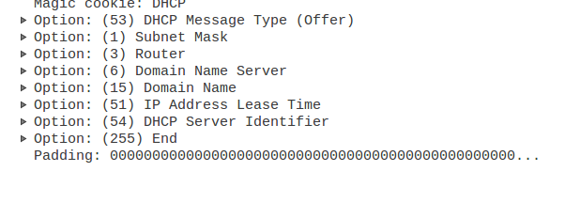

11. Requested IP Address: 192.168.1.101
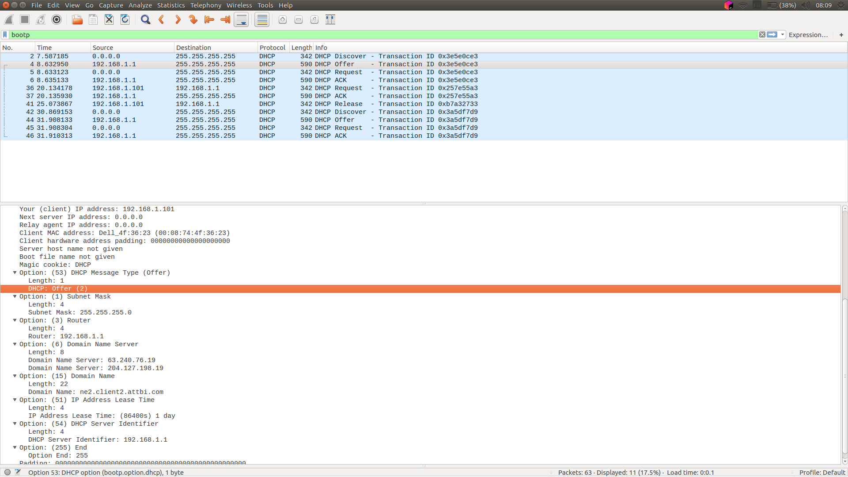

12. Explain the purpose of the lease time. How long is the lease time in your
experiment?

The lease time is the amount of time the DHCP server assigns an IP addresses to a client.
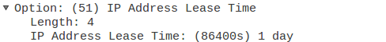

13. What is the purpose of the DHCP release message? Does the DHCP server issue
an acknowledgment of receipt of the client’s DHCP request? What would happen
if the client’s DHCP release message is lost?
The purpose of the DHCP release messages is to cancel the ip addresses offered given to client by DHCP server

14. Clear the bootp filter from your Wireshark window. Were any ARP packets sent
or received during the DHCP packet-exchange period? If so, explain the purpose
of those ARP packets.
Yes, the were some ARP packets sent or received during the DHCP packet-exchange period to map the MAC addresses to the IP addresses.

