1. IP address of my computer: 192.168.1.102
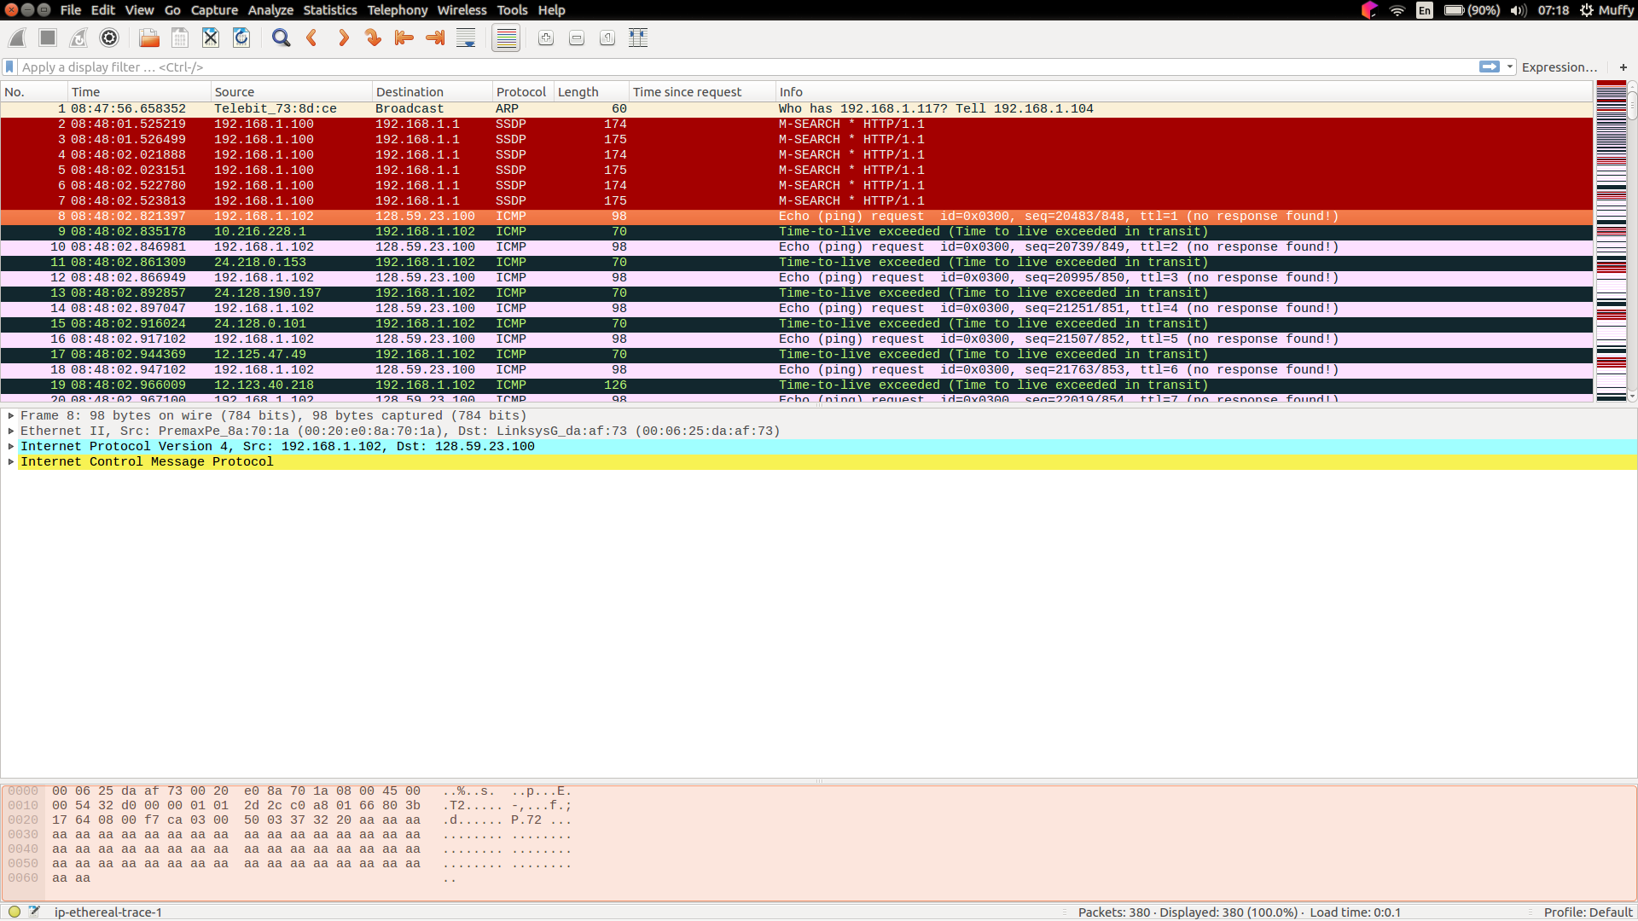
2. ICMP
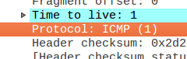

3. IP header: 20 bytes
payload of the IP datagram: 56 (total length) – 20 (IP header) = 36 bytes
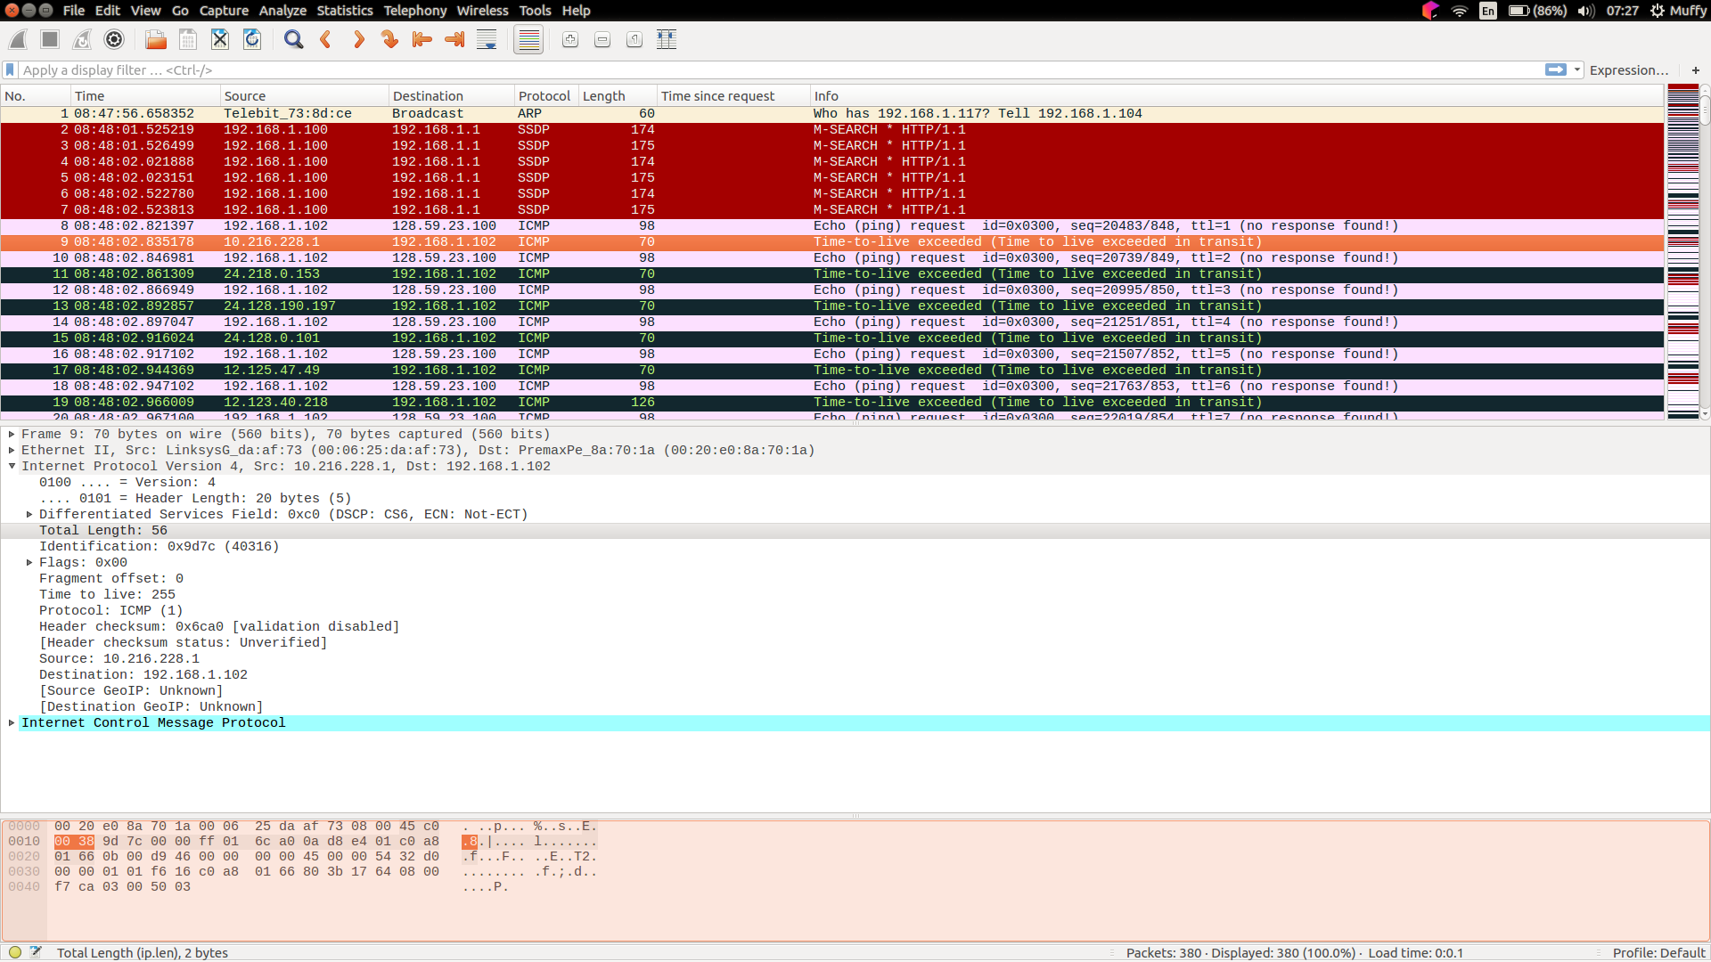
4. this IP datagram hasnt been fragmented because the more fragments bit = 0
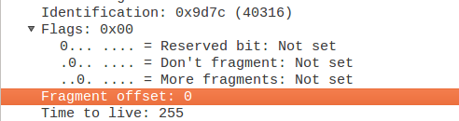
5. The fields always change in IP datagram: Identification, checksum header, time to live
6.
-The fields stay constant:
+Version (using IPv4 for all packets)
+ header length (it’s ICMP packets)
+ source IP (sending from the same source)
+ destination IP (sending to the same destination)
+ Differentiated Services (all packets are ICMP they use the same Type of Service class)
+Upper Layer Protocol (because these are ICMP packets)
-The fields that must stay constant are:
+ Version (using IPv4 for all packets)
+header length (it’s ICMP packets)
+ source IP (sending from the same source)
+ destination IP (sending to the same destination)
+ Differentiated Services (all packets are ICMP they use the same Type of Service class)
+Upper Layer Protocol (because these are ICMP packets)
-The fields that must change are:
+Identification(IP packets must have different identification)
+Time to live (traceroute increase)
+Header checksum (because the header changes)
7. They are incremented by one whenever we have ICMP echo request.
8. In screenshot below, you can see:
Identification: 13009
Time to live: 2
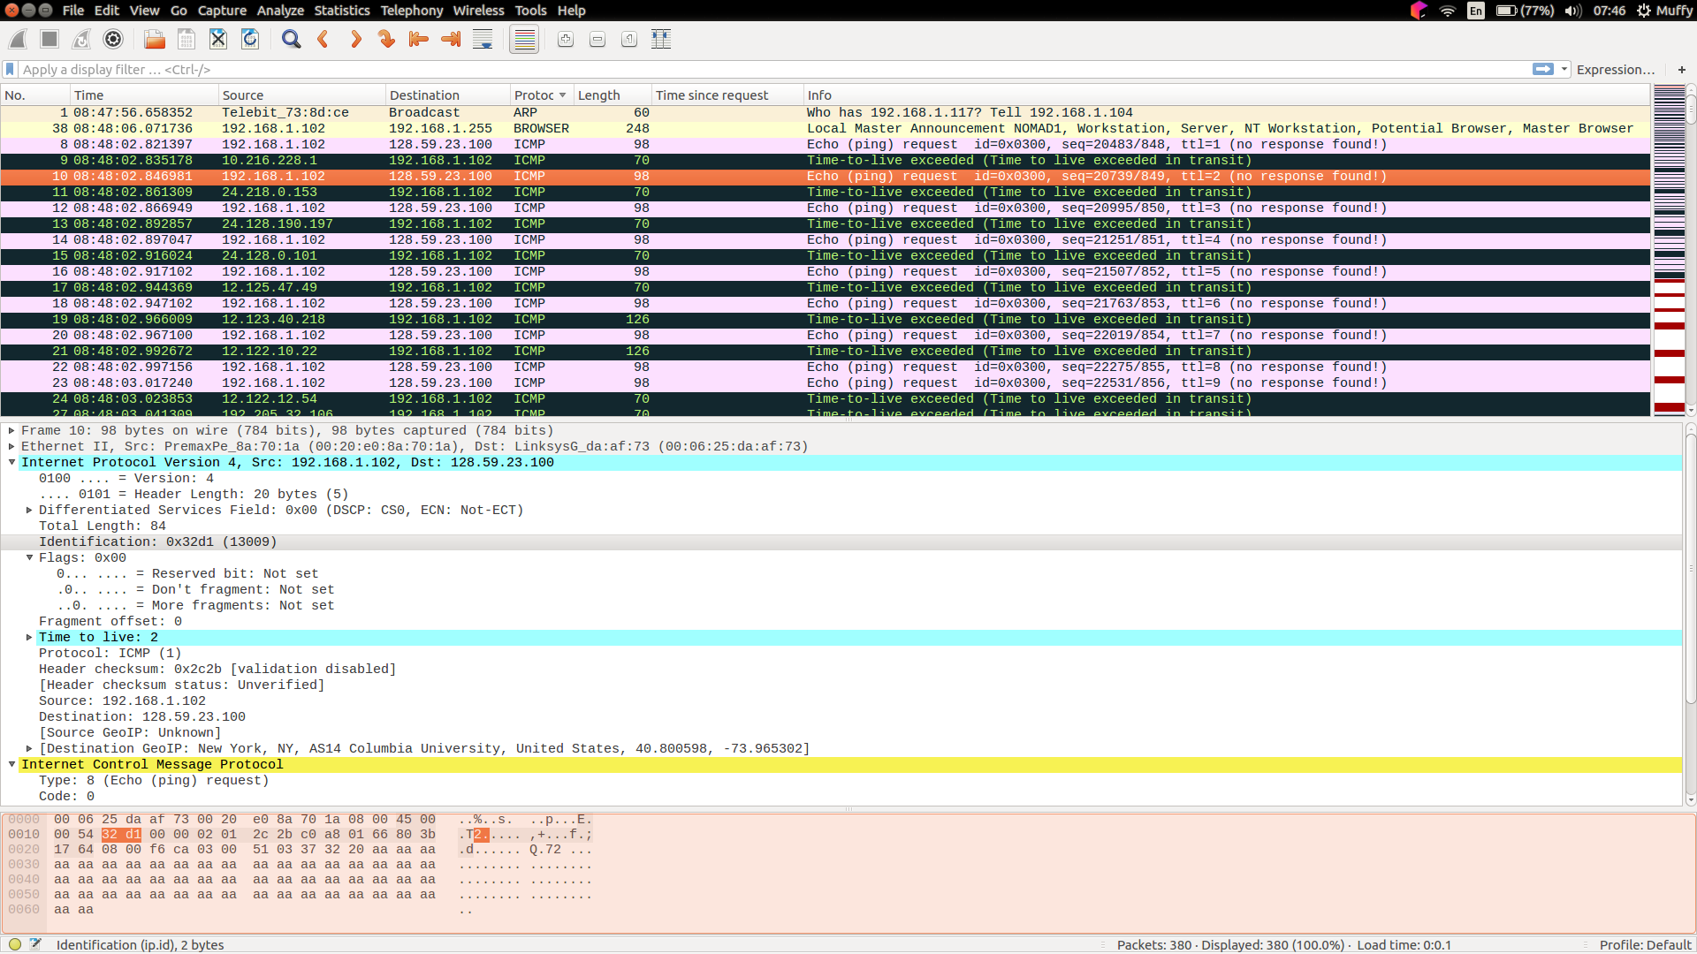
9. The identification field changes because they need to have its own number to know where it was sent.

The TTL does not change because it is always the same in the TTL for the first hop router.
10. Yes, message has been fragmented across more than one IP datagram. You can see in screenshot below.
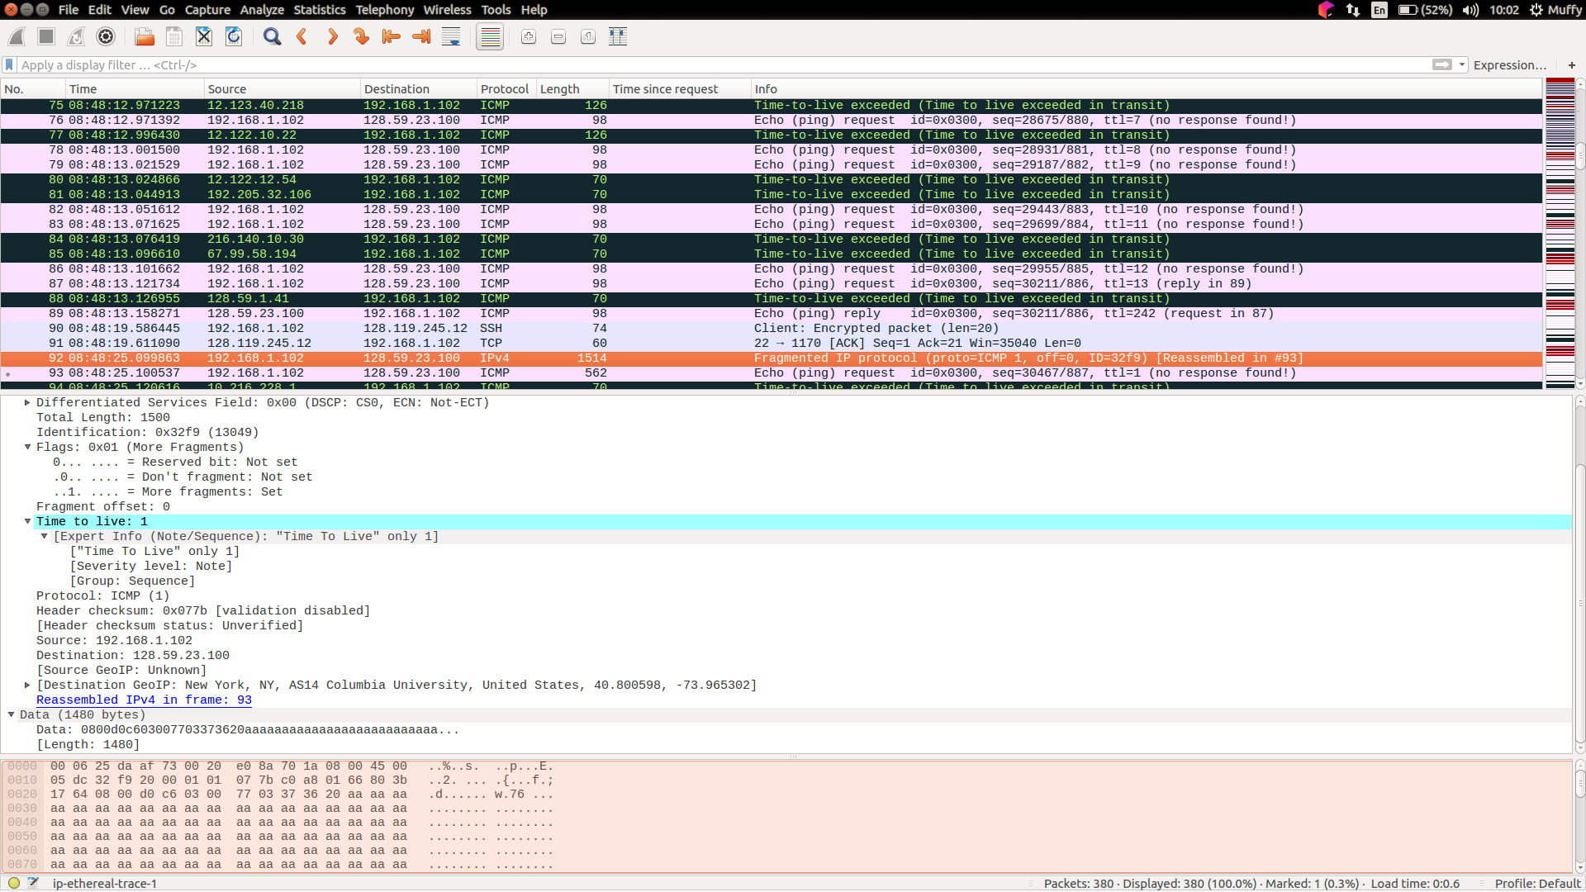
11.
Flags: 0x01 (more fragments)
Fragment offset: 0
Total length: 1500
12.
Flags: 0x00 so there are no more fragments.
Fragment offset: 1480
13.
There are flags, total length, fragment offset
14. How many fragments were created from the original datagram?
3
15. What fields change in the IP header among the fragments?

