1. the 48-bit Ethernet address of your computer: 00:d0:59:a9:3d:68
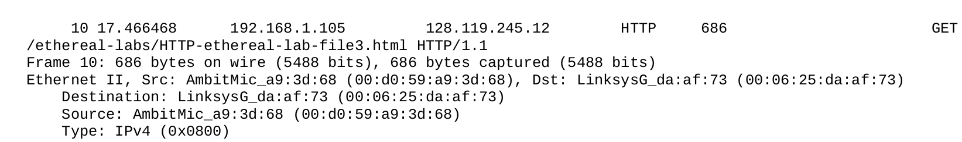
2. the 48-bit destination address in the Ethernet frame: 00:06:25:da:af:73
device has this as its Ethernet address: Linksys router.

3.the hexadecimal value for the two-byte Frame type field: 0x0800
Upper layer protocol is IPv4
You can see in the screenshot above.

4. “G” appear after 54 bytes from start time.
5.
The source Ethernet address for this frame is 00:06:25:da:af:73. This is not of my computer and gaia.cs.umass.edu. It’s of Linksys router.
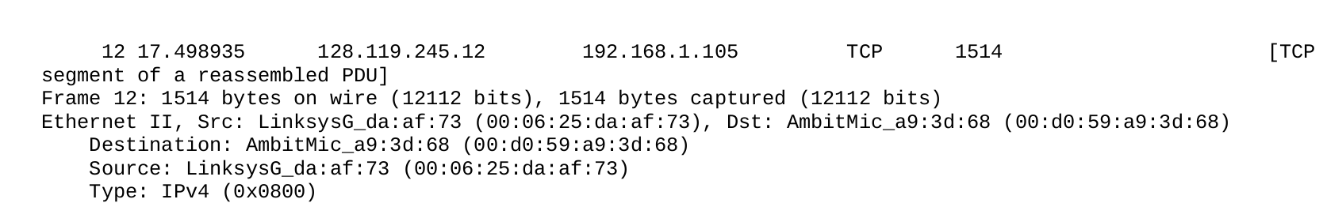
6. The destination address 00:09:5b:61:8e:6d, this is the address of computer.

7. the hexadecimal value for the two-byte Frame type field: 0x0800
Upper layer protocol is IPv4
You can see in the screenshot above.

8. How many bytes from the very start of the Ethernet frame does the ASCII “O” in
“OK” (i.e., the HTTP response code) appear in the Ethernet frame? after 53bytes.
9.
It contain address, hardware type, hardware address, flags, mask, iface

10. the hexadecimal values for the source and destination addresses in the Ethernet frame containing the ARP request message: 00:80:ad:73:8d:ce and ff:ff:ff:ff:ff:ff
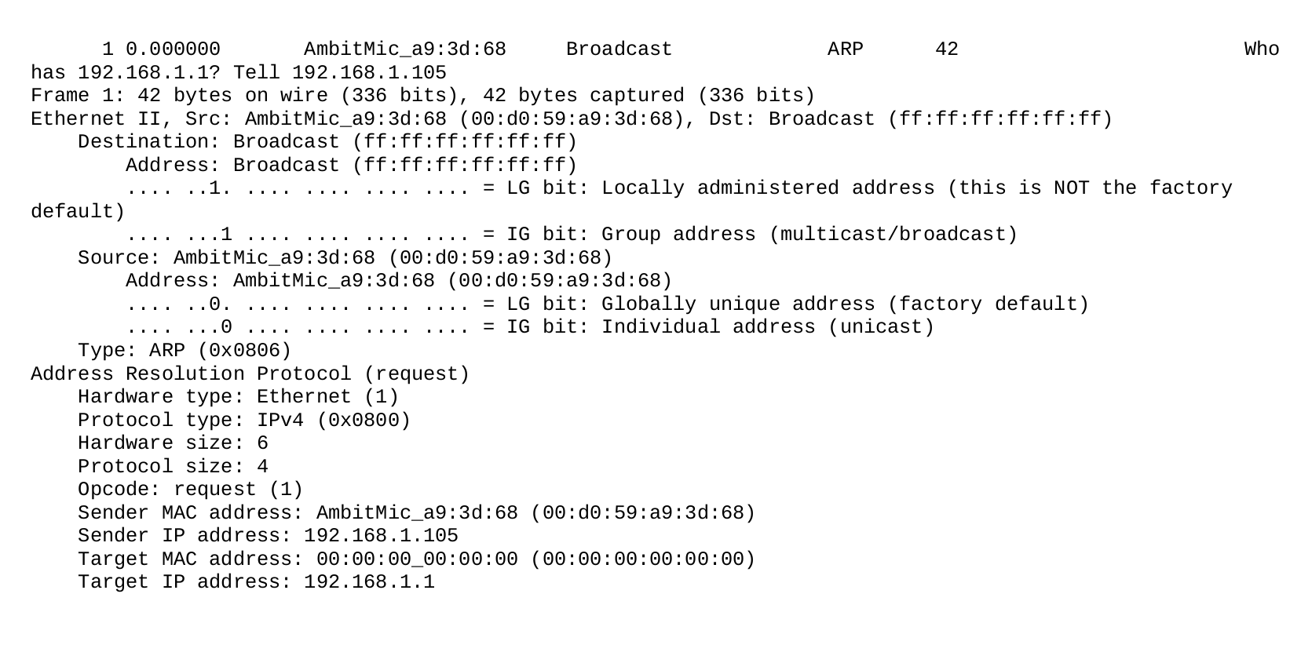
11. 0x0806 and ARP. You can see in screenshot above.
12.
a) How many bytes from the very beginning of the Ethernet frame does the
ARP opcode field begin? 42bytes
b) What is the value of the opcode field within the ARP-payload part of the
Ethernet frame in which an ARP request is made? 0X0001
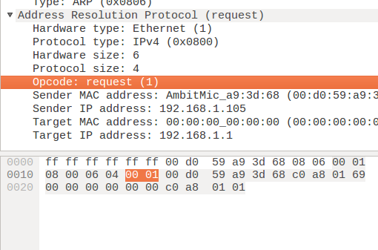
c) Does the ARP message contain the IP address of the sender?
Yes
d) The question appears in the target MAC destination address (00:00:00:00:00:00)

13.
a) How many bytes from the very beginning of the Ethernet frame does the ARP opcode field begin? 20Bytes.
b) What is the value of the opcode field within the ARP-payload part of the
Ethernet frame in which an ARP response is made? 0x0002
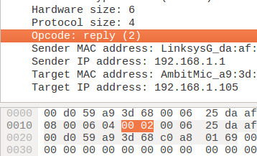

c)

14. What are the hexadecimal values for the source and destination addresses in the Ethernet frame containing the ARP reply message? 00:06:25:da:af:73 and 00:d0:59:a9:3d:68

15. Since the IP addresses of the computer and arp request do not suit.

