1. IP address of my host: 192.168.1.101
IP address of the destination host: 143.89.14.34
2. Because the TCMP packet communicate between hosts and routers, so each TCMP packet has a type and code which know message sent and received.
3.
Type: 8
Code: 0
ICMP packet has checksum, identifier, sequence number, data.
Checksum, sequence number and identifier fields has 2bytes each fields.
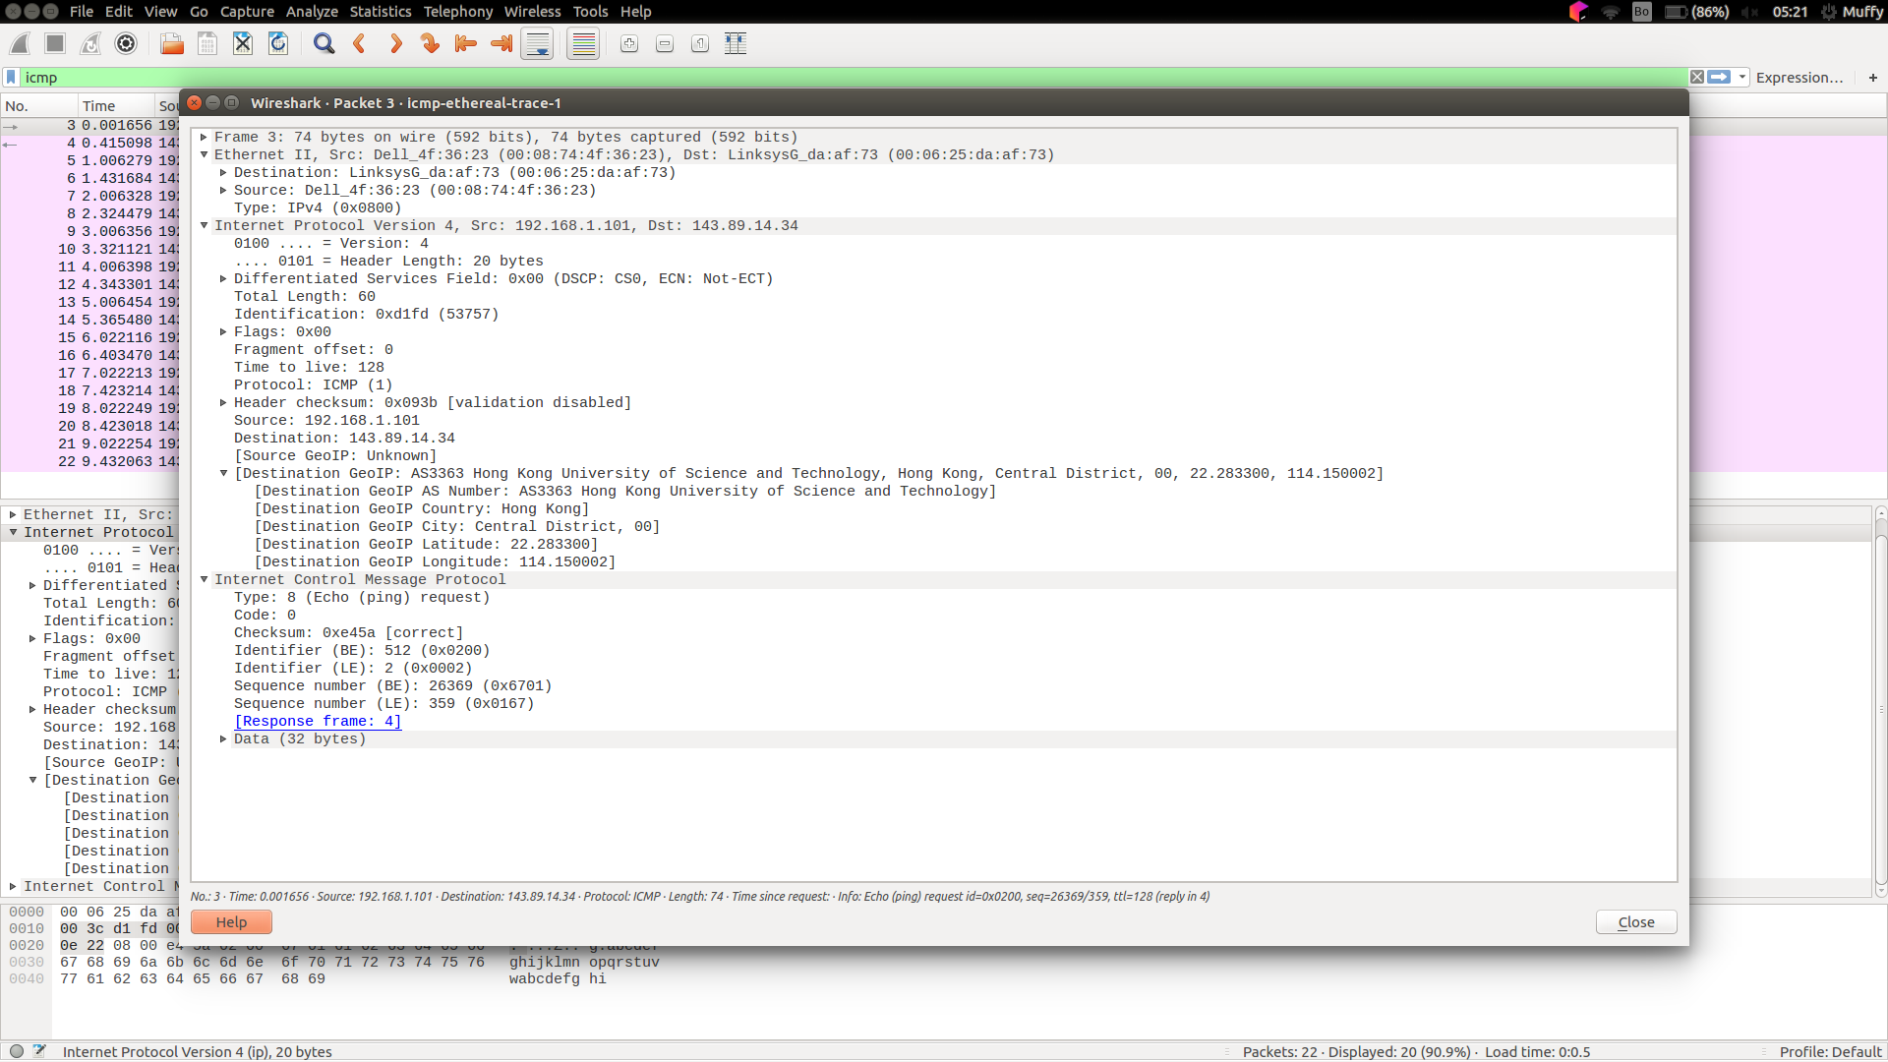
4.
Type: 0
Code: 0
ICMP packet has checksum, identifier, sequence number, data.
Checksum, sequence number and identifier fields has 2bytes each fields.
5.
IP address of my host: 192.168.1.101
IP address of the destination host: 138.96.146.2
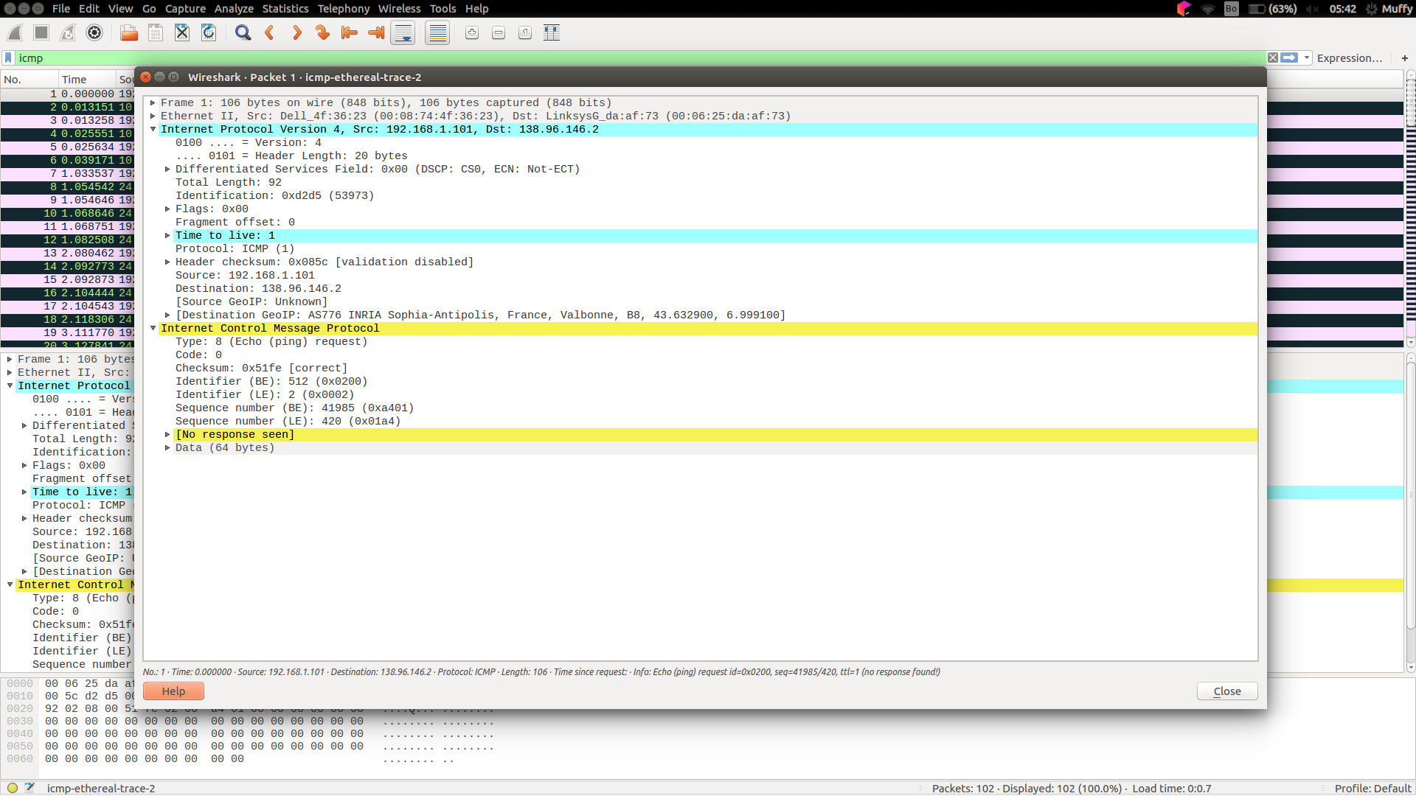
6. No. The IP protocol number would be 0x11
7. No, it’s same with the ICMP ping query packets in the first half of this lab.
8. It includes IP header packet and first 8bytes of the ICMP packet.
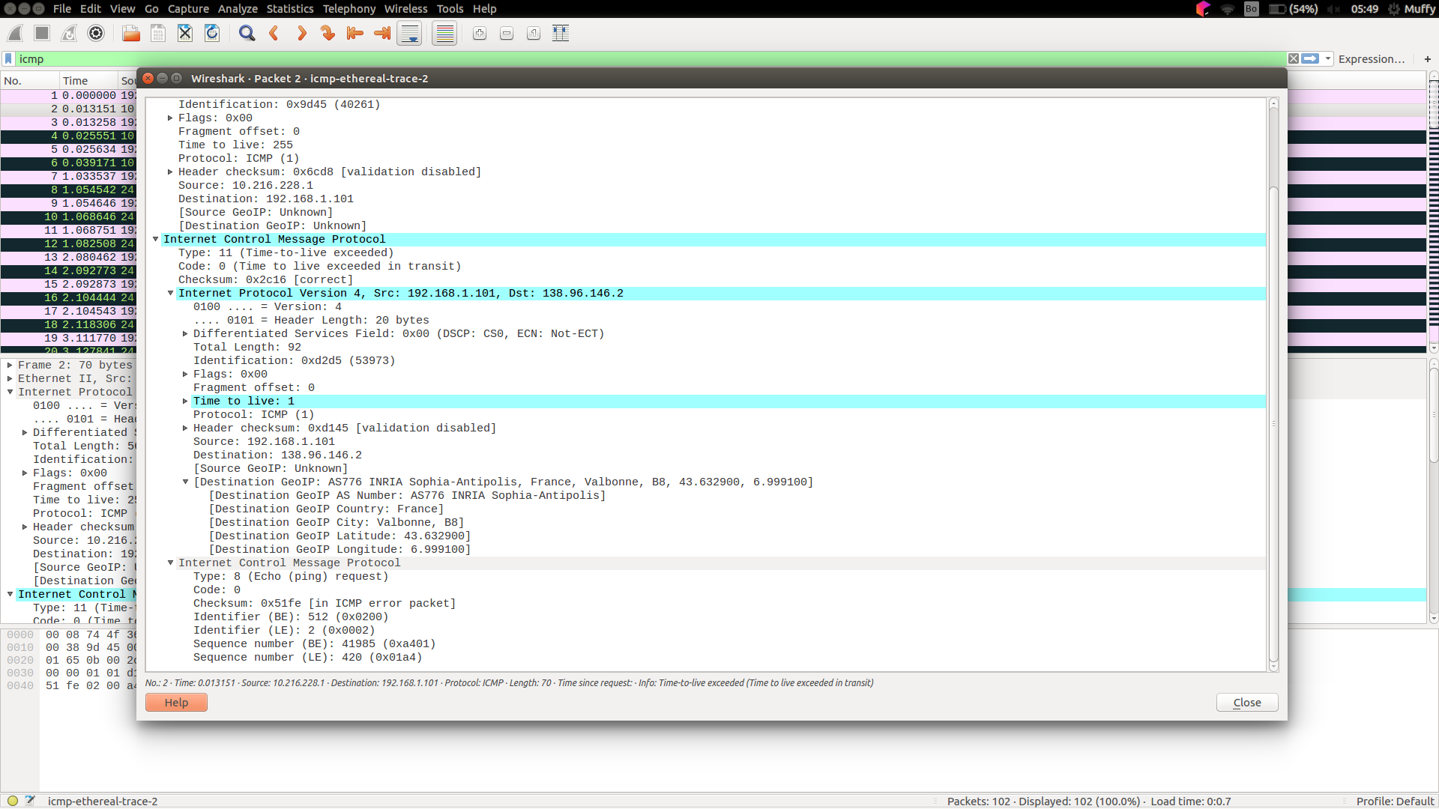
9.
The last three ICMP packets has message type 0 instead of 11.
They are different because all the packets sent to destination host before time-to-live exceeded.
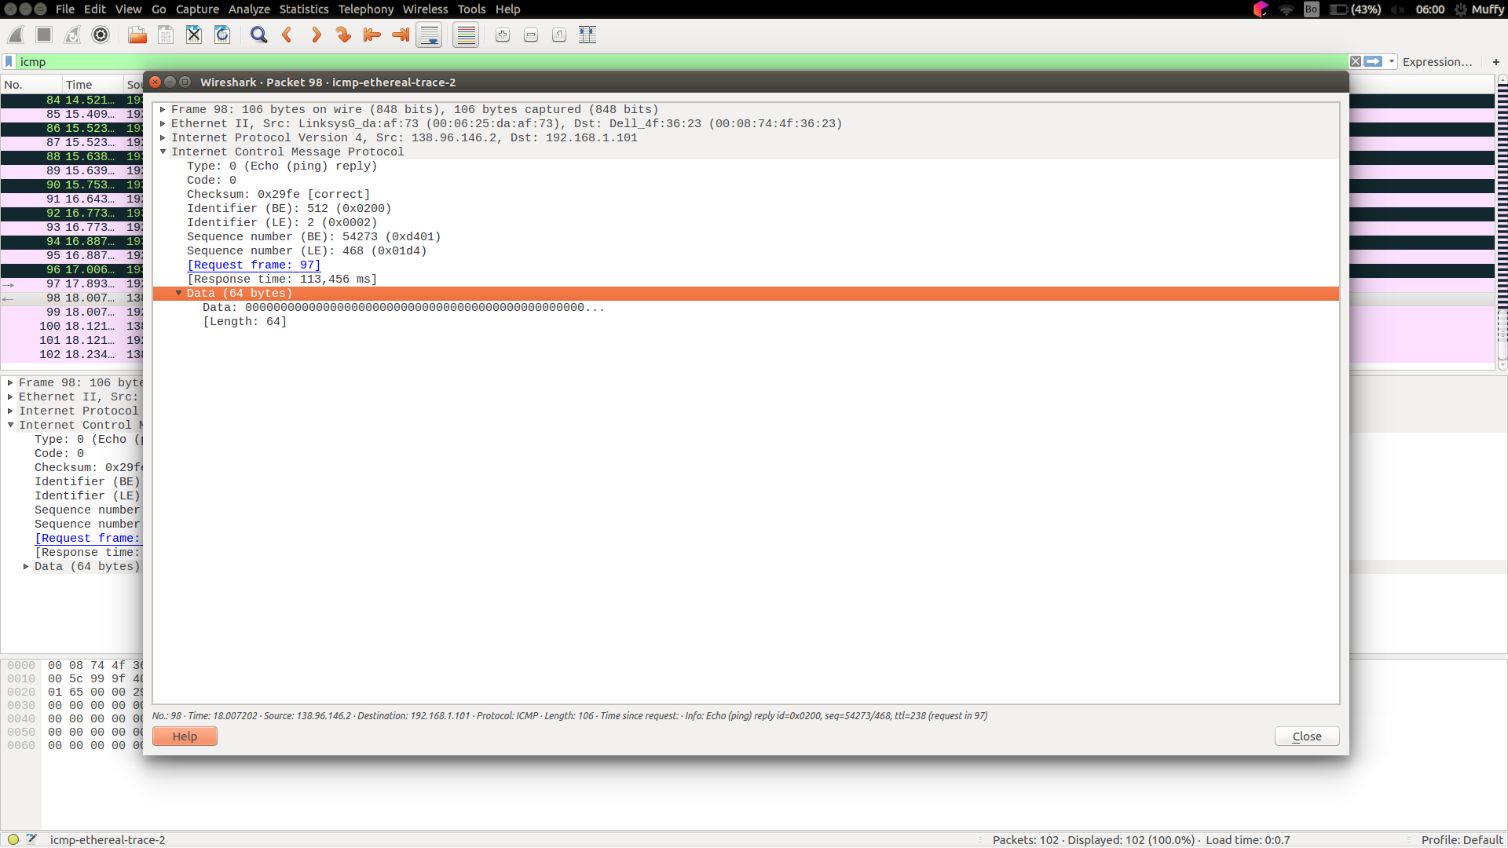
10.
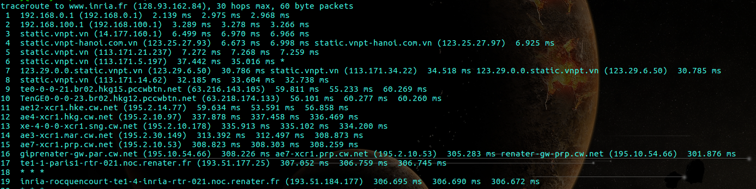
There are between step 11 and 12.
In figure 4 from the lab, I think it’s between step 9 and 11, from newyork to france.

