1.
Linksys_SES_24086 and 30 Munroe St

2.
Beacon frame time interval of linksys_ses_24084 and 30 Munroe St: 0.1024 s.

3.
The source MAC on the beacon feacom frame from 30 Munroe is 00:16:b6:f7:1d:51.

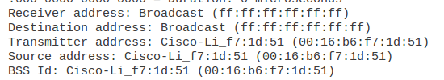

4.
The destination MAC address on the beacon frame from 30 Munroe is ff:ff:ff:ff:ff:ff

5.
The BSS Id for 30 Munroe is Cisco-LI-f7:1d:51 (00:16:b6:f7:1d:51).

6.
The support rates are 1.0, 2.0, 5.5, 11.0 (Mbps).
The extended rates are 6.0, 9.0, 12.0, 18.0, 24.0, 36.0, 48.0, 54.0 (Mbps)

7.
The TCP SYN is sent at t = 24.811093 seconds.
The MAC addresses are BSS Id, source address and destination.
The MAC address corresponds to the wireless host: 00:13:02:d1:b6:4f.
Corresponding to the first hop router: 00:16:b6:f4:eb:a8.
Corresponding to the wireless host sending this TCP segment: 00:16:b6:f7:1d:51.
The corresponding IP of the wireless host: 192.168.1.109.
The destination IP : 128.199.245.12, corresponds to the host.
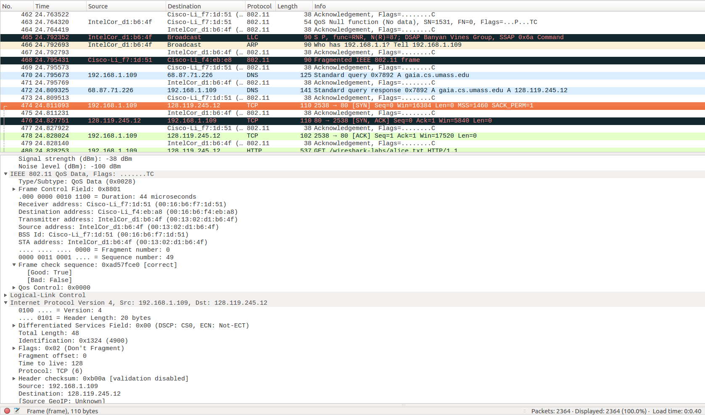

8.
Three MAC address fields in the 802.11 frame:
+ BSS id: 00:16:b6:f7:1d:51
+ Destination: 00:13:02:d1:b6:4f
+ Source address: 00:16:b6:f4:eb:a8.

The MAC corresponds to the host is 00:13:02:d1:b6:4f (Destination).
The MAC corresponds to the first hop is 00:16:b6:f4:eb:a8 (Source).

The sender MAC address in the frame does not correspond to the IP address of the device that sent the TCP segment encapsulated within this datagram as the tcp synack’s IP address is 128:199:245:12 but the destination IP address is 192.168.1.109.
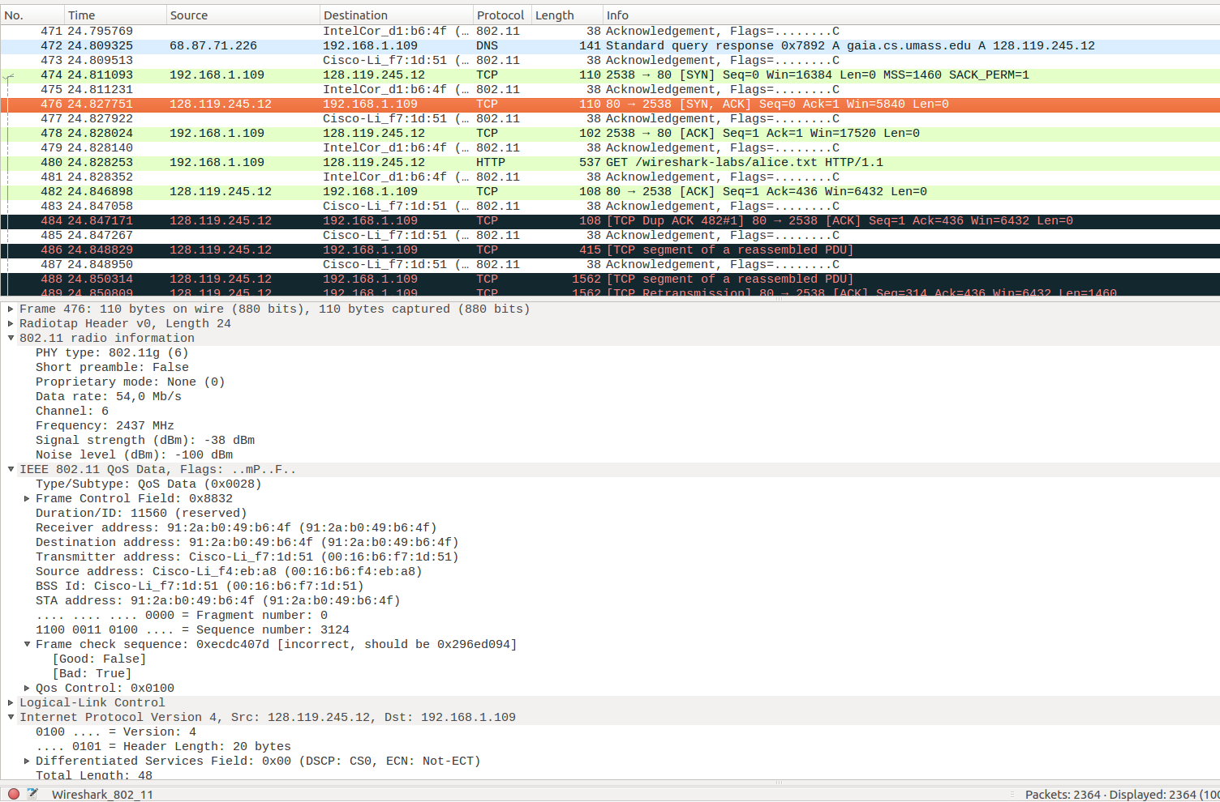

9.
At t = 49.583615 a DHCP release is sent by the host to the DHCP server, 192.168.1.1)
At t = 49.609617, the host sends a Deauthentiacation frame
I expected to see Disassociation request to have been sent.
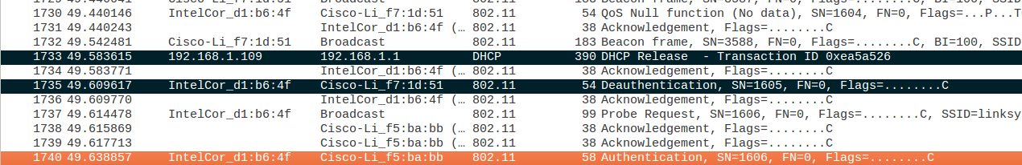
10.
There are 17 authentication messages from the wireless host to the linksys_ses_24086 AP

11. The host want the authentication to require a key or be opened.

12. There is no reply AUTHENTICATION from the linksys_ses_24086 AP in the trace.

13.
The AUTHENTICATION frame sent from host to 30 Munroe at t = 63.168087
The AUTHENTICATION from sent in the reverse direction from the AP to Host at t = 63.169071
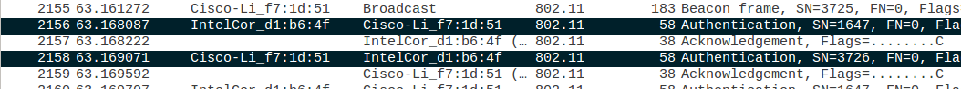
14.
The ASSOCIATE REQUEST from host to the 30 Munroe St AP at t = 63.169910 and replied at t = 63.192101.
15.
There are 1, 2, 5.5, 11, 6, 9, 12, 18, 24, 32, 48, 54 Mbps.

16.
Probe request:
+ Source: 00:12:f0:1f:57:13
+ Destination: ff:ff:ff:ff:ff:ff
+ BSS Id: ff:ff:ff:ff:ff:ff
Probe response:
+ Source: 00:16:b6:f7:1d:51
+ Destination: 00:16:b6:f7:1d:51
+ BSS Id: 00:16:b6:f7:1d:51
The probe request: The host scan for an access point.
The probe response: The access point response the host.
