1.
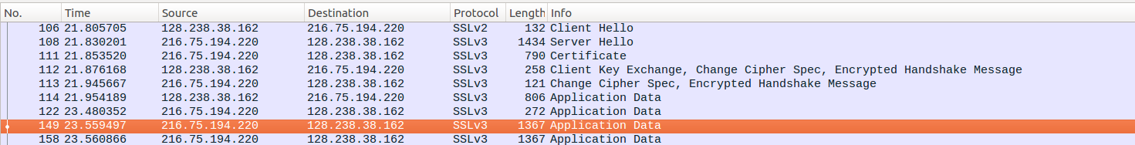

Frame | Source | SSL Count | SSL Type
106 | Client | 1 | Client Hello
108 | Server | 1 | Server Hello
111 | Server | 2 | Certificate  Server Hello Done
112 | Client | 3 | Client Key Exchange  Change Cipher Spec  Encrypted Handshake Message
113 | Server | 2 | Change Cipher Spec  Encrypted Handshake Message
114 | Client | 1 | Application Data
122 | Server | 1 | Application Data
127 | Server | 1 | Application Data

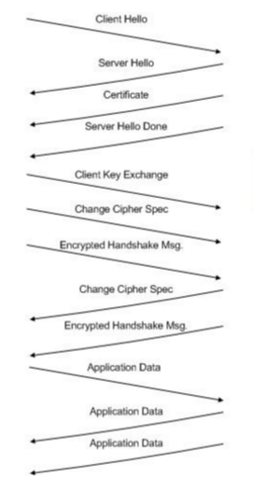
2.
Content Type 1 byte
Version 2 bytes
Length 2 bytes

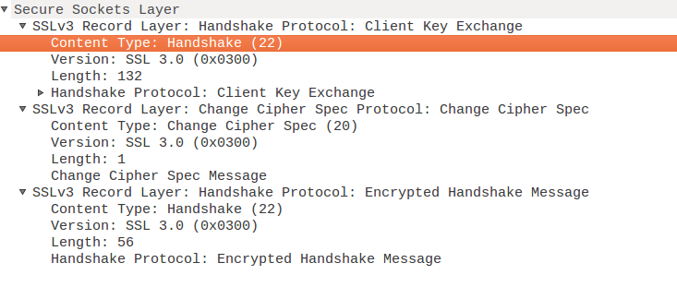

3. The content type is Handshake 22.

4. The value of the challenge in hexadecimal notation?
66 df 78 4c 04 8c d6 04 35 dc 44 89 89 46 99 09

5.
Public key algorithm: RSA
Symmetric‐key algorithm: RC4
Hash algorithm: MD5

6.
Public key algorithm: RSA
Symmetric‐key algorithm: RC4
Hash algorithm: MD5
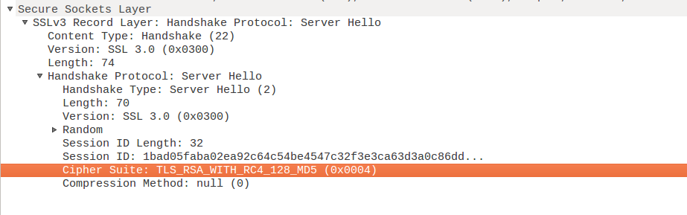

7. this record includes a nonce with 32 bits long to prevent replay attacks.

8. This record includes a session ID, it help client can resume the same session later by using that session ID provided by the server.

9.
The record doesnt contain a certificate, it’s included in a separate record.
The certificate fits into a single Ethernet frame.

10.
This record contains a pre-master secret to creat a session key. The secret is encrypted by public-key which has 120 bytes.
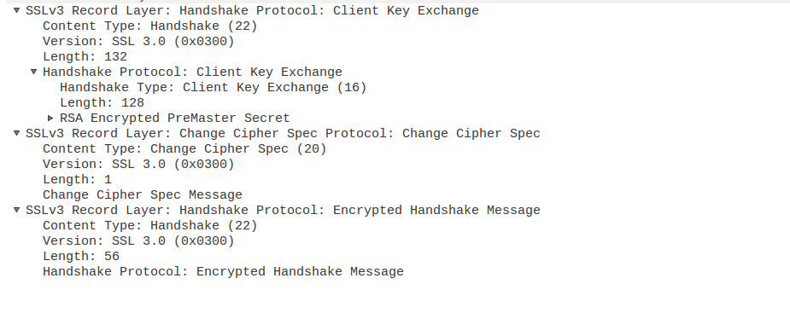

11. The purpose of the Change Cipher Spec record is to update the SSL session to update the cipher suite and the length has 6 bytes: 5 for header and 1 for message segment.

12. In the encrypted handshake record, handshake messages and MAC addresses is being encrypted which are sent to the server.

13. The server also send a change cipher record and an encrypted handshake record to the client.
The server’s encrypted handshake contains all the handshake messages sent from the server. Other contains messages sent from client.

14. The application is being encrypted using symmetric-key encryption algorithm.
The records containing application data include a MAC?
Wireshark doesn’t distinguish between the encrypted application data and the MAC.

