1. The IP address of the client: 192.168.1.100
2.
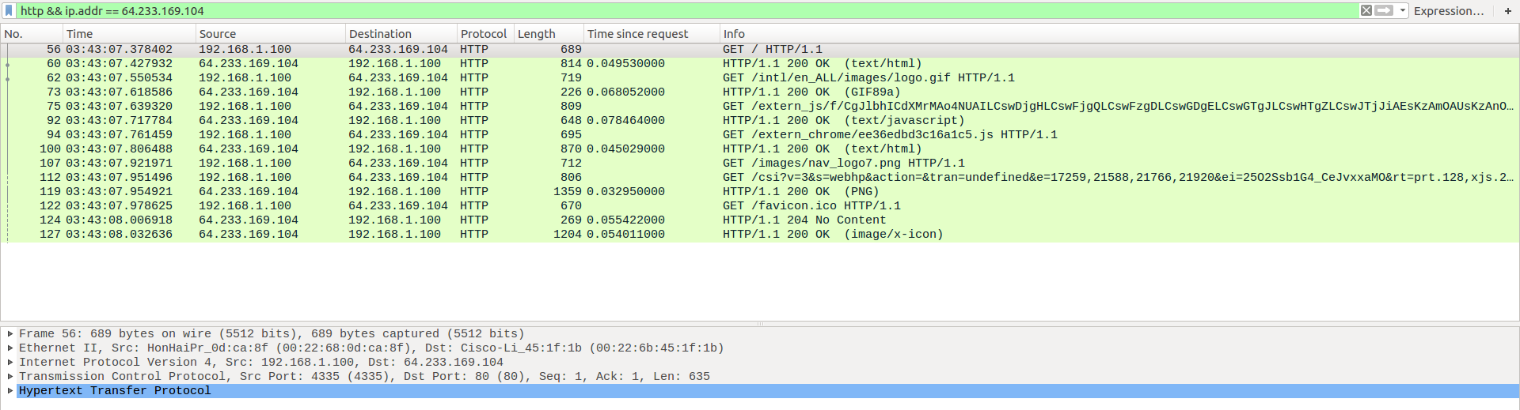
3.
the source and destination IP addresses: 192.168.1.100 and 64.233.169.104
TCP source and destination ports on the IP datagram: 4335 and 80
4.
the corresponding 200 OK HTTP message received from the Google server:
Time: 7.158797
Source: 64.233.169.104, 80
Destination: 192.168.1.100, 4335
5.
To get more details, you can see the screenshot below:
At what time is the client-to-server TCP SYN segment sent that sets up the connection used by
the GET sent at time 7.109267? 7.075657
What are the source and destination IP addresses and source and destination ports for the TCP SYN segment? Source: 192.168.1.100, 4335, Destination: 64.233.169.104, 80
What are the source and destination IP addresses and source and destination ports of the ACK sent in response to the SYN. Source: 64.233.169.104, 80. Destination: 192.168.1.100, 4335
At what time is this ACK received at the client? 7.108986
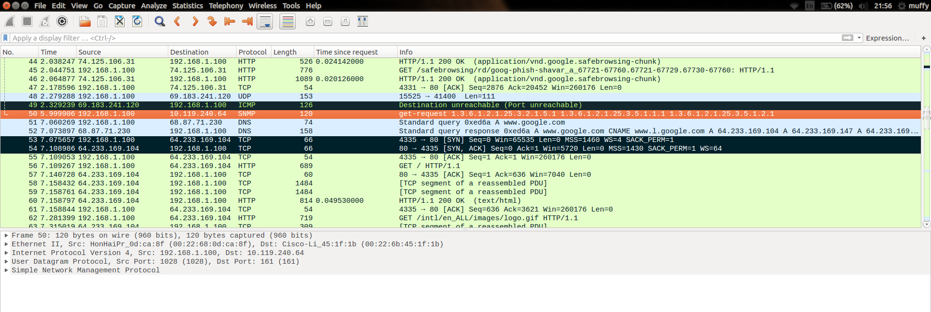
6.
At what time does this message appear in the NAT_ISP_side trace file? 6.069168
What are the source and destination IP addresses and TCP source and destination ports on the IP datagram carrying this HTTP GET (as recording in the NAT_ISP_side trace file)?
Source: 71.192.34.104, 4335
Destination: 64.233.169.104, 80
Which of these fields are the same, and which are different, than in your answer to
question 3 above? The source IP address: different
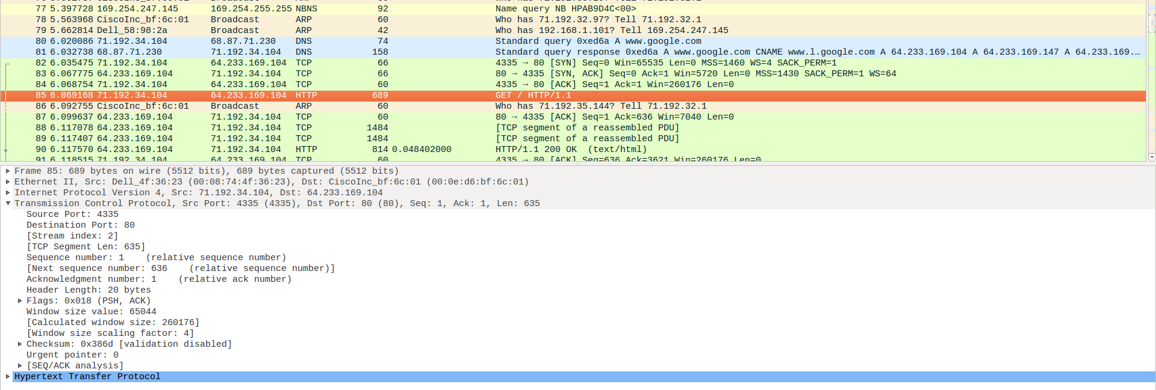
7. Are any fields in the HTTP GET message changed? Yes
There’s Checksum. The checksum includes the value of the source IP address, the checksum has changed.
8.In the NAT_ISP_side trace file, the first 200 OK HTTP message received from the Google server:
The time: 6.308118
Source: 64.233.169.104, 80
Destination: 71.192.34.104, 4335
Destination IP addresses: changed
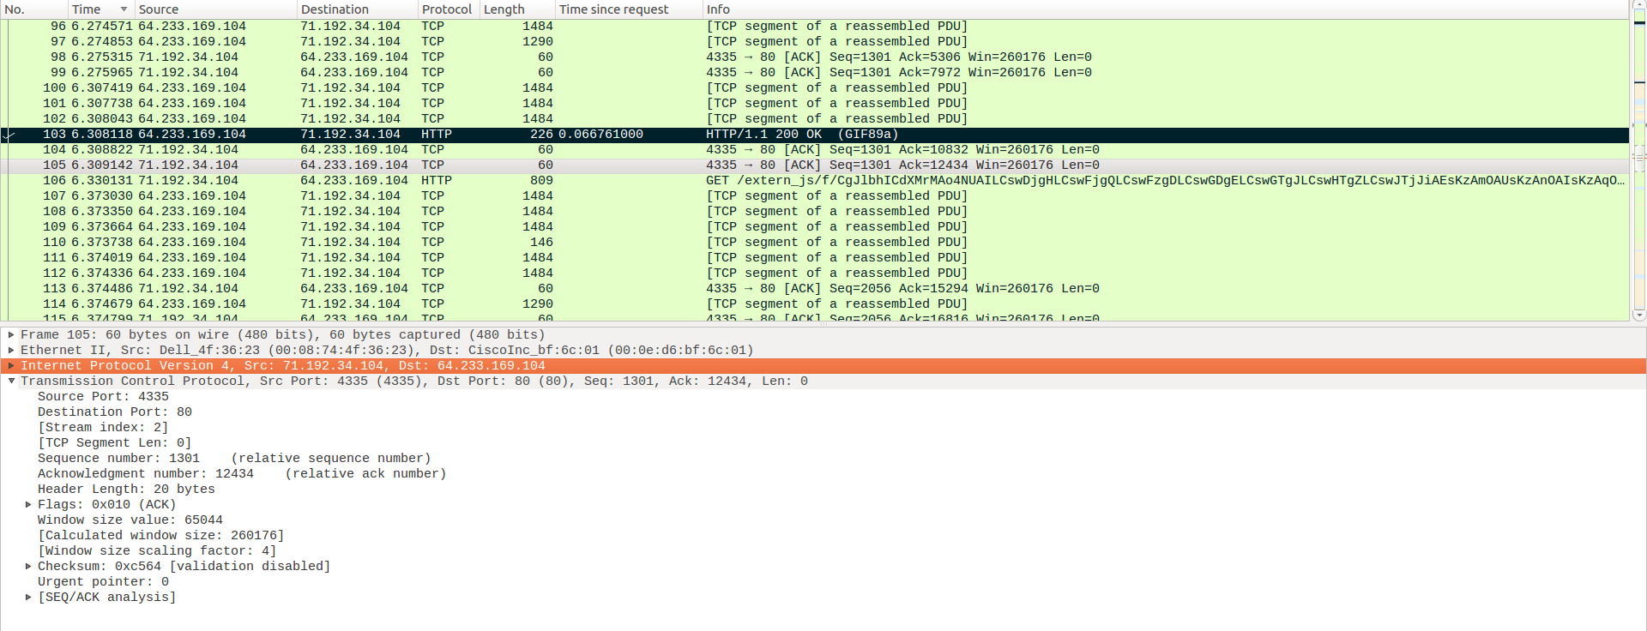
9. Time: 6.035475 and 6.067775
The SYN: Source: 71.192.34.104, 4335; Destination: 64.233.169.104, 80
The source IP address : changed; port number: not changed
The ACK: Source: 64.233.169.104, 80 ;Destination: 71.192.34.104, 4335
The destination IP address: changed; port number: not changed
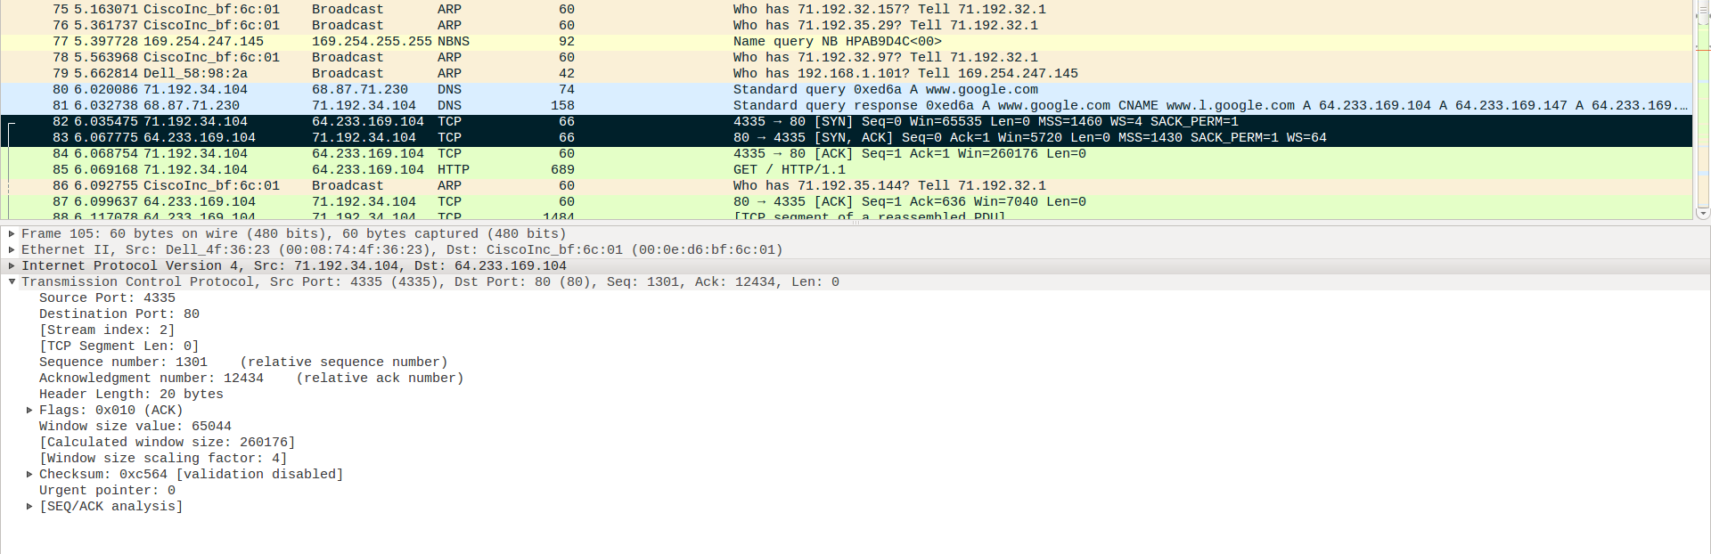

10.
NAT translate table:
WAN side: 71.192.34.104, 4335 | LAN side: 192.168.1.100, 4335

