UniversityofEngineeringandTechnology,Lahore NarowalCampus
DepartmentofComputerScience&Engineering
VidCraft
IntelligentPrompt-DrivenMediaGenerationPipeline
SoftwareRequirementsSpecification
FinalYearProject
Group7–BSCS-B
Session2023–2027
Submittedby | Registrationnumber
MaidaIbrar  Hammad | 2023-CS-505  2023-CS-567
MuhammadMajid(GroupLeader)2023-CS-580
TahirZaka | 2023-CS-596
Supervisor:Ms.RabiaSana
Co-Supervisor:Dr.Yaeen-ul-Haq
Aprojectsubmittedinpartialfulfillmentoftherequirements forthedegreeofBachelorofScienceinComputerScience
12October2026

VidCraft:SoftwareRequirementsSpecification | Group7
ProjectDetails
Projecttitle  Projectgroup | VidCraft:IntelligentPrompt-DrivenMediaGenerationPipeline Group7,BSCS-B,Session2023–2027
Projecttype/natureIndustrial/ResearchandDevelopment
AreaofspecializationArtificialIntelligence,NaturalLanguageProcessing,Multi-Agent SystemsandMultimediaGeneration
Documentversion Department | 2.0  ComputerScience&Engineering,UETLahore,NarowalCampus
GroupMembersandDeclaration
Sr. | Registration | Name | Signature
1 | 2023-CS-580 | MuhammadMajid(Leader)
2 | 2023-CS-596 | TahirZaka
3 | 2023-CS-567 | Hammad
4 | 2023-CS-505 | MaidaIbrar
Declaration for signature:We confirm that this submission acknowledges the third-party toolsandsourcesusedintheproject.Wewillreporttheteam’scontribution,experiments andresultsaccurately.ThedepartmentwillverifyoureligibilityfortheFYP.
i

VidCraft:SoftwareRequirementsSpecification | Group7
PlagiarismCertificate
Project:VidCraft:IntelligentPrompt-DrivenMediaGenerationPipeline
Groupleader:MuhammadMajid Similarityreviewdate: | Registration:2023-CS-580
Groupleader:MuhammadMajid Similarityreviewdate: | Similarityindex: | %

Similarityreportreference: Supervisorreviewoutcome:

Groupleadersignature: Co-supervisorsignature: | Supervisorsignature:  Date:
Thereviewfieldsarecompletedandsignedaftertheinstitutionalsimilaritycheck.
ii

VidCraft:SoftwareRequirementsSpecification | Group7
Abstract
VidCrafttakesauser’swrittenideathroughacreativebrief,astoryboardandaviewable image or short video.Prompt analysis, clarification questions, cinematography retrieval and cooperatingsoftwareagentsaddressdifferentstages.Theanalysisconsiderssubjectclarity, actionspecificity,environmentaldetail,visualrichnessandtemporalcoherence.Thesefive measureshelpidentifywhatneedsclarificationbeforeshotplanningandmediageneration.
The project contribution includes scoring rules for visual prompts, contradiction detection, a clarificationstrategy,sharedworldstate,agentcoordinationandacuratedcinematography knowledge base.Quality feedback is limited to a defined number of attempts.Programmatic rendering turns structured scene descriptions into compositions, and media adapters connect suitablegenerativemodels.Selectedshots,narration,captionsandpost-processingshare atimeline.Backgroundprocessingandrecoveryatindividualstageshelpthesystemwork withinlimitedcomputingresources.
VidCraftconnectspretrainedgenerativemodelsthroughinterchangeablehostedandlocal adapters.Hostedinferenceistheprimarymode;LocalDemosupportsexperimentswith smallermodelsand,ifdevelopedandevaluated,atask-specificfine-tunedadapter.Repro-ducible experiments are planned to assess prompt quality, preservation of intent, storyboard coherence,renderingcorrectnessandresourcetrade-offs.ThisSRSsetsoutthebehaviour, interfaces,data,qualityrequirementsandacceptancetestsagainstwhichtheprojectwill beassessed.
iii

VidCraft:SoftwareRequirementsSpecification | Group7
Contents
ProjectDetails i
PlagiarismCertificate ii
Abstract iii
1 Introduction 1
1.1 Purpose...................................... 1
1.2 Objectives..................................... 1
1.3 ProblemStatement................................ 1
1.4 ProjectContribution............................... 2
1.5 IntendedAudienceandReadingSuggestions.................. 2
1.6 ProductScope ................................... 2
1.7 DocumentConventions.............................. 3
2 OverallDescription 4
2.1 ProductPerspective ............................... 4
2.2 ProductFunctions ................................ 5
2.3 UserClassesandCharacteristics......................... 10
2.4 OperatingEnvironment ............................. 10
2.5 DesignandImplementationConstraints ..................... 10
2.6 AssumptionsandDependencies ......................... 11
2.7 SystemArchitectureandAgentResponsibilities................ 12
3 ExternalInterfaceRequirements 14
3.1 UserInterfaces .................................. 14
3.2 HardwareInterfaces................................ 14
3.3 SoftwareInterfaces................................ 15
3.4 CommunicationInterfaces............................ 16
4 RequirementAnalysis 17
4.1 FunctionalRequirements............................. 17
4.2 Use-CaseDescriptions .............................. 24
4.3 NonfunctionalRequirements........................... 38
5 OtherRequirements 40
5.1 DatabaseRequirements .............................. 40
iv

VidCraft:SoftwareRequirementsSpecification |  |  |  |  |  | Group7
5.2 |  | LogicalDataModel................................ |  |  |  |  |  | 41
5.3 |  | EthicalandLegalRequirements......................... |  |  |  |  |  | 44
5.4 |  | PrivacyRequirements ............................... |  |  |  |  |  | 44
5.5 |  | SystemDocumentation.............................. |  |  |  |  |  | 44
5.6 |  | BusinessRulesandProcessingStates...................... |  |  |  |  |  | 44
6 | SystemTesting |  |  |  |  |  |  | 46
6.1 |  | TestCases..................................... |  |  |  |  |  | 46
6.2 |  | TestingMethodologies |  | .............................. |  |  |  | 50
6.3 |  | TypesofTestingandTools............................ |  |  |  |  |  | 50
6.4 |  | EvaluationoftheProjectContribution..................... |  |  |  |  |  | 51
6.5 |  | AcceptanceCriteria................................ |  |  |  |  |  | 51
6.6 |  | Requirements-to-TestTraceability........................ |  |  |  |  |  | 52
AGlossary |  |  |  |  |  |  |  | 54
BAnalysisModels |  |  |  |  |  |  |  | 55
B.1SystemSequenceDiagram............................ |  |  |  |  |  |  |  | 55
B.2PromptRefinementandMulti-AgentPlanningSequence |  |  |  |  |  |  | ........... | 57
B.3ActivityModel |  |  | .................................. |  |  |  |  | 59
B.4State-TransitionModels |  |  |  |  | ............................. |  |  | 61
B.5DeploymentModel................................ |  |  |  |  |  |  |  | 63
CToBeDeterminedList |  |  |  |  |  |  |  | 64
References |  |  |  |  |  |  |  | 65
v

VidCraft:SoftwareRequirementsSpecification | Group7
ListofTables
1 | ProcessesanddatastoresoftheLevel1dataflowdiagram.......... |  |  |  |  |  |  | 5
2 | Userclassesandcharacteristics |  |  | ......................... |  |  |  | 10
3 | Softwareinterfaces | ................................ |  |  |  |  |  | 15
4 | Principalapplicationserviceoperations..................... |  |  |  |  |  |  | 15
5 | Promptanalysisandrefinement......................... |  |  |  |  |  |  | 17
6 | Styleandworkflowconfiguration |  |  | ........................ |  |  |  | 18
7 | Multi-agentplanningandcinematography |  |  |  | ................... |  |  | 19
8 | Generation,qualitycontrolanddelivery |  |  |  | .................... |  |  | 20
9 | Historyandversioncomparison......................... |  |  |  |  |  |  | 22
10 | Hybridinferenceandprojectevaluation..................... |  |  |  |  |  |  | 23
11 | UsecaseUC-01:Composeandanalyzeaprompt |  |  |  |  |  | ............... | 26
12 | UsecaseUC-02:Clarifyandrefinethebrief |  |  |  |  | .................. |  | 27
13 | UsecaseUC-03:Selectstyle,workflowandexecutionmode.......... |  |  |  |  |  |  | 28
14 | UsecaseUC-04:Createandreviewastoryboard |  |  |  |  |  | ............... | 29
15 | UsecaseUC-05:Generateasingleimage.................... |  |  |  |  |  |  | 30
16 | UsecaseUC-06:Generatestoryboardmedia.................. |  |  |  |  |  |  | 31
17 | UsecaseUC-07:Monitororresumegeneration ................. |  |  |  |  |  |  | 32
18 | UsecaseUC-08:Previewanddownloadmedia................. |  |  |  |  |  |  | 33
19 | UsecaseUC-09:Regeneratefromasavedplan................. |  |  |  |  |  |  | 34
20 | UsecaseUC-10:Inspecthistoryandpromptchanges............. |  |  |  |  |  |  | 35
21 | UsecaseUC-11:Prepareandmaintainthesystem............... |  |  |  |  |  |  | 36
22 | UsecaseUC-12:Evaluatetheproject...................... |  |  |  |  |  |  | 37
23 | Nonfunctionalrequirements |  | ........................... |  |  |  |  | 38
24 | Logicaldatadictionary.............................. |  |  |  |  |  |  | 40
25 | Dataandsupportingrequirements ........................ |  |  |  |  |  |  | 43
26 | Systemtestcases................................. |  |  |  |  |  |  | 46
27 | Testingtypesandsuitabletools......................... |  |  |  |  |  |  | 50
28 | Requirement-to-testtraceability......................... |  |  |  |  |  |  | 52
29 | Definitions,acronymsandabbreviations |  |  |  | .................... |  |  | 54
30 | Outstandingconfigurationandevaluationdecisions |  |  |  |  |  | .............. | 64
vi

VidCraft:SoftwareRequirementsSpecification | Group7
ListofFigures
1 | Contextdiagram(DFDLevel0)ofVidCraft.................. |  |  |  |  | 4
2 | Dataflowdiagram,Level1............................ |  |  |  |  | 7
3 | Dataflowdiagram,Level2:process1.0AnalyzeandRefinePrompt..... |  |  |  |  | 8
4 | Dataflowdiagram,Level2:process2.0PlanStoryboard........... |  |  |  |  | 9
5 | ComponentarchitectureofVidCraft(UMLcomponentdiagram)....... |  |  |  |  | 13
6 | Use-casediagramofVidCraft | .......................... |  |  |  | 25
7 | Logicalentity–relationshipdiagram(crow’s-footnotation) ........... |  |  |  |  | 42
8 | SystemsequencediagramofVidCraft...................... |  |  |  |  | 56
9 | Promptrefinementandmulti-agentplanningsequence |  |  |  | ............ | 58
10 | ActivitydiagramoftheVidCraftworkflow................... |  |  |  |  | 60
11 | State-transitiondiagramofagenerationjob |  |  | .................. |  | 61
12 | State-transitiondiagramofastoryboardshot |  |  | ................. |  | 62
13 | DeploymentdiagramofVidCraft |  | ........................ |  |  | 63
vii

VidCraft:SoftwareRequirementsSpecification | Group7
1Introduction
1.1Purpose
ThisSoftwareRequirementsSpecification(SRS)definesVidCraft’srequiredbehaviourfor theteam,testersandexaminers.Itcoversuseractions,componentinteractions,stored informationandtheconditionsthatthecompletedprojectmustmeet.Therequirements describetheintendedbehaviourofthesystem.Theydonotimplythateveryfeaturehas beenimplementedorevaluated.
1.2Objectives
1.Assessthedetailinaninputpromptandexplainwheretheusercanimproveit.
2.Resolveambiguitywithoutchangingthesubject,actionorsettingexplicitlychosenby theuser.
3.Plan a coherent shot sequence using specialized agents and techniques retrieved from the cinematographyknowledgebase.
4.Carrysharedscenedetailsandthechosenstylethroughplanningandrendering.
5.Produceimagesandshortvideosusingsuitablegenerativemediacomponentstogether withprogrammaticcompositions.
6.Managebackgroundjobs,narration,captionsanddeliverywithlimitedretriesandun-derstandableprogressupdates.
7.Supporthostedandlocalinferencewithinavailableresourcesandmeasurethepipeline’s contribution.
1.3ProblemStatement
Avisualideamayleavethesubject,action,surroundings,framingortimingunclear.Gen-eratingmediadirectlyfromthatideacangiveagenericresultorleaveoutdetailstheuser considersimportant.Whenanarrativecontainsseveralevents,someonemustalsodecide theirshotorder,cameratreatmentandsharedscenedetails.Repeatedgenerationoffers littlecontroloverthesedecisionsandcanconsumeadditionaltimeandresources.
VidCraftseparatesthisworkintoanalysis,clarification,planning,generationandverifica-tion.Itscomponentsestablishacreativeplanandkeeptheoutputsofindividualmodels connectedtothatplan.Theprojectexamineswhetherthisapproachgivesusersclearer feedbackandbettercontroloverprompt-drivenmediacreationwhileremainingpractical withinthecomputingbudgetavailabletothestudentteam.
1

VidCraft:SoftwareRequirementsSpecification | Group7
1.4ProjectContribution
Theteam’sworkconcernstheanalysis,planningandcoordinationthatcarryauser’sidea throughtoamediaartifact.Themaincontributionsare:
•Linguisticanalysis:fivescoringdimensions,missing-detaildetectionandavisual-promptcontradictiondictionary.
•Interactiverefinement:a limited clarification round and a structured brief that retain theuser’sexplicitconstraints.
•Agentcoordination:definedScreenwriterandCinematographerroles,validationbe-tweenstages,semanticchecksandlimitsonplanrevision.
•Cinematographyretrieval:a selected technique corpus, its embedding/index pipeline andretrievalofguidancerelevanttoeachshot.
•Continuityrepresentation:sharedcharacters,settingandstylealongsideeachshot’s actionandcamerainstructions.
•Renderingandorchestration:proceduralcompositions,jobmanagement,provider adapters,failureisolationandmediaassembly.
•Synchronized delivery:one timeline aligning retained shots, measured narration beats andcaptions.
•Experimentalevaluation:controlledcomparisonsofrefinement,agentplanningand hosted/localinference,withseparatedocumentationofanyfine-tuningexperimentun-dertaken.
Pretrainedfoundationmodelssupplylanguageandvisualsynthesiscapabilities.Theteam designs,implementsandevaluatesVidCraftcomponentsthatorganizeandapplythose capabilities.Trainingafoundationmodelfromscratchfallsoutsidetheprojectscope.
1.5IntendedAudienceandReadingSuggestions
Supervisorsandexaminersshouldstartwiththeobjectives,scope,requirementsandaccep-tancecriteria.Developersshouldconsultinterfaces,datamodels,usecasesandanalysis models during implementation.Testers can organize evidence through requirement IDs and the test matrix.Product functions and use cases explain the workflow to users.Environment, configuration,privacyandrecoveryrequirementsareparticularlyrelevanttooperators.
1.6ProductScope
The scope covers text input, optional dictation, prompt analysis, clarification, style settings, single-imagegeneration,multi-shotplanningandrendering.Userscanfollowprogress,pre-viewordownloadresultsandreturntoprompthistory.Sharedscenerecords,cinematog-raphyretrieval,intentchecks,limitedvisualfeedbackandoptionalsynchronizednarration supportthesefunctions.Post-processingcoverscaptions,posterframes,compressionand selectedcolourtreatment.
The deliverable is a browser-based academic prototype for controlled local or laboratory use. It excludes public account registration, subscriptions, collaborative editing, full professional videoediting,nativemobileapplicationsandsocial-mediapublishing.Programmaticcom-positionsproducestylizedanimation,whilegeneratedstillsmaybeassembledwithcamera motion.Genuinegenerativevideorequiresanenabledroutewithavideo-capablemodel. Evaluationdistinguishestheseoutputtypes.
2

VidCraft:SoftwareRequirementsSpecification | Group7
1.7DocumentConventions
Theword“shall”statesarequirement,“should”statesarecommendation,and“may”indi-catesanoptionalcapability.FR,NFR,OR,UCandTCrefertofunctionalrequirements, nonfunctionalrequirements,otherrequirements,usecasesandtestcases. Highpriority coversessentialworkflowandintegrityrequirements;Mediumcoverssupportingfunctions; Optionalappliesonlywhenthecapabilityisenabled.RequirementandtestIDsareunique withinversion2.0.Figuresandtablesarenumberedautomatically.
ISO/IEC/IEEE29148:2018informstherequirementsstructureusedhere[1]. Itserves asareferenceforrequirementsengineering;thedocumentdoesnotclaimcertificationof conformitywiththatstandard.
Data flow diagrams use Gane–Sarson notation [10]:rounded rectangles are processes, shaded rectanglesareexternalentities,open-endedrectanglesaredatastoresandlabelledarrows aredataflows.Use-case,sequence,activity,state-transition,componentanddeployment diagrams follow UML 2.5 [9].The entity–relationship diagram uses crow’s-foot notation.All diagramsusethesamescaleandletteringsize.Theirconnectorsarestraightlines,drawn horizontallyorverticallywhereverthenotationallows,andnoconnectorcrossesanother.
3

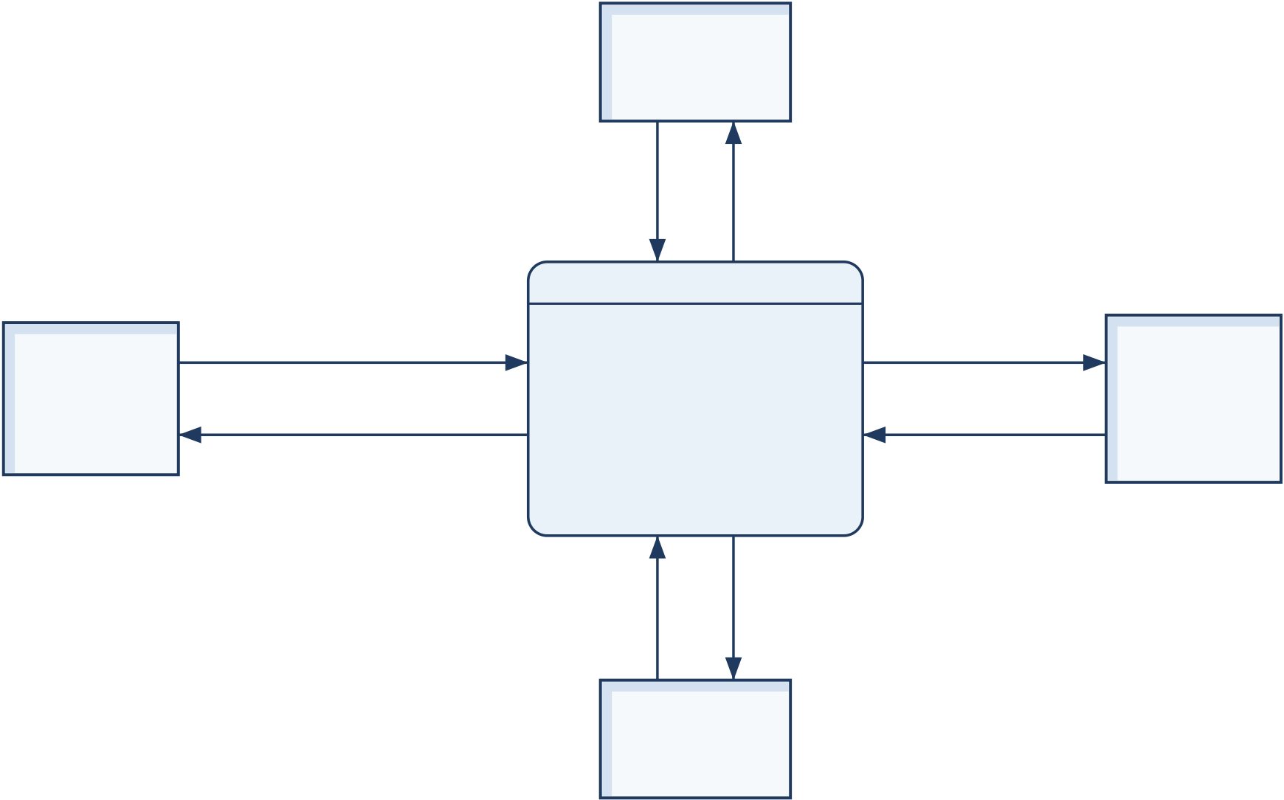
VidCraft:SoftwareRequirementsSpecification | Group7
2OverallDescription
2.1ProductPerspective
VidCraftdividesmediaauthoringamongseveralcomponents.Thebrowserprovidesthe studio.The backend validates requests, stores records and schedules jobs.Linguistic analysis andagentplanningrunintheAIservice,whiletherenderinglayercreatesandprocesses media.Persistentapplicationrecords,retrievalknowledgeandgeneratedfilesarestoredby role.
Each stage passes structured information to the next:analysis records, creative briefs, world state, shots or narration beats.These records allow the system to check outputs, limit retries andcomparealternativeexecutions.Theyalsoretainsuccessfulworkifalaterstagefails.
2.1.1ContextModel
The Creator submits an idea and style choices,then receives analysis,progress updates and media.TheOperatorprepareslocalresourcesandconfigurescomponents.TheEvaluator reviewsrepeatableexperimentsandtheirresults. Modelcapabilitiescomefromhosted servicesoralocalinferenceruntime,eachaccessedthroughacontrolledinterface.
Figure1isthecontextdiagram(Level0dataflowdiagram).Thewholesystemappears asthesingleprocess0,surroundedbyitsfourexternalentities:E1Creator,E2Operator, E3EvaluatorandE4ModelServices.E4representsthehostedmodelservicesinStandard mode and the prepared local inference runtime in Local Demo mode;the selected execution profiledecideswhichoneservesatask.Eacharrowisonenameddataflow,andnodata storeappearsatthislevel.
DFD Level 0 (Context) | E4 = hosted model services (Standard) or local runtime (Local Demo).
E2
Operator
configuration,  models, corpus | readiness,  diagnostics
prompt, answers,
E1 | settings, approvals, | 0 | model requests | E4
E1 | generation request, | 0 | model requests | E4
E1 | history query | 0 | (hosted or local) | E4
E1 | analysis, questions, | VidCraft | model results, | Model
Creator
Creator | analysis, questions, | System | model results, | Services
Creator | brief, storyboard, | System | errors, readiness | Services
progress, media,
history
test prompts,  conditions | results, measures,  provenance
E3
Evaluator
Figure1:Contextdiagram(DFDLevel0)ofVidCraft
4

VidCraft:SoftwareRequirementsSpecification | Group7
2.2ProductFunctions
1.Promptanalysis:explainclearelements,missingdetailsandcontradictionsinvisual descriptions.
2.Promptrefinement:collectfocusedanswersandformastructuredbriefforreview.
3.Stylecontrol:carry the chosen style, mood, lighting, palette and supported dimensions forward.
4.Narrativeplanning:orderstoryboardshotsandrefinecamerainstructionsusingre-trievedcinematographyguidance.
5.Mediacreation:produce procedural compositions or use the selected compatible route togeneratemedia.
6.Qualitycontrol:checkintentandsharedscenedetails,withlimitedvisualcritique whenenabled.
7.Delivery:combineusableshots,alignoptionalspeech/captionsandprovidedownload-ableresults.
8.Reviewandexperimentation:preservepromptversionsandcomparestandardand localrunsunderrecordedconditions.
2.2.1DataFlowDiagrams
Validation,scoringandoptionalclarificationturntheinputpromptintoacreativebrief. Thechosenstyleandexecutionsettingstravelwithit. Asingle-imagerequestgoesto acompatibleimageroute.Astoryboardrequestfirstpassesthroughnarrativeplanning, techniqueretrievalandintentchecking,thenentersthegenerationqueue.Usableshots proceed to narration, composition and post-processing.Results and metadata remain linked totheirsourcepromptandgenerationattempt.
TheLevel1diagram(Figure2)decomposesprocess0ofthecontextdiagramintosix interlinkedprocesses.Processes1.0to4.0formthemainpipelineandpasstheirresults throughthedatastoresplacedbetweenthem.Processes5.0and6.0connecttothesame stores.ThediagramisbalancedwithLevel0:ithasthesamefourexternalentities,and eachLevel0flowappearsinit,eitherunchangedordividedintoitscomponentflows(for example,mediabecomesimagefrom3.0andvideo,downloadsfrom4.0).Whereastoreor entityisneededinseveralrows,itisdrawnagainwiththeGane–Sarsonduplicatemarkso thatnoflowcrossesanother.Table1defineseachprocessanddatastore.
Table1:ProcessesanddatastoresoftheLevel1dataflowdiagram
ID | Name | Responsibilityorcontent
1.0 | AnalyzeandRefine | Validatesandstorestheprompt,scoresit,asks
1.0 | Prompt | clarificationquestionsandbuildstheconfirmedbrief
(FR-01toFR-06).
2.0 | PlanStoryboard | Appliestheselectedstyleandworkflow,draftsand
validatestheshotplan,retrievestechniques,checks intentandpresentsthestoryboard(FR-07,FR-09, FR-11toFR-15).
Continuedonnextpage
5

VidCraft:SoftwareRequirementsSpecification | Group7
ProcessesanddatastoresoftheLevel1dataflowdiagram(continued)
ID | Name | Responsibilityorcontent
3.0 | GenerateMedia | Admitsandqueuesthejob,validatesrouteand
dimensions,generatesandchecksimagesorshots,and recordsattempts(FR-08,FR-10,FR-16toFR-23, FR-29).
4.0 | AssembleandDeliver | Addsoptionalnarration,assemblesthecommon
4.0 | Media | timeline,post-processesanddeliverstheartifacts
(FR-24toFR-28).
5.0 | ManageHistoryand | Answershistoryandcomparisonqueriesandruns
5.0 | Evaluation | controlledevaluationsonfrozentestprompts(FR-30,
FR-31,FR-40).
6.0 | Configureand | Appliestheoperator’sconfiguration,preparesthe

MonitorSystem

indexandreportsmodelandservicereadiness(FR-32 toFR-39).

D1 | PromptRecords | Prompts,promptversions,analysesandconfirmed
briefs.
D2 | PlansandJobs | Storyboards,worldstate,shots,generationattempts
andjobstates.
D3 | TechniqueIndex | Cinematographycorpus,FAISSindexandencoder
metadata.
D4 | MediaFiles | Shotassets,themastervideoanditsderivatives.
D5 | Configuration | Server-sideroutes,limits,featureflagsandexecution
profiles.
6

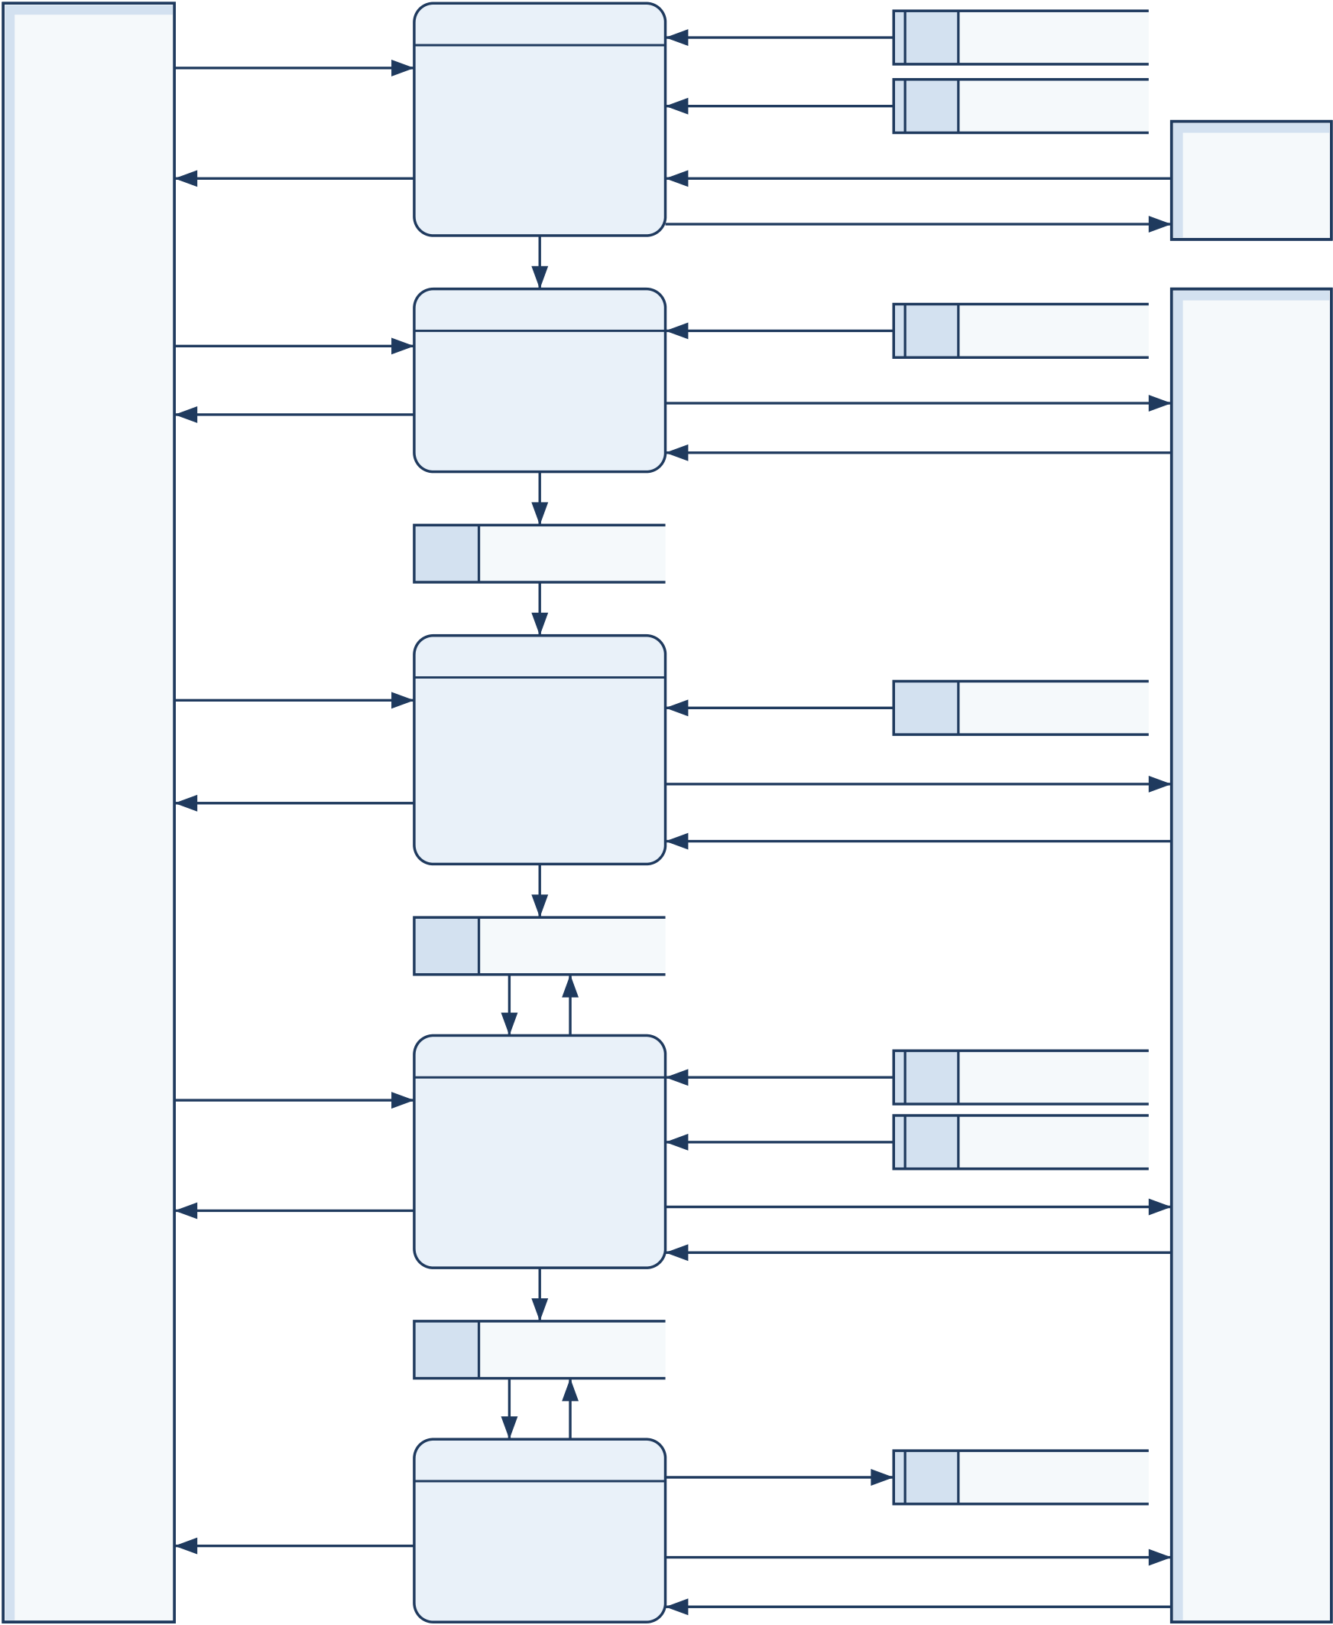
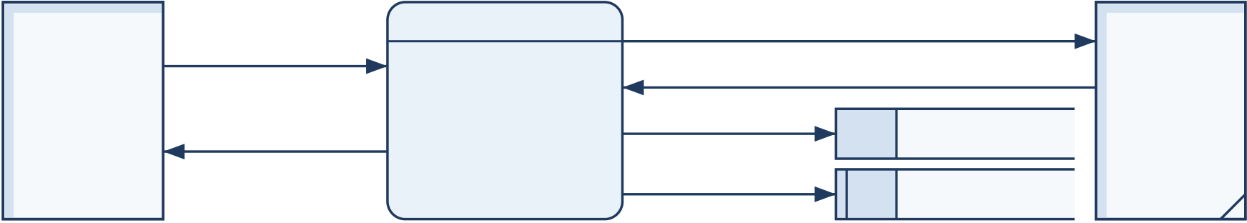
VidCraft:SoftwareRequirementsSpecification |  |  |  |  | Group7
Extra stroke (store) or corner slash (entity) marks a repeated symbol.
  DFD Level 1
history query |  | prompt versions | D1 | Prompt Records
history query | 5.0 | prompt versions | D1
attempt records
history, | Manage History | D2 |  | Plans and Jobs
comparisons | and Evaluation | test prompts, conditions |  |  | E3
results, measures, provenance |  |  |  |  |  | Evaluator
test prompts
prompt, answers | 1.0 | original version
prompt, answers | 1.0 | D1 | Prompt Records
analysis, questions, | Analyze and | clarification requests
analysis, questions, | Refine Prompt | questions, brief drafts
brief
versions, analysis, confirmed brief
D1 Prompt Records
confirmed brief
E1 | settings, | 2.0 | technique
E1 | plan approval | 2.0 | passages
E1 | storyboard | Plan | D3 | Technique Index
E1 | storyboard | Plan | planning, embedding requests
E1 | storyboard | Storyboard
E1 | storyboard | Storyboard | plan drafts, vectors
Creator | storyboard | Storyboard
accepted storyboard
D2 | Plans and Jobs |  |  |  |  | E4  Model  Services
accepted storyboard |  | job state, shot outcomes |  |  |  | E4  Model  Services
generation request | 3.0 | image brief |  | D1 | Prompt Records | E4  Model  Services
routes, limits |  |  |  |  |  | E4  Model  Services
progress, image | Generate |  | D5 |  | Configuration | E4  Model  Services
progress, image | Media |  | generation, critique requests |  |  | E4  Model  Services
media, verdicts
shot assets
E2 | D4 |  | Media Files |  |  |  |  |  | E4
E2 | usable shot assets |  |  | master, derivatives |  |  |  |  | E4
E2 | 4.0 |  |  |  | attempt outcome | D2 |  | Plans and Jobs | E4
E2 | video, downloads | Assemble and |  |  | narration text |  |  |  | E4
E2 | Deliver Media |  |  |  | speech audio |  |  |  | E4
E2 | configuration, | 6.0 |  |  | readiness probes |  |  |  | E4
E2 | models, corpus |  |  |  | capability, identity |  |  |  | E4
E2 | readiness, | Configure and |  |  | routes, limits | D5 | Configuration |  | E4
 |  |  |  |  |  |  |  |  | Model
Operator | diagnostics
Operator | diagnostics | Monitor System |  |  | routes, limits | D5 |  |  | Services
Operator | index, metadata |  |  |  |  |  |  |  | Services
Operator | D3 |  |  |  |  |  |  | Technique Index | Services
Figure2:Dataflowdiagram,Level1
7

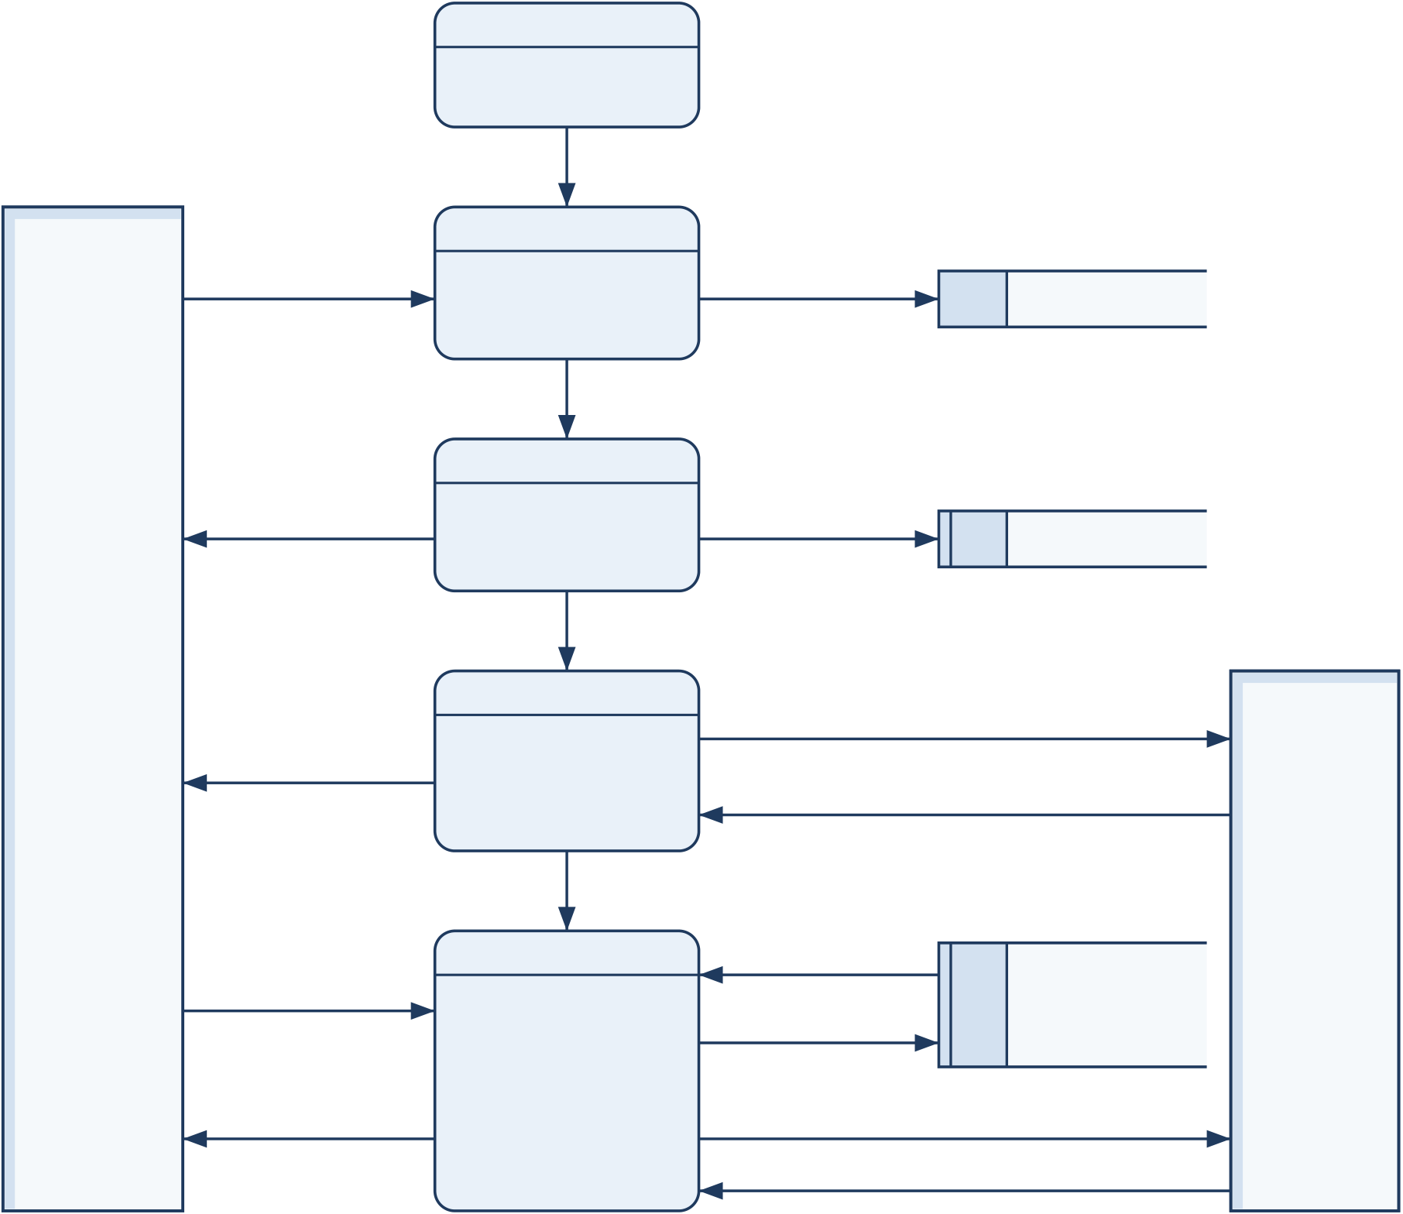
VidCraft:SoftwareRequirementsSpecification | Group7
TheLevel2diagramsdecomposethetwoprocessesthatcontaintheteam’smainanalysis andplanningwork.Eachbalanceswithitsparent:everyflowbetweenasub-processand anentity,storeorotherprocesscorrespondstoaflowoftheparentprocessinFigure2,or tooneofitscomponentflows.
InFigure3,process1.1validatesandstorestheoriginalprompt,and1.2calculatesthe fivedimensionscoresandflags.Process1.3generatesatmostsixclarificationquestions forunresolveddetails.Process1.4combinestheanswerswiththestoredoriginalversionto formtheconfirmedbrief.Testpromptsfromprocess5.0enterat1.1inthesamewayasa Creator’sprompt.
DFD Level 2: Process 1.0 Analyze and Refine Prompt
5.0
Manage History
and Evaluation
test prompts
1.1
prompt | Validate and | original version | D1 | Prompt Records
prompt | Store Prompt | original version | D1 | Prompt Records
valid prompt
analysis: scores, | 1.2 | analysis | D1 | Prompt Records
flags, suggestions | Score and | analysis | D1 | Prompt Records
flags, suggestions | Flag Prompt | analysis | D1 | Prompt Records
unresolved details
E1 | questions (≤ 6) | 1.3 | question request |  | E4
Creator
Creator | questions (≤ 6) | Generate |  |  | E4
Creator | questions (≤ 6) | Clarification | candidate questions |  | E4
Creator | questions (≤ 6) | Questions |  |  | E4
Creator | questions (≤ 6) | question set |  |  | E4
Creator | answers | 1.4 | original version |  | Model
 |  |  |  |  | Services
Creator | answers | D1 |  | Prompt Records | Services
Creator | creative brief | Build | clarified version, | brief request | Services
Creator | creative brief | Build | confirmed brief | brief request | Services
Creator | creative brief | Creative Brief | confirmed brief | brief request | Services
brief draft
Figure3:Dataflowdiagram,Level2:process1.0AnalyzeandRefinePrompt
InFigure4,theScreenwriter(2.1)draftsthreetofiveshotsandtheworldstate,and 2.2validatestheirstructure.TheCinematographer(2.3)retrievestechniquepassagesand refinescamerainstructions.Process2.4comparestherefinednarrativewiththeconfirmed brief,and2.5presentsthestoryboardforacceptance. Bothfeedbackflowsinto2.1are boundedbythesamelimitofafirstdraftandatmosttworevisions(FR-13);aplanthat remainsinvalidisblockedfromrendering(FR-11).
8

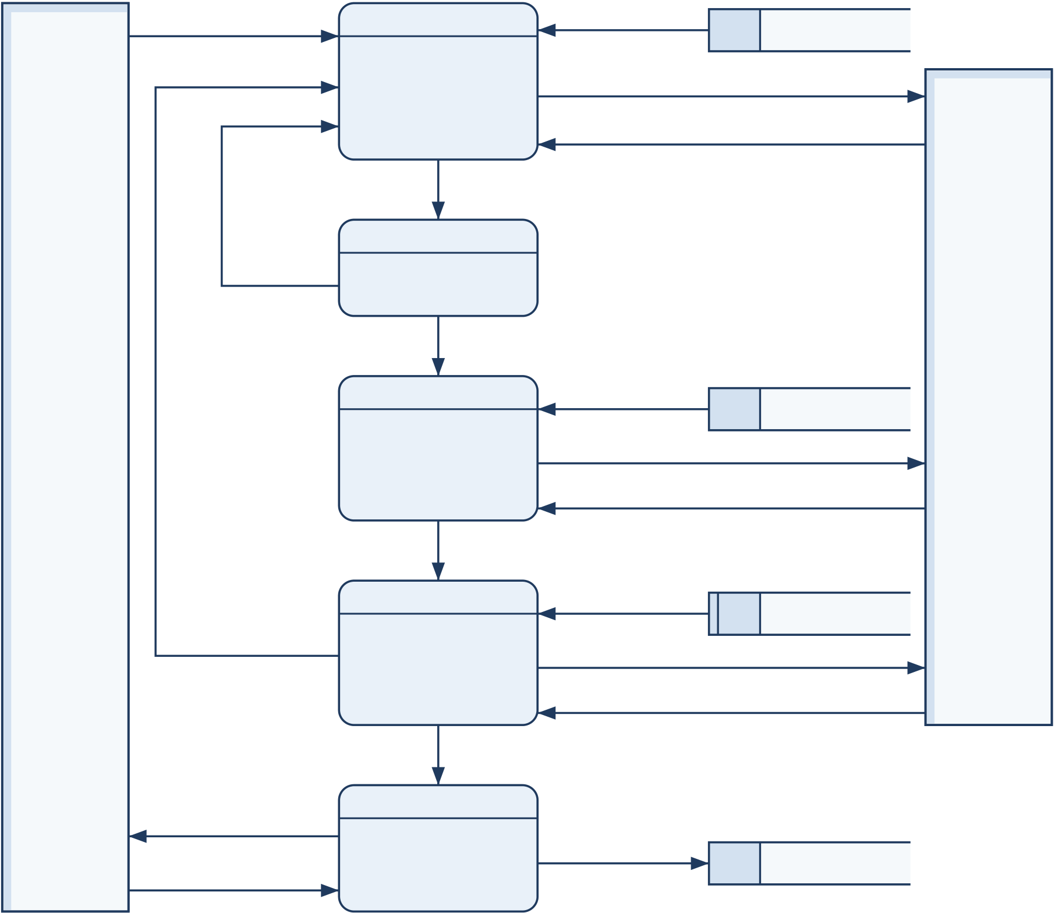
VidCraft:SoftwareRequirementsSpecification | Group7

 |  | DFD Level 2: Process 2.0 Plan Storyboard
settings | 2.1 | confirmed brief
settings | 2.1 | D1 | Prompt Records
settings | Draft Narrative | planning request
settings | Plan
settings | Plan | plan draft
settings | (Screenwriter)
draft plan
structure 2.2
errors Validate Plan
Structure
E1 | valid plan | technique |  | E4
E1 | 2.3 | passages |  | E4
E1 | 2.3 |  |  | Model
E1 | 2.3 | D3 | Technique Index | Model
E1 | Retrieve and | D3 | Technique Index | Services
E1 | Retrieve and | query, refinement request |  | Services
E1 | Refine Shots | query vector, refined shots |  | Services
Creator | Refine Shots |  |  | Services
Creator | (Cinematographer) |  |  | Services
refined plan
revision request | 2.4 | confirmed brief
(score < 0.35, | 2.4
(score < 0.35, | 2.4 | D1 | Prompt Records
at most 2) | Check Intent | embedding request
at most 2) | Preservation | vectors
checked plan, warnings
storyboard | 2.5 | accepted | D2 | Plans and Jobs
plan approval | Present | storyboard | D2 | Plans and Jobs
plan approval | Storyboard | storyboard | D2 | Plans and Jobs
Figure4:Dataflowdiagram,Level2:process2.0PlanStoryboard
9

VidCraft:SoftwareRequirementsSpecification | Group7
2.3UserClassesandCharacteristics
Table2:Userclassesandcharacteristics
Userclass | Characteristics | Mainresponsibilities
Creator | Student,educatororcontent | Submitideas,answerquestions,

creatorfamiliarwithbrowsers.

choosesettings,reviewtheplan anddownloadresults.

Operator | Teammemberfamiliarwith | Setupservices,modelsand

deploymentandconfiguration.

indexes;maintaincredentials,
resourcelimitsandretaineddata.

Evaluator | Supervisor,testerorresearcher | Checkrequirements,conduct

examiningsystembehaviour.

controlledcomparisonsandreview evidencealongsideitslimitations.

2.4OperatingEnvironment
Theclientrequiresadesktoporlaptopbrowsersupportingtheapplication’simage/video formats.Its layout shall also accommodate mobile-width screens.A microphone is optional. TheplannedstackcomprisesReact/TypeScript,Node.js/Express,Python/FastAPI[8], MongoDB,Redis/Bull,spaCy[2],LangGraph[3],FAISS[5],Remotion[6]andFFmpeg[7]. Section3describestheirinterfaces.
Theacceptance-testreferencesetupusesafour-coredevelopmentmachine,16GBRAM andatleast20GBfreediskspace.Thisisatestconfiguration,notaprovenminimum foreverylocalmodel.PerformancereportsmustrecordtheactualCPU,RAM,operating system and any GPU used.The primary hosted profile requires no dedicated GPU. Suitable localmodelsmustbechosenaccordingtomeasuredcapacity,modelsizeandquantization.
DevelopmentservicesmayrunonWindowswithWSLoracompatibleLinuxenvironment. Enabled hosted services and initial resource downloads require network access.After prepa-ration, the local profile may run without hosted inference if every enabled processing compo-nentislocal.ThebaselinelanguagesupportcoversstoredEnglishpromptsandprocessing throughtheEnglishNLPpipeline.
2.5DesignandImplementationConstraints
•The available computing and generation budgets require limits on concurrent jobs, retries andmodelcalls.
•Agent output must pass its structured schema checks before it can be stored or rendered.
•Theretrievalindexanditsqueryembeddingsmustsharethesamemodel/vectorspace.
•Styleandsceneconstraintsexplicitlysetbytheusermustpassintactbetweencompo-nents.
•Credentialsandothersecretsmuststayinserverconfiguration,outsidebrowsercode.
•Theapplicationcontrolssharedsceneparameters;visualcontinuityingeneratedmedia remainsbest-effort.
•Localexperimentsuseexistingsmallmodelsoradocumentedadaptation;theyexclude foundation-modeltraining.
10

VidCraft:SoftwareRequirementsSpecification | Group7
2.6AssumptionsandDependencies
The operator supplies accessible model resources, required credentials, sufficient storage and aworkingdatabase/queue.VidCraftcannotcontrolchangesinmodelavailability,network accessorexternalquotas.Itshallretainuserworkandexplainfailurescausedbythose dependencies.Userssupplytexttheyarepermittedtoprocess.Anytrainingorevaluation datasetmusthavedocumentedprovenance.
11

VidCraft:SoftwareRequirementsSpecification | Group7
2.7SystemArchitectureandAgentResponsibilities
ThePromptAnalyzerappliesdeterministiclinguisticscoring.Clarificationasksalimited setofquestionsandproducesthebrief.TheScreenwriterbuildsthenarrativeplan;the Cinematographerretrievestechniquesandrefinescamera/styleinstructions.Asemantic gate checks intent preservation.When enabled,the Critic reviews eligible generated visuals andmayrequestonlylimitedrevisions.Narrationandrenderingturntheacceptedplan intoanaudiovisualresultwithadefinedtimeline.
Thebackendhandlesproviderselection,queuesubmissionandstoredprogress. Agents cannot silently switch to a more expensive provider.Rendering uses the shared scene context andoneruleforincludingshots.Everyresultremainstraceabletotheinputs,settingsand modelexecutionprofileusedtocreateit.
Figure5showsthesecomponentsasaUMLcomponentdiagramarrangedintiers:the browser client, the Node.js gateway and generation worker, the AI service and the rendering pipeline,andfinallythedatastoresandmodelproviders.Dashedarrowsareusagedepen-dencieslabelledwiththeirpurposeorprotocol.AllmodelcallsfromtheAIservicepass through the inference adapters,which select the hosted or local route recorded in the task’s executionprofile.
12

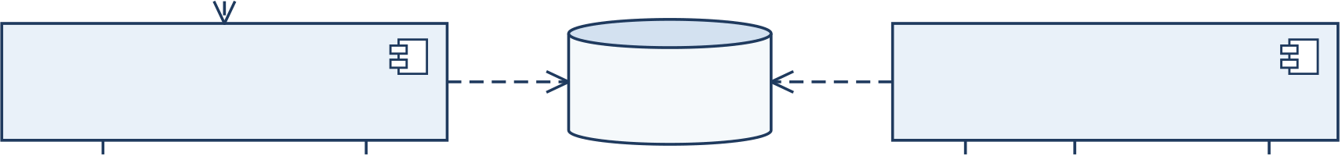
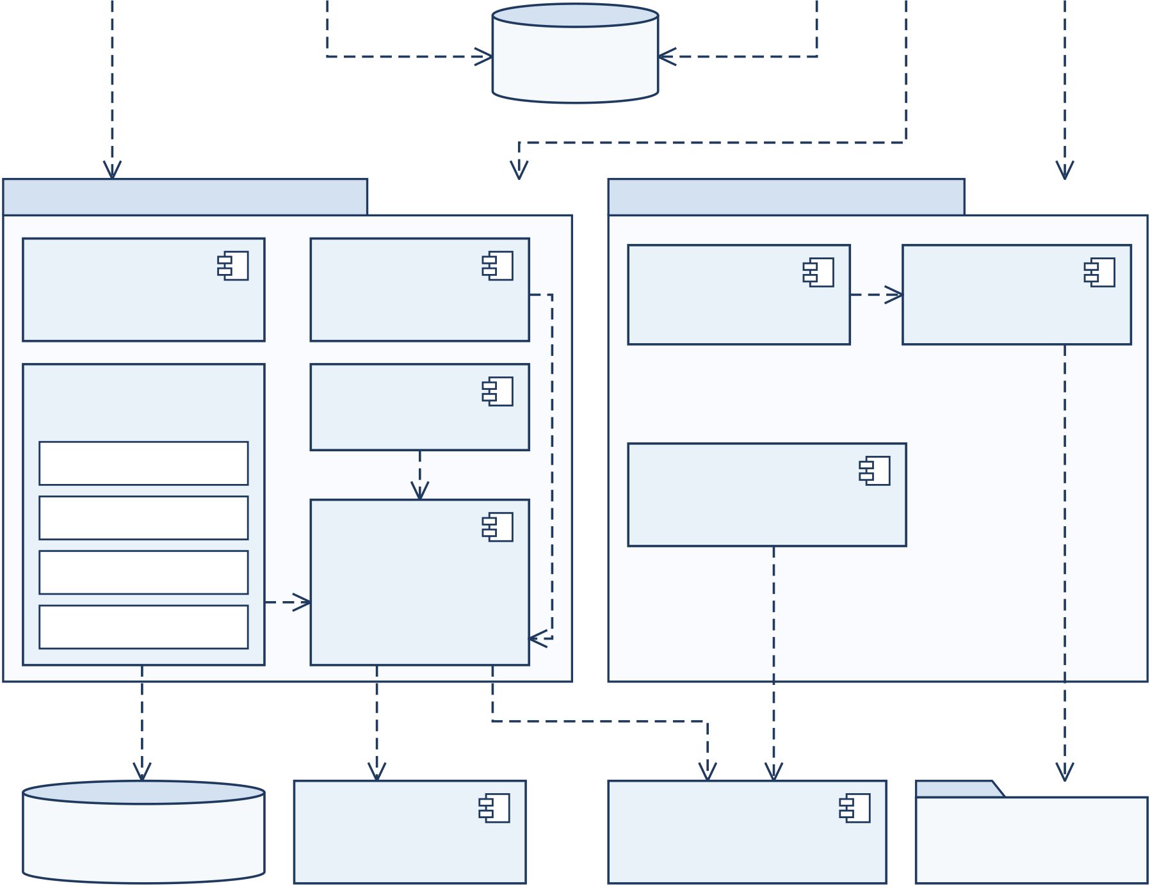
VidCraft:SoftwareRequirementsSpecification | Group7

«React / TypeScript»
Browser Studio
HTTP(S) / JSON
«Node.js / Express» | enqueue | Redis / Bull | jobs | «Node.js / Bull»
API Gateway | records | job queue | outcomes | Generation Worker
REST / JSON | records | MongoDB | outcomes | render,
REST / JSON | records | records | outcomes | render,
 |  |  |  | generate
critique, narration
AI Service «Python / FastAPI» |  | Rendering and Media Pipeline
«spaCy»  Prompt  Analyzer | Clarification Service | Remotion |  | FFmpeg
«spaCy»  Prompt  Analyzer | Clarification Service | Renderer |  | Post-processing
Agent Orchestrator | Narration | «image / video route»  Media Adapters
«LangGraph» | Service
Screenwriter
Cinematographer | «hosted | local»
Intent Gate | Inference | Standard (HTTPS) | selected | artifacts
Critic | Adapters | Standard (HTTPS) | selected | artifacts
retrieve (top-k) | local profile | Standard (HTTPS) | selected | artifacts
retrieve (top-k) | local profile | Standard (HTTPS) | media route | artifacts
FAISS index  + corpus | «Local Demo»  Local Inference Runtime | «external»  Hosted Model  Services |  | Managed  Media Files
Figure5:ComponentarchitectureofVidCraft(UMLcomponentdiagram)
13

VidCraft:SoftwareRequirementsSpecification | Group7
3ExternalInterfaceRequirements
3.1UserInterfaces
Theinterfaceshallprovidetheseworkflowviewsorpanels:
•Prompt composer:text entry, examples or guidance, Analyze and optional microphone control.
•Analysisandrefinement:theoverallscore,fivedimensions,flags,suggestions,clarifi-cationquestionsandabriefforreview.
•Styleandgenerationsettings:choicesforstyle,mood,lighting,palette,custom terms,supportedaspectratio,workflowandmediaroute.
•Executioncontrol:acompactStandard/LocalDemoswitchexplainingthechosen inferencemodeandwhetheritisready.
•Storyboardreview: shotorder,descriptions,camerainstructions,durationsand shareddetailsbeforegeneration.
•Progressandresults:theactivestage,shotstatus,partialerrors,image/videopre-viewsandavailabledownloads.
•History:storedprompts,theirrevisionsandgenerationattempts,withaccesstocom-parisonsandresults.
Theselectedmodeshallstayvisible.Standardnormallyuseshostedmodeladapters,while LocalDemousesapreparedlocalprofile.Switchingmodesaffectsthenextsubmissionand shall not alter a running job.The accompanying explanation shall state which local features areunavailableandwherelatencyorqualitymaydiffer.Anydemonstrationusingsample datashallbeclearlydistinguishedfromarunthatperformsactualinference.
3.2HardwareInterfaces
3.2.1SupportedDevices
Usersinteractthroughakeyboard,pointingdeviceanddisplayusingbrowserinterfaces. Supportedspeechrecognitionmayuseanoptionalmicrophone.TheserverrequiresCPU, memory,storageandnetworkresources.AGPUcanaccelerateaqualifiedlocalmodel,but thestandardprofiledoesnotrequireone.
3.2.2HardwareInteractions
No custom hardware is controlled by the application.Users may refuse browser microphone permissionandcontinuebytyping.Renderingandinferenceshallstaywithinconfigured resourcelimits.Ifcapacityisunavailable,theapplicationshallreportacontrollederroror keeptheworkqueued.
14

VidCraft:SoftwareRequirementsSpecification | Group7
3.3SoftwareInterfaces
Table3:Softwareinterfaces
Component | Interface | Responsibility
Frontendand | HTTP(S),JSONandmedia | Submitprompts/settings,check
gateway | responses | progressandstream/download
artifacts.
GatewayandAI | InternalREST/JSON | Analysis,clarification,storyboards,
service | InternalREST/JSON | semanticchecks,narrationand
critique.
MongoDB | Mongoose/database | Storepromptversions,storyboards,
MongoDB | connection | generationmetadataandartifact
references.
Redis/Bull | Queueinterface | Schedulebackgroundjobs,limit
concurrencyandtrackoperational
status.
Knowledgeindex | FAISSplusmetadata | Findrelevantcinematography
passagesusingacompatible
embeddingmodel.

InferenceadaptersHostedHTTPSor
configuredlocalruntime

Normalizemodelrequests/results; reportreadiness,timeoutsandmodel

Remotionand | interface | identity.
Remotionand | Validatedcompositioninput | Renderthetimeline,validatemedia
FFmpeg | andcontrolledprocess | andproduceposters,captionsand
FFmpeg | invocation | derivatives.
3.3.1PrincipalServiceOperations
Thecontractsbelowdescribethemainworkflowoperations.Historyandexecution-profile
fieldsbelongtothesamevalidated,versionedinterface.Errorsshallcontainsafeexplana-
tionsandstablefailurecategories,excludingcredentialsandinternalstacktraces.
Table4:Principalapplicationserviceoperations
Operation | Input | Result
POST/api/prompts | Prompttext;selected | PromptID,analysisand

executioncontext

applicableclarification questions.

POST/api/prompts/ | Question/answerpairs | Astructuredbriefwiththe
{id}/clarify | Prompt/versionID,style, | clarifiedprompt.
POST/api/storyboards | Prompt/versionID,style, | StoryboardID,sharedworld
POST/api/storyboards | renderrouteand | stateandvalidatedshots.
executionprofile
Continuedonnextpage
15

VidCraft:SoftwareRequirementsSpecification | Group7
Principalapplicationserviceoperations(continued)
Operation | Input | Result
POST/api/storyboards/ | AcceptedstoryboardID | Ahandleandstatusforthe
{id}/generate | Jobidentifier | acceptedjob.
GET/api/jobs/{id} | Jobidentifier | Currentstage,progress,shot
outcomesandavailable
artifacts.
POST/api/images | Prompt/version,image | Image,effectivepromptand
GET/api/storyboards/ | routeandstyle | artifactreference.
GET/api/storyboards/ | Storyboardidentifier | Savedstoryboardand
{id} | Nocontent | associatedresultmetadata.
GET/api/health | Nocontent | Servicehealthandreadiness,
identifyinganyaffected
dependencies.

History/version operationsPagination,
prompt/versionidentifiers

Storedinputs,revisions, comparisonsandthe
correspondinggeneration records.

3.4CommunicationInterfaces
StructuredrequestsandintermediaterecordsuseJSON.Mediaresponsescarrytheappro-priateMIMEtype.Thebrowserchecksprogressthroughboundedpolling;alaterpush channelmayusethesamejob-statecontract.Applicationandmodel-servicetrafficcross-inguntrustednetworksshalluseHTTPS.Accesstothedatabase,queueandlocalruntime interfacesshallremainrestrictedtothedeploymentenvironment.
Eachprovideradaptershalldeclareitssupportedtask,input/outputformat,limitsand anyseedorreference-imagesupport.Timeouts,exhaustedquotasandinvalidresponses shallbecomemeaningfulapplicationerrors.Theoperatorshallconfigurethelocalruntime address;usersshallnotsupplyarbitraryruntimeURLs.Requestsshallpreservethechosen executionprofileacrossallapplicablestages.
16

VidCraft:SoftwareRequirementsSpecification | Group7
4RequirementAnalysis
4.1FunctionalRequirements
TheserequirementsstatetheexpectedbehaviourofVidCraft.Optionalfunctionsapply whenenabled.EachrequirementlinkstotestingevidencethroughitsIDinSection6.6.
4.1.1Promptanalysisandrefinement
Thismoduledevelopsaninitialideaintoareviewablebrief.Linguisticscoringandfocused questionsaddressmissingdetailswhileretainingthecreator’sintendedsubject,actionand setting.
Table5:Promptanalysisandrefinement
ID | Requirement | Priority
FR-01 | Promptsubmission.Thesystemshallacceptnonblanktextup | High
to4,000characters,savetheoriginalandassignapersistent identifier.Itshallrejectinvalidtypesandoversizedtext.
FR-02 | Linguisticscoring.Theanalyzershallassignintegerscores | High
(0–100)forsubjectclarity,actionspecificity,environmentdetail, visualrichnessandtemporalcoherence.Theoverallscoreshall equaltheirroundedarithmeticmean.
FR-03 | Actionablefeedback.Thesystemshallidentifyconfiguredgaps | High
andcontradictoryvisualterms,thensuggestrelevant
improvements.Scoresshallbedescribedaslinguisticindicators, notguaranteesofmediaquality.
FR-04 | Optionaldictation.Supportedbrowsersshallacceptdictated | Optional
promptsandclarificationanswers.Typingshallremainavailable whenrecognitionisunsupportedormicrophonepermissionis denied.
FR-05 | Bounded clarification.The system shall ask one focused question | High
roundforunresolveddetails,uptoaconfigurablemaximumof sixquestions,andvalidateeachquestion–answerassociation.
FR-06 | Creativebrief.Thesystemshallproduceareviewablebrieffrom | High
theoriginalpromptandanswers,retainingexplicit
subject/action/settingconstraintsandeveryversion.Usersshall beabletoeditthebriefbeforestartinganewattempt.
17

VidCraft:SoftwareRequirementsSpecification | Group7
4.1.2Styleandworkflowconfiguration
This module saves visual and production choices for a confirmed brief.Style, mood, lighting andpalettedescribetheintendedappearance.Theworkflow,aspectratioandmediaroute determinehowthatappearanceisproduced.
Theimageworkflowcreatesasinglecomposition,whilethestoryboardworkflowcreates orderedshotsthatshareavisualstyle. Beforesubmission,theinterfaceoffersoptions supportedbytherouteandexecutionprofile.
Table6:Styleandworkflowconfiguration
ID | Requirement | Priority
FR-07 | Stylepropagation.Thesystemshallsavevisualstyle,mood, | High
lighting,paletteandcustomterms,carryingthemintoimage promptsandstoryboardworldstate.Explicituserchoicesshall overrideconflictingstyleinferredbythesystem.
FR-08 | Outputdimensions.Thesystemshallofferaspectratios | High
supportedbythechosenrouteonly.Baselinevideoshalluse 16:9at1920by1080.Thesystemshallrejectunsupported dimensionsbeforegenerationstarts.
FR-09 | Workflowchoice.Theusershallchoosesingle-imageor | High
storyboardgeneration.Theimageworkflowshallskipshot decomposition,whilethestoryboardworkflowshallfollowan orderedplanofshots.
FR-10 | Mediaroutechoice.Thesystemshalluseanexplicitlyselected | High
compatibleroute,identifyunavailableroutesanddiscloseknown costsorquotas.Itshallneversilentlyreplacethatroutewitha chargeablemediaprovider.
Configurationexample.Acreatorchoosesawarmpaletteandsoftlightingforastory-board.Thesechoicesaccompanysharedsceneinformationandeachshotprompt.Explicit choicesoverrideanyconflictingstyleinferredduringplanning. Ifsettingschangewhile generationisrunning,theyapplytoalatertask;theactivetaskkeepsitsrecordedsettings.
18

VidCraft:SoftwareRequirementsSpecification | Group7
4.1.3Multi-agentplanningandcinematography
Thismoduleturnstheconfirmedbriefintoaproductionplanforreview.TheScreenwriter arrangesthenarrativeandsharedscenedetails.TheCinematographerusesthecurated knowledgebasetorefineshotinstructions.Validationandaboundedintentcheckgovern transitionsbetweenthesestages.Thestoryboardshowsshotorder,cameratreatmentand timingbeforecommittingresourcestogeneration.
Table7:Multi-agentplanningandcinematography
ID | Requirement | Priority
FR-11 | Narrativedecomposition.TheScreenwritershallcreatethreeto | High
fiveorderedshots,eachwithanonemptydescription,camera instructionsandfinitepositiveduration,plussharedcharacter andsettinginformation.Invalidstructuredoutputshallbe blockedfromrendering.
FR-12 | Retrieval-groundedplanning.TheCinematographershall | High
retrieverelevantpassagesfromthecuratedknowledgebase, usingadefaulttop-kofthreepershot,torefinecamera/style instructions.Queryandcorpusembeddingsshallsharea matchingmodel/vectorspace.
FR-13 | Intentpreservation.Thesystemshallmeasuresemantic | High
similaritybetweenthebriefandplannednarrative.Ataninitial thresholdof0.35,itshallallowatmosttworevisionsafterthe firstdraft.Itshallwarnoflowfinalscoresandmarkunavailable measurementsunchecked.
FR-14 | Scenecontinuity.Thesystemshallcombinesharedcharacter, | High
settingandstyledetailswitheachshot-specificaction/camera instruction.Supportedroutesmayusereferenceanchoring. Evaluationshallassessgeneratedappearanceseparatelyfrom consistencyofthesuppliedparameters.
FR-15 | Storyboardreview.Beforemediageneration,theusershallbe | High
abletoinspectshotorder,descriptions,camerachoices,duration andsharedsceneinformation.Theinterfaceshalllettheuser accepttheplanorreturntorefinement.
19

VidCraft:SoftwareRequirementsSpecification | Group7
4.1.4Generation,qualitycontrolanddelivery
Table8:Generation,qualitycontrolanddelivery
ID | Requirement | Priority
FR-16 | Proceduralrendering.Thesystemshallmapsupportedshot | High
categoriestowide,mediumandclose-upcompositions. Unknowncategoriesshalluseadocumentedmedium-shot fallback.Finalassemblyshallnotrequireindividualmedia URLsforcompletedproceduralshots.
FR-17 | Imagesynthesis.Thesystemshallcreateasingleimageor | High
storyboardshotimageusingtheeffectivepromptandchosen style.Itshallvalidatereturnedmediaandrecordtherouteand source-inputreferences.
FR-18 | Videosynthesis.Withacompatiblevideo-generationroute | Medium
enabled,thesystemshallacceptandvalidategeneratedclips andpreservetheirtemporalcontentinassembly.Itshall distinguishsequencesofanimatedstillsfromclipscontaining synthesizedmotion.
FR-19 | Backgroundexecution.Thesystemshallqueuegeneration | High
asynchronouslyandreturnajobhandlewithoutwaitingfor rendering.Itsinitialresource-constrainedprofileshallallowone activegenerationworker.
FR-20 | Duplicateprotection.Concurrentstartrequestsforthesame | High
activestoryboardshallresolvetooneeffectivegenerationjob withoutrepeatingchargeablemediawork.Adeliberate regenerationafterthatrunshallcreateaseparateattempt.
FR-21 | Progressandrecovery.Theinterfaceshallshowthecurrent | High
stage,progress,shotoutcomesandstageerrors.Afterreload,it shallusetheretainedjobhandletoresumestatuslookup, stoppingatterminalorexpiredstates.Acompletedjobwithno videoshallnotappearasasuccessfulvideoresult.
FR-22 | Controlledfailurehandling.Thesystemshallboundrequest | High
timeoutsandretries,keepingcompletedshotsifanotherfails.It shallreportpartial/no-outputresultsexplicitlywhenapplicable.
External-servicefailuresshallpreserveinputsandsuccessful artifacts.
FR-23 | Visualfeedback.Whenenabledforcompatiblegeneratedvisuals, | Optional
theCriticshallrecordaverdictandreason.Bydefault,itshall requestatmosttworegenerationspershot,retainingthefinal usableassetwhenexhausted.Unavailablecritiqueshallbe markedunchecked.
FR-24 | Narration.Whenenabled,thesystemshallcreatenarration | Optional
beatsforusableshots,synthesizespeechandsettimingfrom measuredbeatdurations.Failedspeechshallleavearecorded silentintervalorsilentoutputwhilepreservingthevisualassets.
Continuedonnextpage
20

VidCraft:SoftwareRequirementsSpecification | Group7
Generation,qualitycontrolanddelivery(continued)
ID | Requirement | Priority
FR-25 | Commonmediatimeline.Thesystemshallassembleusable | High
shotsinorder,usingthesameinclusionruleforvisuals,
narrationandcaptions.At30FPS,eachincludedshotshalluse max(1,round(durationinsecondstimes30))frames.Failedor heldshotsshalladdnotimelineinterval.
FR-26 | Post-processing.Afterassembly,thesystemshallcreatea | High
poster,WebVTTcaptionsandaweb-compatibleMP4.Itmay createaseparateburned-insubtitlecopy.Optionalderivative failureshallpreservethemaster.
FR-27 | Colourtreatment.Thesystemshouldprovideanamed, | Medium
reproduciblecolour-gradingpresetforaderivedvideowhile retainingthemasterandpreservingdimensions,durationand audiosynchronization.
FR-28 | Previewanddownload.Usersshallbeabletopreviewavailable | High
mediaanddownloadthemaster,images,captions,posterand enabledvariants.Theinterfaceshallidentifymissingorfailed artifactswithoutpreventingvaliddownloads.
FR-29 | Regenerationrecords.Eachnewgenerationattemptshallkeep | Medium
itsowninput,settings,modeandoutputattribution.Earlier retainedresultsshallremainlinkedtotheattemptthat originallyproducedthem.
21

VidCraft:SoftwareRequirementsSpecification | Group7
4.1.5Historyandversioncomparison
Thismoduleconnectseachprompt,revisionandgenerationattemptwithitsinputsand settings.These records help creators trace results and evaluators examine the team’s prompt-refinementworkflow.
Withinthepermitteddeploymentorsessionscope,paginatedhistoryshowstimestamps, status,executionmodeandlinkstoretainedresults.
Table9:Historyandversioncomparison
ID | Requirement | Priority
FR-30 | Savedhistory.Thesystemshalldisplaypaginatedpromptand | Medium
generationhistorywithinthepermitteddeployment/session scope,showingtimestamps,status,selectedmodeandlinksto resultsthatremainavailable.
FR-31 | Promptversions.Thesystemshallsaveoriginal,clarifiedand | Medium
user-editedversions.Selectedversionsshallbecompared
throughtextdifferencesandsubject/action/setting/style
attribution.Semanticcomparisonsshallnametheirencoderand rejectincompatiblevectorspaces.
Version interpretation.Comparison separates original, clarified and edited text, grouping changes by subject, action, setting and style.Semantic similarity provides additional context whentheembeddingspacesmatch.Itdoesnotestablishimprovedmediaquality.
Illustrative workflow.A creator expands “a cyclist on a road” into a mountain-road scene atsunriseandlateradjuststhelighting.Historykeepstheserevisionsandtheiroutputs distinct, helping the creator choose between further editing and regenerating the saved plan.
Record and artifact availability.Media files may expire before their records are removed. History identifies unavailable artifacts while retaining the attempt’s identity.Earlier results keeptheirassociationwiththeiroriginalsettings.
22

VidCraft:SoftwareRequirementsSpecification | Group7
4.1.6Hybridinferenceandprojectevaluation
Table10:Hybridinferenceandprojectevaluation
ID | Requirement | Priority
FR-32 | Execution-modecontrol.AcompactStandard/LocalDemo | High
controlshalldefaulttoStandardanddisplaymodeand
readiness.Theinterfaceshallexplainlocalperformancelimits withoutobscuringworkflow.
FR-33 | Consistentmoderouting.Eachtaskshallkeepaserver-validated | High
profilecoveringallenabledlanguagetasks.ChangestotheUI modeshallaffectsubsequenttasksonly.
FR-34 | Localmodelreadiness.Thelocalprofileshallverifyruntime, | High
installedmodel,structured-outputsupportandlimits.Local andStandardoutputsshallmeetidenticalvalidationcontracts.
FR-35 | Localretrieval.LocalDemoshalluselocalembeddingsanda | High
matchingindexforretrievalandintentchecking.Unavailable resourcesshallbemarkedsetup-requiredorunchecked;hosted embeddingcallsshallnotbeused.
FR-36 | Localcapabilityprofile.LocalDemoshallsupportlocal | High
languageprocessing,embeddingsandproceduralrendering. Visualgeneration,critique,speechanddictationshallbe disabledunlesssupportedlocally.Hostedprocessingshall requireexplicitmodeselection.
FR-37 | Modelprovenance.Recordsshallnamethemodel/runtime, | High
mode,quantizationandadapterversion.Fine-tuningclaims shallrequiretrainingartifacts;pretrainedorquantizedmodels aloneshallnotqualify.
FR-38 | Adaptationexperiment.Iffine-tuningisperformed,theteam | Optional
shallrecordthebasemodel,task,dataprovenance,training settingsandcheckpoint/adapter.Itshallcomparethe adaptationwiththeunchangedbaseondisjointheld-out prompts.
FR-39 | Configurationandreadiness.Theoperatorshallconfigure | High
models/routes,retrylimits,featureflagsandcorpus/index preparation.Healthreportsshalldistinguishprocessavailability fromstorage,queue,modelandrendererreadiness.
FR-40 | Comparativeevaluation.Theprojectshallassessrefinementand | High
baseline-versus-multi-agentplanningusing50frozenprompts, andcompareStandard/LocalDemoonadeclaredpairedset.
Reportsshallincludefailures,actualsamplecounts,model versions,timingsandqualitymeasureswithoutassuming improvement.
23

VidCraft:SoftwareRequirementsSpecification | Group7
4.2Use-CaseDescriptions
TheCreatoristhemainactor.OperatorandEvaluatordenoteprojectroles,notasep-aratepublicaccount-managementsubsystem. ModelServicesisasecondaryactor:the hostedservicesorlocalruntimethatthesystemcallswhileservingausecase.Common failure handling retains typed input, the confirmed brief and stored artifacts.Each use case describestheexpectedsequence,alternativepathsandexceptionalconditions.
4.2.1Use-CaseDiagram
Figure6placesthetwelveusecasesinsideasinglesystemboundary.Theprimaryactor isontheleftandthesecondaryandsupportingactorsareontheright.Tworelationships connectusecases:
•UC-02«extend»UC-01:clarificationisaddedtopromptanalysisonlywhenunresolved detailsremain.
•UC-09«include»UC-06:regeneratingfromasavedplanalwaysperformsstoryboard mediageneration.
24

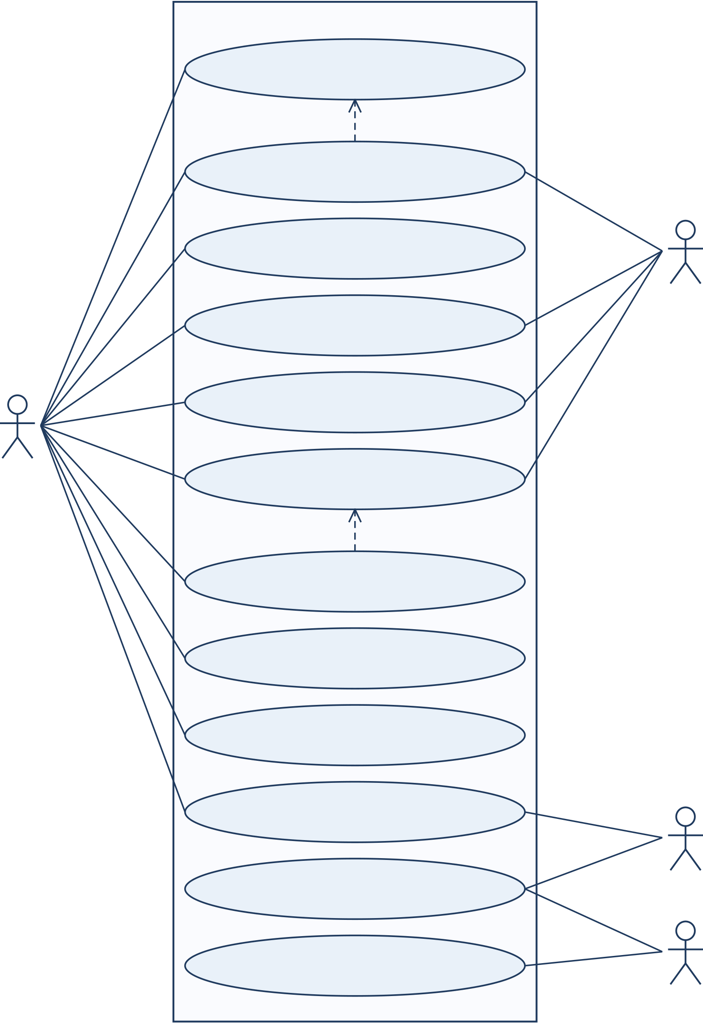
VidCraft:SoftwareRequirementsSpecification | Group7
VidCraft System
UC-01: Compose and analyze
a prompt
«extend»
[unresolved details]
UC-02: Clarify and refine
the brief
UC-03: Select style, workflow
and execution mode
Model Services
UC-04: Create and review  a storyboard | (secondary actor:  hosted or local)
UC-05: Generate a
single image
Creator  (primary actor) | UC-06: Generate  storyboard media
«include»
UC-09: Regenerate from
a saved plan
UC-07: Monitor or resume
generation
UC-08: Preview and
download media
UC-10: Inspect history and
prompt changes
UC-12: Evaluate the  project | Evaluator
UC-11: Prepare and
maintain the system
Operator
Figure6:Use-casediagramofVidCraft
25

VidCraft:SoftwareRequirementsSpecification | Group7
4.2.2UC-01:Composeandanalyzeaprompt
Table11:UsecaseUC-01:Composeandanalyzeaprompt
Attribute | Description
Actors  Preconditions Trigger  Basicflow | Creator  Thestudioandanalyzerareavailable.  TheuserchoosesAnalyze.  1.Typeoroptionallydictateaprompt.2.Validatetheinput.3.
Savetheoriginalandcalculatescores.4.Showdimensionscores, flagsandsuggestions.5.Offerclarificationifneeded.
AlternativeflowDetailedpromptsproceeddirectlytosettings;typingremains availableifdictationisunsupported.
Postconditions Apromptidentifierandanalysisareavailable.
Exceptions Blank/oversizedinput,refusedmicrophonepermissionoranalyzer failure.
Requirements | FR-01–04
Interactiondetail.Scoresdirectthecreatortodescriptionsthatmayneedmoredetail. Apromptmightclearlynameitssubjectbutomittheactionorsurroundings.Theac-companyingfeedbacklinkstheseomissionstopossiblerefinements.Ahighscoreindicates descriptivecompleteness;itcannotpromisethatthegeneratedimageorvideowillmatch theintendedquality.
26

VidCraft:SoftwareRequirementsSpecification | Group7
4.2.3UC-02:Clarifyandrefinethebrief
Table12:UsecaseUC-02:Clarifyandrefinethebrief
Attribute | Description
Actors  Preconditions Trigger  Basicflow | Creator(primary);ModelServices(secondary)  Ananalyzedpromptstillcontainsunresolveddetails.  Theuserrequestsclarification.  1.Showtheboundedquestionset.2.Recordeachcorresponding
answer.3.Formaclarifiedbrief.4.Presenttheresult.5.Accept oredititandsaveitsversion.
AlternativeflowWhenclarificationisunnecessary,usetheoriginalprompt;save editsasnewversions.
Postconditions Thereviewedcreativebriefisready.
Exceptions Unansweredquestions,invalidmodelstructureorinferencetimeout; suppliedanswersareretained.
Requirements | FR-05–06,FR-31
Interactiondetail.Questions address details still missing from the submitted idea.Keep-ingeachanswerwithitsquestionhelpstherevisedbriefreflectwhatthecreatoractually supplied.Thecreatorreviewsthecombinedtextbeforeplanningandcancorrectaninter-pretationthatchangestheintendedscene.Originalandrevisedversionsstaydistinctfor subsequentcomparison.
27

VidCraft:SoftwareRequirementsSpecification | Group7
4.2.4UC-03:Selectstyle,workflowandexecutionmode
Table13:UsecaseUC-03:Selectstyle,workflowandexecutionmode
Attribute | Description
Actors  Preconditions Trigger  Basicflow | Creator  Ausablepromptandknowncapabilitiesareavailable.  Theuseropensthegenerationsettings.  1.Chooseimageorstoryboard.2.Setastyleandsupportedaspect
ratio.3.ChooseStandardorLocalDemo.4.Selectanavailable mediaroute.5.Validateandsavesettingsfortherequest.
AlternativeflowLocalDemoisdisabledifitsruntimeisunavailable;settings changedduringprocessingaffectthenextrequest.
Postconditions Thenexttaskretainsavalidsettings/profilesnapshot.
Exceptions Anincompatibleratio/route,anunavailablemodeloranexhausted budget.
Requirements | FR-07–10,FR-32–36
Interactiondetail.Thethreeselectionsserverelatedpurposes:workflowsetstheformof the output, execution mode sets the processing profile, and media route selects a compatible generationcapability.Thesavedconfigurationkeepsthecombinationsubmittedforthat task.LocalDemomustpassitsreadinesscheck,anditsavailablefunctionsmaybefewer thanthoseofferedthroughhostedservices.
28

VidCraft:SoftwareRequirementsSpecification | Group7
4.2.5UC-04:Createandreviewastoryboard
Table14:UsecaseUC-04:Createandreviewastoryboard
Attribute | Description
Actors  Preconditions Trigger  Basicflow | Creator(primary);ModelServices(secondary) Aconfirmedbriefandcompatiblesettingsexist.  Theuserrequestsastoryboard.  1.TheScreenwriterformsorderedshotsandsharedworldstate.2.
TheCinematographerretrievesrelevanttechniques.3.Validatethe plan.4.Runtheboundedintentcheck.5.Showshotsfor
acceptanceorrefinement.
AlternativeflowLowsimilaritypermitsonlythespecifiedrevisions;missing measurementsremainmarkedunchecked.
Postconditions Exceptions  Requirements | Astructuredplanisstoredandreviewedbeforerendering. Malformedplan,incompatibleindexormodelfailure.  FR-11–15
Review focus.The creator checks that the shot sequence expresses the intended action and retainsthesharedcharacters,settingandvisualstyle.Camerainstructionsanddurations explain how the sequence will unfold.Any similarity warning informs this review but leaves thefinaljudgmentwiththecreator.Acceptingthestoryboardconfirmstheplanforthis generationattempt.
Planningresponsibility. Sharedscenedetailssupportcontinuity,andretrievedtech-niquesguidecamerachoices.Team-developedorchestrationcombinestheserepresentations andvalidationintoareviewableplan.Generatedappearanceischeckedseparatelyafter rendering.
29

VidCraft:SoftwareRequirementsSpecification | Group7
4.2.6UC-05:Generateasingleimage
Table15:UsecaseUC-05:Generateasingleimage
Attribute | Description
Actors  Preconditions Trigger  Basicflow | Creator(primary);ModelServices(secondary)  Aconfirmedpromptandimage-capablerouteareselected.  TheuserchoosesGenerateimage.  1.Combinethepromptwithitsstyle.2.Callthechosenadapter.
3.Validatethereturnedimage.4.Savetheresultandprovenance. 5.Providepreviewanddownload.
AlternativeflowAfterfailure,theusermaychangesettingsandretry;theworkflow doesnotdecomposeastoryboard.
Postconditions Exceptions  Requirements | Oneattributableimageoranexplicitfailureoutcomeisavailable. Timeout,unsupportedformat,providerlimitorstoragefailure.  FR-09–10,FR-17,FR-28
Resultinterpretation.Theimagerequestusestherevieweddescriptiontogetherwith theselectedstyle.Itsresultretainsthoseinputsandtheactualgenerationrouteforlater review.Ifthatroutefailsorreturnsunusablemedia,therecordremainsafailedimage attempt.Thesystemneitherturnsitintoastoryboardnorautomaticallyselectsanother chargeableroute.
Reviewfocus.Inthepreview,thecreatorchecksthesubject,action,settingandchosen style.Recordedinputdetailshelpguideadeliberaterevisioniftheimagedepartsfromthe brief.
30

VidCraft:SoftwareRequirementsSpecification | Group7
4.2.7UC-06:Generatestoryboardmedia
Table16:UsecaseUC-06:Generatestoryboardmedia
Attribute | Description
Actors  Preconditions Trigger  Basicflow | Creator(primary);ModelServices(secondary)  Anacceptedstoryboardexistsandrequiredcomponentsareready. Theuserstartsgeneration.  1.Deduplicatetherequestandissueajobhandle.2.Processshots,
keepingtheiroutcomes.3.Runoptionalboundedcritique.4. Preparenarrationforusableshotswhenenabled.5.Assembleand post-processthemedia.
AlternativeflowFailedshotsareconsistentlyexcluded;failuresinoptionalstages preserveothervalidresults.
Postconditions Therunrecordscomplete,partial,no-outputorfailedresultsand availableartifacts.
Exceptions Amodelfailure,exhaustedresources,queueinterruptionor renderingerror.
Requirements | FR-16–27
Processingdetail.Beforeassembly,thesystemrecordsanoutcomeforeachshot.One inclusion rule governs visuals, narration and captions so that failed shots do not create gaps ormismatchedsegments.Optionalcritiqueandnarrationremainwithintheirconfigured limits.Thefinalstatusstateswhethertherunproducedcompletemedia,partialoutputor nousableresult.
31

VidCraft:SoftwareRequirementsSpecification | Group7
4.2.8UC-07:Monitororresumegeneration
Table17:UsecaseUC-07:Monitororresumegeneration
Attribute | Description
Actors  Preconditions Trigger  Basicflow | Creator  Ajobhandleisretained.  Theuserchecksprogressorreloads.  1.Fetchthejobstate.2.Showitsstageandshotoutcomes.3.
Refreshaccordingtothepollingpolicy.4.Reusethesavedhandle afterreload.5.Stopatterminalstateanddisplayartifacts.
AlternativeflowTemporarydisconnectiontriggersboundedbackoff;anexpiredjob displaysrecoveryguidance.
Postconditions Exceptions  Requirements | Theuserseestheactualstateandavailableresults.  Unreachablebackend,expiredhandleorinterruptedworker.  FR-19–22
Recoverydetail.After reload, the retained handle reconnects the interface to the existing jobwithoutresubmittinggeneration.Progressreflectsthereportedstageandactualshot outcomes;startingastagedoesnotestablishthatitsucceeded.Pollingstopswhenthejob becomesterminalorexpires,andtheinterfaceshowstheavailableresultsorexplainsthe applicablerecoveryaction.
Statusinterpretation.Finishingaqueueoperationdoesnotnecessarilyproduceusable media.Beforereportingsuccessfuldelivery,theresultviewchecksavailableartifactsand retainswarningsforpartiallycompletedstages.
32

VidCraft:SoftwareRequirementsSpecification | Group7
4.2.9UC-08:Previewanddownloadmedia
Table18:UsecaseUC-08:Previewanddownloadmedia
Attribute | Description
Actors  Preconditions Trigger  Basicflow | Creator  Atleastoneartifactisavailable.  Theuseropensaresult.  1.Displaytheavailablepreview.2.Providecaption/poster/variant
links.3.Playmediausingcontrols.4.Downloadthechosen artifact.5.Showwarningsfromanypartiallycompletedstages.
AlternativeflowAnunavailableoptionalderivativeleavesthemasterorsource imageaccessible.
Postconditions Exceptions  Requirements | Thechosenvalidartifactisretrieved.  Expiredfile,unsupportedbrowserformatornetworkfailure.  FR-24–28
Delivery detail.The result view separates the master, supporting files and optional deriva-tives.A creator can therefore retrieve a valid video even if its poster, subtitle copy or another optionaloutputismissing.Warningsremainattachedtopartialresults.Downloadingan availableartifactshouldnotgivetheimpressionthateverystageoftherequestfinished successfully.
Artifactselection.Themaster,captions,posterandenabledvariantseachhaveaclear identity.Creatorscanchoosethedeliverabletheyneedandseewhichoptionaloutputsthe rundidnotproduce.
33

VidCraft:SoftwareRequirementsSpecification | Group7
4.2.10UC-09:Regeneratefromasavedplan
Table19:UsecaseUC-09:Regeneratefromasavedplan
Attribute | Description
Actors  Preconditions Trigger  Basicflow | Creator  Theearlierattemptisterminalanditsplanisretained.  TheuserchoosesRegenerate.  1.Inspectthesourceplanandcurrentsettings.2.Recordanew
attemptwithafixedprofile.3.Queuegeneration.4.Showits progress.5.Keepearlieroutputslinkedtotheiroriginalattempts.
AlternativeflowIfanattemptisactive,returnitsexistinghandlewithout duplicatinggeneration.
Postconditions Adistinct,separatelyidentifiableattemptissaved.
Exceptions Unavailablerouteorexhaustedresources;earlierresultsremain accessible.
Requirements | FR-20,FR-29
Attemptseparation.Regenerationusesthereviewedsourceplanbutrecordsnewexe-cutionsettingsandafixedprofile.Retainedearlieroutputskeeptheiroriginalinputlinks, allowingattemptstobecomparedwithoutoverwritinghistory.Duplicateprotectionpre-ventsrepeatedworkduringanactiveattempt.Adeliberatelaterregenerationreceivesits ownrecord.
Comparisonfocus.Separate records show whether settings changed between attempts or thegeneratedresultssimplyvaried.Theearlierinputandoutputgivethecreatorcontext fordecidingwhattosubmitnext.
34

VidCraft:SoftwareRequirementsSpecification | Group7
4.2.11UC-10:Inspecthistoryandpromptchanges
Table20:UsecaseUC-10:Inspecthistoryandpromptchanges
Attribute | Description
Actors  Preconditions Trigger  Basicflow | Creator;Evaluator  Storedpromptsandtheirversionsareavailable.  TheuseropensHistory.  1.Browsethepaginatedentries.2.Chooseapromptandversions.
3.Showtextdifferences.4.Presentsemanticattributionand compatiblesimilarity.5.Openthelinkedoutputs.
AlternativeflowExpiredmedia,uncertainattributionandincompatibleembeddings areexplicitlyidentified.
Postconditions Exceptions  Requirements | Theresultcanbetracedtoitssourceversionandsettings. Amissingrecord,incompatibleencoderorunavailableartifact.  FR-30–31
Comparison detail.Text differences identify the edits between two versions, while subject, action, setting and style attribution explains how the brief changed.A compatible semantic comparisonsuppliesadditionalcontext.Missingmeasurementsarereportedexplicitly.An expiredartifactisalsodistinguishedfromamissingpromptrecord,souserscanseewhere theavailableevidencestopsandwherecomparisonremainspossible.
Traceabilityfocus. Eachselectedresultpointsbacktoitspromptversionandsaved configuration.Creatorsusethislinkduringrevision,andevaluatorsuseitwhenreviewing theprompt-refinementprocess.
35

VidCraft:SoftwareRequirementsSpecification | Group7
4.2.12UC-11:Prepareandmaintainthesystem
Table21:UsecaseUC-11:Prepareandmaintainthesystem
Attribute | Description
Actors  Preconditions Trigger  Basicflow | Operator  Theoperatorhastrustedconfigurationaccess.  Setupormaintenanceisrequired.  1.Inspectservicereadiness.2.Setpermittedroutesandlimits.3.
Preparethemodelandmatchingindex.4.Validateasmalltask.5. Carryoutcontrolledbackuporcleanupasneeded.
AlternativeflowIfanoptionalcomponentismissing,onlyitsdependentfeatureis disabled.
Postconditions Supportedprofilesandretaineddatacanbeused.
Exceptions Invalidsettings,incompatiblemodel/index,insufficientstorageor anunsuccessfulbackup.
Requirements | FR-34–39,OR-01–03
Readinessdetail. | Arunningprocessalonedoesnotestablishreadiness. | Thechosen
profileneedsusablestorage,aqueue,therequiredmodelresourcesandarendererthat worktogether.Asmallvalidationtaskchecksthesedependenciesbeforeademonstration. Preparingthecorpusalongsideitsembeddingmodelensuresthatindexedpassagesand retrievalqueriesbelongtoacompatiblevectorspace.
Demonstrationpreparation.Beforeasession,theoperatorcheckstheintendedmode and available functions.Missing local models and incompatible indexes remain visible readi-nessproblemsuntilthecorrespondingresourceshavebeenprepared.
36

VidCraft:SoftwareRequirementsSpecification | Group7
4.2.13UC-12:Evaluatetheproject
Table22:UsecaseUC-12:Evaluatetheproject
Attribute | Description
Actors  Preconditions Trigger  Basicflow | Evaluator;Operator  Theinputsarefrozen,modelspreparedandprotocoldeclared. Theevaluatorstartsanevaluationrun.  1.Definebaselineandcomparisonconditions.2.Processidentical
controlledinputs.3.Saveoutputs,timings,provenanceandfailures. 4.Calculatespecifiedmetricsandhumanratings.5.Present
findingsandlimitations.
AlternativeflowFine-tuningaddsaseparatebase-versus-adaptedcomparison; interruptedrunsstatetheactualsamplesize.
Postconditions Conclusionsaboutthedevelopedworkflowhavereproducible supportingevidence.
Exceptions Quotainterruption,amodelchange,dataleakageorunavailable outputs.
Requirements | FR-37–40
Evidenceinterpretation.Evaluationusescontrolledinputsunderdeclaredconditions andkeepsfailedattemptsaswellassuccessfuloutputs.Modelandruntimerecordsde-scribehoweachrunwasprocessed.Timingandqualitymeasurescoverdifferentaspects ofperformance.Findingsaboutrefinement,planningandlocalexecutionmustfollowthe observations.Anadaptationexperimentreportsitsbase-modelcomparisonandheld-out evaluationevidence.
37

VidCraft:SoftwareRequirementsSpecification | Group7
4.3NonfunctionalRequirements
Thesevaluessetacceptancetargetsforthestatedreferenceconfiguration,notcompleted benchmarks.Measurementsmustdistinguishcoldandwarmrunsandrecordmodels,in-putsizesandenabledfeatures.Therequirementscoveracontrolledacademicdeployment. Public-serviceobligationsapplyifsuchadeploymentisintroduced.
Table23:Nonfunctionalrequirements
ID | Requirementandacceptancetarget | Priority
NFR-01 | Responsiveness.Theinterfaceshalldisplayloadingor | High
validationfeedbackwithin200msofanordinaryactioninthe referencebrowser.
NFR-02 | Servicelatency.Withhealthylocaldependencies,status | High
requestsshallachievep95of1secondandjobadmissionp95of 2secondsacrossatleast20measurements,excluding
model/renderexecution.
NFR-03 | Boundedexecution.Eachmodel/renderstageshalldefinea | High
finitetimeoutandretrycap.Initiallimitsare60secondsper hostedlanguagecall,180secondsperlocallanguagecalland 900secondspergenerationjob;deploymenttestsshallverify theirsuitability.
NFR-04 | Resourceefficiency.Thereferenceprofileshallallowoneactive | High
generationandonelocalinferenceatatime,preservea configuredfree-diskreserveandrejectunavailablecapacity withoutlosingsavedwork.
NFR-05 | Reliability.Failureofashotoroptionalstageshallpreserve | High
successfulassets.Thesystemshallreconcileinterruptedwork beforearetrythatcouldcauseanotherexternalcharge.
NFR-06 | Usability.Atleastfouroffiverepresentativefirst-timeusers | Medium
shouldcompleteprompt-to-downloadwithintenminutesof activeinteraction,excludinggenerationwaits,withonlythe suppliedguidance.
NFR-07 | Accessibility.Theworkflowshallallowkeyboardoperation, | High
visiblefocus,labeledcontrolsandstatusfeedbackindependent ofcolour.Layoutsshallremainusableat360,768and1440 CSS-pixelwidths;ordinarytexthasacontrasttargetof4.5:1.
NFR-08 | Security.Credentialsshallbeexcludedfromclientbundlesand | High
publiclogs.Inputs,pathsandmodelresponsesshallbe validated,andgeneratedtextshallneverexecuteascode. Authentication/authorizationandHTTPSshallprecede exposureofashareddeployment.
NFR-09 | Privacy.Theinterfaceshallexplainenabledexternalprocessing | High
andmicrophoneuse.Diagnosticsshallexcludesecretsand unnecessarypromptcontent.Localmodeshallfollowits capabilityprofilewithoutinvokinghostedinference.
Continuedonnextpage
38

VidCraft:SoftwareRequirementsSpecification | Group7
Nonfunctionalrequirements(continued)
ID | Requirementandacceptancetarget | Priority
NFR-10 | Maintainability.Analysis,orchestration,modeladaptersand | Medium
renderingshalluseexplicitinterfacesandcentralized configuration.Replacinganadaptershallleaveunrelated workflowcontractsunchanged.
NFR-11 | Portability.Setupinstructionsshallcovertheselected | Medium
Windows/WSLorLinuxenvironment,includingdependency manifests,safeconfigurationexamplesandrepeatablestepsfor preparingmodelsandindexes.
NFR-12 | Mediacompatibility.BaselineMP4outputshalldecodeat | High
1080p/30FPSinthetesteddesktopbrowsers.Captionsshall matchthefinaltimelinewithinoneframe;narrationshall targetalignmentwithin100msofdeclaredbeatboundaries.
NFR-13 | Reproducibility.Evaluationrecordsshallretain | High
dataset/model/profileidentity,settings,outputs,failuresand timing.Changedmodelsshalldefineseparateexperimental conditionsunlesspoolingisjustified.
NFR-14 | Budgetcontrol.Chargeablecallsandretriesshallberecorded | High
againstanoperator-definedcallorspendcap.Unknown
chargesshallnotbereportedaszero;changingtoapaidroute shallrequireselection.
NFR-15 | Scalability.Thequeueshallacceptatleastthreetestjobs,keep | Medium
statusrequestsresponsiveandprocessjobsattheconfigured concurrencywithoutmixingstateorartifacts.Additional workersmaybeaddedwithoutchangingpubliccontracts.
NFR-16 | Recoverability.Theoperatorshallbackupretainedassessment | Medium
dataatleastdailyduringactiveuse.Arestoretestshall recoverconsistentrecordsandincludedmedia,identifying incompletejobswithoutautomaticallyrepeatingpaidwork.
39

VidCraft:SoftwareRequirementsSpecification | Group7
5OtherRequirements
5.1DatabaseRequirements
MongoDB shall link each prompt to its versions, storyboards, generation attempts and arti-factreferences.Redismanagesqueueexecution;persistenthistoryremainsinthedatabase. Generatedmediashallresideinacontrolleddirectoryoraconfiguredartifactstore.The cinematographyindexshallretainitscorpusandencodermetadata.Prompt-comparison embeddingsshallremaindistinguishablefromcinematographyretrievalvectors.
Table24:Logicaldatadictionary
Entity | Principalinformation | Keyrelationships/
constraints
Prompt | Identifier,originaltextandtimestamps. | Theoriginalwordingis
preserved.

PromptversionVersion/parentID,promptID,clarified oreditedtext,briefandoptional

Belongstooneprompt; earlierversionsremain

Analysis | embeddingreference. | intact.
Analysis | Fivescores,overallscore,flagsand | Belongstooneprompt
Storyboard | suggestions. | version;scoresare0to100.
Storyboard | Sourceversion,sharedworldstateand | Referencesonesource
Storyboard | orderedshots. | versionandplansthreeto
fiveshots.
Worldstate | Characters,setting,styletokensand | Suppliescommoncontext
Shot | optionalreferenceimage. | tothestoryboard.
Shot | ID,description,camera,positive | IDisuniquewithinits
Shot | duration,route,status,assetand | storyboard;procedural
Shot | critique. | shotsmaylackseparate
assets.

NarrationbeatAction,spokentext,measured/silent duration,voiceandaudioreference.

Orderedwithinausable shotandrecordedbyone generationattempt.

Generation | Source,settings,executionprofile,jobID, | Separatesrunsandrecords
attempt | stage/outcome,timingsanderrors. | theactualmodel/route.
Artifact | AttemptID,type,URI,MIMEtype, | Referencesits

dimensions/durationandretentionstate.

source/masterand
indicatesunavailablefiles.

Technique | StableID,text,category,technique,tags, | UsesuniquepassageIDs
passage/index | encoderandindexversion. | andacompatiblevector
space.
Evaluation | AttemptandconditionIDs,model | Referencesthefrozen
record | settings,outputreferences,measuresand | datasetandevaluation
record | failures. | protocol.
40

VidCraft:SoftwareRequirementsSpecification | Group7
5.2LogicalDataModel
Figure 7 shows the logical entity–relationship diagram in crow’s-foot notation.It covers the elevenentitiesofthedatadictionary,arrangedonaregulargridsothateveryrelationship lineisstraight.Themodelislogical:anentitymaybestoredasanembeddedMongoDB document rather than as a separate collection.A generation attempt for a single image has nostoryboard,soanattemptreferstozerooronestoryboard.Aderivativeartifact,such asacaptionedcopy,referstoitsmasterartifactthroughmaster_id.
41

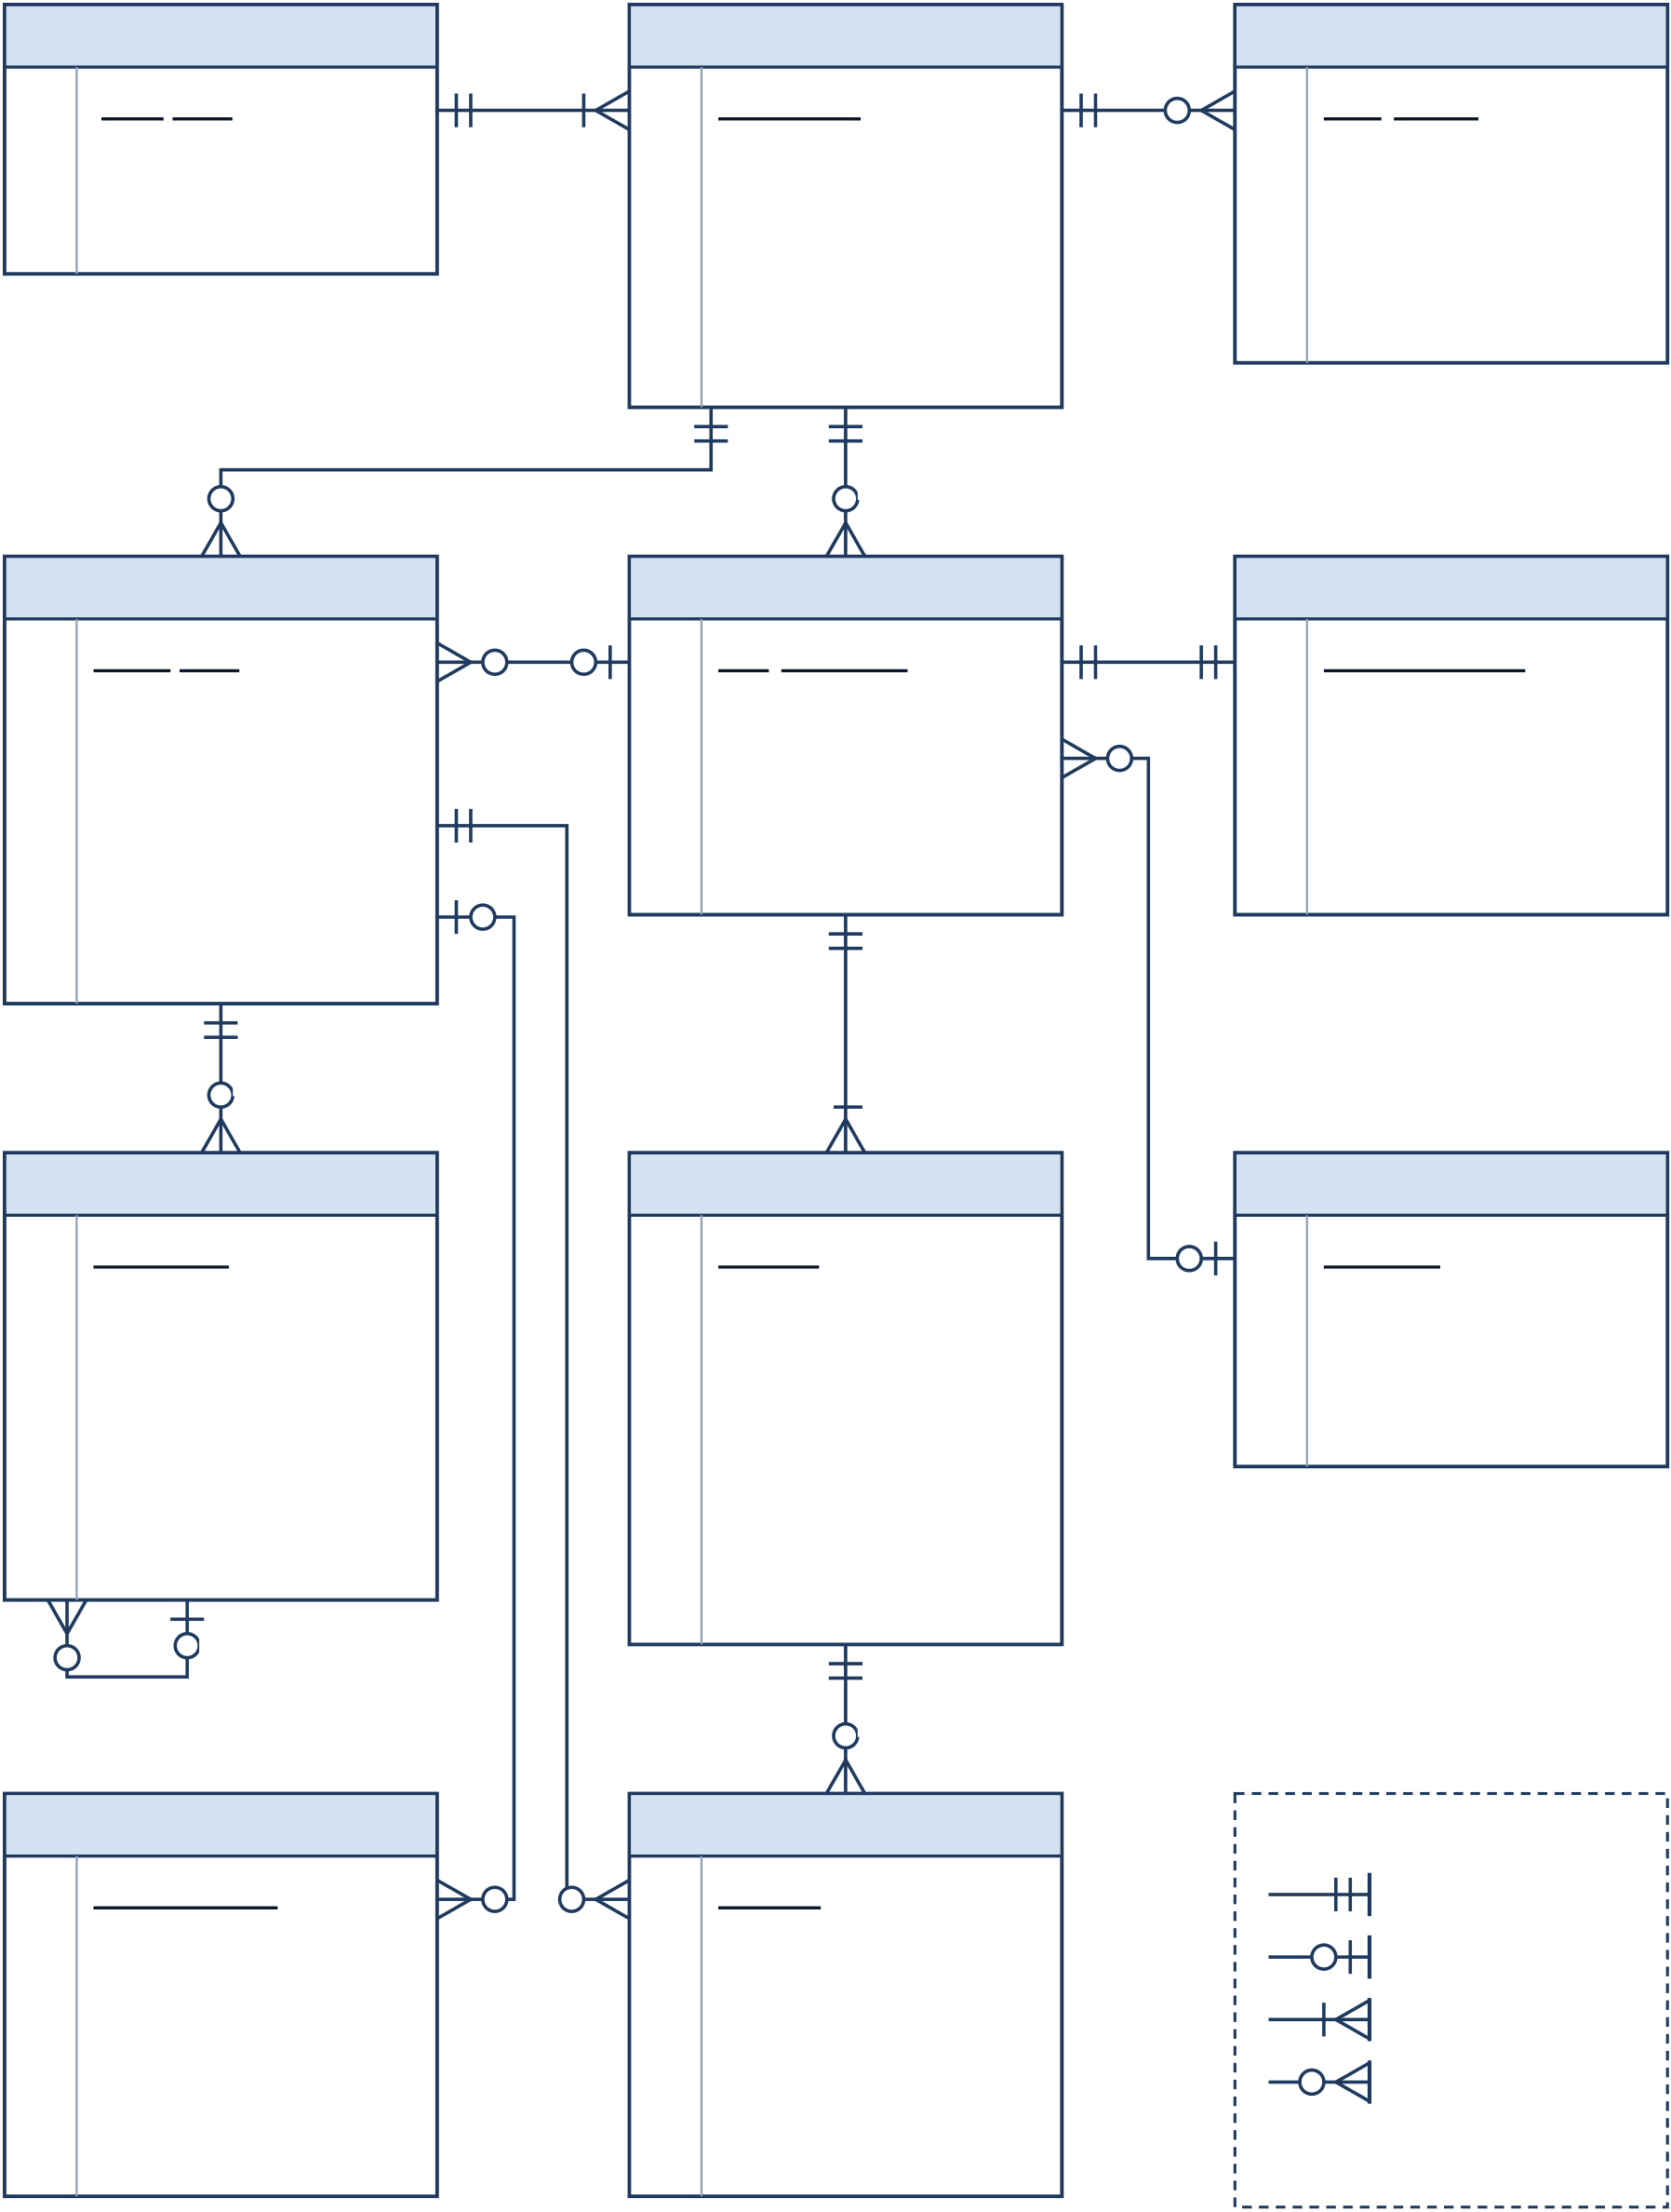
VidCraft:SoftwareRequirementsSpecification |  |  |  |  |  |  | Group7
Prompt |  | retains | Prompt Version |  | scored by | PK | Analysis
PK | prompt_id | PK |  | version_id | scored by | PK | analysis_id
original_text |  | FK |  | prompt_id | scored by | FK | version_id
created_at |  | FK |  | parent_version_id | scored by | FK | dimension_scores [5]
updated_at |  | kind |  |  | scored by | FK | overall_score
text |  |  |  |  | scored by | FK | flags
brief |  |  |  |  | scored by | FK | suggestions
embedding_ref
exact input
source of
PK | Generation Attempt | plan for | PK | Storyboard | shares | PK | World State
PK | attempt_id | plan for | PK | storyboard_id | shares | PK | world_state_id
FK | version_id | plan for | FK | version_id | shares | FK | storyboard_id
FK | storyboard_id | plan for | FK | index_id | shares | FK | characters
FK | job_id | plan for | FK | review_state | shares | FK | setting
FK | settings | plan for | FK | intent_score | shares | FK | style_tokens
FK | execution_profile | plan for | FK | intent_check_state | shares | FK | reference_image
stage, outcome
timings, errors
PK | produces | ordered plan |  | grounded by | PK | Technique Index
PK | produces | (3..5 shots) |  | grounded by | PK | Technique Index
PK | Artifact | Shot |  | grounded by | PK | Technique Index
PK | artifact_id | PK | shot_id | grounded by | PK | index_id
FK | attempt_id | FK | storyboard_id | grounded by | PK | corpus_version
FK | master_id | order |  | grounded by | PK | encoder_id
FK | type | description |  | grounded by | PK | vector_dimension
FK | uri, mime_type | camera |  | grounded by | PK | passages
FK | dimensions | duration_s |  | grounded by | PK | passages
FK | duration | route, status |  | grounded by | PK | passages
FK | retention_state | asset_ref |  | grounded by | PK | passages
critique
derived from
records narrated by
measured in
PK | Evaluation Record | PK | Narration Beat | Notation
PK | evaluation_id | PK | beat_id | exactly one
FK | attempt_id | FK | shot_id | exactly one
 |  |  |  | zero or one
FK | condition_id | FK | attempt_id | zero or one
FK | dataset | FK | spoken_text | one or many
FK | protocol | FK | duration | zero or many
FK | measures | FK | voice | PK primary key
FK | failures | FK | audio_ref | PK primary key
 |  |  |  | FK foreign key
Figure7:Logicalentity–relationshipdiagram(crow’s-footnotation)
42

VidCraft:SoftwareRequirementsSpecification | Group7
Table25:Dataandsupportingrequirements
ID | Requirement | Priority
OR-01 | Dataintegrity.Identifiers,references,finitedurationsand | High
permittedstatesshallbevalidatedbeforestorageorrendering. Artifactsshallbecomeavailableonlyafterfilefinalizationand validation.
OR-02 | Versionandrunattribution.Retainedoutputsshallidentify | High
inputversion,settingsandattempt.Latermodel/profile changesshallleaveprovenanceunchanged.
OR-03 | Retentionandcleanup.Theoperatorshalldocumentretention | Medium
periods.Cleanupshallremoveonlyeligiblemanaged records/files,protectactivejobsandselectedassessment artifacts,andmarkexpiredmediainhistory.
OR-04 | Ethicaluseandprovenance.Theteamshalldocument | High
sources/licensesforsoftware,models,corporaanddatasets, preserverequiredattribution,followproviderrestrictionsand reportexperimentsandgeneratedcontentaccurately.
OR-05 | Documentation.Theteamshallmaintainsetup/userguides, | Medium
component/APIdescriptions,diagrams,testrecordsandan evaluationreportreflectingthedeliveredversion.
43

VidCraft:SoftwareRequirementsSpecification | Group7
5.3EthicalandLegalRequirements
Usersshallbetoldthatoutputsaregeneratedmediaandneedreviewbeforepublication. Theteamshalluseappropriatelysourcedcomponentsanddatasets,documentattribution andavoidunsupportedownershipororiginalityclaimsaboutfoundationmodels.Experi-ment records shall distinguish pretrained, quantized and fine-tuned models.Any fine-tuning shall use separately recorded training, validation and test data, keeping assessment prompts outoftraining.
5.4PrivacyRequirements
Thesystemshallretainonlyinformationneededforauthoring,generation,troubleshooting andagreedevaluation.Microphoneaccessshallremainoptional.Usersshallbeinformed whenanenabledservicereceivestheirpromptormedia. Local-modechecksshallcon-firmthatdisabledhostedtasksarenotcalled.Deletionstatementsshallcoverapplication-controlledstorageonly;theselectedservicedeterminesretentionontheproviderside.
Theinitialsystemrunsinatrustedlocal/laboratoryenvironment.Ifaccessisshared,only authorizedusersshallbeabletoaccesstherelevantprompts,jobsandmedia.Knowinga recordidentifiershallnotbeenoughtoobtainaccess.Secrets,privatenetworkaddresses andfullstacktracesshallnotbeexposedtoordinaryusers.
5.5SystemDocumentation
DeliverablesshallincludetheSRS,designdiagrams,installationanduserguides,source anddependencyinformation,andtestandevaluationreports.Operatorinstructionsshall explain startup, readiness checks, local models, index rebuilding, output types, cleanup and backup.Eachtestrecordshallnamethetestedversionandactualoutcome.Notestpass orbenchmarkresultispresumedbythisspecification.
5.6BusinessRulesandProcessingStates
1.Standardinferenceisselectedbydefault.AuserselectsLocalDemoexplicitly,andits profileremainsfixedfortheattempt.
2.Submissionisallowedonlyforcompatiblecombinationsofworkflow,mediarouteand dimensions.
3.Refining a prompt or generating another result shall preserve its original text and retained versions.
4.Aplanmayhaveaninitialdraftandatmosttworevisions.Optionalvisualcritique allowsatmosttworegenerationspershotbydefault.
5.Retrievalandsemanticcomparisonrequirematchingencoder/indexidentities.Anun-availablequalitycheckshallnotcountasasuccessfulmeasurement.
6.The final visual, audio and caption timeline shall consistently exclude failed or held shots.
7.Queuecompletionalonedoesnotestablishthatanartifactexists.Resultsshalldistin-guishfullsuccess,partialoutput,nooutputandinfrastructurefailure.
8.Afteralocalmodelfailure,hostedprocessingshallrequireanexplicituserchoicebefore retryingthetask.
44

VidCraft:SoftwareRequirementsSpecification | Group7
Shotsusethestatespending,processing,completed,failedandonhold;queuestatesare waiting,active,delayed,completedandfailed.AppendixBgivesthecorrespondingstate-transitiondiagrams(Figures11and12).
45

VidCraft:SoftwareRequirementsSpecification | Group7
6SystemTesting
6.1TestCases
Eachcasestatesitsinputorconditionandexpectedoutcome.Controlledfixturescheck processingrulesandfailurehandling;realmodelandmediarunscheckintegration.These casesformatestplanratherthanacompletedtestreport.
Table26:Systemtestcases
ID | Test | Input/condition | Expectedresult
TC-01 | Prompt | NormalEnglishprompt; | Acceptandpreserveonlyvalid,
TC-01 | validation | blank/non-stringinput; | boundedinput;rejectinvalid
TC-01 | validation | 4,000and4,001 | inputwithaclearerror.
characters.
TC-02 | Scoresand | Fixedpromptsmissing | Returnfiveboundedscoresand
TC-03 | contradictions | subject/action/setting, | theircorrectmean,relevant
TC-03 | contradictions | withconfigured | flags/suggestionsand
TC-03 | Dictation | contradictoryterms. | repeatableanalysis.
TC-03 | Dictation | Supportedbrowser, | Stoptranscriptioncorrectlyand
TC-03 | alternatives | refusedpermission, | keeptypedinputusablein
TC-03 | alternatives | unsupportedrecognition; | everyalternative.
keyboard/pointerrelease.
TC-04 | Clarifiedbrief | Vagueprompt, | Useoneroundofatmostsix
TC-04 | Clarifiedbrief | six-questioncap, | questions,mapanswers

aligned/misaligned
answersandauser

correctly,preserveexplicit
intentandsavetherevisedbrief

TC-05 | Styleand | revision. | asaversion.
TC-05 | Styleand | Differentstyle/palette | Passselectionstoimageand
TC-05 | dimensions | selections;supportedand | storyboardinputs,reject

unsupportedratios.

unsupportedratiosandrender theselecteddimensions.

TC-06 | Workflowand | Singleimageversus | Follow the selected branch,omit
TC-07 | route | storyboard;incompatible | shotplanningforimagesand
TC-07 | route | orunavailableroutes. | preventsilentpaidsubstitution.
TC-07 | Storyboard | orunavailableroutes. | preventsilentpaidsubstitution.
TC-07 | Storyboard | Validthree/five-shot | Rejectinvalidplansanddisplay
TC-07 | contractand | plans;invalidcounts, | validorderedshots/worldstate
TC-07 | review | emptydescriptionsor | forreviewbeforerendering.
nonfinitedurations.
TC-08 | Retrieval | Controlledtechnique | Includerelevantpassagesin
TC-08 | compatibility | corpuswith | planninganddetect
TC-08 | compatibility | matching/mismatching | incompatiblevectorspaces
TC-08 | compatibility | encoderindexes. | beforequeryingthem.
Continuedonnextpage
46

VidCraft:SoftwareRequirementsSpecification | Group7
Systemtestcases(continued)
ID | Test | Input/condition | Expectedresult
TC-09 | IntentretrylimitForcedlowscoresandan |  | Produceatmostthreedrafts,
TC-09 | unavailableembedding |  | warnwhenretriesareexhausted
TC-09 | measurement. |  | andmarkunavailable
measurementasunchecked.
TC-10 | ContinuityinputsThreeshotswithshared | Passsharedcontexttoeach
TC-10 | character/settingbut | shotwhilevarying
TC-10 | differentframing. | action/camera;assessvisual
continuityseparately.
TC-11 | Procedural | Wide,medium,close-up | Selectsupportedcompositions,
TC-12 | rendering | andunknown-camera | applythedefaultforunknown
TC-12 | inputswithoutshot |  | camerasandrenderavalidfinal
TC-12 | imageURLs. |  | video.
TC-12 | ImagegenerationOneauthorizedreal |  | Deliveradecodableimagewith
TC-12 | imageroute,plus |  | sourcemetadataoridentifythe

invalid-mediaandfailure
fixtures.

failurewhilepreservinginput.

TC-13 | Generativevideo | Onerealenabled | Preservetemporalframes
TC-13 | Generativevideo | video-modelclipandfinal | throughplayback/assembly;do
TC-13 | Generativevideo | assembly. | notclassifystill-image
animationassynthesized
motion.
TC-14 | Queueand | Fiveconcurrentstartsfor | Createoneeffectiveshared-plan
TC-14 | concurrency | oneplanandthree | job,isolateotherplanstates

separatelyqueuedplans.

andrespectconfigured concurrency.

TC-15 | Progressand | Reloadduringgeneration, | Resumeretained-handlelookup,
TC-15 | reload | temporarydisconnect, | terminatepollingcorrectlyand
TC-15 | reload | expiredjobandworker | reporttheactualartifact
TC-15 | reload | completionwithouta | outcome.
video.
TC-16 | Failuresand | Providertimeout/429, | Stopwithinconfiguredlimits,
TC-16 | limits | one/allfailedshots, | respectcaps,retainsaved

memory/diskpressure
andasmallcallcap.

inputs/assetsanddistinguish partialfromno-outputresults.

TC-17 | Criticloop | Repeatednegative | Permitatmosttwo

verdicts,disabledcritic
andacriticoutage.

regenerations,retainthefinal usableassetanddistinguish disabled/uncheckedfrom
passed.

TC-18 | Timelineand | Successful/failedshots, | Useincludedshotsonlyfor
TC-18 | speech | measuredbeats,oneTTS | frames/audio/captions,mark
TC-18 | speech | failureandaknown | silentrecoveryandmeettiming
TC-18 | speech | timingfixture. | andmedia-formattargets.
Continuedonnextpage
47

VidCraft:SoftwareRequirementsSpecification | Group7
Systemtestcases(continued)
ID | Test | Input/condition | Expectedresult
TC-19 | Post-processing | Validmaster; | Produceusablederivatives,

poster/VTT;optional
burn-inorcolourpreset;
forcedderivativefailure.

preservethemasterand
timing/dimensions,andreport eachfailedstageindependently.

TC-20 | Resultdelivery | Eachavailableartifact | Decodepreviews/downloads
TC-20 | Resultdelivery | typeandan | correctlyandidentify

expired/missingfile.

unavailableartifactswhile keepingvalidresultsvisible.

TC-21 | Historyand | Multipleversions/runs, | Providestablepagination,
TC-22 | attribution | recordsbeyondonepage | correcttext/semanticchanges,
TC-22 | attribution | andincompatible | distinctattemptsandpreserved
TC-22 | Modeisolation | comparisonencoders. | provenance.
TC-22 | Modeisolation | Twotasksindifferent | StartinStandardbydefault;

modes;togglechanged
duringanactiverun.

retaineachtask’sprofile
withoutchangingtheactive run’smode.

TC-23 | Readiness | Stopped | Markaffectedoperations

queue/model/renderer,
malformedlocalJSON
andabsentlocalindex.

unavailable,stopsafelyon
schemaviolationsandexplain model/indexpreparation.

TC-24 | Reallocal | Preparedsmall | Runactuallocalinference
TC-25 | execution | model/index,procedural | withouthostedcalls,disable
TC-25 | execution | routeandmonitored | unsupportedtasksandretain
TC-25 | Research | networkrequests. | model/adapteridentity.
TC-25 | Research | Frozen50-promptset, | Reportcorrectsample
TC-25 | integrity | pairedconditions, | counts/provenance,disjoint
TC-25 | integrity | recordedfailuresand | training/testsplitsand
TC-25 | integrity | optionaladapter | reproduciblemetrics;exclude
TC-25 | integrity | experiment. | simulatedorunsupported
trainingclaims.
TC-26 | Responsiveness | Twentystatus/admission | MeetNFRtargetsformeasured

requestsonthedeclared
machine,plusordinary

UIfeedbackandp95service times;separatecold/provider

TC-27 | Usabilityand | UIactions. | delaysinreporting.
TC-27 | Usabilityand | Fivefirst-timeusers, | Recordcompletion/time,
TC-28 | access | keyboard-onlyoperation, | provideaccessiblecontrolsand
TC-28 | access | 360/768/1440widthsand | usableresponsiveviews,and
TC-28 | Integrityand | contrastchecks. | retainfailedattemptsinresults.
TC-28 | Integrityand | Invalidreferences/paths, | Preventuntrusted
TC-28 | security | hostilegeneratedstrings, | execution/storageescape,reject

dummysecretsinerrors
andcross-scoperequests.

invaliddataandenforcesafe errorsandappropriateaccess restrictions.

Continuedonnextpage
48

VidCraft:SoftwareRequirementsSpecification | Group7
Systemtestcases(continued)
ID | Test | Input/condition | Expectedresult
TC-29 | Maintenanceand | Isolatedsetupusingthe | Initializeserviceswithstated
TC-29 | setup | documentationanda | prerequisites,preservetask
TC-29 | setup | conformingreplacement | contractsandconfirm
TC-29 | setup | adapter. | documentationmatches
behaviour.
TC-30 | Backupand | Backup/restoreasmall | Restorematchingrecords/files,
TC-30 | cleanup | dataset;removeexpired | protectactive/retained

dataduringanactivejob.

artifacts,restrictcleanupto managedrootsandavoid replayingpaidwork.

49

VidCraft:SoftwareRequirementsSpecification | Group7
6.2TestingMethodologies
Black-boxtestingexaminesinputsandvisibleresultsforgeneration,historyandrecov-ery.White-boxtestingexaminesimplementedscoringrules,validationbranches,agent routing,retrylimitsandframecalculations.Gray-boxtestinguses requestcontracts and storedrecordstocheckcomponentinteractions.Regressiontestingrepeatstherelevant checks when models, adapters or workflow logic change.Acceptance testing demonstrates agreedrequirementswithrepresentativeusersandactualoutputs.
6.3TypesofTestingandTools
Table27:Testingtypesandsuitabletools
Type | Project-specificpurpose | Tools/method
Unit | Scoring,contradictionrules, | pytest;Node.jsbuilt-in
Unit | structured-outputchecks,vector | testrunner.
compatibilityandframe/caption
calculations.
Integration | Gateway/AI/database/queueinteraction, | HTTPtestfixtures;
Integration | providercontractsandexecution-profile | Postmanorequivalent
Integration | transfer. | RESTclient;FastAPIAPI
documentation.
System/ | Authoring-to-downloadworkflow,reload, | Browserdevelopertools;
browser | modeselectionanderrordisplays. | optionalPlaywright;
manualchecks.
Performance | Servicelatency,renderduration,local | Timestampedtestharness;

memoryandboundedconcurrency.

OSprocessmonitoring; optionalLocust.

Security/ | Input/pathchecks,safeerrors,secret | Controllednegative
privacy | handling,scopedaccessandnetwork | fixtures;browser/network
Media | isolationinlocalmode. | inspection.
Media | Container/codecdetails,framecounts, | FFmpeg/ffprobe;browser
validation | audioalignmentandcaptiontiming. | playback;knowntiming
fixtures.
User | Feedbackclarity,workflowcompletionand | Recordedtaskswith
acceptance | thelocaldemonstration. | representativeusers.
Regression | Changesincontracts,timelineprocessing | Repeatable

andfailurerecovery.

pytest/Node/browser checksrelevanttothe change.

50

VidCraft:SoftwareRequirementsSpecification | Group7
6.4EvaluationoftheProjectContribution
The evaluation shall assess what the developed workflow contributes beyond the underlying model.A single enhancement step forms the baseline;the multi-agent condition follows the specifiedclarification,retrievalandplanningprocess.Bothconditionsshallusethesame fixed set of 50 single-beat and multi-beat prompts under controlled settings.For interrupted runs,reportsshallstatethecompletedpaircount.
Thecomparisonofstandardandlocalprocessingshallmeasurestructured-outputvalidity, retention of user constraints, latency, failure rate,resource use and narrative quality.Wher-everfeasible,bothconditionsshouldusethesamerendererandcorpustoisolatelanguage-planningeffects.Changesinthevisual-generationrouteshallbereportedseparately.Ifthe teamdevelopsafine-tunedadapter,itshallbecomparedwiththeunchangedbasemodel onheld-outdata;trainingsettingsandtheresultingartifactshallberetained.
Changesinthefivepromptdimensionsshallbereportedasheuristicmeasuresandaccom-paniedbyindependentreviewoftheplans.Mediaassessmentshallconsiderimage-text alignment,narrativecoherence,shotvarietyandcross-shotcontinuityseparately:aframe-level score cannot establish the quality of a complete video narrative.Human reviewers shall useadeclaredrubricwithrandomizedpresentation.Latencyandmemorymeasurements shallidentifythemachineused.Reportsshallincludefailures,retries,knowncosts,effect estimates and uncertainty suited to the sample size.Whether the workflow improves results remainsaquestionfortheevaluation.
6.5AcceptanceCriteria
1.Valid input completes the core prompt-to-media workflow with clear feedback and down-loadableoutput,anditsassociatedHigh-prioritytestspass.
2.Anacceptedplandemonstrateswide,mediumandclose-upproceduralcompositions;an enabledimageroutealsoproducesarealimage.
3.Theexternal-videoobjectiveistestedwithanactualsynthesizedclip,withresultssepa-ratedfromvideosassembledfromstillimages.
4.StandardandLocalDemomodesrunwithactualprocessingandrecordedmodelidenti-ties;unavailablelocalcapabilitiesremainclearlyidentifiedandrestricted.
5.Thestatedchecksfortiming,stylepropagation,retrylimits,partialresultsandprove-nancearesatisfied.
6.The 50-prompt study and stated standard/local comparison report actual findings,miss-ingobservationsandlimitations.Anyoptionalfine-tuningclaimissupportedbycorre-spondingevidence.
7.Thefinalreportrecordsthestatusofsupportingfeaturesandunresolvedevaluation targets.Documentation,diagramsandtestrecordsdescribethesubmittedsystem.
51

VidCraft:SoftwareRequirementsSpecification | Group7
6.6Requirements-to-TestTraceability
Everyrequirementbelowislinkedtoaprimarytest,whileindividualscenariosmaycover related requirements as well.After execution,the test record shall include the actual result, executiondate,testedversionandareferencetotheevidence.
Table28:Requirement-to-testtraceability
RequirementSubject | Primary
test
FR-01 | Promptsubmission | TC-01
FR-02 | Linguisticscoring | TC-02
FR-03 | Actionablefeedback | TC-02
FR-04 | Optionaldictation | TC-03
FR-05 | Boundedclarification | TC-04
FR-06 | Creativebrief | TC-04
FR-07 | Stylepropagation | TC-05
FR-08 | Outputdimensions | TC-05
FR-09 | Workflowchoice | TC-06
FR-10 | Mediaroutechoice | TC-06
FR-11 | Narrativedecomposition | TC-07
FR-12 | Retrieval-groundedplanning | TC-08
FR-13 | Intentpreservation | TC-09
FR-14 | Scenecontinuity | TC-10
FR-15 | Storyboardreview | TC-07
FR-16 | Proceduralrendering | TC-11
FR-17 | Imagesynthesis | TC-12
FR-18 | Videosynthesis | TC-13
FR-19 | Backgroundexecution | TC-14
FR-20 | Duplicateprotection | TC-14
FR-21 | Progressandrecovery | TC-15
FR-22 | Controlledfailurehandling | TC-16
FR-23 | Visualfeedback | TC-17
FR-24 | Narration | TC-18
FR-25 | Commonmediatimeline | TC-18
FR-26 | Post-processing | TC-19
FR-27 | Colourtreatment | TC-19
FR-28 | Previewanddownload | TC-20
FR-29 | Regenerationrecords | TC-21
FR-30 | Savedhistory | TC-21
FR-31 | Promptversions | TC-21
FR-32 | Execution-modecontrol | TC-22
Continuedonnextpage
52

VidCraft:SoftwareRequirementsSpecification | Group7
Requirement-to-testtraceability(continued)
RequirementSubject | Primary
test
FR-33 | Consistentmoderouting | TC-22
FR-34 | Localmodelreadiness | TC-23
FR-35 | Localretrieval | TC-23
FR-36 | Localcapabilityprofile | TC-24
FR-37 | Modelprovenance | TC-24
FR-38 | Adaptationexperiment | TC-25
FR-39 | Configurationandreadiness | TC-23
FR-40 | Comparativeevaluation | TC-25
NFR-01 | Responsiveness | TC-26
NFR-02 | Servicelatency | TC-26
NFR-03 | Boundedexecution | TC-16
NFR-04 | Resourceefficiency | TC-16
NFR-05 | Reliability | TC-16
NFR-06 | Usability | TC-27
NFR-07 | Accessibility | TC-27
NFR-08 | Security | TC-28
NFR-09 | Privacy | TC-24
NFR-10 | Maintainability | TC-29
NFR-11 | Portability | TC-29
NFR-12 | Mediacompatibility | TC-18
NFR-13 | Reproducibility | TC-25
NFR-14 | Budgetcontrol | TC-16
NFR-15 | Scalability | TC-14
NFR-16 | Recoverability | TC-30
OR-01 | Dataintegrity | TC-28
OR-02 | Versionandrunattribution | TC-21
OR-03 | Retentionandcleanup | TC-30
OR-04 | Ethicaluseandprovenance | TC-25
OR-05 | Documentation | TC-29
53

VidCraft:SoftwareRequirementsSpecification | Group7
AGlossary
Table29:Definitions,acronymsandabbreviations
Term | Definition
SRS/FYP NLP | SoftwareRequirementsSpecification/FinalYearProject. NaturalLanguageProcessing:computationalmethodsfor
analyzingandgeneratinglanguage.
LLM LargeLanguageModel:apretrainedmodelforlanguage understandingandgeneration.
MAS/agent Multi-AgentSystem/aspecializedsoftwarerolewithina coordinatedworkflow.
RAG Retrieval-AugmentedGeneration:supplyingrelevantretrieved passagesascontextforgeneration.
Creativebrief Structuredclarificationofintendedsubject,action,settingand style.
Worldstate Character,settingandstyledetailssharedacrossastoryboard.
Storyboard/ Anorderedvisualplan/onesceneunitspecifyingdescription, shot cameraandduration.
Embedding/ Amodel-specificnumericalrepresentation,withsentence
FAISS embeddingssupportingsemanticcomparison[4]/thevector-index libraryusedforretrieval.
API/adapter ApplicationProgrammingInterface/acomponentmappinga sharedtaskcontracttoaserviceorruntime.
Standardmode Thedefaultprofilecombininghostedinferencewiththeselected compatiblemediaroute.
LocalDemo Apreparedprofilethatrunssupportedcomponentsonthelocal device.
Fine-tuning Documentedtrainingthatupdatesmodelparametersoran adapter;prompting,RAGandquantizationalonedonotqualify.
Quantization Useofreducednumericalprecisionformodelvaluestoalter resourcerequirements.
TTS/beat Text-to-Speech/atimedunitofnarrationorsilentactionwithina shot.
FPS/VTT Framespersecond/WebVTTtimedcaptionformat.
Job/attempt Ascheduledworkunit/aseparate,identifiableexecutionofa generationrequest.
Provenance Recordedinput,settings,component/modelidentitiesand conditionsforanartifactorresult.
54

VidCraft:SoftwareRequirementsSpecification | Group7
BAnalysisModels
These models complement the context diagram, data flow diagrams, component architecture, use-case diagram and entity–relationship diagram presented earlier.They describe required behaviour;internalclassdesignbelongstothedesigndocument.
B.1SystemSequenceDiagram
Figure 8 is the system sequence diagram for the main scenario of UC-01 to UC-08.VidCraft appearsasasingleblack-boxlifeline.Thediagramthereforeshowsonlythesystemevents exchangedwiththeCreatorandtherequeststhesystemmakestothesecondaryactor, ModelServices.Solidarrowsarerequestsanddashedarrowsarereplies.Theoptfragment coversclarification(UC-02).Thealtfragmentseparatesthesingle-imageworkflow(UC-05) fromthestoryboardworkflow(UC-04,UC-06).Theloopfragmentpollsprogresswiththe retained job handle until the job reaches a terminal or expired state (UC-07).Downloading theresults(UC-08)completesthescenario.
55

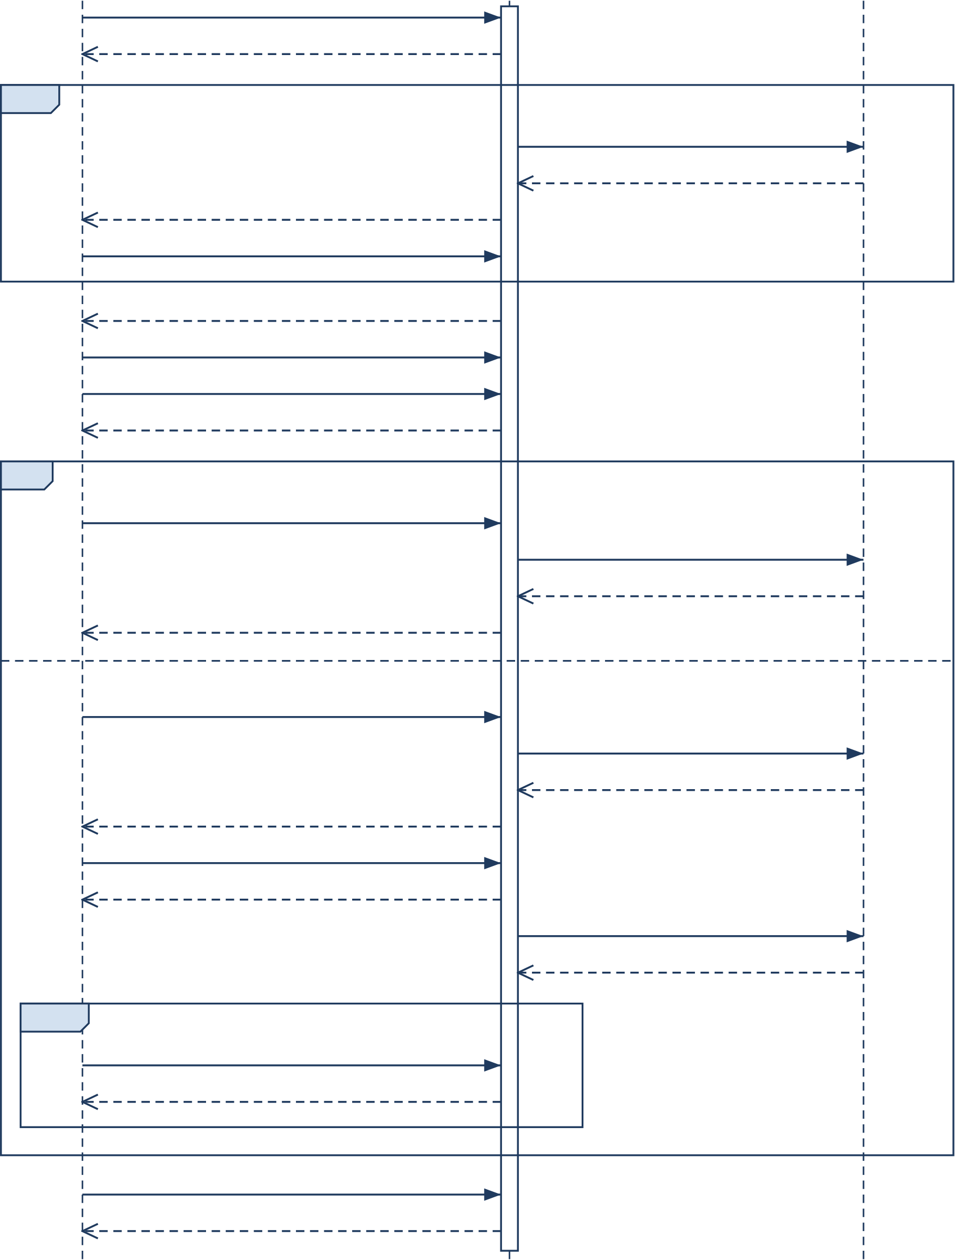
VidCraft:SoftwareRequirementsSpecification |  | Group7
 |  |   Model Services
  :VidCraft System
Creator
submitPrompt(text)
analysis: scores, flags, suggestions
opt | [unresolved details]
generateQuestions(gaps) candidate questions questions (at most 6)
answerQuestions(answers)
creative brief for review
confirmBrief(versionId)
selectSettings(style, route, mode)
validated settings, readiness
alt | [workflow = single image]
generateImage(versionId)
imageRequest(effectivePrompt) image
image, provenance
[workflow = storyboard]
createStoryboard(versionId)
planning, embedding requests plan drafts, vectors storyboard, warnings
acceptAndGenerate(storyboardId)
202 Accepted, jobId
media, critique, speech requests media, verdicts, audio
loop | [until terminal or expired]
getJobStatus(jobId)
stage, progress, shot outcomes
download(artifactId)
master video, captions, poster
Figure8:SystemsequencediagramofVidCraft
56

VidCraft:SoftwareRequirementsSpecification | Group7
B.2PromptRefinementandMulti-AgentPlanningSequence
Figure9openstheblackboxforthepartofthesystemthatcarriestheproject’smain contribution, and it is the only detailed sequence diagram retained.The Workflow Controller analyzestheprompt,asksclarificationquestionswhenneededandbuildsthebrief.Inthe loop,theScreenwriterreturnsthreetofiveshotswithaworldstateandthecontroller validatestheplan.TheCinematographerthenretrievestechniquepassages(top-k=3) withthematchingencoderandrefinestheshots.Next,thecontrollerembedsthebriefand thenarrativewiththesameencoderandchecksintentpreservation.Theloopallowsthe firstdraftandatmosttworevisions,anditendswithapass,alow-scorewarningoran UNCHECKEDstatus.Explicituserstyleremainsinthesharedstate,andeveryinference callfollowsthetask’sexecutionprofile.
57

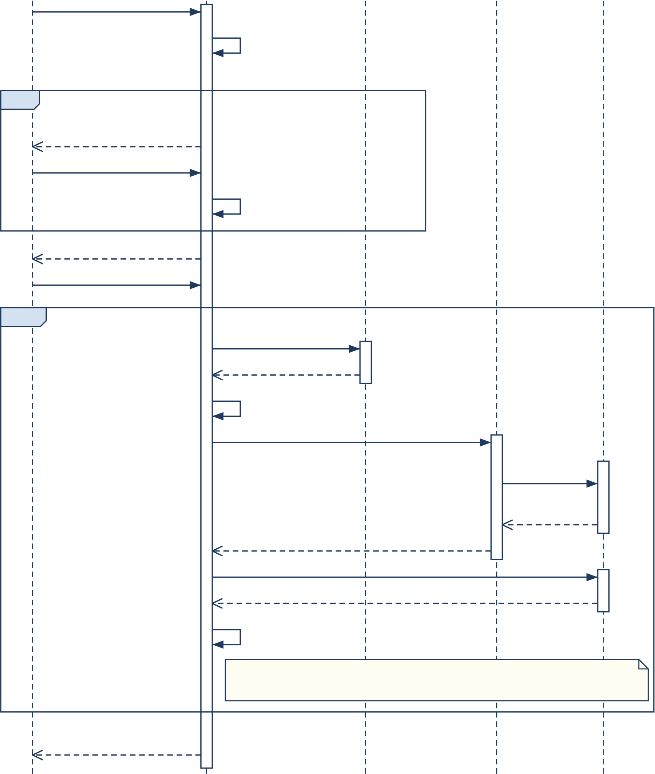
VidCraft:SoftwareRequirementsSpecification |  |  |  | Group7

  :Workflow Controller
  :Screenwriter
  :Cinemato-grapher
  :Embedder / FAISS Index
Creator
submitPrompt(text, style)
analyze(): five
scores, flags
opt | [clarification needed]
feedback,
questions (≤ 6)
answerQuestions(answers)
buildBrief()
brief for review
confirmBrief(version)
loop | [first draft + at most 2 revisions]
draftPlan(brief, style)
3–5 shots, world state
validatePlan()
refineShots(validPlan)
retrieve(query,
k = 3)
passages or
unavailable
refined plan, grounding state
embed(brief, narrative) with the same encoder
vectors or unavailable
checkIntent()
Revise only if similarity < 0.35 and a revision remains;
otherwise exit the loop with PASS, LOW-SCORE WARNING or UNCHECKED.
valid storyboard +
intent status
Figure9:Promptrefinementandmulti-agentplanningsequence
58

VidCraft:SoftwareRequirementsSpecification | Group7
B.3ActivityModel
Figure10tracesthecompleteworkflowwithoneinitialnodeandoneactivityfinalnode. Decisionnodescoverinputvalidity,clarification,capabilityreadiness,theoutputworkflow, planacceptance,boundedqualityretries(atmosttworegenerationspershot),remaining shotsandthepresenceofusableshots;eachoutgoingflowcarriesaguard.Optionalnar-rationandpost-processingprecedetherecordedoutcome:complete,partial,nooutputor failed.A request that is not ready, or a storyboard that the Creator rejects, reaches the same finalnodethroughamergenode;theCreatorthensubmitsanewrequestaftercorrecting it.
SelectingLocalDemotriggersareadinesscheckofthelocalruntime,model,indexandren-derer, and a missing resource follows the not ready or invalidbranch.The selected execution profile governs every model call in the activity.Hosted inference requires a deliberate switch backtoStandardmode.
59

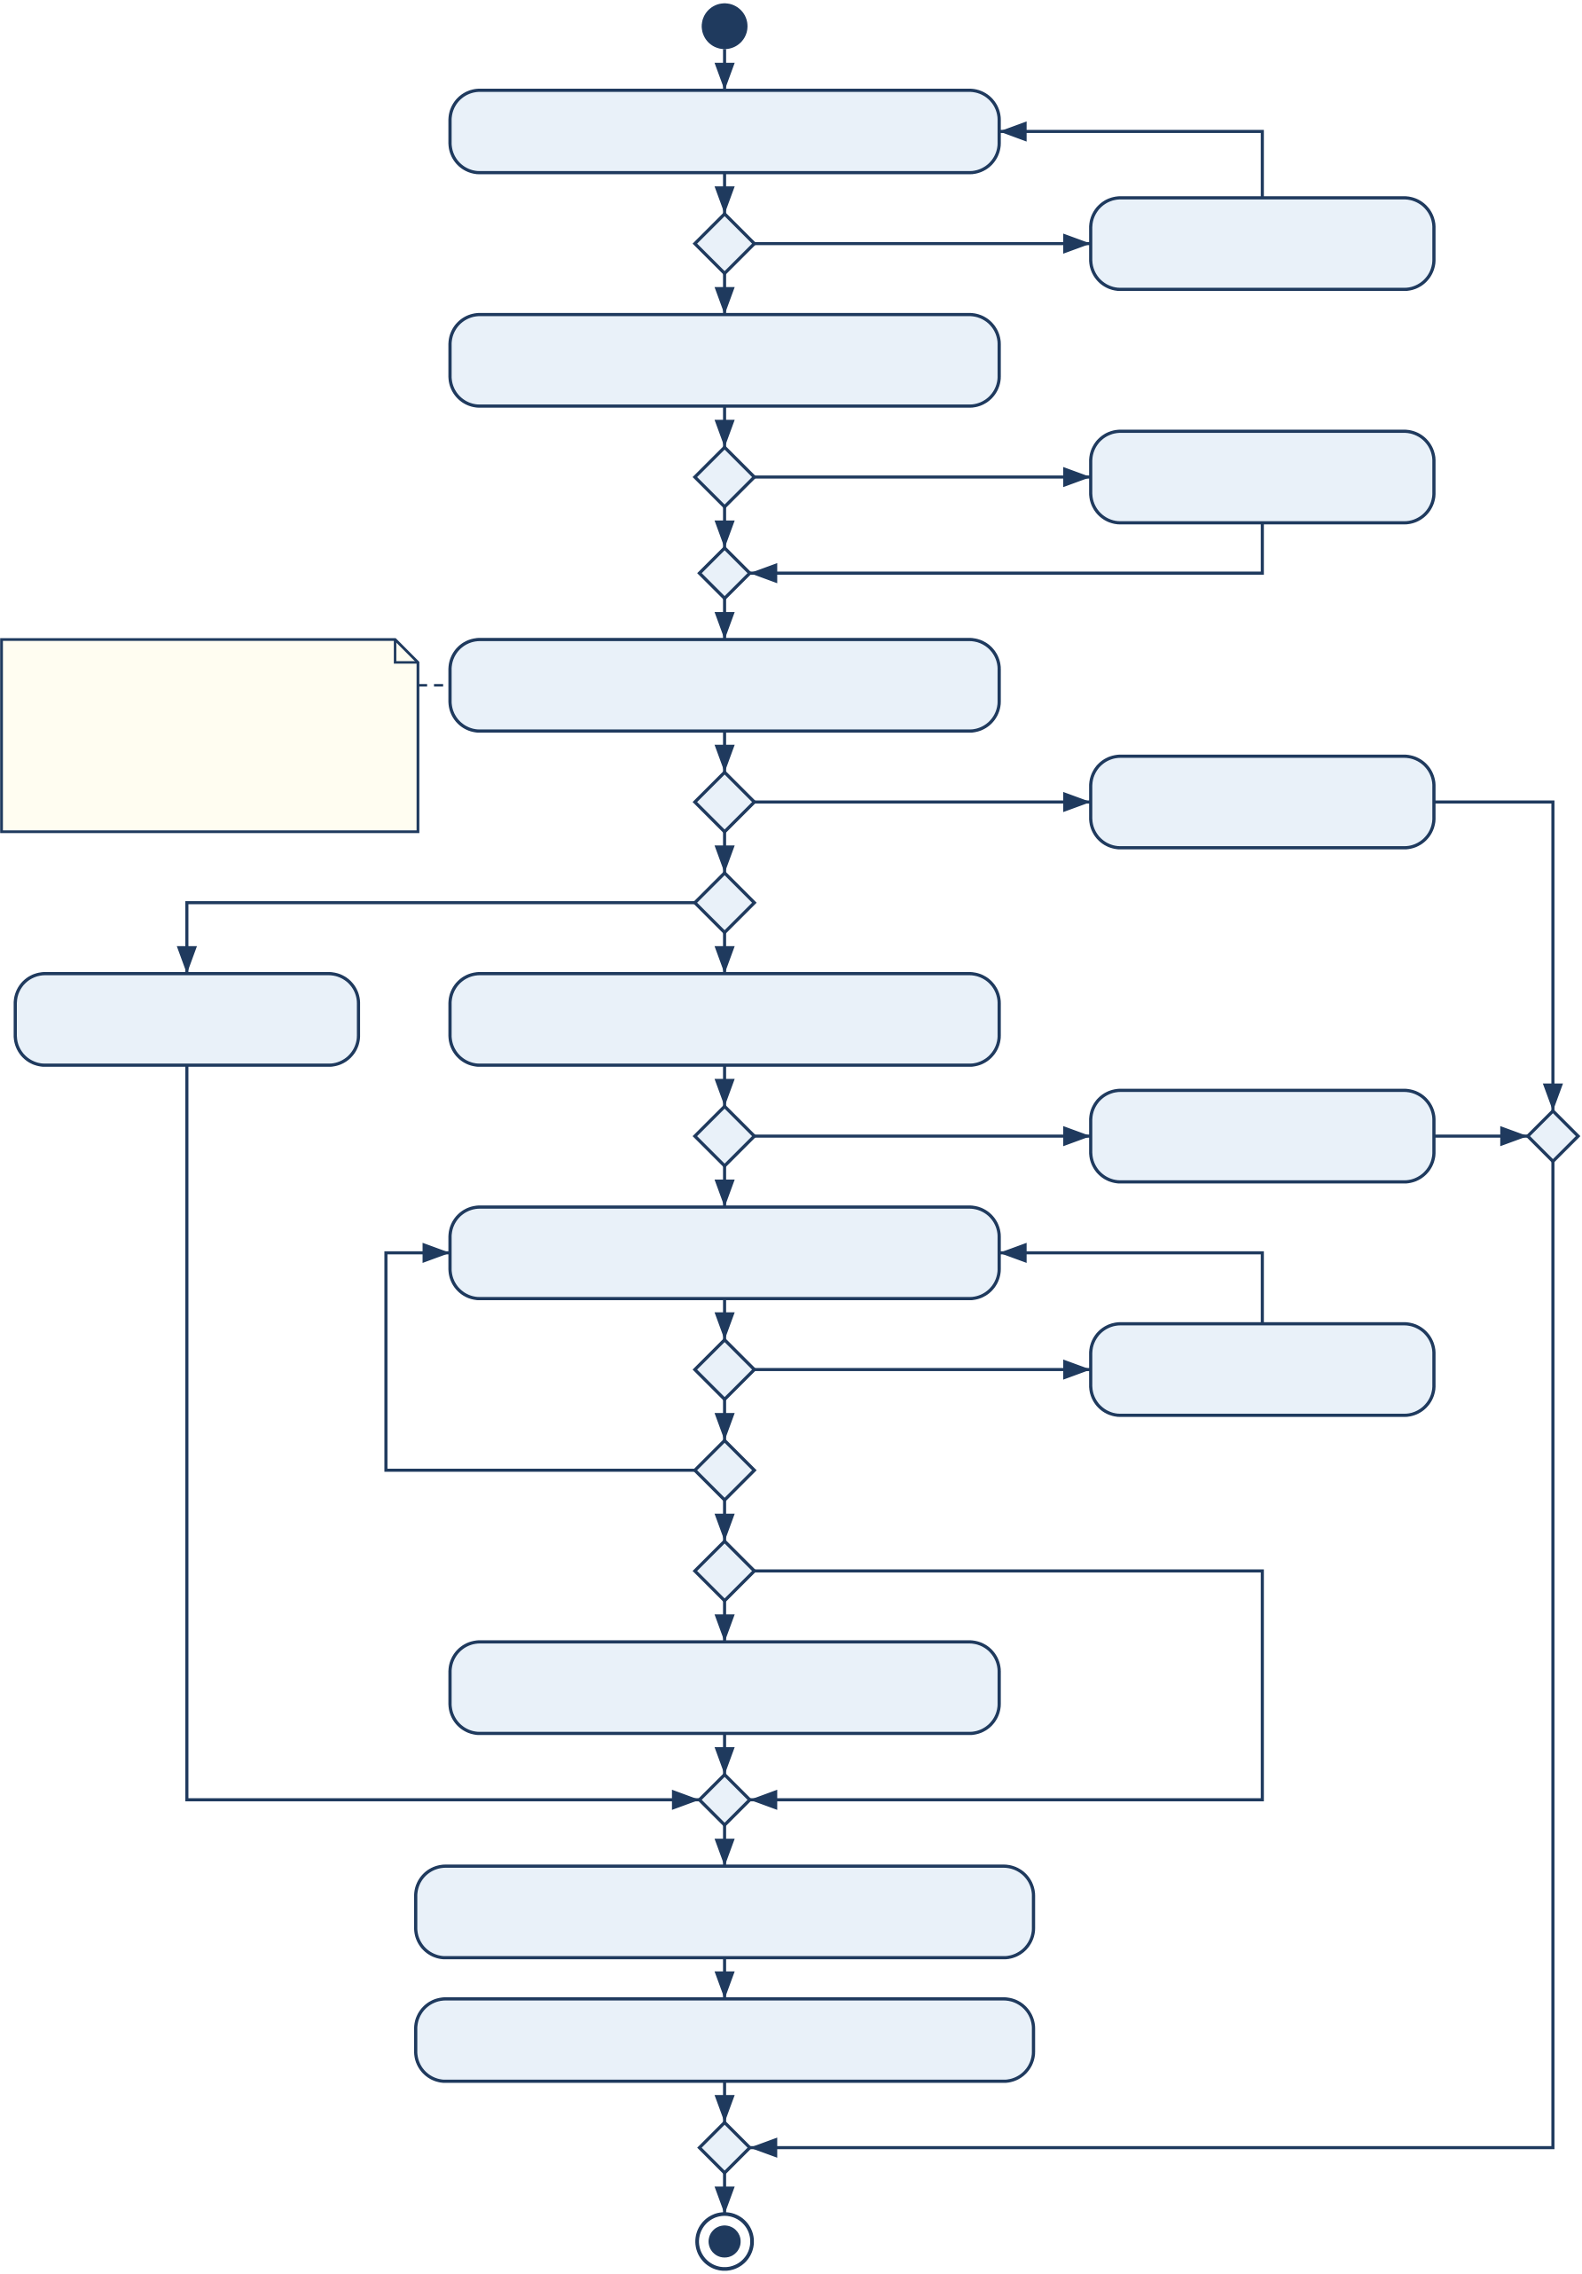
VidCraft:SoftwareRequirementsSpecification | Group7
Enter or dictate a prompt
[valid] | [invalid] | Show validation
[valid] | [invalid] | error
Save prompt; score five
dimensions; show feedback
The execution profile | [details missing] | Answer up to six
The execution profile | [complete] | clarification questions
The execution profile | Review brief; select style, | clarification questions
(Standard or Local Demo) | workflow, route and mode | Show issue;
is fixed at submission | workflow, route and mode | Show issue;
is fixed at submission | [not ready or invalid] | Show issue;
and governs every | [not ready or invalid] | Show issue;
model call. | [not ready or invalid] | Show issue;
model call. | [ready] | await correction
model call. | [single image] | await correction
[storyboard]
Generate and | Plan shots, retrieve techniques, | Return to editing
validate image | check intent (≤ 2 revisions) | Return to editing
validate image | [rejected] | Return to editing
[accepted]
Enqueue job; generate and
check the next shot
[more shots] | [revise, retries < 2] | Regenerate
[more shots] | [else] | the shot
[more shots] | [else] | the shot
[more shots] | [no usable shot] | the shot
[usable shots]
Add optional narration; assemble
30 FPS timeline; post-process
Record provenance and outcome:
complete / partial / no-output / failed
Show results or recovery guidance
Figure10:ActivitydiagramoftheVidCraftworkflow
60

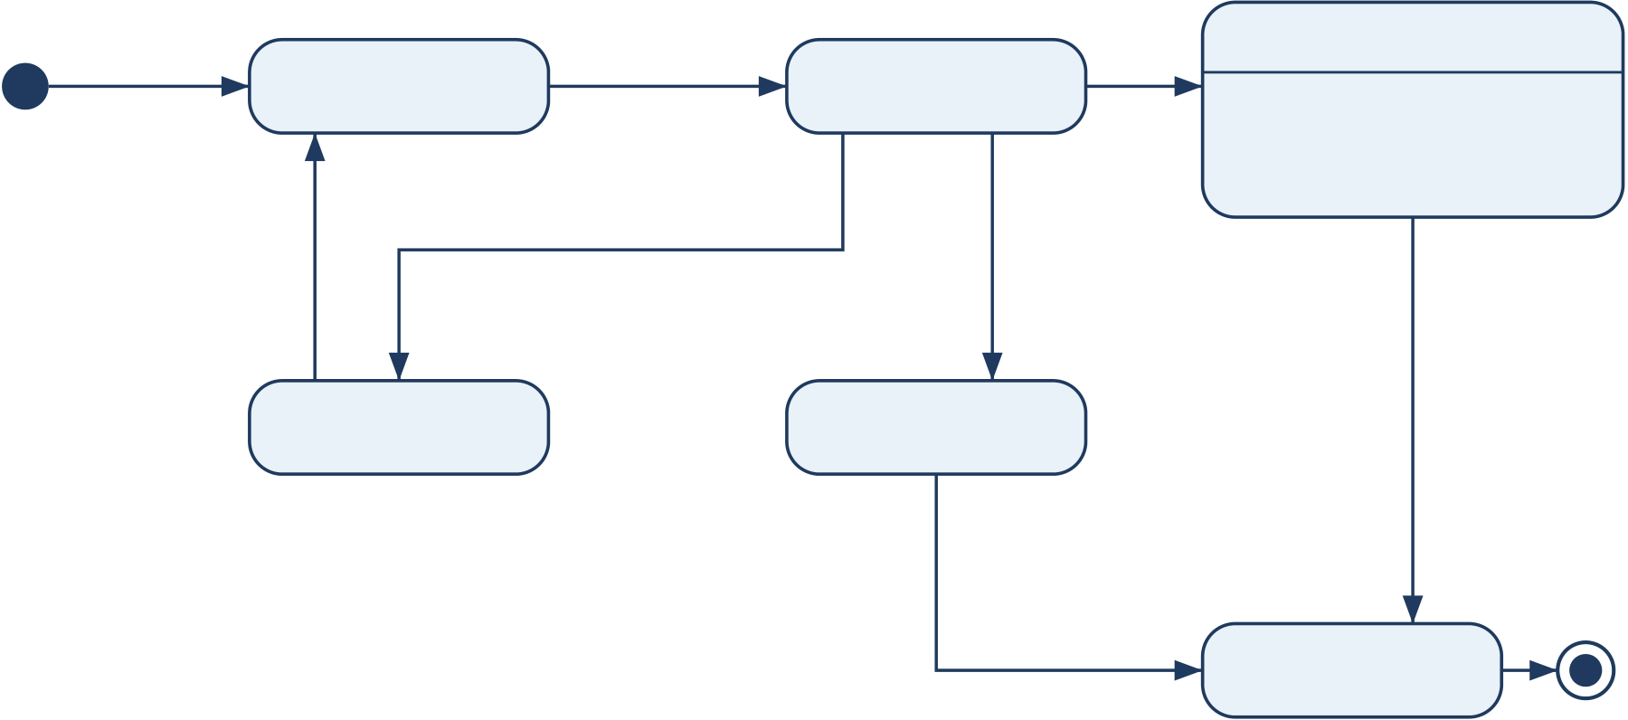
VidCraft:SoftwareRequirementsSpecification | Group7
B.4State-TransitionModels
Thestate-transitiondiagramsformalizetheprocessingstateslistedinthebusinessrules. Figure11followsonegenerationjobfromadmissiontoexpiry.Aduplicatestartrequest returns the existing job handle instead of creating a new job (FR-20).Retryable errors pass through the Delayed state within the retry cap (NFR-03).A completed job records whether its output is complete, partial or absent (FR-21, FR-22), and Expired marks a record whose retentionperiodhaselapsed(OR-03).
Figure 12 follows one storyboard shot.Critique may regenerate a shot at most twice (FR-23). Onlycompletedshotscontributetothecommontimeline;failedandheldshotsaddno interval(FR-25).
enqueue | Waiting | worker | Active | stages | Completed
 |  |  |  | done | Completed
[no duplicate] | Waiting | available | Active | done | Completed
 |  |  |  |  | entry / record outcome:
complete, partial or no-output
retryable error [retries left]
back-off fatal error or elapsed retries exhausted
retention
Delayed | Failed | period
Delayed | Failed | elapsed
retention elapsed
Expired
Completion of the queue job does not by itself mean a video exists: the recorded outcome distinguishes complete, partial and no-output results. A duplicate start request returns the existing job handle instead of a new job.
Figure11:State-transitiondiagramofagenerationjob
61

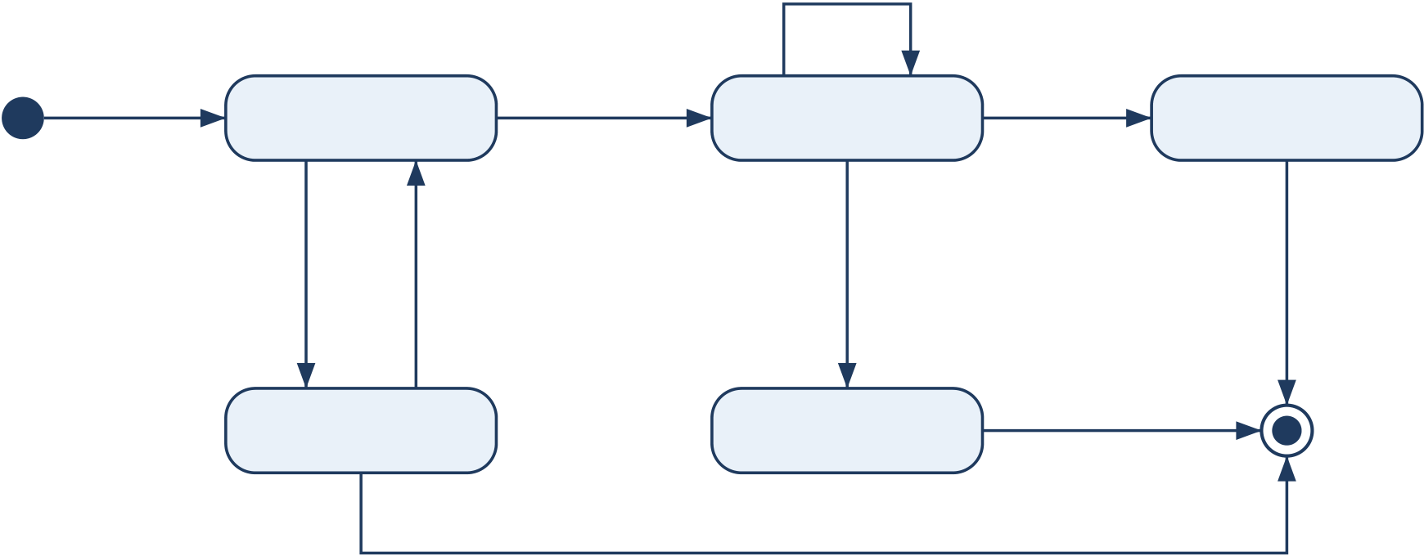
VidCraft:SoftwareRequirementsSpecification | Group7
critic requests revision
[regenerations < 2] / regenerate
storyboard | Pending | worker | Processing | valid asset | Completed
accepted | Pending | starts shot | Processing | valid asset | Completed
[critique passed,
unchecked or
route unavailable or | On Hold | resources | generation error | retries used] | included in
budget cap reached | On Hold | restored | [retries exhausted] | excluded | timeline
budget cap reached | On Hold | restored | Failed | excluded | timeline
job reaches a terminal state: excluded from the timeline
Only completed shots contribute frames, narration and captions; failed and held shots add no timeline interval (FR-25). Each included shot uses max(1, round(duration × 30)) frames at 30 FPS.
Figure12:State-transitiondiagramofastoryboardshot
62

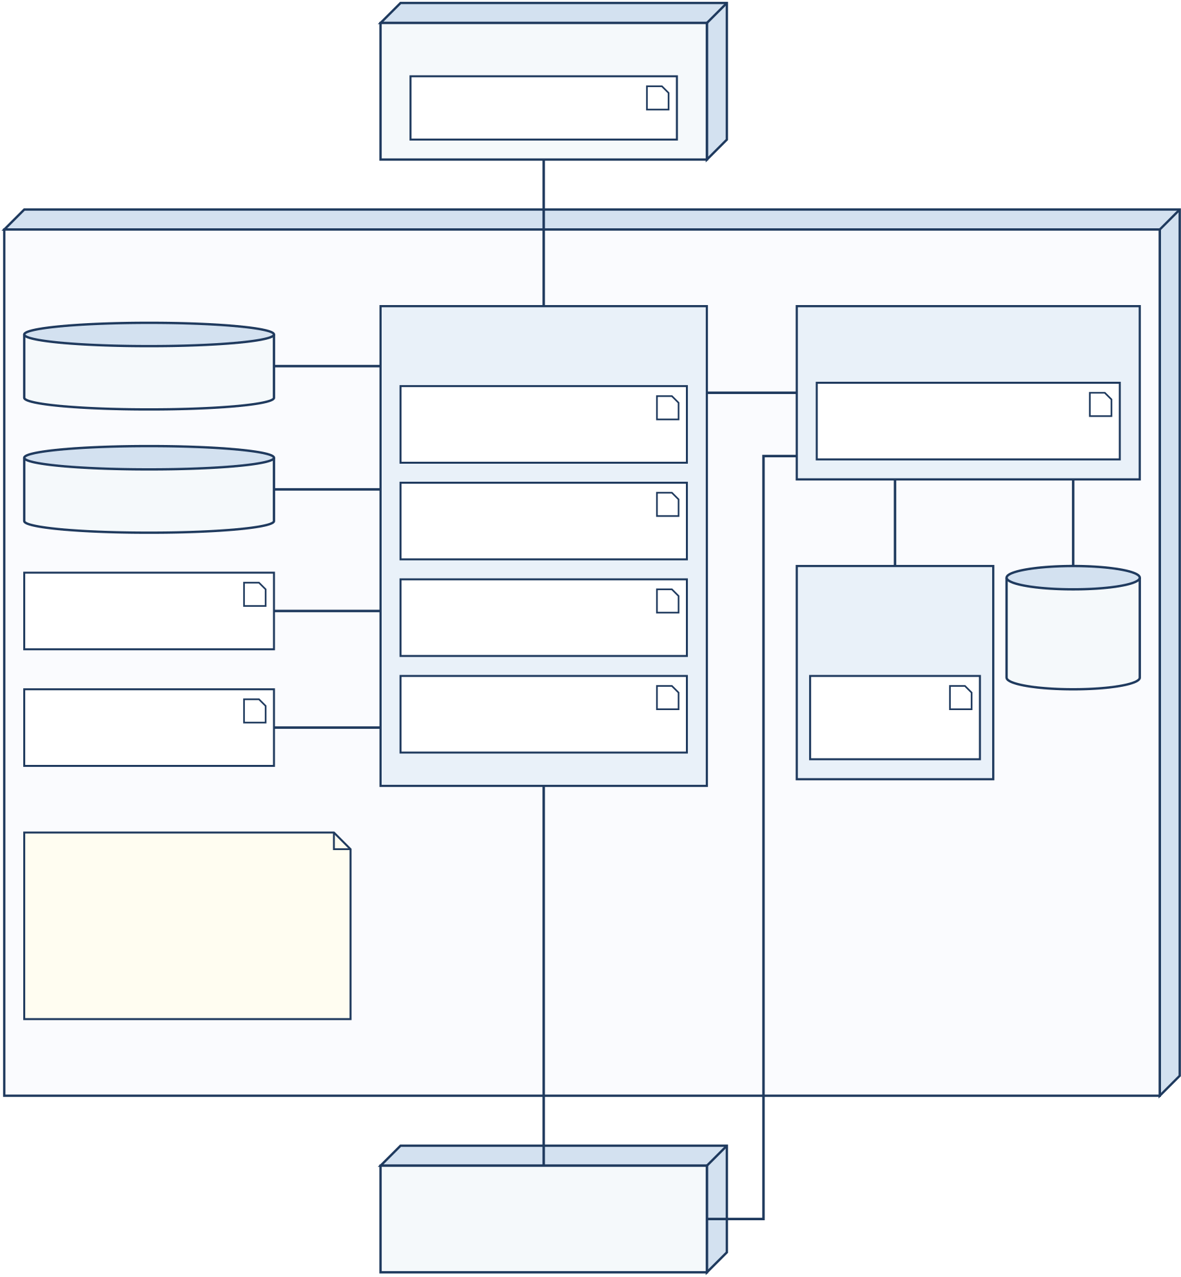
VidCraft:SoftwareRequirementsSpecification | Group7
B.5DeploymentModel
Figure13locatestherun-timecomponentsofthecontrolledacademicdeployment.The client computer runs the browser studio.The local or laboratory host runs the Node.js envi-ronment(gateway,worker,mediaadaptersandRemotionrenderer),thePythonAIservice, MongoDB, Redis, FFmpeg, the FAISS index, managed media storage and the optional local inference runtime.Hosted model services lie outside the host boundary and are reached over HTTPS.Public/sharedhostingisincludedonlywhereconfiguredwiththerequiredaccess controls;thecontrolledacademicdeploymentdoesnotrequiresharedorpublichosting.
«device» Client Computer
Web browser:
studio UI
HTTP(S)
«device» Local / Laboratory Host
(Windows + WSL or Linux)
Redis server | queue | «execution environment» | REST / | «execution environment»
Redis server | queue | Node.js | REST / | Python
Redis server | queue | Node.js | JSON
MongoDB server | database | API Gateway | JSON | FastAPI AI service
MongoDB server | database | (Express) | JSON | (NLP + agents)
MongoDB server | database | Generation | JSON
 |  |  |  | local HTTP | file I/O
MongoDB server | database | Worker (Bull) | JSON | local HTTP | file I/O
FFmpeg | process | Media Adapters | JSON | «execution
 |  |  |  | environment» | FAISS
(executable)
 |  |  |  | Local runtime | index +  corpus
Managed media | file I/O | Remotion Renderer | JSON | Local
Managed media | file I/O | (Chromium) | JSON | models
storage
Local Demo uses only the
local runtime and index; it
never silently calls hosted
services. Database, queue | HTTPS: | HTTPS:
and runtime ports stay | selected media | HTTPS:
and runtime ports stay | selected media | Standard mode
private to the host. | route | Standard mode
«external» Hosted
Model Services
Figure13:DeploymentdiagramofVidCraft
63

VidCraft:SoftwareRequirementsSpecification | Group7
CToBeDeterminedList
These deployment and experimental choices shall be finalized before the relevant acceptance
tests.Theirresolutionshallleavethecoreworkflowunchanged.
Table30:Outstandingconfigurationandevaluationdecisions
ID | Decision | Resolutioncriterion
TBD-01 | Localmodel/runtime,quantizationandtheactual | Validstructuredoutput

machine’sresourcelimit.

withinmeasuredcapacity andtheconfigured
timeout.

TBD-02 | Whethertotrainatask-specificadapterand | Ifpursued,atraining

whichlicenseddata/tasktouse.

artifact,disjointsplits andbase-versus-adapted evaluation.

TBD-03 | Finalvideo-capablemodelroute,budgetand | Anactualclipanda

supporteddimensions.

temporal-content
assemblytest.

TBD-04 | Retentionperiodandbackuplocationforordinary | Documented

andassessmentdata.

cleanup/restore
proceduresthatprotect assessmentrecords.

TBD-05 | Humanassessmentrubric/ratersandthepaired | Afrozenprotocol,

standard/localcomparisonset.

declaredsamplecounts andreproduciblerecords.

64

VidCraft:SoftwareRequirementsSpecification | Group7
References
[1]ISO/IEC/IEEE. 29148:2018:Systems and software engineering—Life cycle processes—Requirements engineering. Official catalogue:.
[2]Explosion.spaCydocumentation..
[3]LangChain.LangGraphdocumentation. .
[4]N.ReimersandI.Gurevych.Sentence-BERT:SentenceEmbeddingsusingSiamese BERT-Networks,EMNLP-IJCNLP,2019.. [5]Meta.FAISSdocumentation..
[6]Remotion.Remotiondocumentation..
[7]FFmpeg.FFmpegdocumentation.. [8]FastAPI.FastAPIdocumentation..
[9]ObjectManagementGroup.OMGUnifiedModelingLanguage(UML),Version2.5.1, 2017..
[10]C.GaneandT.Sarson.StructuredSystemsAnalysis:ToolsandTechniques.Prentice- Hall,1979.
65

