**A Project Proposal**

**“ FUTSA”**



***Submitted To***

**Department of Computer and Software Engineering**

**School of Engineering**

**Pokhara University**

In the Partial Fulfillment of the

Requirements for the Degree of Bachelor of Engineering in Computer/Software Engineering Awarded By Pokhara University

***Submitted By:***

Amrit Adhikari [19180047]

Chiranjibi Ranabhat [19180056]

Saroj Aryal [19180079]

Suraj Gautam [19180089]

**(May 2022)**

**FUTSA**

**Submitted By:**

Amrit Adhikari [19180047]

Chiranjibi Ranabhat [19180056]

Saroj Aryal [19180079]

Suraj Gautam [19180089]

**Submitted To**

**Department of Computer and Software Engineering**

**School of Engineering**

**Pokhara University**

**Acceptance**

We recommended the project entitled **"FUTSA"** submitted by Amrit, Chiranjibi, Saroj, Suraj in partial fulfillment of the requirements for the degree of Bachelor of Engineering in Computer/Software Engineering has been examined by us and accepted for the award of the degree under Pokhara University.

……………………………..

**Er. Udaya Raj Dhungana**

**Program coordinator**

School of Engineering

Pokhara University

……………………………..

**Er. Rishi Khanal**

**Supervisor**

School of Engineering

Pokhara University

# Abstract

**FUTSA** is a technical way of managing the futsal booking process . It will manage the time and the user can book futsal wherever and whenever. We will try to develop the project in such a way that users may not have any difficulty in using it and are highly secure. This system can be used by any Futsal owners, who intend to make the booking process in their business Online and simple to the players. The libraries and tools that we used to develop are Reactjs, Nodejs, Mongodb. Flutter.

Keywords:

*Booking System, Futsal.*

# Table of Contents

**Abstract**2

**Table of Contents**3

**List of Tables**4

**List of Figures**5

**Abbreviations**6

**Introduction**1

1.1 Background 1

1.2 Problem Statement 1

1.3 Objectives 2

1.4 Implication 2

**Literature Revie****w** 3

2.1 Research 3

**Methodology**4

3.1 Required tools 4

3.2 Design 5

3.2.1 Use case diagram 5

3.2.2 E-R diagram 8

3.2.3 System sequence diagram 9

**Timeline Chart 10**

4.1 Work Schedule 10

**References 12**

# List of Tables

Table 1. Comparison of different FBS 3

Table 2. Total Expenses 14

Table 3. Total Income14

# List of Figures

Figure 1. Block Diagram 6

Figure 2. Use Case Model 6

Figure 3. Entity Diagram  9

Figure 4. System Sequence Diagram 10

Figure 5. Gantt Chart 16

# Abbreviations

|  |  |
| --- | --- |
| FBS | Futsal Booking System |
|  |  |
|  |  |
|  |  |
|  |  |
|  |  |
|  |  |
|  |  |
|  |  |
|  |  |
|  |  |
|  |  |
|  |  |
|  |  |

*.*

**Chapter 1**

# Introduction

## 1.1 Background

The present era has achieved glorious milestones and has reached extraordinary landmarks, in contrast to this achievement we have been kind of lost in this maze of technological revolution. Our life is being limited to bounded walls and virtual screens and we have lost our nativeness and social life. There needs to be recreational aspects in our lives apart from these monotonous bounded live sports is one of the ways that leads people out of the maze. So we focus on resolving this burning issue with our small efforts.

Regarding this issue, we aim to develop a web application Futsal booker (a smart user interactive site), which lets people book the futsal instantly with just a click that minimizes the conventional way of booking. Our platform is effective in a sense that the informative, user-friendly digitized system makes it easy for the people to fulfill their objectives.

## 1.2 Problem Statement

We people from different walks of life have many ways to let go of our stress. In the present context the most preferred one is Futsal ( **Place where football is played in an indoor environment**). However, we have very few Futsal grounds throughout the country and yet they are not digitally accessible. Focusing on this issue we have decided to develop an online Futsal Booking System namely FUTSA. This system focuses on digitized solutions of finding the available futsal with available time & schedule nation-wide from any corner inside the country and hence booking the schedule of the game which eradicates the conventional problems saving our precious time, making us more informative and with ease of access.

## 1.3 Objectives

The main objectives of this project are:

* To find nearby and easily accessible futsals.
* To eradicate complicated phone based booking processes.
* To enable the users to book the playing schedule.

## 1.4 Implication

Our system won't have all the features required to be a versatile Booking System, still it won't lag to reduce the practice of manual system, distribute the services to futsal owners and to allow the players who want to facilitate the sports sector. The system will be highly scalable with the proper DBMS, API integrations along with proper UI/UX .

**Chapter 2**

# Literature Review

## 2.1 Research

Futsal is one of the most emerging sports. It is the form of indoor football. It earned the status of FIFA’s official form of indoor football in the 1980s as it was recognized as a scaled down version of outdoor football played on indoor environment. It is a 5 v 5 small-sided game played on a hard surfaced, basketball sized court with a smaller, heavier low bounce ball. This is the game that outdoor football players around the globe play to refine and maintain their control skills and touch. It is superior to walled football in terms of developing better skills and technique.

There are different applications to book the futsal games. (We play, 2021), (Futbox, 2019) are some web applications that are similar to our project.

|  |  |  |  |
| --- | --- | --- | --- |
| **Features \ Apps** | **Futbox** | **Weplay** | **FUTSA** |
| Price Info | No | Yes | Yes |
| Tournament | Yes | No | Yes |
| Location search | Yes | No | Yes |
| Payment Gateway | No | No | Yes |

*Table 1. Comparison of different FBS*

# Chapter 3

# Methodology

## 

## 

## 3.1 Required tools

## For the development of the project, different tools are necessary. These tools are as follows:

## Figma

## Javascript, Nodejs

## Visual studio code

## GitHub: For version control

## Database: Mongodb

## Framework : Reactjs, Expressjs

## 

**3.2 Design**

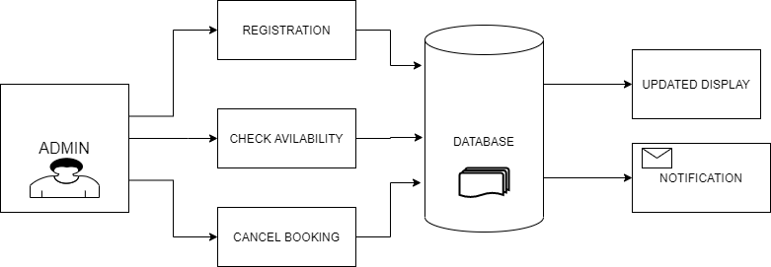

*Figure 1: Block Diagram*

**3.2.1 Use Case Diagram**

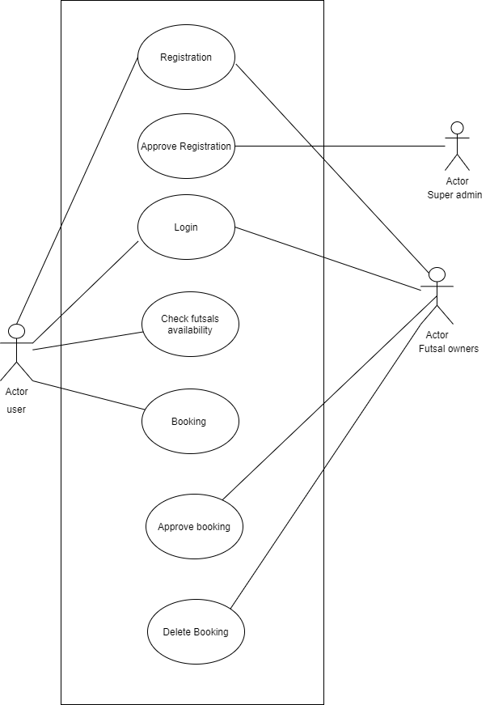

*Figure 2 : Use Case Diagram*

**Use Case UC1: Registration**

**Primary Actor:** Admin

**Secondary Actor:** System

**Stakeholder:** Futsal owner

**User:** Want to fill out a form.

**Pre condition:** User must enter username

**Post condition:** Username is registered and the Dashboard is accessed.

**Basic flow:** User selects appropriate option for the registration.

**Alternate Flow:**

1. Send Confirmation email.

**Use Case UC2: Check Availability**

**Primary Actor:** Customer

**Secondary Actor:** System

**Stakeholder:**  Customer

**User:** User wants to know available time

**Precondition:** User must be registered

**Post condition:** User gets Available Time.

**Basic flow:** Users can book the game.

**Alternate Flow:**

1. Send a Confirmation message.
2. Admin calls for confirmation.

**Use Case UC3: Manage Booking**

**Primary Actor:** User

**Secondary Actor:** System

**Stakeholder:** User

**Precondition:** Must Be Registered.

**Post condition:** Record is Updated.

**Basic flow:** User information.

**Alternate Flow:**

* System display the field required.
* Back to registration.

**Use Case UC4: Cancel Booking**

**Primary Actor:** User

**Secondary Actor:**System

**Stakeholder: Admin**

**User:** User wants to Cancel the Booking

**Precondition:** Must be Registered User.

**Post condition:** Available Time Updated.

**Basic flow:**

* Admin update the booked time.
* System saves the data.

**Alternate Flow:**

* Display an error message.
* Error message is displayed.

**3.2.2 ER Diagram**

The entity relationship diagram shows the relationship between a user and different entities. Those entities are admin, ground, user and reservation as shown in the diagram below. Different entities and their attributes are shown along with the interactions or relationship between them is shown in the diagram below.

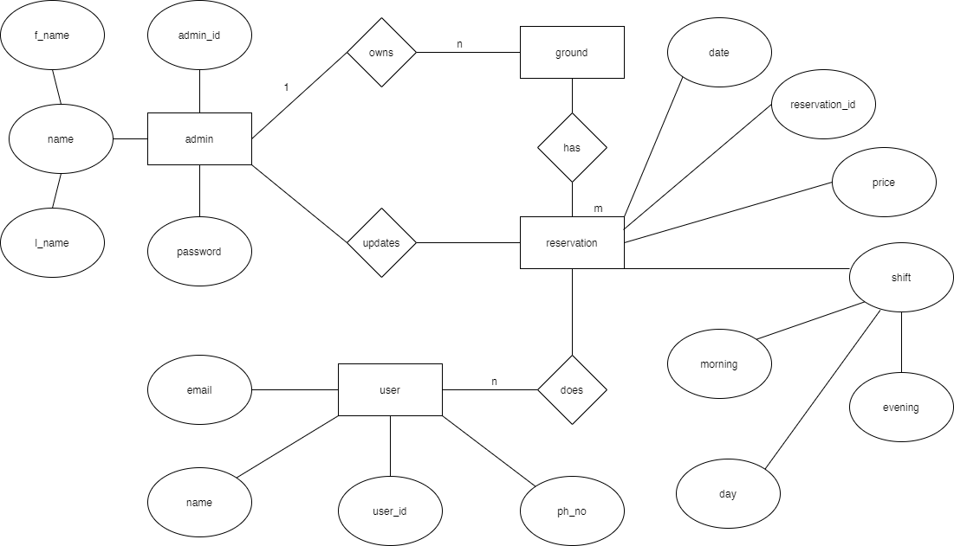

*Figure 3. Entity Relationship Diagram*

**3.2.3 System Sequence Diagram (SSD)**

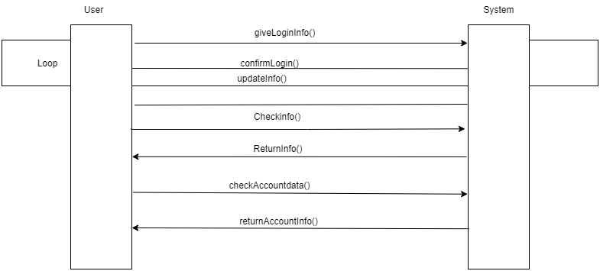

*Figure 4. System Sequence Diagram*

**Chapter 4**

# Timeline Chart

**4.1 Work Schedule**

For the proper completion we will be cooperating with each other and give more time on familiarization with tools required for the project. We will pay more attention and try to balance between learning, how code works and researching compulsory details about our project. As we have almost 12 weeks to clear our project as well as documentation and report. We are planning to spends our weeks as follows :

**• Week 1-9:**

As Expressjs and concepts of Mongodb are new to us, we will spend our first to ninth week on researching (1-9), familiarization with tools (1-3) and planning(3-4). We will also take notes about our progress making it easier to create documentation and report in future work.

• **Week 4-10:**

4-5 weeks we will focus on user interface designing and 5-10 weeks we will go for actual coding. We will also complete some major programming related to actual software and database management.

In a nutshell, we will combine all our work and we will process and complete the project. The final testing will be done by 9-11 weeks. Finally, we will prepare documentation and report on the last remaining two weeks and submit it to our department.

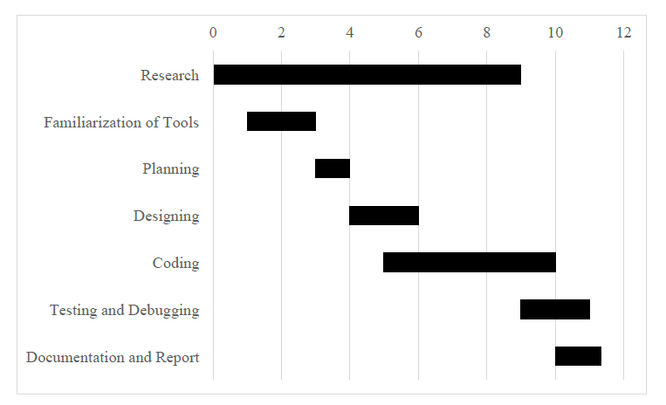

*Figure 5. Gantt Chart of FBS*

# 

# 

# 

# 

# References

*Futbox. 2019. Futbox Futsal Center I Indoor Soccer I Miami FL. [ONLINE] Available at:* [*https://www.futbox.co/*](https://www.futbox.co/)*. [Accessed 16 July 2019].*

*TITLE. 2019. TITLE. [ONLINE] Available at: http://www.ibookcourt.com/. [Accessed 16 July 2019].*

*Flowchart Maker & Online Diagram Software. 2019. Flowchart Maker & Online Diagram Software. [ONLINE] Available at:* [*https://www.draw.io/*](https://www.draw.io/)*. [Accessed 16 July 2019].*

*FIFA.com. 2019. Futsal - FIFA.com. [ONLINE] Available at:* [*https://www.fifa.com/futsal/*](https://www.fifa.com/futsal/)*. [Accessed 16 July 2019].*

*https://themeforest.net/user/dan_fisher. 2019. Welcome To UML Website!. [ONLINE] Available at:* [*https://www.uml.org/*](https://www.uml.org/)*. [Accessed 16 July 2019].*