**A Minor Project II Report on**

**“ FUTSA”**



***Submitted To***

**Department of Science and Technology**

**School of Engineering**

## Pokhara University

In the Partial Fulfillment of the Requirements for the Degree of Bachelor of Engineering in Computer/Software Engineering Awarded By Pokhara University

***Submitted By:***

Amrit Adhikari [19180047]

Chiranjibi Ranabhat [19180056]

Saroj Aryal [19180079]

Suraj Gautam [19180089]

**(September, 2022)**

**FUTSA**

**Submitted By:**

Amrit Adhikari [19180047]

Chiranjibi Ranabhat [19180056]

Saroj Aryal [19180079]

Suraj Gautam [19180089]

**Submitted To**

**Department of Science and Technology**

**School of Engineering**

**Pokhara University**

# BONAFIDE CERTIFICATE

This is to certify that this project titled **FUTSA** in partial fulfillment of the requirements for the degree of **BACHELOR OF ENGINEERING IN SOFTWARE ENGINEERING** is a bonafide work of **Saroj Aryal**, **Amrit Adhikari**, **Suraj Gautam**, **Chiranjibi Ranabhat** under the supervision of **Er. Rishi Saran Khanal**. It is further certified that this work doesn’t form part of any other project work on the basis of which a degree or award was conferred on any earlier occasion on this by any other candidate.

……………………………..

**Er. Udaya Raj Dhungana** **(PHD)**

**Program coordinator**

School of Engineering

Pokhara University

……………………………..

**Er. Rishi Saran Khanal**

**Supervisor**

School of Engineering

Pokhara University

# Abstract

**FUTSA** is a technical way of managing the futsal booking process. It will manage the time and the user can book futsal wherever and whenever. We developed the project in such a way that users may not have any difficulty in using it and are highly secure. This system can be used by any Futsal owners, who intend to make the booking process in their business Online and simple to the players. The libraries and tools that we used to develop are Reactjs, Nodejs, Mongodb,

Keywords:

*Booking System, Futsal.*

## Acknowledgement

We would like to express our sincere gratitude and appreciation to all who gave us the opportunity to do this project. Completion of this project could not have been accomplished without the support of many individuals and the college administration. Firstly, we would like to give special thanks to our project supervisor, Er. Rishi Khanal for providing necessary information from beginning to end of the project. Thanks to our parents for their encouragement and kind cooperation. We express our deepest gratitude to the program coordinator Er. Udaya Raj Dhungana for inspiring and supporting us during the entire project. Last but not least we are thankful to all our teachers and friends who have been always helping and encouraging us throughout this project.

Saroj Aryal

Amrit Adhikari

Suraj Gautam

Chiranjibi Ranabhat

School of Engineering, Pokhara University

# Table of Contents

**Bonafide Certificate** i

**Abstract** ii

**Acknowledge** iii

**Table of Contents** iv

**List of Tables** vi

**List of Figures** vii

**Abbreviations** viii

**Introduction** 1

1.1 Background 1

1.2 Problem Statement 1

1.3 Objectives 2

1.4 Implication 2 **Literature Review** 3

2.1 Research 3 **Methodology** 4

3.1 Required tools 4

3.2 Design 5

3.2.1 Use case diagram 5

3.2.2 E-R diagram 8

3.2.3 System sequence diagram 8

|  |  |
| --- | --- |
| **Test Cases** | **9** |
| 4.1 Software Testing | 9 |
| 4.2 Test Objectives | 9 |
| 4.3 Test Results | 9 |

**Results and Discussion 10**

5.1 Limitations 10

5.2 Future Improvements 11

5.3 Conclusion 11

**References 12**

**Appendix 13**

# List of Tables

Table 1. Comparison of different FBS 3

# List of Figures

Figure 1. Block Diagram 6

Figure 2. Use Case Model 6

Figure 3. Entity Diagram 9

Figure 4. System Sequence Diagram 10

# Abbreviations

FBS Futsal Booking System

*.*

## Chapter 1

## Introduction

### 1.1 Background

The present era has achieved glorious milestones and has reached extraordinary landmarks, in contrast to this achievement we have been kind of lost in this maze of technological revolution. Our life is being limited to bounded walls and virtual screens and we have lost our nativeness and social life. There needs to be recreational aspects in our lives apart from these monotonous bounded live sports is one of the ways that leads people out of the maze. So we focus on resolving this burning issue with our small efforts.

Regarding this issue, we aim to develop a web application Futsal booker (a smart user interactive site), which lets people book the futsal instantly with just a click that minimizes the conventional way of booking. Our platform is effective in a sense that the informative, user-friendly digitized system makes it easy for the people to fulfill their objectives.

### 1.2 Problem Statement

We people from different walks of life have many ways to let go of our stress. In the present context the most preferred one is Futsal (**Place where football is played in an indoor environment**). However, we have very few Futsal grounds throughout the country and yet they are not digitally accessible. Focusing on this issue we have decided to develop an online Futsal Booking System namely FUTSA. This system focuses on digitized solutions of finding the available futsal with available time & schedule nation-wide from any corner inside the country and hence booking the schedule of the game which eradicates the conventional problems saving our precious time, making us more informative and with ease of access.

### 1.3 Objectives

The main objectives of this project are:

* To find nearby and easily accessible futsals.
* To eradicate complicated phone based booking processes.
* To enable the users to book the playing schedule.

### 1.4 Implication

Our system won't have all the features required to be a versatile Booking System, still it won't lag to reduce the practice of manual system, distribute the services to futsal owners and to allow the players who want to facilitate the sports sector. The system will be highly scalable with the proper DBMS, API integrations along with proper UI/UX.

## Chapter 2 Literature Review

### 2.1 Research

Futsal is one of the most emerging sports. It is the form of indoor football. It earned the status of FIFA’s official form of indoor football in the 1980s as it was recognized as a scaled down version of outdoor football played on indoor environment. It is a 5 v 5 small sided game played on a hard surfaced, basketball sized court with a smaller, heavier low bounce ball. This is the game that outdoor football players around the globe play to refine and maintain their control skills and touch. It is superior to walled football in terms of developing better skills and technique (FIFA.com).

There are different applications to book the futsal games (We play, 2021), (Futbox, 2019). Below are some web applications that are similar to our project.

|  |  |  |  |
| --- | --- | --- | --- |
| **Features \ Apps** | **Futbox** | **Weplay** | **FUTSA** |
| Price Info | No | Yes | Yes |
| Tournament | Yes | No | Yes |
| Location search | Yes | No | Yes |
| Payment Gateway | No | No | Yes |

*Table 1. Comparison of different FBS*

## Chapter 3

## Methodology

### 3.1 Required tools

For the development of the project, we used many different tools, libraries and frameworks. These tools are as follows:

1. Figma
2. Javascript, Nodejs
3. Visual studio code
4. GitHub: For version control
5. Database: Mongodb
6. Framework : Reactjs, Expressjs

### 3.2 Design

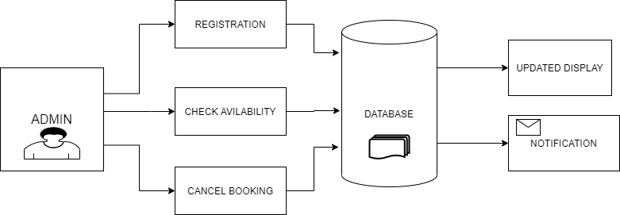

*Figure 1: Block Diagram*

#### 3.2.1 Use Case Diagram

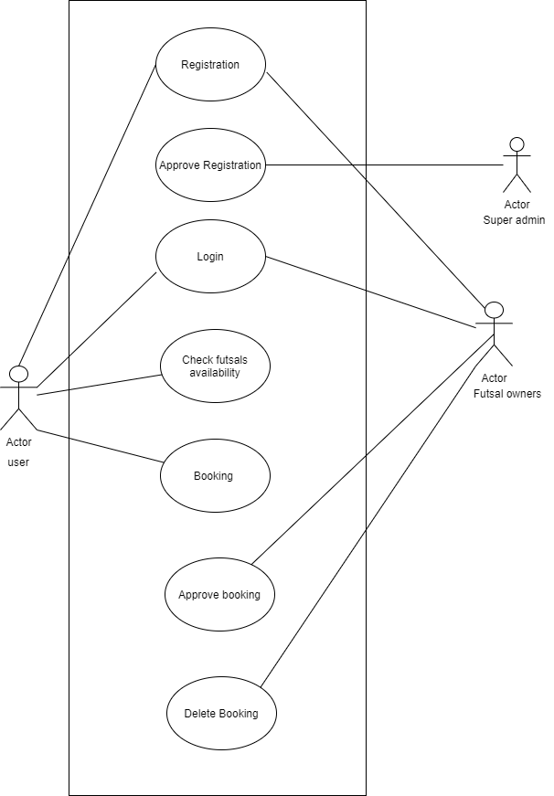

*Figure 2 : Use Case Diagram*

### Use Case UC1: Registration

**Primary Actor:** Admin

**Secondary Actor:** System

**Stakeholder:** Futsal owner

**User:** Want to fill out a form.

**Pre condition:** User must enter username

**Post condition:** Username is registered and the Dashboard is accessed.

**Basic flow:** User selects appropriate option for the registration.

**Alternate Flow:**

1. Send Confirmation email.

### Use Case UC2: Check Availability

**Primary Actor:** Customer

**Secondary Actor:** System

**Stakeholder:**  Customer

**User:** User wants to know available time

**Precondition:** User must be registered

**Post condition:** User gets Available Time.

**Basic flow:** Users can book the game.

**Alternate Flow:**

1. Send a Confirmation message.
2. Admin calls for confirmation.

### Use Case UC3: Manage Booking

**Primary Actor:** User

**Secondary Actor:** System

**Stakeholder:** User **Precondition:** Must Be Registered.

**Post condition:** Record is Updated.

**Basic flow:** User information.

**Alternate Flow:**

* System display the field required.
* Back to registration.

### Use Case UC4: Cancel Booking

**Primary Actor:** User

**Secondary Actor:**System

**Stakeholder: Admin User:** User wants to Cancel the Booking **Precondition:** Must be Registered User.

**Post condition:** Available Time Updated.

**Basic flow:**

* Admin update the booked time. ● System saves the data.

**Alternate Flow:**

* Display an error message.
* Error message is displayed.

#### 3.2.2 ER Diagram

The entity relationship diagram shows the relationship between a user and different entities. Those entities are admin, ground, user and reservation as shown in the diagram below. Different entities and their attributes are shown along with the interactions or relationship between them is shown in the diagram below.

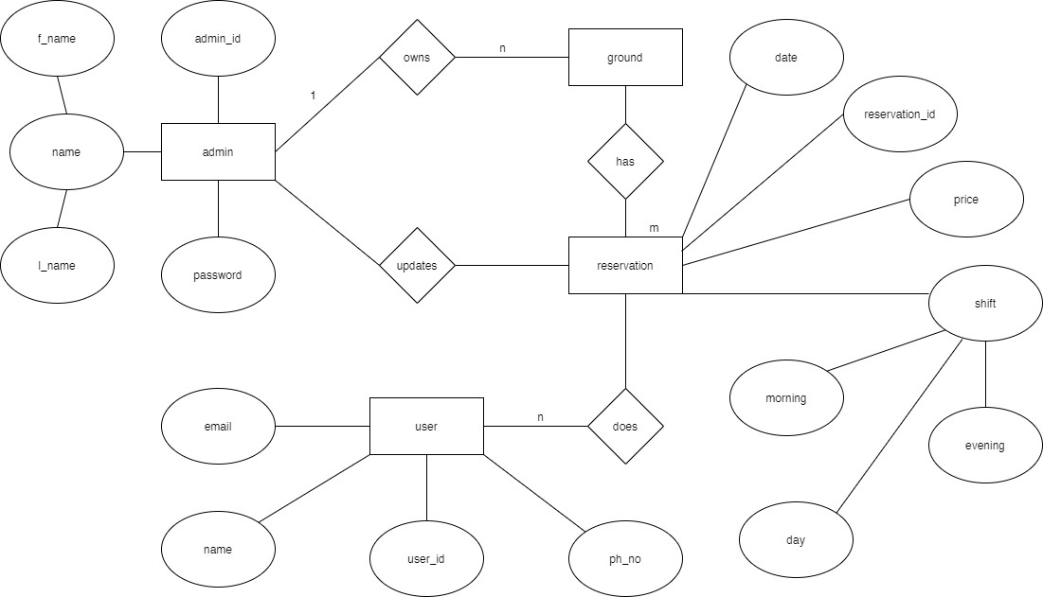

*Figure 3. Entity Relationship Diagram*

#### 3.2.3 System Sequence Diagram (SSD)

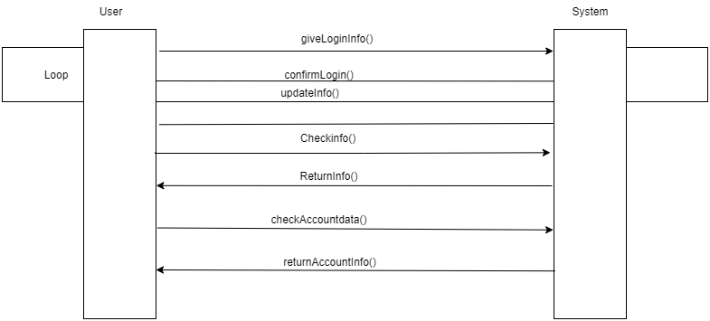

*Figure 4. System Sequence Diagram*

## Chapter 4

## Test Cases

### 4.1 Software Testing

Software testing is a process to evaluate the software application whether it is built or not to meet the intended requirements. It also identifies the defects, bugs to ensure that the product is defect-free in order to produce a quality product.

### 4.2 Test Objectives

The main objectives of testing FUTSA were:

* To check whether the Web Application is built per the set objectives.
* To ensure errors get fixed before deployment.
* To gain confidence in the level of quality of the system.

### 4.3 Test Results

|  |  |  |  |  |
| --- | --- | --- | --- | --- |
| **SN.** | **Test Cases** | **Expected** | **Observed** | **Result** |
| 1. | Authentication for customer and futsal owner. | Customer and owner with the correct email and password can login. | Only specific emails with its respective correct password were logged in. | **ok** |
| 2. | Book the time slot for certain date. | Customer authenticated can only view details and book the time for specific time. | Only authenticated user was able to view and book the time for futsal. | **ok** |
| 3. | Accept or cancel the booking request | Authenticated owner user can only confirm or cancel the booking request. | Only authenticated owner can confirm or cancel the booking request. | **ok** |

## Chapter 5

## Result and Discussion

Our project entitled FUTSA helped us to learn in detail about the development of web Application and to learn about project milestones. It provided us the opportunity to learn various related systems with gradual improvements. Our project has fulfilled all its objectives. Customer can view the information and availability of time about futsal .Also, Owners can list their futsal and make booking process digital. This project was completed within the estimated time and with the coordination of team members and our respected supervisor.

### 5.1 Limitations

This futsal booking system called FUTSA was designed and developed to make easy access of futsal information for various users. But there are some limitations. They are listed below:

**Technical feasibility**: Internet access is required to use the system, people with internet access are comparatively few in some areas. This app targets only specific customers i.e football enthusiasts.

**Economic feasibility**: Service users and service providers have to bear hardware and software costs, due to which they may feel uneasy to use our web application. Similarly, administrators have to bear training costs.

### 5.2 Future Improvements

Some of the improvements that can be implemented in the future are as follows:

* Payment gateway integration.
* Google Map integration
* Better user Interface and mobile app.
* More information about futsal and better searching of location.
* Improved security and system.
* Real time chat system for interaction between futsal and customer.

### 5.3 Conclusion

FUTSA is a web Application which aims to digitize the futsal booking system. It also shows adequate information about futsal and makes browsing easier using features like search and recommendations. Similarly, it has an Owner Dashboard for managing futsals including confirming and declining the request. This web App makes it easier for various users to browse and know information about futsal around them by choosing nearest location according to their needs which saves time and effort rather than manual asking and phone calls.

## References

*Futbox. 2019. Futbox Futsal Center I Indoor Soccer I Miami FL. [ONLINE] Available at:* [*https://www.futbox.co/.*](https://www.futbox.co/) *[Accessed 16 July 2019].*

*TITLE. 2019. TITLE. [ONLINE] Available at: http://www.ibookcourt.com/. [Accessed 16 July 2019].*

*Flowchart Maker & Online Diagram Software. 2019. Flowchart Maker & Online Diagram Software. [ONLINE] Available at:* [*https://www.draw.io/.*](https://www.draw.io/) *[Accessed 16 July 2019].*

*FIFA.com. 2019. Futsal - FIFA.com. [ONLINE] Available at:* [*https://www.fifa.com/futsal/.*](https://www.fifa.com/futsal/) *[Accessed 16 July 2019].*

*https://themeforest.net/user/dan_fisher. 2019. Welcome To UML Website!. [ONLINE] Available at:* [*https://www.uml.org/.*](https://www.uml.org/) *[Accessed 16 July 2019].*

## APPENDIX

1. Homepage (Normal User)

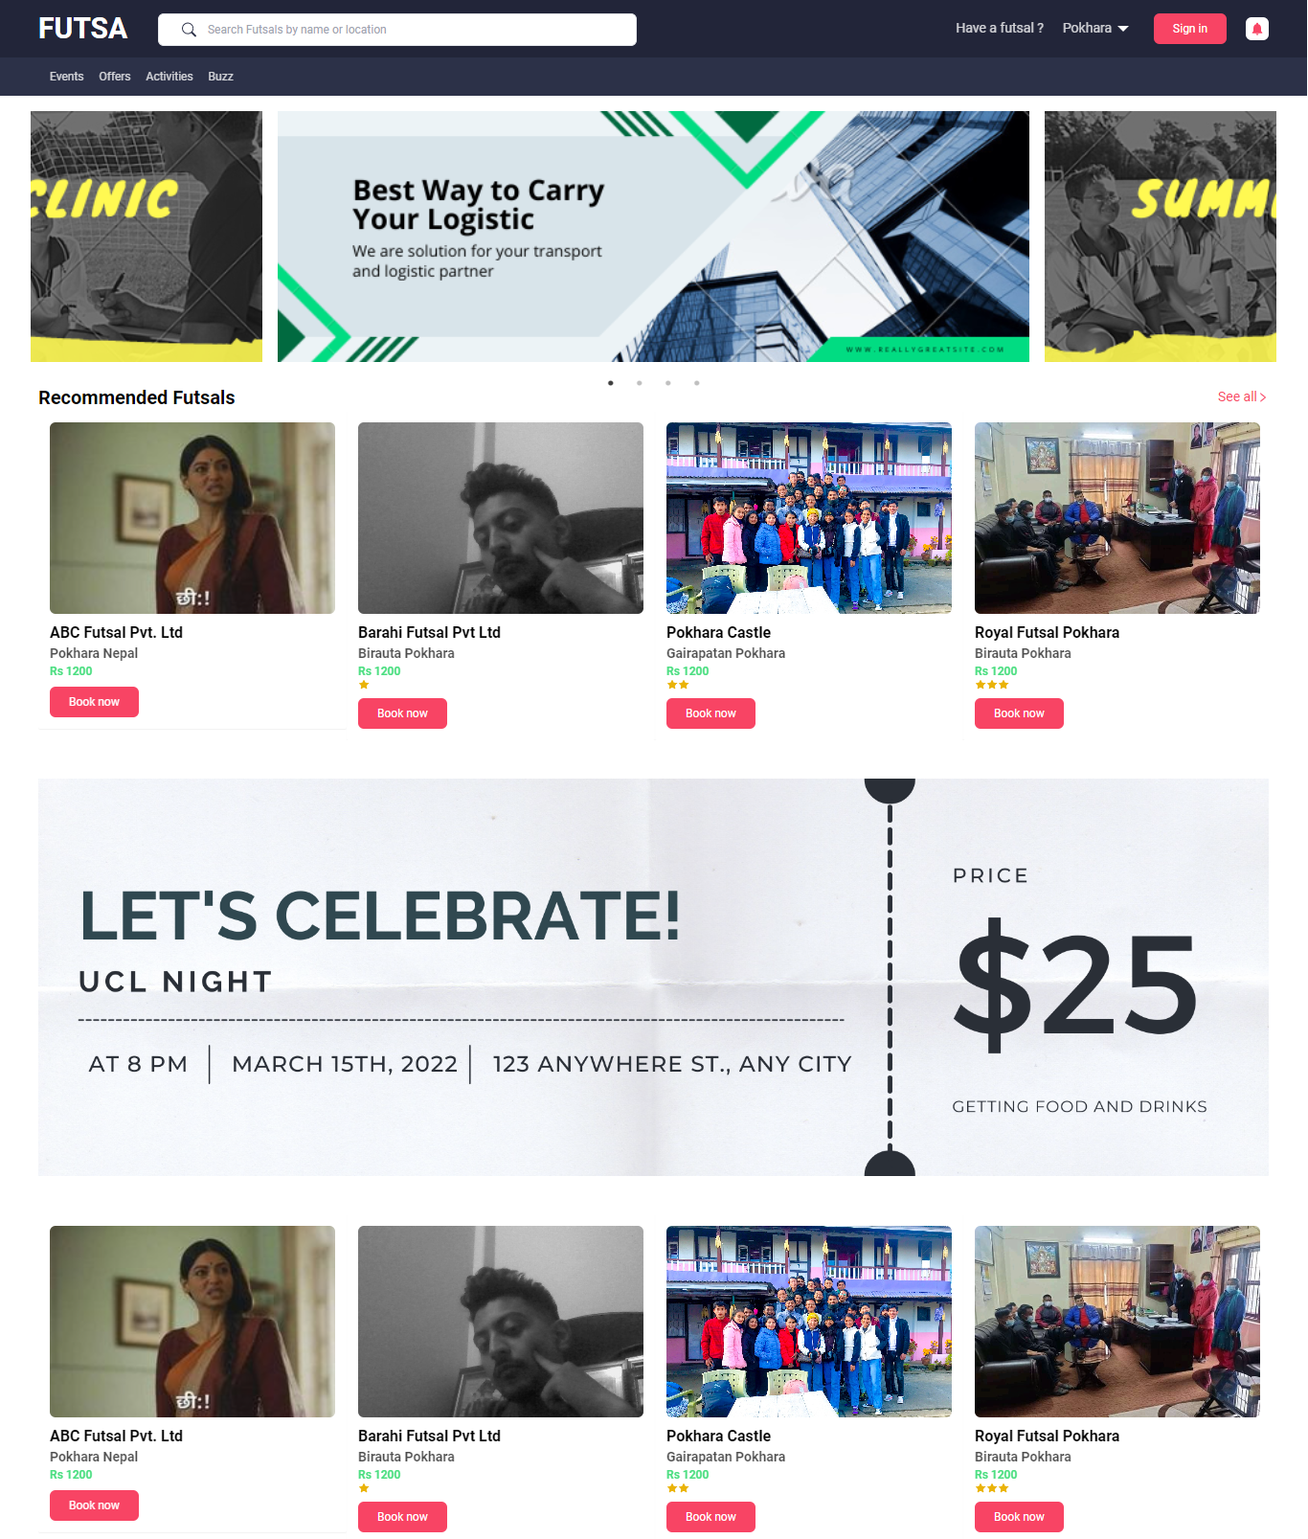

1. Futsal Page (After Login Only )

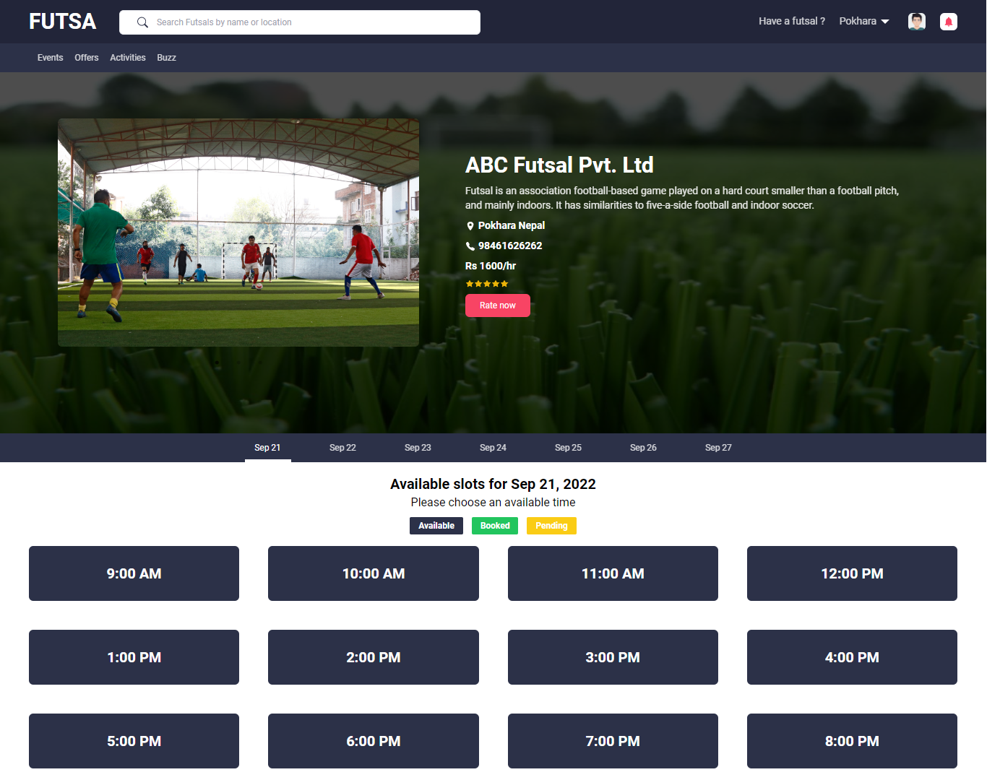

1. Futsal Dashboard (After Login )

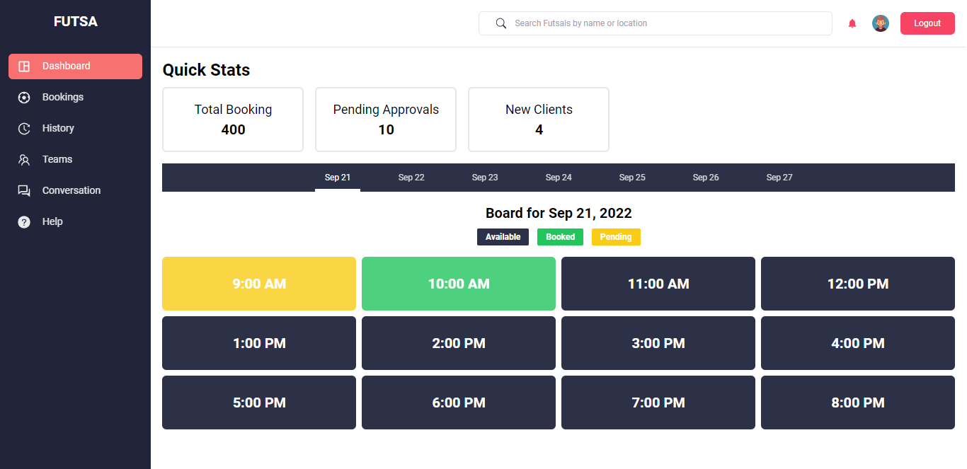

1. Bookings requests pages (Dashboard)

