ATM SIMULATOR USING JAVA
PSPJ Project Report

1. ABSTRACT
The ATM Simulator is a console-based Java application developed as a Programming for Problem Solving using Java (PSPJ) project. The system simulates the basic operations performed by an Automated Teller Machine, including account login, PIN verification, balance enquiry, cash withdrawal, cash deposit, and viewing a mini statement. The project uses Java classes, objects, conditional statements, loops, switch-case, methods, ArrayList, and user input through Scanner. The purpose of the project is to demonstrate how fundamental Java programming concepts can be combined to solve a practical real-world problem. The application is designed as a simple educational model and does not connect to a real banking system.
2. ADVANTAGES
- Simple and user-friendly console interface for performing basic ATM operations.
- Demonstrates important Java concepts such as classes, objects, methods, loops, conditions, and switch-case.
- Provides PIN-based login verification before allowing access to account operations.
- Allows users to check their current balance, deposit money, and withdraw money.
- Prevents withdrawals when the requested amount is greater than the available balance.
- Maintains a mini statement of deposit and withdrawal transactions during the program session.
- Easy to test, modify, and extend with additional features in future versions.
- Suitable for beginners because the implementation does not require a database or external banking system.
3. IMPLEMENTATION
The ATM Simulator is implemented using Java and organized into three main classes: Account, Transaction, and ATM. The Account class stores the account number, PIN, account holder name, and balance, and provides methods for deposit and withdrawal. The Transaction class stores the transaction type and amount and is used to display the mini statement. The ATM class contains the main method, accepts user input using Scanner, verifies the login details, displays the menu, and performs the selected operation.
Main implementation steps:
- Create an account object with sample account details and an initial balance.
- Accept the account number and PIN from the user.
- Compare the entered details with the stored credentials.
- Display the ATM menu after successful login.
- Use switch-case to execute balance enquiry, withdrawal, deposit, or mini statement.
- Use a loop so the menu continues until the user selects Exit.
- Store deposit and withdrawal records in an ArrayList of Transaction objects.
- Display appropriate messages for successful operations, invalid choices, and insufficient balance.
Sample test credentials:
Account Number: 1234567890
PIN: 1234
Initial Balance: Rs. 5000.00
4. OUTPUT SCREENSHOTS
The following screenshots represent sample console outputs from the ATM Simulator. They demonstrate successful login, balance enquiry, deposit, withdrawal, and mini statement operations.
Figure 1: Login and Balance Enquiry
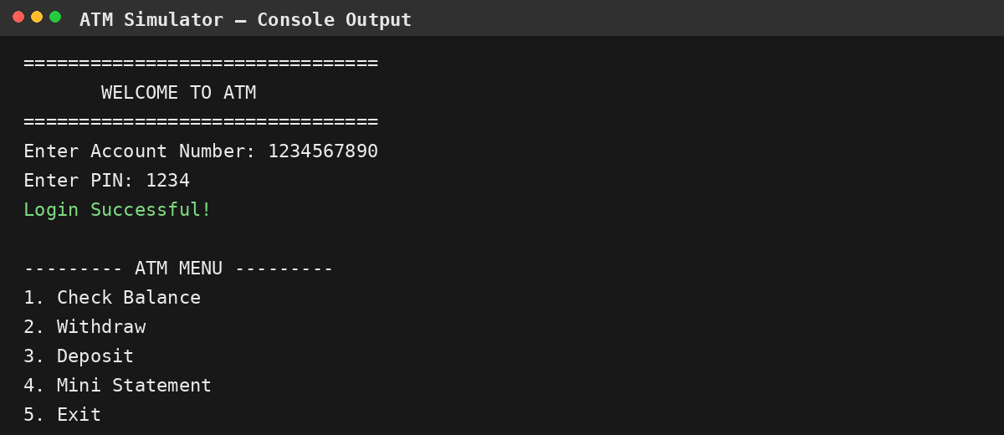
Figure 2: Deposit, Withdrawal and Mini Statement
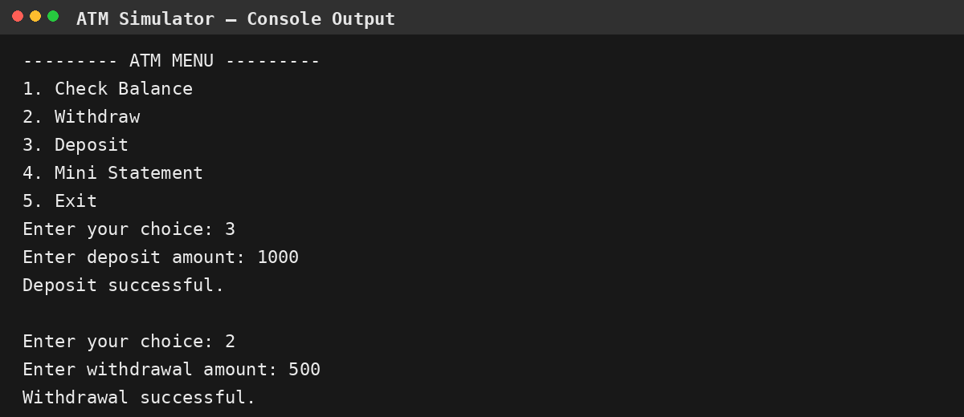
5. CONCLUSION
The ATM Simulator successfully demonstrates the implementation of a small real-world application using Java programming fundamentals. The project provides essential ATM operations such as authentication, balance checking, deposit, withdrawal, and transaction history through a simple console interface. Developing this project helps strengthen understanding of object-oriented programming, decision making, loops, collections, methods, and user input in Java. The project can be extended in the future by adding multiple accounts, database connectivity, transaction dates and times, account creation, PIN change, transfer facilities, and a graphical user interface.

