

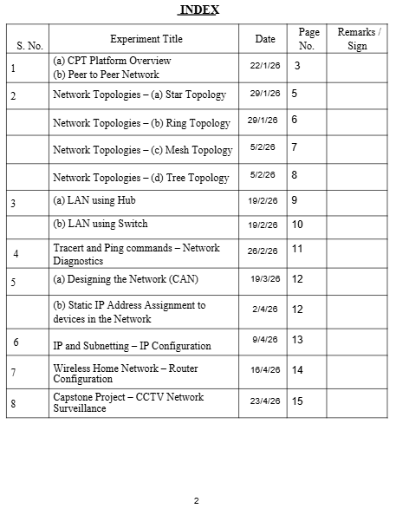
Computer Networks Lab
[ENCS352]
BTech CSE AI & ML
2301730192
Ms. Jyoti
SUBMITTED TO:
SUBMITTED BY:
With Specialization In AI & ML
SCIENCE AND ENGINEERING
BACHELORS IN TECHNOLOGY IN COMPUTER
For
KR. MANGALAM UNIVERSITY
Vaibhav Bhardwaj

1

EXPERIMENT 1

(a): CPT PLATFORM OVERVIEW
Theory
Cisco Packet Tracer is a network simulation tool used to design and test network
topologies without physical hardware. It provides a virtual environment with devices like
routers, switches, and PCs. It helps students understand networking concepts. It supports
both real-time and simulation modes. It is widely used for learning and experimentation.
Steps

1.
Open Cisco Packet Tracer.

2.
Observe workspace, device toolbar, and connections panel.

3.
Drag one PC and one switch.

4.
Connect them using a straight-through cable.

5.
Click on devices to explore Desktop and Config tabs.
Result
Successfully explored the Cisco Packet Tracer interface.
Conclusion
Packet Tracer provides an effective platform for learning networking concepts.

3

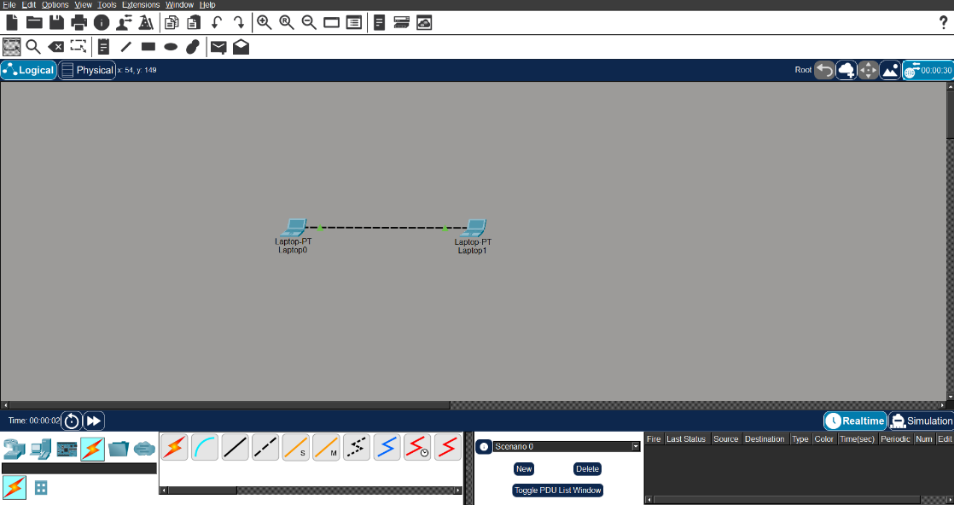

(b): PEER-TO-PEER NETWORK
Theory
A peer-to-peer network allows devices to communicate directly without a central server.
Each device acts as both client and server. It is simple, cost-effective, and suitable for
small networks. Data sharing can be done directly between devices. However, it lacks
centralized control and security.
Steps

1.
Add two PCs (PC0, PC1).

2.
Connect using a cross-over cable.

3.
Assign IP addresses:

a.
PC0 → 192.168.1.1

b.
PC1 → 192.168.1.2

4.
Open Command Prompt on PC0.

5.
Run: ping 192.168.1.2

Result

Ping successful between PCs. Peer-to-peer communication was established successfully
.

4

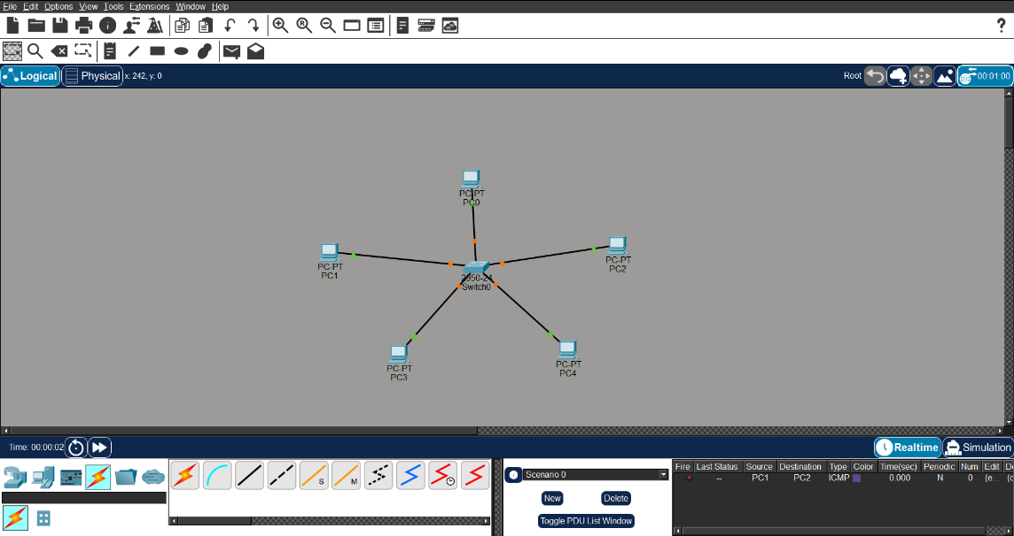
EXPERIMENT 2

(a): STAR TOPOLOGY
Theory
Star topology connects all devices to a central switch. All communication passes through
this central device. It is easy to install and manage. Failure of one link does not affect
others. However, failure of the central device stops the entire network.
Steps

1.
Add one switch and multiple PCs.

2.
Connect PCs to switch using straight cable.

3.
Assign IPs:

a.
PC0 → 192.168.1.1

b.
PC1 → 192.168.1.2

c.
PC2 → 192.168.1.3

d.
PC3 → 192.168.1.4

4.
Test using ping.

Result
All devices communicate through switch. Star topology is reliable and easy to

troubleshoot.

5

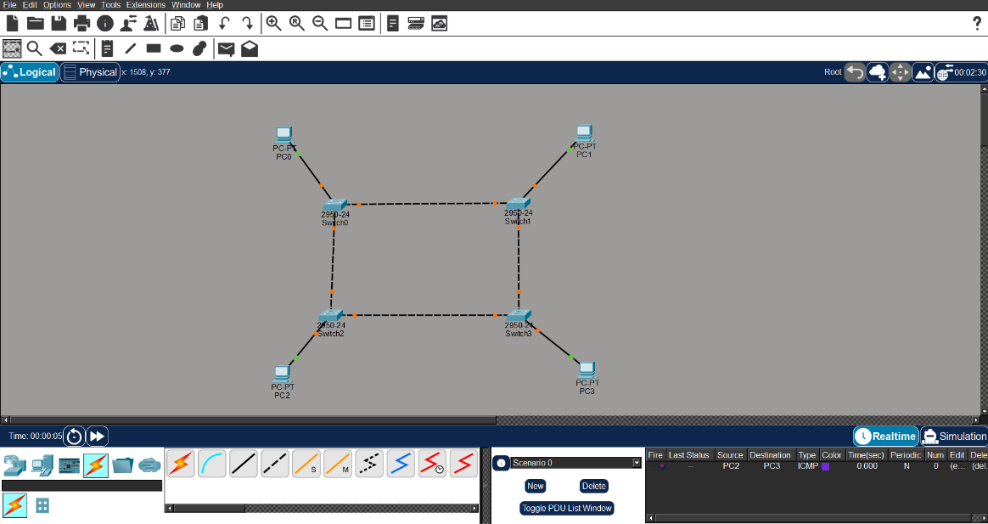

(b): RING TOPOLOGY
Theory
Ring topology connects devices in a circular form where each node is connected to two
others. Data travels in one direction around the ring. It ensures equal access to all nodes.
However, failure of a single link can disrupt the entire network. It is less commonly used
in modern networks.
Steps

1.
Add 4 PCs and 4 switches.

2.
Connect switches in circular form.

3.
Connect PCs to switches.

4.
Assign IPs:

a.
PC0 → 192.168.1.1

b.
PC1 → 192.168.1.2

c.
PC2 → 192.168.1.3

d.
PC3 → 192.168.1.4

5.
Test connectivity using ping.

Result
Communication is successful in ring structure. Ring topology works but is less reliable

than star.

6

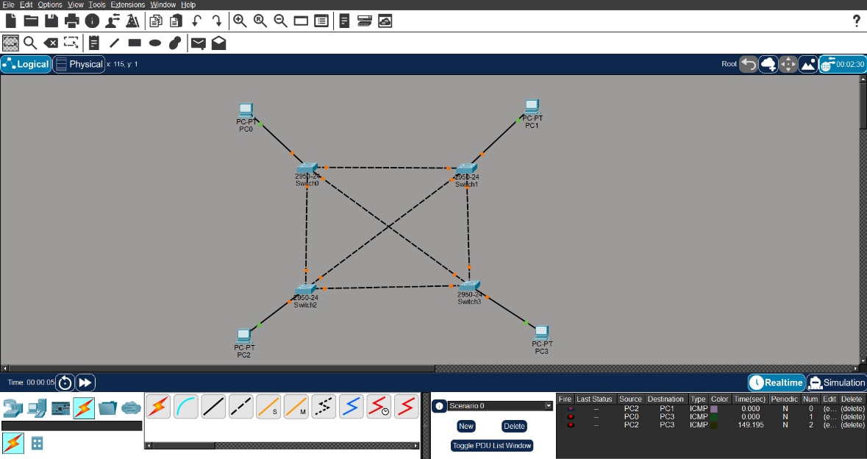

(c): MESH TOPOLOGY
Theory
Mesh topology connects every device to every other device. It provides multiple paths for
data transmission. This increases reliability and fault tolerance. Even if one path fails,
communication continues. However, it is expensive and complex to implement.
Steps

1.
Add switches and PCs.

2.
Connect each switch with every other switch.

3.
Connect PCs to switches.

4.
Assign IPs:

a.
PC0 → 192.168.1.1

b.
PC1 → 192.168.1.2

c.
PC2 → 192.168.1.3

d.
PC3 → 192.168.1.4

5.
Test using ping.

Result

Multiple communication paths are established. Mesh topology provides high reliability.

7

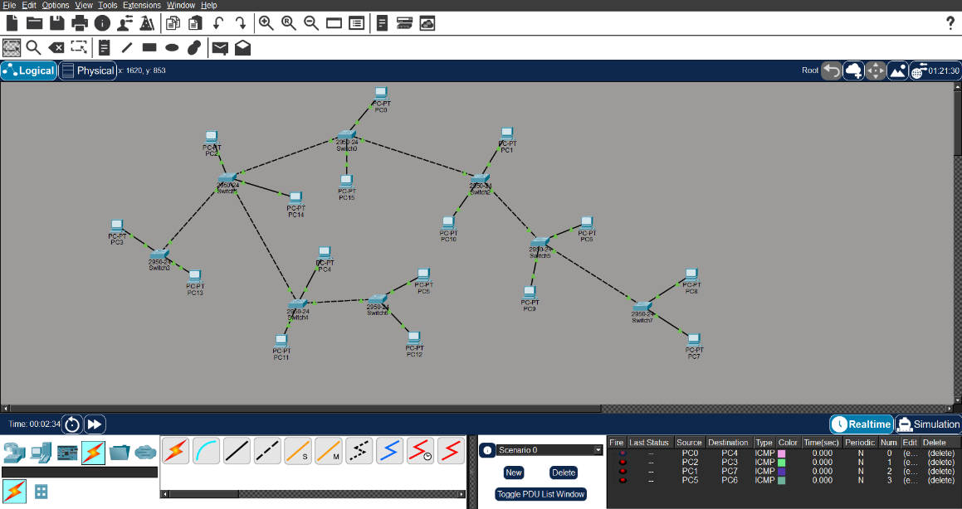

(d): TREE TOPOLOGY
Theory
Tree topology is a hierarchical network structure combining multiple star topologies. It
has a root node and multiple levels. It is suitable for large networks. It allows for easy
expansion and management. However, failure of backbone can affect the entire network.
Steps

1.
Add multiple switches in hierarchy.

2.
Connect switches in parent-child structure.

3.
Connect PCs to switches.

4.
Assign IPs:

a.
PC0 → 192.168.1.1

b.
PC1 → 192.168.1.2

c.
PC2 → 192.168.1.3

d.
PC3 → 192.168.1.4

e.
PC4 → 192.168.1.5

f.
PC5 → 192.168.1.6

5.
Test connectivity.

Result
Hierarchical communication was established. Tree topology is scalable and efficient.

8

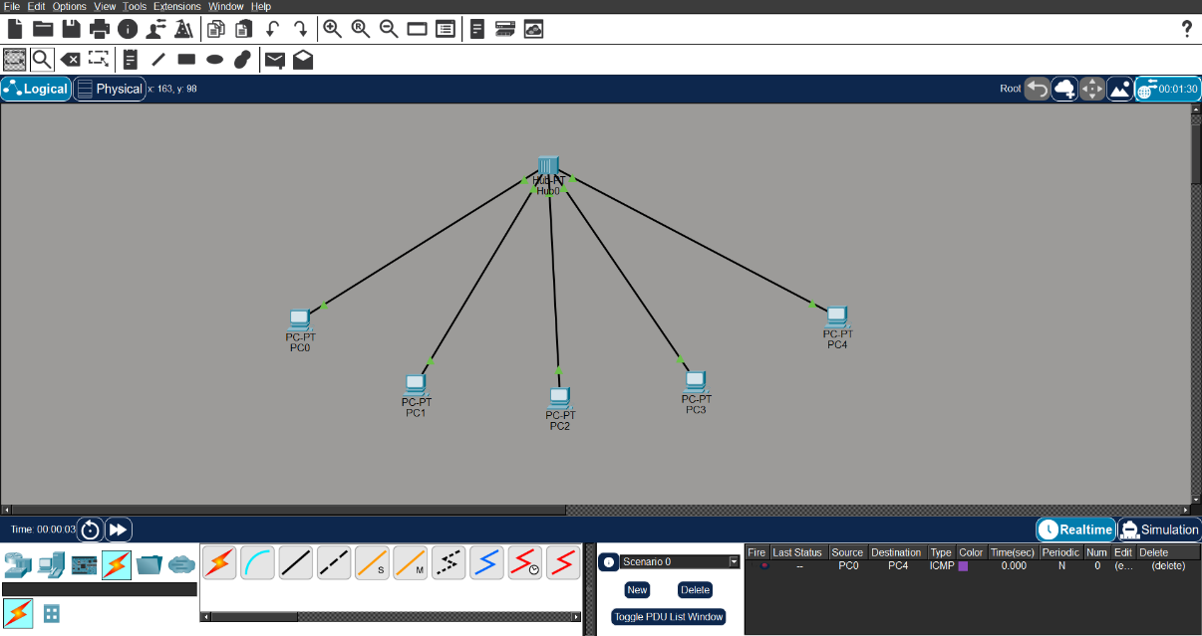
EXPERIMENT 3

(a): LAN USING HUB
Theory
A hub is a basic networking device that broadcasts data to all connected devices. It
operates on the physical layer. It does not filter data, leading to collisions. It is simple but
inefficient. It is mostly replaced by switches.
Steps

1.
Add one hub and three PCs.

2.
Connect PCs to hub.

3.
Assign IPs:

a.
PC0 → 192.168.1.1

b.
PC1 → 192.168.1.2

c.
PC2 → 192.168.1.3

4.
Test using ping.

Result
All devices receive transmitted data. Hub-based LAN is inefficient due to broadcasting.

9

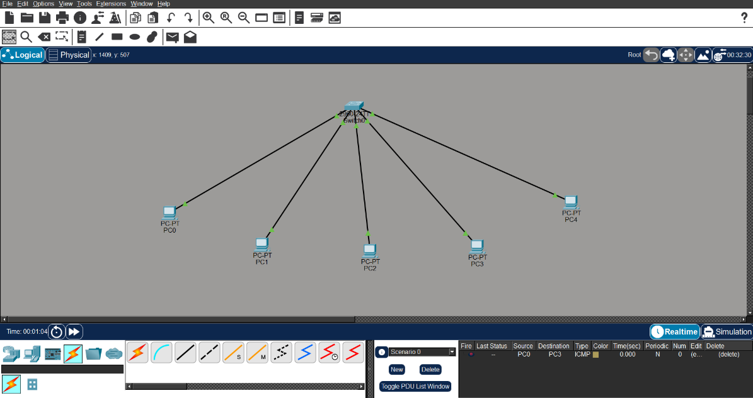

(b): LAN USING SWITCH
Theory
A switch is a networking device that forwards data only to the destination device. It
operates on the data link layer. It reduces collisions and improves performance. It uses
MAC address tables for efficient communication. It is widely used in LANs.
Steps

1.
Add one switch and multiple PCs.

2.
Connect PCs to switch.

3.
Assign IPs:

a.
PC3 → 192.168.1.1

b.
PC4 → 192.168.1.2

c.
PC5 → 192.168.1.3

d.
PC6 → 192.168.1.4

4.
Test connectivity.

Result

Efficient communication is achieved. Switches improve network performance.

10

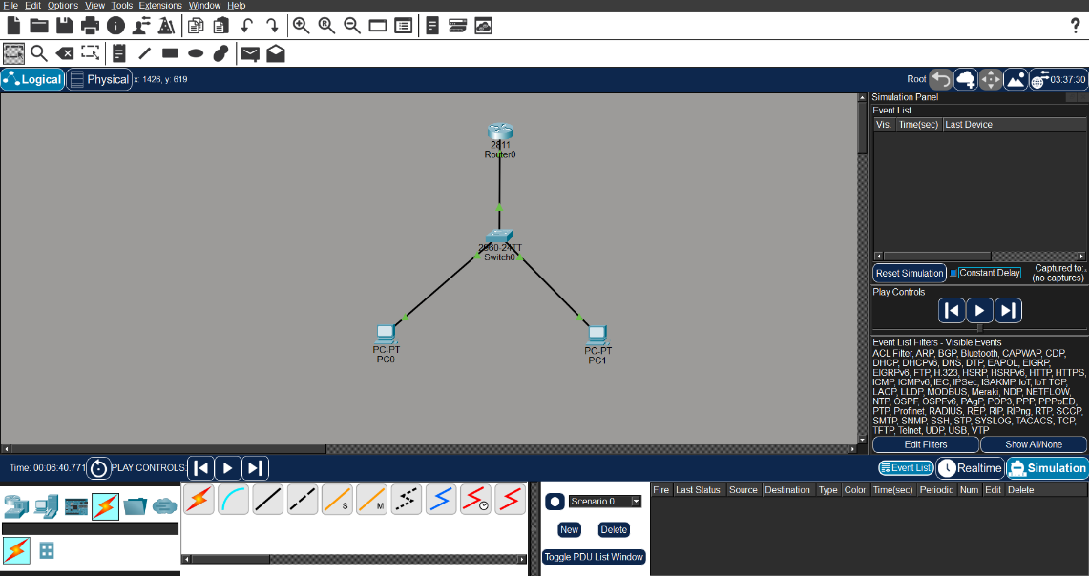
EXPERIMENT 4

PING & TRACERT
Theory
Ping is used to test connectivity between devices using the ICMP protocol. Tracert shows
the path taken by packets. These tools help troubleshoot network issues. They provide
information about delays and failures. They are essential diagnostic tools.
Steps

1.
Add router, switch, and PCs.

2.
Connect devices properly.

3.
Assign IPs:

a.
PC0 → 192.168.1.1

b.
PC1 → 192.168.1.2

c.
Router → 192.168.1.254

4.
Set gateway in PCs → 192.168.1.254

5.
Run ping and tracert commands.

Result
Connectivity and path verified successfully. Ping and tracert help diagnose network
problems.

11

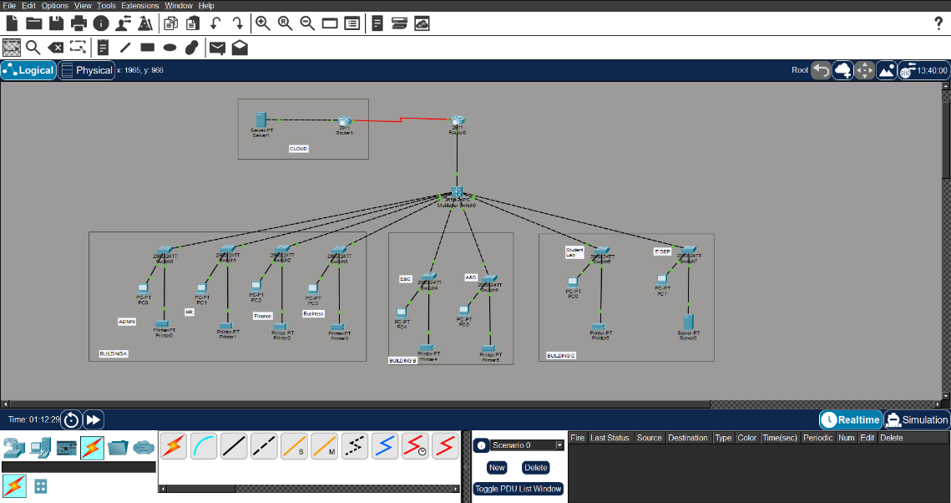
EXPERIMENT 5

CAMPUS AREA NETWORK (CAN)
Theory
A Campus Area Network connects multiple LANs across buildings. It includes routers,
switches, and servers. It allows communication between departments.
Steps

1.
Add router, multilayer switch, switches, PCs, servers.

2.
Divide network into departments.

3.
Connect all switches to central switch.

4.
Assign IPs:

a.
ADMIN → 192.168.1.1

b.
HR → 192.168.2.1

c.
FINANCE → 192.168.3.1

d.
BUSINESS → 192.168.4.1

e.
E&C → 192.168.5.1

f.
A&D → 192.168.6.1

g.
STUDENT LAB → 192.168.7.1

5.
Set gateways → 192.168.X.254

6.
Test communication.

Result -
All departments connected successfully. CAN enables efficient campus-wide

communication.

12

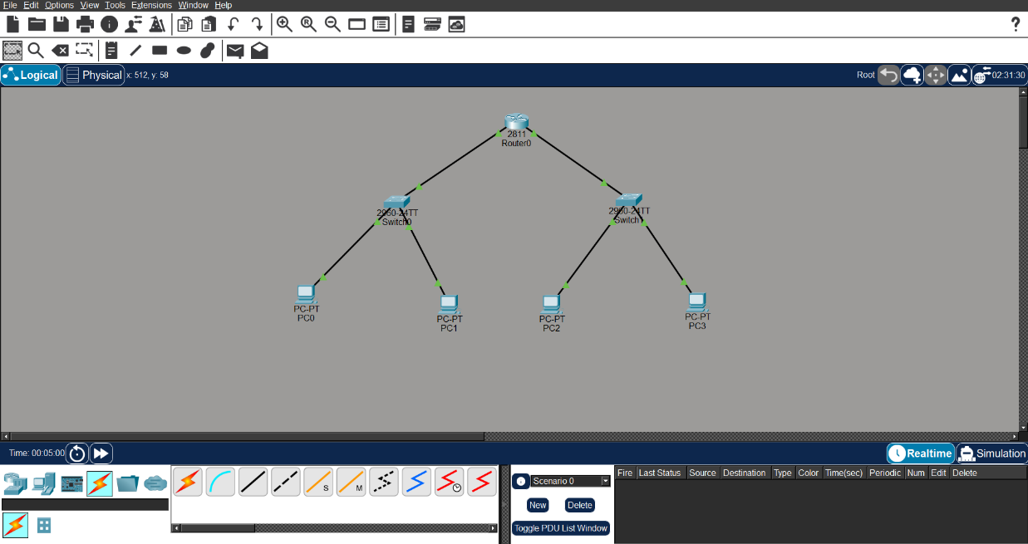
EXPERIMENT 6

IP CONFIGURATION & SUBNETTING
Theory
IP addressing uniquely identifies devices in a network. Subnetting divides a large
network into smaller subnetworks. It improves performance and security. Each subnet
has its own range. It reduces congestion and improves management.
Steps

1.
Add router, switches, and PCs.

2.
Divide network:

a.
Subnet1 → 192.168.1.0/25

b.
Subnet2 → 192.168.1.128/25

3.
Assign IPs accordingly.

4.
Configure router interfaces.

5.
Set the gateways.

6.
Test connectivity.

Result

Subnetted network works correctly. Subnetting improves efficiency and organization.

13

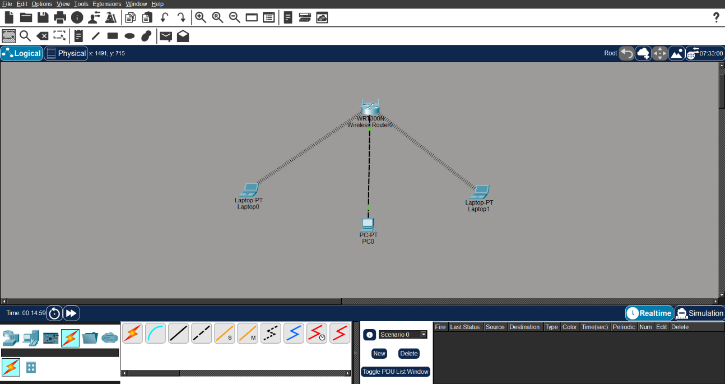
EXPERIMENT 7

WIRELESS NETWORK
Theory
Wireless networks connect devices without cables using radio signals. A wireless router
provides connectivity through SSID. Devices like laptops connect using Wi-Fi. It
provides flexibility and mobility. It is widely used in homes and offices.
Steps

1.
Add wireless router and laptops.

2.
Configure SSID and password.

3.
Connect laptops wirelessly.

4.
Assign IPs:

a.
Router → 192.168.0.1

b.
Laptop0 → 192.168.0.2

c.
Laptop1 → 192.168.0.3

5.
Test connectivity.

Result
Wireless communication is established. Wireless networks provide flexibility and ease of

use.

14

EXPERIMENT 8

CAPSTONE PROJECT - CCTV NETWORK SURVEILLANCE FOR CAMPUS

Theory
A CCTV (Closed-Circuit Television) Network Surveillance System is designed to monitor and secure a campus building using IP-based cameras connected over a structured network. Unlike traditional analog CCTV which uses coaxial cables and a DVR, modern IP-based surveillance uses standard Ethernet infrastructure, allowing for centralized recording, remote monitoring, and easy scalability. In this project, a three-floor campus building is equipped with multiple IP cameras on each floor, connected through floor-level switches that aggregate at a central core switch. A Network Video Recorder (NVR) server stores the footage, and a monitoring PC at the security desk allows live viewing of feeds. The router acts as the default gateway. Concepts like IP addressing, hierarchical (star-tree) topology, switching, and HTTP services are implemented to simulate a real-world campus surveillance system.

Steps
- Open Cisco Packet Tracer and create a new project file.
- Add devices: a. 1 Router (2811) b. 1 Core Switch (2960) c. 3 Floor Switches (2960) d. 9 IP Cameras (3 per floor) e. 1 NVR Server f. 1 Monitoring PC
- Connect devices using cables: a. Straight-through → Router to Core Switch b. Straight-through → Core Switch to Floor Switches c. Straight-through → Cameras, NVR, and Monitor PC to their switches
- Configure IP addressing for the surveillance subnet 192.168.10.0/24: a. Router (Gig0/0) → 192.168.10.1 b. NVR Server → 192.168.10.10 c. Monitor PC → 192.168.10.20 d. Floor 1 Cameras → 192.168.10.101 to 192.168.10.103 e. Floor 2 Cameras → 192.168.10.111 to 192.168.10.113 f. Floor 3 Cameras → 192.168.10.121 to 192.168.10.123 g. Subnet Mask: 255.255.255.0 h. Default Gateway (all devices): 192.168.10.1
- Configure the router's GigabitEthernet0/0 interface using CLI commands.
- Enable the HTTP service on the NVR Server to simulate the video feed portal.
- Test the network: a. Ping from Monitor PC to Router (192.168.10.1) b. Ping from Monitor PC to NVR Server (192.168.10.10) c. Ping from Monitor PC to cameras on each floor d. Open web browser on Monitor PC and visit http://192.168.10.10
15

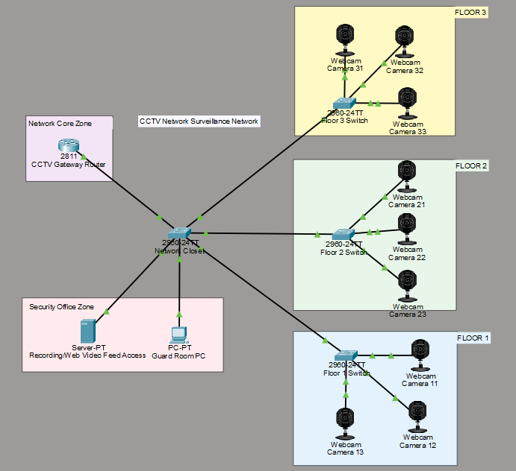

Devices Used
- 1 Router (Cisco 2811)
- 1 Core Switch (Cisco 2960)
- 3 Floor Switches (Cisco 2960)
- 9 IP Cameras
- 1 NVR Server (Server-PT)
- 1 Monitoring PC (PC-PT)

Protocols Used
- IP (Internet Protocol)
- TCP/UDP
- ICMP (for ping testing)
- ARP (Address Resolution Protocol)
- HTTP (for NVR web portal access)
16

Features Implemented
- Hierarchical Star-Tree Topology
- Static IP Addressing across all devices
- Central NVR Server with HTTP Service
- Multi-floor Camera Distribution
- End-to-End Connectivity Verification using Ping
- Web-based NVR Access from Monitoring Workstation

Result
The CCTV Network Surveillance System for the campus building was successfully implemented, demonstrating real-world IP-based surveillance networking concepts including hierarchical topology, static IP addressing, switching, and centralized video recording with HTTP-based monitoring access.
17

