NORMAIN – DATA PROCESSING AGREEMENT
- Scope of the agreement
When fulfilling the obligations under the agreement entered into between by Normain AB, reg. no 559464-9526 (“Normain”) and its customer (“Customer”) regarding Normain’s provision of The Platform and other services, it is possible that Normain processes Personal Data on behalf of the Customer. As a consequence thereof, the Parties are entering into this Data Processing Agreement (“DPA”) to govern the conditions for the Normain’s Processing of, and access to, Personal Data to which the Customer is a Controller. This DPA shall by reference apply to all agreements executed between the Parties in which Normain is the Processor of the Customer, and the DPA shall remain in force for as long as Normain Processes Personal Data on behalf of the Customer.
- Definitions
Unless the circumstances clearly indicate otherwise, definitions or terms used in this DPA shall be defined as set forth below and any term which is used in the General Data Protection Regulation and which is not stated below shall be defined as follows from Article 4 of the General Data Protection Regulation.
“Other Regulation” | means national laws, regulations, provisions, and judicial decisions, as well as decisions, guidelines, and general guidance from relevant agencies (including the Article 29 Group/European Data Protection Board) which, from time to time, apply to Processing of Personal Data (excluding the General Data Protection Regulation);
“Processing” | means an operation or set of operations which is performed on Personal Data or on sets of Personal Data, whether or not by automated means, such as collection, recording, organisation, structuring, storage, adaptation or alteration, retrieval, consultation, use, disclosure by transmission, dissemination or otherwise making available, alignment or combination, restriction, erasure, or destruction;
“General Data Protection Regulation” | means Regulation (EU) 2016/679 of the European Parliament and of the Council of 27 April 2016 on the protection of natural persons with regard to the Processing of Personal Data and on the free movement of such data (General Data Protection Regulation);
“Instruction” | means the instructions which the Customer gives to Normain from time to time within the scope of this DPA;
“Personal Data” | means any information relating to an identified or identifiable natural person, whereupon an identifiable natural person is a person who can be identified, directly or indirectly, in particular by reference to an identifier such as a name, an identification number, location data or online identifiers, or one or more factors specific to the physical, physiological, genetic, mental, economic, cultural, or social identity of that natural person;
“Controller” | means a natural or legal person, public authority, institution, or other body which, alone or jointly with others, determines the purposes and means of the Processing of Personal Data; where the purposes and means of such Processing are determined by Union law or Member State law, the Controller or the specific criteria for its nomination may be provided for by Union law or Member State law;
“Processor” | means a natural or legal person, public authority, institution, or other body which processes Personal Data on behalf of the Controller;
“Personal Data Breach” | means a breach of security leading to the accidental or unlawful destruction, loss, alteration, unauthorised disclosure of, or access to, Personal Data transmitted, stored, or otherwise Processed; and
“Data Subject” | means the living natural person who is alive and whose Personal Data is Processed.
- Generally regarding the processing of personal data
  - The Customer is the Controller of the Personal Data which is Processed within the scope of the services provided by Normain.
  - Normain is regarded as the Processor on behalf of Customer. In its capacity as Processor, Normain shall be responsible for carrying out all Processing of Personal Data on the Customer’s behalf in accordance with the DPA, the General Data Protection Regulation, any Other Regulation, and the Instruction.
  - Normain warrants that it shall take suitable technical and organizational measures to ensure that the Processing of Personal Data under this DPA meets the requirements of the General Data Protection Regulation and any Other Regulation and ensures protection of the Data Subject.
  - Normain undertakes to Process the Personal Data only as is necessary to attain the purpose of each Processing. This undertaking relates, for example, to the quantity of Personal Data, the scope of the Processing, the duration of the Processing of the Personal Data, and its accessibility.
  - Taking into consideration the nature of the Processing, Normain shall assist the Customer by taking suitable technical and organizational measures, to the extent possible, to enable the Customer to perform its obligation to respond to requests regarding the exercise of the Data Subject’s rights in accordance with Chapter III of the General Data Protection Regulation.
  - Normain shall without undue delay inform the Customer if Normain cannot perform its obligations under this DPA.
  - The Processing by the Processor occurs in the below stated manner and scope and for the below purposes. Further, the types of Personal Data and categories of Data Subjects are also set forth below. The duration of the processing is the period during which Normain provides services to the Customer.
Purpose and scope of the Processing | Provision of Normain’s services to the Customer and the fulfillment of Normain’s obligations under the agreement governing such provision.
Types of Personal Data | Any data provided by the Customer into Normain’s service(s).
Categories of Data Subjects | Data Subjects included in the data provided by the Customer into Normain’s service(s).
- Normain’s personnel etc.
  - Normain, its employees, and other persons who perform work under Normain’s supervision and who gain access to Personal Data belonging to the Customer may only process such Personal Data in accordance with the Instructions, unless such person is obligated to do so pursuant to Union law or Swedish national law.
  - Normain shall ensure that its employees and all other persons for whom Normain is liable and who are authorized to process Personal Data covered by this DPA adheres to a confidentiality undertaking (unless such person is subject to a relevant and suitable statutory confidentiality obligation).
- Security
  - Normain shall take all necessary safeguards in conjunction with the Processing as are required under the General Data Protection Regulation (and particularly Article 32), any Other Regulation, and this DPA.
  - Taking into consideration the type of Processing and the information which Normain has, Normain shall assist the Customer in ensuring that the obligations regarding security can be satisfied in a manner which follows from Article 32 of the General Data Protection Regulation.
  - In conjunction with the assessment of an appropriate security level, particular consideration shall be given to the risks which follow from the Processing, particularly resulting from unintentional or unlawful destruction, loss, or modification, from unauthorised disclosure, or from unauthorised access to the Personal Data which is transferred, stored, or otherwise processed.
- Personal Data breach
  - Taking into consideration the type of Processing and the information available to Normain, Normain shall assist the Customer in ensuring that the obligations arising due to any Personal Data Breach can be fulfilled in a manner as required in Articles 33-34 of the General Data Protection Regulation.
  - Normain shall notify the Customer without undue delay after Normain has learned of a Personal Data Breach. The notification shall contain the following:
- a description of the nature of the Personal Data Breach, the categories and approximate number of affected Data Subjects, and the categories and approximate numbers of affected personal data records;
- a description of the likely consequences of the Personal Data Breach.
  - Normain undertakes to document all Personal Data Breaches, including the circumstances surrounding the Personal Data Breach, its effects, and any corrective measures Normain is aware have been taken. Upon request, the documentation shall be provided to the Customer as soon as possible.
- Impact assessment and prior consultation
Taking into consideration the nature of the Processing and the information, which is available to Normain, Normain shall assist the Customer in fulfilling its obligations, if any, to conduct an impact assessment and/or prior consultation with a supervisory authority pursuant to Articles 35 and 36 of the General Data Protection Regulation.
- The Instruction
Normain may only process the Personal Data which is covered under this DPA in accordance with the instructions of the Customer (including in respect of transfers of Personal Data to a third country or an international organization, provided such Processing is not required pursuant to EU law or the national law of a Member State to which the Normain is subject and, in such case, Normain shall inform the Customer of the legal requirement before the data is Processed, unless such information is prohibited with reference to an important public interest under relevant national law). The Customer’s instructions are in principle conclusively stipulated and documented in this DPA. Any separate instructions deviating from what is stated in this DPA or which impose additional requirements requires Normain’s consent. on the documented Instructions.
- Subprocessors
  - The list of subprocessors engaged by Normain at the date of the DPA is attached to this DPA (Appendix A). Normain shall not use subprocessors, other than subprocessors (i) identified in this DPA or (ii) otherwise deemed approved in accordance with the below, for the processing of personal data under this DPA, without the prior written authorisation of the Customer. A notification of such changes will be sent at least thirty days before the change comes into effect. The Customer may only object to such change for important reasons and in the event no objection is raised within fourteen days after the receipt of the notification, the Customer’s right to object lapse. If the Customer objects to the change, Normain is entitled to terminate the agreement regarding provision of services to the Customer with a notice period of three months. Normain shall ensure that any subprocessors enter into a written data processing agreement before the subprocessor begins work related to the Customer. Where Normain engages a subprocessor for carrying out specific processing activities on behalf of the data controller, the same data protection obligations as set out in the DPA shall be imposed on such subprocessor by way of contract or other legal act under EU or Member State law, in particular providing sufficient guarantees to implement appropriate technical and organizational measures in such a manner that the processing will meet the requirements of the DPA and the GDPR. Normain shall therefore be responsible for requiring that the subprocessor at least complies with the obligations to which the data processor is subject pursuant to the DPA and the GDPR.
  - Normain shall, from time to time, maintain an updated list of the subprocessors who may be retained, and have been retained. At the Customer’s request, Normain shall submit a copy of the list to the Customer.
  - Any transfer of personal data to third countries or international organizations by Normain shall only occur on the basis of documented instructions from the Customer and shall always take place in compliance with Chapter V GDPR and while ensuring an equivalent level of protection of the personal data under this DPA as granted within the EU/EEA through the GDPR. If not otherwise agreed, the parties agree that for any transfer of personal data to countries outside of the EU member states / the EEA (where such country does not have an adequate level of data protection as deemed by the European Commission or such other supervisory authority from time to time), Normain agrees to process personal data in compliance with the European Commission approved controller to processor Standard Contractual Clauses ("Model Clauses"), including adherent appendices, applicable at the effective date. The Model Clauses are hereby incorporated into this DPA by reference. For these purposes, Normain agrees that it is a "data importer" and the Customer and/or its affiliates, as applicable, is/are the "data exporter" under the Model Clauses. For the purposes of the Model Clauses, section 3.6 A1-5 of this DPA shall serve as Annex I, Appendix A shall serve as Annex III and Section 5 shall serve as Annex II. If after the effective date, the European Commission issues new Model Clauses for controller-to-processor contracts that replace the Model Clauses, the parties agree to replace the Model Clauses effective at the effective date with the new Model Clauses. The terms of the new Model Clauses shall apply to the personal data processed under this DPA from the effective date of the new Model Clauses and thereafter. Such action will not invalidate or render this DPA unenforceable. For the avoidance of doubt, and if agreed between the parties, data transfers to the United States of America, may be transferred on the basis of the EU-US Data Privacy Framework, provided that the data importer holds a valid and current certificate under said framework. In case transfers to third countries or international organizations, which Normain has not been instructed to perform by the Customer, is required under EU or Member State law to which the data processor is subject, Normain shall inform the Customer of such legal requirement prior to processing, unless prohibited by law on important grounds of public interest.
- Request for information
  - In cases where a Data Subject or other third party requests information from Normain in respect of Processing of Personal Data which belongs to the Customer, Normain shall refer such Data Subject or third party to the Customers.
  - In cases other than those which follow from clause 10.1, Normain may only disclose information to a third party where Normain has obtained an instruction to do so from the Customer or such obligation is stipulated in an agreement or mandatory provision of law.
- Right to transparency
Normain shall grant the Customer access to information which is required and necessary to enable the Customer to verify compliance with the obligations which follow from this DPA, the General Data Protection Regulation (particularly Article 28 of such Regulation), and any Other Regulation. Normain shall also enable and assist in audits, including inspections, which are conducted by the Customer or by a third party authorized by the Customer, however that such audits shall be notified at least 14 days in advance and carried out on Normain’s normal office hours and without interfering with Normain’s regular operations.
- Liability
  - Normain’s liability under this DPA is governed also by any disclaimers and/or limitations of liability set forth in the agreement(s) regarding provision of services entered into between Normain and the Customer.
  - The Customer shall indemnify and hold harmless Normain for any third party claims (including fines) to the extent corresponding to the Customer’s part of the responsibility for the infringement such claim is based upon.
- Termination of the DPA
  - When the Normain discontinues Processing Personal Data on behalf of the Customer, Normain shall return all Personal Data to the Customer in the manner instructed by the Customer or, upon the Customer’s written notification, destroy and erase all Personal Data which is associated with the DPA. This DPA shall remain in force notwithstanding the termination of another agreement between the Parties until such time as Normain and any subprocessors retained by Normain discontinue Processing Personal Data on behalf of the Customer.
  - Following termination of the DPA, Normain shall not be entitled to save any Personal Data belonging to the Customer, except as required by law.
- Assignment
Neither Party shall be entitled to assign its rights and/or obligations under the DPA, in whole or in part, without the prior written consent of the other Party.
- Governing law and dispute resolution
  - This DPA shall be governed and interpreted in accordance with Swedish law (however not including conflict of law provisions).
  - Any dispute, controversy or claim arising out of or in connection with this contract, or the breach, termination or invalidity thereof, shall be finally settled by arbitration administered by the Arbitration Institute of the Stockholm Chamber of Commerce (the “SCC”).
  - The Rules for Expedited Arbitrations shall apply, unless the SCC in its discretion determines, taking into account the complexity of the case, the amount in dispute and other circumstances, that the Arbitration Rules shall apply. In the latter case, the SCC shall also decide whether the Arbitral Tribunal shall be composed of one or three arbitrators. The seat of arbitration shall be Stockholm, Sweden. The language to be used in the arbitral proceedings shall be Swedish, unless the Parties agree that it shall be English.
  - All arbitral proceedings conducted with reference to this arbitration clause will be kept strictly confidential. The confidentiality provision includes all information which emerges during the proceedings as well as any decisions or arbitration award of the Arbitral Tribunal. Any information covered by this confidentiality provision may not be disclosed to any third party without the other Party’s prior consent. This confidentiality provision shall however not prevent a Party from disclosing information as required by compulsory law, a decision of a court or authority, in order to safeguard in the best possible way its rights vis-à-vis the other Party in connection with the dispute, or in order to enforce, appeal or challenge a decision or arbitration award.
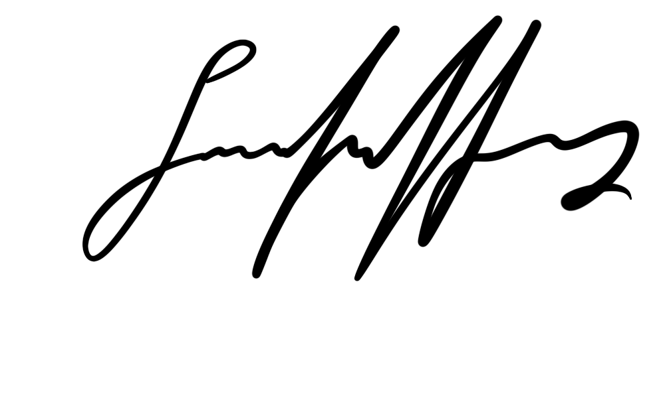
Sara Landfors
CEO, Normain AB

Appendix A - List of subprocessors
Available here.

