Microsoft Corporation

Azure Commercial FedRAMP

Penetration Test Report
Prepared by:
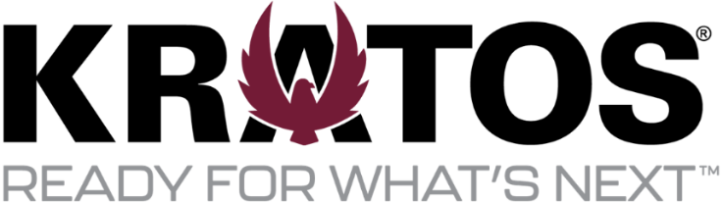

Kratos Technology & Training Solutions, Inc.
10680 Treena Street, Suite 600
San Diego, CA 92131
888.677.9351

Executive Summary

Background
Microsoft Corporation retained Kratos Technology & Training Solutions, Inc. (“Kratos”) to perform a penetration test of Azure Commercial FedRAMP. This test is a representation of the security posture as of the end date of testing, prior to any mitigation. This report provides the results of the activities performed and serves as a permanent record of testing activities. The testing effort was performed between 02/12/2025 and 04/21/2025. The testing included automated and manual activities using the penetration testing guidance found in the Kratos Penetration Testing Methodology and any Augmenting Framework guidance detailed in section 1.2 of this document.

Findings
There were (0) high, (2) moderate, and (3) low findings identified during testing. The findings by impact level chart summarizes the findings by impact level. This table does not reflect any findings corrected during testing or risk reductions. Detailed information about all findings is included in “Appendix A – Findings”.

Document Revision History
Date | Pages | Description | Author
6/10/2025 | All | Draft Deliverable | Kratos
6/13/2025 | All | Quality Assurance | Kratos
8/11/2025 | All | Final Deliverable | Kratos

Table of Contents
Executive Summary 2
Background 2
Findings 2
Document Revision History 3
Table of Contents 4
Table of Figures 6
Table of Tables 7
1. Overview 8
1.1. Timeline 8
1.2. Scope 8
1.3. Restrictions and Alterations 8
1.4. Attack Vectors 8
2. Open-Source Intelligence Gathering 10
2.1. Overview 10
2.2. Testing Narrative 10
3. Web applications 11
3.1. Overview 11
3.2. Testing Narrative 12
3.2.1. Account Roles 12
3.2.2. Authentication and Session Management 12
3.2.3. Authorization 13
3.2.4. Application Logic 13
3.2.5. Input Validation 13
3.2.6. Tenant to Tenant 14
4. External Network 15
4.1. Overview 15
4.2. Testing Narrative 15
5. Social Engineering 17
5.1. Overview 17
5.2. Testing Narrative 17
6. Physical 18
6.1. Overview 18
6.2. Testing Narrative 20
7. Findings 21
7.1. Overview 21
7.2. Severity 21
7.3. Findings Updates 21
7.4. PF-01 SSL Medium Strength Cipher Suites Supported (SWEET32) 22
7.5. PF-02 Legacy TLS Versions Detected 23
7.6. PF-03 Disable Azure Monitoring Agent 25
7.7. PF-04 Misconfigured TLS Certificate 27
7.8. PF-05 Phishing Click Rate Low 28
Appendix A- Findings Table 29
Appendix B – Evidence 30

Table of Figures
Figure 3-1: Session Token Creation 13
Figure 3-2: Example of Input Validation 14
Figure 3-3: Azure Subscriptions 14
Figure 3-4: Example of Cross-Tenant Testing 14
Figure 4-1: External Aggressive Service Enumeration 16
Figure 5-1: Phishing Click Rate 17
Figure 7-1: PF-01 Medium Strength Cipher 22
Figure 7-2: PF-02 TLS 1.1 Enabled 24
Figure 7-3: PF-03 MonAgentCore Process Stopped 25
Figure 7-4: PF-03 Azure Monitor Dashboard Disabled 25
Figure 7-5: PF-04 Misconfigured TLS Certificate 27
Figure 7-6: PF-04 Phishing Results 28

Table of Tables
Table 1-1: Attack Vectors 9
Table 2-1: OSINT Queries 10
Table 3-1: In-scope Applications 12
Table 3-2: Account Roles 12
Table 4-1: External Enumeration Scans 15
Table 6-1: In-scope Data Centers 20
Table 7-1: CVSS Rating Specification 21

Overview
Microsoft Corporation, hereafter referred to as “customer”, retained Kratos Technology & Training Solutions, Inc. (“Kratos”), an accredited FedRAMP independent 3PAO, to perform penetration testing of Azure Commercial DoD IL5, hereafter referred to as “service offering”, using penetration testing guidance outlined in the Rules of Engagement (RoE). Kratos conducted a proactive and authorized test to validate security controls implemented. The primary goals for the test include:
- Gaining access to sensitive information
- Circumventing access controls and privilege escalation
- Exploiting vulnerabilities to gain access to systems or information
- Confirming remediated items are no longer a risk
During the test, Kratos attempted to identify exploitable security weaknesses of the service offering such as cloud service and/or application flaws, improper configurations, employees’ security awareness, and the organization’s ability to identify and respond to security incidents. Testing was conducted using both automated and manual testing activities. Findings were validated, documented, and given an appropriate impact rating which can be found in Section 7 and “Appendix A – Findings Table”.

Timeline
The testing was performed between 02/12/2025 and 4/21/2025.

Scope
The scope for testing included the agreed-upon attack vectors detailed and authorized in the signed and approved RoE. Additional detail can be found in the signed and approved Rules of Engagement (RoE) attached as evidence EV-01 in “Appendix B – Evidence”.

Restrictions and Alterations
During the engagement, Kratos did not perform any tests that would knowingly result in a denial of service (DoS) to operations, networks, servers, or telephone systems.

Attack Vectors
Based on threat modeling, FedRAMP has defined Six (6) attack vectors in addition to a physical penetration test. The attack vectors are potential avenues of compromise that signal a degradation of system integrity, confidentiality, or availability. For the service offering test, Kratos mapped each FedRAMP attack vector to specific tests and results as shown in Table 1-1.
Attack Vector | Description of Testing and Results
External to Corporate:  External Untrusted to Internal Untrusted | Consisted of an unannounced spear phishing exercise targeted at the CSP Service system administrators. The Spear Phishing campaign was launched on 4/15/2025 and ended on 4/21/2025. 100% of identified administrators were targeted during the phishing campaign. 16.9% of targeted administrators clicked the phish.  Resulted in PF-05
External to Target System:  External Untrusted to External Trusted | Simulated Internet-based attacks by an external un-credentialed entity attempting to gain unauthorized access to the CSP Service web applications and the underlying API, and the CSP Service network infrastructure, as configured in a production environment.  Resulted in no findings.
Target System to CSP Management System:  External Trusted to Internal Trusted | Simulated an external attack as a credentialed system user attempting to access the CSP management system or infrastructure.  Resulted in PF-01(Moderate), PF-02(Moderate), PF-03(Low), PF-04(Low)
Tenant to Tenant:  External Trusted to External Trusted | Simulated an external attack as a credentialed system user, originating from a tenant environment instance, attempting to access or compromise a secondary tenant instance within the target system.  Resulted in no findings
Corporate to CSP Management System:  Internal Untrusted to Internal Trusted | Simulated an internal attack attempting to access the target management system from a system with an identified or simulated security weakness on the CSP corporate network that mimics a malicious device.  Resulted in no findings
Mobile Application:  External Untrusted to External Trusted | Kratos, in collaboration with the CSP, has determined that the Mobile Application Penetration Testing vector is not included in scope. Per the SSP, the CSP service does not offer mobile services.
Physical Penetration Testing:  Control Assessment | Conducted an announced (escorted) visit at the in-scope data center(s) to verify security controls in place (perimeter, internal, doors, alarms, guards, CCTV, etc.).
Table 1-1: Attack Vectors

Open-Source Intelligence Gathering

Overview
Open-Source Intelligence (OSINT) testing attempted to identify publicly available information about the target service offering, customer, or customer employees which could be used by an attacker. OSINT varies depending on the type of information being gathered but can include resources such as:
- Search Engines
- Social Media
- Public Repositories
- Exploit Databases
- Public Data breaches
During OSINT testing, testers do not directly interact with the target system.

Testing Narrative
Internet searches were performed to leverage useful insights for formulating attacks against the target. Targeted information included but was not limited to documentation, cached pages, and vulnerability information. Activities performed during this testing included:
- Targeted searches of popular search engines
- Targeted searches of internet archive projects
- Targeted searches of publicly available vulnerability information
- Targeted queries of public resources for information
Information identified are results of queries from publicly available databases which in some cases may be outdated or inaccurate. These types of anomalies can be expected when conducting this testing. Results of OSINT testing have been populated into Table 2-1 and relevant evidence files are included in “Appendix B – Evidence”.
Source | Query | Result
WHOIS | Domains and IP | No findings
Google Dorking | System Name | No findings
Spiderfoot | Domains and Ips | No findings
Subfinder | Domains and Ips | No findings
Table 2-1: OSINT Queries

Web applications

Overview
Web application testing emulated a malicious external actor attempting to gain access to the target web application(s) over the internet. Testing also examined publicly available Application Programming Interfaces (APIs). Specifically, the following test cases are covered at a minimum:
- A simulated Internet attack by an external un-credentialed entity (e.g., public) against the target(s)
- A simulated Internet attack by an external credentialed entity (e.g., customer) against the target(s) management infrastructure
- A simulated Internet attack by an external credentialed entity (e.g., customer #1) on a primary tenant against a secondary tenant (e.g., customer #2)
Web application testing was conducted against all endpoints included in Table 3-1. Any deviation in testing between endpoints is documented in the narratives below.
Application Title | Type | Endpoint/URL
Developer Hub | Web Application | N/A
Azure Monitor | Web Application | N/A
Background Services | Web Application | N/A
Power Platform Authorization Service | Web Application | N/A
D365 Finance - Nexus - Core Services | Web Application | N/A
Dynamics 365 Office Apps | Web Application | N/A
Dynamics 365 Sales Insights CoPilot | Web Application | N/A
M365D DS Platform | Web Application | N/A
Defender for App Service | Web Application | N/A
Defender for Azure Cosmos DB | Web Application | N/A
Microsoft Defender for AI | Web Application | N/A
Power Platform Copilot Governance | Web Application | N/A
BAP GIA Survey - Backend | Web Application | N/A
Desktop Flows AI Service | Web Application | N/A
Health Insights | Web Application | N/A
Health Data AI Control Plane | Web Application | N/A
AEP AI Copilot | Web Application | N/A
ASZ-Arc Managed VMs | Web Application | N/A
Copilot DevOps | Web Application | N/A
Azure AI Agents | Web Application | N/A
Copilot Telemetry | Web Application | N/A
Defender Hawkeye | Web Application | N/A
Geneva Accounts for MDE Client | Web Application | N/A
Fabric Job Service | Web Application | N/A
GraphQL - Fabric Product | Web Application | N/A
Microsoft Purview - Privacy | Web Application | N/A
Purview Data Access | Web Application | N/A
AI Foundry Portal | Web Application | N/A
Defender for Servers | Web Application | N/A
Conditional Access UX | Web Application | N/A
SQL Connectivity | Web Application | N/A
SQL Control Plane | Web Application | N/A
SQL Security | Web Application | N/A
Azure Search | Web Application | N/A
CRM Activity Logging | Web Application | N/A
Dynamics 365 - Data Sync Framework | Web Application | N/A
Microsoft Defender for Cloud | Web Application | N/A
Microsoft Defender for Cloud Apps | Web Application | N/A
AAD First Party Apps | Web Application | N/A
AAD Identity Governance Insights | Web Application | N/A
AAD Multi-Tenant Collaboration | Web Application | N/A
Azure Cosmos DB | Web Application | N/A
Enterprise App Management | Web Application | N/A
Identity LiveSite Manager | Web Application | N/A
PMI Federation | Web Application | N/A
API Management | Web Application | N/A
Azure OpenAI Service | Web Application | N/A
Copilot Studio - Runtime | Web Application | N/A
Dataverse API | Web Application | N/A
Power Automate Portal | Web Application | N/A
Cognitive Service Form Recognizer | Web Application | N/A
Cognitive Services | Web Application | N/A
Cognitive Services Face API | Web Application | N/A
Table 3-1: In-scope Applications

Testing Narrative

Account Roles
Table 3-2 identifies the account roles and associated applications used during testing.
Application Title | Account Name | Account Role
Azure Portal | v-liebermanb@microsoft.com  v-joshallen@microsoft.com | Administrator
Azure Portal | v-liebermanb@microsoft.com  v-joshallen@microsoft.com | User
Table 3-2: Account Roles

Authentication and Session Management
Testers reviewed the authentication and session management of the in-scope applications. The authentication workflow requires the submission of a valid username and password combination which, upon successful submission, returns a session token tracked in as an OAuth 2.0 workflow, which outputs a token using the authorization bearer schema. Testers examined the instantiation of the session token to confirm that appropriate options are configured upon creation. The session token creation process is captured in Figure 3-1.
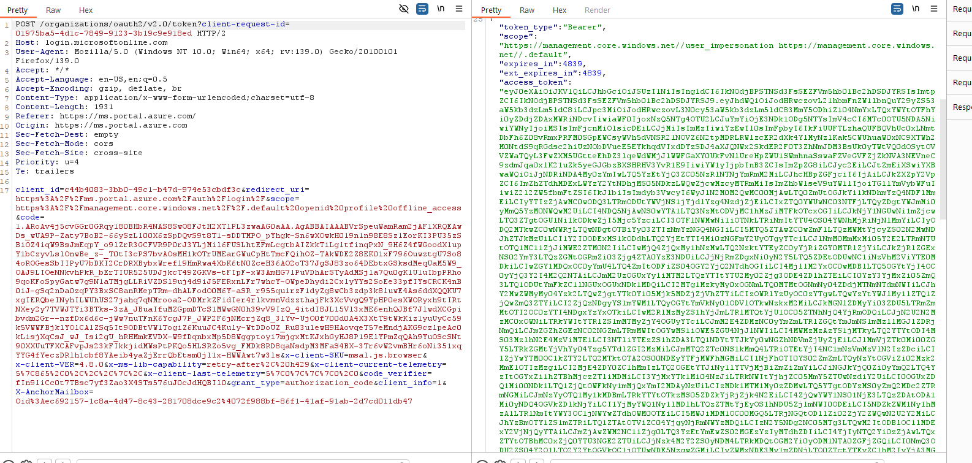
Figure 3-1: Session Token Creation

Authorization
Testers examined the roles within the in-scope applications to determine if application privileges are properly enforced. Testers leveraged the various levels of privilege to submit requests that should, and should not, be allowed and validated the application carried out these actions as expected.

Application Logic
Testers reviewed the in-scope applications’ logic patterns and error handling. These tests attempted to identify any flaws which bypass integrity controls or negatively impact the application. Testers examined these controls at various points throughout the application to ensure consistency in the applications’ response to these payloads. Additionally, application dependencies and referenced libraries, such as JavaScript, were reviewed for any known vulnerabilities that expose the application to additional risk.

Input Validation
Testers used targeted manual and automated injection attacks against the in-scope applications. Testers selected key user input locations within the application to identify any flaws or vulnerabilities in input validation or data reflection. These injection attempts are executed to identify multiple vulnerabilities including but not limited to:
- Cross Site Scripting (Stored, Reflected, DOM)
- Injection Vulnerabilities (SQL, PHP, OS, LDAP, NoSQL, etc.)
- Buffer Overflows
- Poor Error Handling
- Directory Traversal
- XML External Entities
Figure 3-2 demonstrates a sample of injection attacks used against the application.
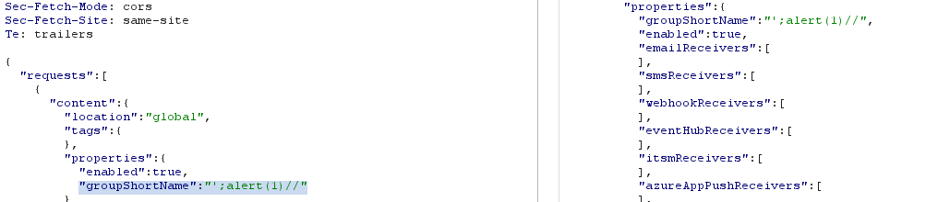
Figure 3-2: Example of Input Validation

Tenant to Tenant
Testers were provided to access two customer subscriptions. These subscriptions were used to ensure separation of customer assets, application flows, and data. Subscriptions are shown in Figure 3-3.
Figure 3-3: Azure Subscriptions
Information in the service offering is segmented at the subscription ID level. A subscription ID is linked to assets such as virtual machines, networks, databases, resource groups, and other services offered by the product. A customer account may have access to multiple subscriptions however each subscription contains the collection of unique resources. Resources are not able to be shared across subscriptions. An example of attempting to access resources across subscriptions is shown in Figure 3-4.

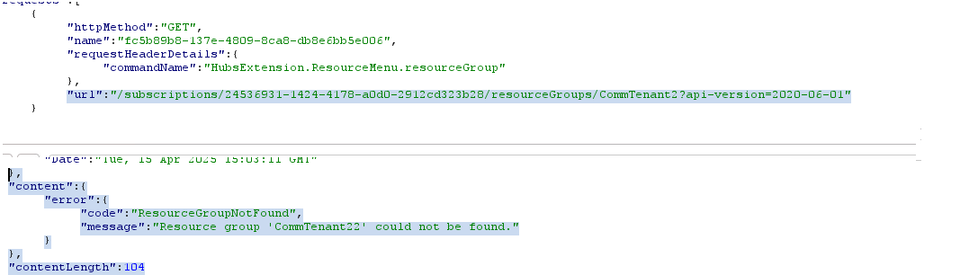
Figure 3-4: Example of Cross-Tenant Testing

External Network

Overview
Network testing emulated a malicious external actor attempting to access the internet accessible components of a service offering. This testing examined the external security posture and focused on ways to gain unauthorized access to the underlying infrastructure. Specifically, testing simulated an uncredentialed external attacker against the external security posture of an offering as configured in the production environment. Activities conducted during network testing include:
- Network discovery
- Network exploitation
- Network post-exploitation (when applicable)
Successful exploitation of the service offering was leveraged to identify additional access paths and sensitive data exposure. This activity allowed testers to assess the overall risk of a vulnerability to the target system.

Testing Narrative
Testers began network testing by using enumeration techniques to identify publicly available hosts and protocols offered by the service offering. Initially, a standard ping sweep was initiated to in-scope networks and hosts followed by a more intrusive service scan. A service ping was used to bypass any ICMP filters that may be present. The objective of this enumeration was to identify hosts with services available behind network-based protections.
Service enumeration was leveraged to identify software versions listening on previously identified hosts and ports. This process probed the remote infrastructure on both TCP and UDP protocols and attempted to fingerprint services available.
Results of enumeration efforts have been compiled into Table 4-1 and raw scan output is included in “Appendix B – Evidence”.
Description | Tool | Result
Host Discovery and Port Scan, Vulnerability Scan | Nessus Professional | See EV-02 under Appendix B – Evidence for additional information
Host Discovery and Port Scan | Nmap | See EV-02 under Appendix B – Evidence for additional information
Table 4-1: External Enumeration Scans
Testers attempted to identify vulnerabilities by performing analysis using data obtained from the enumeration phase. This effort focused on the external, or internet accessible, infrastructure such as software, protocols, and operating systems. Testing was executed from the level of privilege of an uncredentialed external entity.
Testers, armed with this information, analyzed the risk to the service offering of any identified vulnerabilities. Testers attempted to identify any paths of exploitation along with any sensitive or overly verbose information being exposed. An uncredentialed vulnerability scan was leveraged as an additional layer of detection for known vulnerabilities in the public infrastructure. Figure 4-1 demonstrates a sample of the testing and analysis performed.
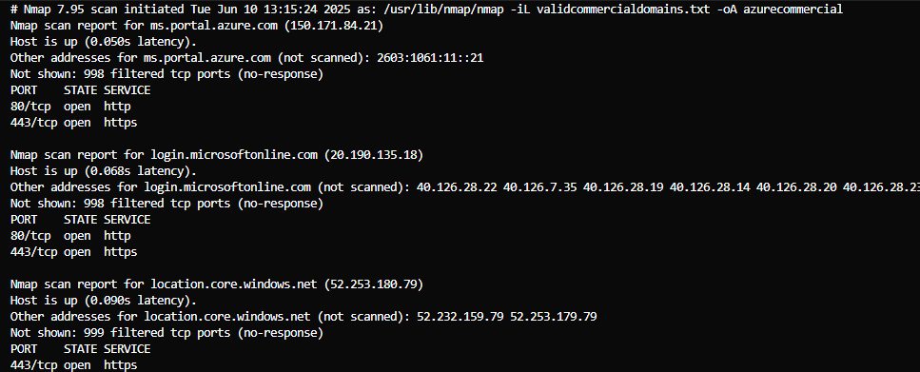
Figure 4-1: External Aggressive Service Enumeration

Social Engineering

Overview
Social Engineering testing focused on gaining access to the service offering through the corporate network owned and operated by the customer. Testing attempted to simulate an attack by an external untrusted entity (i.e., public) against designated in-scope personnel. A coordinated, but unannounced spear phishing exercise was executed against the designated personnel. Social Engineering aimed to gain insight into the possibility of exploiting weaknesses in the human factor coupled with leveraging corporate trust relationships to obtain access to the target system.
As outlined in the Rules of Engagement (RoE), personnel are not targeted specifically to disclose Personal Identifiable Information (PII), as defined by NIST Special Publication 800-122.

Testing Narrative
A spear phishing campaign was executed against targeted individuals authorized in the Rules of Engagement (RoE). This campaign was targeted at key individuals with ability to impact the service offering. Testers developed a scenario and fabricated a customized email template to support this narrative. This email was then used to target the individuals.
A phishing campaign was launched on 4/15/2025 and targeted 46,954 personnel. The campaign concluded on 4/21/2025. Statistics were collected from the campaign to gauge the user’s level of security awareness around phishing campaigns. Testers tracked the amount of interaction and engagement received from the targeted campaign as well as unique interactions decoupled from individual identities. Figure 5-1 details in chart form that of the total 100% targeted, 16.9% interacted with the malicious email and 83.1% did not.

Figure 5-1: Phishing Click Rate

Physical

Overview
Physical testing included physical security tests attempting to circumvent a datacenter’s physical security to gain unauthorized access to critical service offering assets. Physical security tests attempt to simulate an attack by an external untrusted individual, such as an untrusted employee, against each datacenter processing service offering data. The scope of physical security testing is described in the Penetration Testing RoE document attached as evidence EV-01 in “Appendix B – Evidence”.
Physical testing was conducted against all datacenters included in Table 6-1. Any deviation in testing between datacenters is documented in the narrative below.
Name | Location | Date of Test | Point of Contact
US East - AVC01 | 210 Tunstall Rd. South Hill VA 23970-3239 | 5/15/2025 | Sarah Owens ian.owens@kratosdefense.com / Sarah.Owens@kratosdefense.com
US East – AVC09 | 216 Brunswick-Mecklenburg Commerce Dr., Lacrosse, VA 23950, USA | 5/15/2025 | Sarah Owens ian.owens@kratosdefense.com / Sarah.Owens@kratosdefense.com
US East- BN49 | 101 Herbert Dr, Boydton, VA 23917 | 05/14/2025 | Sarah Owens ian.owens@kratosdefense.com / Sarah.Owens@kratosdefense.com
US East – BN80 | 101 Herbert Dr Boydton, VA 23917-3742 | 05/14/2025 | Sarah Owens ian.owens@kratosdefense.com / Sarah.Owens@kratosdefense.com
US East – CHI05 | 2200 Lakewood Boulevard, Hoffman Estates, IL 60192-3163 | 05/29/2025 | Andrew Overmyer andrew.overmyer@kratosdefense.com
US East – DSM14 | 8855 Grand Avenue, West Des Moines, IA | 04/11/2025 | William Zellers william.zellers@kratosdefense.com
US East – DSM40 | 1475 SE Maffitt Lake Rd, West Des Moines, IA, 50265-8530 | 04/10/2025 | William Zellers william.zellers@kratosdefense.com
US East – LVL09 | 829 Ridge Road, Bldg9, Boydton, United States 23917-3742 | 05/14/2025 | Sarah Owens ian.owens@kratosdefense.com / Sarah.Owens@kratosdefense.com

Table 6-1: In-scope Data Centers

Testing Narrative
Physical testing was conducted against the service offering’s in-scope data centers. This testing activity was captured as an independent report. This report has been included in “Appendix B – Evidence”.

Findings

Overview
This section is dedicated to findings identified for the service offering and any relevant validation, exploitation, and post exploitation. For each finding, testers have documented the following key pieces of information:
- Risk to the service offering
- Related Testing Narrative
- A description of the finding
- Steps to reproduce the finding and any related notes
- A recommendation for remediation of the finding
- Any additional impact from post exploitation activities

Severity
Finding severity is represented as defined in the CVSS specification. The severity to base score mapping as defined by this specification is provided for reference in Table 7-1. Included with risk severity is the corresponding CVSS string and base score.
Severity | Base Score
Low | 0.1-3.9
Moderate | 4.0-6.9
High | 7.0-10.0
Table 7-1: CVSS Rating Specification

Findings Updates
Section 7 does not incorporate any risk reduction or remediation after the initial test findings. Any updates to these findings are located in the following sections of the Security Assessment Report (SAR):
- Table 5-1 Summary of Risks Corrected During Testing
- Table 5-2 Summary of Risks with Mitigating Factors
All final security weaknesses can be found in the SAR Appendix A. Risk Exposure Table.

PF-01 SSL Medium Strength Cipher Suites Supported (SWEET32)
Related Testing Narrative: Network
Risk: Moderate, CVSS:3.0/AV:N/AC:H/PR:N/UI:N/S:U/C:H/I:N/A:N, 5.9
Description:
The remote host supports the use of SSL/TLS ciphers that offer medium strength encryption. Nessus regards medium strength as any encryption that uses key lengths at least 64 bits and less than 112 bits, or else that uses the 3DES encryption suite.
Proof of Concept:
Step 1. Manually connect to the remote service using a SSL/TLS cipher enumeration utility.
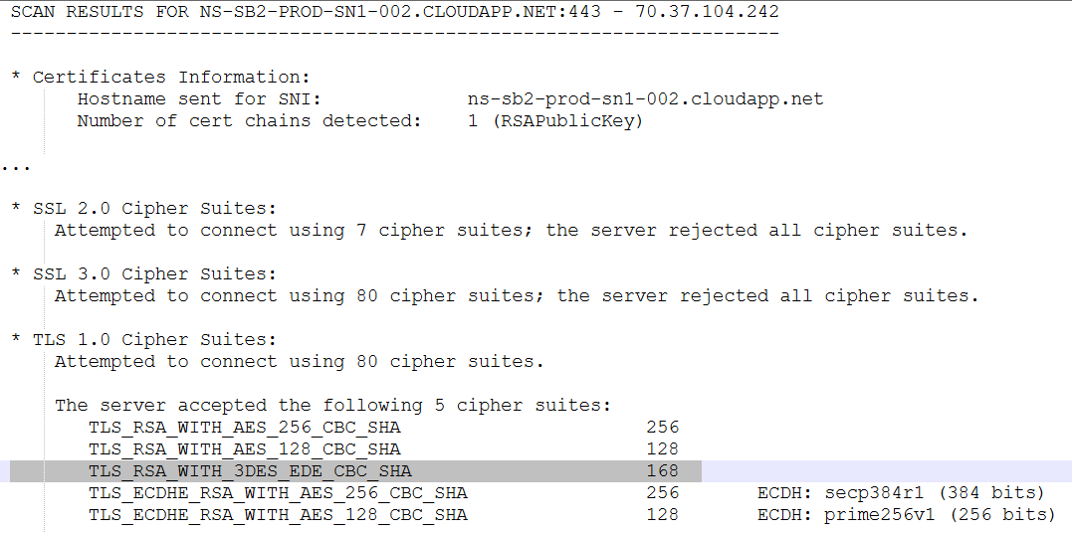
Figure 7-1: PF-01 Medium Strength Cipher
Step 2. Examine the accepted service versions and cipher suites for susceptible ciphers.
Recommendation:
Reconfigure the affected application, if possible, to avoid use of medium strength ciphers.

PF-02 Legacy TLS Versions Detected
Related Testing Narrative: Network
Risk: Moderate, CVSS:3.0/AV:N/AC:H/PR:N/UI:N/S:U/C:L/I:L/A:N, 4.8
Description:
Testers confirmed the remote server accepts communications using at least one of the following legacy protocol versions:
- TLS 1.1
- TLS 1.0
- SSL 3.0
- SSL 2.0
NIST has determined that SSL 3.0 and older is no longer acceptable for secure communications. As of the date of enforcement found in PCI DSS v3.1, any version of SSL will not meet the PCI SSC's definition of 'strong cryptography'.
TLS 1.0 has several cryptographic design flaws. Modern implementations of TLS 1.0 mitigate these problems, but newer versions of TLS like 1.2 and 1.3 are designed against these flaws and should be used whenever possible. TLS 1.1 lacks support for current and recommended cipher suites. Ciphers that support encryption before MAC computation, and authenticated encryption modes such as GCM cannot be used with TLS 1.1.
As of March 31, 2020, Endpoints that are not enabled for TLS 1.2 and higher will no longer function properly with major web browsers and major vendors.
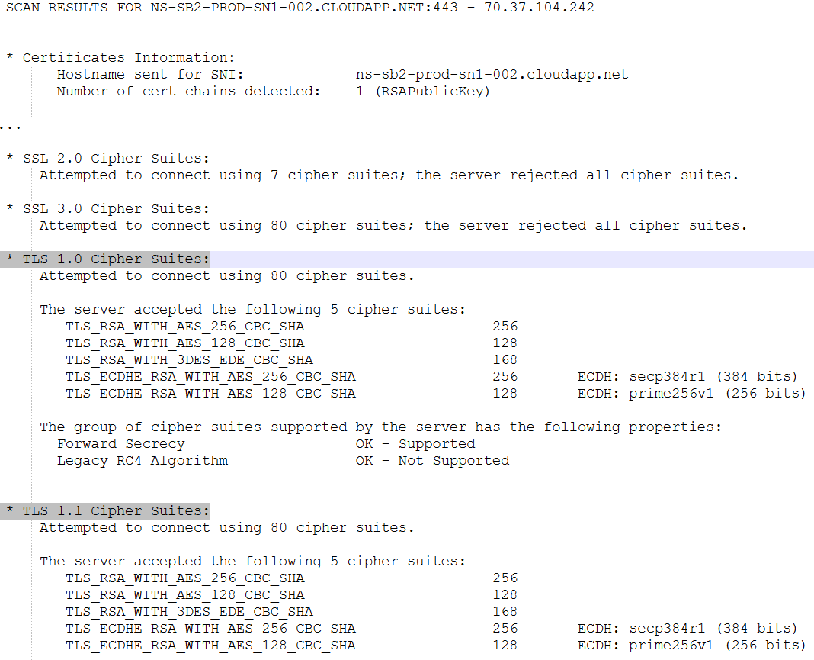
Figure 7-2: PF-02 TLS 1.1 Enabled
Recommendation:
Step 1. Manually connect to the remote server using a TLS protocol version enumeration utility.
Step 2. Observe the TLS protocol versions accepted by the remote server.

PF-03 Disable Azure Monitoring Agent
Related Testing Narrative: Cloud
Risk: Low, CVSS:3.1/AV:N/AC:L/PR:H/UI:R/S:U/C:N/I:L/A:L, 3.5
Description:
The azure monitor agent, "MonAgentCore.exe" inside an Azure VM can be terminated with regular admin permissions. This allows someone operating within the machine to kill communications with the console, preventing administrators from monitoring the effected machine.
Proof of Concept:
Step 1. Create a Virtual Machine Loaded with Azure Monitor Services.
Step 2. Open an administrative PowerShell session or task manage and kill the MonCoreAgent.exe process.
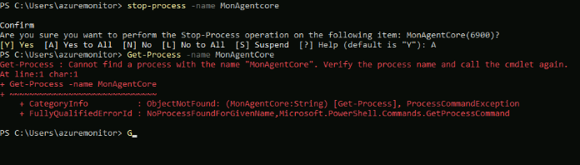
Figure 7-3: PF-03 MonAgentCore Process Stopped
Step 3. Verify the process is stopped using the Azure Monitor dashboard.
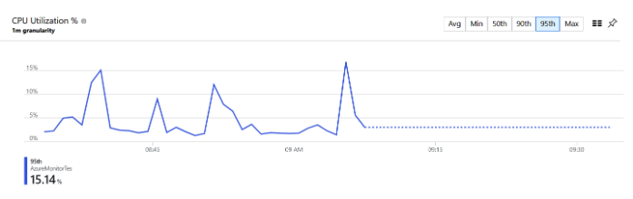
Figure 7-4: PF-03 Azure Monitor Dashboard Disabled
Recommendation:
To prevent administrative users from terminating the MonAgentCore process, implement Protected Process Light (PPL) to elevate the agent’s protection level beyond standard administrative control. In conjunction with this, apply stricter access controls on all associated files—executables, configurations, and logs—ensuring they can only be modified or accessed by trusted, signed system-level components.

PF-04 Misconfigured TLS Certificate
Related Testing Narrative: Network
Risk: Low, CVSS:3.0/AV:N/AC:H/PR:N/UI:N/S:U/C:L/I:N/A:N, 3.7
Description:
The remote TLS certificate has been misconfigured. The certificate is not valid for the server's hostname.
Proof of Concept:
Step 1. Manually connect to the remote service using a TLS version enumeration utility and request the remote certificate.
Step 2. Examine the certificate for misconfigurations.
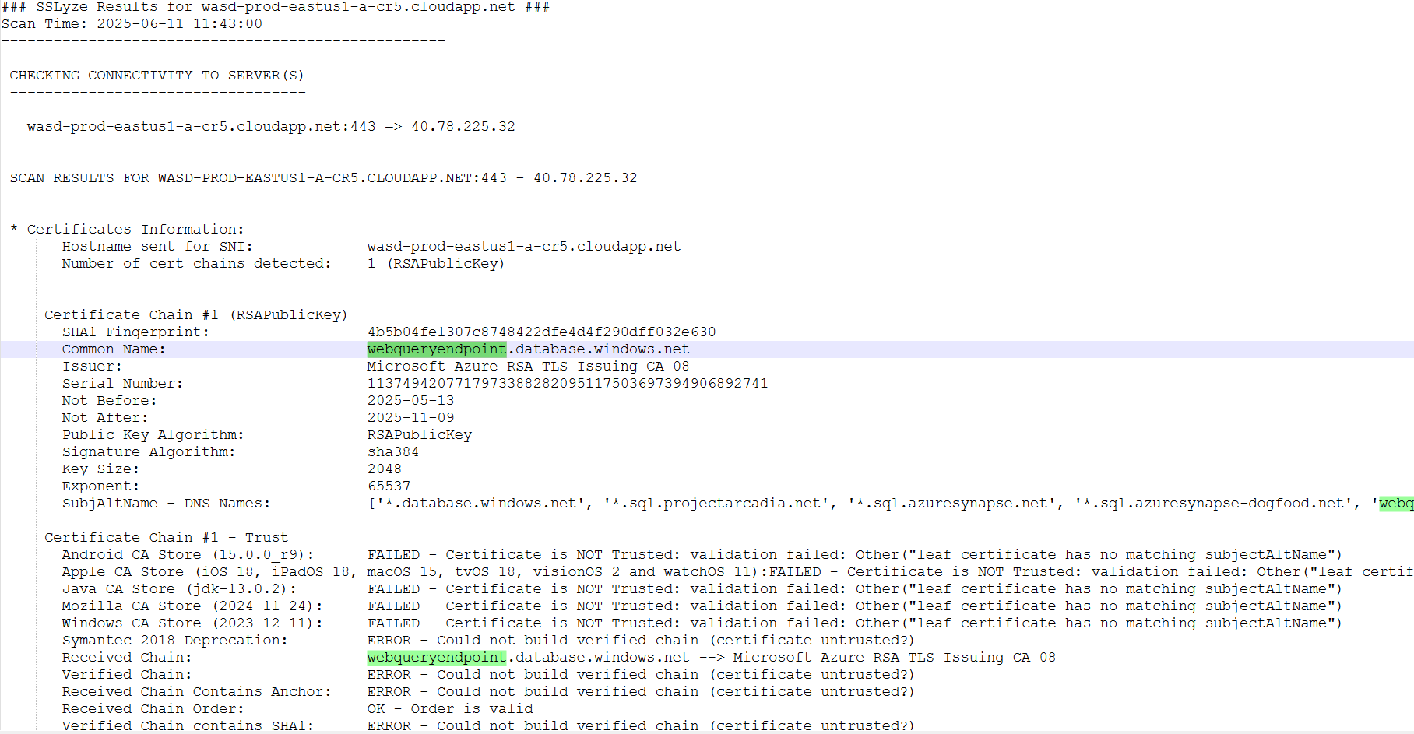
Figure 7-5: PF-04 Misconfigured TLS Certificate
Recommendation:
Purchase or generate a proper TLS certificate for this service.

PF-05 Phishing Click Rate Low
Related Testing Narrative: Phishing
Risk: Low, CVSS:3.1/AV:N/AC:H/PR:N/UI:R/S:C/C:L/I:N/A:N, 3.4
Description:
16.9 percent (16.9%) of the targeted administrators interacted with the malicious server as the result of the phishing campaign.
Proof of Concept:
Microsoft executed a phishing campaign with content developed by Kratos. The results can be viewed in Section 5.
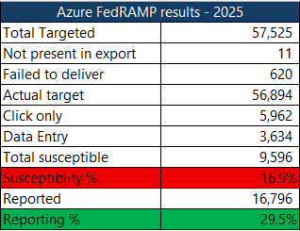
Figure 7-6: PF-04 Phishing Results
Recommendation:
Implement phishing exercises to ensure optimal phishing awareness or update the phishing training provided to the administrators to help them better identify phishing emails.

Appendix A- Findings Table
Findings | File
This Excel Spreadsheet Contains Penetration Test Findings. | Evidence Package /Appendix A

Appendix B – Evidence
Evidence ID | Description | Testing Narrative | Path to Evidence
EV-01 | This artifact contains the signed Rules of engagement and any subsequent addendums. | N/A | Evidence Package/EV-01 Rules of Engagement
EV-02 | This artifact contains the external Nmap scans. | Network | Evidence Package /EV-02 External Network
EV-03 | This artifact contains the web application testing results. | Web Application | Evidence Package /EV-03 Web Application
EV-04 | This artifact contains the results of the unannounced phishing campaign. | Social Engineering | Evidence Package /EV-04 Social Engineering
EV-05 | This artifact contains the results of OSINT testing. | OSINT | Evidence Package  /EV-05 OSINT
EV-06 | This artifact contains a Microsoft-provided offerings file. | N/A | Evidence Package/EV-06 Offerings
EV-07 | This artifact contains the datacenter walkthrough reports. | Physical | Provided Externally

