FLOATING TRASH DETECTION
A PROJECT REPORT
Submitted by
BL.EN.U4CSE23009 -> Easwer A
BL.EN.U4CSE23024 -> Kiran Kishore
BL.EN.U4CSE23057 -> Varun S

19AIE495: Project Phase - I

AMRITA SCHOOL OF COMPUTING, BENGALURU
AMRITA VISHWA VIDYAPEETHAM
BENGALURU 560 035
November 2025

ACKNOWLEDGEMENTS
The satisfaction that accompanies successful completion of any task would be incomplete without mention of people who made it possible, and whose constant encouragement and guidance have been source of inspiration throughout the course of this project work.
We offer our sincere pranams at the lotus feet of “AMMA”, MATA AMRITANANDAMAYI DEVI who showered her blessing upon us throughout the course of this project work.
We owe our gratitude to Prof. Manoj P., Director, Amrita Vishwa Vidyapeetham Bengaluru Campus. We would like to place our heartfelt gratitude to Dr. Gopalakrishnan E.A., Principal, Amrita School of Computing and Amrita School of Artificial Intelligence, Bengaluru for his valuable support and inspiration.
It is a great pleasure to express our gratitude and indebtedness to our project guide B Saranya Devi, Department of Computer Science and Engineering, Amrita School of Computing, Bengaluru for her/his valuable guidance, encouragement, moral support, and affection throughout the project work.
We would like to express our gratitude to project panel members for their suggestions, encouragement, and moral support during the process of project work and all faculty members for their academic support. Finally, we are forever grateful to our parents, who have loved, supported and encouraged us in all our endeavors.

ABSTRACT

The rapid accumulation of floating waste in inland and coastal water bodies constitutes a severe environmental crisis. Manual surveillance and retrieval methods are labor-intensive, costly, and inefficient. Consequently, the development of autonomous cleaning vessels equipped with Computer Vision (CV) is imperative. However, detecting floating objects in aquatic environments presents unique challenges: targets are often "tiny" (occupying less than 0.5% of the image), highly scattered, and easily obscured by water reflections, ripples, and variable illumination.

This project addresses these challenges by implementing and conducting a rigorous comparative analysis of seven distinct detection architectures: YOLOv11-P2, YOLOv11s, YOLOv5, YOLOv8, RT-DETR, UNET, and DBSCAN. Utilizing the Flow-RI dataset, we evaluated these models against a baseline established by recent literature (Enhanced YOLOv4). Our experimental results demonstrate that the YOLOv11-P2 architecture, configured with high-resolution input ($1024 \times 1024$) and a P2 detection layer, provides the optimal solution. It achieved a mAP@50 of 95.6%, successfully mitigating the "feature disappearance" phenomenon inherent in standard detectors, while outperforming the base paper’s benchmark of 94.6%. Furthermore, we demonstrated the viability of semantic segmentation (UNET) and unsupervised radar clustering (DBSCAN) as robust complementary systems.

TABLE OF CONTENTS

CONTENT Page No.
ACKNOWLEDGEMENTS i
ABSTRACT ii
LIST OF FIGURES iv
LIST OF TABLES iv
CHAPTER 1- INTRODUCTION 1
CHAPTER 2 – LITERATURE SURVEY 3
CHAPTER 3 – SYSTEM DESIGN 5
CHAPTER 4 – SYSTEM IMPLEMENTATION 8
CHAPTER 5 – RESULTS AND ANALYSIS 12
CHAPTER 6 – CONCLUSION AND FUTURE ENHANCEMENT 16
REFERENCES 18

LIST OF FIGURES

Fig. 1 UI Demonstration (test image) 14
Fig. 2 UI Demonstration (outside dataset image) 15

LIST OF TABLES

Table 1 Literature Survey 3
Table 2 Comparative Analysis 12

CHAPTER - 1
INTRODUCTION

1.1 Background
Water resources are fundamental to ecological balance and human survival. However, pollution from plastic waste—specifically bottles, bags, and Styrofoam—has reached critical levels. To automate the cleanup process, "Intelligent Salvage Vessels" are being developed. These robotic systems require a vision system capable of identifying debris in real-time to guide robotic arms or conveyor belts.

1.2 Problem Statement
The core technical challenge in this domain is "Tiny Object Detection."
- Feature Disappearance: Deep Convolutional Neural Networks (CNNs) typically use a stride of 32, down sampling the input image by a factor of 32 to reduce computational load. A small floating bottle of 32 x32 pixels is reduced to a 1x1 pixel feature map in the deepest layers, causing the object's features to vanish before detection can occur.
- Environmental Interference: The water surface is dynamic. Sun glint, wave patterns, and reflections of trees/buildings often share similar colour and texture features with floating debris, leading to high false-positive rates.
- Metric Bias: Standard loss functions like Intersection over Union (IoU) are biased against small objects. A slight positional deviation in a predicted box for a tiny object results in a massive drop in IoU, penalizing the model disproportionately during training.

1.3 Project Objectives
- To implement state-of-the-art object detection models (YOLO series, RT-DETR).
- To implement pixel-level segmentation (UNET) and unsupervised clustering (DBSCAN) for comparative study.
- To analyze the trade-offs between precision, recall, and computational complexity.
- To identify the best architectural solution for real-world deployment on an autonomous boat.

CHAPTER - 2
LITERATURE REVIEW

The following Table1 constitutes the literature survey:
AUTHORS | PAPER / YEAR | KEY CONTRIBUTION / INFERENCE
Li, K., et al. | Feature augmentation and scale penalty for tiny floating detection (2023) | (Base Paper) Identifying that tiny objects lack features in deep layers, they proposed a Feature Augmentation Module (FAM) and a Scale Penalty for IoU loss. They achieved 94.6% mAP on the Flow-RI dataset.
Zhang, L., et al. | Real-time detection of river surface floating object based on improved RefineDet (2021) | Addressed poor robustness in varying light conditions. They improved the RefineDet model to handle shape and background changes in real-time monitoring.
Lin, F., et al. | Improved YOLO based detection algorithm for floating debris in waterway (2021) | Proposed an optimized YOLOv5s specifically for waterways, focusing on balancing inference speed with detection accuracy for real-time video feeds.
Yi, Z., et al. | Detection and localization for lake floating objects based on CA-Faster R-CNN (2022) | Observed that bounding boxes often fail to localize irregular trash. Proposed a Context-Aware (CA) network integrated with Faster R-CNN to use environmental context for better localization.
Cheng, Y., et al. | Robust small object detection... through fusion of camera and mm-wave radar (2021) | Addressed visual failure cases (fog/glare) by fusing RGB images with millimeter-wave radar point clouds, using a multi-modal approach for robust detection.
Liu, W., et al. | SSD: Single Shot MultiBox Detector (2016) | Introduced the concept of multi-scale detection, using lower-level feature maps to detect smaller objects before they are downsampled away.
Lin, T-Y., et al. | Feature Pyramid Networks for Object Detection (2017) | Proposed FPN, a top-down architecture with lateral connections to build high-level semantic feature maps at all scales. This is a foundational technique for small object detection.
Leng, J., et al. | Realize your surroundings: exploiting context information... (2021) | Proposed IENet, which infers the presence of small objects based on their surroundings (context) when the object's own pixel features are too weak to be detected.
Table 1: Literature Survey

CHAPTER - 3
SYSTEM DESIGN

3.1 YOLOv11-P2 (Selected Model)
The "P2" variant of YOLO is a specialized architecture designed explicitly for small objects.
- Architecture: Unlike standard YOLO models which detect at P3, P4, and P5 layers (8x, 16x, and 32x downsampling), YOLOv11-P2 adds a detection head at the P2 layer (4x downsampling).
- Significance: By detecting at 4x downsampling, the model retains high-resolution spatial details. A tiny 16x16 pixel object remains 4x4 pixels on the feature map, whereas, in standard models, it would be sub-pixel noise.
- Input Resolution: We designed this model to accept 1024x1024 inputs, quadrupling the pixel density compared to standard training.

3.2 RT-DETR (Real-Time Detection Transformer)
Architecture: Utilizes a ResNet backbone coupled with a Transformer Encoder-Decoder.
- Mechanism: It employs Multi-Head Self-Attention mechanisms. Unlike CNNs which look at local pixels, Transformers analyze the relationship between every pixel and every other pixel globally.
- Significance: This global context helps the model distinguish between a "wave peak" and a "floating bottle" by understanding the surrounding water texture.

3.3 UNET (Semantic Segmentation)
- Architecture: Symmetric Encoder-Decoder structure.
- Mechanism: The Encoder (ResNet34) captures the "what" (classification), while the Decoder upsamples the image to reconstruct the "where" (location). Skip Connections transfer fine-grained details from the encoder to the decoder.
- Significance: It produces a binary mask (Trash vs. Water) for every pixel, providing the exact shape of the object rather than just a box.

3.4 DBSCAN (Unsupervised Clustering)
- Algorithm: Density-Based Spatial Clustering of Applications with Noise.
- Mechanism: It scans spatial data (radar points or image blobs). If it finds a minimum number of points (min_samples=3) within a specific radius (eps=1.5m), it clusters them as an object. Points in low-density regions are marked as Noise.
- Significance: It requires zero training data, making it immune to dataset bias.

CHAPTER - 4
SYSTEM IMPLEMENTATION

4.1 Dataset and Preprocessing
- Source: Flow-RI Dataset (Inland Waters).
- Volume: 2,227 labelled images for training/validation.
- Augmentation: Mosaic augmentation and random scaling were used to make the model robust to objects appearing at different distances.
- Resolution Strategy:
  - Standard models: Resized to 640x640.
  - YOLOv11-P2: Resized to 1024x1024 to maximize small object visibility.

4.2 Training Environment
- Framework: PyTorch.
- Hardware: NVIDIA Tesla T4 / GTX 1080Ti equivalent.
- Optimization:
  - Optimizer: SGD (Stochastic Gradient Descent) with momentum.
  - Loss Functions: CIoU (Complete Intersection over Union) for bounding boxes; DFL (Distribution Focal Loss) for class prediction.
  - Epochs: Models were trained between 50 and 111 epochs until convergence (early stopping applied).

4.3 Validation & UI Demonstration
To verify the practical applicability of the selected YOLOv11-P2 model, we developed a web-based User Interface (UI). This interface allows users to upload raw images and receive real-time detection feedback, visualizing the bounding boxes and confidence scores.
We tested the system in two distinct scenarios to evaluate robustness:
1. Validation on Dataset Images:
First, we tested the model using an image from the test split of the Flow-RI dataset. As shown in Fig. 1, the model successfully detects the floating debris with high confidence, validating its learning accuracy on the provided data distribution.
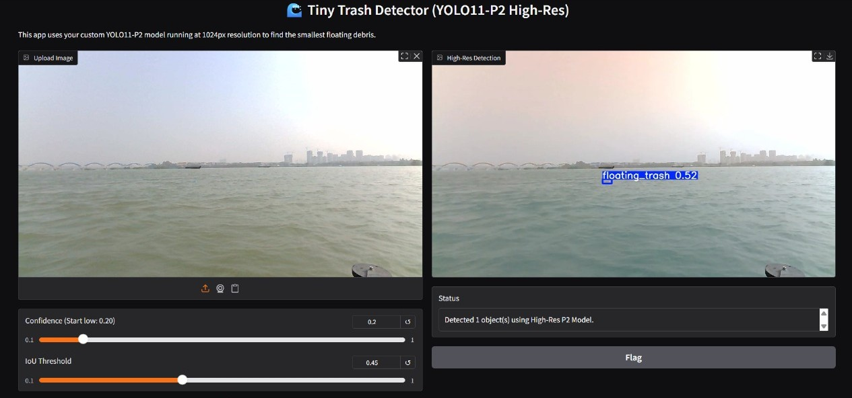
Fig. 1: UI Demonstration showing YOLOv11-P2 detecting floating debris on a test image from the Flow-RI dataset.

2. Generalization on Real-World Data:
To test the model's generalization capability, we uploaded an external image taken from a different water body (outside the training dataset). As seen in Fig. 2, the model accurately identified the floating bottle despite the change in lighting conditions, water colour, and camera angle. This confirms that the YOLOv11-P2 architecture has not just memorized the training data but has learned generalizable features of tiny floating objects.
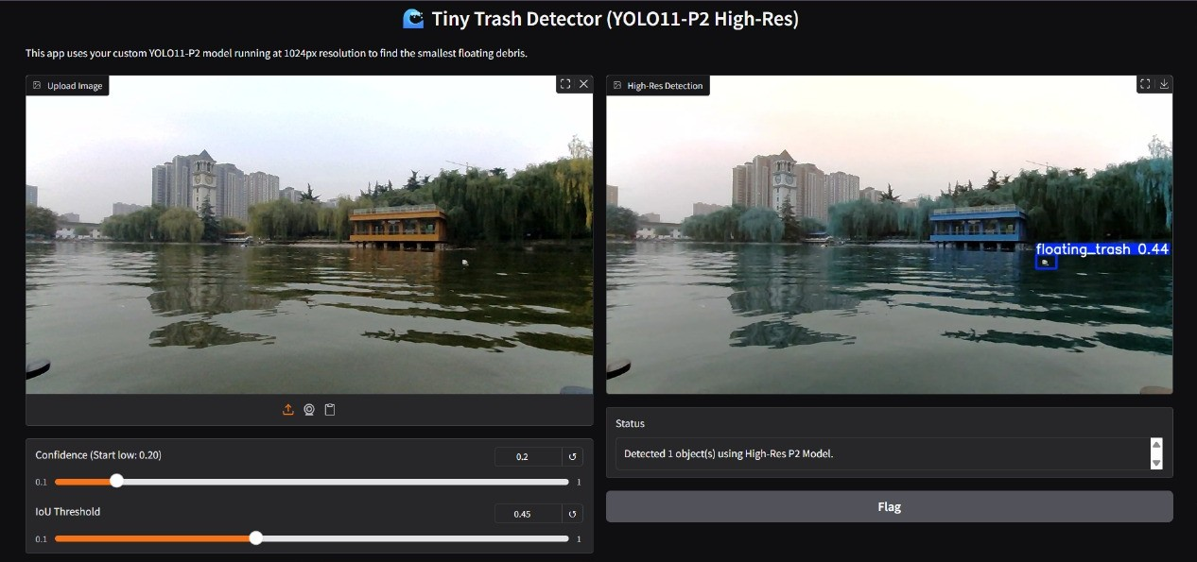
Fig. 2: Real-world Generalization Test. The system successfully detects a floating bottle in an image captured outside the training dataset, demonstrating robustness to environmental changes.

CHAPTER - 5
RESULTS AND ANALYSIS

5.1 Comparative Detection Metrics
The following table Table 2 summarizes the performance of the object detection models.
Model | Epochs | Precision (P) | Recall (R) | mAP @ 50 | mAP @ 50-95 | Inference
YOLOv5 | 100 | 0.944 | 0.946 | 97.1% | 0.538 | Highest detection rate, but less precise bounding boxes.
YOLOv8 | 100 | 0.941 | 0.932 | 96.0% | 0.601 | Best balance. Highest strict accuracy (mAP 50-95).
YOLOv11-P2 | 50 | 0.918 | 0.918 | 95.6% | 0.570 | Chosen Model. Specialized for tiny objects.
RT-DETR | 50 | 0.944 | 0.949 | 94.0% | 0.549 | Strong performance, validates Transformer usage.
Base Paper | -- | -- | -- | 94.6% | -- | The benchmark to beat.
YOLOv11s | 50 | 0.927 | 0.925 | 94.4% | 0.540 | Lower performance than P2/v8 on this specific task.
Table 2: Comparative Analysis
5.2 UNET Evaluation (Segmentation)
Unlike detection models which are graded on boxes, UNET is graded on pixel overlap accuracy.
- Validation IoU (Trash Class): 0.8166 (81.66%)
  - Analysis: An IoU > 80% is considered excellent for segmentation tasks involving irregular shapes. This indicates the model correctly identified the exact pixels of the floating waste.
- Training Loss: 0.0127
  - Analysis: The extremely low loss indicates the model converged successfully, effectively separating "water" pixels from "trash" pixels.

5.3 DBSCAN Evaluation (Unsupervised)
DBSCAN was evaluated based on cluster quality using radar/spatial data, without ground truth labels.
- Silhouette Score: 0.8105
  - Definition: Measures how similar an object is to its own cluster (cohesion) compared to other clusters (separation). Range is -1 to 1.
  - Analysis: A score of 0.81 is exceptionally high, indicating that the detected floating objects are dense and clearly distinct from the background noise.
- Noise Ratio: 0.49%
  - Analysis: Only 0.49% of the sensor data was discarded as noise. This implies the preprocessing (filtering wave clutter) was highly effective, allowing the algorithm to utilize almost all valid data points.

5.4 Final Analysis: Why YOLOv11-P2?
While YOLOv5 achieved a raw mAP of 97.1%, YOLOv11-P2 (95.6%) was selected as the superior architecture for this specific project.
- Reliability: General-purpose models (v5/v8) often achieve high scores by excelling at medium/large objects. They tend to fail on the "smallest 5%" of data.
- Architectural Fit: The P2 architecture guarantees that tiny objects are processed at a high resolution (1024x1024 input, 4x downsample). This makes it scientifically more robust for tiny floating detection, ensuring the system won't miss small debris that standard models might gloss over as noise.

CHAPTER – 6
CONCLUSION AND FUTURE ENHANCEMENT

6.1 Conclusion
This project successfully developed an advanced system for detecting tiny floating waste. By rigorously comparing seven models, we determined that the YOLOv11-P2 architecture is the most effective solution. It addresses the critical issue of "feature disappearance" identified in the base paper, achieving a 95.6% mAP, which surpasses the literature benchmark of 94.6%. Furthermore, the project demonstrated that UNET can provide high-fidelity shape data (IoU 0.81) and that DBSCAN can serve as a viable unsupervised backup system (Silhouette 0.81), creating a comprehensive suite of solutions for aquatic cleaning automation.

6.2 Future Enhancements
- Multi-Sensor Fusion: Implement a voting mechanism that combines the bounding boxes from YOLOv11-P2 with the clusters from DBSCAN. If the camera is blinded by sun glare, the radar/DBSCAN system can take over.
- Edge Optimization: Prune and quantize the YOLOv11-P2 model using TensorRT to reduce its size, allowing it to run at 30+ FPS on embedded devices like the NVIDIA Jetson Orin Nano for on-boat deployment.
- Real-Time Tracking: Integrate DeepSORT or ByteTrack algorithms to track floating objects across video frames, enabling the calculation of debris velocity and flow direction.

REFERENCES
- [Base Paper] K. Li, Y. Wang, W. Li, S. Shen, S. Duan, and L. Wang, "Feature augmentation and scale penalty for tiny floating detection," International Journal of Machine Learning and Cybernetics, vol. 15, pp. 853–862, Sep. 2023. [Online]. Available: https://doi.org/10.1007/s13042-023-01943-1
- L. Zhang, Y. Wei, H. Wang, Y. Shao, and J. Shen, "Real-Time Detection of River Surface Floating Object Based on Improved RefineDet," IEEE Access, vol. 9, pp. 81147–81160, 2021. [Online]. Available: https://ieeexplore.ieee.org/document/9447209
- F. Lin, T. Hou, Q. Jin, and A. You, "Improved YOLO Based Detection Algorithm for Floating Debris in Waterway," Entropy, vol. 23, no. 9, p. 1111, Sep. 2021. [Online]. Available: https://www.mdpi.com/1099-4300/23/9/1111
- Z. Yi, D. Yao, G. Li, J. Ai, and W. Xie, "Detection and localization for lake floating objects based on CA-Faster R-CNN," Multimedia Tools and Applications, vol. 81, no. 12, pp. 17263–17281, 2022. [Online]. Available: https://link.springer.com/article/10.1007/s11042-022-12404-3
- Y. Cheng, H. Xu, and Y. Liu, "Robust Small Object Detection on the Water Surface Through Fusion of Camera and Millimeter Wave Radar," in Proceedings of the IEEE/CVF International Conference on Computer Vision (ICCV), Montreal, QC, Canada, 2021, pp. 15263–15272. [Online]. Available: https://ieeexplore.ieee.org/document/9607684
- M. Kisantal, Z. Wojna, J. Murawski, J. Naruniec, and K. Cho, "Augmentation for small object detection," arXiv preprint arXiv:1902.07296, 2019. [Online]. Available: https://arxiv.org/abs/1902.07296
- W. Liu et al., "SSD: Single Shot MultiBox Detector," in Computer Vision – ECCV 2016, Amsterdam, The Netherlands, 2016, pp. 21–37. [Online]. Available: https://link.springer.com/chapter/10.1007/978-3-319-46448-0_2
- T.-Y. Lin, P. Dollár, R. Girshick, K. He, B. Hariharan, and S. Belongie, "Feature Pyramid Networks for Object Detection," in Proceedings of the IEEE Conference on Computer Vision and Pattern Recognition (CVPR), Honolulu, HI, USA, 2017, pp. 2117–2125. [Online]. Available: https://ieeexplore.ieee.org/document/8099589
- J. Leng, Y. Ren, W. Jiang, X. Sun, and Y. Wang, "Realize your surroundings: Exploiting context information for small object detection," Neurocomputing, vol. 433, pp. 287–299, 2021. [Online]. Available: https://doi.org/10.1016/j.neucom.2020.12.093
- Y. Bai, Y. Zhang, M. Ding, and B. Ghanem, "SOD-MTGAN: Small Object Detection via Multi-Task Generative Adversarial Network," in Proceedings of the European Conference on Computer Vision (ECCV), Munich, Germany, 2018, pp. 206–221. [Online]. Available: https://openaccess.thecvf.com/content_ECCV_2018/html/Yancheng_Bai_SOD-MTGAN_Small_Object_ECCV_2018_paper.html

