Login Screen:

Agent would be allowed to login into the EMT using AD-ID credentials.

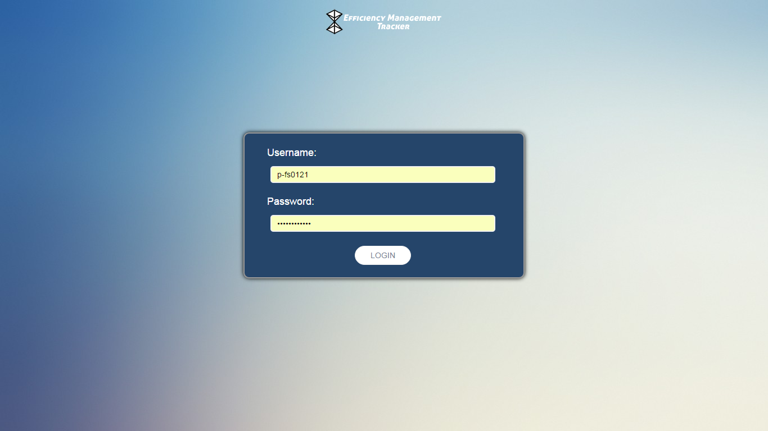

Home Page:

After login agent have this screen as Home page. The clock starts immediate after successful login and it is continue till logout. In this screen user has option to take break time by selecting the code from dropdown and press break button.

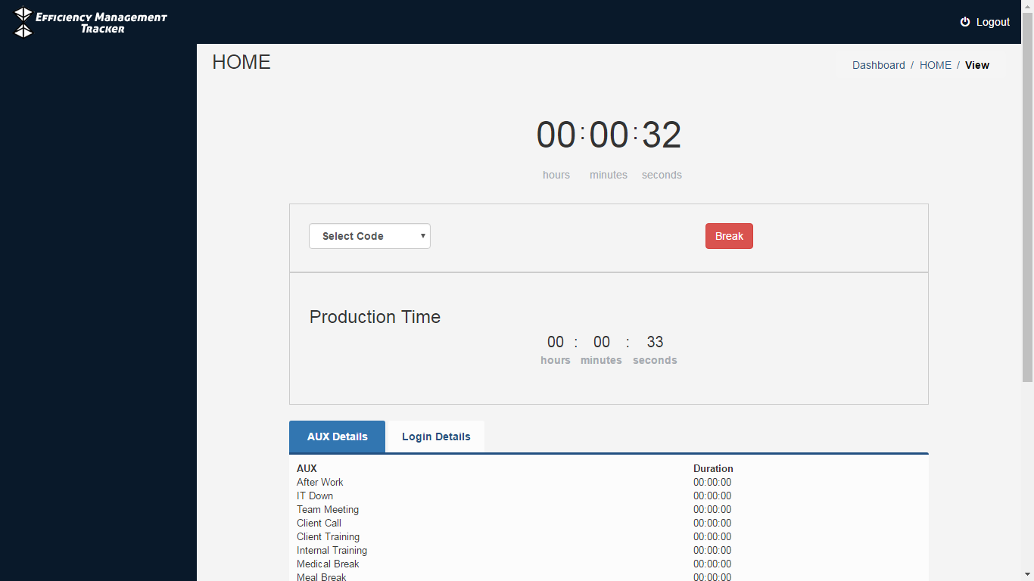

On click “**BREAK**” button, this application starts break time counter and it is continue until the “**RESUME**” button pressed. The production time for an agent is determined by subtracting the Total AUX Duration from Total Login Duration.

**AUX Details** tab describes the total break duration per AUX that is taken by the agent.

**Login Details** tab describes the last 10 login and logout date-time taken by the agent.

