Login Screen:

Supervisor or an employee would be allowed to login into the RADAR using AD-ID credentials.

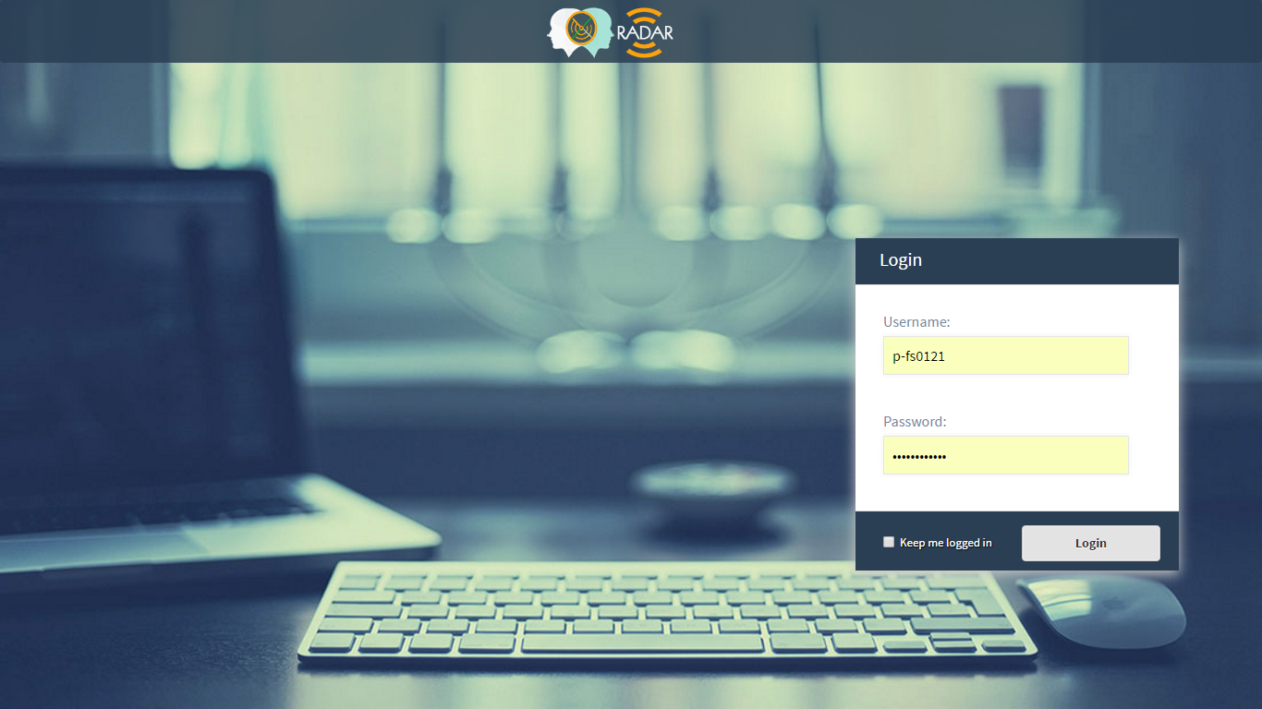

Home Page:

On successful login,

1. Supervisor or employee would be able to see those screens according to the rights assigned to him.
2. Supervisor or an employee would be able to see data available status in the application.

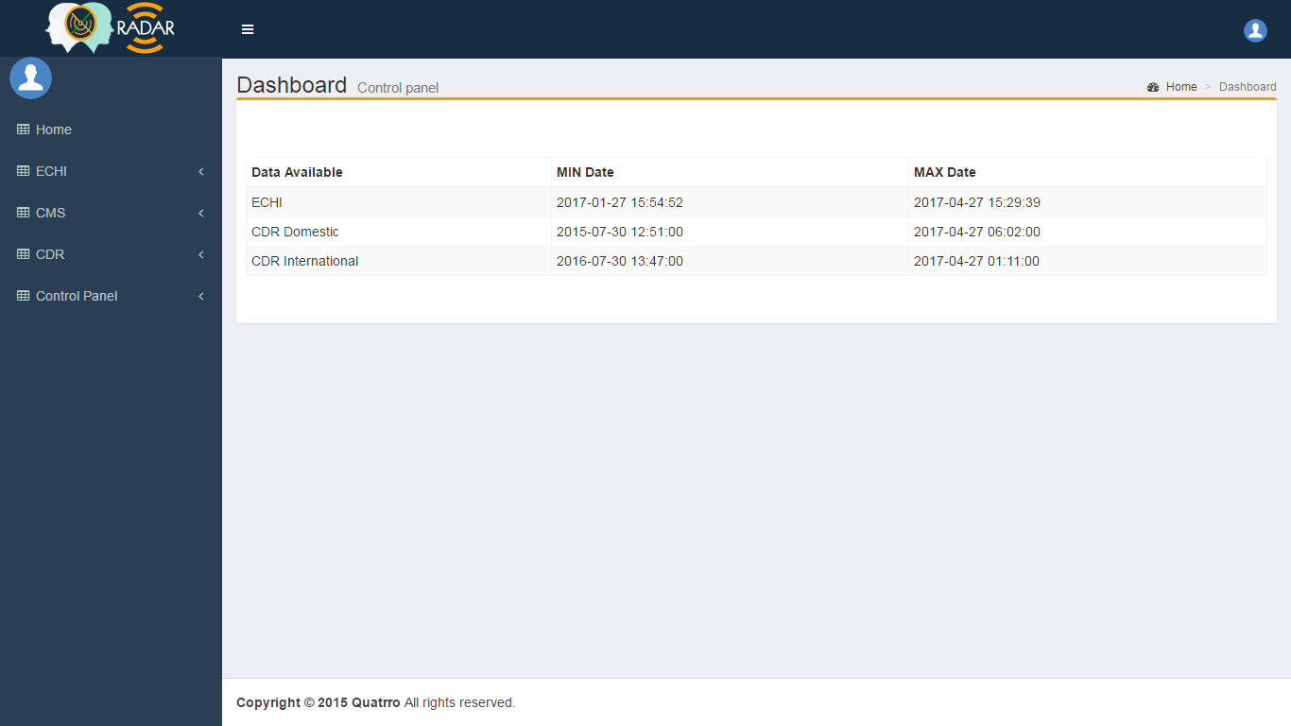

Menu Master:

The entire application navigation menu is created with this module. To create menu, we need to enter the details of the module, e.g, ‘Module Name’, ‘Description’, ‘Parent Menu’ and ‘Page Name’. To create main menu or parent menu, we have to set “PARENT MENU” as NULL and “PAGE NAME” as ‘#’.

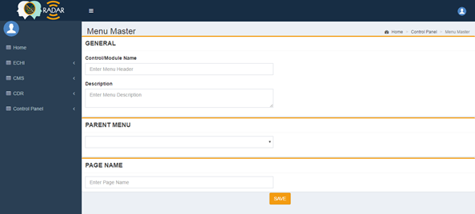

All Menus:

All saved navigation menu can be viewed on these screen. Supervisor or employee would able to modify menu details or it can be set active or inactive.

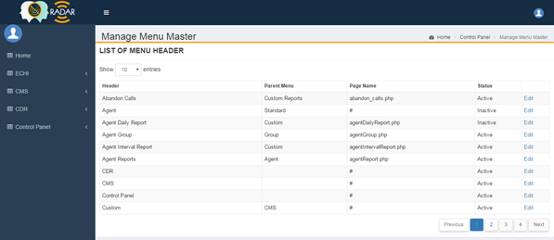

Group Master:

User rights are created with this module. In the below given form, we have following option that we assign the rights to a user.

1. To assign reports download option in csv we set download right to “Yes”.
2. Click on checkboxes of Echi Fields which are required to assign to a user group.
3. Click on checkboxes of Menus which are required to give access to that module to a user group.

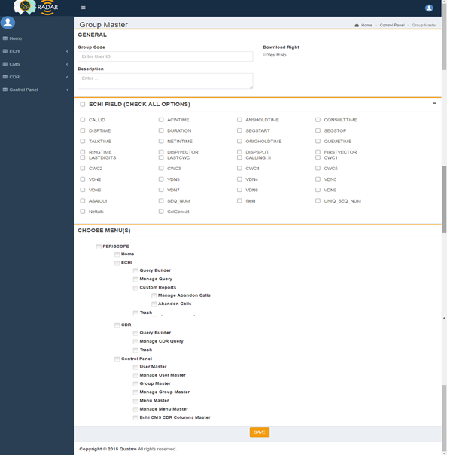

Group List:

All saved group can be viewed on these screen. Supervisor or employee would able to modify group details or it can be set active or inactive.

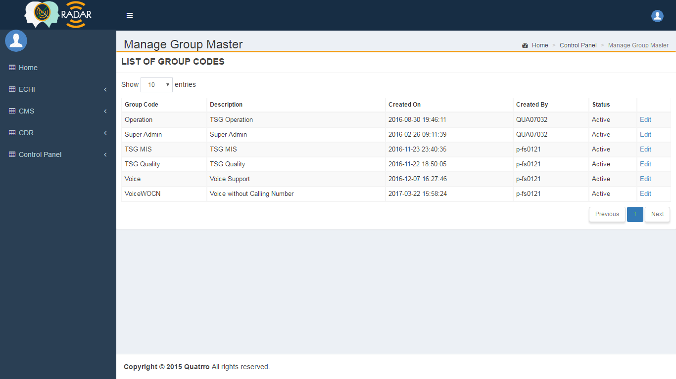

User Module:

To create a user the following are required,

1. Employee ID as user id, employee name, employee email id.
2. Employee manager ID, manager email id.
3. Number of queries allow user to create.
4. Select group to which user to be assigned.

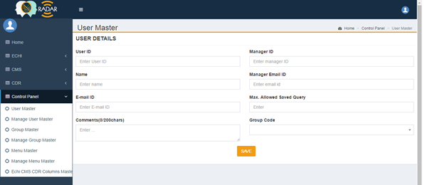

User List:

All saved user can be viewed on these screen. Supervisor or employee would able to modify user details or it can be set active or inactive.

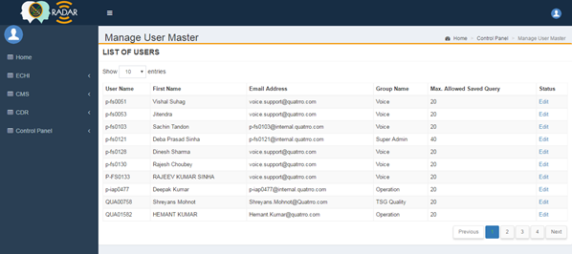

Echi CMS CDR Columns Master:

This master is used to save echi and cdr field which are being used in the ECHI and CDR query builder. The followings are required,

1. Source i.e, echi, cdr
2. Datatype i.e, int, varchar, char
3. Column name
4. Formula. Formula can be either simply column of the table or combination of two or more columns, e.g, column1*column2, or any mysql function with columns i.e, GROUP_CONCAT(firstname, ‘ ‘,lastname).

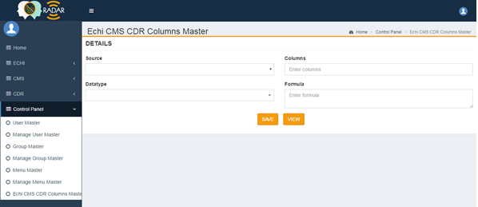

Echi CMS CDR Columns Master:

All saved field can be viewed on these screen. Supervisor or employee would able to modify user details or it can be set active or inactive.

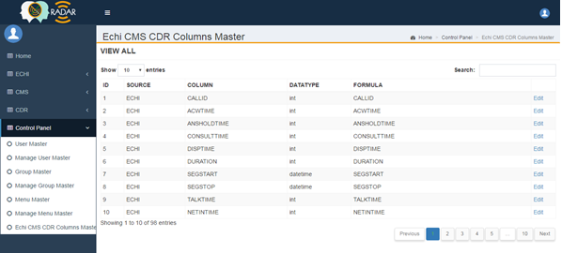

Echi Query Builder (section one):

Echi query builder is divided into four sections. For each section require field and its description given below:

1. Query Name, Description
2. Query type **private** i.e, only the user who created the query will have the access or the query can **shared** i.e, the user will have option to select other user with whom the query will be shared.
3. Date and time range (on click date and time range field we will have window to select date and time range and then apply the selected date)
4. Time zone

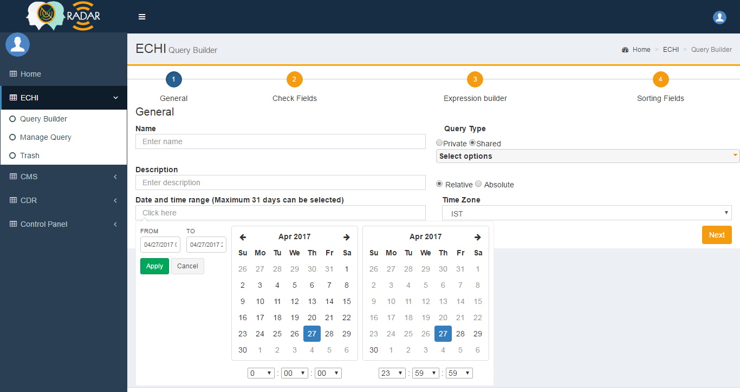

Echi Query Builder (section two):

In this section, all ECHI fields which are assigned to the user group are displayed and users have option to select field which are required in the report.

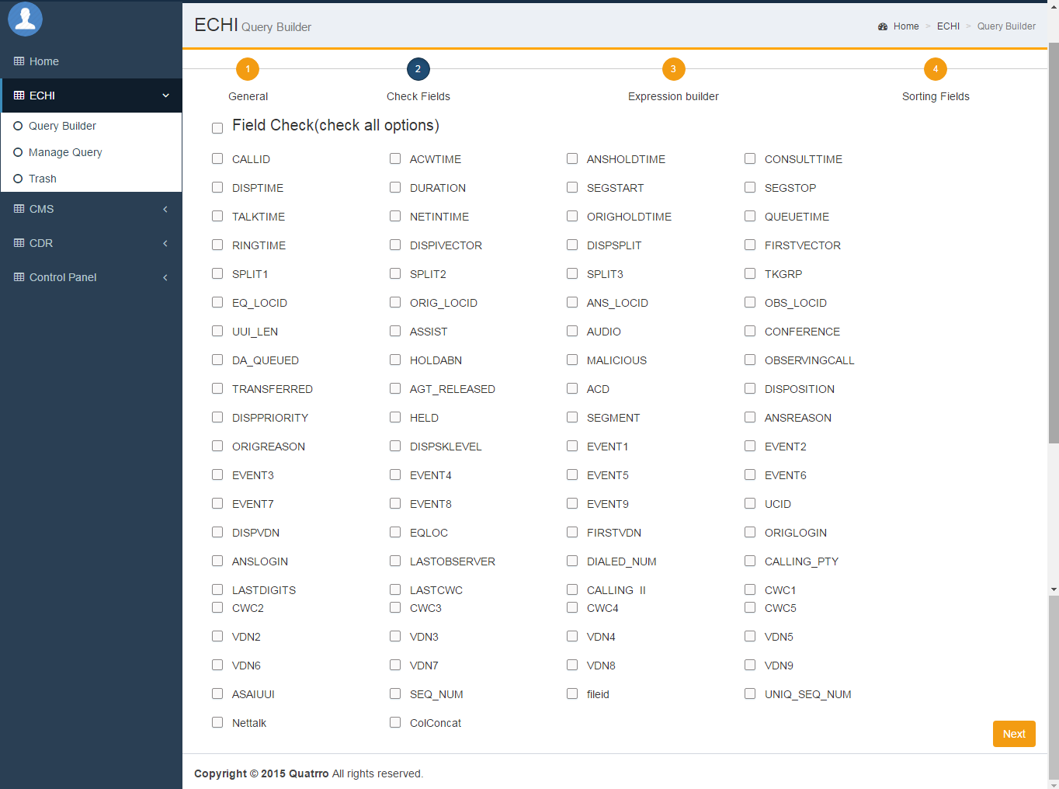

Echi Query Builder (section three):

In this section, we have option to prepare conditions on which data can be fetched. For that the required fields are,

1. Field
2. Query operator
3. Logical Operator
4. Value

After filling up the required fields we press add button to add condition to current expression.

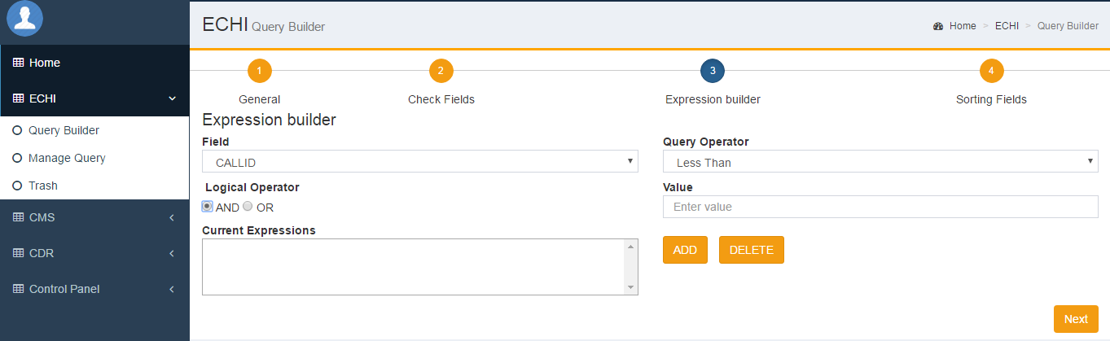

Echi Query Builder (section four):

In this section, we set all record to be sorted in ascending or descending order. For that the required fields are,

1. Field
2. logical operator

After filling up the required fields we press add button to add condition to sort expression.

And finally we press **SAVE AND RUN or SAVE or RUN** to get the result.

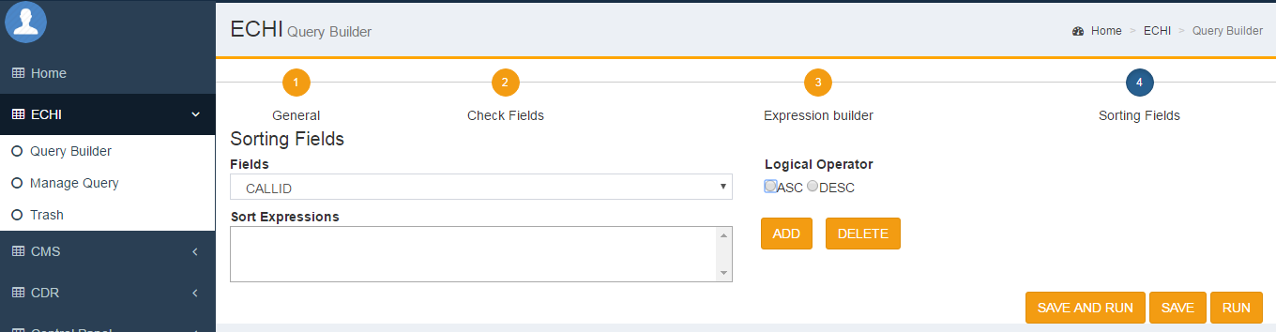

Echi Manage Query:

In this screen we have list of all saved query. User would modify/run/suspend saved query as per requirement. **RUN** functionality is given to run a saved query and generate report and **SUSPEND** functionality is given to suspend a query which is not required. Suspended query is moved to **TRASH**.

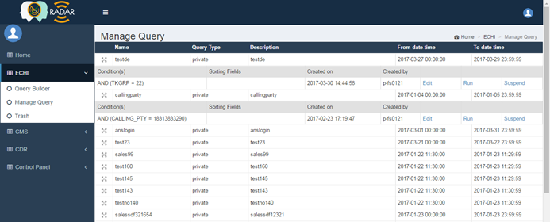

Trash:

In this screen we have list of all suspended query. User would reactive the suspended query as per requirement.

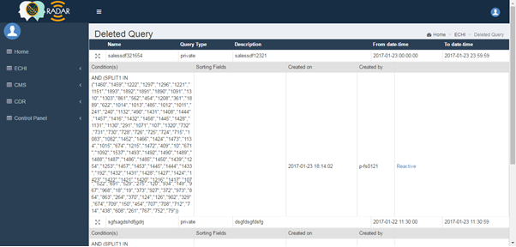

CDR Query Builder (section one):

Like ECHI, CDR query builder is also divided into four sections. For each section require field and its description given below:

1. Query Name, Description
2. Query type **private** i.e, only the user who created the query will have the access or the query can **shared** i.e, the user will have option to select other user with whom the query will be shared.
3. Date and time range (on click date and time range field we will have window to select date and time range and then apply the selected date)
4. Time zone

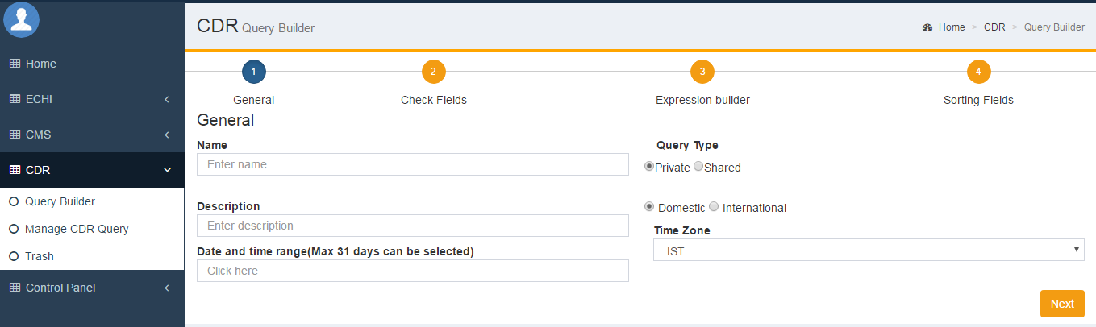

CDR Query Builder (section two):

In this section, all CDR Fields which are assigned to the user group are displayed and users have option to select field which are required in the report.

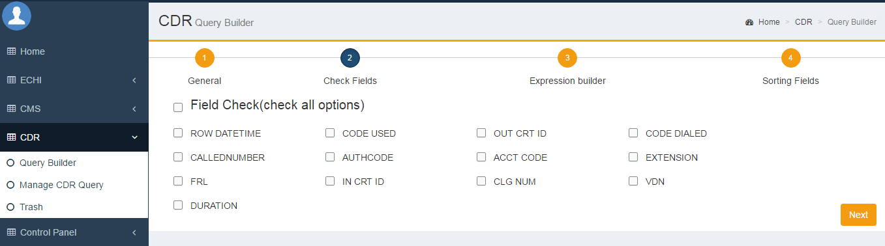

CDR Query Builder (section three):

In this section, we have option to prepare conditions on which data can be fetched. For that the required fields are,

1. Field
2. Query operator
3. Logical Operator
4. Value

After filling up the required fields we press add button to add condition to current expression.

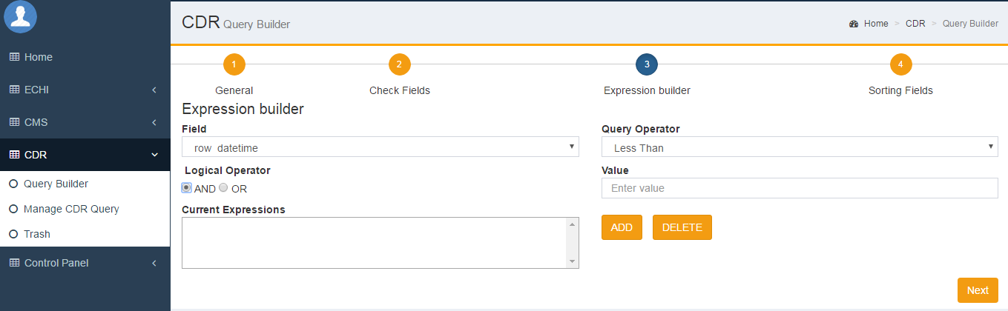

CDR Query Builder (section four):

In this section, we set all record to be sorted in ascending or descending order. For that the required fields are,

1. Field
2. logical operator

After filling up the required fields we press add button to add condition to sort expression.

And finally we press **SAVE AND RUN or SAVE or RUN** to get the result.

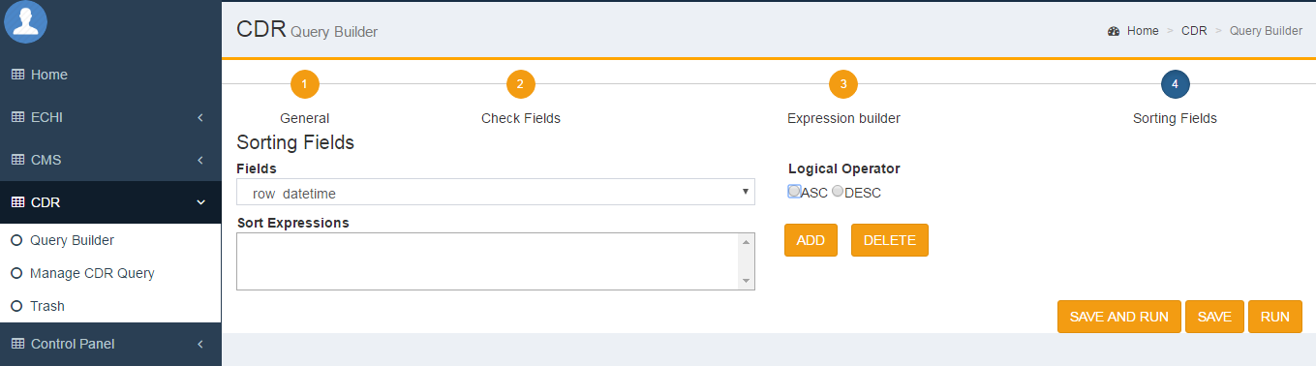

CDR Manage Query:

In this screen we have list of all saved query. User would modify/run/suspend saved query as per requirement. **RUN** functionality is given to run a saved query and generate report and **SUSPEND** functionality is given to suspend a query which is not required. Suspended query is moved to **TRASH**.

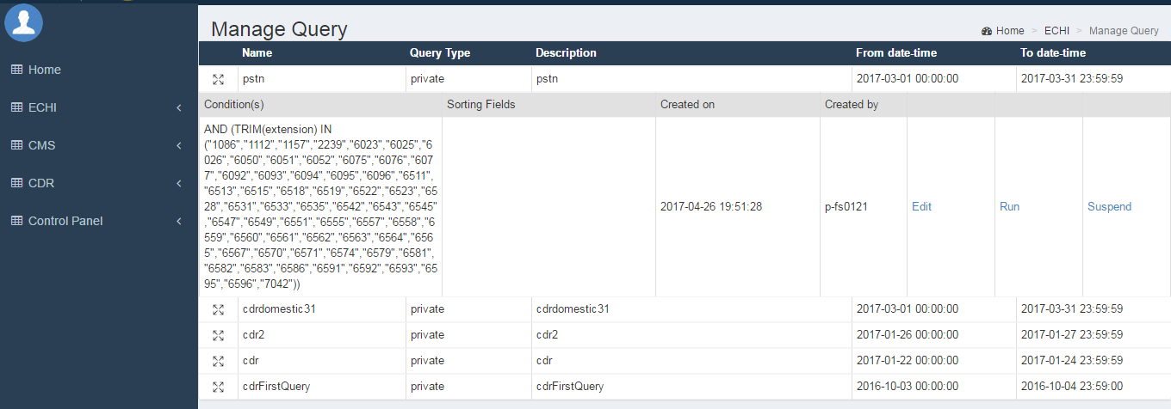

Trash:

In this screen we have list of all suspended query. User would reactive the suspended query as per requirement.

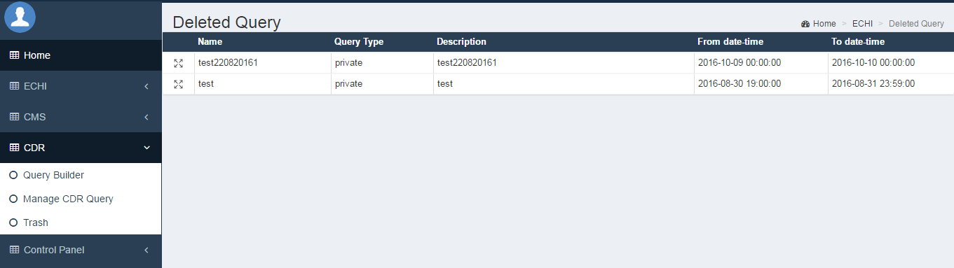

Task Management:

This module is used for managing task according to shift & user.

User Master –

In this screen we will have all registered user of task management module. Admin user would create/modify/delete user for access task management module.

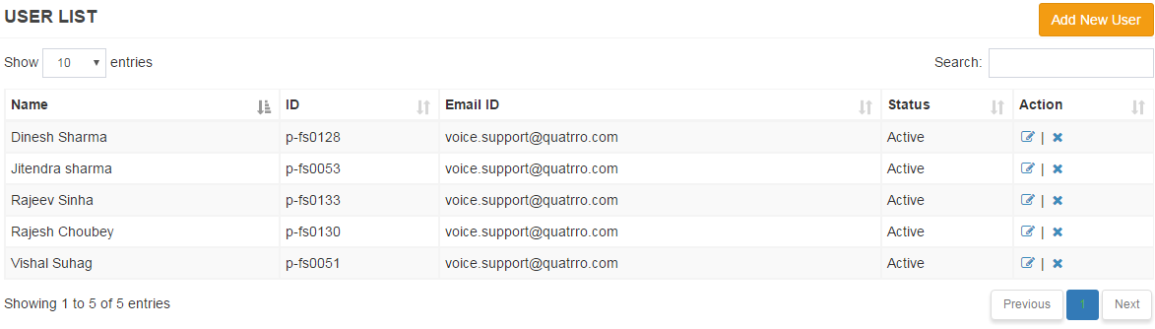

After click on add new user button it show a pop up form to add details of user.

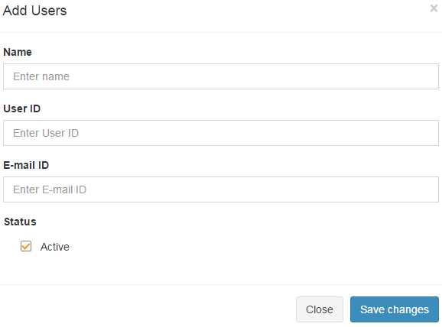

In the list of users click on icon for edit & delete user. On click **edit icon**, it will show a pop up form of prefilled user data. Change in user details as per requirement & save changes.

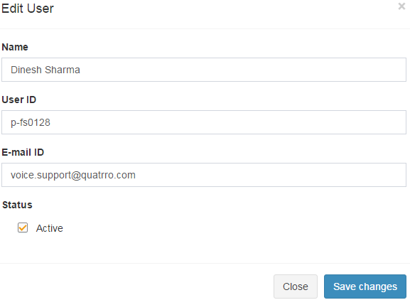

To **delete user**, click on delete icon. It shows confirmation box. On click “OK” button user data will be deleted.

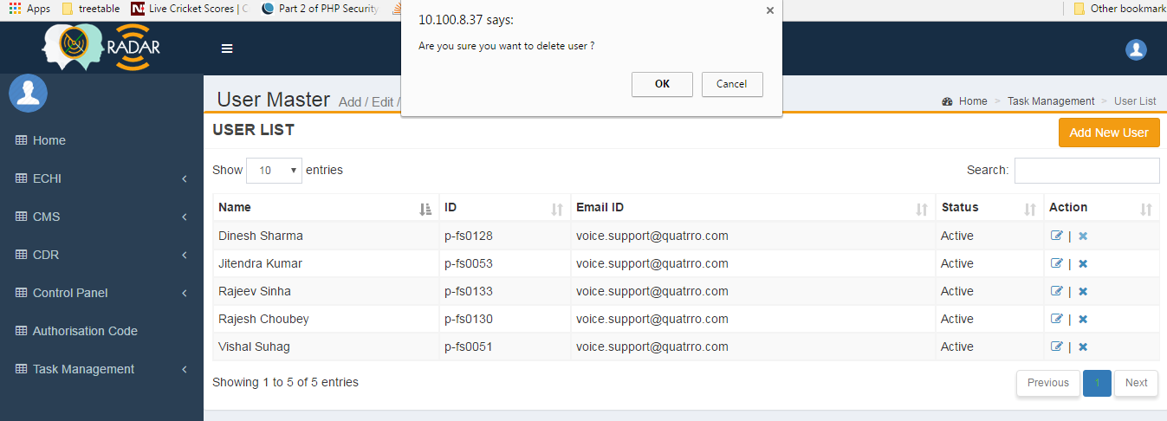

Shift Master

In this screen we have list of all shifts saved in the database. Admin user would create/ modify/ delete. 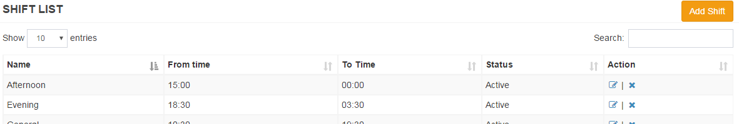

On click “Add Shift” button, a popup window will appear. After filling up details click “Save Changes” button to save the record.

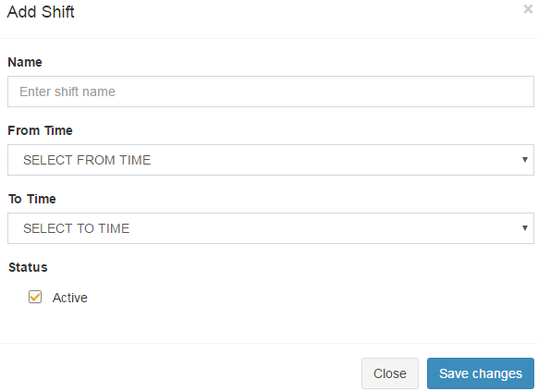

On click “Edit Shift” button, a popup window will appear with filled up details. Make changes as per requirement and click “Save Changes” button to update the record.

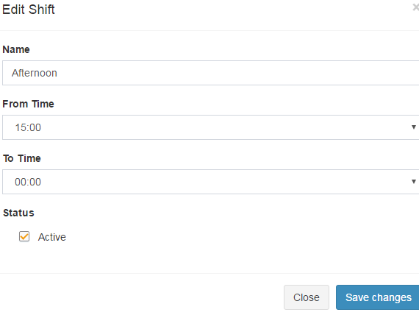

Roster Master

This master is used for add & Edit Roster. In This master first show the form for create roster, fill the form as users name, date range, shift & week off day & click on generate roster button.

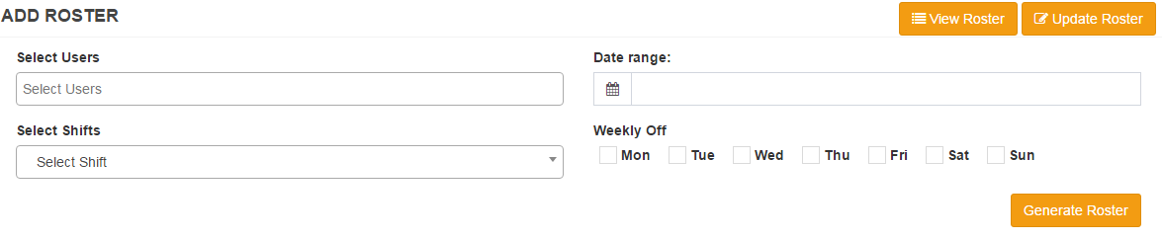

After click on generate roster button, show multiple roster for multiple user. Check the roster information & click on save button. Click on update roster button, it show a form for fill user name, date range & shift. If want to add leave then first select N/A in shift dropdown, it show leave type & select leave type for particular date & particular user.

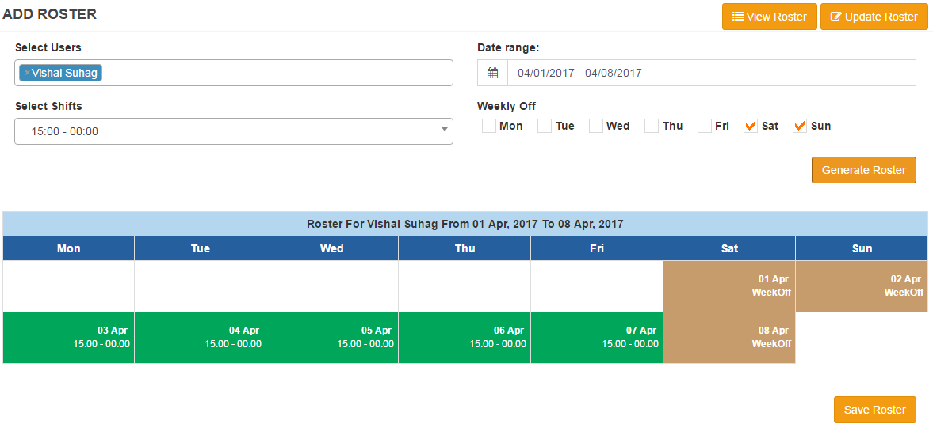

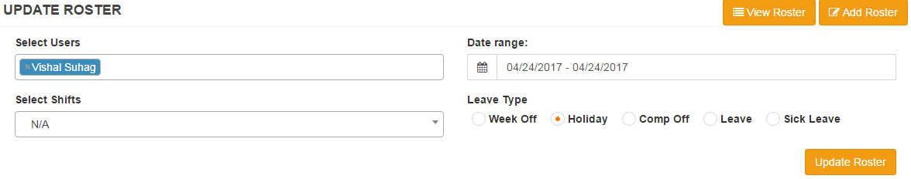

View Roster

On Click View Roster button shows a form. Select user, month, year and click on show roster button. It shows the roster of user of particular month.

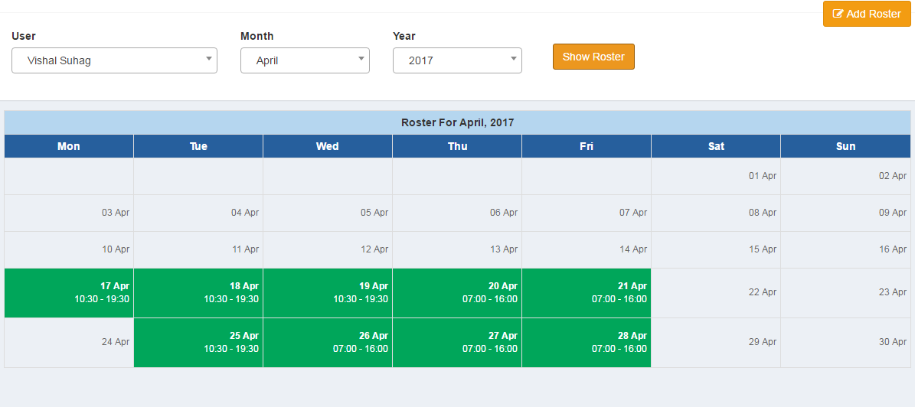

Task Master

Task master is used for add, Edit & delete task for uses / team. On click of task master menu link, it shows list of task & right side button for add task. Click on button on add task it shows a form for adding task. Fill the form & click in submit button for save task. User can update & delete task as required.

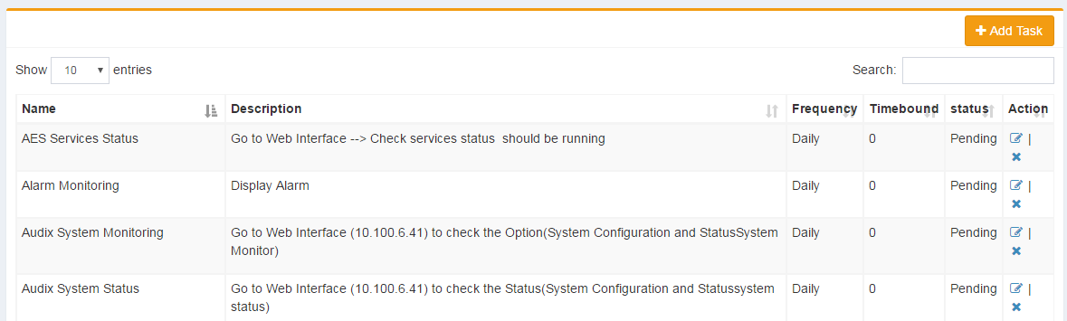

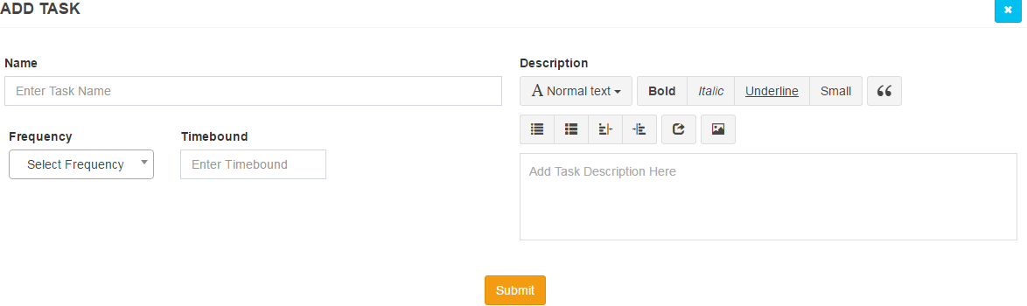 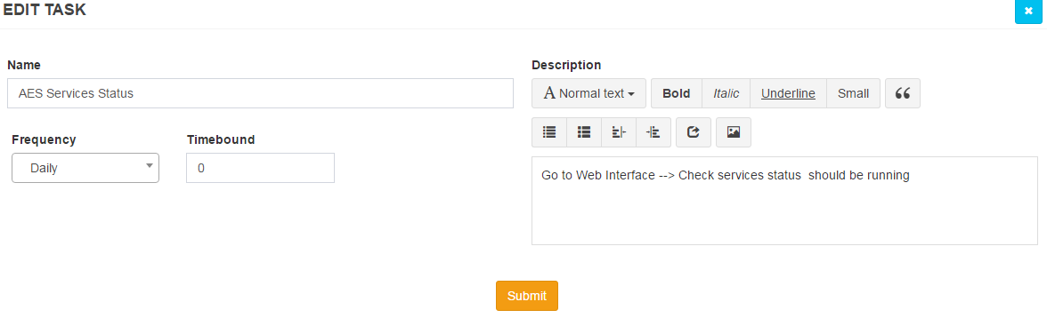

Shift Task Mapping

Task mapping module is used for map task with shift or assign task for shift. For mapping first select shift & after check on checkbox left to task which task you want to assign for particular shift and click on update button. It’s mapped to the shift. And show to all user available in that shift.

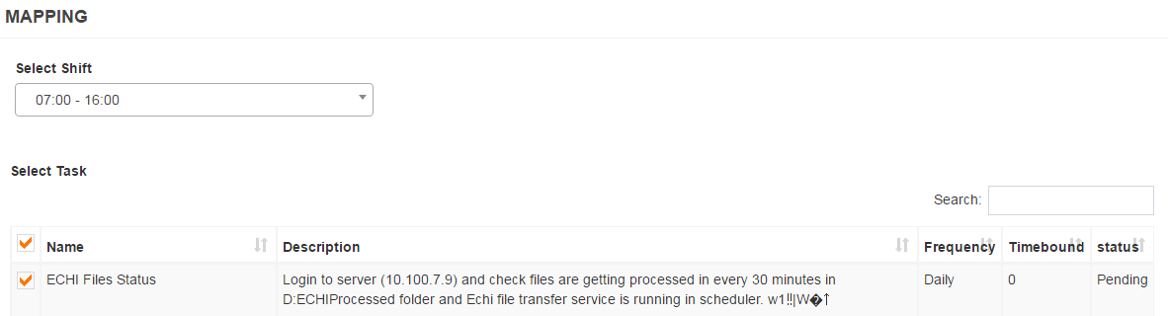

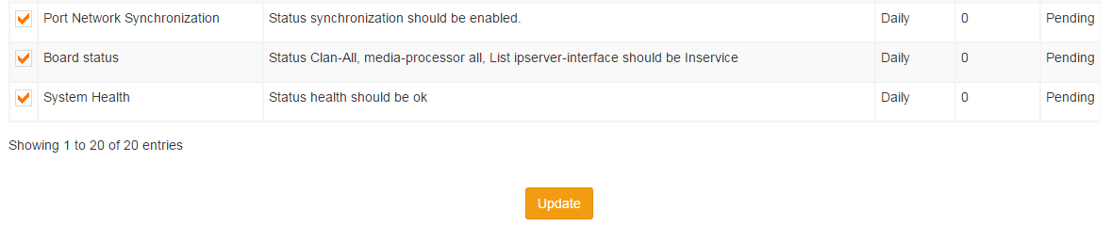

My task list

On Click my task list menu show all the task list mapped with the particular shift. For change status of task click on status hyperlink.

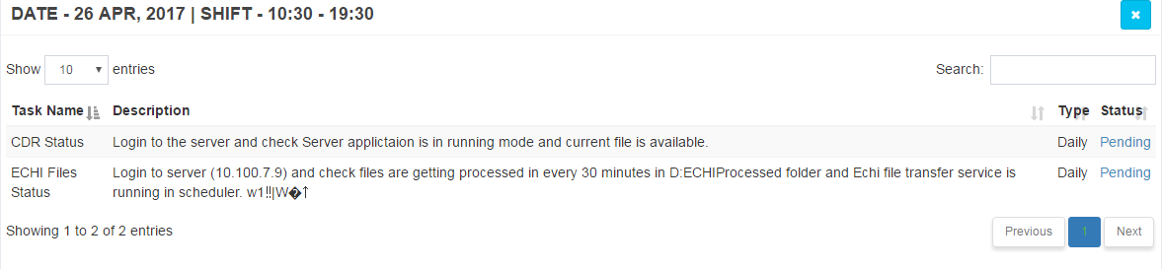

It shows a pop up form. Check on status type radio button & add remark according to task. After that click on save changes for update the task.

