Declan Urbaniak-Dornstauder
3716081
COMP 452
Assignment 1

Game description:

- This is a simple game where the player must avoid the enemies on-screen for 15 seconds.
- The player controls the yellow character with the mouse/cursor of their computer.
- There are two types of enemies, five in total:
  - Four blue enemies begin moving in a random direction at a random speed and ‘bounce’ off the boundaries of the screen
  - One red enemy seeks the players while avoiding the blue enemies. When 5 seconds remain on the timer, the red enemy moves faster and no longer avoids the other enemies.
- The player begins with 3 HP. If an enemy comes in contact with the player, the player loses 1 HP.
- If the player successfully avoids the enemies for 15 seconds, they win.
- Otherwise, if the player has 0 HP before the timer ends, they lose.

Steering behaviours:

- Two simple steering behaviours are implemented:

- wander():
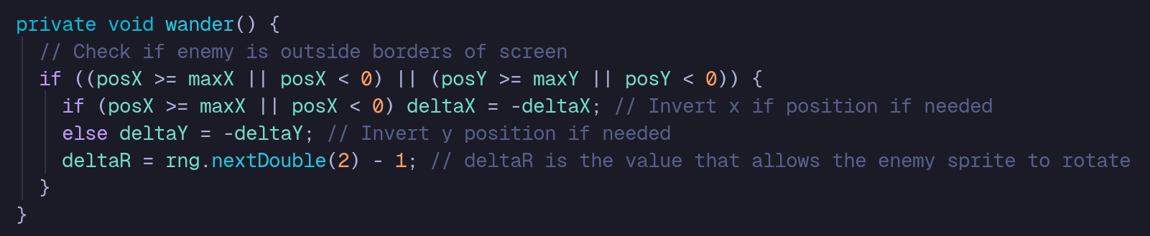
Source: src/java/com/example/a1/model/BlueEnemy.java

- seek() :


Source: src/java/com/example/a1/model/RedEnemy.java

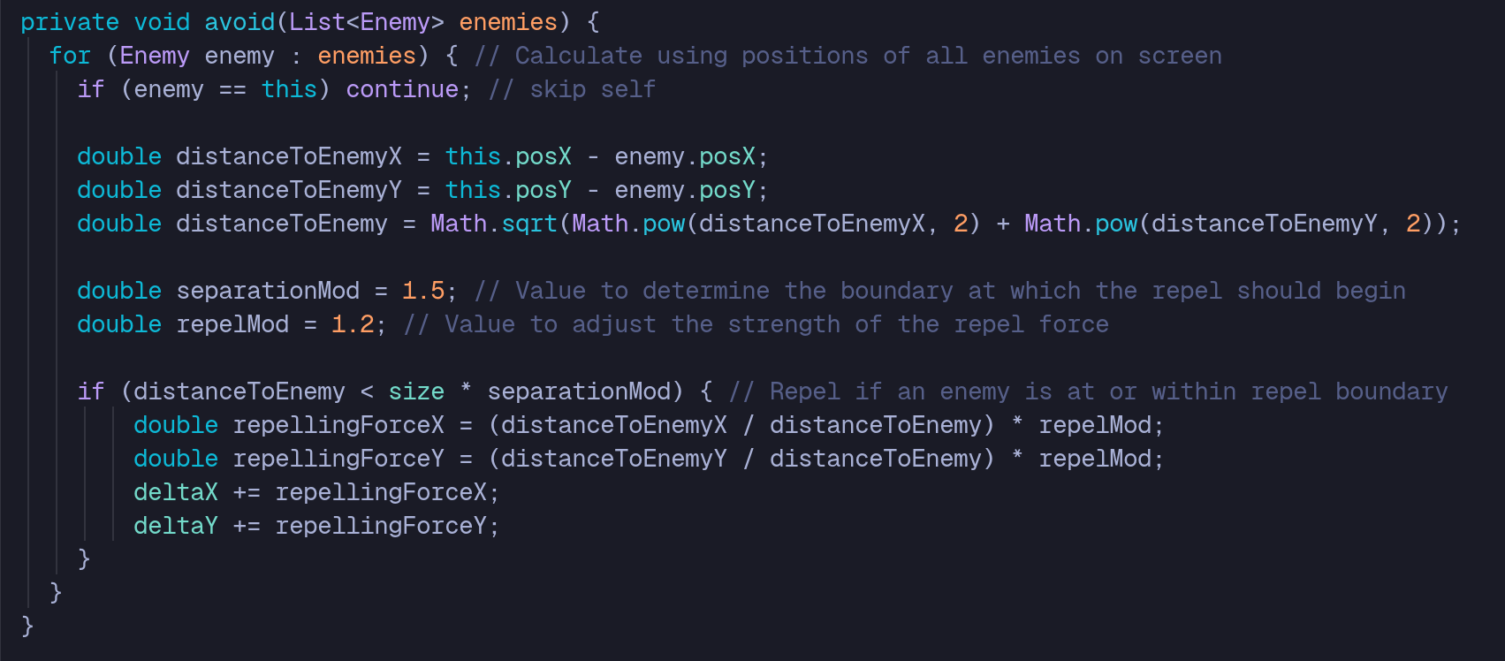
- One complex steering behaviour is implemented through the combination of seek() and avoid() in the red enemy. This allows the red enemy to seek the player while modifying its velocity to avoid the other enemies on-screen, giving it a more natural path in its pursuit.
Source: src/java/com/example/a1/model/RedEnemy.java

