**DISPOSAL REQUEST FORM DRF-1**



|  |  |
| --- | --- |
| **Ministry/Agency:** Agriculture | **Branch/Division:** {{ branch }} |

|  |
| --- |
| **Address:** 3085 Albert Street, Regina SK S4S 0B1 |

|  |  |
| --- | --- |
| **Contact Name ( if other than the DRO) :** | {{ contact }} |

|  |  |
| --- | --- |
| **Tel:** {{ phone }} | **Email:** {{ email }} |

|  |  |  |  |
| --- | --- | --- | --- |
| **Transfer/Transit Number (if applicable):** | {{ transfer }} | **Location of Records:** | Records Centre |

|  |  |  |  |
| --- | --- | --- | --- |
| **Total # of Boxes:** | {{ total }} | **Boxes #’s:** | {{ boxes }} |

**PLEASE COMPLETE THE APPROPRIATE SECTION(S) BELOW. COMPLETED INVENTORY SHEETS MUST BE ATTACHED. FORWARD THIS FORM WITH ATTACHED INVENTORY SHEET(S) TO:**

**Records Management Unit, Access Privacy Branch 1510 – 1855 Victoria Avenue, Regina, Saskatchewan S4P 3T2**

**DISPOSAL REQUEST**

The ADMINISTRATIVE and/or OPERATIONAL records as described on the attached inventory sheets have met retention requirements as prescribed in ARMS2014 or the relevant operational schedule(s). I hereby request authorization to dispose of the records in question.

|  |  |
| --- | --- |
| **Disposition Requested by:** | Jackie DeWaal |

**Designated Records Officer (DRO) Name, please print**

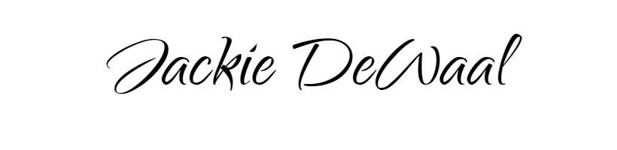

**Designated Records Officer: ____________________________________________________**

**(Signature)**

|  |  |
| --- | --- |
| **DRO Address:** | 226 - 3085 Albert Street, Regina SK S4S 0B1 |

**ARCHIVES USE ONLY:**

Date Received: ____________________________

Audit: Y N

GRB Number: ____________________________

|  |
| --- |
| **Date:** {{ date }} |

**FOR MORE INFORMATION PLEASE CONTACT INFORMATION MANAGEMENT UNIT (IMU) AT (306) 787-0734, or** [**recordhelp@archives.gov.sk.ca**](mailto:recordhelp@archives.gov.sk.ca) **, or** [**www.saskarchives.com**](http://www.saskarchives.com) **.**