Cathy Zhuang

BIOL 450 Dr. Jaeger

18 March 2022

Assignment 6: Cable Theory

# **Part 1**

## **Question A**

The length constant, λ, is the distance it takes for the membrane voltage to decay to 37% of its initial value, which in this case is the maximum voltage (Vmax).

Thus, once the membrane was charged, we captured the spatial distribution of voltage, observing that the initial value was 34.644 mV (see crosshairs of Figure 1). The distance to which the voltage decays to 12.8 mV, which also known as 37% of the initial value (0.37 * 34.644 = 12.8), is approximately 1.5 mm as demonstrated by the crosshairs in Figure 1. We were not able to pinpoint the exact value at 12.8 mV due to the skipping of the crosshairs, so we picked the closest value.

Our length constant, λ, is thus 1.5 mm.Then, the electronic length L = actual length/λ, so 20/1.5 = 13.3.

Figure 1. Crosshairs to pinpoint initial voltage value (left) and the distance to which the initial value decays by 37% (right) using a 10 µm diameter cable.

Figure 2. Settings used to find the answers above.

## **Question B**

Once changing the diameter from 10 µm to 5 µm, the first value increases to 98.1909 mV. The distance to which the voltage decays to 36.3 mV, which also known as 37% of the initial value (0.37 * 98.1909 = 36.3), is approximately 1 mm as demonstrated by the crosshairs in Figure 3. We were again not able to pinpoint the exact value at 36.3 mV due to the skipping of the crosshairs, so we picked the closest value.

Our length constant, λ, is thus 1 mm. Then, the electronic length L = actual length/λ, so 20/1 = 20.

We see that compared to a larger diameter cable, the smaller diameter cable charges/discharges with smaller distances, and thus the length constant is shorter. This can be explained using the following cable theory equations:

where , the geometry-dependent membrane resistance, is given by

(with Rm being the *specific* membrane resistance)

and where , the geometry-dependent axial (internal) resistance, is given by

(with Ri being the *specific* axial resistance).

Keeping Rm and Ri as constants, we can then write the following:

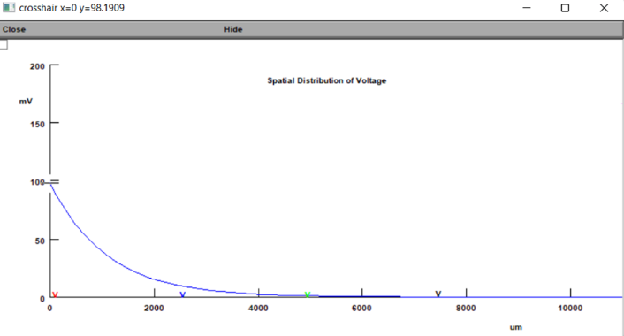Thus, the length constant λ depends on the radius of the axon and is proportional to the square root of the radius. It is then evident that when decreasing the radius of the cable, the length constant also decreases. This is consistent with our results. It is also known that a decrease in the radius of the cable produces an increase in axial resistance. An increased resistance to ion flow through the cable in turn means that an area will become charged/discharged more before passively moving down the cable. This results in a smaller length constant—it takes less distance to charge/discharge the cable.

Figure 3 (top). Crosshairs to pinpoint initial voltage value (left) and the distance to which the initial value decays by 37% (right) using a 5 µm diameter cable.

Figure 4 (left). Settings used to find the answers above.

# **Part 2**

## **Question A**

### ***Mid-Dendritic Location***

The interval that elicits an AP the quickest is at a spacing of 0.3 ms. This is because at intervals of 0.3 seconds, an excitatory stimulus occurs immediately after the previous stimulus has peaked, which maximizes temporal summation and therefore produces an AP the quickest.

Firing all inputs at the same time is not an optimal solution because it does not utilize the advantages of temporal summation. With temporal summation, if the intervals between inputs are too short, an input occurs before the previous input can maximize its charging, resulting in a smaller summation. Since firing all inputs at once means that there is zero time between intervals, temporal summation is not used at all, rendering this method ineffective (See Figure 5).

Likewise, if the intervals between inputs are too long, an input occurs after the previous input has begun to decay, which also leads to a smaller summation or even no summation at all. Thus, having too long intervals is also ineffective (See Figure 7).

The longest interval that still elicits an AP is 0.8 ms.

|  |  |
| --- | --- |
| Temporal Spacing (ms) | Time Range Where Spike is Elicited (ms)* |
| 0 | No Spike |
| 0.1 | No Spike |
| 0.2 | 2.66-2.68 |
| 0.3 | 2.65-2.66 |
| 0.4 | 2.77-2.78 |
| 0.5 | 2.96-2.97 |
| 0.6 | 3.21-3.23 |
| 0.7 | 3.52-3.53 |
| 0.8 | 4.01-4.02 |
| 0.9 | No Spike |

* Since the crosshair skips 0 mV, the time points were taken as the closest points below and above 0 mV. To see the images of the temporal spacing vs. spikes, see **Appendix A**.

### ***Distal Location***

The interval that elicits an AP the quickest is at a spacing of 0.5 ms. The longest interval that still elicits an AP is 0.9 ms.

The best timing for summation in a distal location differs from a mid-dendritic location. Both the best timing interval as well as the longest interval that still elicits an AP is shorter for a mid-dendritic location and longer for a distal location. This may be because the potential must travel a longer distance to reach the soma, so temporal summation is effective when it does not fire in succession too quickly.

|  |  |
| --- | --- |
| Temporal Spacing (ms) | Time Range Where Spike is Elicited (ms)* |
| 0 | No Spike |
| 0.1 | No Spike |
| 0.2 | No Spike |
| 0.3 | No Spike |
| 0.4 | 3.60-3.70 |
| 0.5 | 3.37-3.38 |
| 0.6 | 3.46-3.47 |
| 0.8 | 3.91-3.92 |
| 0.9 | 4.33-4.34 |
| 1.0 | No Spike |

* Since the crosshair skips 0 mV, the time points were taken as the closest points below and above 0 mV. To see the images of the temporal spacing vs. spikes, see **Appendix B**.

## **Question B**

Both: Syn0 synapse at the proximal end of the dendrite, Syn1 in the middle, and Syn2 at the distal end.

Scenario 1: For Syn0 at a delay of 1 ms, Syn1 at a delay of 1.4 ms, and Syn2 at a delay of 1.8 ms: The smallest conductance level that can still trigger an action potential is 2.2 µS.

Scenario 2: For Syn0 at a delay of 1.8 ms, Syn1 at a delay of 1.4 ms, and Syn2 at a delay of 1 ms: The smallest conductance level that can still trigger an action potential is 1.5 µS.

An action potential occurs in this three-synapse scenario when the synapses fire (at spaced intervals of 0.4 ms) and depolarize the membrane of the neuron. Once the membrane is depolarized to reach threshold potential, an action potential occurs.

When the synapse is placed closer to the soma of the post-synaptic neuron, the stimulus from that synapse travels a shorter distance and, assuming the same time/length constants, will be able to decay less than if a synapse was placed farther away from the soma. Thus, an excitatory potential coming from a more proximal synapse will be stronger than that coming from a more distal synapse. In terms of timing, the earlier that a stimulus occurs, the earlier it will begin travelling down the axon.

The conductance for Scenario 2 can be smaller because of the arrangement of the timing and position of the synapses. In the case of Scenario 1, the synapse that fires first is closest to the soma, while the synapse that fires last is farthest from the soma. Thus, the stimulus from the first synapse has both the least time and distance to travel, while the last stimulus has the most time and distance to travel. This leads to intervals that are far apart, meaning that by the time an input reaches the axon, the previous input may have already begun to decay. To compensate for this decay, the conductance must be stronger; it must be easier for ions to flow through the cable, since this will shorten the gaps between the inputs. In contrast, for Scenario 2, the synapse that fires first is farthest the soma, while the synapse that fires last is closest to the soma. Thus, the stimulus from the first synapse has the least time but the most distance to travel, while the last stimulus has the most time but the least distance to travel. This leads to intervals that are closer together, which takes advantage of temporal summation as opposed to letting the potential decay. The conductance can thus be lower in Scenario 2 since it is already easier to produce an action potential due to the timing and position of the synapses.

Figure 5. Smallest conductance level that can trigger an AP, Scenario 1.

Figure 6. Smallest conductance level that can trigger an AP, Scenario 2.

APPENDIX A

APPENDIX B

