

*BIOS 522: Survival Analysis Methods*

**Activity 1:**

**Introduction to time-to-event data**

*This week, we provided an overview of methods for time-to-event data. We studied examples of failure time events, time origins, and time scales. We defined and characterized right censoring. We reviewed the analysis of continuous, binary, and person-time data.*

Problem 1. Sample cohort data

Below is hypothetical survival data for 7 cohort study participants. Each participant is enrolled at time $t=0$ and followed for up to $t=5$*years*. An “X” indicates the time when a participant was observed to die. An “O” indicates the time when a participant was censored due to loss to follow-up or end of study. You can assume that individuals who were censored did not have the event at the censoring time (e.g. the first participant survived beyond $t=5$).

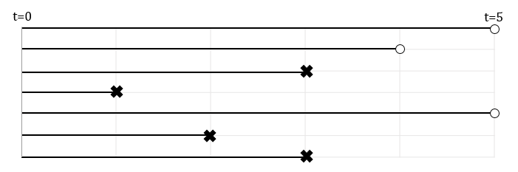

Use this hypothetical data to calculate the following quantities. Answers can be reported as raw fractions or using a calculator. The answers to some questions may be “not calculable.” Be prepared to share your answer with the group.

1. Write out the data in $(T_{i}^{*},δ_{i})$ notation.
$$\left(5, 0\right), \left(4,0\right), \left(3,1\right), \left(1,1\right), \left(5,0\right), \left(2,1\right), \left(3,1\right)$$

2. Write out the data in shorthand notation (e.g., 1, 2+, 3, 4+)

(1,2, 3, 3,4+,5+,5+)

1. Calculate the probability of death at 2 years after enrolment.

Answer: 2/7

1. Calculate the probability of death at 5 years after enrolment.

Answer: not calculable. Though it lies in the range 4/7 to 5/7

1. Calculate the incidence rate during the study period.

Answer: Person time = 5+4+3+1+5+2+3 = 23

Events = 4

Incidence rate = 4/23 or 0.17 events per PY

1. Calculate the mean survival time.

Answer: not calculable.

1. Calculate the median survival time:

Answer: 3 years.

Problem 2. More sample cohort data

Below is an excerpt from a spreadsheet of data for 6 hypothetical cohort study participants. Cancer-free participants are invited to enroll in the prospective study during 1990-1991 and are followed over a period of 20 years. The outcome of interest is diagnosis of cancer.

* “id” is the unique participant identifier
* “dob” is the date of birth (all dates in mm/dd/yyyy format)
* “date_baseline” is the date of enrolment into the study
* “date_cancer” is the date of cancer diagnosis for participants diagnosed with cancer during the follow-up period
* “date_last_followup” is the end of the study (12/31/2010) or date of loss to follow-up (e.g. participant id=6, who moves out of the study region before the end of the study).

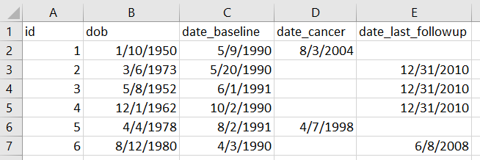

1. Describe how you would create a right-censored follow-up time variable for time since enrolment into the study. (*It is not necessary to calculate the follow-up times exactly. Just describe the process*.)

Calculate difference between date cancer and date of baseline. For these individuals, set the event indicator to 1. For all other individuals (censored at last date of follow-up), calculate the difference between date of baseline and date of last follow-up, and set the event indicator to 0.

1. What is a limitation of using time since enrolment in the analysis? Think about the underlying scientific question.

Time since enrolment is not a biologically meaningful quantity that predicts cancer risk. Age, on the other hand, is an important predictor. Consider calculating a variable for age at enrolment as a covariate in models.

Problem 3. Incidence rates

What is the difference between an incidence rate and cumulative incidence? Describe their units. Can each exceed one?

A cumulative incidence is a probability. It is bounded between 0 and 1. It does not have units of time, but it is calculated assuming a particular duration of follow-up (e.g. cumulative incidence of cancer progression 5 years after diagnosis).

Incidence rates are calculated based on person-time, as they are calculated from the number of events divided by person-time follow up. They will have units like per 100,000 person-years. They are rates, so they are necessarily positive, but are not bounded above by 1.