

*BIOS 522: Survival Analysis Methods*

**Activity 4:**

**The hazard and cumulative hazard functions**

*This week, we defined the hazard and cumulative hazard functions and their relationship to the survival function. We studied three key parametric distributions used for time-to-event data. We reviewed maximum likelihood estimation for survival data. We estimated the cumulative hazard function using the Nelson-Aalen estimator.*

Problem 1. Wordle and discrete time survival

Wordle is a popular word game. Each day, players are given six guesses to guess a secret five-letter word. If the player cannot guess the word in six guesses, they lose. The game tracks statistics for how often a player wins, and, among the wins, how often the player gets the answer in 1, 2, 3, 4, 5 or 6 guesses. An example of a player’s win statistics are provided below.

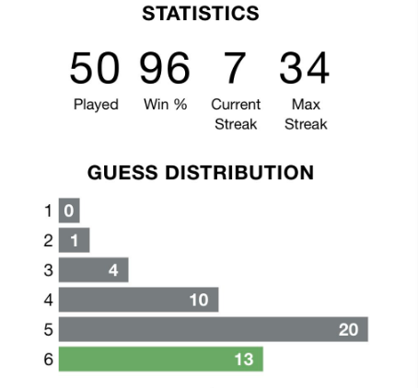

1. To the extent allowable by the data, estimate the density function for this player’s guess distribution. What happens after 6 guesses?

$$\hat{f}\left(1\right)=\frac{0}{50}, \hat{f}\left(2\right)=\frac{1}{50}, \hat{f}\left(3\right)=\frac{4}{50}$$

$$\hat{f}\left(4\right)=\frac{10}{50}, \hat{f}\left(5\right)=\frac{20}{50}, \hat{f}\left(6\right)=\frac{13}{50}$$

After 6 guesses, the data are censored, so we are unable to estimate the rest of the density, although we know it has mass 2/50 (corresponding to the two lost games of 50 total played).

1. In discrete time, the hazard is the conditional probability of the event occurring at time $t$ given that the event has not yet occurred immediately before time $t$. Estimate the hazard function for times $t=1,…,6$ using the player’s guess distribution.
$$\hat{h}\left(1\right)=\frac{0}{50}=0, \hat{h}\left(2\right)=\frac{1}{50}=0.02, \hat{h}\left(3\right)=\frac{4}{49}=0.08$$

$$\hat{h}\left(4\right)=\frac{10}{45}=0.22, \hat{h}\left(5\right)=\frac{20}{35}=0.57, \hat{h}\left(6\right)=\frac{13}{15}=0.87$$

2. Do the density function and hazard function maximize at the same time? Why or why not?

No, they do not need to maximize at the same time. Here, they do not. The density function declines after the 5th guess, but the hazard continues to increase. That is because the player has typically won by the 5th guess, meaning it isn’t typical for them to make it to the sixth guess. But if they haven’t won yet, they have a very high probability of winning on the sixth guess (as characterized by the high hazard).

Problem 2. Sketching the hazard functions

For each of the five pairs of survival curves shown below, sketch the corresponding pairs of hazard functions.

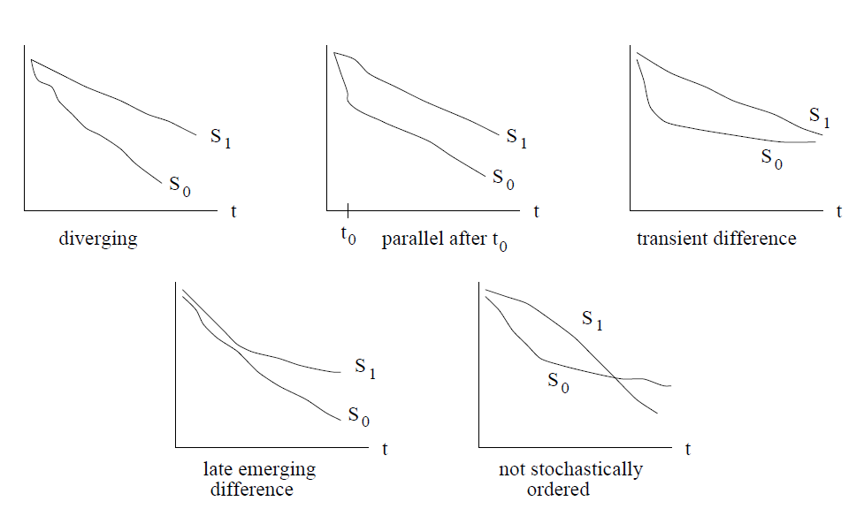

Rough answers

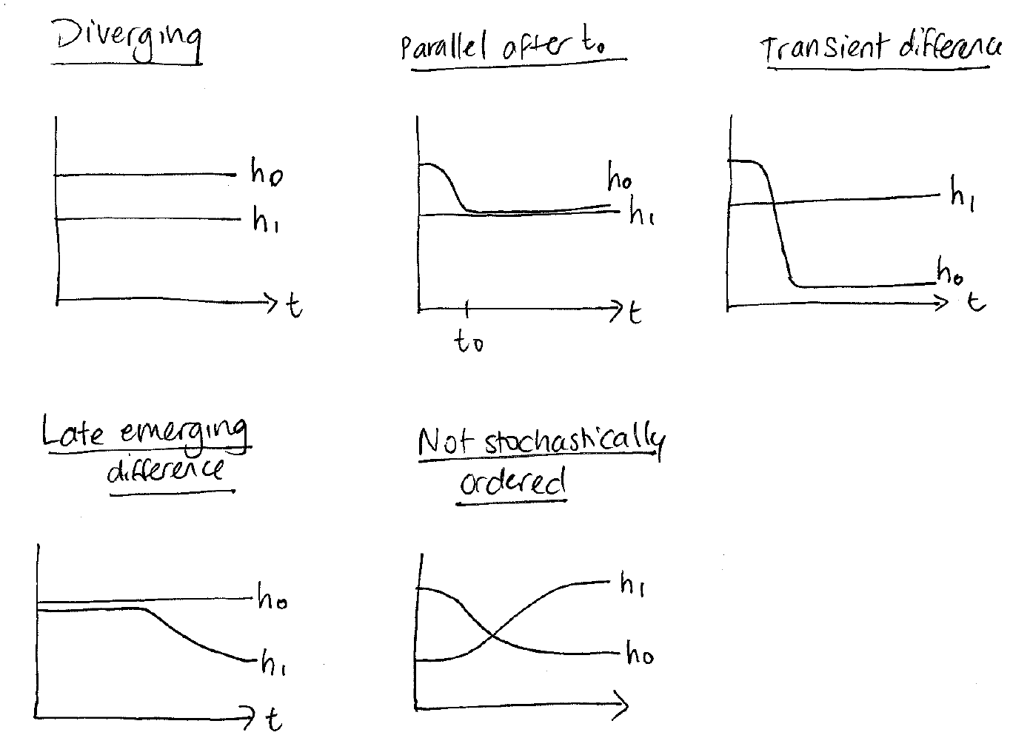

Problem 3. Log-logistic likelihood function

Recall that the log-logistic distribution has rate parameter $λ$ and shape parameter $γ$. It has hazard function:

$$h\left(t\right)=\frac{λγ{\left(λt\right)}^{γ-1}}{1+{\left(λt\right)}^{γ}}$$

And survival function:

$$S\left(t\right)=\frac{1}{1+{\left(λt\right)}^{γ}}$$

Define the likelihood function for right-censored data when the underlying failure time random variable $T$ follows the log-logistic distribution.

We start with the general form of the likelihood function for right-censored data, and then we plug in the hazard and survival functions for the Weibull distribution to get our likelihood function:

$$L\left(λ,γ\right)=\prod_{i=1}^{n}{{\left[h\left(T_{i}^{*}|λ,γ\right)\right]}^{δ_{i}}S(T_{i}^{*}|λ,γ)} \\ =\prod_{i=1}^{n}{{\left[\frac{λγ{\left(λT_{i}^{*}\right)}^{γ-1}}{1+{\left(λT_{i}^{*}\right)}^{γ}} \right]}^{δ_{i}}\left(\frac{1}{1+{\left(λT_{i}^{*}\right)}^{γ}}\right)}$$