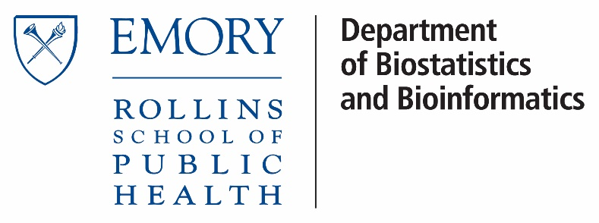

*BIOS 522: Survival Analysis Methods*

**Activity 9:**

**Parametric regression models**

*This week, we defined the parametric proportional hazards model and accelerated failure time model.*

Problem 1. Weibull AFT model with ACTG 320 data

Consider data from the ACTG 320 trial comparing AIDS-free survival for HIV-infected patients receiving indinavir versus placebo. This data set was first introduced in **Reading 6**.

We fit a Weibull accelerated failure time model to the data, including treatment $X_{i,tx}$ and age $X_{i,age}$ (continuous) as covariates.

$$T_{i}=\exp\left(α_{tx}X_{i,tx}+α_{age}X_{i,age}\right)T_{0}$$

We can use maximum likelihood estimation to estimate ${\hat{α}}_{tx}$ , ${\hat{α}}_{age}$ , ${\hat{λ}}_{0}$ , and ${\hat{γ}}_{0}$ .

The estimated baseline rate parameter is   weeks-1, and the estimated baseline shape parameter is ${\hat{γ}}_{0}=0.781$ .

For our covariates, the coefficients, their standard errors, Wald test statistics, and p-values are provided in the table below:

|  |  |  |  |  |
| --- | --- | --- | --- | --- |
| **Covariate** | **Coefficient** | **Standard error** | **Wald test Z** | **Wald test p-value** |
| *Treatment* | 0.8875 | 0.2881 | 3.08 | 0.0021 |
| *Age* | -0.0255 | 0.0141 | -1.80 | 0.0712 |

1. Report the acceleration factor for treatment, adjusting for age. Provide a written interpretation.

We exponentiate the coefficient:

$$\exp\left({\hat{α}}_{tx}\right)=\exp\left(0.8875\right)=2.43$$

Thus, the estimated acceleration factor is 2.43. After adjusting for age, patients receiving indinavir survived 2.43 times longer on average than patients receiving placebo.

1. Report a 95% confidence interval for the acceleration factor for treatment, adjusting for age. Do this by calculating a 95% Wald-confidence interval for the *coefficient* ($±1.96 \hat{SE}$) and then transforming to the acceleration factor scale.

$$\left({\hat{α}}_{tx}-1.96 \hat{SE}\left({\hat{α}}_{tx}\right), {\hat{α}}_{tx}+1.96 \hat{SE}\left({\hat{α}}_{tx}\right)\right) \\ =\left(0.8875-1.96(0.2881), 0.8875+1.96\left(0.2881\right)\right) \\ =(0.3228, 1.4522)$$

To calculate a confidence interval for the acceleration factor, we exponentiate the endpoints of the above interval.

$$\left(\exp\left(0.3228\right),\exp\left(1.4522\right)\right)=(1.381, 4.272)$$

Thus, a 95% confidence interval for the acceleration factor is (1.381, 4.272).

1. Is there evidence of a statistically significant effect of indinavir on AIDS-free survival, adjusting for age?

We are interested in testing the null hypothesis that indinavir has no effect on AIDS-free survival, or, equivalently, $H_{0}: α_{tx}=0$. We can perform a Wald test:

$$Z=\frac{{\hat{α}}_{tx}}{\hat{SE}({\hat{α}}_{tx})}=\frac{0.8875}{0.2881}=3.08$$

This test statistic has associated two-sided p-value of 0.0021. Thus there is significant evidence that indinavir improves AIDS-free survival.

1. Calculate the acceleration factor for a 10-year increase in age, holding treatment constant. Provide an interpretation.

To calculate the change in survival for a ten-year increase in age:

$$\exp\left({\hat{α}}_{age}×10\right)=\exp\left(-0.0255×10\right)=0.775$$

Thus, patients ten-years older have AIDS-free survival times 77.5% as long as their younger counterparts receiving the same treatment.

*Because the AFT model is fully parametric, we can use our fitted model to make predictions about survival for any population. Recall that one way of expressing the AFT model is:*

$$S_{i}\left(t\right)=S_{0}\left(e^{-\left(α_{1}X_{i1}+…+α_{k}X_{ik}\right)}t\right)$$

*Thus, to use a fitted model to calculate survival at time $t$ for individual $i$ with covariates $X_{i1},…,X_{ik}$, we follow these steps:*

* *Use the covariates $X_{i1},…,X_{ik}$ and fitted coefficients ${\hat{α}}_{1},…,{\hat{α}}_{k}$  to calculate the combined effect of the covariates, relative to the reference group $e^{-\left({\hat{α}}_{1}X_{i1}+…+{\hat{α}}_{k}X_{ik}\right)}$*
* *Given the desired time $t$, calculate the “sped up” or “slowed down” time for our target population $t^{*}=e^{-\left({\hat{α}}_{1}X_{i1}+…+{\hat{α}}_{k}X_{ik}\right)}t$*
* *Use the fitted baseline/reference group parameters to define the survival function in the baseline/reference group ${\hat{S}}_{0}(t)$ . For example, if we are using a Weibull AFT model:*
$${\hat{S}}_{0}\left(t\right)=\exp\left(-{\left({\hat{λ}}_{0}t\right)}^{{\hat{γ}}_{0}}\right)$$

* *Plug the “sped up” or “slowed down” time $t^{*}$ into ${\hat{S}}_{0}(t^{*})$*

*We follow these steps using our example from the ACTG 320 data set, using an example of predicted one-year survival for a 60 year old receiving indinavir.*

1. Calculate the combined acceleration factor, relative to the reference group, for an individual who is 60 years old and is receiving indinavir.
$$\exp\left\{-\left({\hat{α}}_{tx}+{\hat{α}}_{age}60\right)\right\}=\exp\left\{-\left(0.8875-0.0255×60\right)\right\}=1.901$$

2. We are interested in calculating one-year survival. Calculate the sped up or slowed down time equivalent for our target population.

There are 52 weeks in a year.

$$t^{*}=\exp\left\{-\left({\hat{α}}_{tx}X_{i,tx}+{\hat{α}}_{age}X_{i,age}\right)\right\}t$$

$$t^{*}=1.901*52=98.852 wks$$

1. Write out an expression for the survival function for the reference group.

Recall that the Weibull distribution has survival function

$$S\left(t\right)=\exp\left(-{\left(λt\right)}^{γ}\right)$$

So, the reference group has distribution:

$$S_{0}\left(t\right)=\exp\left(-{\left(0.0001*t\right)}^{0.781}\right)$$

This refers to the group with age=0 years, treatment=placebo.

1. Use the expression above to calculate the model-predicted one-year AIDS-free survival for a 60-year old receiving indinavir.

$$S_{0}\left(t\right)=\exp\left(-{\left(0.0001*98.852\right)}^{0.781}\right)=97.32\%$$