

*BIOS 522: Survival Analysis Methods*

**Homework - Weeks 1-3**

*Homework assignments contain a mix of theoretical, applied, and computing questions. Students are encouraged to work with classmates but must prepare their answers individually. Copying and pasting between students is not allowed. Assignments are graded on presentation, and points will be deducted from messy or illegible answers.*

Problem 1. Glioma data (3 points)

The following data summarize weeks to death or censoring in 20 adults with recurrent gliomas. Adults are separated into two groups by glioma type: astrocytoma or glioblastoma.

|  |
| --- |
| Astrocytoma: 6, 6+, 13, 21, 30, 31+, 37, 38, 47+, 49 |
| Glioblastoma: 10, 10, 13, 25, 33, 36, 47, 49, 50+, 50+ |

*For all questions, provide your code throughout or append it to the end of your document.*

1. (1 point) Read the above data into R. Create a single plot that includes a Kaplan-Meier curve for each glioma type. Include proper labels.



1. (0.5 points) For the Astrocytoma group, report a point estimate of survival at 25 weeks. Include a Wald confidence interval, a log-transformed confidence interval, and a log-log transformed confidence interval.

The estimated survival probability for the Astrocytoma group at 25 weeks is 0.675. The 95% Wald confidence interval is 0.371 to 0.979. The 95% log-transformed confidence interval is 0.430 to 1.00. Finally, the log-log transformed confidence interval is 0.291 to 0.882.

1. (0.5 points) Report median survival time for each glioma type.

The median survival time is 37.0 weeks for the Astrocytoma group and 34.5 weeks for the Glioblastoma group.

1. (0.5 points) Setting the astrocytoma group as Group 0 and the glioblastoma group as Group 1, calculate $O_{j}$, $E_{j}$, and $V_{j}$ for the **first 3 distinct failure times**. *It is not necessary to calculate the entire test statistic.*

Starting with $t_{1}=6:$

|  |  |  |  |
| --- | --- | --- | --- |
|  | Fail | Survive | At risk |
| Group 0 | 1 | 9 | 10 |
| Group 1 | 0 | 10 | 10 |
|  | 1 | 19 | 20 |

$$O_{1}=1$$

$$E_{1}=\left(\frac{10}{20}\right)(1)=0.5$$

$$V_{1}=\frac{\left(10\right)\left(10\right)(1)\left(20-1\right)}{{20}^{2}(20-1)}=0.25$$

At this time point, observed is higher than expected, indicating a higher rate in Group 0.

Then at $t_{2}=10$, note that one person in group 0 was censored at $t=6$, so only 8 people are at risk.

|  |  |  |  |
| --- | --- | --- | --- |
|  | Fail | Survive | At risk |
| Group 0 | 0 | 8 | 8 |
| Group 1 | 2 | 8 | 10 |
|  | 2 | 16 | 18 |

$$O_{2}=0$$

$$E_{2}=\left(\frac{8}{18}\right)(2)=0.889$$

$$V_{2}=\frac{\left(8\right)\left(10\right)(2)\left(18-2\right)}{{18}^{2}(18-1)}=0.465$$

At this time point, observed is lower than expected, indicating a lower rate in Group 0 (and a higher rate in Group 1).

Finally (for this question at least), at $t_{3}=13$:

|  |  |  |  |
| --- | --- | --- | --- |
|  | Fail | Survive | At risk |
| Group 0 | 1 | 7 | 8 |
| Group 1 | 1 | 7 | 8 |
|  | 2 | 14 | 16 |

$$O_{3}=1$$

$$E_{3}=\left(\frac{8}{16}\right)(2)=1$$

$$V_{3}=\frac{\left(8\right)\left(8\right)(2)\left(16-2\right)}{{16}^{2}(16-1)}=0.467$$

At this time point, observed is equal to expected, indicating equal rates in Groups 0 and 1.

1. (0.5 points) Use R to compute a log-rank test statistic and associated p-value. Clearly identify the test statistic and p-value. Provide a conclusion for the data.

The chi-squared test statistic is 0.0872. The p-value is 0.8.

There is no evidence of a statistically significant difference in survival between patients with astrocytoma and patients with glioblastoma. We draw this conclusion because the test statistic $Z^{2}<3.84$. In fact, it is nearly zero, indicating that the groups are highly similar. This can be further assessed with a Kaplan-Meier plot.

R code for Question 1:

Problem 2. The empirical CDF and Kaplan-Meier estimator (2.5 points)

When there is no censoring or truncation, the Kaplan-Meier estimator simplifies to $\hat{S}\left(t\right)=1-\hat{F}(t)$  where $\hat{F}(t)$  is the empirical CDF. Confidence intervals are also identical. In this problem, you will prove this.

1. (0.5 points) Show that $n_{j+1}=n_{j}-d_{j}$ for all $j$ when there is no right censoring or left truncation.

Since there is no left truncation, we have no delayed entry into the study. Since there is no right censoring, the only way to exit the study is to fail. Thus, the number of people at risk in $\left(t_{j},t_{j+1}\right]$ includes the $n_{j}$ people at risk in $\left(t_{j-1},t_{j}\right]$ minus the $d_{j}$ who failed at $t_{j}$ so $n_{j+1}=n_{j}-d_{j}$.

1. (1 point) Use the result of part (a) to show that $\hat{S}\left(t\right)=1-\hat{F}\left(t\right)$ when there is no censoring or truncation.

Choose $t$ and let $k-1=max j:t_{j}≤t$. We start with $n_{1}=n$ people under observation and have $n_{k}$ people with survival times $>t$. When there is no censoring or truncation, $n_{j+1}=n_{j}-d_{j}$ for each $j$ and the distribution of survival times $T_{1},…,T_{n}$ is the same as the distribution of the times to failure $T_{1}^{F},…,T_{n}^{F}$. The empirical CDF is

$$\hat{F}\left(t\right)=\frac{1}{n_{1}}\sum_{i=1}^{n}{1_{T_{i}^{F}}}=\frac{n_{1}-n_{k}}{n_{1}}=1-\frac{n_{k}}{n_{1}}$$

The Kaplan-Meier estimate of the survival function is



$$=\frac{n_{2}}{n_{1}}×\frac{n_{3}}{n_{2}}×...×\frac{n_{k}}{n_{k-1}}=\frac{n_{k}}{n_{1}}$$

Therefore $\hat{S}\left(t\right)=1-\hat{F}\left(t\right)$.

1. (1 point) Show that $Var\left(\hat{S}\left(t\right)\right)=\frac{\hat{S}\left(t\right)\left(1-\hat{S}\left(t\right)\right)}{n}$ when there is no censoring or truncation. Compare this to the variance of the empirical CDF. [Hint: with no censoring or truncation,

$$\frac{d_{j}}{n_{j}\left(n_{j}-d_{j}\right)}=\frac{n_{j}-n_{j+1}}{n_{j}n_{j+1}}=\frac{1}{n_{j+1}}-\frac{1}{n_{j}}$$

For all $j$.]

The Greenwood formula for the estimated variance of $\hat{S}\left(t\right)$ is



Because $n_{j}-d_{j}=n_{j+1}$ when there is no censoring or truncation, we can simplify the sum:



$$=\sum_{j=1}^{k-1}{\frac{1}{n_{j+1}}}-\frac{1}{n_{j}}$$

$$=\left(\frac{1}{n_{2}}-\frac{1}{n_{1}}\right)+\left(\frac{1}{n_{3}}-\frac{1}{n_{2}}\right)+...+\left(\frac{1}{n_{k}}-\frac{1}{n_{k-1}}\right)$$

$$=\frac{1}{n_{k}}-\frac{1}{n_{1}}$$

Using the result from part b) that $\hat{S}\left(t\right)=\frac{n_{k}}{n_{1}}$ and the result from above that, we find that the Greenwood variance formula simplifies to

$$Var\left(\hat{S}\left(t\right)\right)=\hat{S}{\left(t\right)}^{2}\left(\frac{1}{n_{k}}-\frac{1}{n_{1}}\right)=\hat{S}{\left(t\right)}^{2}\left(\frac{n_{1}-n_{k}}{n_{1}n_{k}}\right)$$

$$=\hat{S}{\left(t\right)}^{2}\left(\frac{1-\hat{S}\left(t\right)}{n_{1}\hat{S}\left(t\right)}\right)=\frac{\hat{S}\left(t\right)\left(1-\hat{S}\left(t\right)\right)}{n_{1}},$$

which is the same as the estimated variance from a binomial proportion with $n_{k}$“successes” out of $n_{1}$ trials.

Problem 3. Log- and log-log-transformed confidence intervals (3 points)

Consider unknown quantity of interest $β$. Let $\hat{β}$  be a valid estimator of $β$, and $\hat{Var}(\hat{β})$  is an estimator of the variance of $\hat{β}$ . We are interested in the transformation $g(β)$. One can estimate $g(β)$ by $g(\hat{β})$. The Delta method suggests the following estimator for the variance of $g(\hat{β})$:

$$\hat{Var}\left[g\left(\hat{β}\right)\right]={\left[g^{'}\left(\hat{β}\right)\right]}^{2}\hat{Var}(\hat{β})$$

In this problem, you will derive log transformed and complementary log-log transformed confidence intervals for the Kaplan-Meier estimator.

1. (1.5 points) Follow the steps below to create a log-transformed confidence interval estimator for $S\left(t\right)$.

* **Step 1.** Use Greenwood’s formula and the Delta method to find an estimator of $\hat{Var}\left[\log\left(\hat{S}\left(t\right)\right)\right]$.
* **Step 2.** Build a confidence interval for $\log\left(S\left(t\right)\right)$.
* **Step 3.** Transform this interval to create an interval for $S(t)$.

Step 1:

Greenwood’s formula:

$$\hat{Var} \hat{S}\left(t\right)={\left(\hat{S}\left(t\right)\right)}^{2}\sum_{j:t_{j}≤t}{\frac{d_{j}}{n_{j}(n_{j}-d_{j})}}$$

The transformation is $g\left(β\right)=log⁡(β)$ with first derivative $g^{'}\left(β\right)=1/β$. $$\hat{Var}\left[\log\left(\hat{S}\left(t\right)\right)\right]={\left[\frac{1}{\hat{S}\left(t\right)}\right]}^{2}\hat{Var}\left(\hat{S}\left(t\right)\right) \\ ={\left[\frac{1}{\hat{S}\left(t\right)}\right]}^{2}{\left(\hat{S}\left(t\right)\right)}^{2}\sum_{j:t_{j}≤t}{\frac{d_{j}}{n_{j}(n_{j}-d_{j})}} \\ =\sum_{j:t_{j}≤t}{\frac{d_{j}}{n_{j}(n_{j}-d_{j})}}$$

Step 2:

$$\log\left(\hat{S}\left(t\right)\right)±1.96\sqrt{\hat{Var}\left[\log\left(\hat{S}\left(t\right)\right)\right]}$$

Step 3:

$$\exp\left\{\log\left(\hat{S}\left(t\right)\right)±1.96 \sqrt{\hat{Var}\left[\log\left(\hat{S}\left(t\right)\right)\right]}\right\}$$

$$\hat{S}\left(t\right)\exp\left\{±1.96 \sqrt{\sum_{j:t_{j}≤t}{\frac{d_{j}}{n_{j}(n_{j}-d_{j})}}}\right\}$$

Can also be written as:

$$\left(\hat{S}\left(t\right)e^{-1.96w}, \hat{S}\left(t\right)e^{1.96w}\right)$$

Where $w=\sqrt{\sum_{j:t_{j}≤t}{\frac{d_{j}}{n_{j}(n_{j}-d_{j})}}}$

1. (1.5 points) Follow the steps below to create a complementary log-log transformed confidence interval estimator for $S\left(t\right)$.

* **Step 1.** Use $\hat{Var}\left[\log\left(\hat{S}\left(t\right)\right)\right]$ and another application of the Delta method to find an estimator of $\hat{Var}\left[\log\left\{-\log\left(\hat{S}\left(t\right)\right)\right\}\right]$.
* **Step 2.** Build a confidence interval for $\log\left\{-\log\left(S\left(t\right)\right)\right\}$.
* **Step 3.** Transform this interval to create an interval for $S(t)$.

Step 1:

From the previous question:

$$\hat{Var}\left[\log\left(\hat{S}\left(t\right)\right)\right]=\sum_{j:t_{j}≤t}{\frac{d_{j}}{n_{j}(n_{j}-d_{j})}}$$

For the next application of the Delta method, our transformation is $g\left(β\right)=\log\left(-β\right)$ with first derivative $g^{'}\left(β\right)=-1/β$:

$$\hat{Var}\left[\log\left\{-\log\left(\hat{S}\left(t\right)\right)\right\}\right]={\left[-\frac{1}{\log\left(\hat{S}\left(t\right)\right)}\right]}^{2}\sum_{j:t_{j}≤t}{\frac{d_{j}}{n_{j}(n_{j}-d_{j})}} \\ =\frac{1}{{\left[\log\left(\hat{S}\left(t\right)\right)\right]}^{2}}\sum_{j:t_{j}≤t}{\frac{d_{j}}{n_{j}(n_{j}-d_{j})}}$$

Step 2:

$$\log\left\{-\log\left(\hat{S}\left(t\right)\right)\right\}±1.96\sqrt{\hat{Var}\left[\log\left\{-\log\left(\hat{S}\left(t\right)\right)\right\}\right]}$$

Step 3:

To back-transform, apply the first exponential:

$$\exp\left\{\log\left\{-\log\left(\hat{S}\left(t\right)\right)\right\}±1.96\sqrt{\hat{Var}\left[\log\left\{-\log\left(\hat{S}\left(t\right)\right)\right\}\right]}\right\}$$

$$-\log\left(\hat{S}\left(t\right)\right)\exp\left\{±1.96\sqrt{\frac{1}{{\left[\log\left(\hat{S}\left(t\right)\right)\right]}^{2}}\sum_{j:t_{j}≤t}{\frac{d_{j}}{n_{j}(n_{j}-d_{j})}}}\right\}$$

Take the negative of the inside and then the second exponential:

$$\exp\left(\log\left(\hat{S}\left(t\right)\right)\exp\left\{±1.96\sqrt{\frac{1}{{\left[\log\left(\hat{S}\left(t\right)\right)\right]}^{2}}\sum_{j:t_{j}≤t}{\frac{d_{j}}{n_{j}\left(n_{j}-d_{j}\right)}}}\right\}\right)$$

Which can be rewritten as:

$$\left({\left[\hat{S}\left(t\right)\right]}^{exp⁡(1.96w)},{\left[\hat{S}\left(t\right)\right]}^{exp⁡(-1.96w)}\right)$$

Where

$$w=\sqrt{\frac{1}{{\left[\log\left(\hat{S}\left(t\right)\right)\right]}^{2}}\sum_{j:t_{j}≤t}{\frac{d_{j}}{n_{j}\left(n_{j}-d_{j}\right)}}}$$

Solution also described on pages 24-26 of <https://mathweb.ucsd.edu/~rxu/math284/slect2.pdf>

Problem 4. Anatomy of a Kaplan-Meier figure (1.5 points)

A randomized trial was conducted to evaluate a novel treatment for carcinoma of the head and neck (Ferris et al 2016, NEJM, DOI: 10.1056/NEJMoa1602252). Patients were randomized to receive either nivolumab or standard therapy. The primary endpoint of the trial was overall survival (death by any cause) from the time of randomization.

Figure 1, Panel A is provided below and “shows the Kaplan-Meier curves for overall survival among all the patients who underwent randomization and were assigned to receive either nivolumab or standard therapy.”

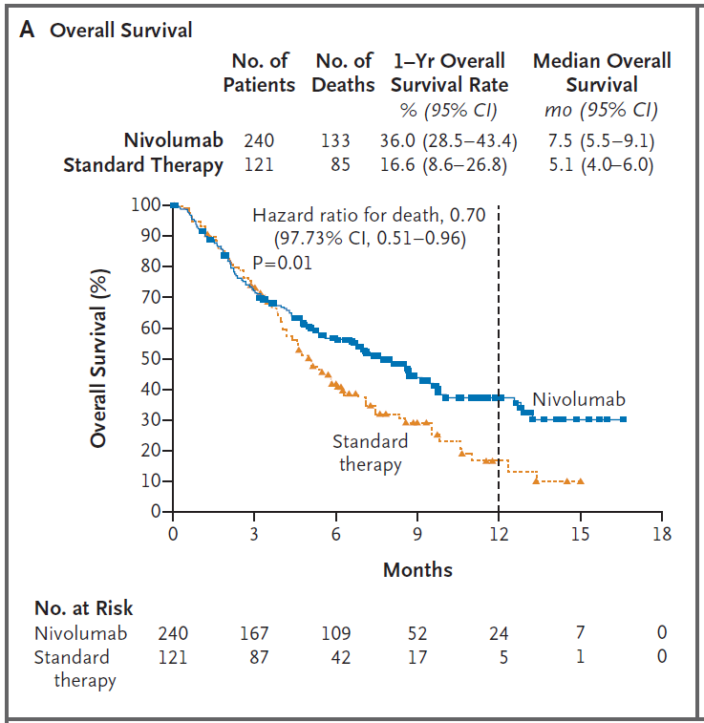

1. (0.5 points) The p-value reported in Figure 1 is p=0.01. From the Statistical Analysis section of the Methods, “[t]he distributions of overall survival and progression-free survival were estimated by the Kaplan–Meier method and compared by means of log-rank tests stratified according to previous receipt of cetuximab (yes or no).”

Why did the authors choose to stratify on previous receipt of cetuximab? Is stratification necessary for valid inference in this setting? (*Suggested answer length: 2-4 sentences*)

Improves precision. Not necessary since it is a randomized trial.

1. (0.5 points) Considering the shape of the curves above, if we were to use a weighted log-rank test approach (e.g. Generalized Wilcoxon) instead of an unweighted approach, would we expect $Z^{2}$ to increase to a HIGHER value or decrease to a LOWER value?

*Explain your reasoning. (Suggested answer length: 1-2 sentences)*

A weighted test statistic would emphasize early differences, but in fact the groups are quite similar early on. This would tend to decrease the test statistic (and increase the p-value).

Figure 1, Panel B is also provided below and “shows the Kaplan-Meier curves for progression-free survival among all the patients who underwent randomization.”

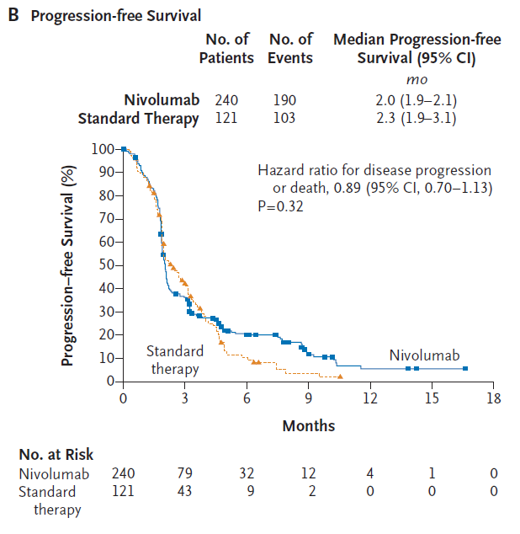

1. (0.5 points) Describe the difference between the definition of progression-free survival and overall survival. How do the resulting sets of Kaplan-Meier curves differ (Panel A vs. Panel B)? (*Suggested answer length: 2-4 sentences*)

Survival OR disease progression. Many patients progress within the first few months, so there is a steeper and earlier drop off than in the overall survival plot. Less of an apparent difference between the groups.