ROCHESTER INSTITUTE OF TECHNOLOGY

HACKING FOR HUMANITY:
INCREASING PARTICIPATION IN HUMANITARIAN FREE/OPEN SOURCE SOFTWARE DEVELOPMENT THROUGH “RANDOM HACKS OF KINDNESS”
GLOBAL HACKATHONS

Submitted as a Capstone Project Report in partial fulfillment of a Master of Science Degree in Professional Studies at RIT’s Center for Multidisciplinary Studies

J. R. DeCausemaker
April 19th, 2013
Table of Contents

Title Page | 1 |  | Conclusion
Table of Contents | 2 |  | Problem Recap | 32
Abstract | 3 |  | Overall Summary | 32
Problem Background | 4
Literature Review |  |  | Recommendations
Copyright Basics | 7 |  | How to Utilize | 35
Licensing and Intellectual Property | 8 |  | What to Do Differently | 36
Copyleft Licenses | 8 |  | Specific Course Preparation | 38
Permissive Licenses | 9 |  | Showing the Story | 40
Normative Behavior | 10 |  | Acknowledgments and Thank Yous | 41
Motivation through Reputation | 11
Community Architecture: Streams and Stacks | 12 |  | References Cited | 42
Knowledge Spillover and Positive Externalities | 13 |  | Appendices
Publicly Licensed Software as Public Good | 14 |  | Appendix A: License To RhoK | 45
Project Description and Methodology |  |  | Appendix B: The Event Flyer | 47
The Idea | 16 |  | Appendix C:Eventbrite.com Registration Page | 48
The License | 17 |  | Appendix D: RIT Press Release | 49
The Venue | 17 |  | Appendix E: Henrietta Post Online Article | 50
The Acceptance | 18 |  | Appendix F: Radio Interview with Bob Smith WXXI | 51
The Flyer | 18 |  | Appendix G: YNN News Clip | 52
The Event Listing | 19 |  | Appendix H: YNN Online Article | 53
The CapitolCamp Conference | 20 |  | Appendix I: RIT Reporter Online Article | 54
The Press Release Draft | 22 |  | Appendix J: RIT Reporter Magazine Article | 55
The Keynotes Confirm | 23 |  | Appendix K: 13WHAM Online Article | 56
The Press Release Released | 23 |  | Appendix L: 13WHAM News Clip | 57
The Swag | 24 |  | Appendix M: Democrat & Chronicle Newspaper Article | 58
The Radio Interview | 24 |  | Appendix N: Venue Photos | 59
The Keynotes Arrive | 24 |  | Appendix O: RHoK Event Planning Kit | 62
The Day of | 25 |  | Appendix P: Multi-Gource Scripts | 96
Project Results
The Count Down | 29
The Main Event | 27
The Press | 27
The Next Day | 28
The Presentations | 29
Abstract

This capstone will address the important problem of improving the exposure of, and participation in, the Random Hacks of Kindness Global Hackathon.

Hackathons—or social coding marathons—are focused events that require low-time commitment, but can provide high-impact results. In the case of Random Hacks of Kindness (RHoK), this is achieved through partnering with International organizations such as the PeaceCorps, Amnesty International, and the Red Cross, as well as governments, emergency responders, volunteers, and aid workers around the world, to identify pressing but solvable problems that can be tackled over the course of a weekend (RHoK.org/about).

The ultimate outcome of this work will be increased awareness and exposure to the history, process, and impact that events such as RHoK can have on some of the most complex problems facing humanity; leading to increased participation, stronger partnerships, and a higher quality and quantity of technical solutions.

Problem Background

It is not just one, but many problems that organizations like Random Hacks of Kindness (RHoK) attempt to solve each year. There are thousands of volunteers who donate their time and effort to answer the call from aid organizations such as the PeaceCorps, however, these volunteers do not always possess the requisite technical skills to build their own solutions.
More often than not, many of these aid organizations must prioritize their budgets to meet the physical needs of devastated and impoverished communities. Hardware and software development projects, though having the potential and capacity to have significant impact, are prohibitively expensive, and are problematic to fund, due to Intellectual property issues and talent deficits within aid organizations.
Most technical professionals with the capabilities to build such products are in high demand in the global labor force, require extensive education (with extensive loans to repay), and are accustomed to high-technology environments. Volunteer work rarely takes place in highly technological destinations, is rarely compensated at the same levels as private-sector employment, and usually require multi-year tours of duty.
If a project is not developed 'in-house' at an organization, buying an 'off the shelf' solution is usually the only alternative. These solutions require the aid organization to purchase expensive licenses, in many cases on an annual or monthly basis, for each location they would like to use the solution. These solutions almost always require site-specific customizations to solve a particular kind of problem in each location, which requires technical prowess, and incurs additional consulting, support, or contracting costs. Software licenses themselves can be prohibitively expensive, let alone paying for customization and maintenance.
Enter RHoK.org, Random Hacks of Kindness. An international organization whose mission is "to create a self-sustaining global community of innovators building practical open technology for a better world, and to ensure their work creates impact in society." Through partnering with public and private sector organizations, RHoK hosts world-wide collaborative coding events that produce solutions to a whole gamut of problems over the course of 48 hours.
United Nations Secretary General Ban Ki-Moon, gave the keynote address at the 2nd annual Random Hacks of Kindness kickoff. Below is an excerpt of his address hosted at the United Nations Global Pulse Blog, UNGlobalPulse.org:

"In this room, we have two cutting edge 21st century movements coming together.
The first is the participatory development movement, where developers work with people in need to improve their lives. Because people have a sense of ownership, what is created is more sustainable, appropriate, and effective. The second movement is the Free/Open Source Software movement, in which programmers around the world work together to create tools that are available to anyone. This is software that people can use to raise their standards of living, and those of their communities. Both movements have a common denominator; empower people at the grassroots level to build their own solutions. The global pulse initiative of the United Nations is also about harnessing technology for the greater good." (UNGlobalPulse.org)

At the federal level, there have been a number of initiatives and statements of support that have surfaced on Whitehouse.gov since President Obama took office in 2008. Starting day one of his first term with the Open Government Memo from the Office of Management and Budget. Aneesh Chopra's Hacking for Humanity blog post on the Whitehouse Blog was specifically released to help promote RHoK participation. Most recently the comprehensive Digital Government: Building a 21st Century Platform to Better Serve the American People, was released which is a compilation of Open Source and Open Government strategies all collected in one place. Walking the talk and leading by example, the site itself is hosted Drupal, and was built with Bootstrap, both of which are Open Source Software. The Whitehouse has even begun to give back to the community, and established an official presence on upstream websites and online code forges, as evidenced by Peter Welsch in his Whitehouse.gov blog post Open Source and the Power of Community.
Though Government-as-a-Platform, Open Government, Open Data, and Humanitarian Development have all been supported as proposed solutions at the national and international level, there is still a problem; there are never enough people to start, let alone finish, all the problems submitted for this event, and others like it.

Literature Review

Before discussing the capstone project and its outcomes, we must first frame the terminology, motivations, and challenges and benefits of Free/Open Source Software Development. Here we will review the myths around FOSS, the basics of copyright, categories of FOSS licenses, normative behavior, motivation, community architecture, and positive externality and benefit to the market.

Copyright Basics

Copyright in the United States protects "original works of authorship," such as literary, dramatic, musical, artistic and other works (United States Copyright Office, 2008). It grants authors these Exclusive rights to their original works:
- To Reproduce, or copy the works;
- To make derivatives, or modify the works;
- To distribute copies of the works to the public, by sale, transfer of ownership, rental, lease, or lending;
and in the case of case of literary, musical, dramatic, and choreographic works, pantomimes, and motion pictures and other audio visual works
- To perform the works publicly;
- To display the works publicly;
additionally in the case of sound recordings,
- to perform the work publicly by means of a digital audio transmission.

Licensing and Intellectual Property
(DeCausemaker, Source Code, p. 9-10)

Exclusivity may be the default state of these copyrights (even for unpublished works) but it is for the author to decide if, when, and how to grant these copyrights to others in the form of a license agreement. Authors can choose to license some or all of their rights to third-parties under conditions of the author's choosing .
The license under which copyrighted code is released is possibly one of the most powerful non-verbal cues a hacker can send to the development community. It is a statement of exactly what the original author permits others to do with their own original work, and any future conditions under which that work should be released. Regardless of how sloppily or elegantly crafted source code is, or how much effort a hacker puts into making a library useful or easy to use, the license decision frames all communication that occurs, and the relationship between each project's members. For the most part, Free/Open Source licenses fall under two categories; copyleft and permissive.

Copyleft Licenses

(Fontana et al., 2008)
“Copyleft” is a play on the word “copyright”. Whereas copyright law has traditionally been used to withhold permission to copy, modify or distribute software, some licenses instead use copyright law to require that such permissions be granted.
Copyleft licenses are conditional licenses. One of the conditions you must satisfy before distributing copylefted software is that any changes you make to that software be likewise released under the copylefted license. A copyleft license ensures that all modified versions of your project remain free in the same way. Such licenses are said to keep code “forever free”.
FOSS licenses can have stronger, weaker or no copyleft provisions, but they all share a common goal: creation of a large pool of software that can be combined and built upon to create new works. Copyleft licenses require that those who take material from the common pool give something back as well.

Permissive Licenses

(Fontana et al., 2008)
There are many licenses commonly referred to as “BSD” or “BSD-style” licenses Most of these licenses differ from each other in only minor ways, which is why they can be grouped together and described generally as “permissive, non-copyleft” licenses.
These licenses are permissive in that they place the bare minimum of restrictions on subsequent development and distribution. Using these licenses is as close to releasing into the public domain as FOSS licenses get ... The advantage of these and similar licenses (i.e. the ISC License) over more restrictive licenses like the GPL is that they are very tolerant of redistribution under a variety of licensing conditions, including under proprietary licenses. For some projects, having their code included in proprietary software is desirable. Many developers believe this may facilitate wide and quick adoption of the technology by both proprietary software distributors and FOSS projects.

The difference between copyleft and permissive licensing makes all the difference on how source code will be used or adopted. Not only does software depend on a network of technical dependencies, but a network of licensing dependencies guide how those can legally be used and combined. If a hacker wants to incorporate a library into their project, the license that that author chooses should be carefully considered with the license of other libraries included in the project. This licensing decision can preclude certain software, or entire categories of software, from being a released as part of a project. As an upstream developer, the licensing decision will ultimately impact any adoption or inclusion of their project in future projects. It signals to downstream developers what the attitudes of the project are toward commercial development, or if the project cares about strengthening the ecosystem of Free/Open Source software—The Commons.
Most projects that are serious about development will choose from a buffet of licenses listed by either the Free Software Foundation, or the Open Source Initiative. These licenses have been proven to be legally enforceable, and contain standard language that has been honed over years of development.
In the case of Random Hacks of Kindness, and most humanitarian hackathons like it, all solutions are required to be released under Free/Open licenses. The purpose of this practice is lower the legal barrier of entry, just as much as the technical barrier of entry, to reusing (a pillar of The Open Source Way) and redeploying codebases.

Normative Behavior
(DeCausemaker, Source Code, p. 4)

There has been codified, a collection of normative behavioral guidelines for hackers who choose to participate in Open Source Software development. These guidelines were paraphrased and interpolated within a lecture at TEDxBuffalo entitled Open Data, Open Government, and The Open Source Way. (DeCausemaker, Source Code, p. 4)

"What is The Open Source Way? It is a philosophy. It is a mindset. It is a production process. It is a state of being, that maximizes the potential of collaborative community development. According to Opensource.com (2009), it has Five pillars (TED.com, 2011):

- Open Exchange
We learn more from eachother when information is open. ReUsing
Information frees up our cognitive surplus to solve new problems,
and not recreate the wheel.

- Participation
When the barriers of entry are few, and the barriers are low, creation and innovation thrive.

- Rapid Prototyping
Learn by doing. Release early, release often. Fail early, fail often, find the right answer faster.

- Meritocracy
In a free marketplace of ideas, everyone has access to the same information. Successful work determines which ideas rise and gather momentum from the community.

- Community
The more people who look at a problem, the faster and more likely we are to solve it.

Motivation through Reputation
(DeCausemaker, Source Code, p. 5)

These principles help to explain the benefits of this ecosystem to all participants, but there have been proposed other individual incentives that drive hackers to contribute to such projects. Steven Weber in The Success of Open Source (2004) provides a critical analysis of a theory of "Reputonics," originated by Lerner and Tirole in their work for the National Bureau of Economic Recovery entitled The Simple Economics of Open Source (2000):

"The incentive to prove your worth shifts to the side of the developer. As is true of many technical and artistic disciplines, the quality of a programmer's mind and work is not easy for others to judge in standardized metrics. To know what is really good code and thus to assess the talent of a particular programmer takes a reasonable investment of time. The best programmers, then, have a clear incentive to reduce the energy that it takes for others to see and understand just how good they are. Hence comes the importance of signaling. The programmer participates in an open source project as a demonstrative act to show the quality of her work. Reputation within a well-informed and self-critical community becomes the most efficient proxy measure for that quality."

This signaling establishes between speakers within the hacker community their proficiency in the state of the art. It is what helps to establish hierarchy within a decentralized production system, and influences the behavior of subsequent contributors and potential contributors moving to and/or from competing projects.

Community Architecture: Streams and Stacks
(DeCausemaker, Source Code, p. 5)

A useful characterization of the FOSS ecosystem is that of a river. Code bases that a project depends on are upstream from that project; changes made upstream flow down the river and impact anyone else relying on their code. Users, developers, or other dependents of a code base are downstream; changes made flow down the river to the consumers of that code.
This dependency structure can be thought of as a Stack, with core upstream libraries forming the base of the stack, and downstream libraries piling on top of the base in order of dependence. This structure is a result of how software is built, and does not always take the form of a simple hierarchy. Interactions between these code bases occurs through iterative development, or incremental changes and additions that accumulate over time. Sometimes changes happen on a scheduled release cycle, sometimes intermittently or bursts, or sometimes not at all, with one library fading into obsolescence, being replaced by competing libraries with more active contributors.
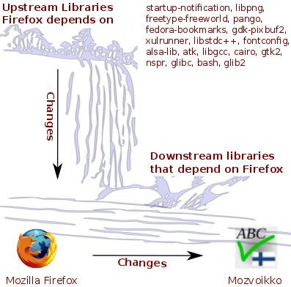Illustration 2: Picture a waterfall and a river. Changes to core libraries upstream from Firefox, impact Firefox, thereby impacting projects that depend on Firefox downstream.

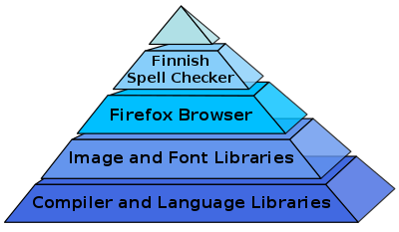Illustration 1: The lowest level upstream libraries form the base of the stack. The farther a library is downstream, the higher it is on the stack. In order for images and fonts to be rendered in the Firefox browser, compilers and language libraries must be installed. The Finnish spell checker, Mozvoikko, only works within Firefox, so it sits highest on the stack.

Knowledge Spillover and Positive Externalities
(DeCausemaker, Should Government, p. 21)

In their work for the Center for American Progress entitled An Open Source Tax Credit: Proposal and Economic Analysis Irons and Malamud make the case for the Positive Externalities that are begotten from Open Source development, and the knowledge spillover that occurs when code is made publicly available (Irons and Malamud, 2006, p. 5-7):
"The textbook example of an externality is the case of pollution. Consider a company that creates a product for its customers, but that creates pollution in the process. If the pollution negatively impacts those living around the factories, then the product is said to creative negative externalities. Pollution abating policy might then increase over-all economic welfare.

Positive externalities can also arise in economic transactions. Such is the case when a bee-keeper's hive helps to pollinate a neighboring farmer's field. Externalities typically lead to a situation in which the costs (or benefits) of an economic transaction to individuals differ from the broader social costs (or benefits) to the broader community...

Consider now the case of open source software. An individual developer can, if she chooses, keep her software code private, and charge for that product. In that case the private gains would accumulate (in some proportion) to the developer and purchaser (the end users). There are not necessarily any positive externalities in this transaction.

Suppose the code were, instead, open source. The benefits from that piece of software would then accumulate to (a greater number of) end users AND it would also benefit other developers. Users would also have a potential of even greater gain with open source, since they would have the ability to refine or enhance the product themselves.

Importantly, other developers benefit from the open-source code by
1. learning from the code,
2. incorporating their product or components into their work, and/or
3. by expanding/modifying the original code.

Open source development can thus be thought of as disseminating knowledge and ideas in addition to providing a specific product to market. And as before, these benefits accumulate to those who are not part of the initial transaction.

The positive spillover of knowledge to a broader community creates an opportunity for public policy to improve upon the private outcome...

Publicly Licensed Software as Public Good
(DeCausemaker, Should Government, p. 22)

This positive spillover of knowledge to the broader community can lead to massive positive network effects, due to the extended area-of-effect provided by the internet. By offering affordable software, and free access to information, this can lead to positive impacts for both 1st and 2nd degree parties, but more so for the 3rd and 4th degree. Education has been recognized as a public good that all of society has an interest in promoting, even if they are not the ones directly in school. It helps to raise the standard of living for everyone, when more people are educated. This is why everyone helps pay school taxes (even those without children) and educational institutions can receive 501(c)3 designation, and be granted a tax-exempt status. Open source software provides applied vocational education opportunities that supplement the public education system, and help to bridge the digital divide. Providing affordable software increases the digital standard of living for everyone, and allowing everyone to contribute to the FOSS ecosystem allows us, as a global society, to maintain and improve that standard on an ongoing basis.

Project Description and Methodology

The Idea (10/10/12)

Professor Jacobs, Director of the RIT Lab for Technological Literacy, and Capstone Project Consultant, received an email out of the blue. Ihudiya Ogburu, a former student of the Humanitarian Free/Open Source Software Development course (at the time, just an Honor's Seminar Course) reached out to myself, Prof. Jacobs, and Jim Myers, Provost of International Studies with a simple and earnest question:
Hi Remy and James,
Would either you be interested or know of students who would be
interested in hosting the Peace Corps Innovation Challenge at RIT?
Here is the website link: http://www.peacecorpsinnovationchallenge.org/
Let me know, and thank you Prof. Jacobs for your fast response.
Cheers,
Ihudiya Finda Ogburu

Prof. Jacobs immediately replied, saying that he would have me look into it. As I was researching the challenge a couple days later, I found the FAQ, or Frequently Asked Questions Page, and it mentioned that the PeaceCorps Innovation Challenge was participating in a program called Random Hacks of Kindness. I followed the link, and immediately recognized the initiative. I was a huge fan of their “finite state cellular automata” style theme on their website, and had even pointed our student designers to their site for inspiration in the past. Their hackathon had been on my radar for years, but each year I only heard about it after the application period had closed, and the sites were already accepted. Not this year.

The License (10/16/12)

From the FAQ, I followed the link to the “License to RHoK” application (Appendix: A), which was a series of pointed questions about my familiarity with their organization, my experience as an event organizer, prospective sponsors, partners, and venues, and why I wanted to hold the event. This type of event is at the core of our program, leveraging Free/Open technology to give students real-world development experiences, while having humanitarian impact. I indicated as such in the application and held my breath for the “10 Business Days” the submission page indicated it would take for me to receive my “license.”

The Venue (10/19/12)

In my excitement for filling out the application, I had checked to be sure the space was available on the events calendar, but neglected to actually book the venue I was proposing as the site for our event. I sent an email to the Innovation Center Operations Manager Clare Lagiewski, asking her to book the event officially. She replied with news of the first challenge of organizing the event. In the handful of days since I checked the Calendar Initially, the Office of Co-op and Career Services had booked the Innovation Center all day on the Saturday RhoK was to begin for the Google Puzzle Challenge. After re-reading the contest website, I discovered a loop-hole of sorts; since the event was a global event, with hackathons taking place across many time-zones, it did not matter what the start and end times were, just that the event be at least 24 hours long. I replied to Clare, telling her to book the venue immediately after Google's event, which ended up being at 9pm after accounting for clean-up/tear-down time.

The Acceptance (10/29/12, 12:21pm)

Dear Remy,

I am pleased to inform you that your application to RHoK has been approved. I have created you a RHoK.org landing page here: http://www.rhok.org/event/rochester-ny-usa. I have also created an Eventbrite registration page for you. You should be getting admin access instructions shortly. I will get your your logo as soon as it is created. Please let me know if you have any questions.

Best,
Thea Aldrich
RHoK Community Support Manager

I was thrilled when my first of many emails from Thea Aldrich, RhoK Community Support Manager showed up in my inbox. This was a highly visible international event in the world centered around Humanitarian Software Development, and my application was accepted! I knew our students and community members had the potential to tackle many of the problems listed on the PeaceCorps Innovation Challenge page, and now we'd have the chance to actually do it! Soon after the acceptance email, another arrived that shared with me the official Random Hacks of Kindness Event Planning Kit which would help shape and guide our local event, and the events happening world-wide. (See Appendix O, included at end of report).

The Flyer (11/02/12)

It always begins with the flyer. Each event we run has a promotional flyer that must be designed. I ascribe to the “5 W's” rule—Who, What, Where, When, Why. Nowadays, our lab employs a part-time designer and artist, but in those days, flyer design fell under my purview as the sole employee of our program. I was more than happy to take on the task. At the time I was enrolled in a Digital Design Course as part of my Communications and Media technology Concentration, and was excited to put my improved skills to the test. Using Inkscape, “An Open Source vector graphics editor, with capabilities similar to Illustrator, CorelDraw, or Xara X, using the W3C standard Scalable Vector Graphics (SVG) file format“ (http://inkscape.org, 2013), I was able to quickly cobble together a flyer (Appendix: B) with all the requisite information, sponsor logos, and even include a QR Code. QR, or Quick Response Codes, are “a two dimensional (2-D) matrix code that belongs to a larger set of machine-readable codes, all of which are often referred to as barcodes, regardless of whether they are made up of bars, squares or other-shaped elements” (Brostoff, 2011). QR Codes can contain alpha-numeric characters, as well as Unicode characters for non-English languages. In this case, the code contained the URL for the event information page on our website that when scanned by a barcode reader common to most smartphone and tablet devices, directed prospective attendees where to register on the printed flyer. On the particular Linux distribution I use on my laptop, Fedora, there is packaged and available a FOSS licensed command-line tool qrencode that can easily generate such codes. By using inkscape, and qrencode, and the Firefox web browser, I was able to download all the sponsor logos, create the QR Code, and design the flyer needed for the event.

The Event Listing (11/03/12)

Random Hacks of Kindness utilizes Eventbrite.com for both informational and registration purposes for their hackathon events. Each local site gets an Eventbrite page which organizers can edit, and the Community Managers can access to monitor the progress and reach of each local event (Appendix C). The website allows organizers to do things like sell and distribute tickets, email registered participants, email organizers when new registrations occur, list and link to sponsors, print out attendance lists, and even an app to check-in and attendees. The site had many more features available that were not needed for our local event, in addition to those listed above. Eventbrite.com is a site that continues to be an resource for our lab, and we've used it successfully for a number of events since RHoK. To create the event page, I had the option to use a Rich Text Editor, which is a WYSIWIG (“What You See Is What You Get”) editor, or to edit the web page source directly. As an avid blogger and novice web developer, I don't shy away from editing the source, in fact, I prefer it, and even write most of my academic papers in HTML. I used the vim text-editor to write HTML directly, and then upload the code to the site directly to create the page itself. I was able to embed our newly created flyer within the HTML, directly linking to the flyer previously uploaded to our lab's website. By using the website OpenStreetMap.org (The Open Source version of Google or Bing Maps) I was able to export an image map of campus. Then using inkscape, edit and add an overlay to highlight both the venue and parking to complete the event listing.

The CapitolCamp Conference (11/15/2012 to 11/16/2012)

CapitolCamp is an Unconference and Developer Summit held in Albany, NY. It draws not only your garden-variety-hackers, but academics, journalists, and above all, public servants. It was a first of its kind event in 2008, the only unconference to be held in a Legislative Building. I have had the privilege of attending and speaking at all of them, and this past year was particularly poignant. Taking place just a short-while after Hurricane Sandy ravaged much of the East Coast, including New York City, emergency management and disaster relief were still fresh in many of the attendee's minds. In fact, at the time, there were still thousands of New Yorkers still without basic services like electricity and other utilities. During the developer summit, there were five projects under active development, with hackers from the Senate, the CIO-OFT office, LIPA, the Governor's office, and other agencies and constituencies.
During the project pitch session, we were told an interesting story about how the Governor's website (Governor.ny.gov, 2012) was serving as a clearing-house for storm related information and resources. One webpage was being hand-curated with information from all different departments and agencies, ranging from warming shelters and food banks, to outage information, Red Cross donation information, and much much more. Employees were working around the clock to help victims, and were at capacity doing so. After gathering about two weeks or so of website traffic and analytics data, they had come to an interesting conclusion. Most people who were visiting the storm resources page were doing so on a mobile device. This was consistent with the conditions caused by the storm; many citizens were still without power, let alone internet, so desktops were difficult, if not impossible, to use. Smartphones and other mobile devices were the primary tools used by folks looking for relief information, but the Governor's Storm Resources webpage was not optimized for mobile devices. This was the issue that folks at the hackathon were looking to address, and a handful of attendees, including myself and one of our lab's students, answered the call.
Dan Pozzie from the NYS Senate.gov development team took the lead, as he had both Drupal and mobile development experience. Working with Ginger Gericitano and Meredith Case of the CIO's office, we were able to mostly piece together the flow of information between agencies, and the current work-flow for updating the site. Numerous others stopped by to contribute their input, but unfortunately I was not able to record all of their names and emails. By the end of the day, we had created some very basic initial components needed to complete the task; a data aggregation back-end that was screen-scraping information from other state and local agencies and NGO websites, a Drupal environment that was based off of the technology currently deployed by the Senate and others within the state, and a very rudimentary jQuery mobile user interface.
The team agreed that this was a good start, but that much more would need to be done. From the beginning, I knew that if we made any kind of demonstrable progress that could be built upon, that we would dedicate resources at the RHoK Rochester hackathon to continuing development. When the summit was over, the others agreed, and because the project was released under the GNU Public License (GPL), we would be able to continue development.
Even though no government employees from the original team were able to physically attend the event, Ginger from the ITS office joined us virtually via Internet Relay Chat (IRC) during the hackathon.

The Press Release Draft (11/19/12)

Upon returning to RIT, with an improved resolve from witnessing the direct impact of our efforts, and the efforts of the other four projects at CapitolCamp, I began drafting the press release for our hackathon (Appendix D). In it we provided all the same information from the flyer, with some additional information about the Hurricane-Sandy-Relief mobile site. Prof. Jacobs and myself sent back and forth edits via email, and sought out other faculty and staff, such as Professor Andrea Hickerson, to get their input and professional opinion.

The Keynotes Confirm (11/26/12)

During the press release editing process, we received an update from Thea that one of the Core Organizers from RHoK would be joining us in Rochester. Sean Herron, member of the NASA Open Government Team had agreed to join us. He was a Syracuse University Alumni, no stranger to Upstate New York, and would visit his Alma Mater on the way to our event.
Professor Antonio Mondragon, organizer of the 3rd annual ARM Developer Day and alumni of the RIT Professor's Open Source Summer Experience (POSSE) program, reached out to us at about the same time, and asked for our help to organize a hackathon for his on-campus conference, focusing on Open Hardware. We told him that we'd be happy to piggy-back and combine the events, as they had one day of overlap. He informed us that Rob Bishop of the Raspberry Pi foundation was going to be in attendance, and that he was planning to hack with us on Saturday. We offered Rob a chance to be a keynote speaker, and he accepted. The program was really starting to come together, and we had two more items to add to the press release.

The Press Release Released (11/27/12)

Through working with Scott Bureau and Kelly Sorenson of RIT University News, we created a final draft of the press release that made the front page of RIT.edu. The release was then widely distributed to news and media outlets around the region, and local news outlets stated to carry the story (Appendix E), and we started to get our first big boosts in registration that same day.

The Swag (11/27/12)

No hacker event is complete without swag (colloquially “Stuff We All Get”), which are freebies and give-aways for registered participants. Thea was again in my inbox, and this time, asking how many attendees we were expecting, so she could send our site official RHoK tshirts. We ordered 60, and I asked for a couple “extra-larger” sizes for the more voluminous hackers (such as my myself) who had already registered.

The Radio Interview (11/28/12)

Bob Smith, Radio Personality from Talk1370AM on WXXI agreed to have myself and Professor Jacobs on as guests for his one hour show (Appendix F). This was my first live radio appearance, and an experience I will not soon forget. I attended live at the station in downtown Rochester, and Professor Jacobs called in. We took questions, promoted the hackathon, and informed the community about the activities of our lab and the benefits of FOSS to educational outcomes, and real-world humanitarian development. We saw another surge in registration later that same day.

The Keynotes Arrive (11/30/12)

Much of the day that Friday before the hackathon was spent showing Rob Bishop around the Golisano Building and the Innovation Center, introducing him to our facilities and our people at RIT. I even got to attend one of the hands-on Raspberry Pi workshops, getting my first opportunity to experiment with the hardware that would play a central role in our upcoming hackathon. After the day's workshops were completed, myself and four students tore down the 30 workstations in the lab, and carted all of the hardware over to the FOSSBox, where it would stay until next day.
Later that night, myself and a colleague of mine, Ralph Bean (formerly of RIT Research Computing, recently minted Software Engineer at Red hat) carpooled over to the Hotel where Sean Herron would be staying for the weekend. The three of us went out to dinner, and discussed a plethora of NASA projects and initiatives that were happening, as well as Sean's personal connection to the PeaceCorps innovation challenge through his sweetheart who was at the time on a tour of duty. We discussed all types of challenges that NASA faced, the gargantuan amounts of data that beamed down from each of their missions every day, and plotted out what the schedule for the next day would look like. It was my first time meeting Sean, and I was inspired by the discovery that NASA's Open Government Team had core members who were as young (or younger) than I was, doing real work, leading social media and web development strategy for the agency. We spent a handful of hours plotting and conversing, before deciding that it would be best to rest while we could—we were, after all, about to embark on an over-24-hour hackathon.

The Day of (12/01/2012)

Saturday was spent showing Rob and Sean around campus, checking out the Google Puzzle Challenge, and a brief visit to the Microsoft Imagine Cup in the IGM Labs. After watching the results of the Challenge, we had a chance to catch up with the Google team, who generously donated their left-over swag from the puzzle challenge to our hackathon. After helping pack up, we did a trash sweep, and awaited the arrival of our student volunteers. Powerstrips were laid out. Raspberry Pi workstations were assembled (four of them to be exact). The swag table was laden with stickers, keychains, and other goodies. The sign-in sheet was placed. The mic and speakers were checked. The whiteboard signs scrawled with registration and event information. The 4 projector screens were populated with a twitter feed, IRC back-channel, text to match the whiteboard instructions, and our Turntable.fm music room. The key screen though, was a Google Doc containing all of the PeaceCorps Innovation Challenges we had identified that were considered “low hanging fruit,” or could be reasonably accomplished over the 24 hour event. The stage was set, and now all to do was wait for the players to arrive.

Project Results

The Main Event (12/01/2012, 9:00pm)

And arrive they did. Mostly RIT Students at first, then the folks from StormFrog, one of the event sponsors, who in the end would lead up the largest, most active team of hackers spearheading the Hurricane-Sandy-Relief mobile app development. At around 9:30pm or so, we double-checked that everyone was signed in, and kicked things off with Rob Bishop. Sean Herron then got up to give his keynote to a crowd of around 45 hackers, speaking on many of the things we had discussed the prior evening. After keynotes, we gave the audience a chance to talk amongst each other, gather their teams, and then report back to the group what challenges they would be taking on. Eight different project teams emerged, some taking on PeaceCorps challenges, some helping with Sandy Relief, some engaging in civic hackery at the local level, and other brandishing Raspberry Pi's and soldering irons. Once teams had formed, and people started to get into the groove, pizza arrived (along with plenty of caffeinated beverages) and people fueled up for the long night ahead.

The Press (12/01/12, 10:00pm)

Somewhere around 10pm or so, camera crews began to show up. YNN was the first, and they did a quick spot that we were told would show on the 11 o'clock news. Sure enough, I got a link via email from their correspondents later that night, and I was able to put the video up on the big screen for all the attendees to see (Appendix G, H).
Photographers and student journalists from the RIT Reporter Magazine showed up at about the same time, taking pictures of the event, and interviewing attendees (Appendix I, J). Their presence was felt by the attendees at the event, providing a sense of gravity and purpose to the “norm” or “business as usual” of writing code to solve problems.
The attendees continued on through the night, slowly the crowd of 45 thinning to a skeleton crew of about 20 or so die-hard hackers around 3:00am. At around 6:00am, I decided to turn in for the night and take a quick nap to recharge my batteries for the next day. Using an air mattress, and some felt table cloths, I set up a makeshift bed.

The Next Day (12/02/12, 9:00am)

The next morning I awoke, splashed some water on my face in the restroom, and returned to the fray. Professor Jacobs arrived with breakfast from Bruegger's Bagels; juice, bagels, muffins, cream cheese, fruit, and large boxes of coffee. Within about 15 minutes of returning finishing my first cup of coffee and a bagel, our second camera crew arrived, this time from WHAM13 (Appendix K, L). They took footage of the aftermath of the evening; pizza boxes and soda bottles strewn about the room, and a steadily growing crowd of hackers returning for their second shift, to join the stalwart and groggy folks who worked through the night.
By 11:00am or so, Justin Murphy, a reporter from the Democrat and Chronicle arrived and did in depth interviews with myself, and some of the project teams around the room. Scrawling notes on a Steno pad, he made his way around the room over the course of an hour or so, and informed us that the article would be online that evening, and in print in Monday's newspaper (Appendix M).

The Count Down (12/02/12, 2:00pm)

Once lunch arrived, most of the folks who had left the day before had returned, and the venue was back at capacity. Most of the folks who had been working through the night were targeting lunch as the 'end' of their double day, and wanted to polish off their work, so they could take a nap before the presentations later that evening. Lunch was an opportunity to rally the wagons, and get folks back on the same page. Many folks got up from their computers and walked around to check out the work that the other teams were getting done, and the software (and hardware) projects that had been built over the night. With everyone no longer glued to their screens, I was able to address the audience, set the expectations for the remainder of the day, and lay out the presentation and submission process. Everyone was now going from a “lets crank like mad” mindset, to 'let's polish off what we've got so we can show others what we've done.” There was a renewed focus on longevity, sustainability, and maintainability; making projects available on open code forges, and preparing to hand off their work to the NGOs and Agency “clients” who had posted the challenges listed.

The Presentations (12/02/12, 6pm)

Each team's name was added a whiteboard next to the podium, and they were given 5-10 minutes to show off what they had been working on for the last 24 hours. This list of project presenters went as follows:
- RadioBird

Description: A project using a commodity radio antenna hooked up to a Raspberry Pi that creates a Software defined radio. Can be used to tap into a number of frequencies, including transmissions from NASA Satellites

Source Code: https://github.com/skykooler/radiobird

- Outages

Description: A live map of power outages in the North Eastern US, based on data feeds from National Grid and other Power Companies.

Source Code: https://github.com/gregjurman/outages

- Peacestagram

Description: A webapp that shows a gallery of all the instatgram photos of PeaceCorps volunteers around the world, by searching for pictures tagged with terms like “PeaceCorps,” or the names of Host Countries.

Source Code: https://github.com/seanherron/peacestagram

- Monroe Minutes

Description: Tools to scrape websites within Monroe County and pull meeting minutes and other important documents from various village, town, city, and county websites, and convert them to machine-readable text. These are then indexed using a histogram method with keyword rejection via a black list of common words to exclude from results.

Source Code:https://github.com/thequbit/monroeminutes

- RhoK-Media

Description: A repository of art and design assets such as wallpapers, badges, and powerpoint templates, based on the Random Hacks of Kindness logos and color pallette.

Source Code: https://github.com/JennX/RHoK-Media

- PNC Notify

Description: A project to notify expecting mothers with health pre-natal care information during their pregnancy over SMS.

Source Code (Deleted): https://github.com/adamhayes/pnc_notify

- SMS-to-Spreadsheet

Description: web application to allow users to send SMS messages to a designated phone number, and the contents of the message will be parsed and used to update a spreadsheet.

Source Code: https://github.com/kaldrenon/sms_to_spreadsheet

- Hurricane Sandy Relief

Description: A mobile storm resources site to accompany http://governor.ny.gov/storm-resources that will; 1) aggregate all of the disparate data into one comprehensive data source, and 2) provide a mobile view of the information from the Governor's website, using Drupal as the underlying content management system

Source Code: https://github.com/stormfrog/hurricane-sandy-relief

Conclusion and Recommendations

Problem Recap

Thousands of volunteers who answer the call to service each year, though motivated, do not possess the requisite technical skills to build their own solutions. Aid organizations must prioritize their budgets to meet physical needs first. Technology solutions are often prohibitively expensive, and problematic to fund due to intellectual property issues. Technical professionals are in high demand, and are often drawn to high technology regions with high-salary, private sector jobs (not volunteer work) to repay the high-cost of education. Even with the efforts of Humanitarian hackers doing weekend or side projects, there are still many, many more problems than problem solvers.

Overall Summary

Our satellite event in Rochester drew over 50 participants over the course of the weekend, who worked on eight distinct projects, each attempting to solve, or get a bit closer to solving, both global and local problems.
Radiobird was a project started to utilize very inexpensive, very open hardware, to build a generalizable radio communication tool. The Raspberry Pi only costs $35 dollars, and has most of the capacity and amenities of a modern computer. HDMI, stereo audio, the same type of processor that is shipped with many tablets and phones, and uses the same power adapter as the average cell phone. This is a computing platform ripe for empowering underserved communities here and abroad. The more tools we build for the Raspberry Pi computer, and the more publicity we build for the Raspberry Pi Foundation, the more we further the goal of bringing affordable technology and avenues to literacy, to those who could benefit from it most.
Outages as a product provides an easy interface to difficult to find data, and aggregates it from many resources. Power outages not only affect citizens, but businesses, and governments alike. By improving the flow of information, we can improve the flow of aid and support to areas that need it most. As the tool is Open Source it can be repurposed (with some effort) to aggregate other kinds of data from other sources too. A tool for citizens, technicians, and emergency responders alike.
As has been said a number of times in this report already, there are more problems than problem solvers. Maybe someday we can close this gap entirely, but until then, we need to inspire as many people as possible to answer the call. Peacestagram is tapping into one of the most popular social networks used for mass visual communication. The old saying goes "A picture is worth a thousand words." Often it is more effective to show someone, rather than tell someone, how important it is get involved, or to show them how they can make a direct impact in the lives of others.
“This first step to solving a problem is recognizing that there is one.” “Knowledge is power.” “All politics are local.” These phrases may sound somewhat cliche, but are all applicable to the goals of Monroe Minutes. We all have a civic duty as a citizen, but don't have the time or resources to be personally involved at the highest levels of policy, let alone the mundane and everyday. Monroe Minutes is helping to inform our local community, and help people tap into issues they care about, at home. This is important not just for us in our County, but helps to set an example and to build a working model that can be replicated in other local communities around the world. Monroe Minutes has been under active development since RHoK Rochester, and the site's creator has branched off into a number of other municipal datasets and information sources to deploy new websites and build more tools. Tim Duffy is still creating, still releasing new code every day, and still improving his technical skills every time he adds a new feature to his growing repertoire of tools and sites. He is doing himself, and the Greater Rochester Community a great service.
The RHoK-Media repository is proof that you don't have to be a computer programmer to make an impact at a hackathon. Artists, designers, and other creative people need to know that their skills are also in high demand, and they too can make a big difference. Just as was said in the problem statement, aid organizations and non-profits (such as RHoK itself) must choose the practical over the technical, often times that means undervaluing the aesthetic. Jenn Kotler's artwork, backgrounds, and badges are available for future RHoK organizers and participants to use to promote their local events. Her efforts provide inspiration, while reducing perspiration for those who come after her.
SMS-to-Spreadsheet was one of the Darling projects of our event. Sean Herron, RHoK core organizer, personally reached out to Patrick Choquette, Special Assistant to the Director of Innovation at the PeaceCorps, after seeing Andrew and Caleb's App in action during their presentation. Patrick has been working with our students to stand up a test server to experiment with the app, and make it scalable, and possibly do some field testing in the near future. We are very excited to see where this goes from here. The challenge Patrick and Sean listed for the Innovation Challenge, that Andrew and Caleb's solution addressed, was very clear-cut, specific, and tackled a real-world problem experienced by volunteers in the field everyday. Patrick said that of the 8000 active volunteers in 76 countries, each has their own use case for an app like this, and this app has the variability to help all of them.

Recommendations

As someone who has organized or advised over 40 hackathons in the last four years, I cannot recommend social coding events highly enough. I am blessed to have the resources of a university like RIT backing me up when I host events at this kind of scale, but some of the most productive coding sessions I've ever had were with two or three dedicated people working together in a focused and purposed way. You don't have to give away tshirts and stickers, you don't have to have the fanciest catering, you don't have to have the latest-and-greatest computing devices—sure that all helps—but it is not necessary for making a difference. All you really need is careful planning to avoid calendar conflicts, whatever computing hardware you can get your hands on, internet access (and if you had to you could probably do without it), a purpose, and a willingness to share your work with the world. Iterative development in the FOSS world represents not just process, but progress! The more people you have working on a problem, the more likely you are to fail early and find the right answer faster.

How to Utilize This Work

The good news is, you do not need my permission, or anyone else's who worked on these solutions to start making a difference. All of the code and content developed during our event was released under a Free or Open license. This means that, by design, and on purpose, you already have permission to continue improving or leveraging this technology, so long as you are willing to give the same permission to others. If any of these projects sound interesting or important to you, or you have the willingness to learn, my job is to help you get involved. Many of the original authors of these projects are still around--and if they are not, we still have ways we can reach them--to help you get started. Start by sending me an email, and we'll go from there.

What to do differently

I do not intend to paint this picture as entirely rosey. There were certainly things that I did not do as well as I would have hoped, and things that I would have liked to have accomplished, but did not have the time to do. Hurricane-sandy-relief, I felt, was the most promising local project. It had all of the right ingredients; government stakeholder buy-in, a real-world need, top-notch professional assistance, around-the-clock hacker cycles during the event, a solid technological foundation to start from, and all of the good intentions you could ask for. Sure, there were some development problems that we could point to, or so one of my students told me.
There were multiple copies of Drupal's core code nested within the repository that had to be cleared out and refactored during the hackathon (which was probably my fault as the least savvy programmer on the team in Albany.) Though it was a pain, the team still managed to overcome that obstacle. With inheriting an 'approved' codebase, there were many design decisions that were already made before we ever sat down to write a single line of code. We had lofty goals when we started work in Rochester, and we achieved many of them in the short amount of time that we had to work, but ultimately the mobile site was “just a protoype.” It was very difficult for me, to know how hard everyone worked on it, to then have it never actually be deployed in production. This is no fault of the developers who worked so hard to make the concept a reality, or the government stakeholders who identified the need and asked for help, but likely my own for taking for granted the community relations that happen within the hacker community. In the FOSS community, most developers get to choose which projects they will put their very precious time into, and do it on their own schedule.
The dynamic when dealing with public servants is very different. They have a bazillion other problems to deal with at any one time, and public service is all too often is a thankless craft. No matter how much you get done, there will always be more to do. There are miles of red-tape to get through just to get permission to start planning, let alone work on, a new project. It is my duty as liaison and community organizer to help navigate those official channels, and go through the motions needed to collaborate with the largest and most complex bureaucracies in the country. I did not make that happen in time for our hackers, but above all, in time for those affected by the storm.
Don't get me wrong, it was not ,by any stretch of the imagination, a total loss. Much goodwill was exchanged between our developers in Rochester, and the Developers in the Capitol. The experience in Albany was eye-opening, and showed that even when there there isn't a (fast) Way, the Will is still there. Perhaps next time, rather than start an entirely new project, we can get permission to modify existing code to serve our purpose, rather than recreate the wheel (it is one of the pillars after all...) Next time, we'll be sure to start planning wayyy in advance, months before an actual event takes place if we want a .gov presence at our next hackathon. Even if the code we wrote can't help as many people now as if it were deployed two weeks after the storm, it can still help some of those people who are still affected, or those who could be. Like all Open code bases, it can be repurposed and generalized. Maybe we can deploy it eventually, to provide a mobile interface to other kinds of content, not just storm resources? The work that was done is still viable, and was by no means wasted, but we all wish we could do more.

Specific Course Preparation

Many of the methods used to make this event successful were based on effective written communication, and digital design. The initial “License to RHoK” application required an understanding of the audience reading the work, and how to properly represent the work we've already done as part of our program. Courses like Crafting the Message, with an explicit focus on conveying information in a succinct manner, certainly helped with crafting my answers to the questions asked.
Courses like Contexts and Trends with Prof. McQuade helped me to think about the 'bigger picture' of how the themes expressed in RHoK's Mission applied to the work we were already doing. Being able to take the macro level concepts and connect them to the micro level of implementation and planning was crucial in showing that not only did we agree with the context in which RHoK was operating, but that we knew how to apply those concepts to motivate and involve others to share their vision.
Once our application was accepted, the core of the message used for promotion revolved around a digital document, a flyer. This document was created using tools and methods that were honed during my work in the Digital Design course with Prof. Cameron. In her course, we were creating flyers and brochures (among other assignments), the exact types of promotional material that needed to be created for this event. Creating these art assets in a scalable and reusable fashion, for use in many different mediums, was an important factor in being able to quickly turn around deliverables with tight deadlines, such as press releases.
Courses like Public Administration and Management with Prof. Cooper helped provide an understanding of public/private partnerships, and the challenges those efforts face.. When the government stakeholders were unable to attend our hackathon in person, it wasn't because they weren't interested, it was just a consequence of doing business at the scale that a government does. Turning around a travel request in a few short weeks is difficult, let alone implementing a brand new piece of technology policy. I appreciated what involvement the ITS was able to have at our event, and I look forward to working together in the future.
Though it was after the RHoK hackathon when I took Graduate Science Technology Policy Seminar with Prof. Foltz, he assigned an entire book on the Challenger Decision, which gave me a much greater understanding of the organizational culture within NASA. This was a boon later, and made me feel much more personally connected to the agency that I would eventually work with to organize our next big humanitarian hackathon, the NASA International SpaceAppsChallenge. (Which would do well as the subject of an entire capstone report in and of itself, worthy of the same amount of attention paid here to RHoK.)
All of these courses carried extensive writing requirements, and prepared me well for the amount of writing that would need to be done under a deadline in order to pull off organizing an event like this one. Compared to the 60 plus pages I was accustomed to turning around in a week or two, the piddly 500 words needed for the press release was something I could almost handle in my sleep.
Bill Johnson's Community Economic Development course put students directly in the board room with community leaders making decisions with broad and far-reaching impact, who had to balance public input. Learning from the professionals about balancing interests and effective team building (and campaign building) helped to give both knowledge, and confidence in speaking with other doers and decision makers.

Showing the Story

In addition to this written account and literature review, as part of the report, I have created source control visualizations, using the Gource (Cauldwell, 2010), and MultiGource (Clark, 2012) libraries. These simulations provide a visual aid for understanding the scope and magnitude of development that occurs during RHoK and other events like it. Provided below is the procedure and source code (Appendix P) used to create these coding components of my capstone research.
The Process
- Compile list of local projects worked on during event.
- Work with Sean Herron to aggregate revision controlled RhoK projects.
- Clone each repository, both local and international.
- Clone the MultiGource library, and edit the existing configurations to work with RHoK repositories.
- Use the log generation script to stitch together the development histories of each project into one comprehensive file.
- Use a colorization and categorization script to parse the log, apply a color to each commit.
- Use inkscape to adapt the art assets from the RhoK-Media project, to serve as the background image in the visualization.
- Configure and test the ffmpeg pipeline for rendering the video.
- Render the visualization, and save it in a playable format.

The list may seem simple enough, but involved many more hours for some of the steps than was previously anticipated during the proposal phase of this capstone. Allowances needed to be made for human error in the project's own revision control, and to re-write portions of the colorization script.
This visualization, though not able to be included in a written form, will be demonstrated at the Capstone Presentation. Source code is available at http://github.com/FOSSRIT/multigource-foss in the 'rhok' branch of the repository. Rendered video will be available at http://foss.rit.edu/rhok2012-multi-gource.

Acknowledgments and Thank Yous

All of the work I do is built and predicated upon the work and support of others. As a FOSS developer, I should even acknowledge the authors of the very software used to create this report, and the accompanying source code visualizations and presentations (https://www.libreoffice.org/about-us/credits/).

To the RIT Center for Multidisciplinary Studies, who's support and guidance has provided me with the opportunity to make my life's work, and my academic experience one and the same.

To Dr. Sam McQuade, who challenged me to be the best student I could be and gave me the opportunity to do so.

Abby Berner, now Abby Cantwell, is the reason why I was able to make it through my first degree, and without which a second would not have been possible.

Professor Stephen Jacobs for always treating me as a colleague, and for his whole-hearted support of my research and professional development.

Jim Bell, Ken Zalewski, Dean Hill, the NYSenate.gov development team (past and present), The office of ITS-OFT, and the volunteers who organize CapitolCamp, and work with many agencies and branches to bring the Open Source Way to the Great State of New York.

Special thanks to Ginger Gericitano for going above and beyond her duty to be involved with RHoK Rochester.

To the FOSSBox and its hackers. Nathaniel Case, Justin Lewis, Ryan Brown, Sam Lucidi, Ross Dellinger, Andres Ruiz, Matt Soucy, Luis Rosario, Duy Nguyen, Jenn Kotler, David Gay, Greg Jurman, Tim Duffy, Justin Sherrill, David Silverman, Kevin Hockey, JT Mengel, and anyone else in the commit logs at http://github.com/FOSSRIT.

To the members of the Fedora Team, Opensource.com, and Red Hat, who have had our lab's back since Day zero. In particular, Tom Callaway, Luke Macken, Ralph Bean, Ruth Suehle, Leslie Hawthorn, Dave Malcolm, Tohsio Kuratomi, and Mo Duffy.

Thea Aldritch, and the other members of the Random Hacks of Kindness organizing team.

The RhoK Global Sponsors.

Sean Herron, for being a speaker, and for getting the NASA Space Apps Challenge on our radar. We look forward to many more.

Rob Bishop and the Raspberry Pi Foundation, for supporting Open Hardware on a global scale, and for bringing that presence to our local event.

Brian Moyer, Karthik Balasubramanian, and StormFrog's ace crew of developers and designers who pulled a second 9-5 shift, after pulling a 9-5 shift, to help others.

The RhoK Rochester volunteers and attendees. No amount of planning or sponsorship will do much to help without all of your hard work.

And finally, my partner Marie Nordin, for her patience and support through my entire graduate school experience. Particularly the patience. And the love.

References Cited

- Brostoff, David. (2011). DENSO ADC QR Code White Paper r1f.
California : DENSO ADC Inc.

- Chopra, Aneesh. Hacking For Humanity (2010). (Reviewed online 2/1/2013 at http://www.whitehouse.gov/blog/2010/06/03/hacking-humanity).

- Copyright Office, United States. (2008). Circular 1: Copyright Basics. Washington D.C.: Library of Congress

- DeCausemaker, J. R. Should Government Endorse, Promote, or Develop Free/Open Source Software Policy? (2013). Rochester Institute of Technology: Unpublished.

- DeCausemaker, J. R. (2011, October 11) "Open Data, Open Government, and The Open Source Way." (Reviewed online 04/02/2013 at http://tedxtalks.ted.com/video/TEDxBuffalo-2011-Remy-DeCausema).

- DeCausemaker, J. R. Source Code: Living Artifacts of Developer Communication (2013). Rochester Institute of Technology: Unpublished.

- Fontana, Richard, Kuhn, Bradley, M., Moglen, Eben, Norwood, Matthew, Ravicher, Danial, B., Sandler, Karen, Vasile, James, Williamson, Aaron. (2008). A Legal Issues Primer for Open Source and Free Software Projects. Software Freedom Law Center: Manhattan.

- Inkscape (2013). Inkscape, Draw Freely. (Reviewed online 02/20/2013 at http://inkscape.org)

- Ki-Moon, Ban. Random Hacks of Kindness Keynote Address (2010). (Reviewed online 2/1/2013 at http://www.unglobalpulse.org/blog/un-secretary-general-appeals-global-open-source-community).

- Lerner, Josh, and Tirole, Jean. (2000). The Simple Economics of Open Source. National Bureau of Economic Research : Washington D.C.

- Office of the CIO, Executive Office of the Governor (2012). Resources | Governor Andrew M. Cuomo. (Reviewed online 02/18/2012 at http://www.governor.ny.gov/resources/storm/)

- Office of Management and Budget, Executive Office of the President (2012). Digital Government: Building a 21st Century Platform to Better Serve the American People. (Reviewed online 2/1/2013 at http://www.whitehouse.gov/sites/default/files/omb/egov/digital-government/digital-government.html).

- Opensource.com (2009). Open Source Way - Open Source Principles. (Reviewed online 04/02/13 at http://opensource.com/open-source-way).

- Random Hacks of Kindness (2013). About | Random Hacks of Kindness. (Reviewed online 2/1/2013 at http://www.rhok.org/about).

- Skytland, Nick. Change The World (2012). (Reviewed online 2/1/2013 at http://open.nasa.gov/blog/2012/12/01/changetheworld/).

- United States PeaceCorps. PeaceCorps Innovation Challenge (2011). (Reviewed online 10/20/2012 at http://innovationchallenge.peacecorps.gov/learn/).

- Weber, Steven. (2004). The Success of Open Source. Massachusetts: Harvard University Press.

- Welsh, Peter. Open Source and the Power of Community (2012). (Reviewed online 2/1/2013 at http://www.whitehouse.gov/blog/2012/11/20/open-source-and-power-community).

Appendix A: License to RhoK Application

Remy DeCausemaker
remydcsi@rit.edu
3159451601
LTL/FOSS@RIT

Q: What do you know about RHoK? Which events have you attended?
A: I've been following RHoK's work since 2008(ish), and have always been inspired. I have not actually attended any RHoK events in person.

Q: What drew you to RHoK?
A: http://www.peacecorpsinnovationchallenge.org/learn/

Our lab at RIT was approached by a current Peace Corps Member (who is one of our former students) who thought that this type of event would be interesting for our students. As we run at least 2 hackathons per quarter, it certainly was.

Q: What issues are you most passionate about?
A: Our lab focuses on Free/Open Source Software and Open Web Technologies. Our research in the past has included subject areas like Humanitarian development, Educational Games, Open Data, Accessibility Technology, Open Courseware, Gamification, and Social Coding.

Q: Why are you interested in organizing a RHoK event?
A: The Peace Corps Innovation Challenge provides a discrete list of problems that need tackling. After looking at the list, we are confident that our students can help solve a number of these problems in a single hackathon. Having a humanitarian focus, and solving real world problems are at the core of our lab's mission, and a big motivator for many civic- minded hackers here in our lab, and across campus.

Q: What experience do you have organizing “hack days” or other events?
A: One of my duties as a Research Associate is to run at least 2 hackathons per quarter. I've organized and staffed at least 20 hackathons in the last 3 years, both for local communities, and upstream projects. Here is a decent example:

http://opensource.com/education/11/8/bridging-boxes-hacker-matchmaking-upstate-new-york-opensource-way

Q: Do you have experience seeking sponsorships for events? In media or promotions? Please describe?
A: Yes. I've helped to organize and locate sponsorship for events like Startup Weekend Rochester, Software Freedom Day, and other on and off campus conferences.

Q: List at least one website that will help us understand you better (e.g. Your blog, your company’s website, research papers, biography, photos taken by you, …) *
A: Campaigns:
http://foss.rit.edu
http://civx.us

Code:
http://github.com/FOSSRIT

Storytelling:
https://www.youtube.com/watch?v=YZ6ILsOIBgA
http://opensource.com/users/remyd
https://www.youtube.com/watch?v=08RqkYxoiLw

Q: What do we need to know about you that we didn’t ask?
A: My 2011 TEDx Talk: https://www.youtube.com/watch?v=fZxI2ZqSyrA

Q: In which city and country would you like to host a RHoK event?
A: Rochester, NY, USA

Q: Will you be planning the event on your own or with others? If you’re working as part of a team, list the names and email addresses of the team you’re working with?
A: Stephen Jacobs, sj@mail.rit.edu
Ryan Brown, ryansb@csh.rit.edu
Nate Case, qalthos@gmail.com
James Myers, jamisr@rit.edu

Q: Do you a venue in mind for the event? What contacts do you have with the venue? *
A: The RIT Center for Student Innovation is where we host all of our on-site hackathons. It can accommodate over 200 people, and meets all the venue requirements listed here: http://www.rhok.org/node/1577

Q: Which speakers or subject-matter experts do you plan on inviting?
A: RIT Professors and Faculty in both Computing and Policy Departments.
Local Hacker/Maker Space Representatives.
Linux and other Local User Group Organizers.
Possibly someone from Github (we just had a github rep at our last
hackathon, so they may not be able to make it.)
Local Web/Mobile Development Shops in Town (such as StormFrog)
Current Red Hat Software Engineers.
Anyone from RHoK who would be willing to join us :)

Q: Do you have contact with the hacker community? with media? with possible sponsors? Please describe.
A: We've partnered with the following organizations in the past:

Hackers:
RIT Linux User Group
Computer Science House @ RIT
Rochester Python User Group
Rochester Tech Startups Meetup
Syracuse Student Sandbox (Student Business Incubator)
Coworking Rochester
InterlockROC
Hacks/Hackers ROC
BarcampROC
One Laptop Per Child (OLPC)

Media:
RIT University News
Rochester NPR Affiliate WXXI
YNN

Sponsors:
Github
Red Hat
StormFrog
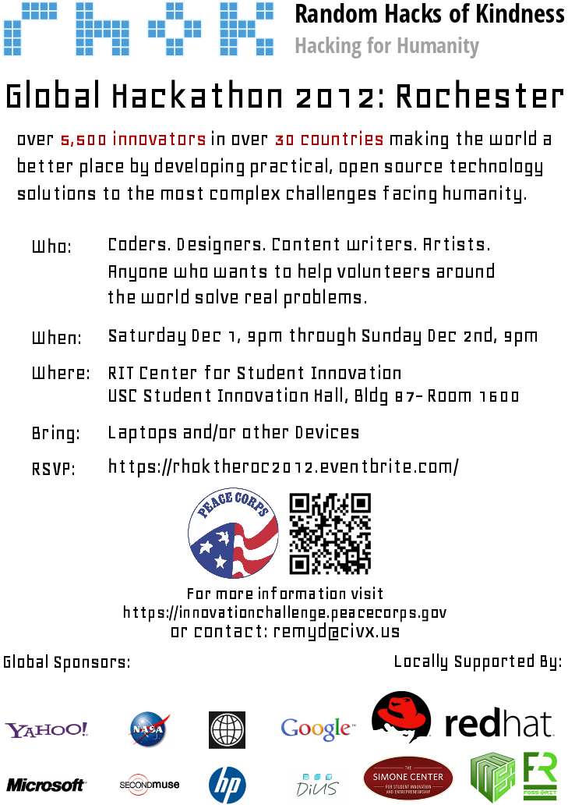
Appendix B: The Event Flyer
Appendix C: The Eventbrite.com Registration Page
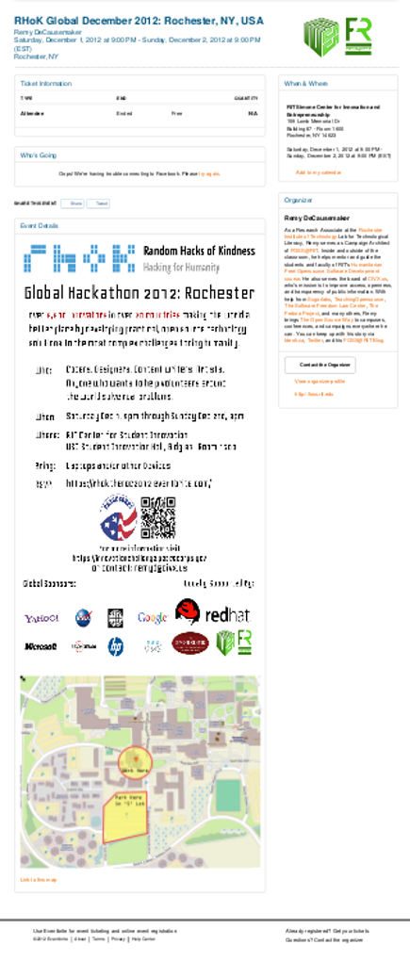

Appendix D: The RIT Press Release

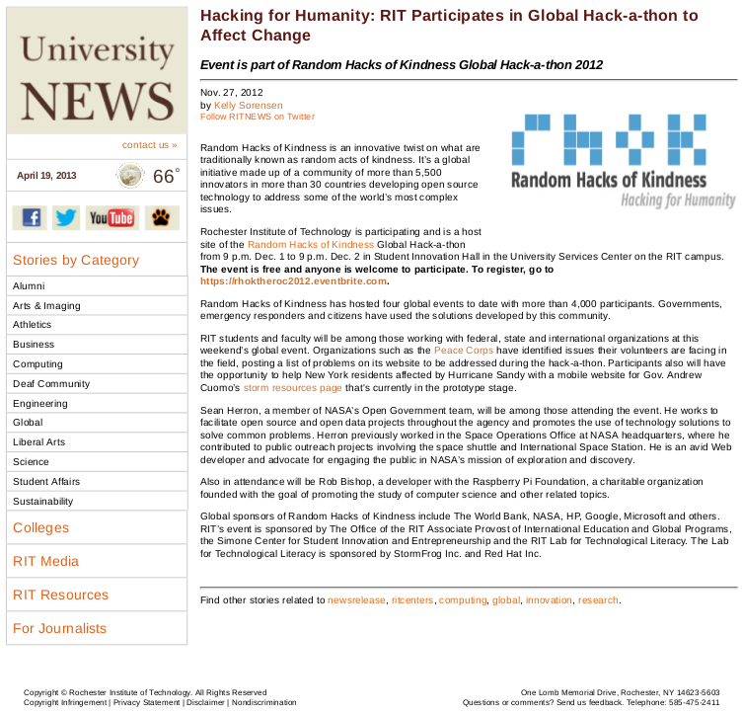

Appendix E: Henrietta Post Online Article

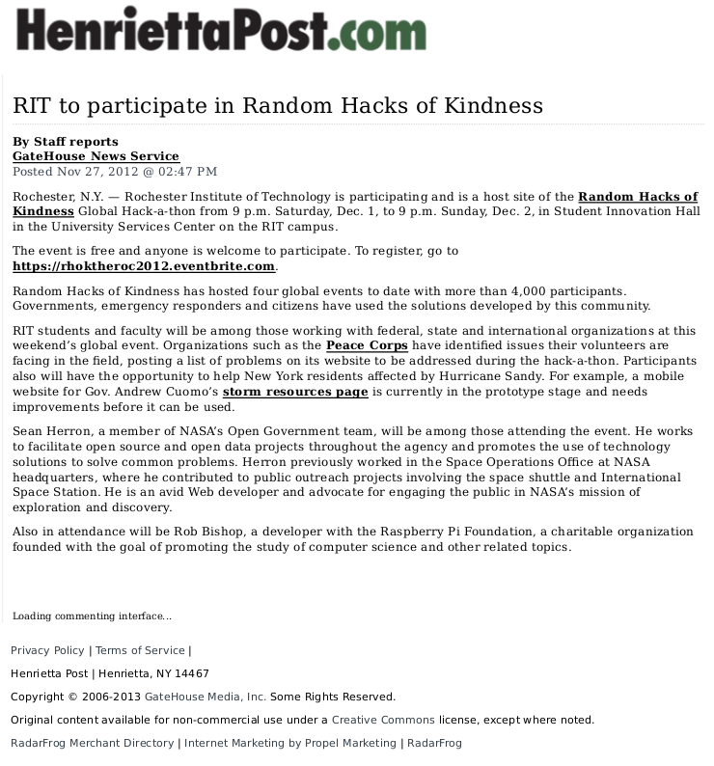

Appendix F: Radio Interview with Bob Smith of WXXI

http://foss.rit.edu/media/WXXI-AM%201370%20(am-hi)%20-%20.wav



Appendix G: YNN News Clip

http://foss.rit.edu/media/13WHAM_RHoK.mp4

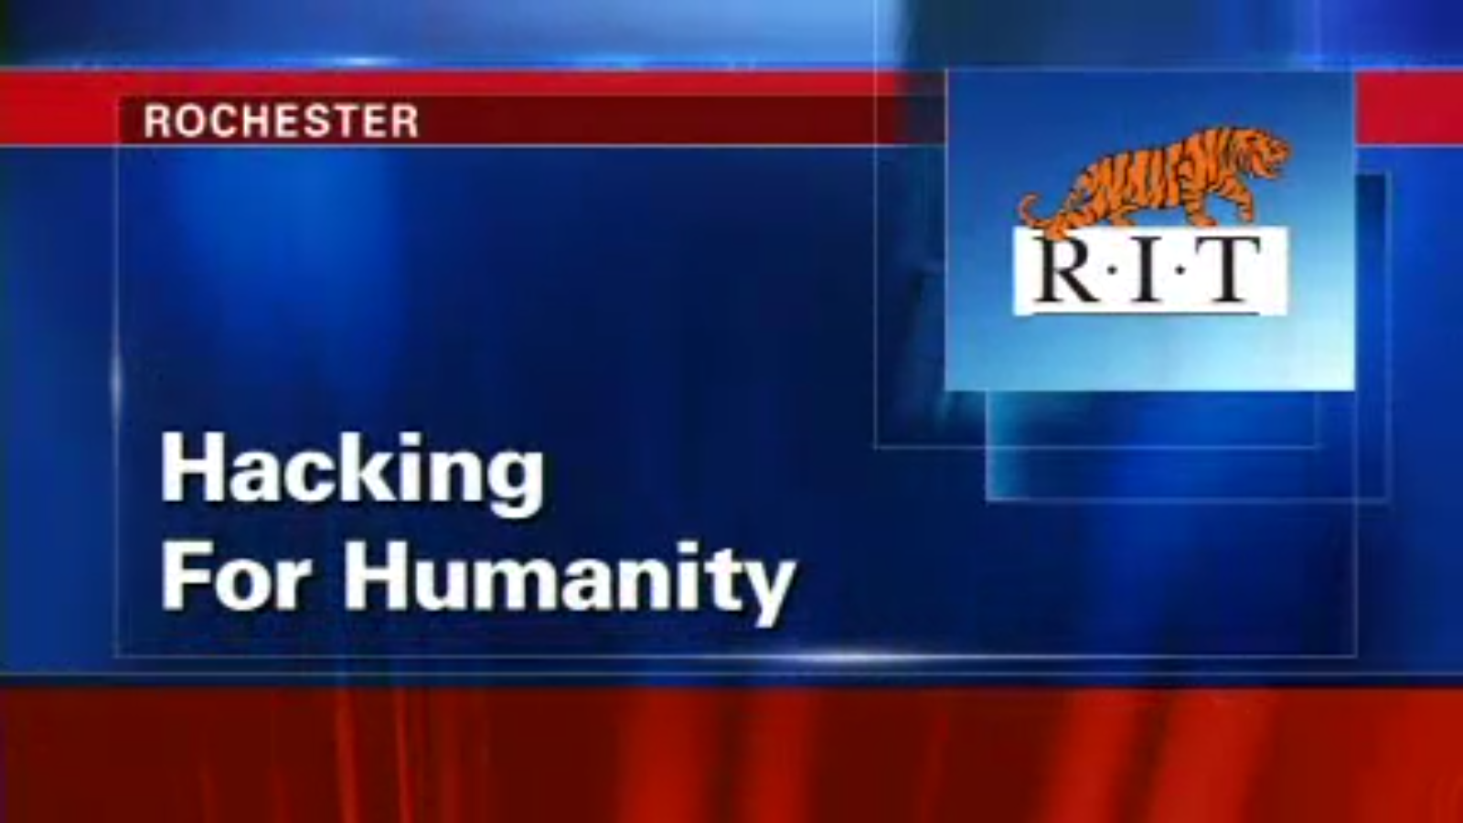

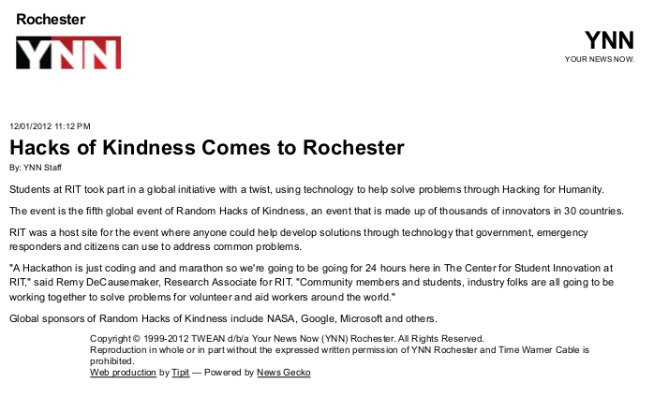
Appendix H: YNN Online Article

Appendix I: RIT Reporter Online Article

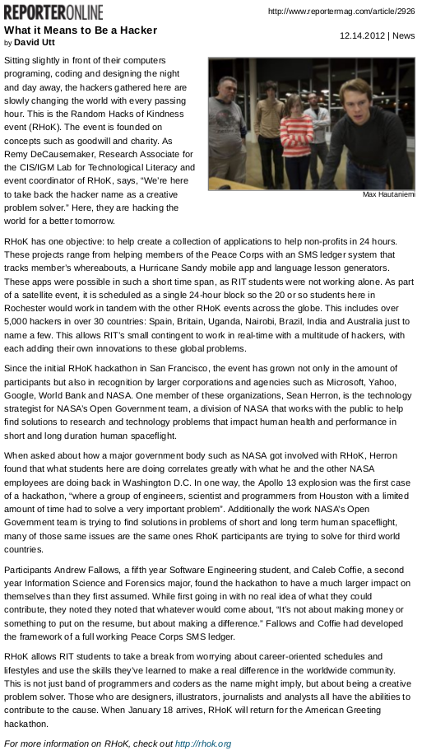

Appendix J: RIT Reporter Magazine Article
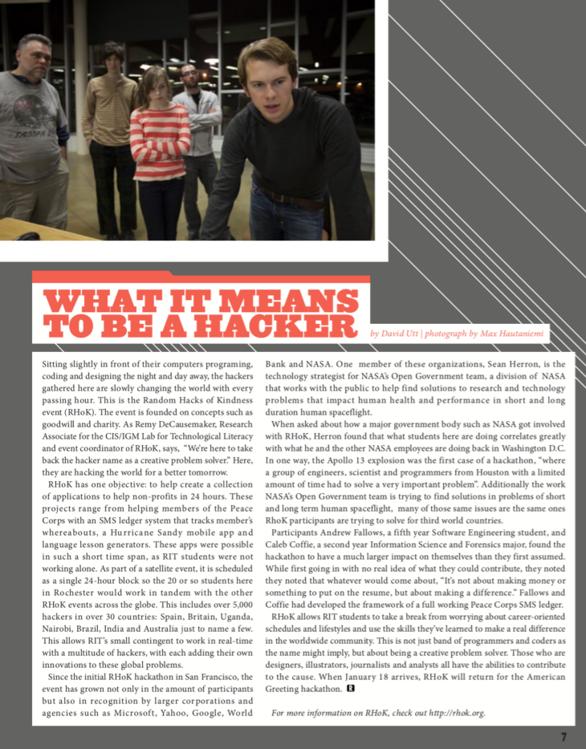
Appendix K: 13WHAM Online Article

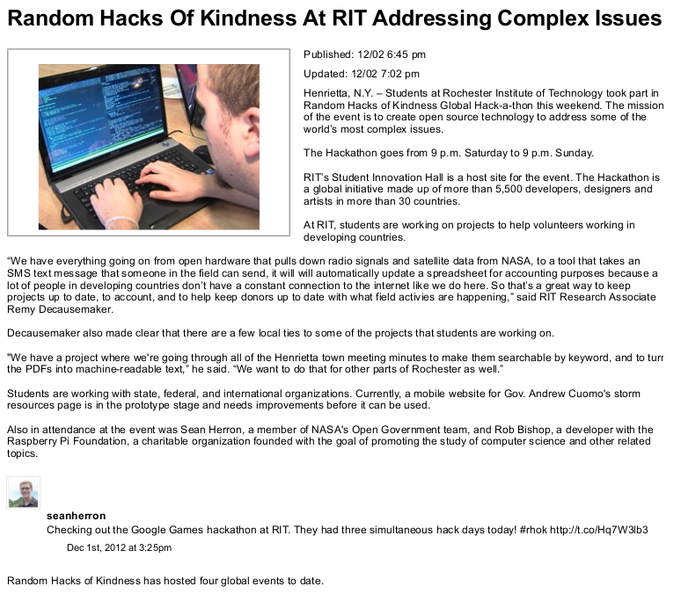

Appendix L: 13WHAM News Clip

http://foss.rit.edu/media/YNN_RHoK.mp4

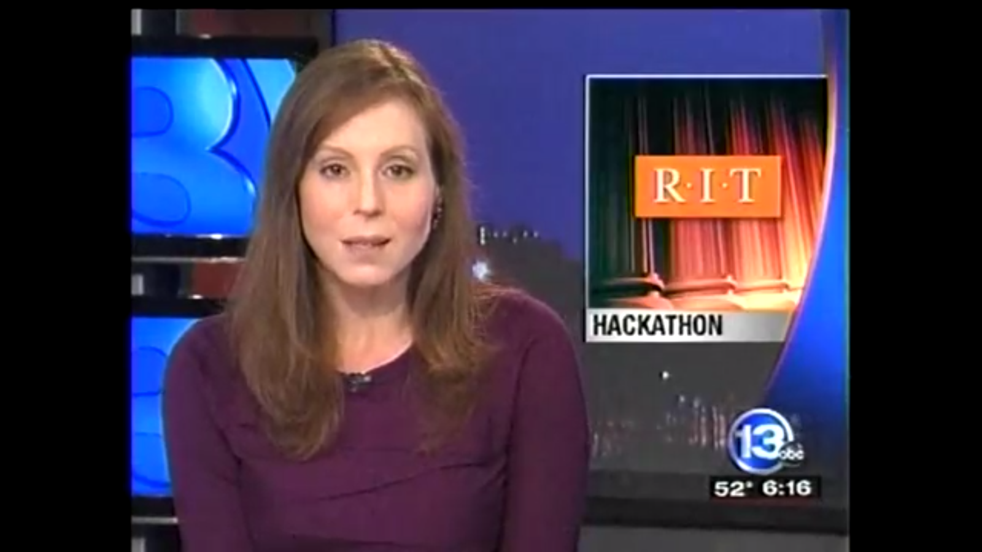

Appendix M: Democrat & Chronicle Newspaper Article
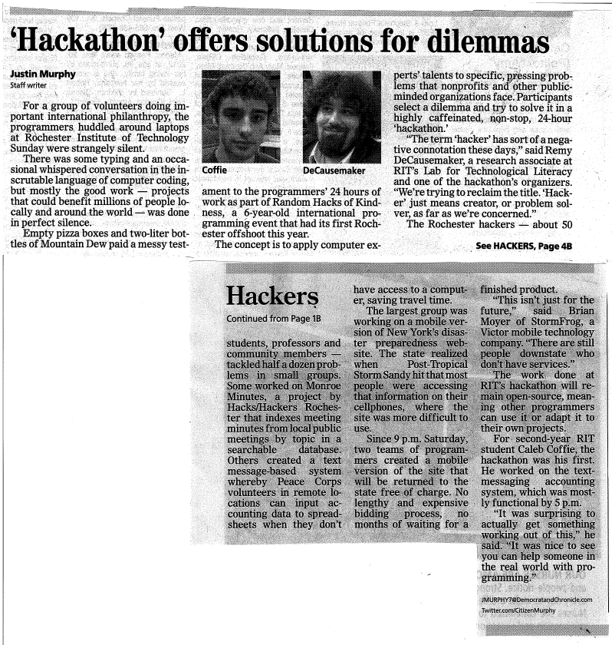

Appendix N: Venue Photographs

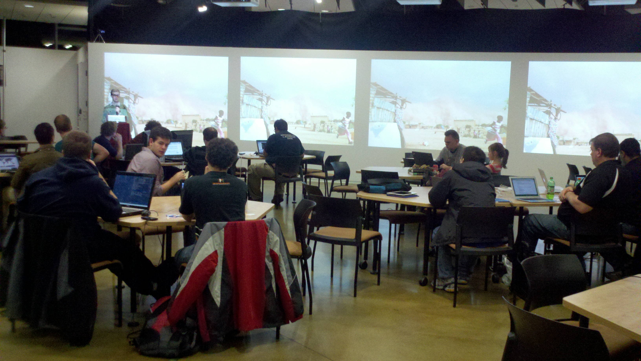Illustration 3: Keynote Address photographed from center of venue.
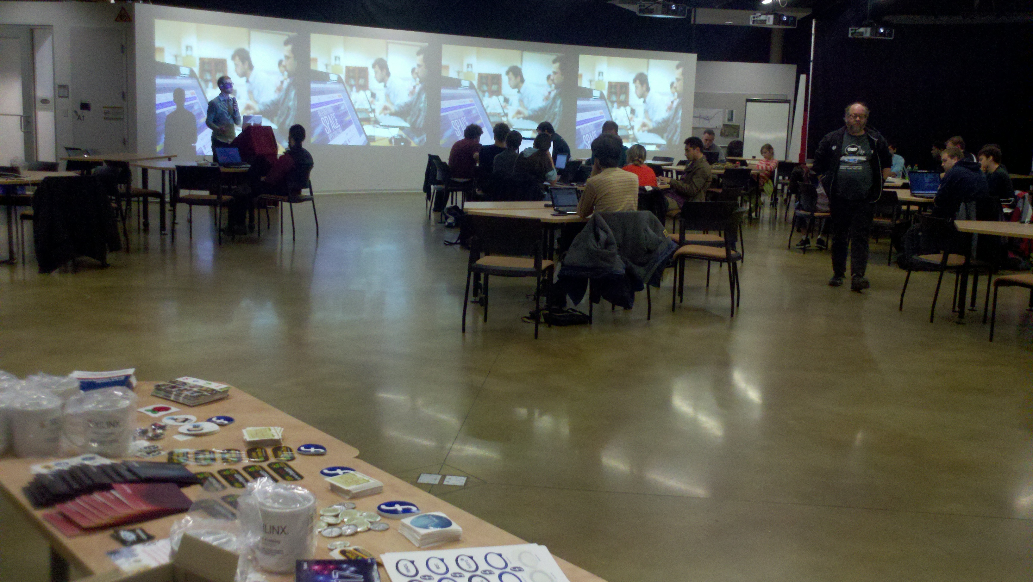Illustration 4: Keynote photo, taken from behind swag table. Prof. Stephen Jacobs pictured top right.
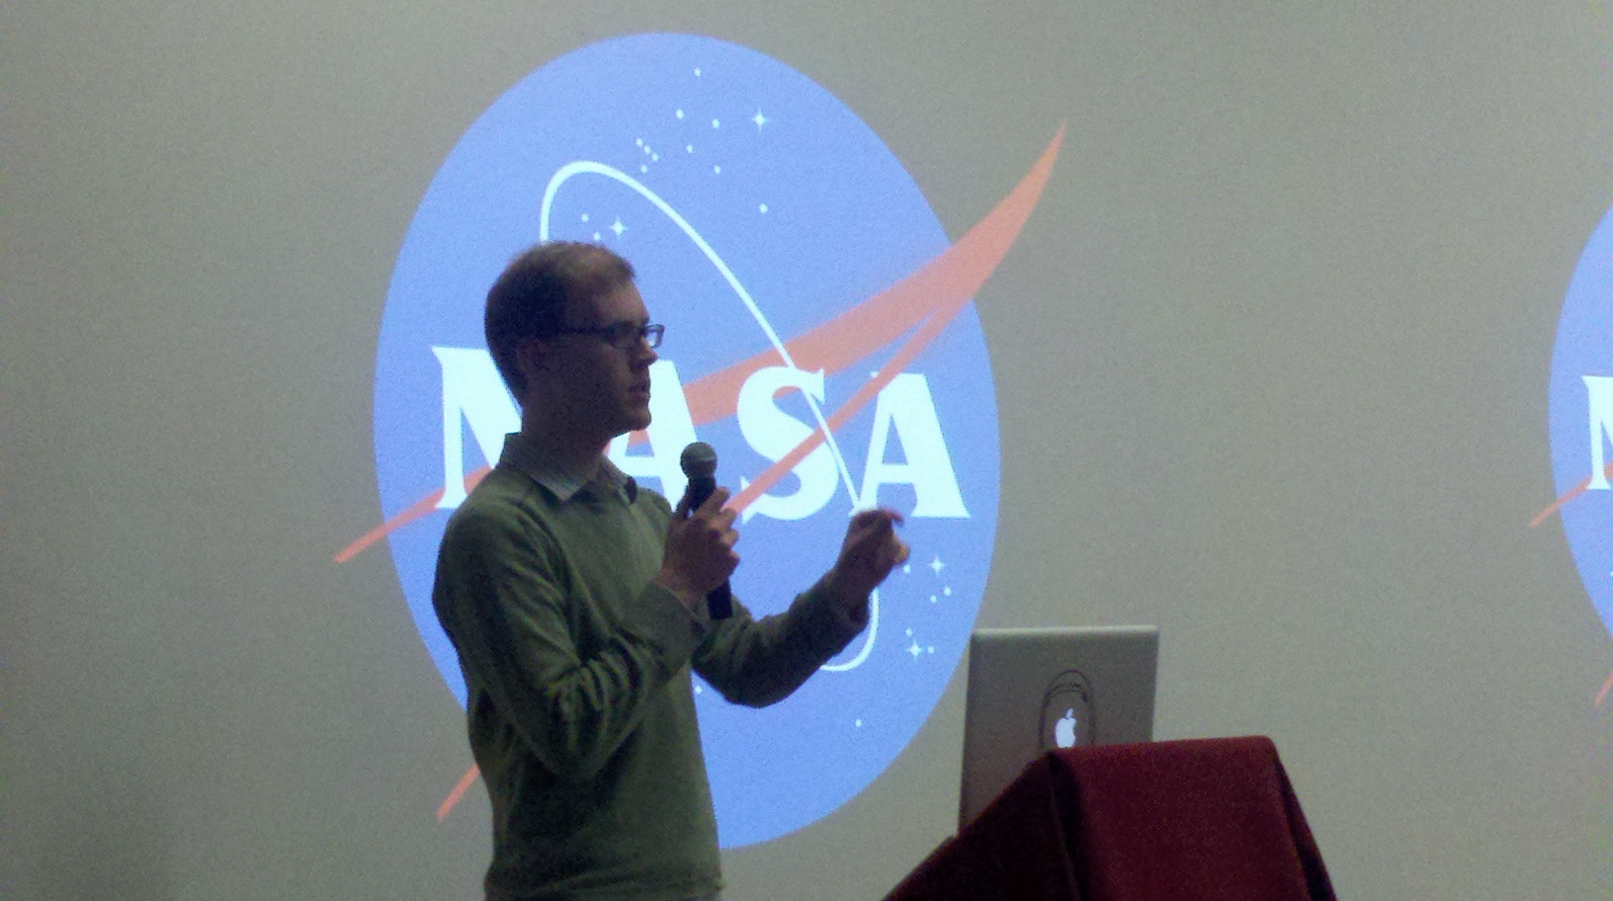Illustration 5: Sean Herron, Technical Lead of NASA's Open Government Team Addresses the Audience at RHoK Rochester

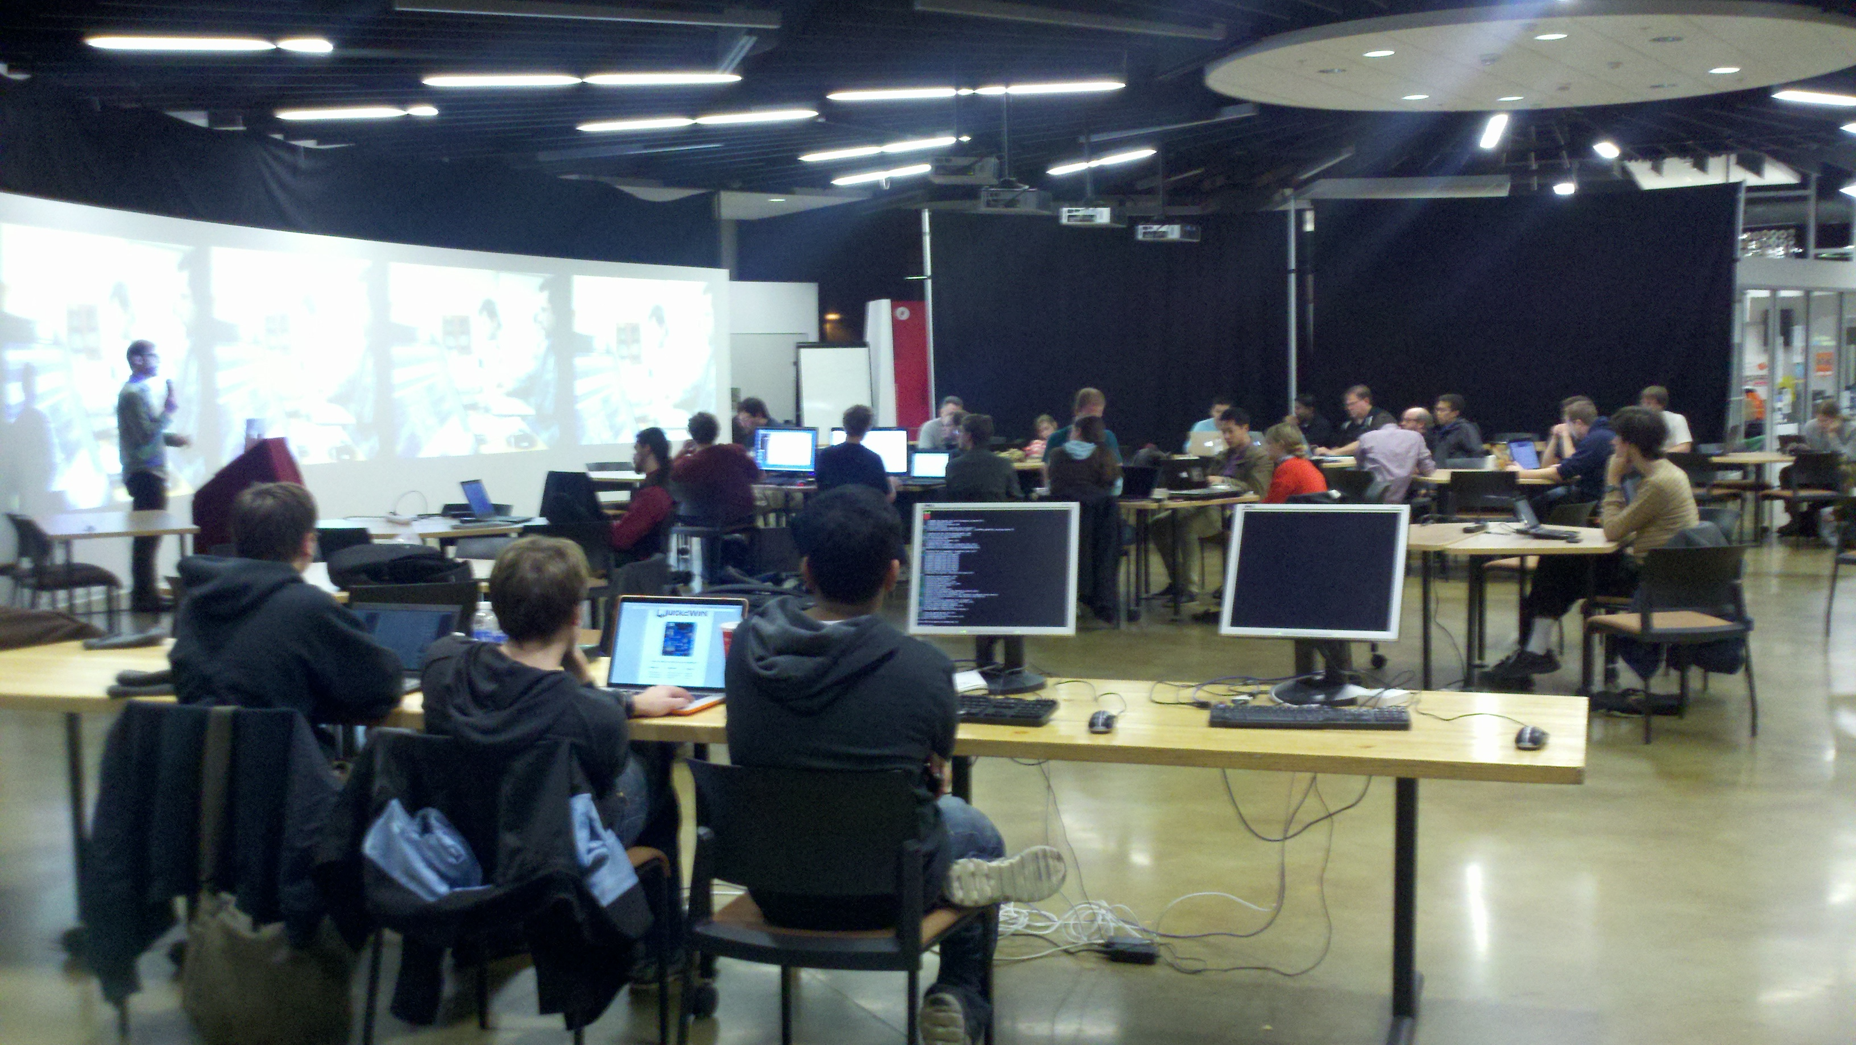Illustration 6: RHoK Rochester Audience during Herron's Keynote. Shot from behind Raspberry Pi workstations at east end of venue.
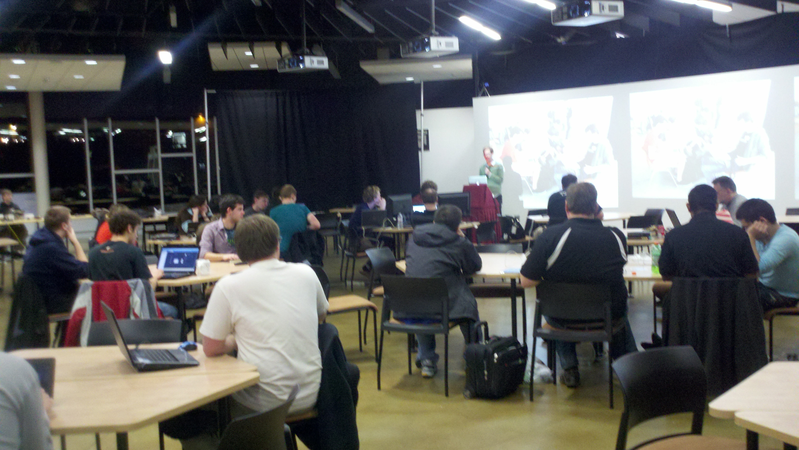Illustration 7: RHoK Rochester Audience, shot from other west end of venue.

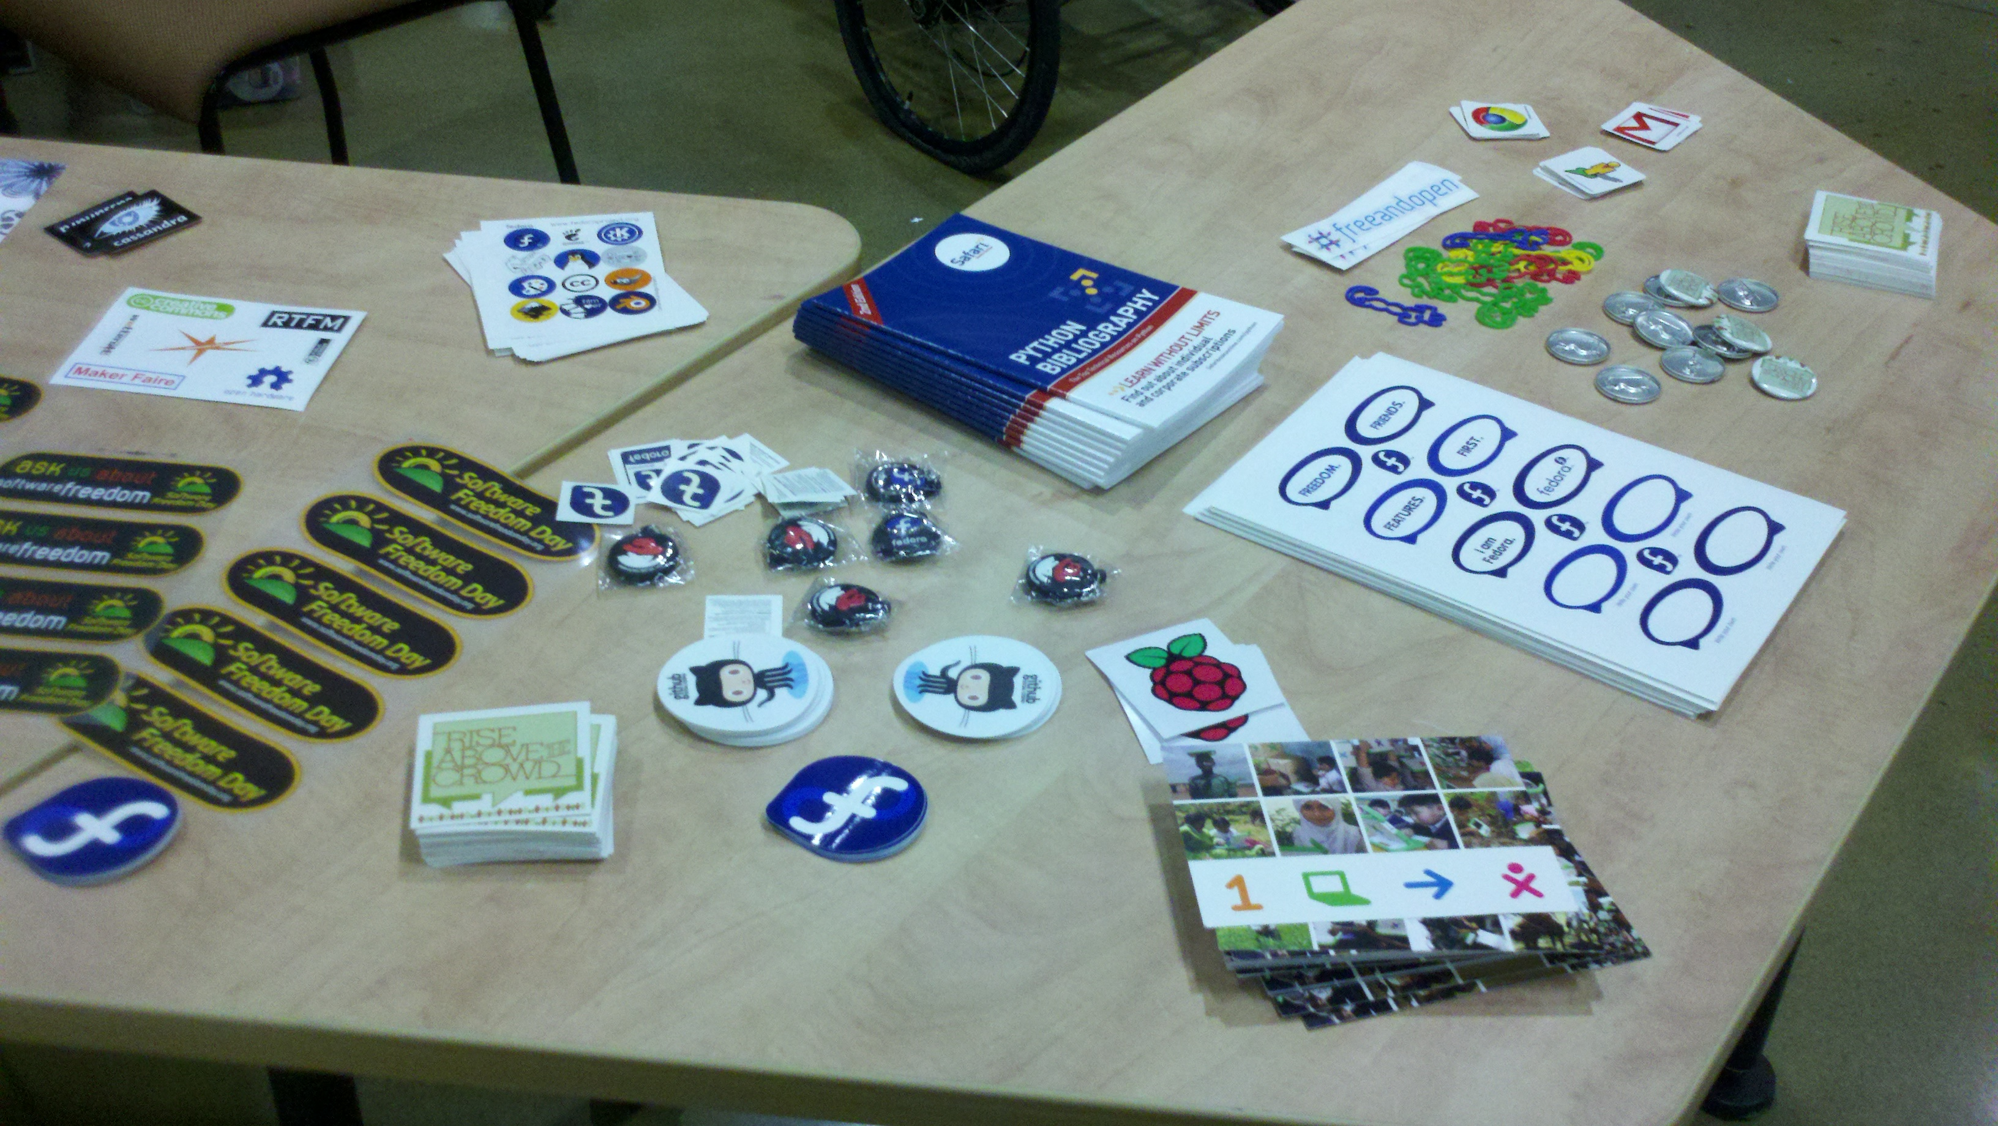Illustration 8: The swag table: a staple of social coding events everywhere. Stickers, buttons, keychains, postcards, and other literature available to attendees free of charge.

Appendix O: RHoK Event Planning Kit
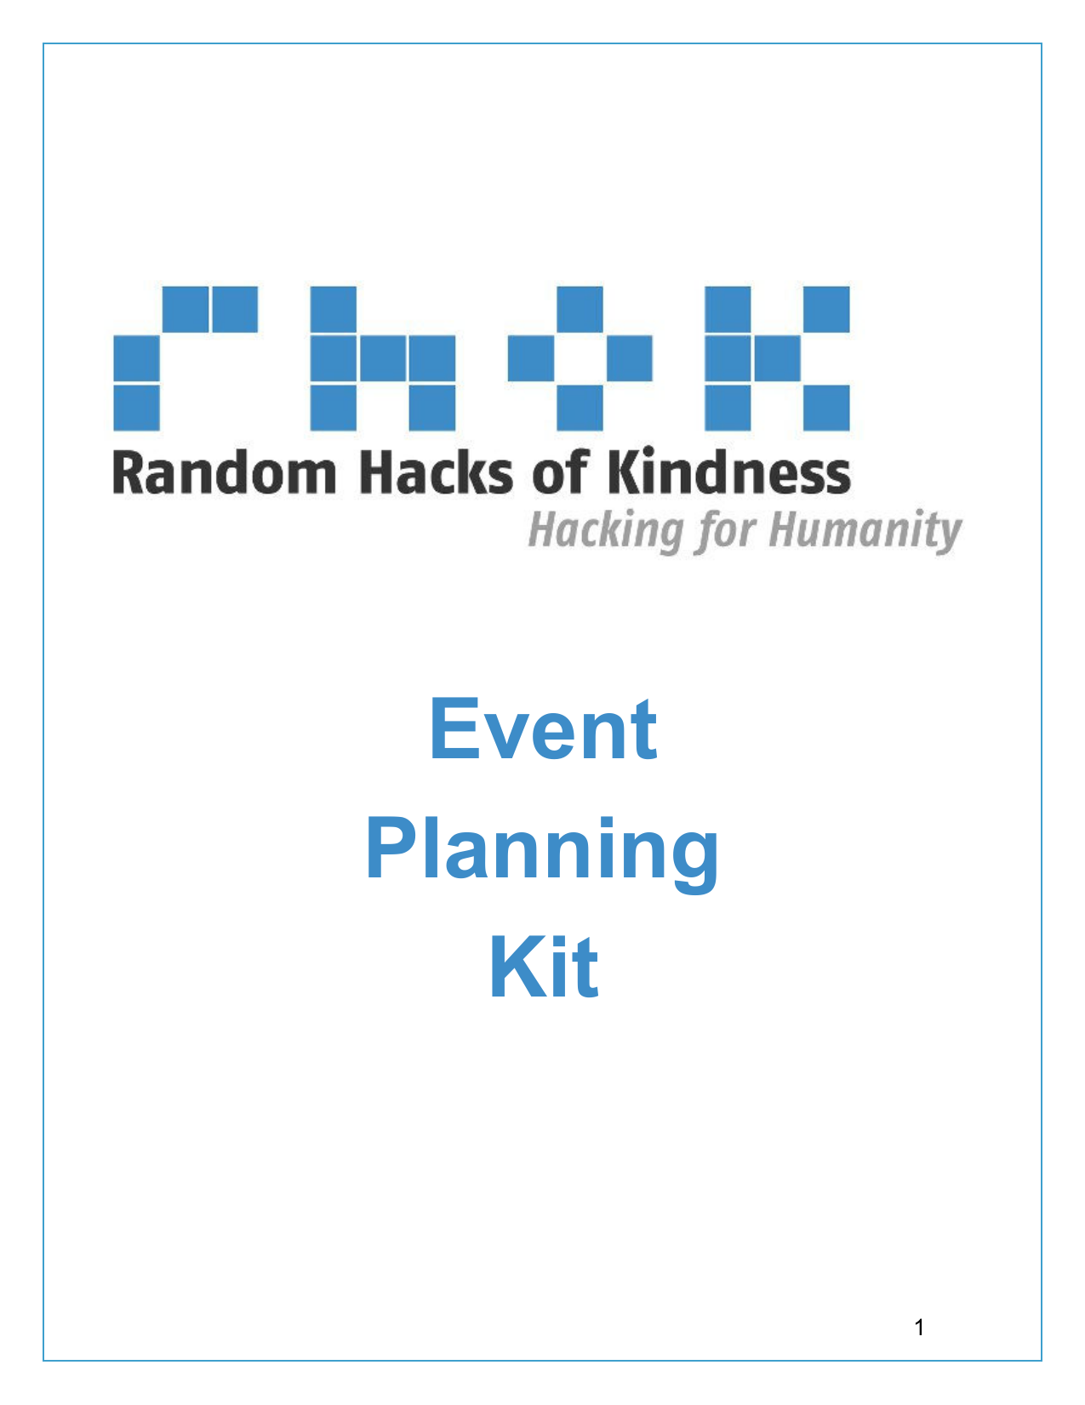
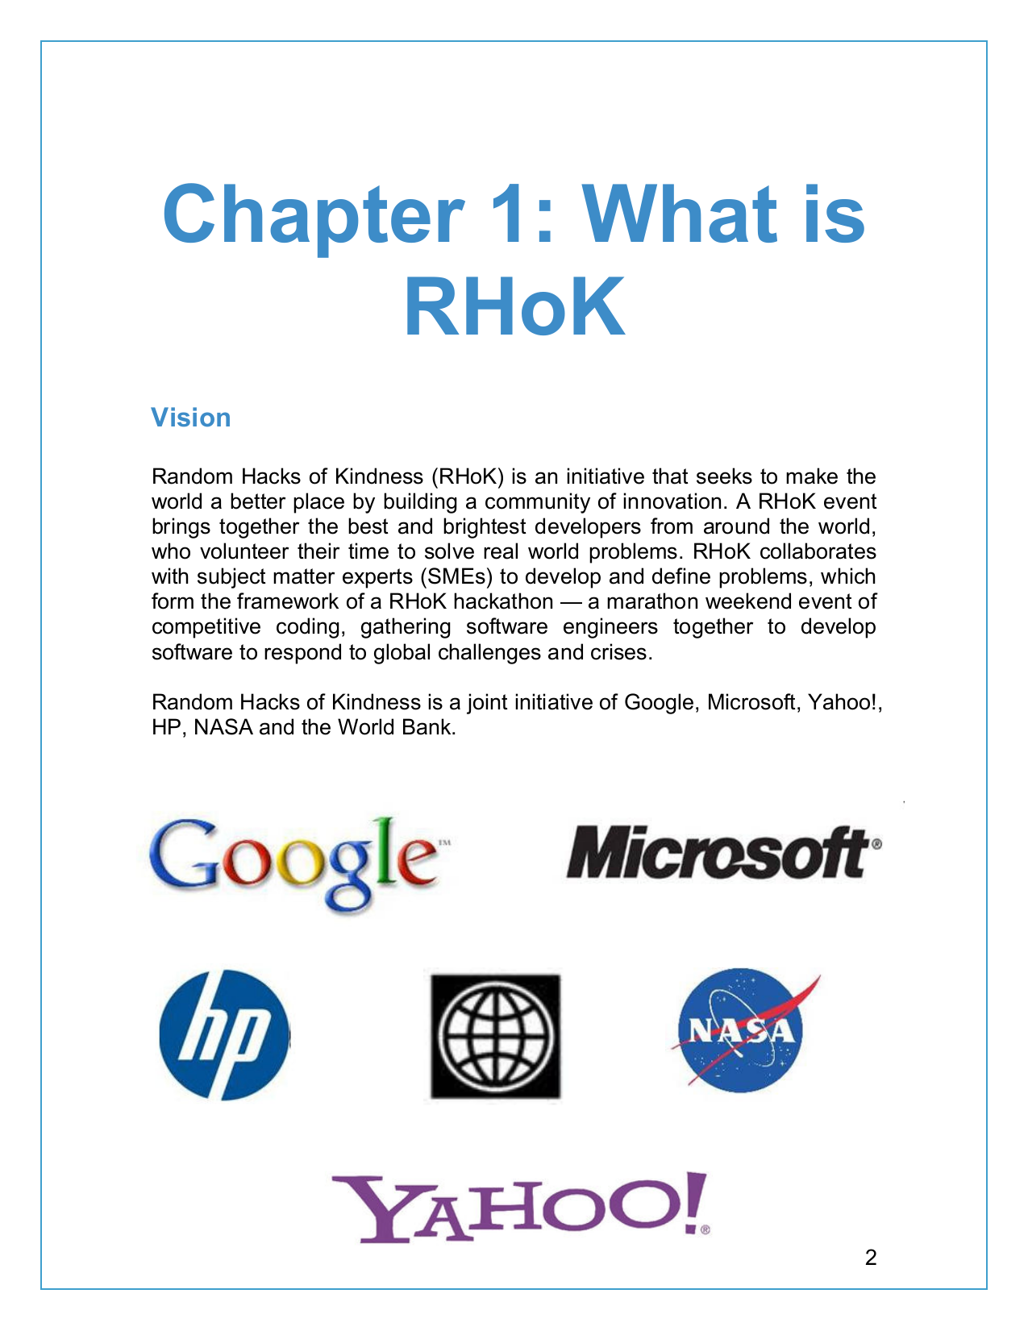
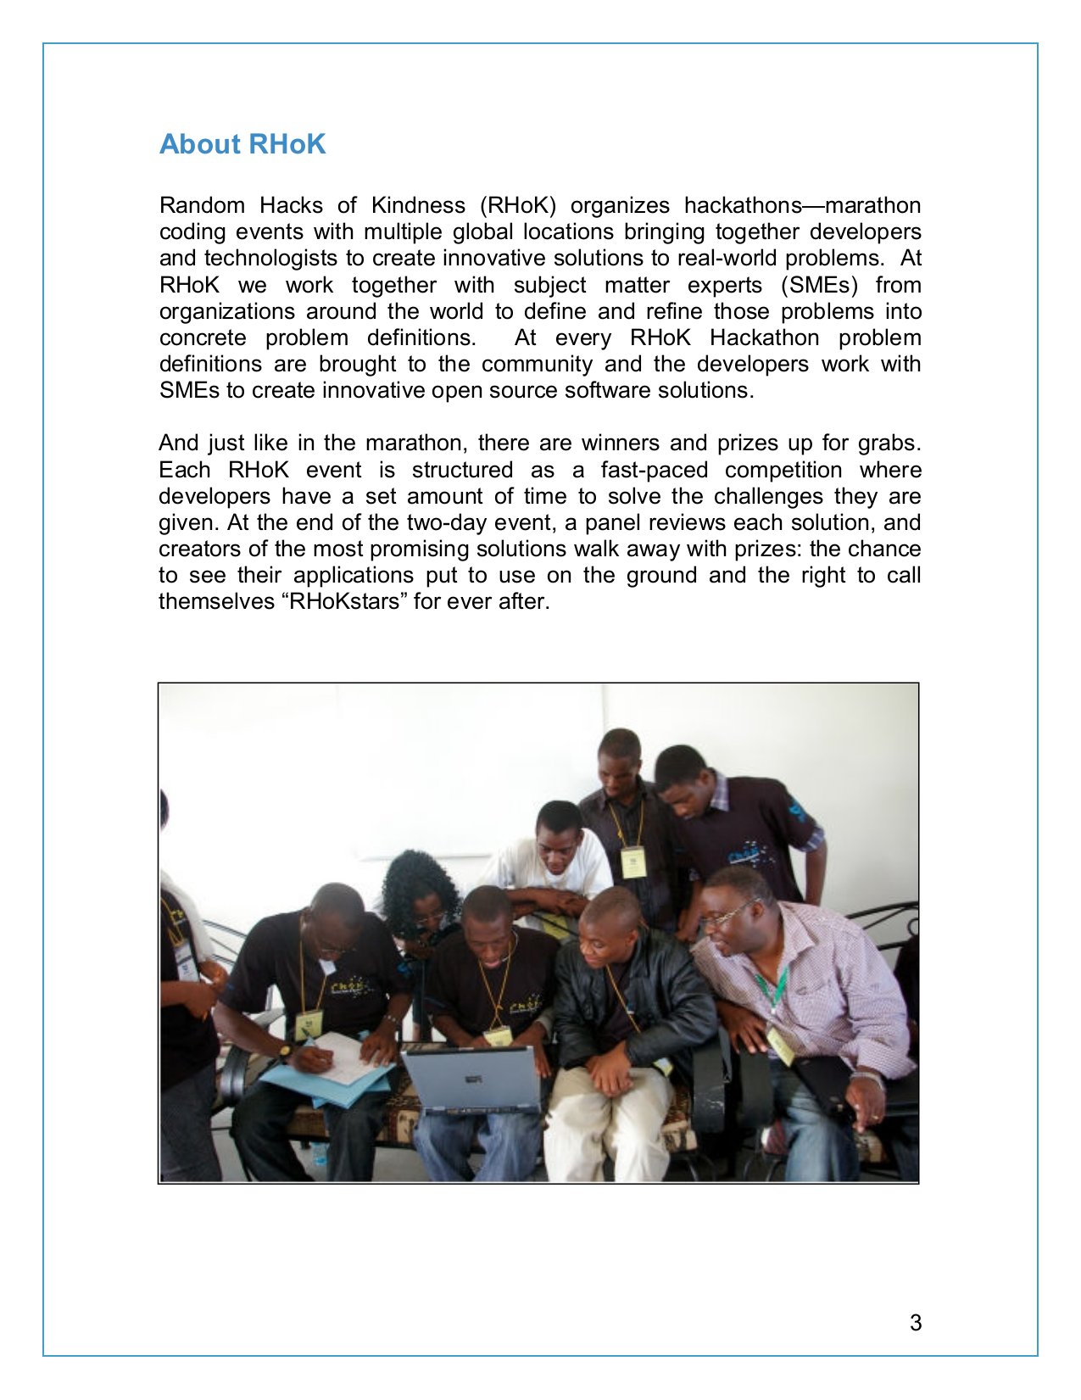
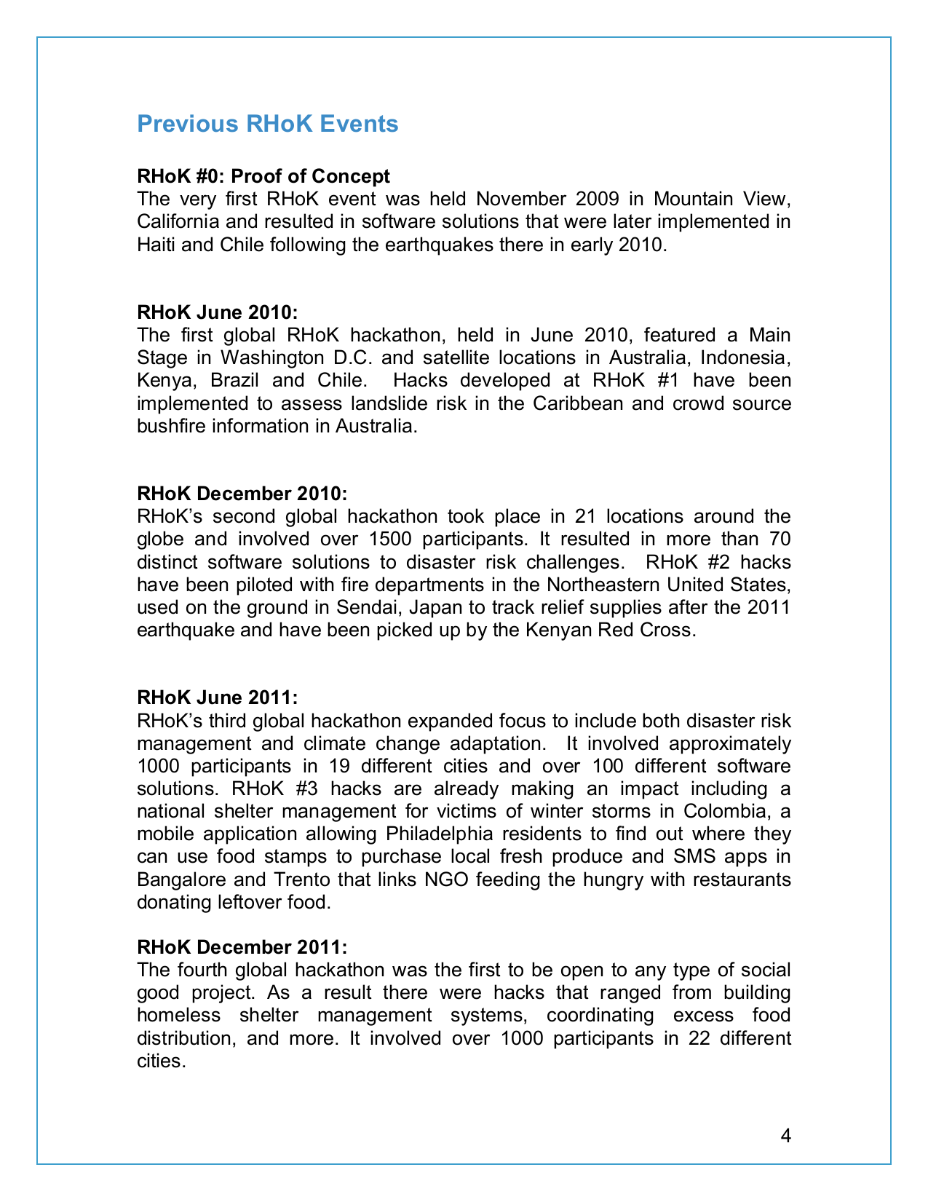
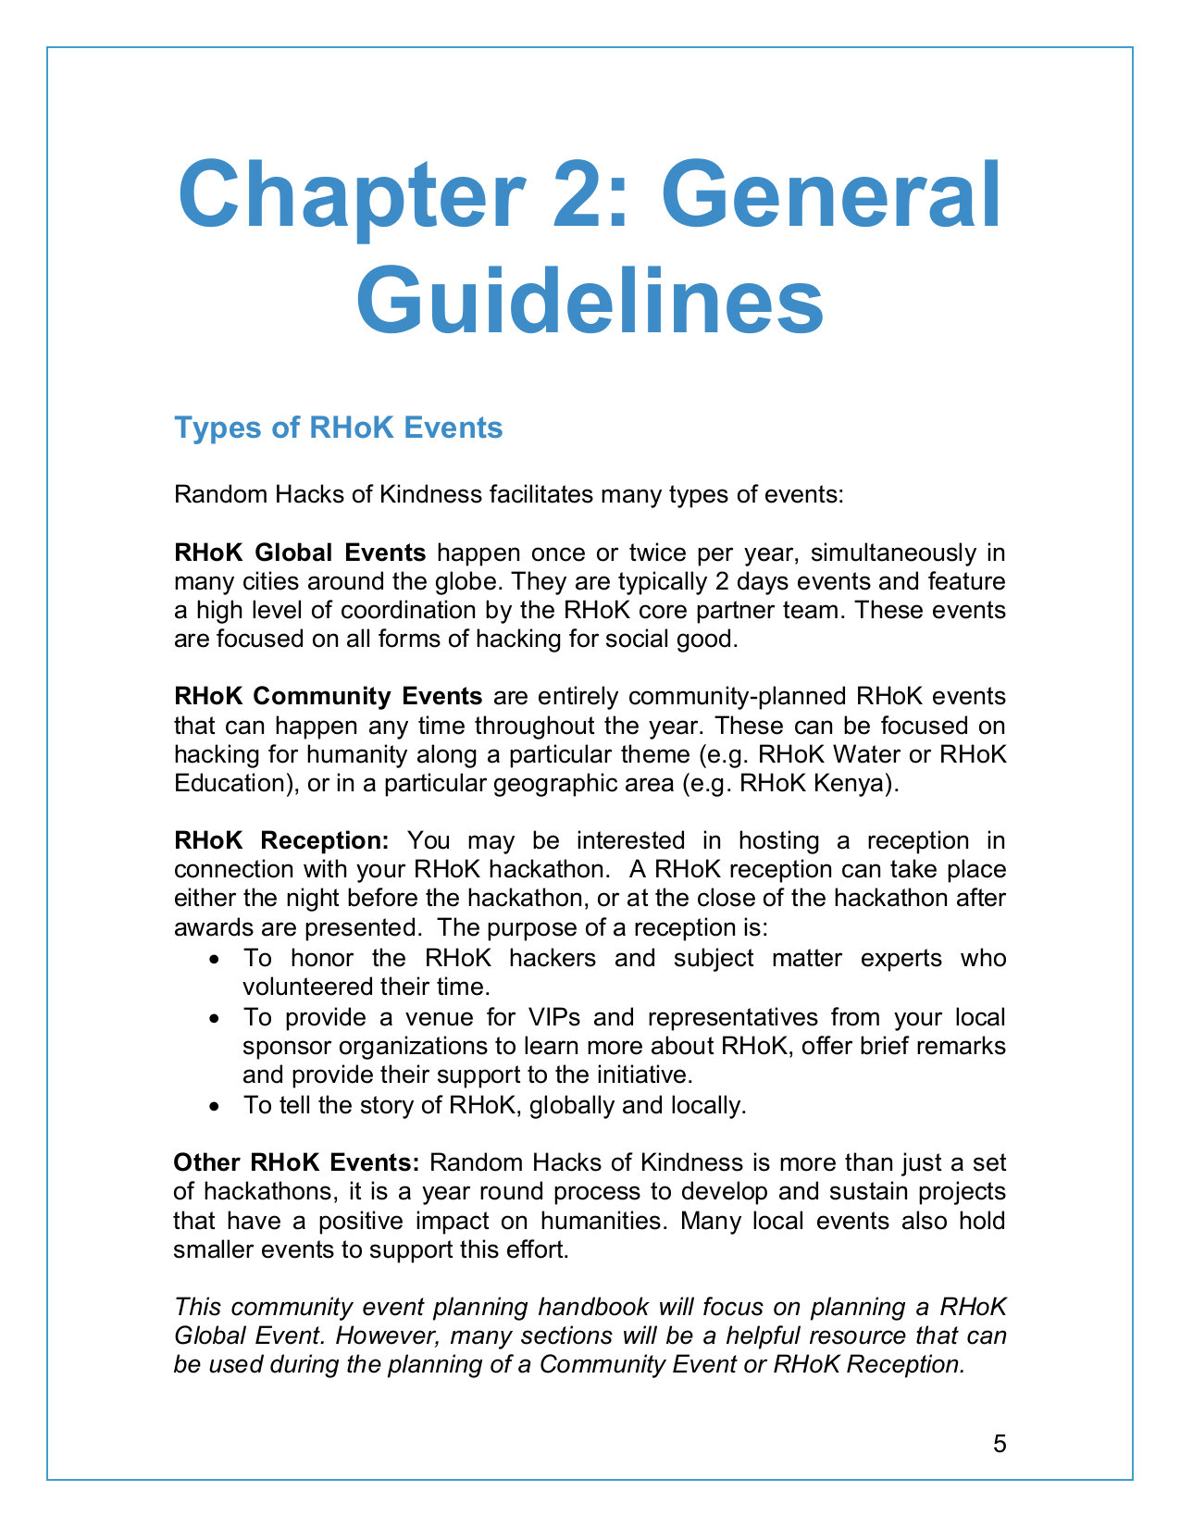
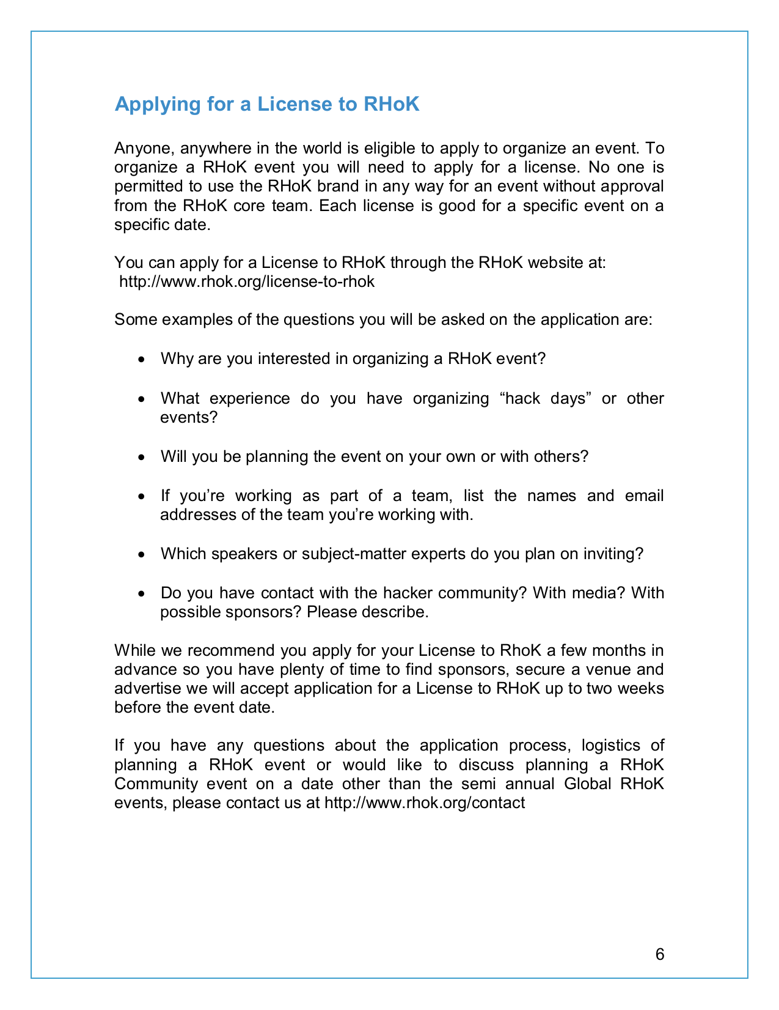
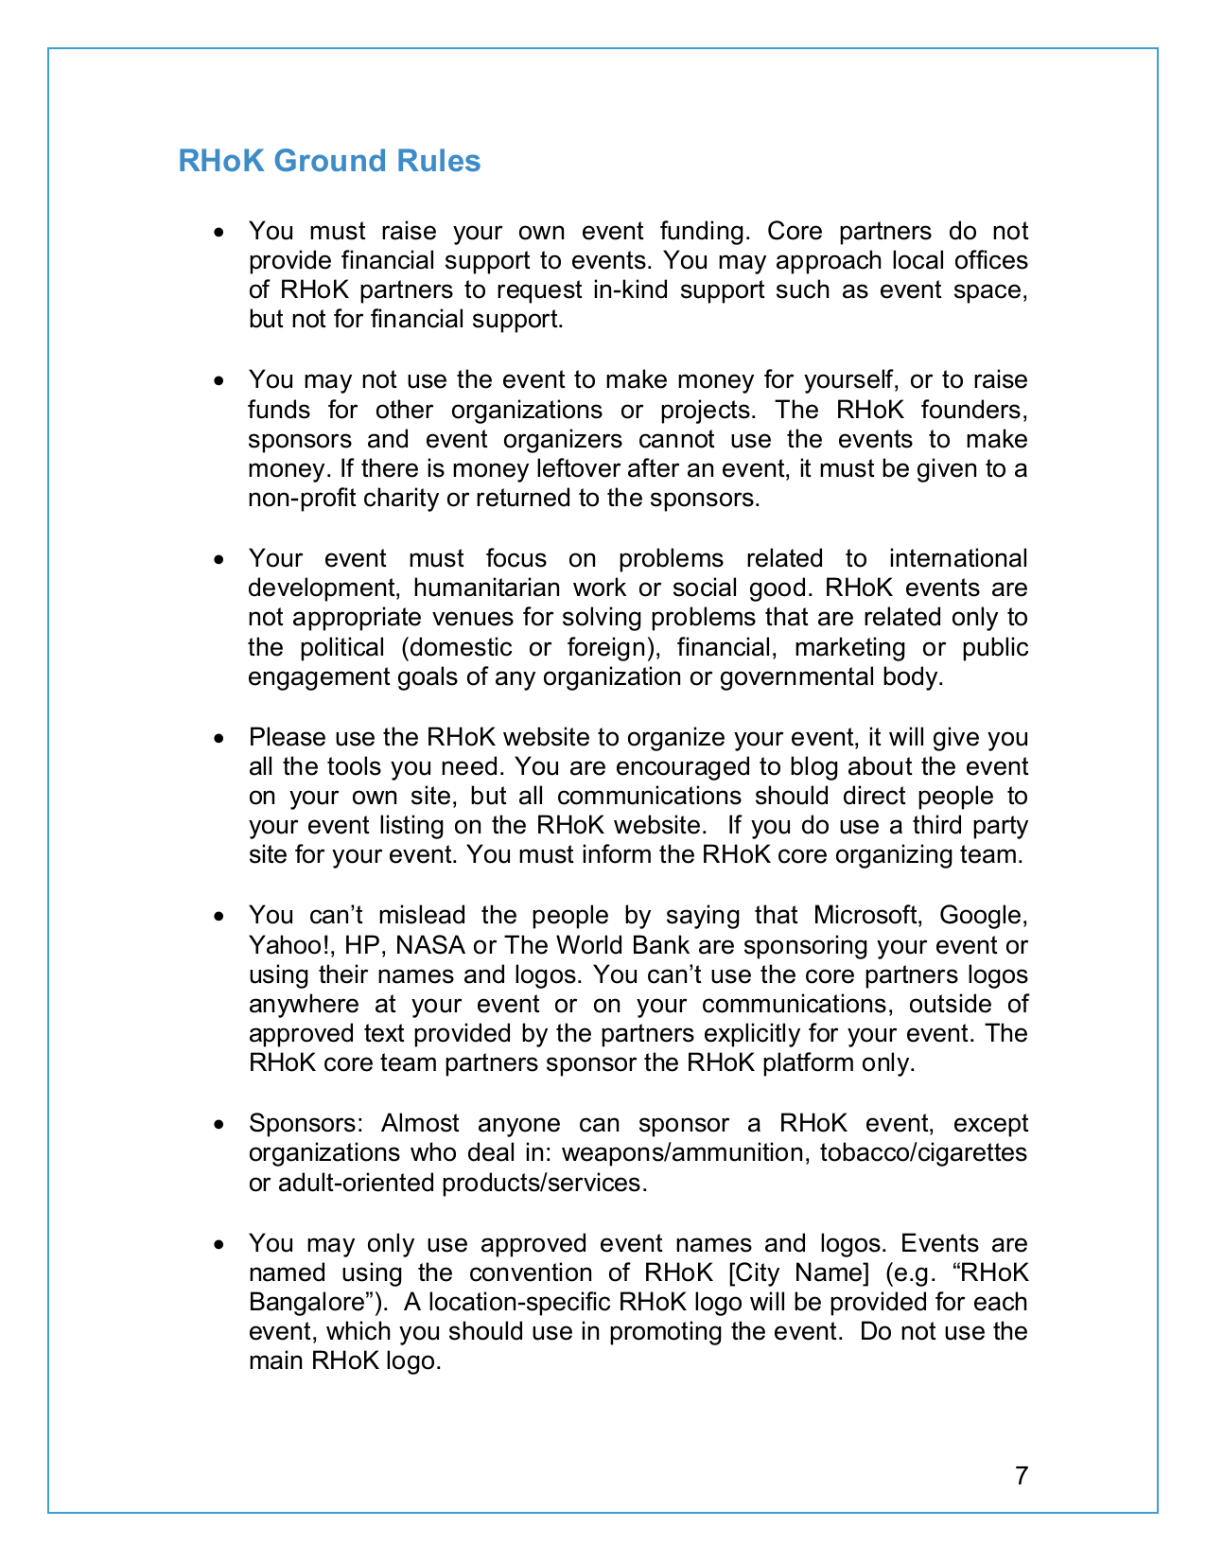
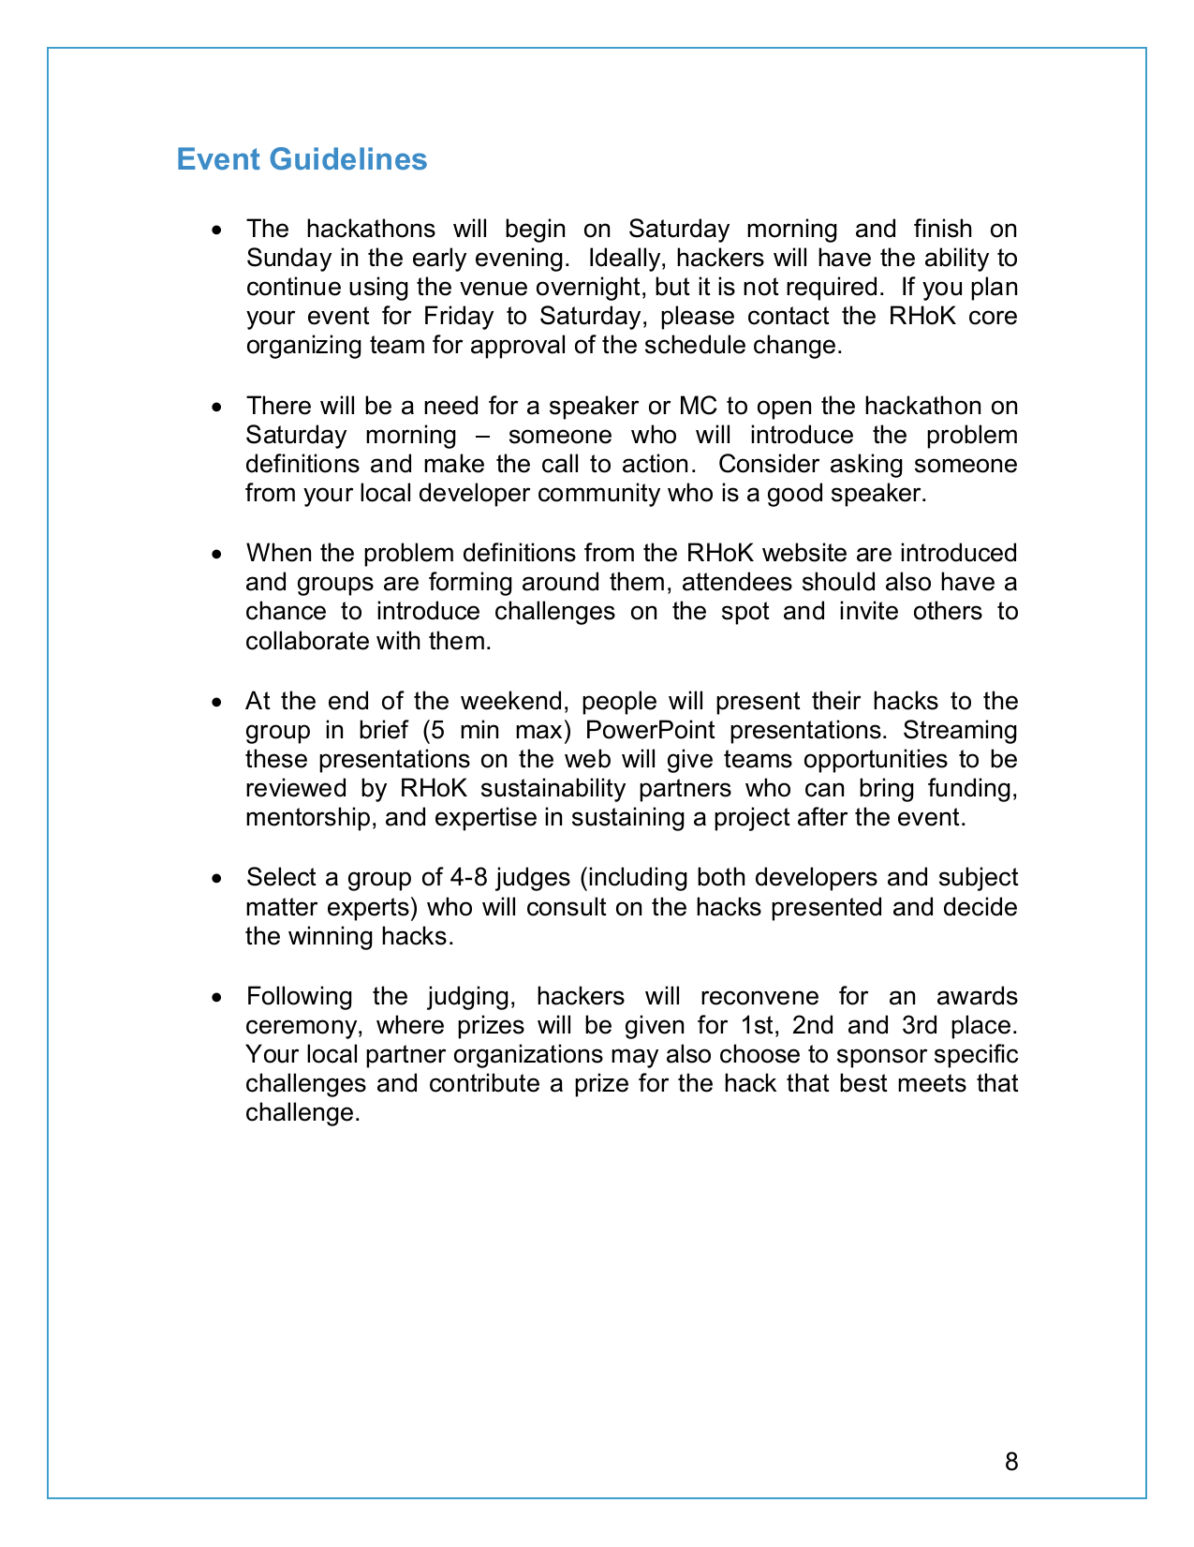
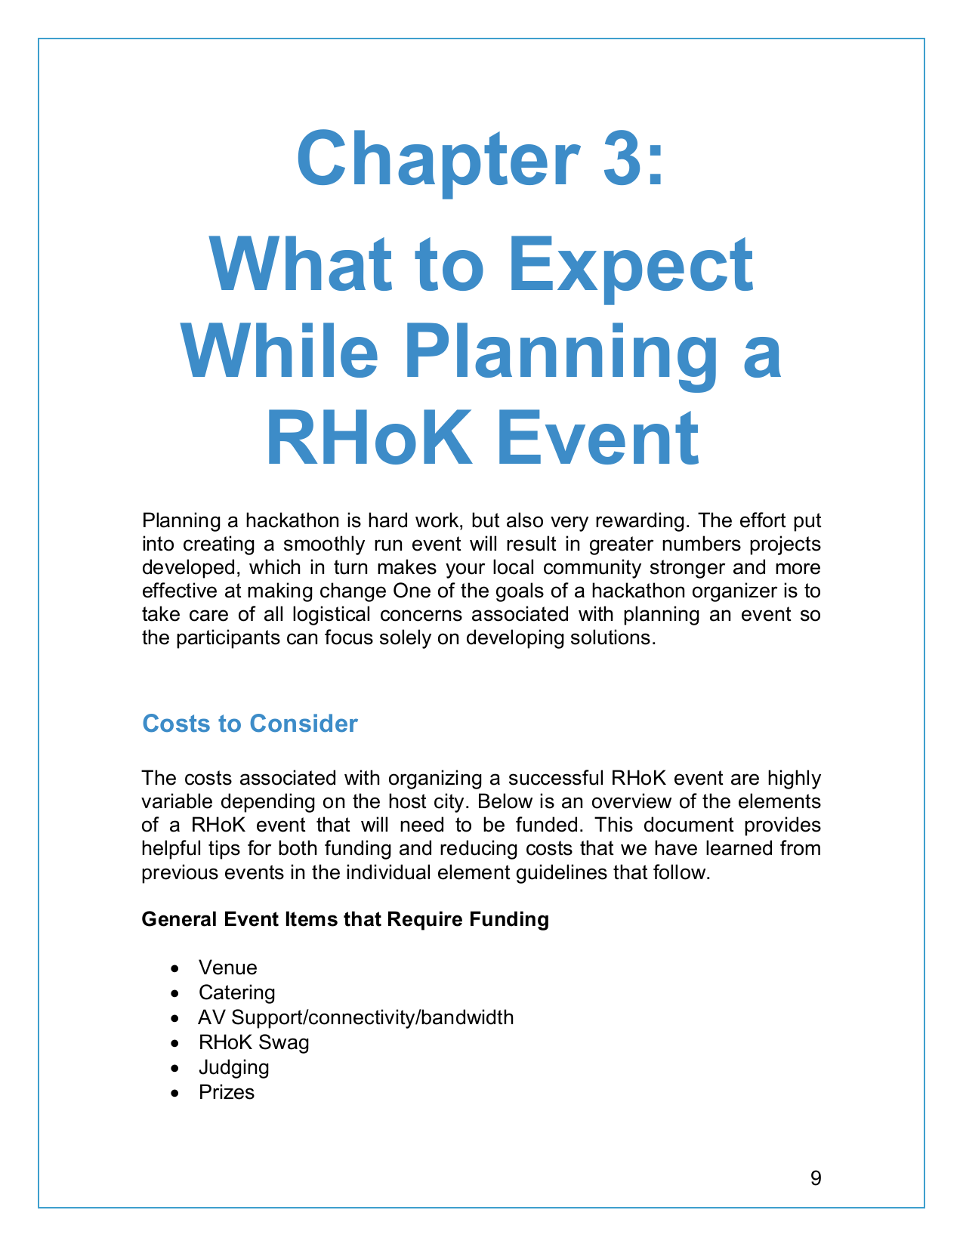
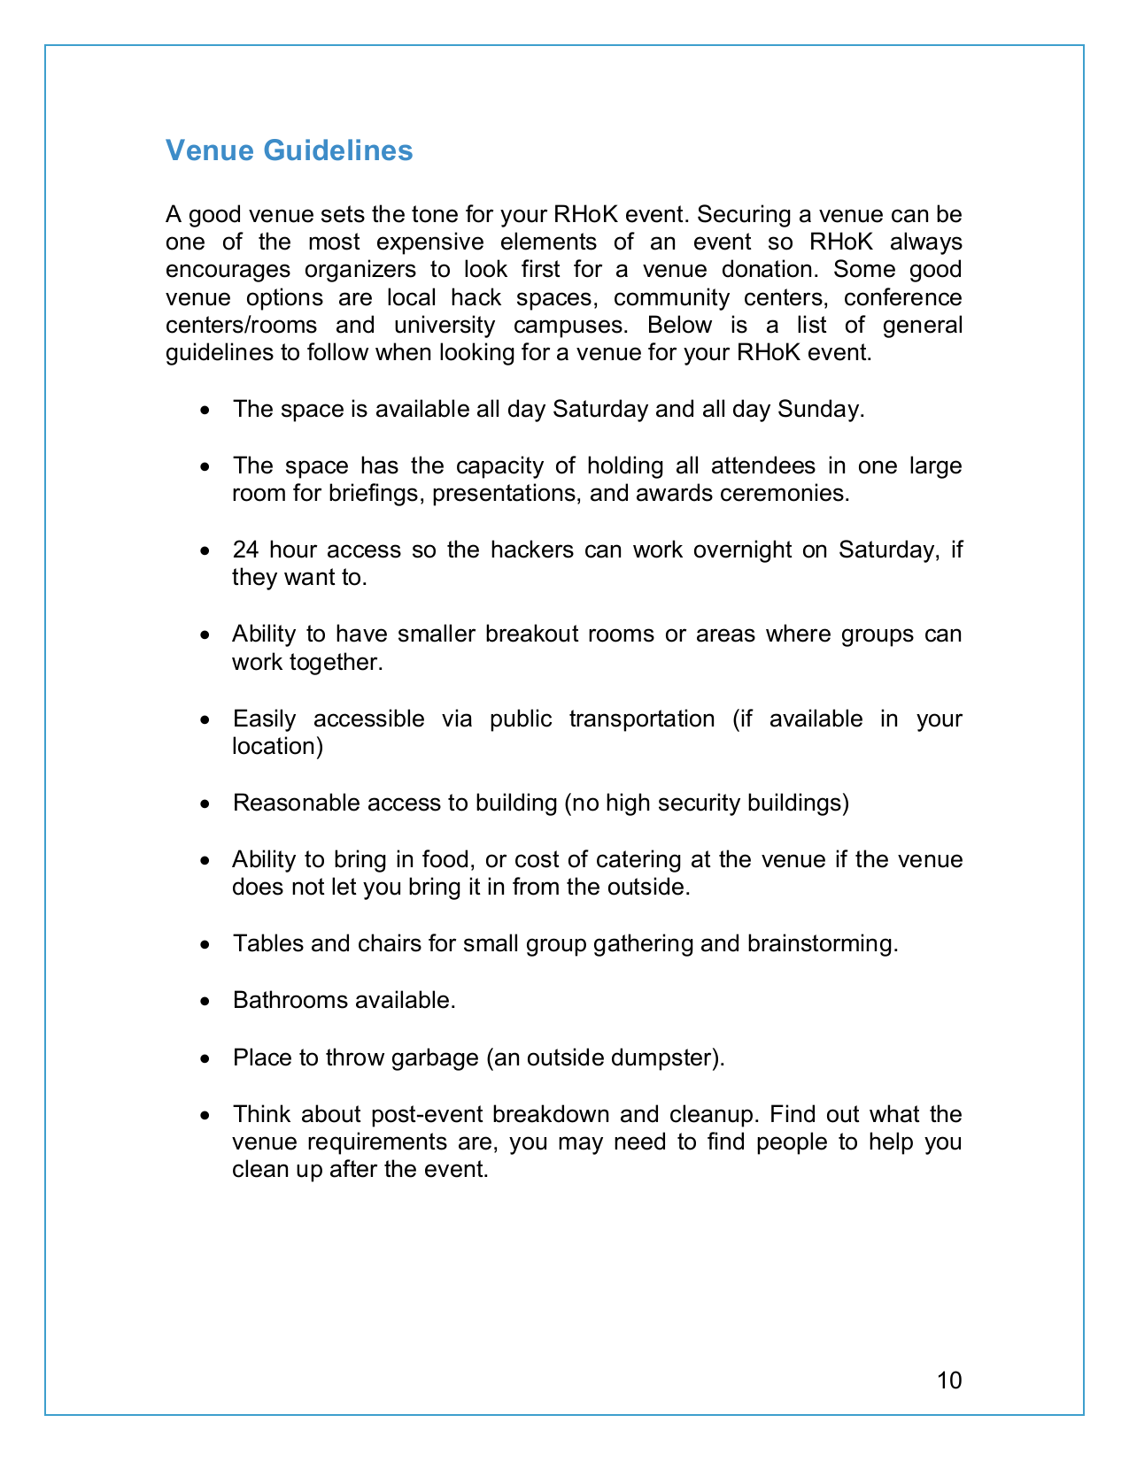
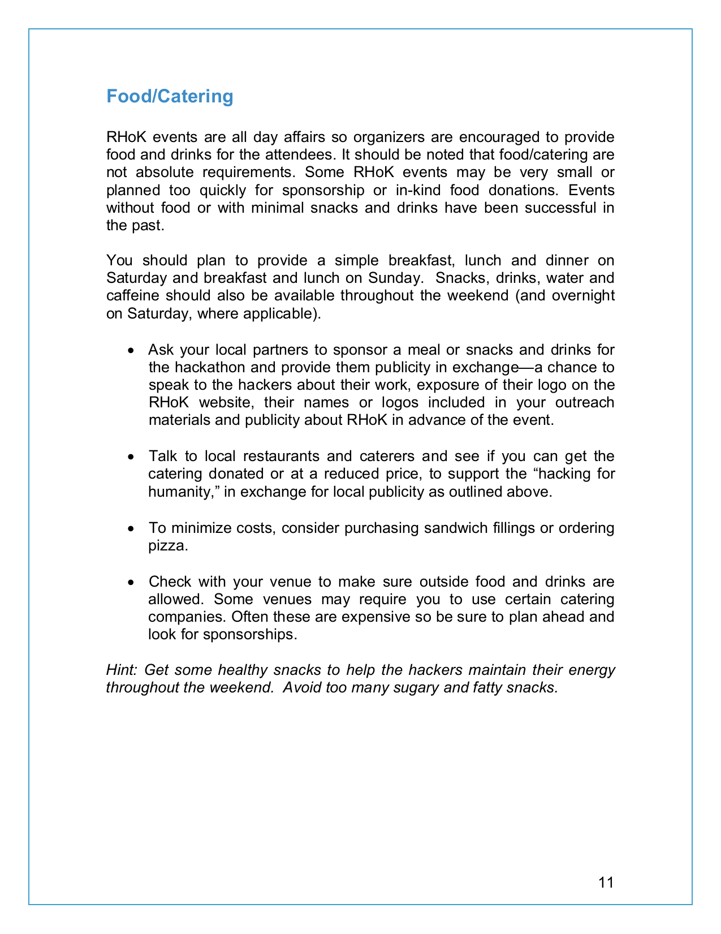
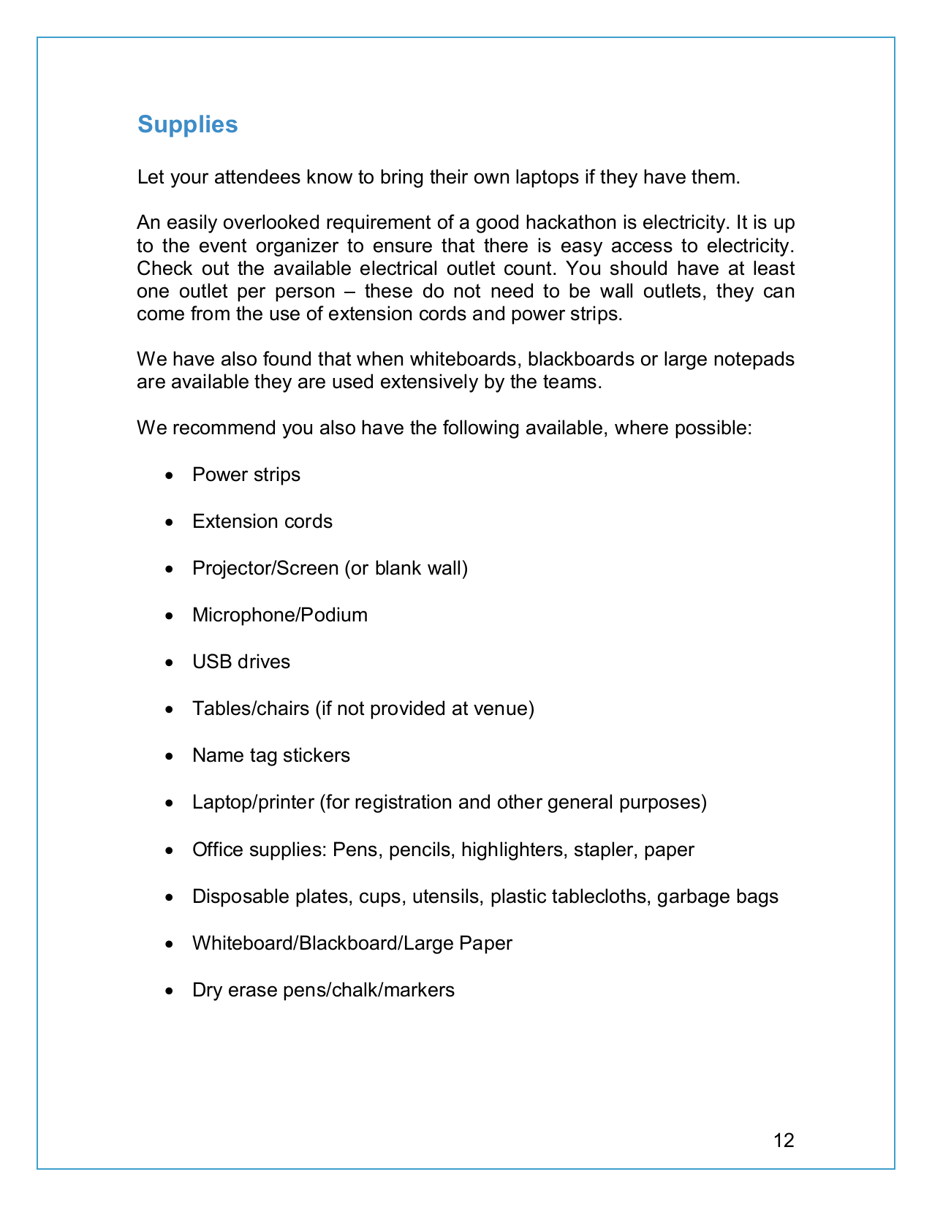
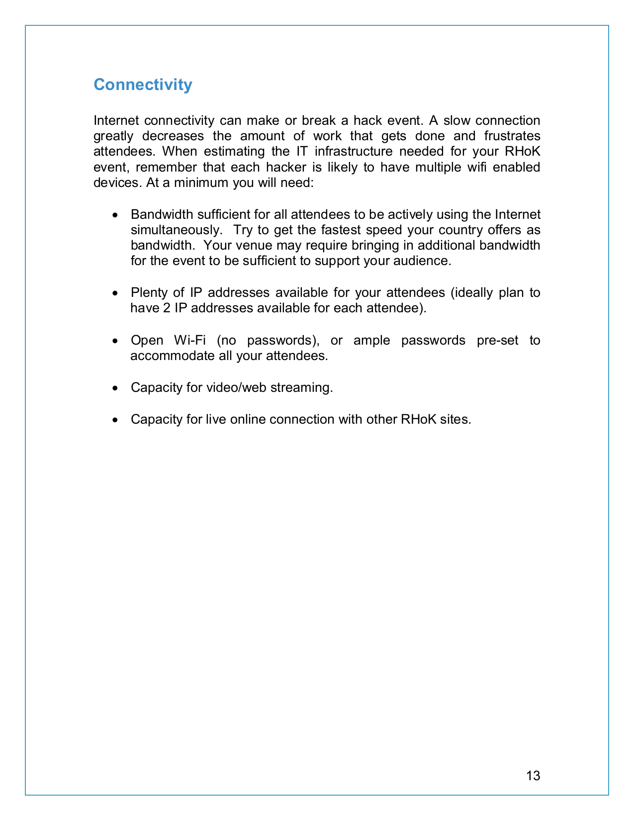
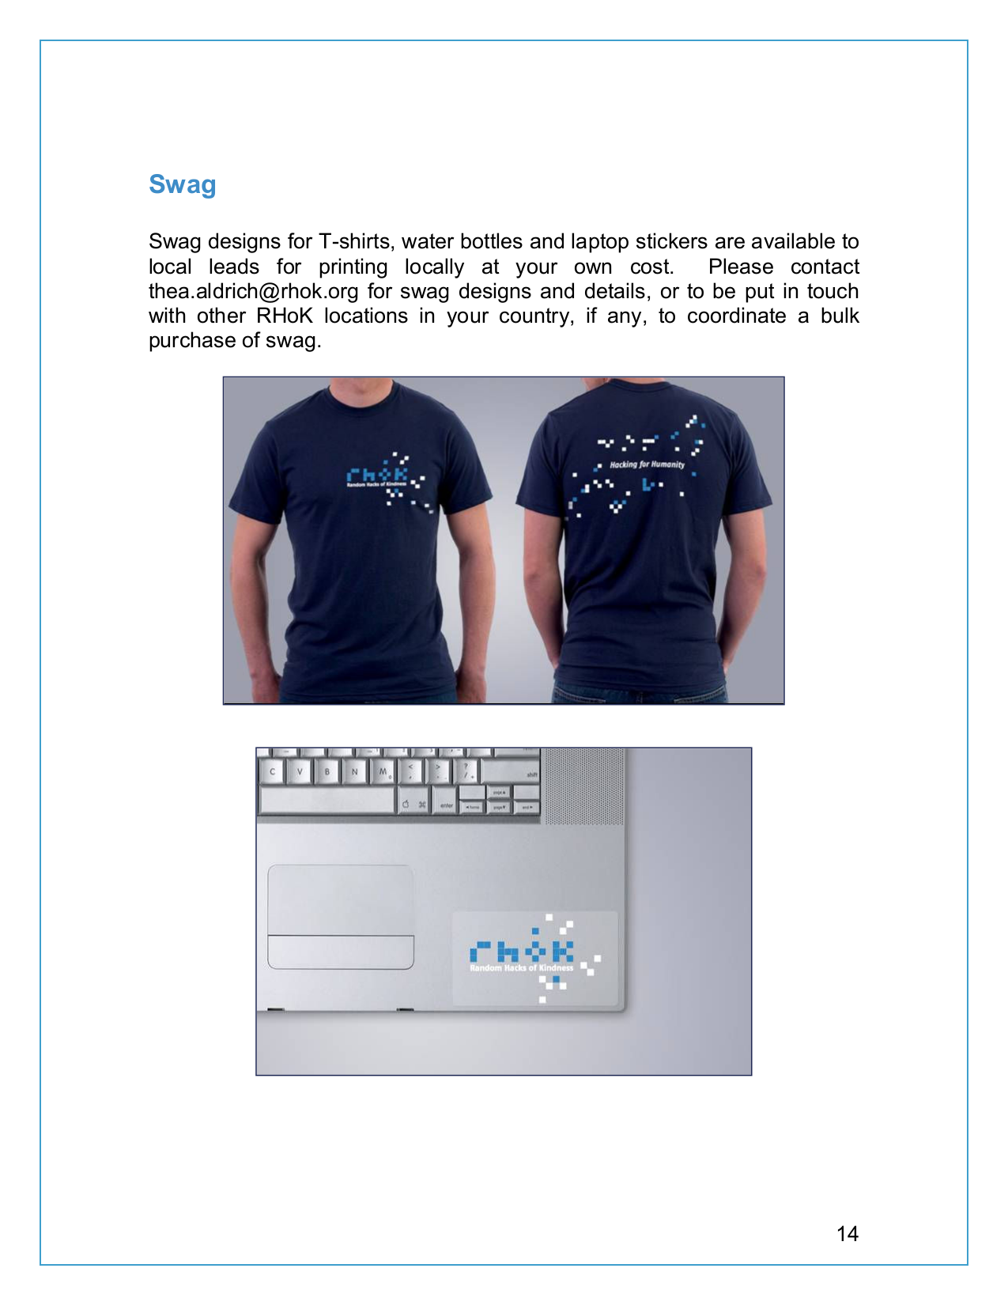
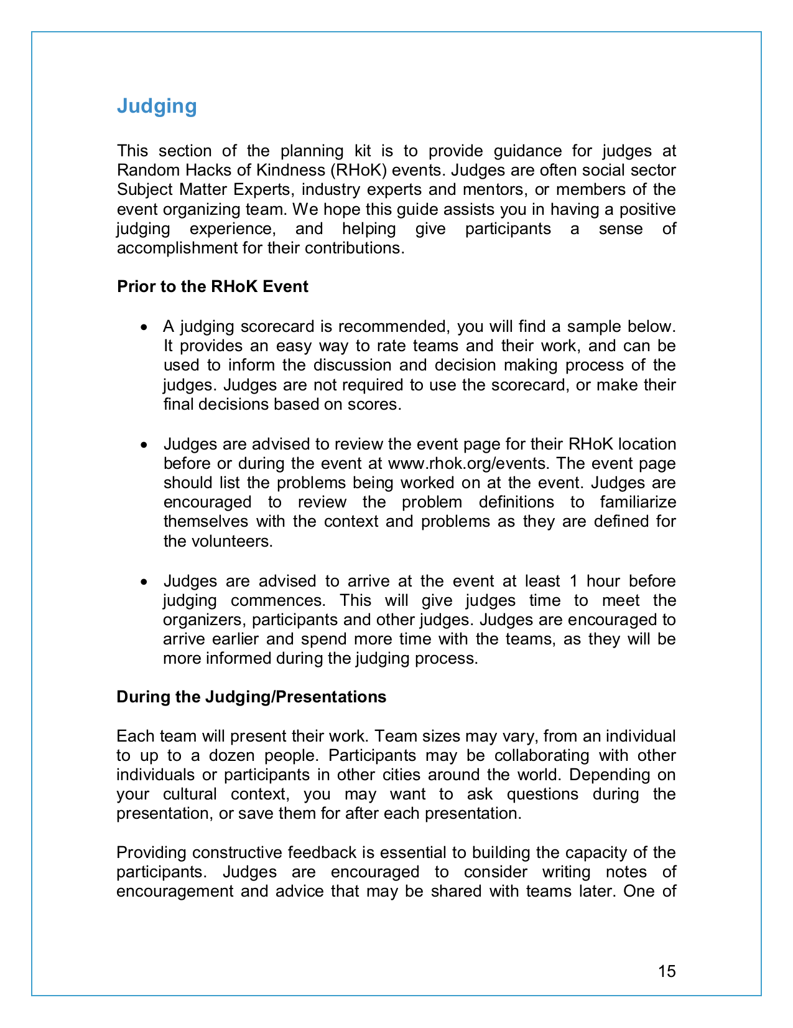
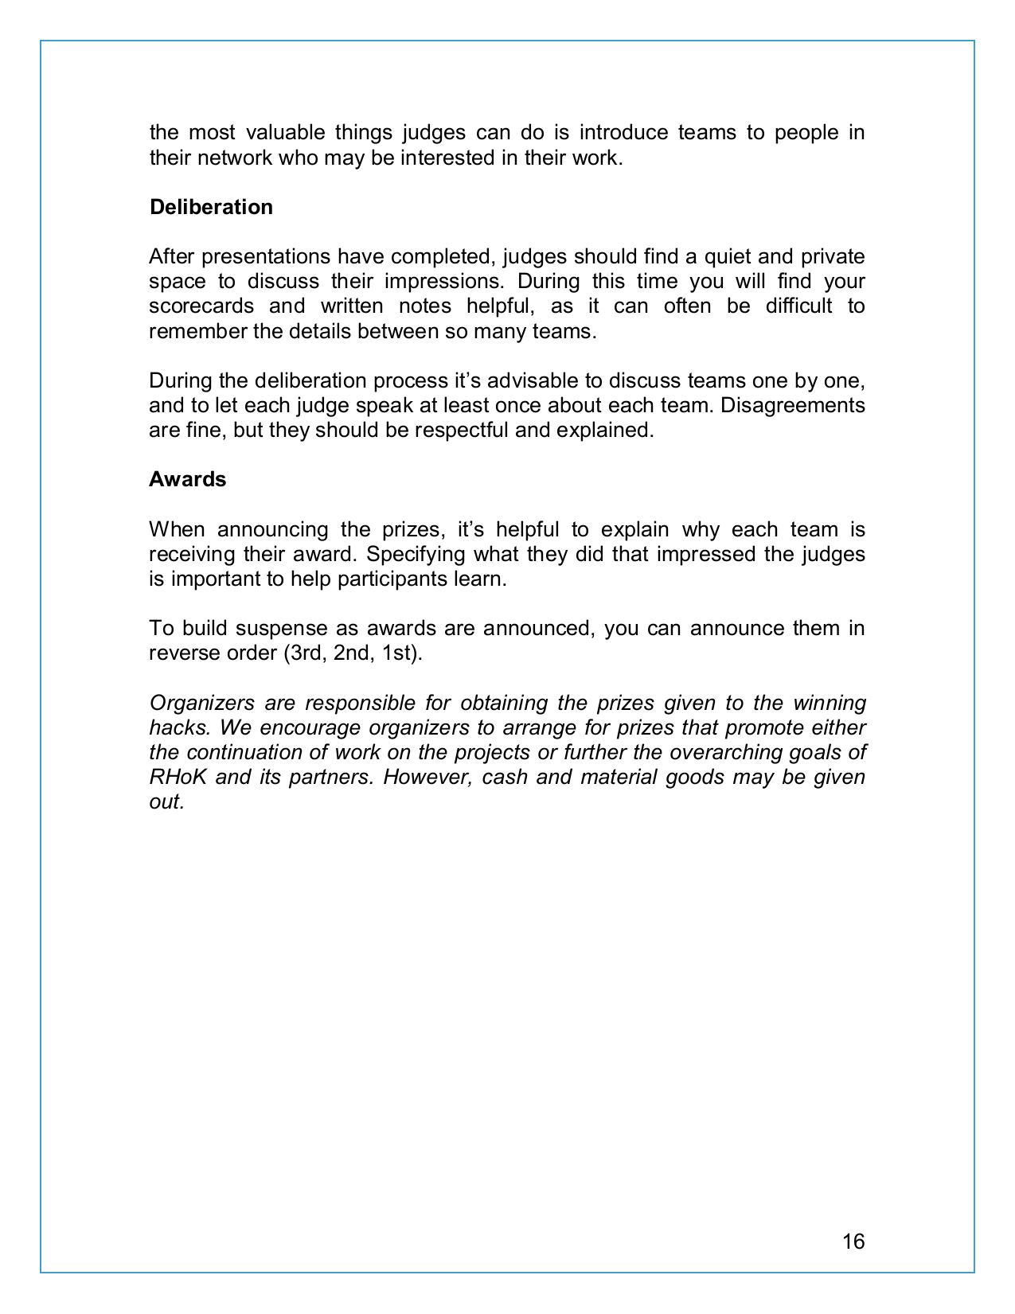
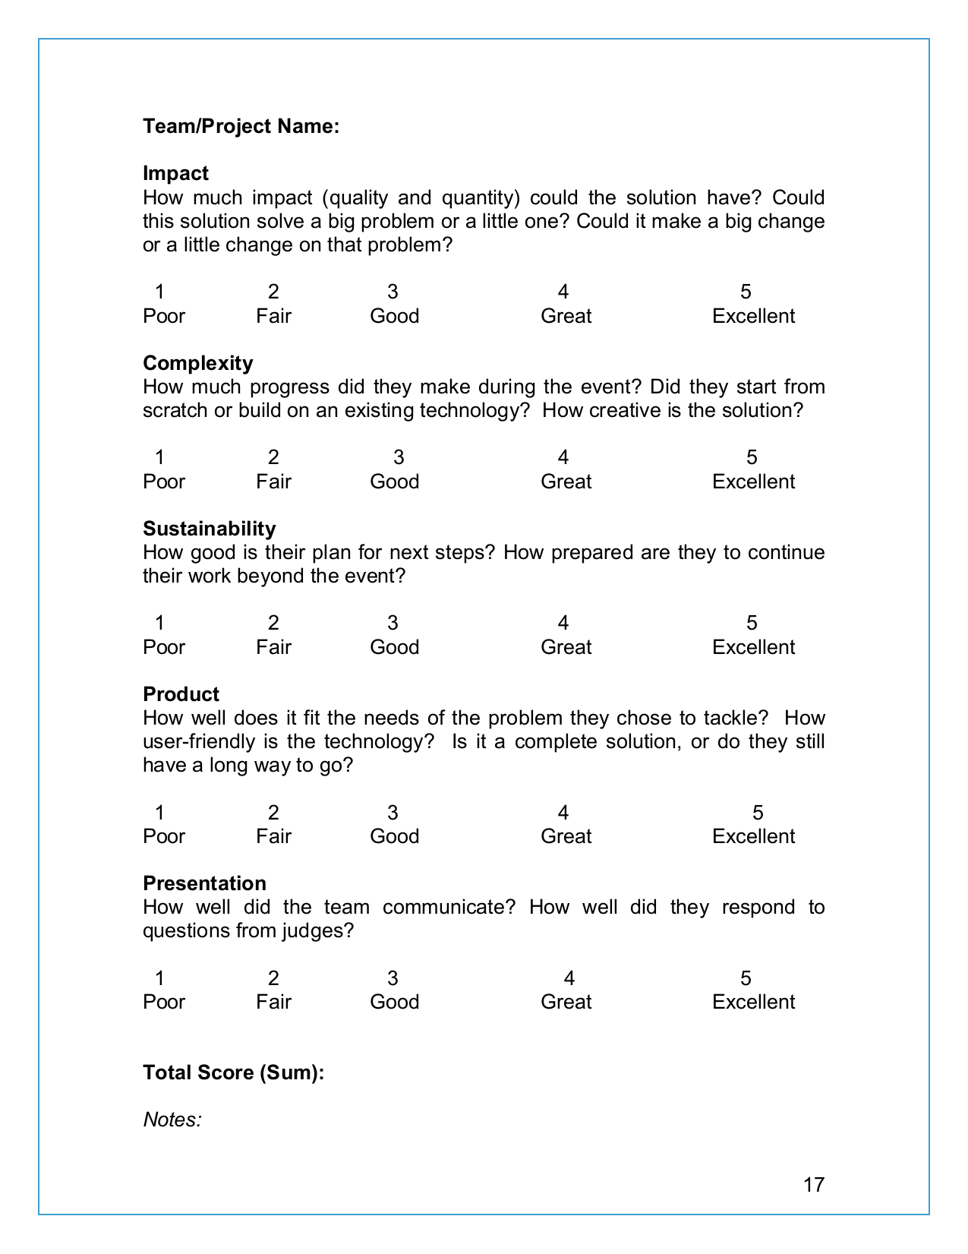
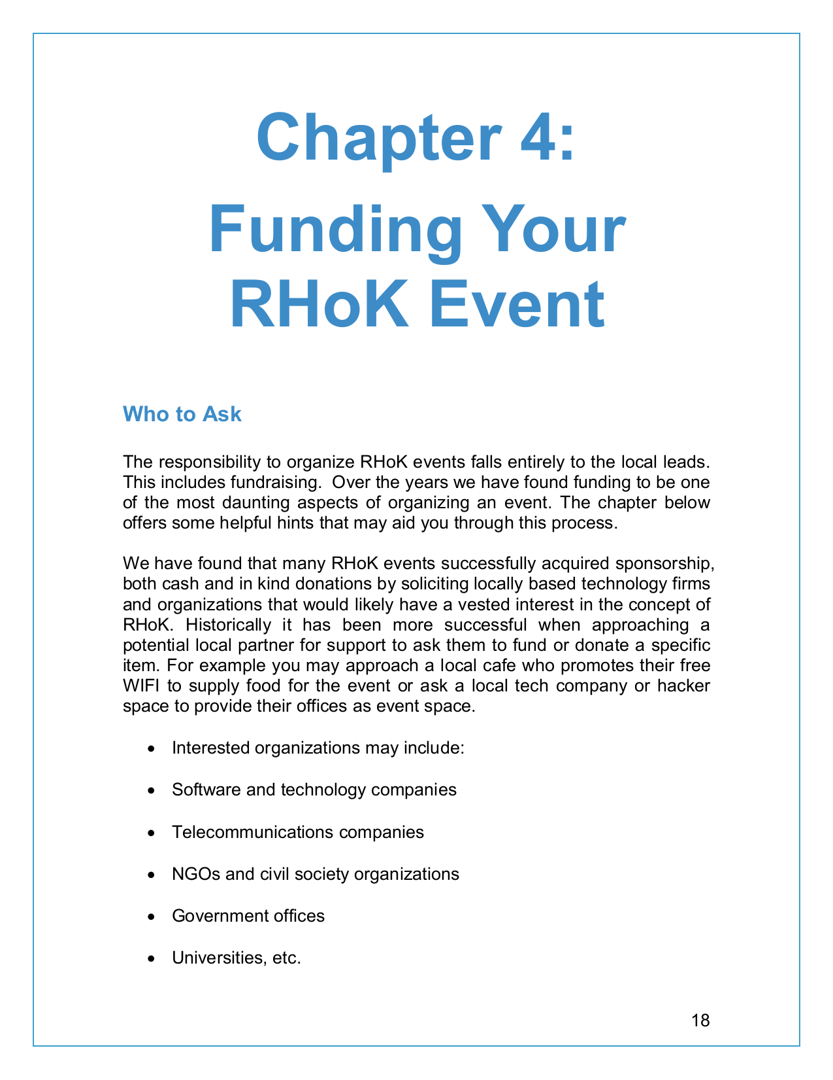
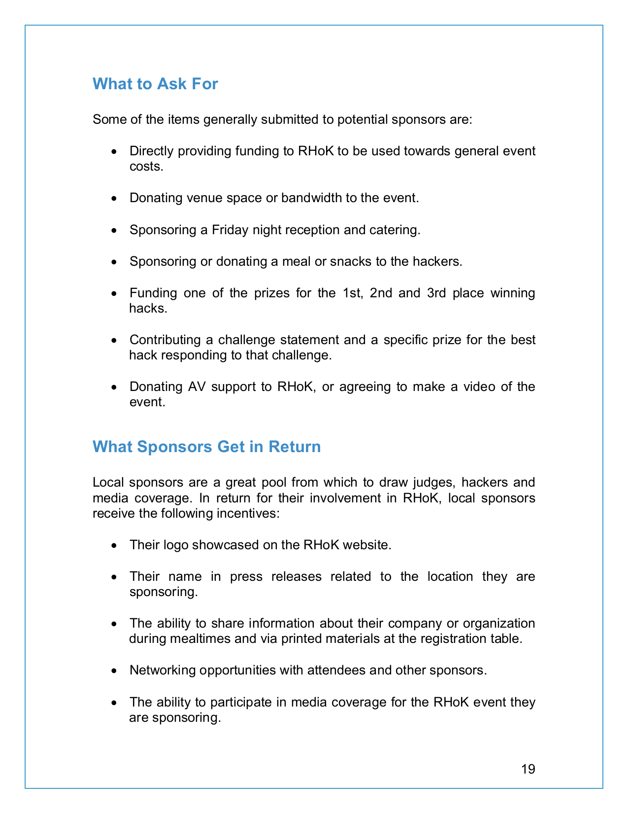
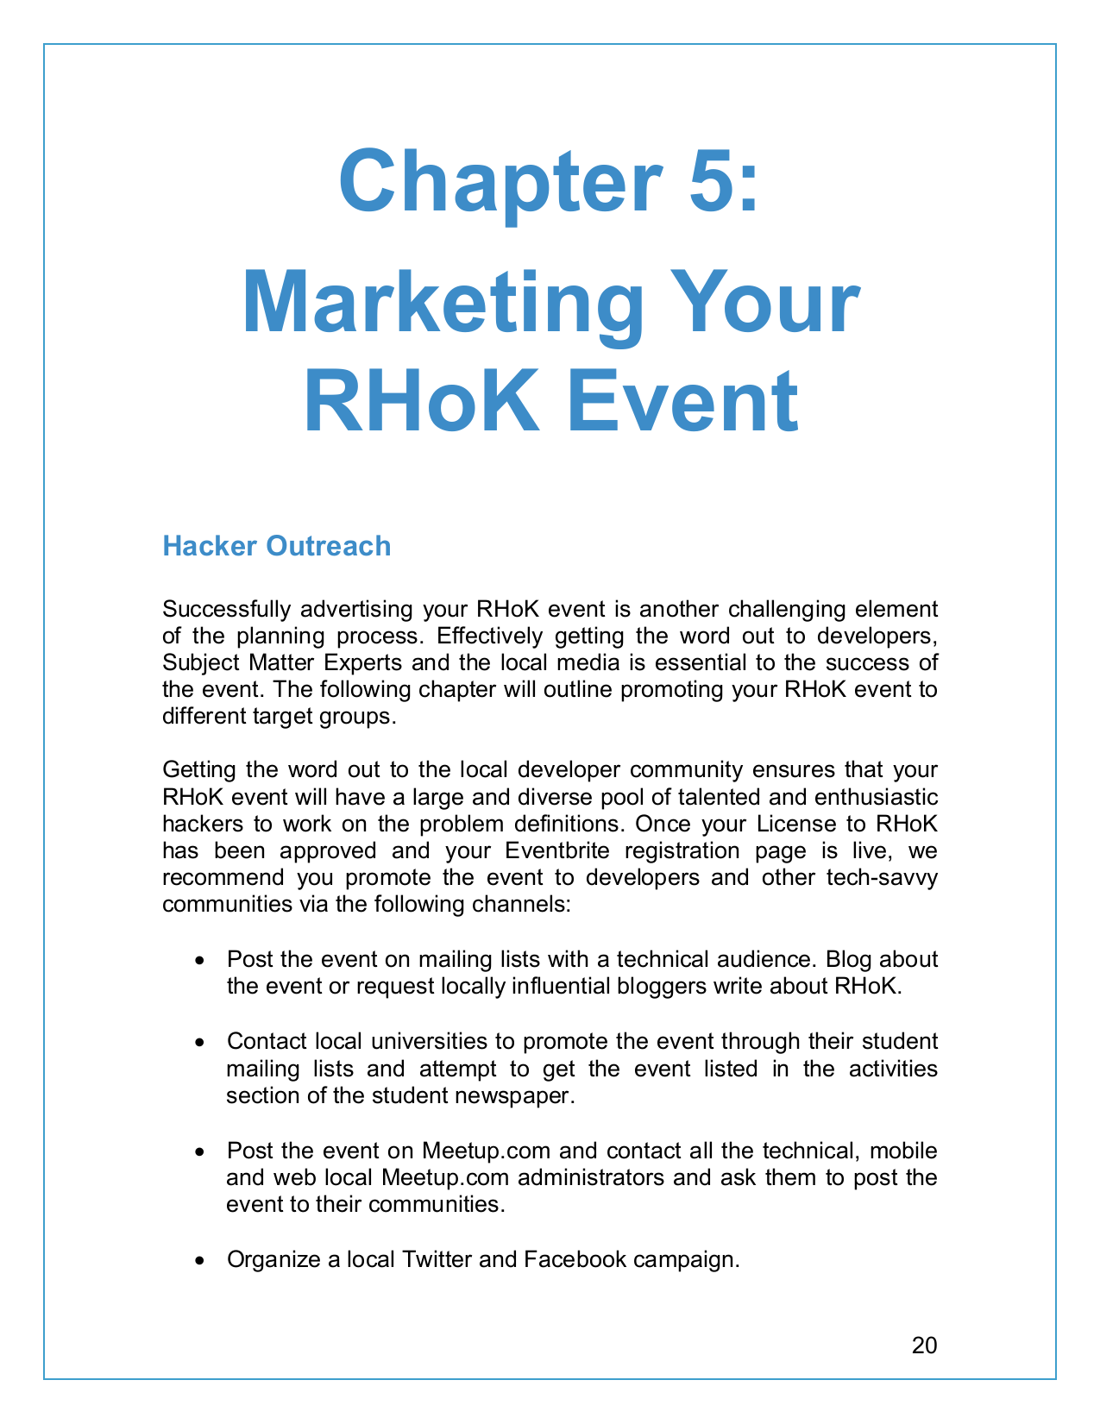
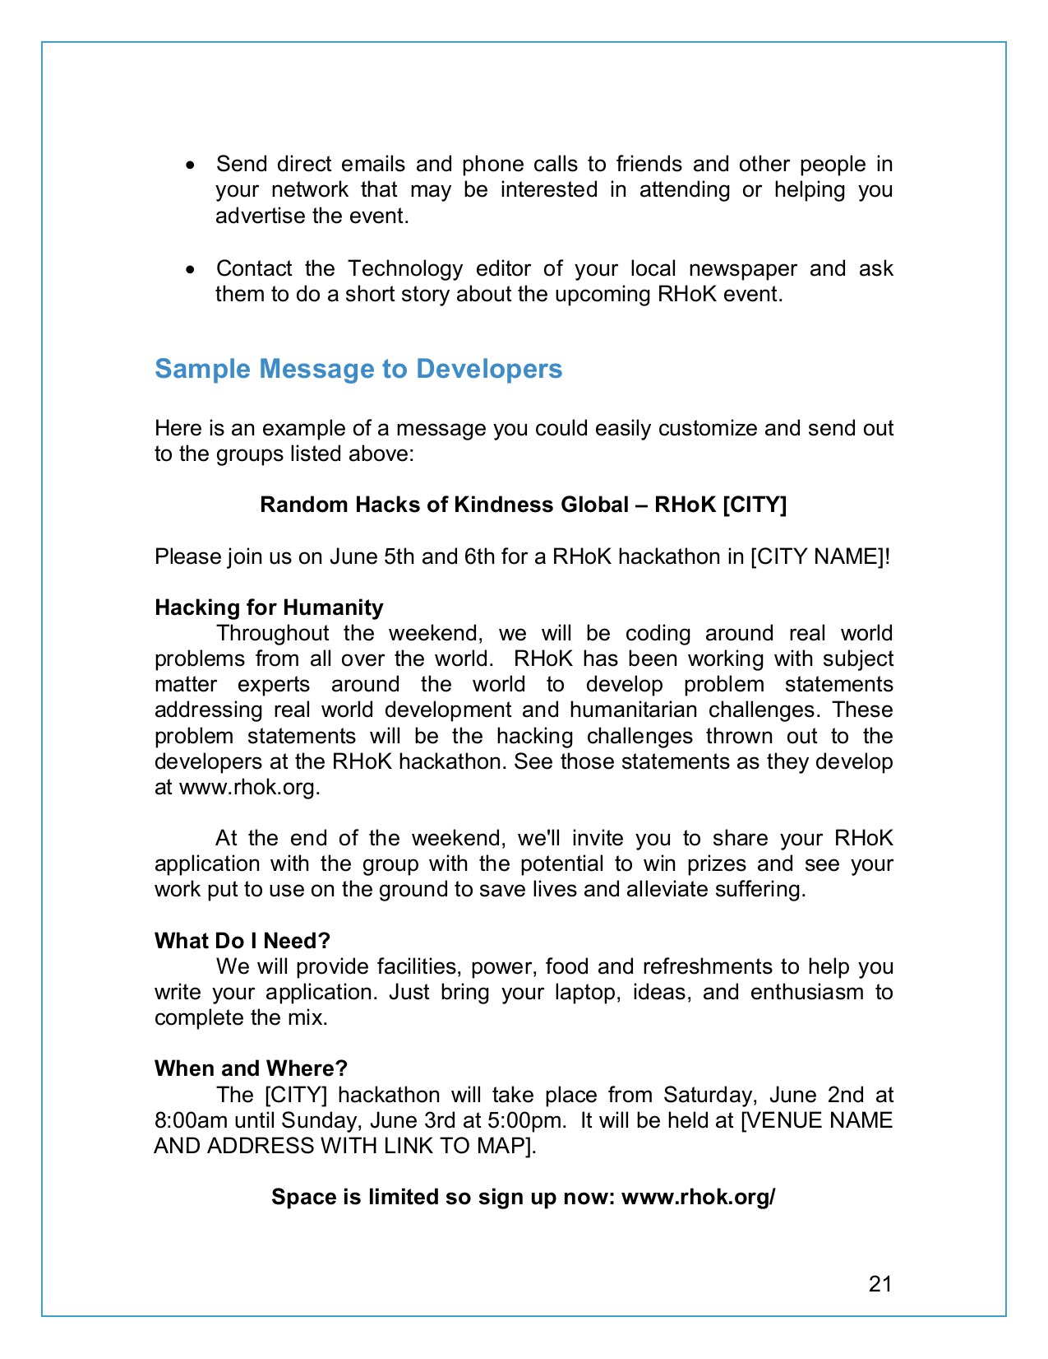
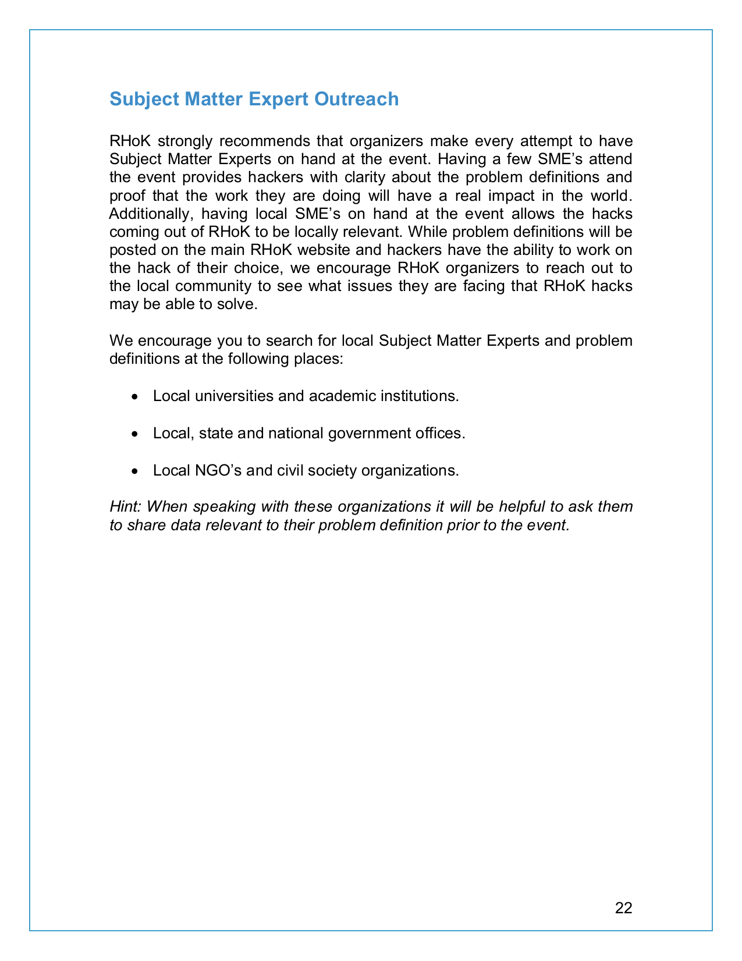
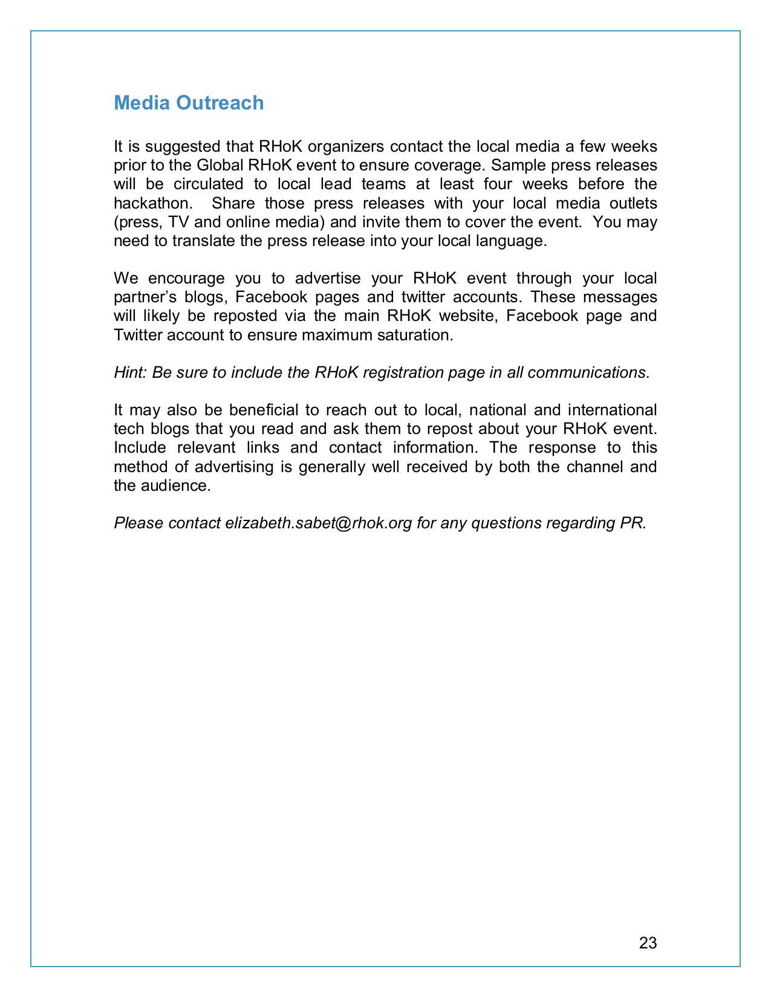
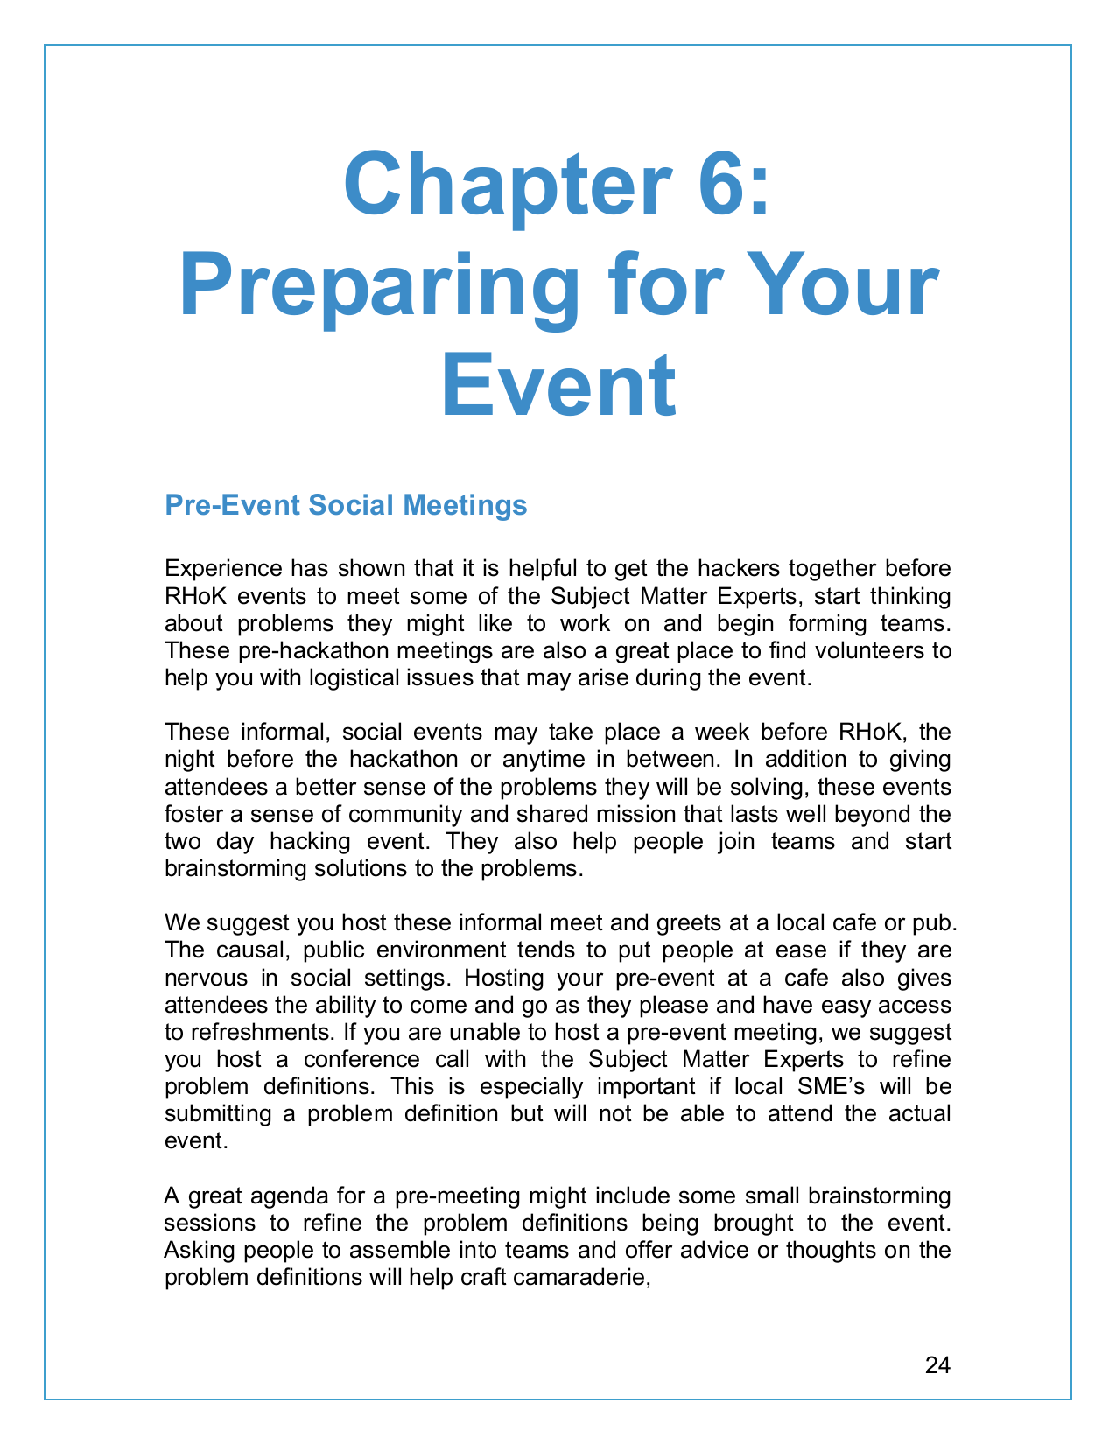
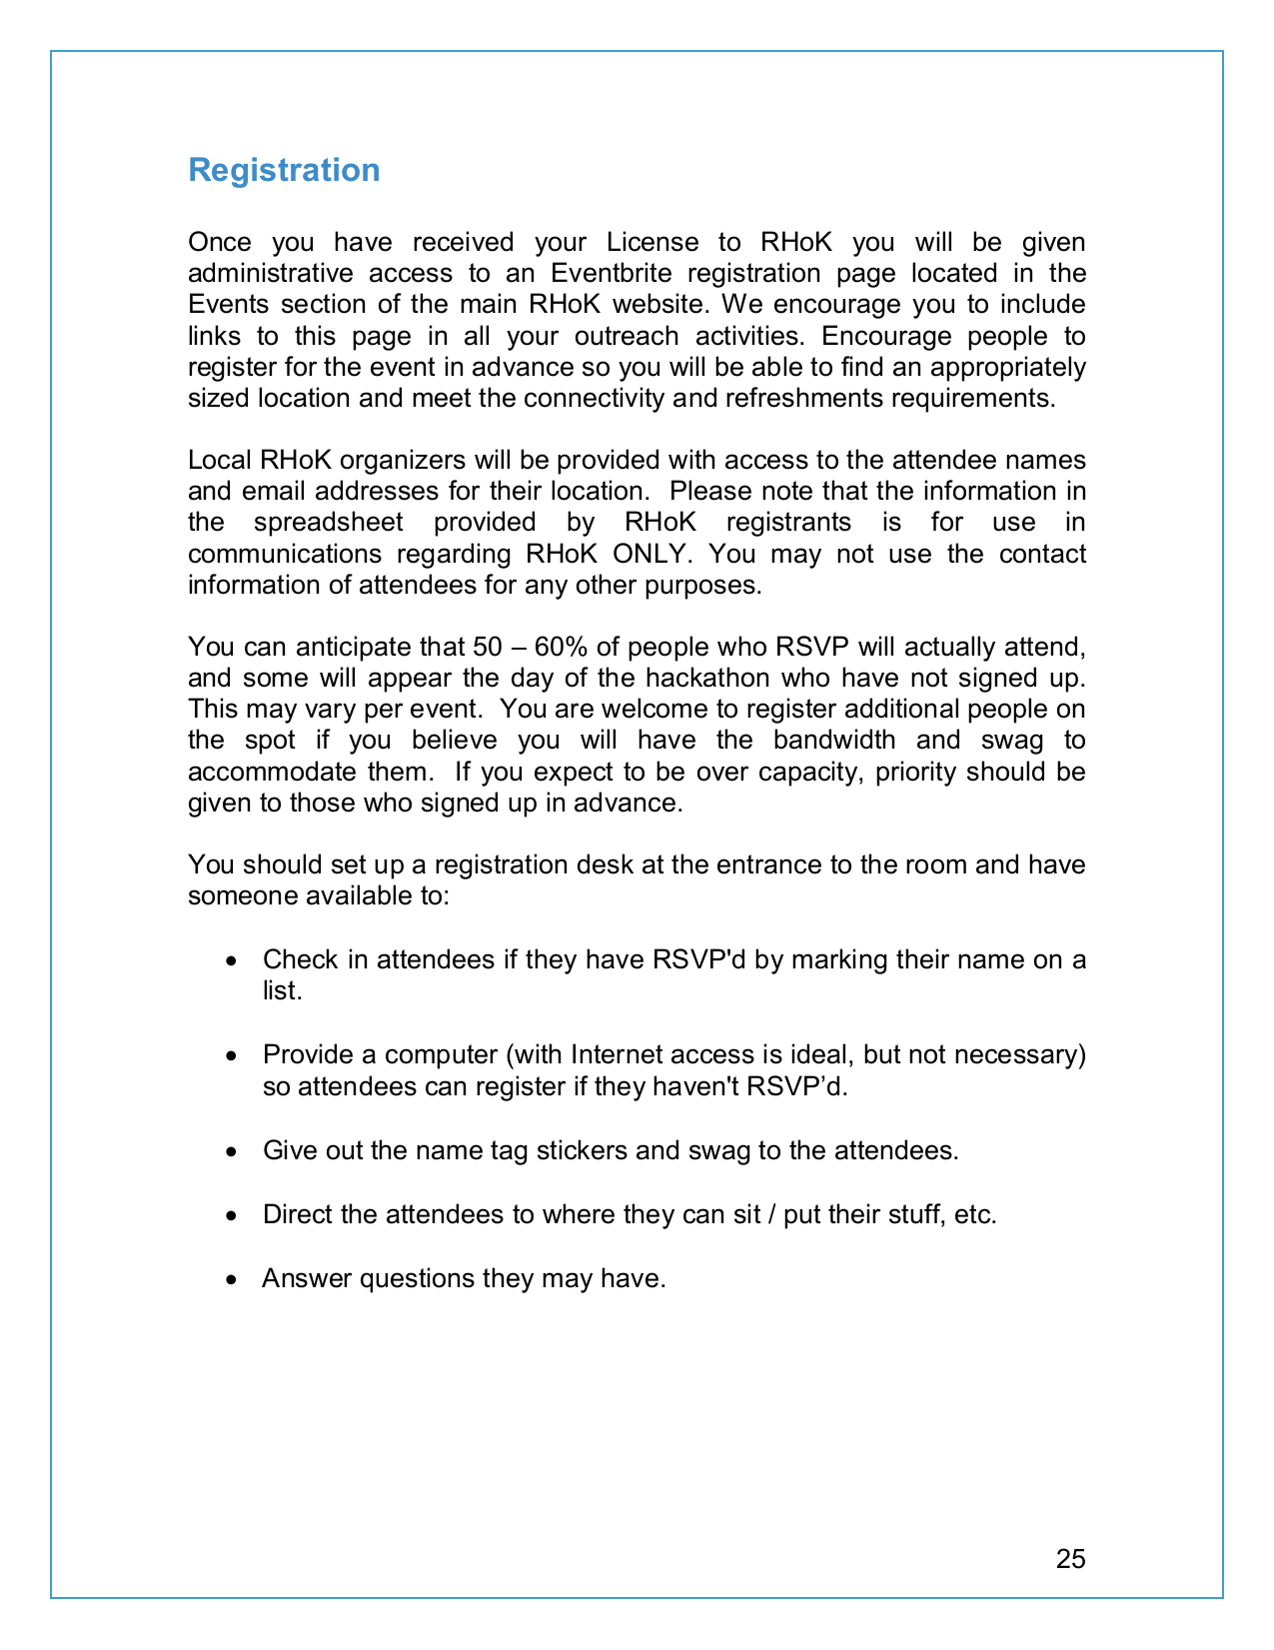
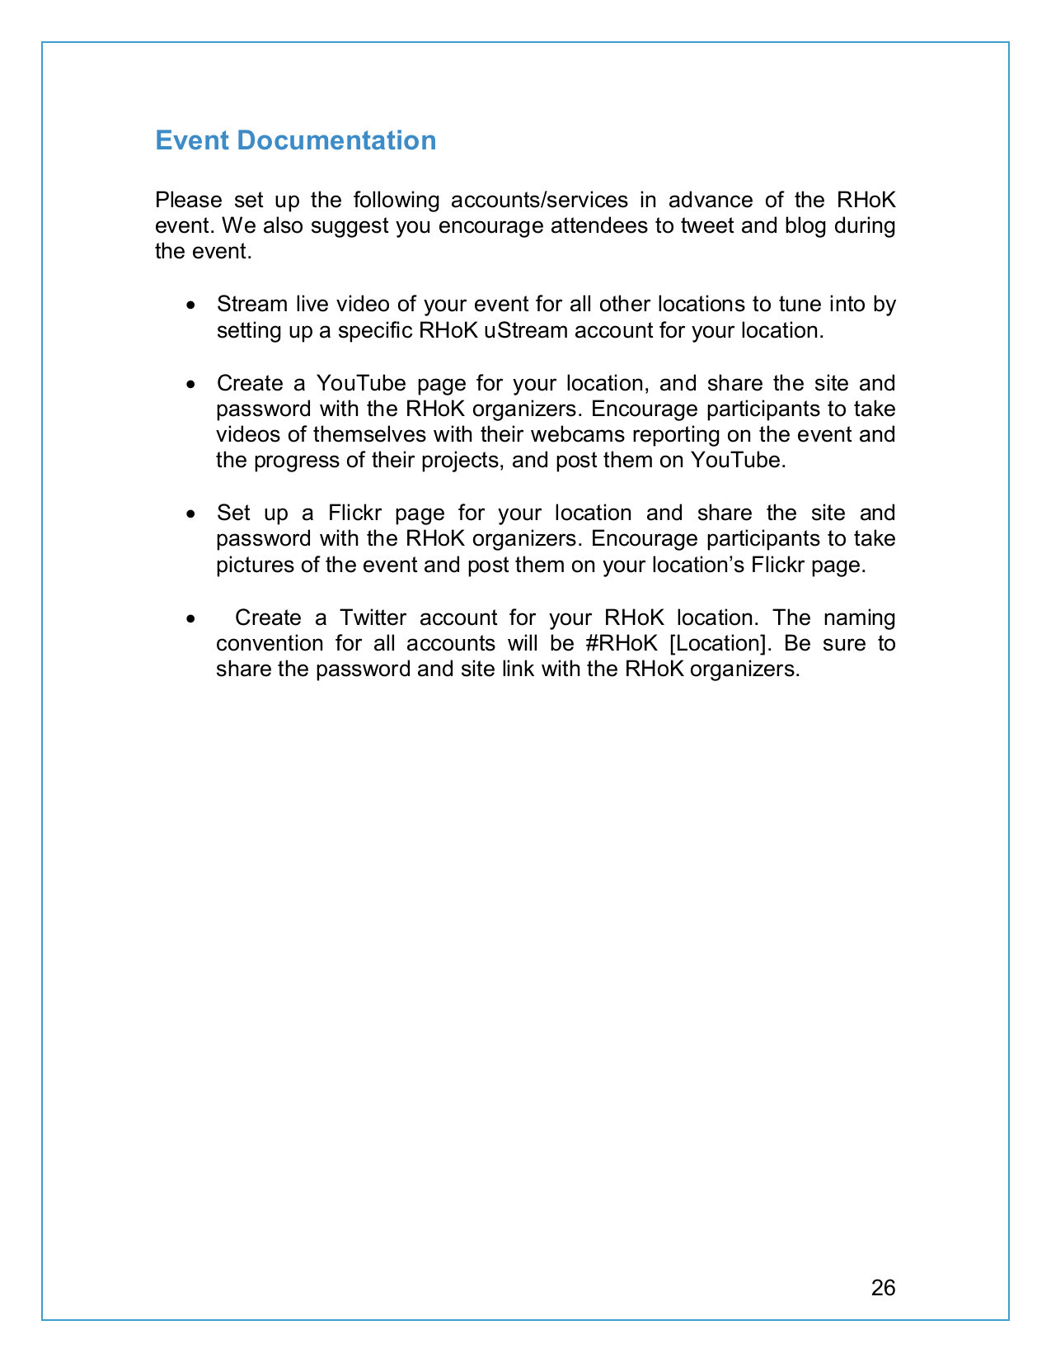
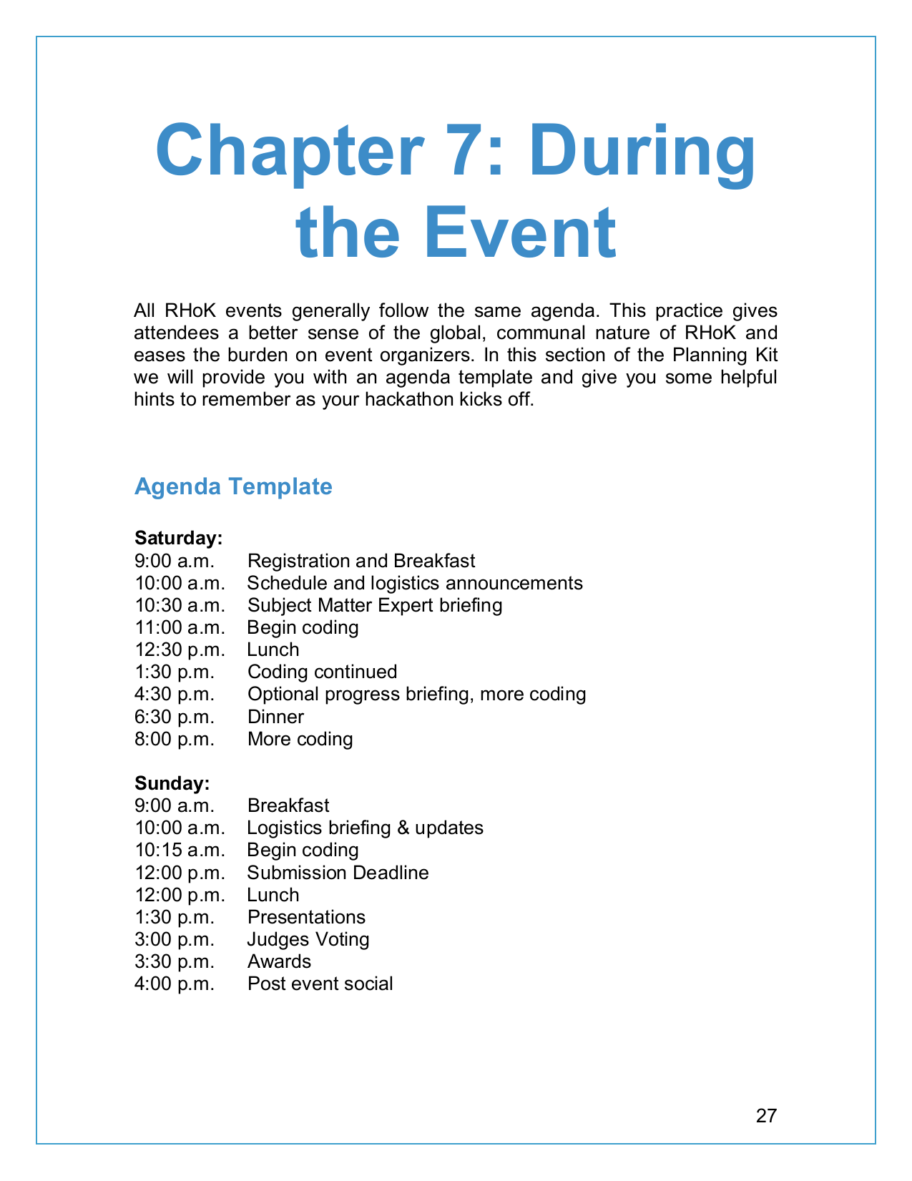
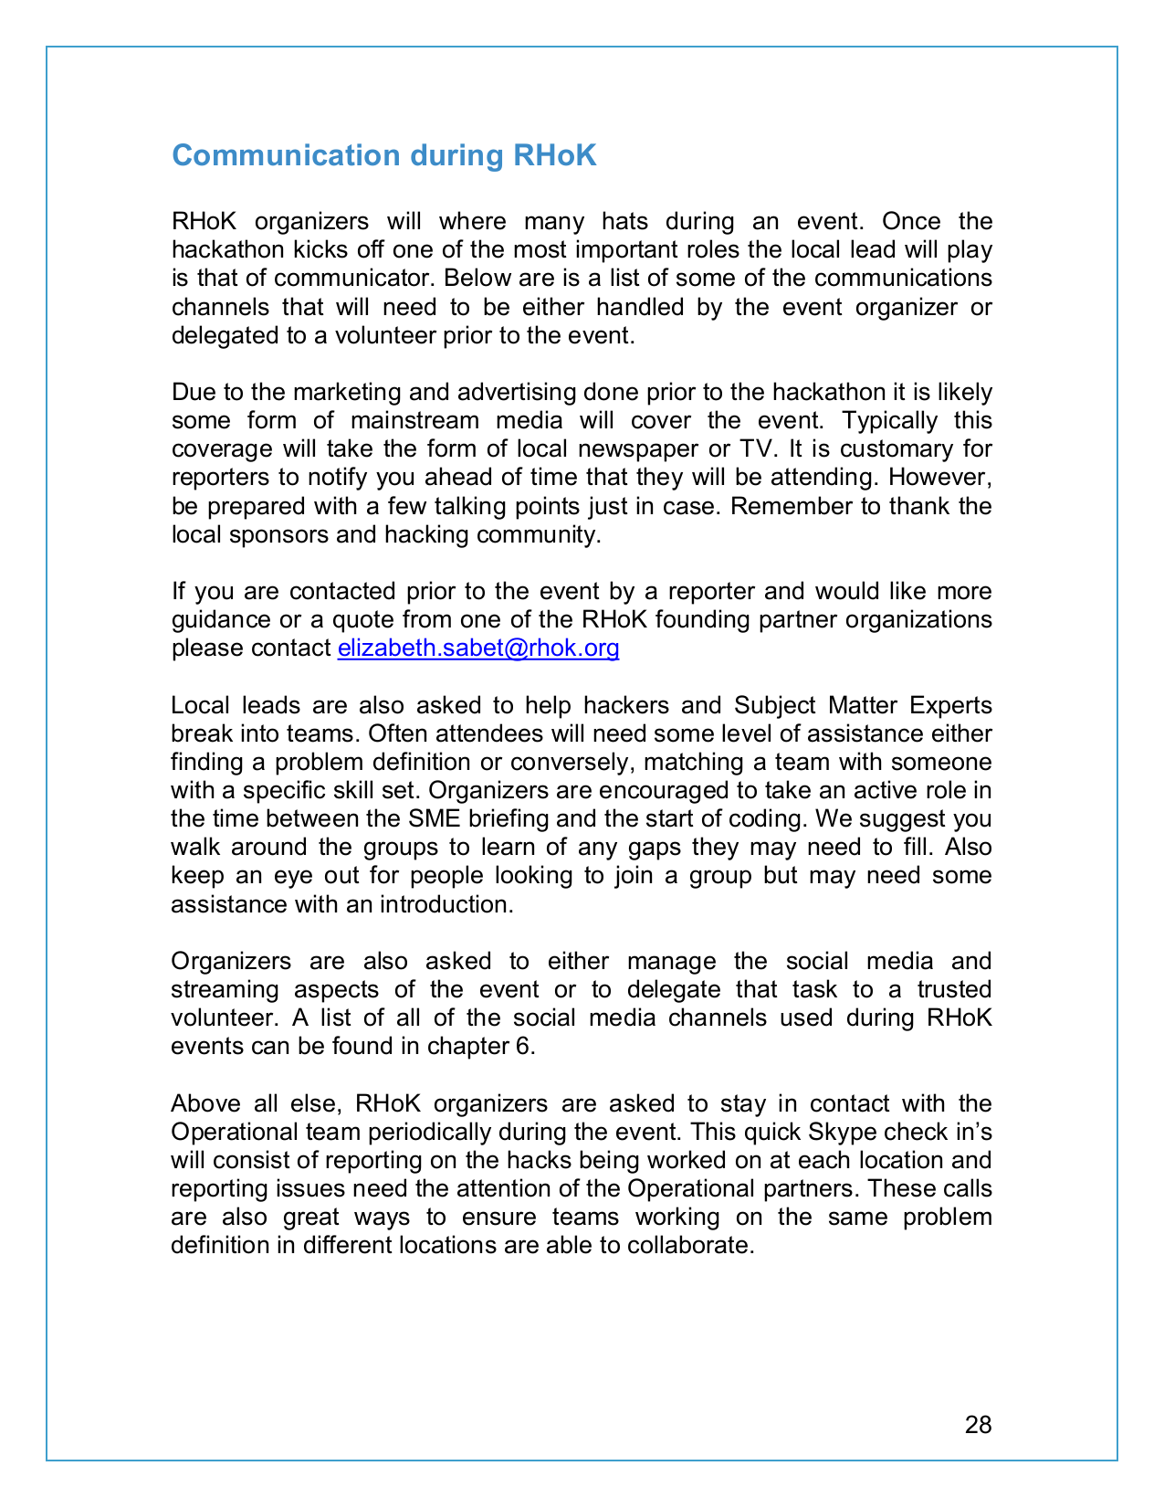
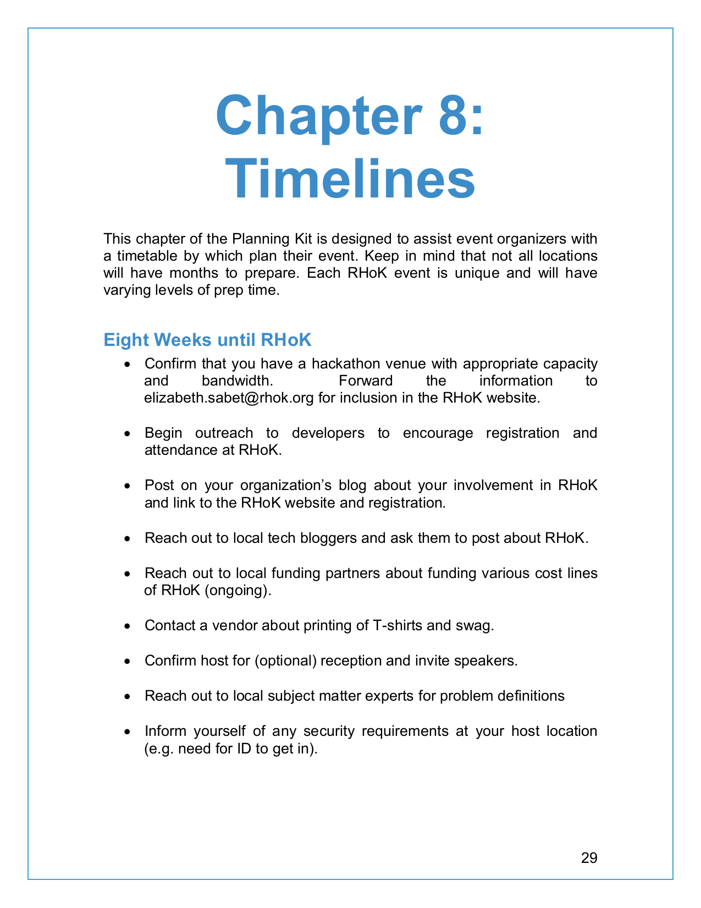
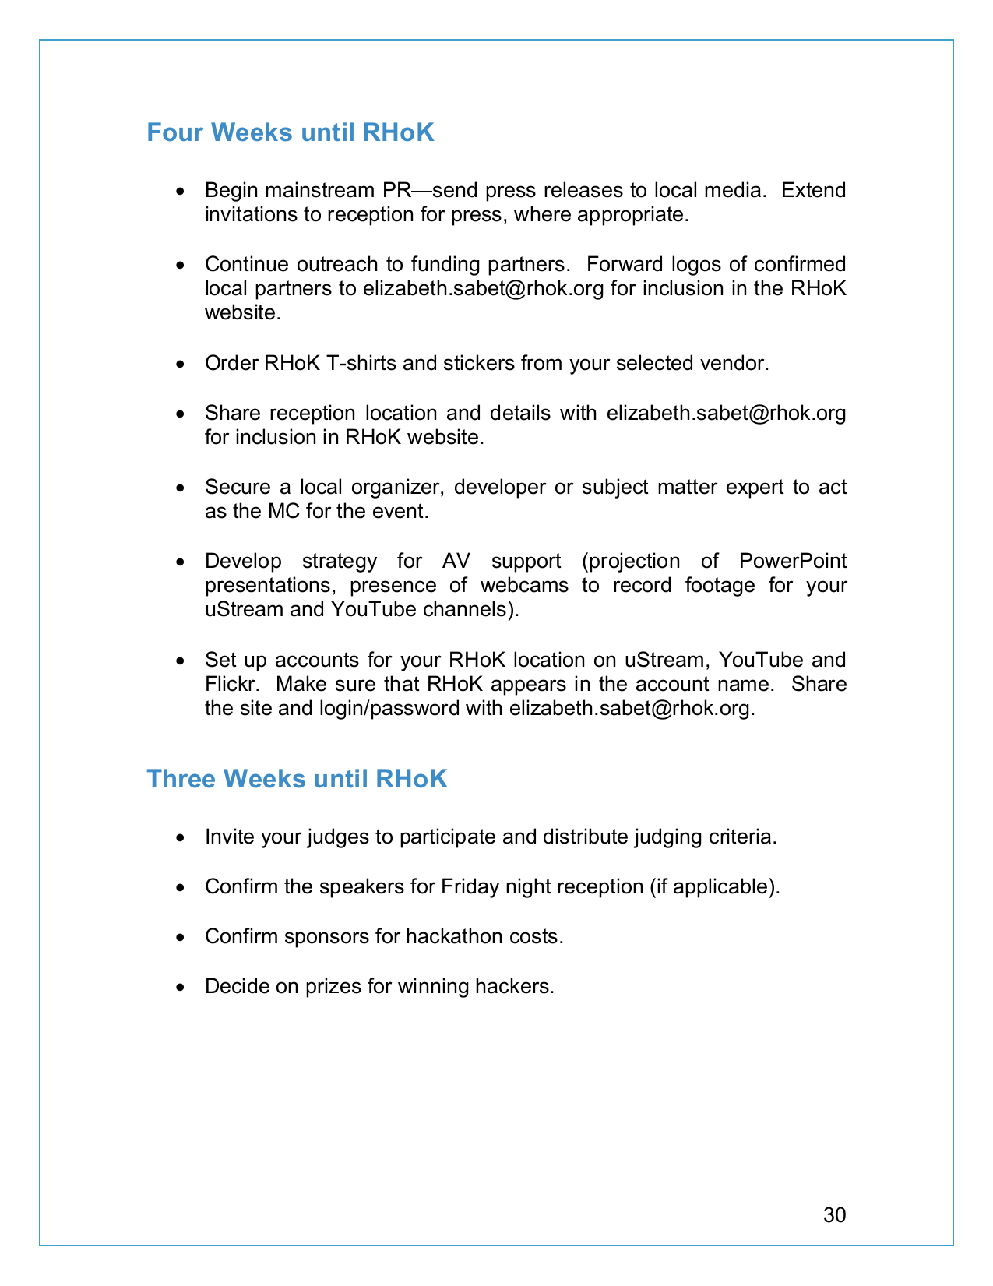
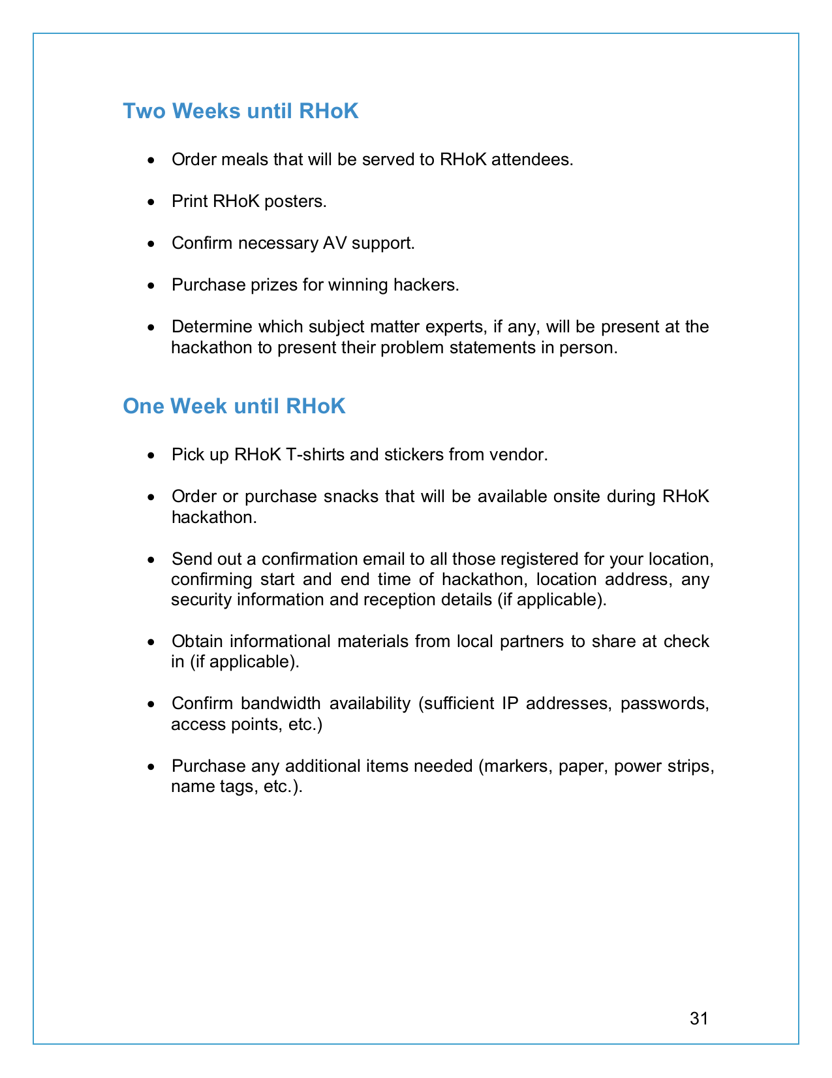
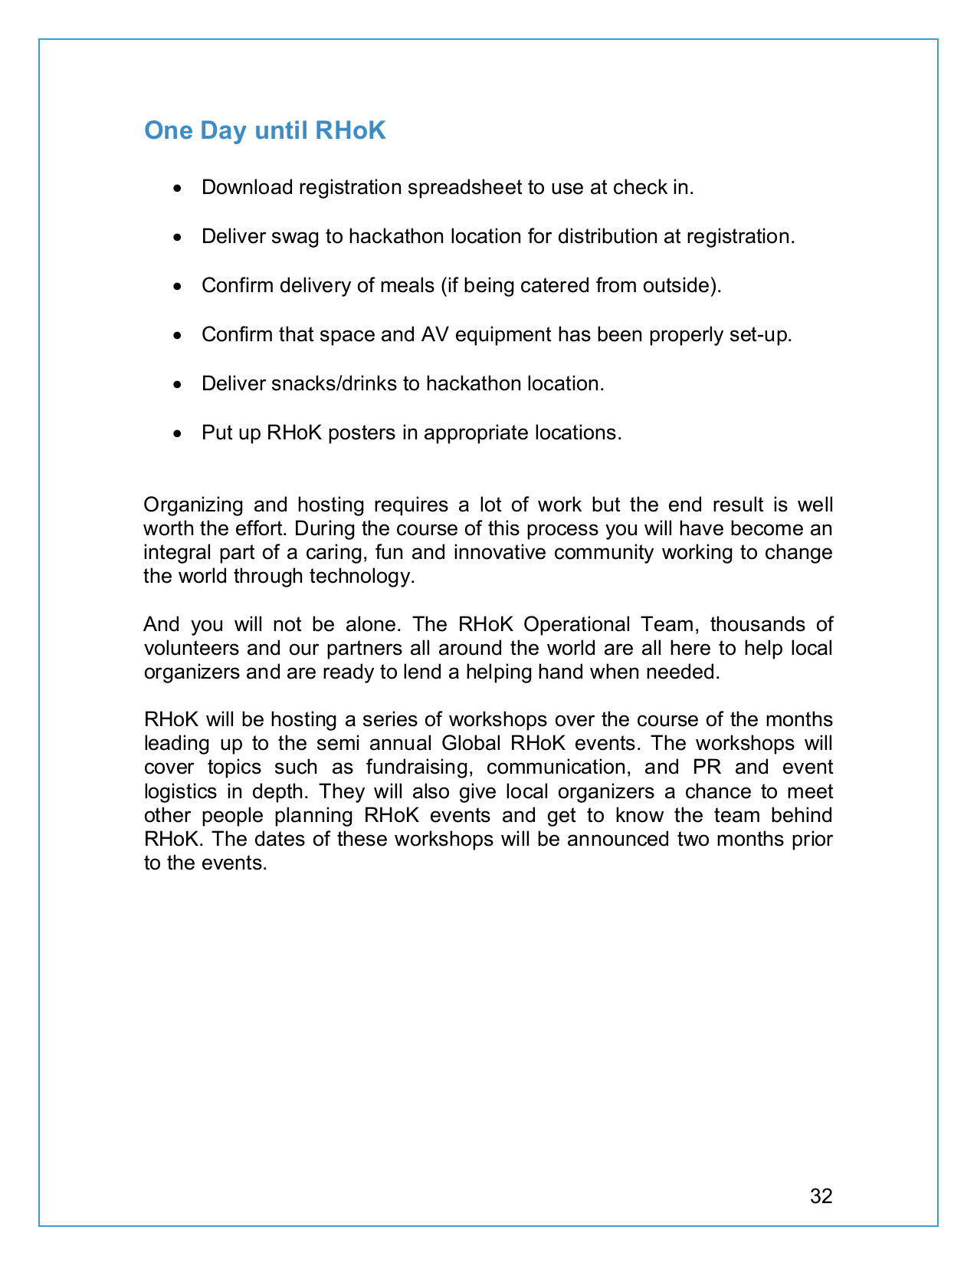
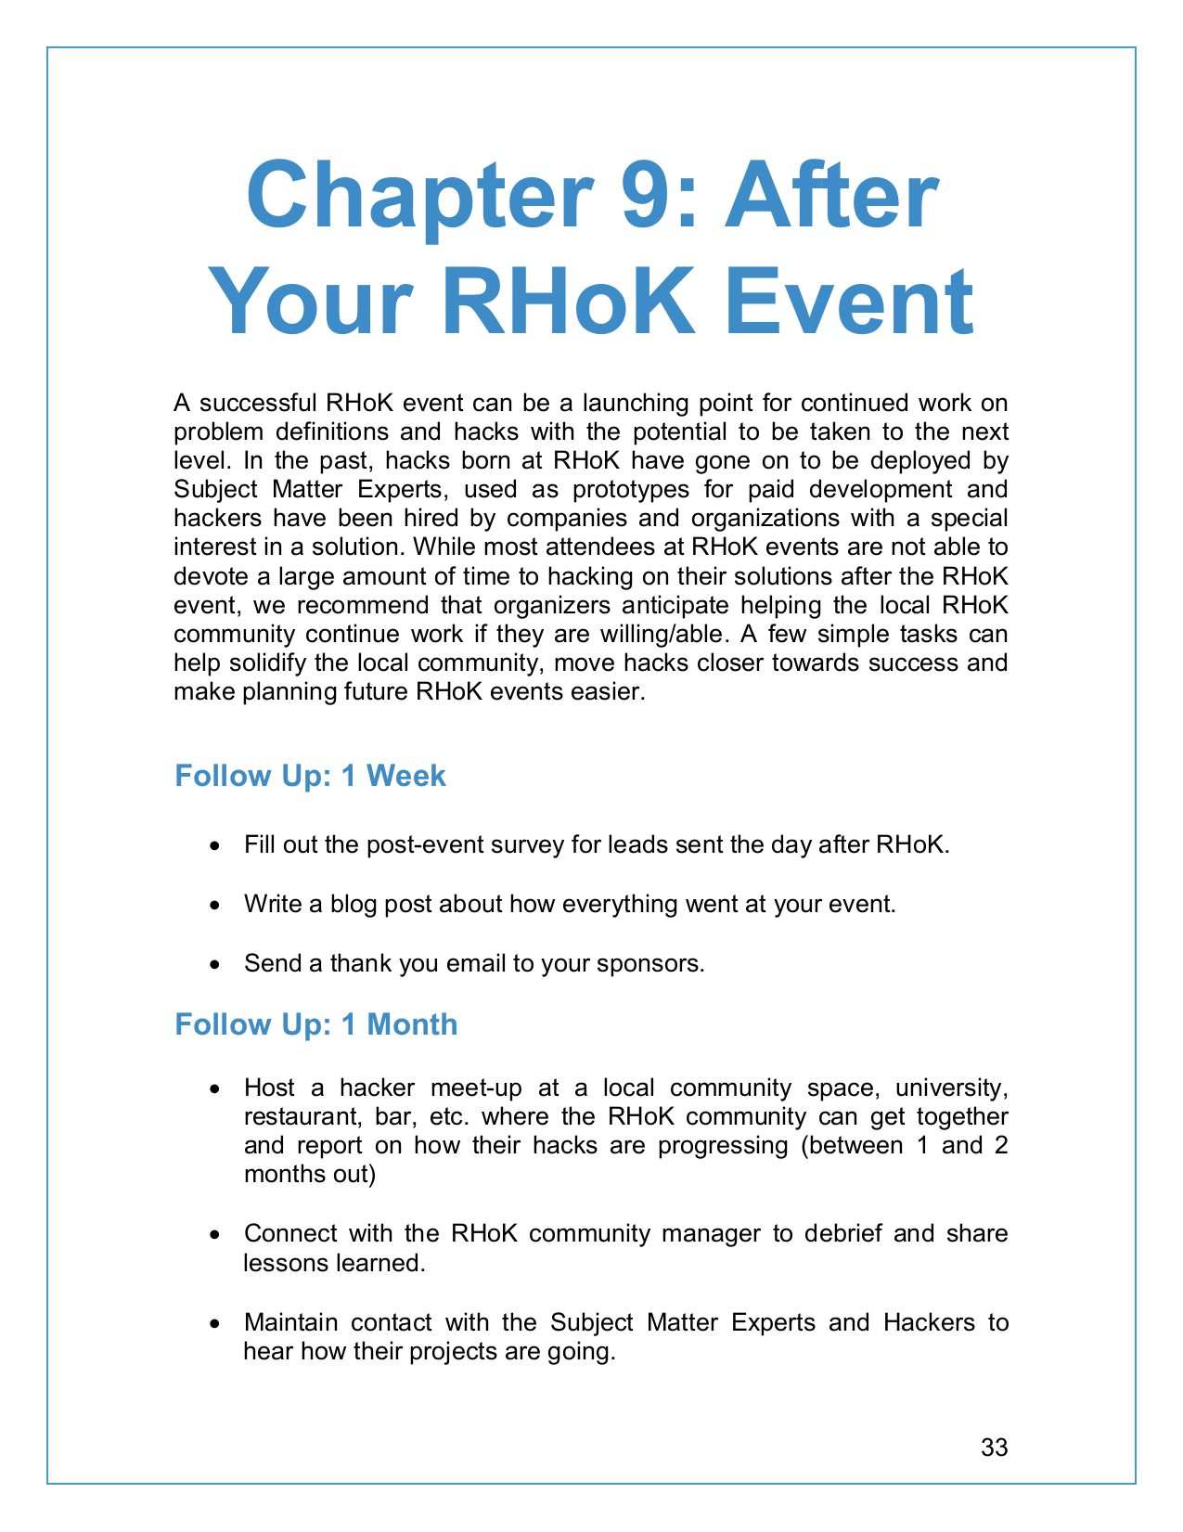
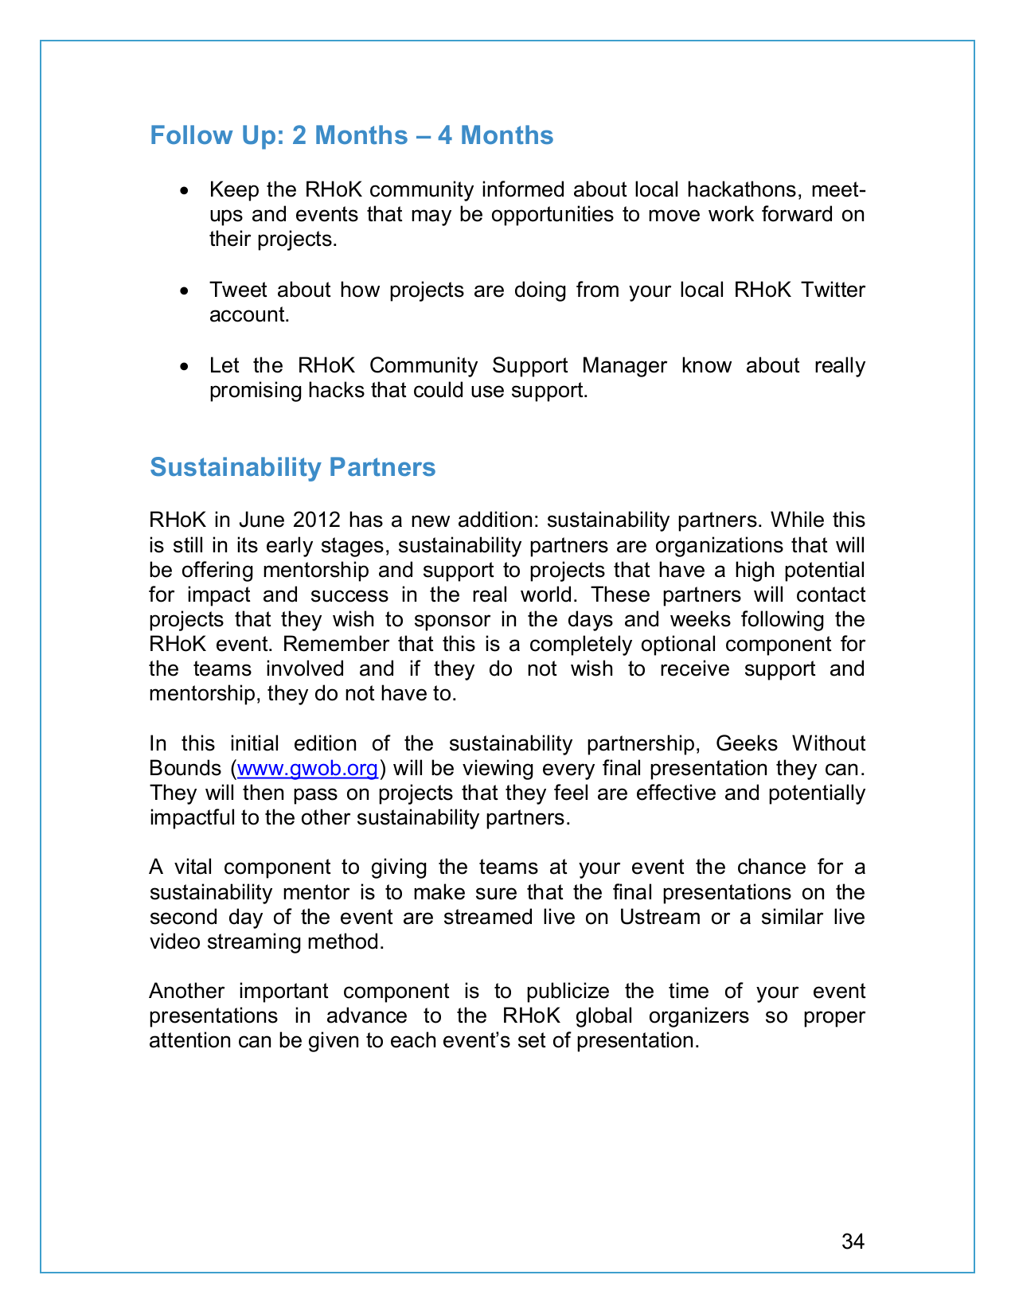
Appendix P: Multi-Gource Scripts

https://github.com/FOSSRIT/multigource-fossrit/tree/rhok



