Error Analysis Report
MIRROR-Based Robust Detection of AI-Generated Images
Executive summary. Across all evaluated conditions, 3,712 condition-level error instances were recorded, of which 482 (13.0%) met the team’s severe-confidence criterion. Transformation effects were strongly asymmetric: Gaussian blur produced the highest false-positive rate on the 30,983-image labeled-real collection (3.05%), whereas Gaussian noise produced the highest false-negative rate on 15,841 SD v1.5 images (3.18%). Representative residual heatmaps add model-grounded evidence to the case analysis. Severe false positives are concentrated in highly regular commercial or low-texture imagery, while severe false negatives often imitate familiar human-made visual styles such as hand drawing or pixel art. Importantly, residual magnitude alone does not determine the final prediction: MIRROR combines the comparison residual with reconstruction perplexity, and the six analyzed cases show that similar residual ranges can lead to opposite decisions. The core robustness challenge is therefore the mismatch between visual style and content provenance, compounded by preprocessing and decision-threshold effects.

1. Scope, Data, and Error Definitions
Objective. This report analyzes representative false positives (FP), false negatives (FN), transformation-sensitive errors, confidence trade-offs, and MIRROR comparison-residual heatmaps for the team’s zero-shot AIGC detector.
Model context. MIRROR follows a reference-comparison paradigm. An input is projected onto a learned real-image manifold to obtain an ideal reference. The comparison residual between the input representation and that reference, together with reconstruction perplexity, contributes to the final fake probability. The team uses the officially released pretrained weights for zero-shot inference; challenge validation data are used for evaluation rather than training.
Interpretability protocol. For six representative hard cases, the model was rerun and a 14×14 spatial residual-norm grid was exported for the center 224×224 model view. The red rectangle in each figure marks the actual model crop. Each heatmap is normalized independently to [0, 1]; warmer colors indicate larger residual magnitude within that image, while the absolute residual-norm range is shown in the figure title.
Term | Operational definition used in this report
Prediction score | pred = estimated probability that an image is AI-generated.
Team analysis threshold | 0.5 for the binary FP/FN analysis. This is a team diagnostic threshold, not a challenge-defined metric.
False positive (FP) | A labeled-real image with pred ≥ 0.5.
False negative (FN) | A labeled-fake image with pred ≤ 0.5.
Severe FP | Internal diagnostic criterion: labeled-real image with pred > 0.75.
Severe FN | Internal diagnostic criterion: labeled-fake image with pred < 0.25.

Dataset distinction. The challenge specification lists 4,998 COCO val2017 labeled-real images and 8,843 DALL·E Advanced labeled-fake images for demonstration validation. The downloaded COCO archive used in the team’s pipeline contained 5,000 images; all 5,000 were evaluated. The broader internal robustness collections are separate datasets and are therefore reported independently rather than merged into one accuracy figure.

2. Overall Error Profile
Evaluation slice | Size | Correct | Errors | Accuracy / error rate
COCO val2017 downloaded archive (real) | 5,000 | 5,000 | 0 | 100.00% accuracy
DALL·E Advanced (fake) | 8,843 | 8,732 | 111 | 98.74% accuracy; 1.26% FNR
Internal REAL, clean | 30,983 | 30,237 | 746 | 97.59% accuracy; 2.41% FPR
Internal SD v1.5, clean | 15,841 | 15,839 | 2 | 99.99% accuracy; 0.01% FNR

Confidence severity. Across all rows in the team’s error-analysis outputs, 3,712 condition-level error instances were recorded. Only 482 were severe under the internal 0.25/0.75 severity criterion, yielding a severe-error share of 13.0%. The remaining 3,230 instances (87.0%) were less extreme, indicating that many failures are confidence-boundary problems rather than complete inversions of the model’s belief.

3. Transformation-Specific Error Patterns

3.1 Labeled-real images: Gaussian blur is the strongest FP stressor
Condition | FP count | FPR | Real accuracy
Clean | 746 | 2.41% | 97.59%
Color jitter | 137 | 0.44% | 99.56%
Center crop | 327 | 1.06% | 98.94%
Gaussian blur | 946 | 3.05% | 96.95%
JPEG compression | 128 | 0.41% | 99.59%
Resize | 221 | 0.71% | 99.29%
Gaussian noise | 30 | 0.10% | 99.90%

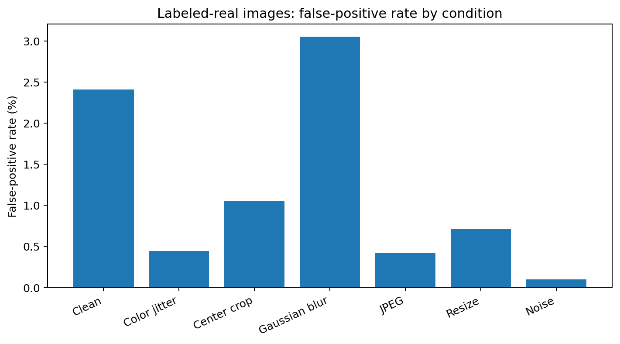
Figure 1. False-positive rate on the 30,983-image labeled-real collection. Gaussian blur produced the highest FPR in the available evaluation.
Interpretation. Blur is the only tested transformation that worsened the aggregate real-image error rate relative to clean. Several other transformations reduced the observed FP count on this dataset. This should not be generalized as evidence that those transformations are intrinsically beneficial; the defensible conclusion is that MIRROR’s errors are transformation-dependent rather than uniformly monotonic.

3.2 SD v1.5 images: noise, JPEG compression, and resize dominate false negatives
Condition | FN count | FNR | Fake accuracy | Severe FN share
Clean | 2 | 0.01% | 99.99% | 100.00% (2/2)
Color jitter | 4 | 0.03% | 99.97% | 50.00% (2/4)
Center crop | 3 | 0.02% | 99.98% | 33.33% (1/3)
Gaussian blur | 8 | 0.05% | 99.95% | 0.00% (0/8)
JPEG compression | 313 | 1.98% | 98.02% | 11.18% (35/313)
Resize | 170 | 1.07% | 98.93% | 38.82% (66/170)
Gaussian noise | 504 | 3.18% | 96.82% | 12.10% (61/504)

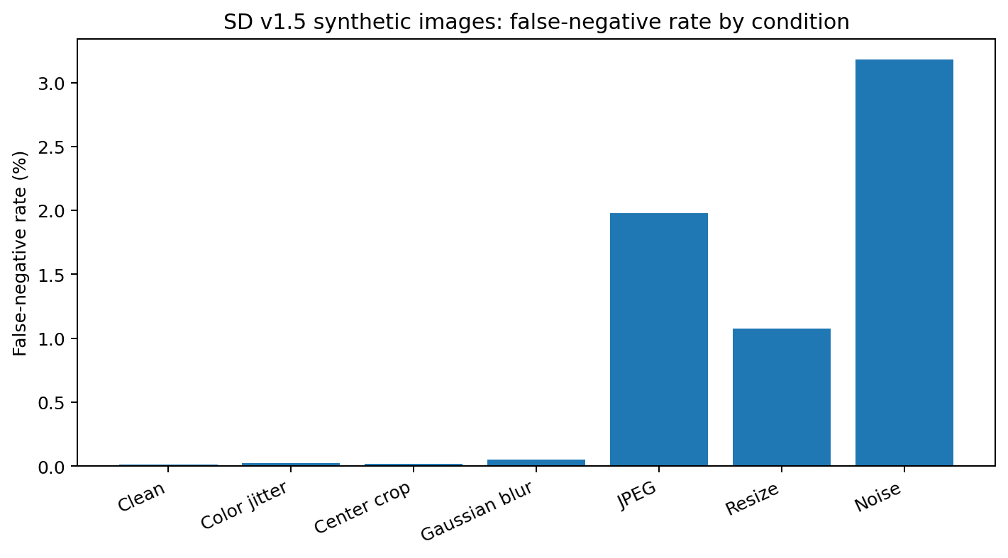
Figure 2. False-negative rate on 15,841 SD v1.5 images. Gaussian noise caused the largest number of misses, followed by JPEG compression and resize.
Error quantity and error severity are different phenomena. Gaussian noise caused the most SD v1.5 false negatives (504), but only 12.10% of those errors were severe. Resize caused fewer errors (170), yet 38.82% were severe. Thus, noise and JPEG mainly create more near-boundary misses, whereas resize produces fewer but more strongly wrong predictions.

4. False-Positive Analysis with Residual Evidence
Observed pattern. The selected severe FPs are not ordinary documentary photographs. They are highly regular commercial images, low-texture studio content, or isolated-product imagery. The residual maps now allow the interpretation to be tied to the actual 224×224 model crop rather than to the full-image semantics.

4.1 FP-1 — Repeated commercial product layout
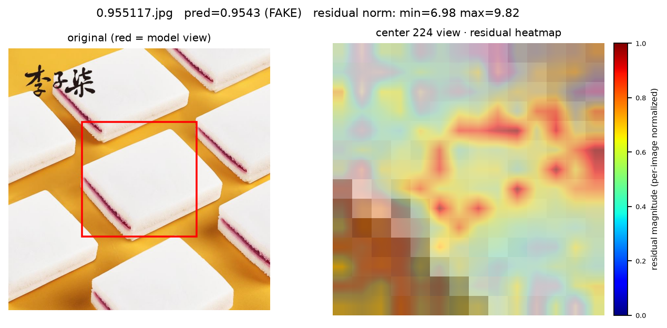
Figure 3. Labeled-real commercial product image. Visualization-run P(fake)=0.9543; residual norm range 6.98–9.82, grid mean 8.38.
The red model crop excludes the calligraphic text and focuses on a repeated white pastry block against a highly uniform yellow background. The heatmap shows elevated residuals around product boundaries, filling seams, and sharp transitions between smooth white surfaces and the flat background. This supports a failure mode driven by highly regular geometry, repeated layout, and low scene randomness rather than by any single semantic object.

4.2 FP-2 — Low-texture studio portrait crop
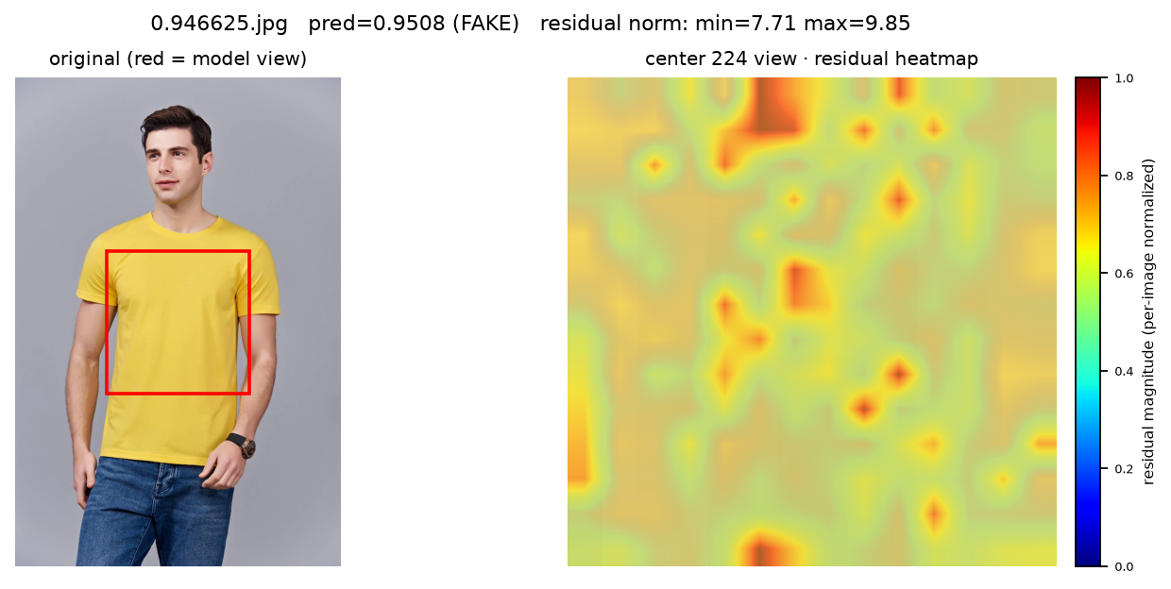
Figure 4. Labeled-real studio portrait. Visualization-run P(fake)=0.9508; residual norm range 7.71–9.85, grid mean 8.45.
The red model crop is centered primarily on the yellow shirt and torso; most of the face is outside the actual model view. The residual response is broadly warm, with stronger local responses along garment folds, boundaries, and smooth low-texture regions. The case therefore supports a more precise explanation than “facial retouching”: controlled illumination and a large uniform textile region can themselves look atypical relative to the learned real-image reference.

4.3 FP-3 — Isolated e-commerce product with reflective geometry
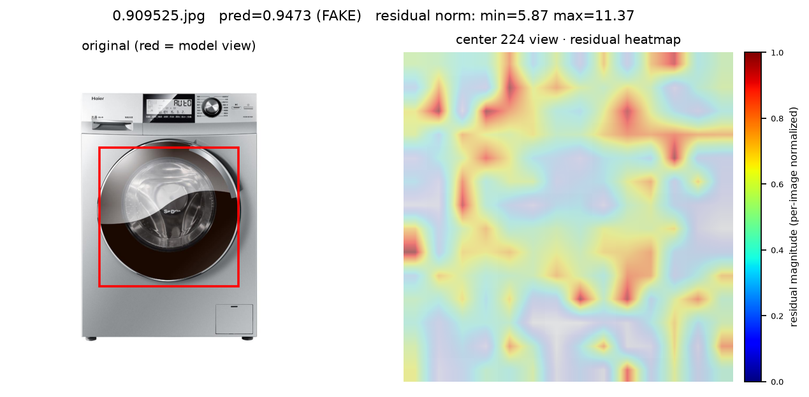
Figure 5. Labeled-real e-commerce washing-machine image. Visualization-run P(fake)=0.9473; residual norm range 5.87–11.37, grid mean 8.19.
The model crop centers on the circular door and reflective drum rather than the surrounding white background. Strong residual responses are distributed around circular edges, reflective transitions, and repeated high-contrast structural boundaries. This is consistent with the broader FP pattern: authentic commercial imagery with strong symmetry, polished reflections, and regular geometry can resemble rendered or synthetic visual statistics.
FP synthesis. Across the three high-confidence FPs, the residual evidence points to a distributional rather than semantic problem. MIRROR appears sensitive to real images whose visible crop is unusually clean, regular, low-texture, or highly controlled. These images are real by provenance but can sit far from the dominant statistics of everyday natural photography.

5. False-Negative Analysis with Residual Evidence
Severe FN pattern. The selected DALL·E hard cases are not highly photorealistic images. Instead, they imitate familiar human-made visual media such as hand drawing and pixel art. The red model-view boxes reveal that the low fake scores persist even when the detector sees the stylized content itself rather than only an outer physical frame.

5.1 FN-1 — AI-generated hand-drawn character on paper
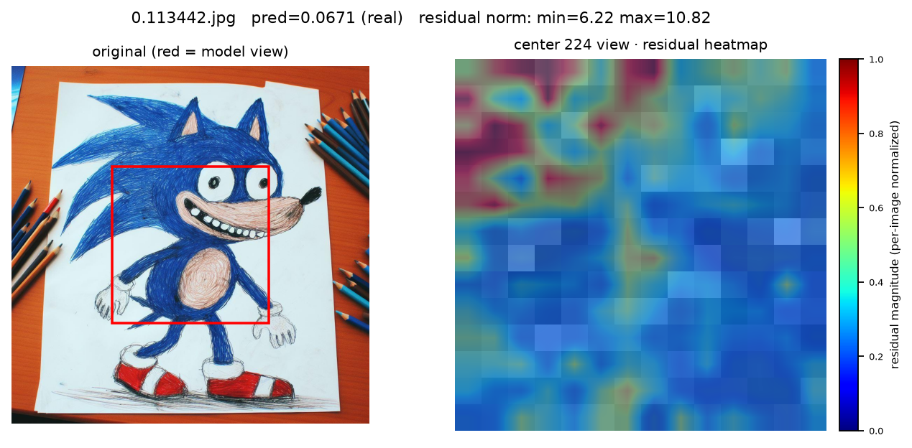
Figure 6. DALL·E false negative. Visualization-run P(fake)=0.0671; residual norm range 6.22–10.82, grid mean 8.28.
The model crop contains the hand-drawn character and paper background, while most surrounding pencils are outside the crop. Residuals are strongest in the upper hair/outline region and weaker across much of the center and lower body. The low final score therefore cannot be explained only by realistic surrounding props. A more defensible interpretation is that AI-generated content that convincingly imitates irregular hand-drawn texture can remain compatible with the model’s real-image reference despite localized residual peaks.

5.2 FN-2 — Pixel-art scene
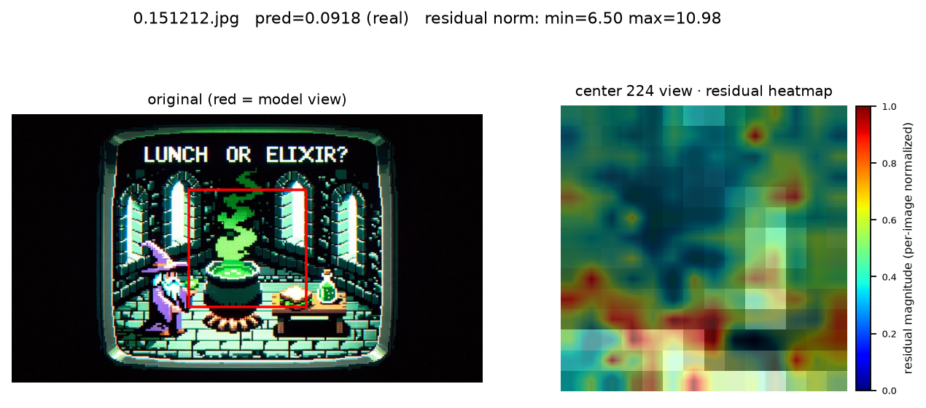
Figure 7. DALL·E false negative. Visualization-run P(fake)=0.0918; residual norm range 6.50–10.98, grid mean 8.67.
The red crop is dominated by the pixel-art game scene itself, with little of the outer display bezel contributing to the model view. The heatmap is heterogeneous, with several strong responses around high-contrast edges and the lower scene, yet the final fake probability remains very low. Pixelation, aliasing, and hard color transitions are semantically expected in retro digital art, so they are not reliable generator cues by themselves. This case is also important quantitatively: its grid mean residual is high, yet its final P(fake) is low, demonstrating that residual magnitude alone is not equivalent to the detector score.

5.3 FN-3 — Hand-drawn family illustration
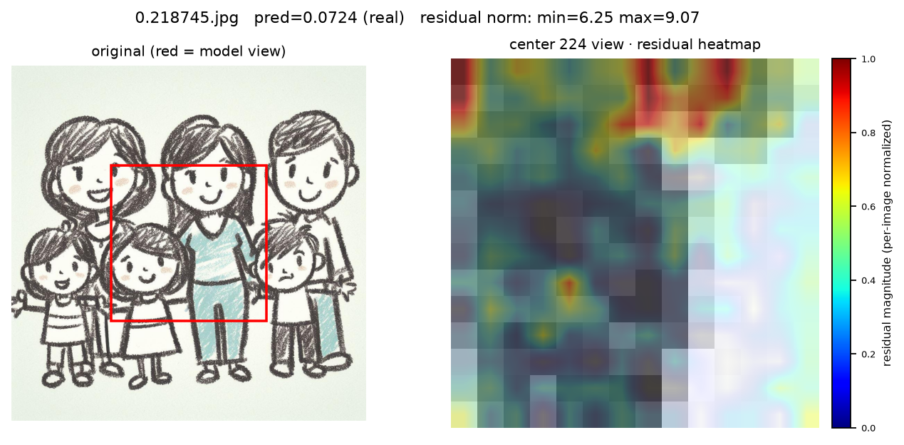
Figure 8. DALL·E false negative. Visualization-run P(fake)=0.0724; residual norm range 6.25–9.07, grid mean 7.06.
The center crop contains the hand-drawn family figures and their irregular line work. Much of the central and right portion of the residual map remains comparatively weak, with stronger responses localized around selected strokes and upper structures. The generated image successfully imitates a visual distribution that is common in legitimate human-made drawings, illustrating how synthetic origin can be visually decoupled from “synthetic-looking” style.
FN synthesis. The severe misses show that the open-world challenge is not only that AI photographs are becoming photorealistic. Generators can also imitate established human-made media. When the stylization itself is plausible for genuine human-created content, provenance becomes harder to infer from visual statistics alone.

6. Cross-Case Residual Analysis
Case | Label | Error | P(fake) | Residual min | Residual max | Grid mean
0.955117.jpg | Real | FP | 0.9543 | 6.98 | 9.82 | 8.38
0.946625.jpg | Real | FP | 0.9508 | 7.71 | 9.85 | 8.45
0.909525.jpg | Real | FP | 0.9473 | 5.87 | 11.37 | 8.19
0.113442.jpg | AI-generated | FN | 0.0671 | 6.22 | 10.82 | 8.28
0.151212.jpg | AI-generated | FN | 0.0918 | 6.50 | 10.98 | 8.67
0.218745.jpg | AI-generated | FN | 0.0724 | 6.25 | 9.07 | 7.06

Residual magnitude is not a monotonic proxy for P(fake). For example, the pixel-art FN (0.151212.jpg) has a grid mean residual of approximately 8.67, which is higher than the e-commerce FP (0.909525.jpg) at approximately 8.19, yet their fake probabilities are 0.0918 and 0.9473 respectively. This is consistent with MIRROR’s design: the final decision is not the scalar average of a residual map; the comparison residual is processed together with reconstruction perplexity by the detection pipeline.
The model-view crop materially changes interpretation. Two earlier full-image intuitions become weaker once the red boxes are considered: the studio-portrait case is driven mainly by the shirt/torso crop rather than the face, and the pixel-art FN is evaluated mainly on the game content rather than the outer CRT bezel. Heatmap explanations should therefore be grounded in the actual 224×224 model view, not in visual elements that the detector never sees.
Per-image normalization also matters. Each heatmap colorbar is normalized independently, so equal colors across two figures do not imply equal absolute residual magnitude. Cross-image comparison should rely on the reported absolute residual ranges and grid statistics, while the heatmap colors are primarily useful for within-image localization.

7. Boundary False Negatives and Confidence Calibration
A second FN group lies extremely close to the 0.5 team analysis threshold. Screening-stage examples at approximately 0.490–0.494 are not cases where the model strongly believes an AI image is real; they are cases where the detector is nearly indifferent. These errors are qualitatively different from the severe FNs above.
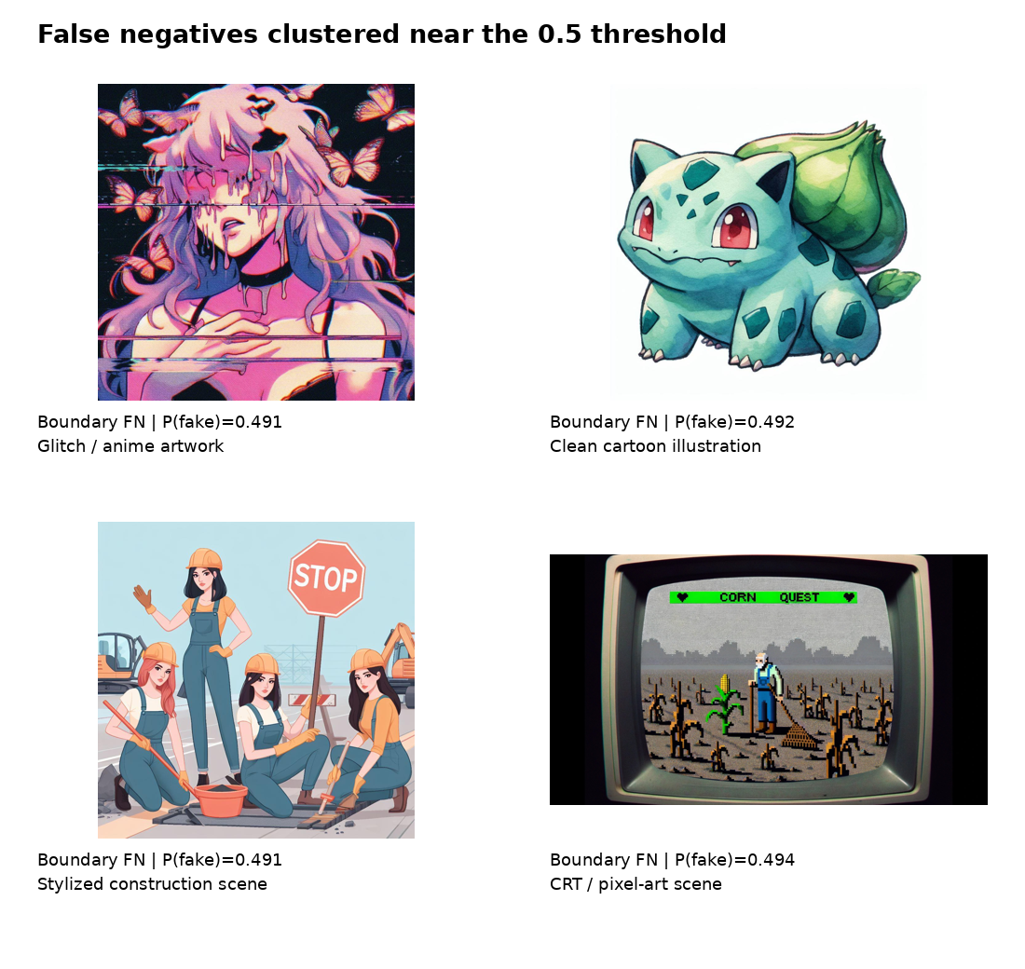
Figure 9. Representative boundary FNs from the batch screening manifests. These images miss the 0.5 analysis threshold by less than one percentage point in probability.
Threshold trade-off. Lowering the decision threshold slightly could recover some boundary FNs, but it would also convert additional labeled-real samples into FPs. Threshold calibration therefore cannot be judged from the fake side alone. Any calibration should use an independent calibration set, not the challenge validation subset, and should report both FPR and FNR.

8. Transformation-Amplified False Positives
The selected transformation pairs are not clean-to-error flips. Each example is already a false positive before transformation. The transformation increases the fake probability further, so the correct description is “amplification of an existing FP tendency.”
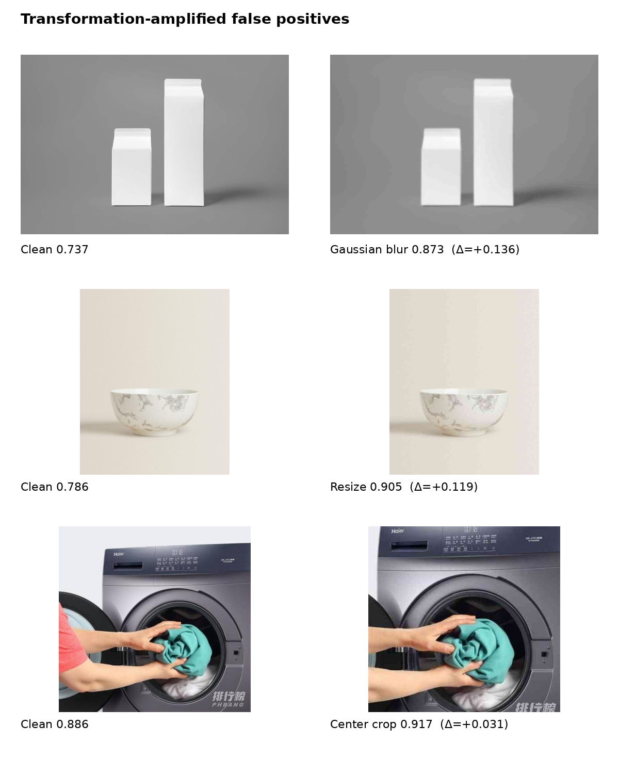
Figure 10. Three labeled-real examples before and after transformation. Blur and resize show the largest score increases in these selected cases.
Transformation | Clean P(fake) | Transformed P(fake) | Δ P(fake) | Interpretation
Gaussian blur | 0.737 | 0.873 | +0.136 | Fine photographic detail is suppressed while an already regular scene layout is preserved.
Resize | 0.786 | 0.905 | +0.119 | Down/up-sampling reduces fine texture in a minimalist product image and strengthens an existing synthetic-looking profile.
Center crop | 0.886 | 0.917 | +0.031 | Cropping removes contextual pixels and slightly increases confidence in an already strong FP.

9. Cross-Cutting Interpretation and Trade-offs
- Visual style vs. provenance: the detector must infer how an image was produced, but many accessible visual cues describe how an image looks. Real images can be highly synthetic-looking, while AI images can imitate legitimate human-made media.
- Model-view dependence: explanations must be based on the center 224×224 crop actually processed by the detector. Full-image semantics outside the red crop can be visually compelling but causally irrelevant to the displayed prediction.
- Residual is evidence, not the score itself: the six residual grids do not show a monotonic relationship between mean residual magnitude and P(fake). MIRROR combines residual information with reconstruction perplexity and a learned detection head.
- Real-class heterogeneity: product shots, advertisements, graphics, screenshots, studio images, and highly processed content may all be labeled real by provenance while differing strongly from natural-image statistics.
- Robustness is transformation-specific: blur increases FPs on the labeled-real collection, whereas noise and JPEG substantially increase FNs on SD v1.5 images. A single robustness number would hide these asymmetric effects.
- Error count vs. confidence severity: Gaussian noise produces many SD v1.5 misses, while resize produces fewer but more severe misses. Both dimensions should be reported.
- Threshold calibration trade-off: moving the 0.5 analysis threshold can recover boundary FNs but risks increasing FPs. Calibration must be performed on independent data and evaluated jointly with FPR/FNR.

10. Limitations of This Error Analysis
- Residual heatmaps are diagnostic localization tools rather than pixel-level causal explanations. A highlighted region indicates stronger disagreement with the ideal reference, but it does not prove that the region alone caused the final decision.
- The six heatmaps are independently normalized to [0, 1]. Cross-image color intensity should not be compared directly; absolute residual ranges and grid statistics are more appropriate for cross-case comparison.
- The residual-visualization rerun produced slightly different P(fake) values from the earlier batch-screening manifests. Case figures therefore use the visualization-run scores shown on each heatmap, while aggregate statistics continue to use the original batch evaluation outputs. The difference should be treated as an inference/preprocessing-path reproducibility issue rather than silently merged.
- The manifest files are filtered hard-case collections rather than random samples of the complete datasets. They are used for representative case analysis, not for estimating overall error rates.
- The labeled-real collection includes non-photographic and commercial visual assets. “Real” is interpreted as the dataset provenance label, not as a guarantee of unedited natural photography.
- Transformation results depend on the exact implementation, strength, preprocessing, and threshold protocol. Conclusions are therefore specific to the current evaluation pipeline.
- Representative images may be subject to dataset or third-party licensing. Before public reuse in Devpost or video, the team should verify licensing or replace them with self-created equivalents while retaining the numerical analysis.

11. Recommended Next Steps
Priority | Action | Rationale
High | Standardize the batch-inference and residual-visualization preprocessing paths, then rerun the six selected cases. | Eliminates score drift between screening manifests and heatmap reruns and improves reproducibility.
High | Export separate residual and reconstruction-perplexity contributions for representative FP/FN cases. | Tests why similar residual magnitudes can lead to opposite final predictions.
High | Generate paired residual heatmaps for clean vs. transformed versions of the same images. | Moves robustness analysis from score changes to spatially localized mechanism evidence.
High | Evaluate threshold calibration on an independent non-challenge calibration set. | Quantifies the FP/FN trade-off without contaminating the demonstration validation set.
Medium | Stratify the real set into natural photos, product photography, graphics/logos, and heavily edited images. | Tests whether FPs are concentrated in particular real-content domains.
Medium | Add targeted stress tests for hand-drawn, pixel-art, and other human-made-style synthetic content. | Directly addresses the severe FN pattern observed in the residual case analysis.

12. Conclusion
The combined quantitative and residual-map analysis reveals two complementary failure modes. On the real side, severe false positives occur in highly regular, low-texture, commercially controlled imagery; the residual maps localize disagreement around repeated geometry, smooth regions, reflective structures, and sharp boundaries inside the actual model crop. On the synthetic side, severe false negatives arise when AI-generated content convincingly imitates familiar human-made styles such as hand drawing or pixel art. The residual maps show localized mismatch, but the final scores remain low, demonstrating that residual magnitude alone is insufficient to explain the detector output. Transformation effects remain asymmetric: Gaussian blur is the strongest FP stressor on the labeled-real collection, whereas Gaussian noise is the strongest FN stressor on SD v1.5 images. Overall, robust AIGC detection requires disentangling provenance from visual style, grounding explanations in the model’s true input view, and reporting class-specific robustness, confidence severity, and threshold trade-offs rather than clean accuracy alone.

Appendix A. Data Basis
- Challenge specification: robustness transformations, demonstration validation protocol, and required FP/FN error analysis.
- MIRROR implementation documentation: reference-comparison framework, ideal reference, comparison residual, reconstruction perplexity, model setup, and zero-shot inference protocol.
- Aggregate evaluation outputs: clean/transformed performance summaries for labeled-real and synthetic evaluation collections.
- Per-image prediction manifests and representative hard cases used to identify high-confidence FPs, severe FNs, boundary FNs, and transformation-amplified FP examples.
- Six 14×14 comparison-residual grids and corresponding center-224 residual heatmaps used for model-grounded qualitative analysis.

